Problem 1.

 Problem 2.



Problem 3.

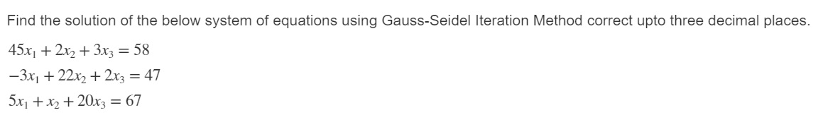

Problem 4.

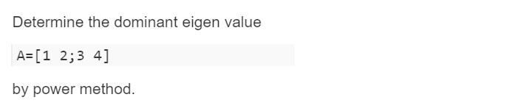

Problem 5.

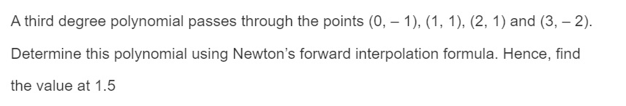

Problem 6.

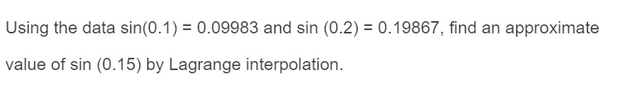

Problem 7.

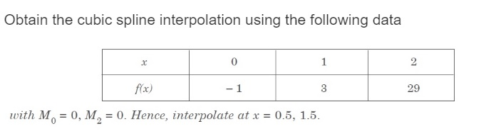

Problem 8.

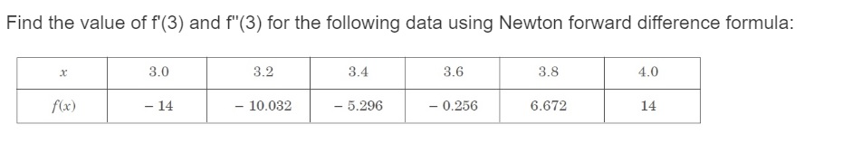

Problem 9.



Problem 10.

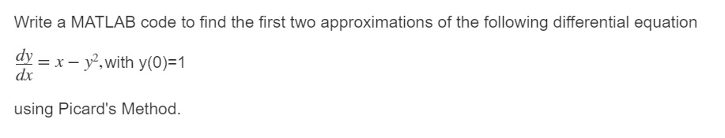

Problem 11.

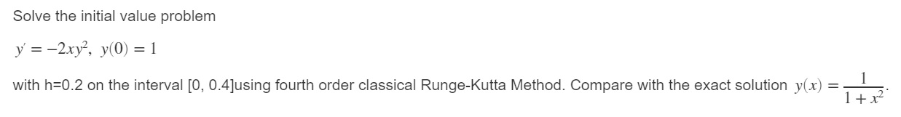

Problem 12.

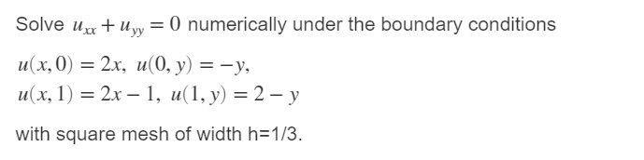

Problem 13.

