“Unless you are willing to have a go, fail miserably , and have another go ,success won’t happen”
“Phillip Adams”

Laws of Motion

State of Motion :The state of motion of an object is described by its speed and the direction of motion. The state of rest is considered to be the state of zero speed. An object may be at rest or in motion; both are its states of motion.

Force : A push or pull acting on an object is known as Force.

Forces do not always cause motion, however. For example, as you sit reading this book, the force of gravity acts on your body and yet you remain stationary.

Newton’s First Law of motion:

“A body continues to be in its state of rest or of uniform motion in a straight line unless compelled by some external force to act otherwise.”

The state of rest or uniform linear motion both imply zero acceleration. The first law of motion can,therefore, be simply expressed as:
If the net external force on a body is zero, its acceleration is zero. Acceleration can be non zero only if there is a net external force on the body.

Inertia :The tendency of an object to resist any attempt to change its velocity is called the inertia of the object.

We do have examples of inertia of motion and inertia of rest in day to day life.for e.g. Suppose we are standing in a stationary bus and the driver starts the bus suddenly. We get thrown backward with a jerk.

Inertial Frames
A moving object can be observed from any number of reference frames. Newton’s first law, sometimes called the law of inertia, defines a special set of reference frames called inertial frames.

Quiz 1 (a) Is it possible to have motion in the absence of a force.
(b) It is possible to have force in the absence of motion.

Answer : (a) Yes ! Newton’s first law tells us that motion requires no force: An object in motion continues to move at constant velocity in the absence of external forces.
(b) True! A stationary object can have several forces acting on it, but if the vector sum of all these external forces is zero, there is no net force and the object remains stationary.
-It also is possible to have a net force and no motion, but only for an instant. A ball tossed vertically upward stops at the peak of its path for an infinitesimally short time, but the force of gravity is still acting on it. Thus, although v = 0 at the peak, the net force acting on the ball is not zero.
_____________________________________________________________________
Mass : Mass is that property of an object that specifies how much inertia the object has.
-the SI unit of mass is the kilogram.

-Mass is an inherent property of an object and is independent of the object’s
surroundings and of the method used to measure it. Also, mass is a scalar quantity and thus obeys the rules of ordinary arithmetic. That is, several
masses can be combined in simple numerical fashion.

linear Momentum : linear Momentum, p of a body is defined to be the product of its mass m and velocity v, and is denoted by p:
p = m v
p is a vector quantity having units of kgm/s

If a particle is moving in an arbitrary direction, p must have three components, and above Equation is equivalent to the component equations

p_{x} = mv_{x} , p_{y} = mv_{y} p_{z} = mv_{z}
______________________________________________________________________
Quiz : Two objects have equal kinetic energies. How do the magnitudes of their momenta compare?
(a)p₁< p₂ (b) p₁> p₂ (c) p₁= p₂ (d) not enough information to tell

Answer : (d). Two identical objects (m1 = m2) travelling in the same direction at the same speed (v1 = v2) have the same kinetic energies and the same momenta.
-However, this is not true if the two objects are moving at the same speed but in different directions. In the latter case, K1 = K2 , but p₁≠ p₂ the differing velocity directions indicate that because momentum is a vector quantity.

-It also is possible for particular combinations of masses and velocities to satisfy K1 = K2 but not p1 = p2 .
For example, a 1-kg object moving at 2 m/s has the same kinetic energy as a 4-kg object moving at 1 m/s, but the two clearly do not have the same momenta.
________________________________________________________________________
Newton’s Second Law

“The rate of change of momentum of a body is directly proportional to the applied force and takes place in the direction in which the force acts.”

Impulse
We sometimes encounter examples where a large force acts for a very short duration producing a finite change in momentum of the body.

For example, when a ball hits a wall and bounces back, the force on the ball by the wall acts for a very short time when the two are in contact, yet the force is large enough to reverse the momentum of the ball. Often, in these situations, the force and the time duration are difficult to ascertain separately.

However, the product of force and time, which is the change in momentum of the body remains a measurable quantity. This product is called impulse:

Impulse = Force × time duration = Change in momentum (5.7)
A large force acting for a short time to produce a finite change in momentum is called an impulsive force.

Quiz 2 Is there any relationship between the net force acting on an object and the direction in which the object moves?

Answer : No. Direction of motion is part of an object’s velocity, and force determines the direction of acceleration, not that of velocity.

The Force Of Gravity And Weight

We are well aware that all objects are attracted to the Earth. The attractive force exerted by the Earth on an object is called the force of gravity F_{g} .

This force is directed toward the center of the Earth, and its magnitude is called the weight of the object.

We know that a freely falling object experiences an acceleration g acting toward the center of the Earth.

Applying Newton’s second law, we obtain F_{g} = mg

Thus, the weight of an object, being defined as the magnitude of F_{g} , is mg.

Because it depends on g, weight varies with geographic location. Hence,weight, unlike mass, is not an inherent property of an object.

Quiz 4: How Much Do You Weigh in an Elevator?
You have most likely had the experience of standing in an elevator that accelerates upward as it moves toward a higher floor. In this case, you feel heavier. In fact, if you are standing on a bathroom scale at the time, the scale measures a force magnitude that is greater than your weight. Thus, you have tactile and measured evidence that leads you to believe you are heavier in this situation. Are you heavier?

Answer : No, your weight is unchanged. To provide the acceleration upward, the floor or scale must exert on your feet an upward force that is greater in magnitude than your weight. It is this greater force that you feel, which you interpret as feeling heavier. The scale reads this upward force, not your weight, and so its reading increases.
________________________________________________________________________
Quiz 5 : A baseball of mass m is thrown upward with some initial speed. If air resistance is neglected,what forces are acting on the ball when it reaches
(a) half its maximum height and (b) its maximum height?
Answer : (a) Force of gravity. (b) Force of gravity. The only external force acting on the ball at all points in its trajectory is the downward force of gravity.
Newton’s Third Law Of Motion

“To every action, there is always an equal and opposite reaction.”

1.Forces always occur in pairs. Force on a body A by B is equal and opposite to the force on the body B by A.

2. “There is no cause effect relation implied in the third law. The force on A by B and the force on B by A act at the same instant.”

3. Action and reaction forces act on different bodies, not on the same body.

4. Action and reaction forces always occur in pairs.This is equivalent to stating that a single isolated force cannot exist.

-For equilibrium; the vector sum of all the forces must be zero.

-If the force is parallel or antiparallel to the motion, it changes only the magnitude of v but not the direction and the path followed by the body is a straight line.

-If the force is acting perpendicular to the motion of body, it changes only the direction but not the magnitude of v and the path followed by the body is a circle (uniform circular motion).

-If the force acts at an angle to the motion of a body, it changes both the magnitude and direction of v . In this case path followed by the body may be elliptical, non-uniform circular, parabolic or hyperbolic.

Apparent weight of a body in a lift:
(i) When the lift is at rest or moving with uniform velocity, i.e., a =0

mg-R=0 or R=mg or Weight apparent W_{app}. = W_{o ,}where, W_{app} = R = reaction of supporting surface

and W_{o} = mg = true weight.

(ii) When the lift moves upwards with an acceleration a : R - mg = mA or R = m(g+a) = mg(1+a/g)

or Weight apparent W_{app}. = W_{o}(1+a/g)

(iii) When the lift moves downwards with an acceleration a: mg - R = mA or R = m(g - a) = mg(1- a/g)

or Weight apparent W_{app}. = W_{o}(1- a/g)

Here, if a> g, W_{app} will be negative. Negative apparent weight will mean that the body is pressed against the roof of the lift instead of floor.

(iv) When the lift falls freely, i.e., a = g: R = m(g-g)=0 or W_{app}.=0

- Problem of monkey climbing a rope: Let T be the tension in the rope

(i) When the monkey climbs up with uniform speed: T=mg.
(ii) When the monkey moves up with an acceleration a :: T-mg = ma or T = m(g+a)
(iii) When the monkey moves down with an acceleration a :: mg - T = ma or T = m( g - a)

Problem of a mass suspended from a vertical string in a moving carriage

Following cases are possible:
(i) If the carriage (say lift) is at rest or moving uniformly (in translatory equilibrium), then R = T_{o} = mg.

(ii) If the carriage is accelerated up with an acceleration a, then T = m(g+a) = mg(1+a/g) = T_{o}(1+a/g)

(iii) If the carriage is accelerated down with an acceleration a, then T = m(g- a) = mg(1-a/g) = T_{o}(1-a/g)

(iv) If the carriage begins to fall freely, then the tension in the string becomes zero.

(v) If the carriage is accelerated horizontally, then
(a) mass m experiences a pseudo force ma opposite to acceleration;

(b) the mass m is in equilibrium inside the carriage and Tsinθ =ma ; Tcosθ =mg i.e. T = m√(g²+a²)

(c) the string does not remain vertical but inclines to the vertical at an angle θ = tan^{-l} (a/g) opposite
to acceleration;

(d) This arrangement is called accelerometer and can be used to determine the acceleration of a moving carriage from inside by noting the deviation of a plumbline suspended from it from the vertical.

Systems of variable mass:
(i) According to Newton's 2nd law:

If the mass of the system changes and the velocity of escaping mass is constant, then dv/dt = 0 and
F=v(dm/dt)
(ii) lf ‘n' bullets each of mass m are fired per unit time from a machine gun, then the force required to hold the gun = F=v(dm/dt)= v(mn)

(iii) If sand is dropped onto a conveyor belt at a constant rate, then the extra force required to maintain the speed of the belt constant = F=v(dm/dt)

(iv) If a jet of liquid coming out from a pipe of uniform area of cross-section A hits a wall normally with a velocity v, then the force applied by the jet on the wall = Av²ρ(ρ = density ofliquid).

Motion of a rocket:
(i) In the case of a rocket ejecting gases, with a constant velocity v_{rel}. (relative to rocket), Newton's 2nd law
takes the form:
F_{ext}. + v_{rel}.dm/dt = ma

where term v_{rel}.dm/dt is the reaction force exerted by the leaving gases on the rocket and is called as thrust on the rocket.

(ii)In the absence of air resistance, if the rocket moves up with an acceleration a, then thrust

= v_{rel}.dm/dt = ma +mg

(iii)If the rocket just moves up with constant velocity, then thrust = v_{rel}.dm/dt = mg

Motion of a block on a horizontal smooth surface:
S.no. | Different cases | Diagram | Result
a | When subjected to a horizontal pull. |  | (i) R=mg  (ii) a=F/m
b | When subjected to a pull acting at an  angle θ to the horizontal. |  | (i) R= mg -Fsinθ  (ii) a=Fcosθ/m
c | When subjected to a push acting at an  angle θ to the horizontal |  | (i) R= mg + Fsinθ  (ii) a = Fcosθ/m

Motion of a body on a smooth inclined plane:
S.no. | Different cases | Diagram | Result
a | When smooth inclined plane is fixed. |  | (i) R=mgcosθ  (ii) a=gsinθ
b | When the smooth inclined plane is  moving horizontally with an  acceleration b |  | (i) R= m(gcosθ + bsinθ )  (ii) a= gsinθ - bcosθ

Motion of bodies in contact: Force of contact
S.no. | Different cases | Diagram | Result
a | When two bodies are kept in contact and  force is applied on the body of mass m₁.
b | When two bodies are kept in contact and  force is applied on the body of mass m₂
c | When three bodies are kept in contact and  force is applied on the body of mass m₁.
d | When three bodies are kept in contact and  force is applied on the body of mass m₃

Motion of connected bodies
S.no. | Different cases | Diagram | Result
a | When two bodies are connected by a string  and placed on a smooth horizontal surface.
b | When three bodies are connected through  strings as shown in figure and placed on a  smooth horizontal surface
c | When two bodies of masses m₁ and m₂ are  attached at the ends of a string passing over a pulley as shown in the figure (neglecting the mass of the pulley.)  If in the above system mass (m) of the pulley is taken into account then
d | When two bodies of masses m₁ and m₂  attached at the ends of a string passing over a pulley in such a way that mass ,m_{l} rests on a smooth horizontal table and mass m₂ is hanging vertically.
e | If in the above case, mass m₁ is placed on a smooth inclined plane making an angle θ with horizontal as shown in figure, then.
f | In case (d), masses m₁ and m₂ are placed on inclined planes making angles α and β with the horizontal respectively, then.

Some other important points regarding friction:
(i) Because limiting force is higher than kinetic friction, hence we require more force to start a motion than to maintain it against friction.

(ii) When a body rolls on a surface, the resistance offered by the surface is called rolling friction. In rolling the surfaces in contact do not rub each other. The velocity of the point of contact with respect to surface remains zero all the time, although the centre of the body moves forward. Rolling friction is negligible as compared to static or kinetic friction, i.e.,μ_{r}<μ_{k}<μ_{s}.

(iii) If the normal force remains constant, then the force of friction does not depend on the area of surfaces in
contact and their relative velocity.

(iv) If lubricants are used, then force of friction generally decreases.
(v) If a rubber wheel is rolling on a road, then lesser is the deformation in it, lesser is the friction.
(vi) Friction is a non-conservative force, i.e., work done against friction is path dependent. In its presence,
mechanical energy is not conserved. Due to frictional forces, heat is produced..
(vii) When a person is pedalling a bicycle and the bicycle is moving towards east, then direction of frictional
force on the front wheel is towards west and on the rear wheel is towards east. However, if pedalling is stopped, both wheels move themselves and so experience a force of friction in backward direction.

(a) Pushing a body on a rough horizontal surface(Fig 4.4):

-Frictional force towards left, f= μR = μ (Fsinθ + mg)

-Force towards right = Fcosθ

(b) Pulling a body on a rough horizontal surface(Fig 4.5):
-Frictional force towards left, f= μ (mg -Fsinθ )

- Pulling force towards right = Fcosθ

Hence, it is easy to pull a lawn roller than to push it, since frictional force is more in the latter case.

Motion of a body on rough inclined plane:
(i) If we consider a body on an inclined plane which is just at the verge of sliding as
shown in the figure 4.6. Consider the equilibrium of forces along and perpendicular to the plane.
f_{L} =mgsinθ and R = mgcosθ

Now, f_{L} =μ_{s}R or mgsinθ =μ_{s} mgcosθ therefore μ_{s} =tanθ
where θ is called as angle of friction or angle of repose.
(ii) Angle of repose may also be defined as the angle made by the resultant of maximum force of static friction and the reaction force, with the reaction,
i.e f_{L} / R = μ_{s} = tanθ

(iii) If the body slides down the inclined plane, then:

(a) Net force on the body, F =mg sinθ - μ_{k} mgcosθ .
(b) Net acceleration of the body, a = g sinθ - μ_{k} gcosθ

(c) Time taken by the block to reach the bottom t = √(2L/a)
(d) Velocity acquired by the body on reaching the bottom

(e) Work done by gravitational force = (mg sinθ)L and work done against frictional force = (μmgcosθ)L

(iv) In above problem, apart from all these forces if an external force F is also applied on the block in the
downward direction along the plane, to move the block with an acceleration a, then
F +mg sinθ - μmgcosθ =ma

(v) But if the block is dragged up the inclined plane by applying an external force F in the upward direction
along the plane, to move the block with an acceleration a, then
F - mg sinθ - μmg cosθ = ma

We can get the corresponding results on a smooth inclined plane by simply putting μ = 0 in all the above equations.

Comparison between physical quantities when a body falls freely from a height and another body slides down a smooth inclined plane of same height

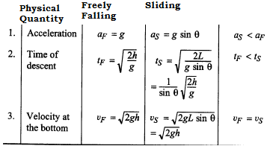

Comparison between downward motion on smooth and rough inclined planes
Physical quantity | Smooth Inclined Plane | Rough Inclined Plane | Conclusion

Comparison of downward and upward motions (when the body is given a velocity at the bottom) of a body on a rough inclined plane:
Physical quantity | Downward motion | Upward Motion | Conclusion

Truck-Box problem:
(a) Suppose a box is placed on a truck which is at rest. If the truck moves forward with an acceleration a) then the box is acted upon by pseudo force (= ma) just in backward direction while the frictional force f (= μmg) starts acting in forward direction.
(b) lf ma > μmg or a > μg, the box moves backward. Hence, the maximum acceleration that the truck can have without the box sliding is μg.

Motion of connected bodies on rough surfaces:

Conservation Of Momentum

law of conservation of linear momentum, states that” Whenever two or more particles in an isolated system interact, the total momentum of the system remains constant.”
This law tells us that the total momentum of an isolated system at all times equals its initial momentum.

Quiz : Two objects are at rest on a frictionless surface. Object 1 has a greater mass than object 2.When a force is applied to object 1, it accelerates through a distance d. The force is removed from object 1 and is applied to object 2. At the moment when object 2 has accelerated through the same distance d, which statements are true?
(a) p₁ < p₂ (b) p₁ = p₂ (c) p₁ > p₂ , (d) K1 < K2 , (e) K1 = K2 , (f) K1 > K2 .Where K denotes kinetic energy.

Solution : (c) and (e).
Object 2 has a greater acceleration because of its smaller mass. Therefore, it takes less time to travel the distance d. Thus, even though the force applied to objects 1 and 2 is the same, the change in momentum is less for object 2 because ∆t is smaller. Therefore, because the initial momenta were the same (both zero),p1 > p2 .

The work W = Fd done on both objects is the same because both F and d are the same in the two cases. Therefore, K1 = K2

Circular Motion
We have seen in Chapter 4 that acceleration of a body moving in a circle of radius R with uniform speed v is v²/R directed towards the centre.

According to the second law, the force f providing this acceleration is :

f =mv²/ R (5.16)

where m is the mass of the body. This force directed forwards the centre is called the centripetal force.
-For a stone rotated in a circle by a string, the centripetal force is provided by the tension in the string.
-The centripetal force for motion of a planet around the sun is the gravitational force on the planet due to the sun.
-For a car taking a circular turn on a horizontal road, the centripetal force is the force of friction.

The circular motion of a car on a flat and banked road give interesting application of the laws of motion.

Motion of a car on a level road
Three forces act on the car. (Fig. 5.14(a)
(i) The weight of the car, mg
(ii) Normal reaction, N
(iii) Frictional force, f
As there is no acceleration in the vertical direction
N–mg = 0 or N = mg (5.17)

The centripetal force required for circular motion is along the surface of the road, and is provided by the component of the contact force between road and the car tyres along the surface. This by definition is the frictional force.

Note that it is the static friction that provides the centripetal acceleration. Static friction opposes the impending motion of the car moving away from
the circle.

Using equations fs ≤ μs N & f = μ_{k} N we get the result

which is independent of the mass of the car.
This shows that for a given value of μ_{s} and R,there is a maximum speed of circular motion of the car possible, namely

Motion of a car on a banked road
We can reduce the contribution of friction to the circular motion of the car if the road is banked (Fig. 5.14(b)). Since there is no acceleration along the vertical direction, the net force along this direction must be zero. Hence,

N cos θ = mg + f sin θ (5.19a)

The centripetal force is provided by the horizontal components of N and f.

N sin θ + f cos θ = mv²/R (5.20a)

But f ≤ μ_{s} N

Thus to obtain v_{max} we put f = μ_{s} N .

Then Eqs. (5.19) & (5.20) become

N cos θ = mg + μ_{s} N sin θ (5.19b)
N sin θ + μ_{s}N cos θ = mv²/R (5.20b) We obtain

Substituting value of N in Eq. (5.20b), we get

Comparing this with Eq. (5.18) we see that maximum possible speed of a car on a banked road is greater than that on a flat road.
For μ_{s} = 0 in Eq. (5.21 ),

v_{o} = ( R g tan θ ) ^{½} (5.22)

At this speed, frictional force is not needed at all to provide the necessary centripetal force.Driving at this speed on a banked road will cause little wear and tear of the tyres. The same equation also tells you that for v < v_{o}, frictional force will be up the slope and that a car can be parked only if
tan θ ≤ μs.

Quiz : Is it possible for a car to move in a circular path in such a way that it has a tangential acceleration but no centripetal acceleration?

Answer : No. The tangential acceleration changes just the speed part of the velocity vector. For the car to move in a circle, the direction of its velocity vector must change, and the only way this can happen is for there to be a centripetal acceleration.

Home Assignment- Laws of Motion
- Define state of motion ?
- Define ‘net force’?

- State Newton’s First Law of motion ?

- Define Inertia ?Which physical quantity determines inertia of an object ?
  - Is it possible to have motion in the absence of a force.
  - It is possible to have force in the absence of motion.

- Two objects have equal kinetic energies. How do the magnitudes of their momenta compare?
- (a)p₁< p₂ (b) p₁> p₂ (c) p₁= p₂ (d) not enough information to tell

- State and derive Newton’s Second Law of motion?
- Does the history of motion of object influences the impact of 2nd law of motion?

- Define impulse and write it’s SI unit? Why do we need to use impulse ?

- Is there any relationship between the net force acting on an object and the direction in which the object moves?

- A bullet of mass 0.04 kg moving with a speed of 90 m/s enters a heavy wooden block and is stopped after a distance of 60 cm. What is the average resistive force exerted by the block on the bullet?

- The motion of a particle of mass m is described by y = ut + ½ gt² . Find the force acting on the particle

- A batsman hits back a ball straight in the direction of the bowler without changing its initial speed of 12 m/s. If the mass of the ball is 0.15 kg, determine the impulse imparted to the ball. (Assume linear motion of the ball)

- Define weight ? Write differences between mass and weight of an object ?

- A baseball of mass m is thrown upward with some initial speed. If air resistance is neglected,what forces are acting on the ball when it reaches (a) half its maximum height and (b) its maximum height?

- State and derive Newton’s third Law of motion ?

- Write 4 properties of action & reaction ?

- Define normal force ?

- A large man and a small boy stand facing each other on frictionless ice. They put their hands together and push against each other so that they move apart.
- (a) Who moves away with the higher speed? (b) Who moves farther while their hands are in contact?

- Define free-body diagram ?

- State and derive law of conservation of linear momentum?

- Two objects are at rest on a frictionless surface. Object 1 has a greater mass than object 2.When a force is applied to object 1, it accelerates through a distance d. The force is removed from object 1 and is applied to object 2. At the moment when object 2 has accelerated through the same distance d, which statements are true? (a) p₁ < p₂ (b) p₁ = p₂ (c) p₁ > p₂ , (d) K1 < K2 , (e) K1 = K2 , (f) K1 > K2 .Where K denotes kinetic energy

- Define and derive an expression for static frictional force?

- Define and derive an expression for kinetic frictional force?

- Derive an expression for the maximum possible speed of a car on a level road ?

- Derive an expression for the maximum possible speed of a car on a banked road ?

- Is it possible for a car to move in a circular path in such a way that it has a tangential acceleration but no centripetal acceleration?

- A circular racetrack of radius 300 m is banked at an angle of 15°. If the coefficient of friction between the
wheels of a race-car and the road is 0.2, what is the (a) optimum speed of the racecar to avoid wear and tear on its tyres, and (b) maximum permissible speed to avoid slipping ?

- A constant retarding force of 50 N is applied to a body of mass 20 kg moving initially with a speed of 15 m s-1. How long does the body take to stop ?

- A body of mass 5 kg is acted upon by two perpendicular forces 8 N and 6 N.Give the magnitude and direction of the acceleration of the body.

- A rocket with a lift-off mass 20,000 kg is blasted upwards with an initial acceleration of 5 m/s². Calculate the initial thrust (force) of the blast.

- A bob of mass 0.1 kg hung from the ceiling of a room by a string 2 m long is set into oscillation. The speed of the bob at its mean position is 1 m/s. What is the trajectory of the bob if the string is cut when the bob is (a) at one of its extreme positions, (b) at its mean position.

- A man of mass 70 kg stands on a weighing scale in a lift which is moving
(a) upwards with a uniform speed of 10 m/s, (b) downwards with a uniform acceleration of 5ms²,
(c) upwards with a uniform acceleration of 5ms².
What would be the readings on the scale in each case?
(d) What would be the reading if the lift mechanism failed and it hurtled down freely under gravity ?

- Explain why
  - a horse cannot pull a cart and run in empty space,
  - passengers are thrown forward from their seats when a speeding bus stops suddenly,
  - it is easier to pull a lawn mower than to push it,
  - a cricketer moves his hands backwards while holding a catch.

- The velocity of a body of mass 2 kg as a function of t is given by v(t ) = 2t ˆi + t ²ˆj . Find the momentum and the force acting on it, at time t= 2s.

- Why are porcelain objects wrapped in paper or straw before packing for transportation

- Define and derive an expression for angle of friction ?

- Define and derive an expression for angle of repose ?

- . What is the angle of friction between two surfaces in contact, if μ=1/√3.

- The driver of a truck travelling with velocity v suddenly notices a brick wall in front of him at a distance ‘d’.It is better for him to apply brakes or to make a circular turn without applying brakes in order to just avoid crashing into the wall ? why ?.

- Derive an expression for acceleration of a body moving down an inclined plane.?

- What is angular velocity in radian/s of the hour, minute and second hand of a clock ?

Objectives Laws of Motion

1. When a body is stationary:
(a) there is no force acting on it
(b) the forces acting on it are not in contact with it
(c) the combination of forces acting on it balances each other
(d) the body is in vacuum

2. In conservative force fields, at equilibrium, potential energy:
(a) must be maximum (b) must be minimum
(c) must be constant (d) may be maximum or minimum or constant

3. Passengers standing in a bus are thrown outwards when the bus takes a sudden turn. This happens because of: (a) outward pull on them (b) inertia
(c) change in momentum (d) change in acceleration
4. A bullet moving with a velocity of 100 m/s can just penetrate two planks of equal thickness. The number of such planks penetrated by the same bullet, when the velocity is doubled, will be
(a) 4 (b) 6 (c) 8 (d) 10

5. A plumb line is suspended from the roof of a railroad car. when the car is moving on a circular road the plumb line inclines:
(a) forward (b) rearward (c) towards the centre of the path
(d) away from the centre of the path

6. A satellite in force-free space sweeps stationary interplanetary dust at a rate (dM/dt)= αv. The acceleration of satellite is: (a) -2αv ²/M (b) -αv ²/M (c) -αv ²/2M (d) -αv ²

7. A block of metal weighing 2 kg is resting on a frictionless plane. It is struck by a jet releasing water at a rate of 1kg/s and at a speed of 5 m/s. The initial acceleration of the block will be:
(a) 2.5 m/s² (b) 5 m/s² (c) 10 m/s² (d) 20 m/s²

8. Two blocks of masses 2kg and l kg are in contact with each other on a frictionless table. when a horizontal force of 3.0 N is applied to the block of mass 2kg,the value of the force of contact between the two blocks is:
(a) 4 (b)3N (c) 2N (d)1N

9. Two persons are holding a rope of negligible weight tightly at its ends so that it is horizontal. A l5 kg weight is attached to the rope at the mid-point, which now no longer remains horizontal. The minimum tension required to completely straighten the rope is:
(a) 15 kg (b) 15/2 kg (c) 5 kg (d) infinitely large

10. A boy of mass 40 kg is hanging from the horizontal branch of a tree. The tension in his arms is minimum when the angle between the arms is: (a) 0⁰ (b) 90⁰ (c) 120⁰ (d) 180⁰

11. A block of mass M is pulled along a horizontal frictionless surface by a rope of mass m. If a force F is applied at one end of the rope, the force which the rope exerts on the block is:
(a) F/(M + m) (b)F (c) FM/(M + m) (d)zero

12. A string of length L and mass M is lying on a horizontal table. A force F is applied at one of its ends. Tension in the string at a distance y from the end at which the force is applied is:
(a) zero (b)F (c) F(L-y)/(L) (d) F(L-y)/(M)

13. A chain of mass M and length L is held vertical by fixing its upper end to a rigid support. The tension in the chain at a distance y from the rigid support is:
(a) Mg (b) mg(L- y)/L (c) MgL /(L- y) (d) Mgy/L

14. A boy of mass 40 kg is climbing a vertical pole at a constant speed. If the coefficient of friction between his palms and the pole is 0.8 and g: l0 m/s 2 ,the horizontal force that he is applying on the pole is :
(a) 300 N (b) 400 N (c) 500 N (d) 600 N

15. An electric fan is placed on a stationary boat and air is blown with it on the sail of the boat. which of the following statements is correct?
(a) The boat will be uniformly accelerated in the direction of the flow of the air.
(b) The boat will start moving with uniform speed.
(c) The boat will be uniformly accelerated opposite to the direction of flow of air.
(d) The boat will remain stationary as before.

16. A bird is sitting in a wire cage hanging from the spring balance. Let the reading of the spring balance be W₁ .If the bird flies about inside the cage, the reading of the spring balance is W₂. Which of the following is true?
(a) W₁ = W₂ (b) W₁ > W₂ (c) W₁ < W₂ (d) Nothing definite can be predicted

17. Which of the following statements about the centripetal and centrifugal forces is correct?
(a) Centripetal force balances the centrifugal force.
(b) Both centripetal force and centrifugal force act on the same body.
(c) Centripetal force is directed opposite to the centrifugal force
(d) centripetal force is experienced by the observer at the centre of the circular path described by the body

18. A body is under the action of three forces F₁,F₂ & F₃.In which case the body cannot undergo angular acceleration?
(a) F₁,F₂ & F₃ are concurrent. (b) F₁,F₂ & F₃ =0.
(c) F₁+ F₂ is parallel to F₃ but the three forces are not concurrent.
(d) F₁ and F₂ act at the same point but F₃ acts at different point.
19. Two masses of l0 kg and 20 kg respectively are connected by a massless spring as shown in figure 4.9. A force of 200 N acts on the 20 kg mass. At the instant when the l0 kg mass has an acceleration of 12 m/s² ,the acceleration of the 20 kg mass is:
(a) 2 m/s² (b) 4 m/s² (c) 10 m/s² (d) 20 m/s²

20.A massless string passes over a frictionless pulley(fig 4.10) and carries two masses m₁ and m₂ (m₁ > m₂ )at its ends. If g is the acceleration due to gravity, then the thrust on the pulley
(a) 2m₁m₂g/( m₁ - m₂) (b) 2m₁m₂g/( m₁ + m₂) (c) 4m₁m₂g/( m₁ + m₂) (d) zero

21.In the arrangement shown in figure(4.11), the ends P and Q of an unstretchable string move downwards with a uniform speed u. Pulleys A and B are fixed. Mass M moves upwards with a speed:
(a) 2ucosθ (b) u/cosθ (c) 2u/cosθ (d) ucosθ

22.In the arrangement shown in figure(4.12), what is the reading of the balance? (Take g = 10 m/s²)
(a) 10N (b) 20N (c) 5N (d) zero

23.A block is dragged on a smooth plane with the help of a rope which moves with a velocity v as shown in figure(4.13).The horizontal velocity of the block is:
(a) v (b) v /sinθ (c) v sinθ (d) v /cosθ

24. In the adjoining figure(4.14), the tension in the string connecting A and B is:
(a) g (b) g/9 (c) 8g/9 (d) 10g/9

25.In the system shown in the adjoining figure(4.15), the acceleration of the 1 kg mass is:
(a) g/4 downwards (b) g/4 upwards (c) g/2 downwards (d) g/2 upwards

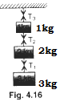

26. In the system shown in the adjoining figure (4.16),the tensionT₂ is:
(a) g (b) 2g (c) 5g (d) 6g

27. Three blocks of masses 2 kg,3 kg and 5 kg are connected to each other with light strings and are then placed on a smooth frictionless surface(fig 4.17). The system is pulled with a force F from the side of the lighter mass so that it moves with an acceleration of 1m/s². T₁ and T₂ denote the tensions in the other strings. The value of F is:
(a) 2N (b)3N (c) 5N (d) 10 N
28. Three blocks of masses 2 kg,3 kg and 5 kg are connected to each other with light strings and are then placed on a smooth frictionless surface(fig 4.17). The system is pulled with a force F from the side of the lighter mass so that it moves with an acceleration of 1m/s². T₁ and T₂ denote the tensions in the other strings. The value of T₁ is:
(a) 1N (b)5 N (c) 8 N (d) 10 N

29. Three blocks of masses 2 kg,3 kg and 5 kg are connected to each other with light strings and are then placed on a smooth frictionless surface(fig 4.17). The system is pulled with a force F from the side of the lighter mass so that it moves with an acceleration of 1m/s². T₁ and T₂ denote the tensions in the other strings. The value of T₂ is:
(a) 1N (b)5 N (c) 8 N (d) 10 N

30. A cricket player catches a ball of mass l0^{-l} kg, moving with a velocity of 25 m/s. If the ball is caught in 0.1 s, the force of the blow exerted on the hand of the player is:
(a) 4 N (b)25 N (c) 40 N (d) 250 N

31. Two masses M₁ and M₂ are attached to the ends of a string which passes over a Pulley attached to the top of a double inclined plane of angles of inclination α and β(fig.4.18). If M₂ > M₁,the acceleration a of the system is given by :
(a) M₂(sinβ)g/( M₁+M₂) (b) M₁(sinα)g/( M₁+M₂)
(c) (M₂sinβ - M₁sinα)g/( M₁+M₂) (d) zero

32. Two masses M₁ and M₂ are attached to the ends of a string which passes over a Pulley attached to the top of a double inclined plane of angles of inclination α and ββ(fig.4.18). If M₂ > M₁,the tension in the string is given by :
(a) (M₁M₂)( sinα + sinβ)g/( M₁+M₂) (b) (M₁M₂)( sinα + sinβ)g/( M₁-M₂)
(c) (M₁)( sinα + sinβ)g/( M₁+M₂) (d) (M₂)( sinα + sinβ)g/( M₁+M₂)

33. The sum of the magnitudes of two forces acting at a point is 18 N and the magnitude of their resultant is 12 N. If the resultant is at 90⁰ with the smaller force, the magnitude of the forces (in Newton) are:
(a) 6,12 (b) l1 , 7 (c) 5 , 13 (d) 14 , 4

34. The length of an elastic string is x when the tension is 5 N. Its length is y when the tension is 7 N. what will be its length, when the tension is 9 N?
(a)2x+ y (b) 2y-x (c) 7y -5x (d) 7y + 5x

35. A passenger train is brought to rest by suddenly applying brakes. Which compartment will come to rest first? (a) Compartment attached to the engine. (b) compartment at the tail end.
(c) The middle compartment. (d) All compartment will come to rest simultaneously

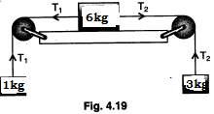
36. The potential energy of a body of mass m is given by: U = ax + by, where x and y are the position co-ordinates of the particle. The acceleration of the particle is
(a) (a²+b²)/m (b) √(a+b) /m (c) (a+b) /m (d) √(a²+b²)/m

37.Three masses of 1 kg, 6 kg and 3 kg are connected to each other with threads and are placed on a table as shown in figure(4.19). What is the acceleration with which the system is moving?(g=10m/s²)
(a) Zero (b) 1 m/s² (c) 2 m/s² (d) 3 m/s²

38. A player caught a cricket ball of mass 150 g moving at a rate of 20 m/s. lf the catching process is completed in 0.1 s, the force of the blow exerted by the ball on the hand of the player is equal to
(a) 150 N (b)3 N (c) 30 N (d) 300N [AIEEE 2006]

39. A ball is dropped from a spacecraft revolving around the earth at a height of 120 km. What will happen to the ball? (a) It will continue to move with velocity v along the original orbit of spacecraft.
(b) It will move with the same speed tangentially to the spacecraft.
(c) It will fall down to the earth gradually. (d) It will go very far in space.

40. Three equal weights A, B and C of mass 2 kg each are hanging on a string passing over a fixed frictionless pulley as shown in the figure(4.21). The tension in the string connecting-weights B and C is:
(a) zero (b) 13 N (c) 3.3 N (d) 19.6 N

41. Two masses 2 kg and 3 kg are attached to the ends of the string passed over a pulley fixed at the top. The tension and acceleration in the string in terms of 'g' are:
(a) 7g/8 , g/8 (b) 21g/8 , g/8 (c) 21g/8 , g/5 (d) 12g/5 , g/5

42. A body of mass 50 kg is pulled by a rope of length 6 m on a surface by a force 106 N applied at the other end. The linear density of the rope is 0.5 kg/m. The force acting on 50 kg mass is:
(a) 50N (b) 100 N (c) 150N (d) 200 N

43. A body of mass 2 kg has an initial velocity of 3 metre/sec along OE and it is subjected to a force of4 N in a direction perpendicular to OE. The distance of body from O after 4 sec will be(fig 4.22):
(a) 12 metre (b) 20 metre (c) 8 metre (d) 48 metre

44. A balloon has 8 gram of air. A small hole is pierced into it. The air escapes at a uniform rate of 7 cm/s. If the balloon shrinks in 5.6 seconds then the average force acting on the balloon is:
(a) 10⁻⁴ N (b) l0⁻² dyne (c) 56 dyne (d) 10⁻⁶ N

45. A bird dismounts on a stretched telegraph wire. The additional tension produced in the wire is:
(a) zero (b) greater than the weight of the bird
(c) less than the weight of the bird (d) equal to the weight of the bird

46.With what minimum acceleration can a fireman slide down a rope whose breaking strength is 2/5th of his weight : (a)1 g (b) 0.4 g (c) 0.6 g (d) 0.8 g

47. A force produces an acceleration of 4 m/s² in, a body of mass m₁ kg and the same force produces an acceleration of 6 m/s² in another body of mass m₂. If the same force is applied to (m₁ + m₂) then the acceleration will be: : (a) 10 m/s² (b) 2 m/s² (c) 2.4 m/s² (d) 5.4 m/s²

48. Which one of the following cannot be explained on the basis of Newton's third law of motion?
(a) Rowing of a boat in a pond (b) Motion of jet in the sky
(c) Rebounding of a ball from a wall (d) Returning back of body, thrown above

49. A rope of length 8 m and linear density 0.5 kg/m is lying lengthwise on a horizontal smooth floor. It is pulled by a force of 12 N. The tension at the mid-point would be:
(a) 12 N (b) 8 N (c) 6N (d) 4N

50. A rope of length 10 m and linear density 0.5 kg/m is lying lengthwise on a smooth horizontal floor. It is pulled by a force of 25 N. The tension in the rope at a point 8 m away from the point of application is:
(a) 20 N (b) 15 N (c) 10 N (d) 5 N

51. A spring is compressed between two toy cars of masses M₁ and M₂. When the cars are released they move apart. If x_{l} and x₂ be the displacements of the cars when in contact with the spring, then:
(a) M₁x₁ =M₂x₂ (b) M₁x₂ =M₂x₁ (c) M₁x₁² =M₂x₂² (d) M₁x₂² =M₂x₁²

52. A body starts climbing up an inclined plane having inclination 30⁰ and stops at a distance of 17.3 m. If the angle of inclination be 60⁰, how long will it be able to climb up starting with the same speed?
a) 8.6m (b) 10m (c) 12.9m (d) 17.3m

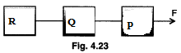
53. Three equal masses P, Q and R are pulled with a constant force F(fig 4.23). They are connected to each other with strings. The ratio of the tension between PQ and QR is:
(a) 1: 1 (b)2:1 (c) 1 :2 (d)3:l

54. A block of mass m is placed on a smooth inclined plane of inclination θ with the horizontal. The inclined plane is accelerated horizontally so that the block does not slide down. What is the vertical force exerted by the inclined plane on the block?
(a)mg sinθ (b)mg cosθ (c)mg (d)none of these

55. A block released from rest, from the top of a smooth inclined plane of inclination 45⁰, takes time t to reach the bottom. The same block released from rest, from top of a rough inclined plane of same inclination takes time 2t to reach the bottom. The coefficient of friction is:
(a) 0.75 (b) 0.5 (c) 0.25 (d) 0.4

56. A rocket of mass 120 kg is fired in the gravity free space. It ejects gases with velocity 600 m/s at the rate of 1 kg/s. What will be the initial acceleration of the rocket?
(a) 1 m/s² (b) 5 m/s² (c) 10 m/s² (d) 15 m/s²

57. A rocket of mass 120 kg is fired in the gravity free space. It ejects gases with velocity 600 m/s at the rate of 1 kg/s., what is the initial thrust on the rocket?
(a) 60 N (b) 120 N (c) 600N (d) 1200 N

58. A rocket of mass 120 kg is fired in the gravity free space. It ejects gases with velocity 600 m/s at the rate of 1 kg/s. If 80 per cent of the mass of the rocket is fuel, what will be the acceleration of the rocket 100 seconds after the firing?
(a) Zero (b) 1 m/s² (c) 5 m/s² (d) 10 m/s²

59. The breaking load of the rope is half the weight of the climber. In which of the following cases, is the rope not likely to break?
(a) Climbing up fast (b) Climbing down fast (c) Climbing up slowly (d) Climbing down slowly

60.A machine gun is mounted on a 200 kg vehicle on a horizontal smooth road (friction negligible). The gun fires 10 bullets per sec with a velocity of 500 m/s. If the mass of each bullet is 10 gm, what is the acceleration produced in the vehicle?
(a) 25 cm/s² (b) 25 m/s² (c) 50 cm/s² (d) 50 m/s²

61.A block of mass M is pulled along a horizontal frictionless surface by a rope of mass m. Force P is applied at one end of the rope. The force which the rope exerts on the block is:
(a) P/(M-m) (b) P/M(M + m) (c) PM/(M + m) (d) PM/(M - m)

62.Two blocks of masses 2 kg and 1 kg are placed on a smooth horizontal table in contact with each other. A horizontal force of 3 newton is applied on the first so that the block moves with a constant acceleration. The force between the blocks would be:
(a) 3 N (b) 2 N (c) 1 N (d) zero

63. Two blocks of masses 2 kg and 1 kg are placed on a smooth horizontal table in contact with each other. A horizontal force of 3 newton is applied on the first so that the block moves with a constant acceleration. what is the common acceleration of the two blocks?
(a) 2 m/s² (b) 3 m/s² (c) 1 m/s² (d) zero

64. Assuming the gravity to be in negative z-direction, a force F = v x A is exerted on a particle in addition to the force of gravity, where v is the velocity and A is a constant vector in positive x-direction. With what minimum speed a particle of mass m be projected so that it continues to move undeflected with constant velocity?
(a) –Aj/mg (b) Aj/mg (c) mgj/A (d) – mgj/A

65. Of the following forces of friction, the one which is self-adjusting is:
(a) rolling friction (b) sliding friction (c) static friction (d) dynamic friction

66. The maximum force of static friction up to which body does not move is called:
(a) normal reaction (b) coefficient of friction (c) limiting friction (d) rolling friction

67. The maximum static frictional force depends on:
(a) area of surfaces in contact (b) normal reaction
(c) direction of applied force (d) none of the above

68. The static friction is:
(a) equal to the dynamic friction (b) always less than the dynamic friction
(c) always greater than the dynamic friction
(d) sometimes greater and sometimes equal to dynamic friction

69. Which of the following statements is true?
(a) More force is required to start a motion than to maintain it against friction.
(b) Less force is required to start a motion than to maintain it against friction.
(c) Equal force is required to start a motion and to maintain it against friction.
(d) None of the above.

70. If the normal reactional force is doubled the coefficient of friction is:
(a) doubled (b) halved (c) not changed (d) tripled

71. When a wheel rolls on a surface, the resistance offered by the surface, i.e., rolling friction:
(a) is greater than kinetic friction (b) is equal to the kinetic friction
(c) is negligible in comparison to kinetic friction (d) none of the above

72. If the smoothness of surface in contact is increased, the force of friction:
(a) must decrease (b) must increase (c) may decrease (d) none of these

73. Friction:(a) does not affect the efficiency of a machine(b) increases the efficiency of a machine
(c) decreases the efficiency of a machine
(d) nothing can be said about the effect of friction on efficiency of a machine

74. Friction:
(a) always opposes the motion of a moving body (b) may cause the motion of the body
(c) is a conservative force (d) none of the above

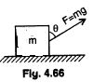
75.A block of mass m rests on a rough horizontal surface as shown in the figure(4.66). Coefficient of friction between the block and the surface is μ. A force F =mg(pull) acting at angle θ with the vertical side of the block pulls it. In which of the following cases can the block be pulled along the surface?
(a) tanθ ≥ μ (b) cot θ ≥ μ (c) tan(θ/2) ≥ μ (d) cot(θ/2) ≥ μ

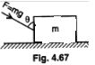
76. A block of mass m rests on a rough horizontal surface as shown in the figure(4.67). Coefficient of friction between the block and the surface is μ. A force F =mg(push) acting at angle θ with the vertical side of the block pulls it. In which of the following cases can the block be pushed along the surface?
(a) tanθ ≥ μ (b) cot θ ≥ μ (c) tan(θ/2) ≥ μ (d) cot(θ/2) ≥ μ

77. A block placed on a horizontal surface is being pushed by a force F making an angle θ with the vertical. The coefficient of friction between block and surface is μ. The force required to slide the block with uniform velocity on the floor is:
(a) μmg/(sinθ - μcosθ ) (b) (sinθ - μcosθ)/μmg (c) μmg (d) none of these

78. A block placed on a horizontal surface is being pushed by a force F making an angle θ with the vertical. The coefficient of friction between block and surface is μ. if θ is smaller than a certain angle θ_{o}, the block cannot be made to slide across the floor, no matter how great the force be. Then, θ_{o} is given by:
(a) θ_{o} =cot^{-l} μ (b) θ_{o} =cos^{-l} μ (c) θ_{o} =tan^{-l} μ (d) θ_{o} =sin^{-l} μ

79. A body of mass m rests on a horizontal floor with which it has a coefficient of static friction μ. It is desired to make the body move by applying the minimum possible force F. The magnitude of F is:
(a) μmg (b) [√(1+ μ²)]mg/μ (c) [√(1+ μ²)] μmg (d) μmg/[√(1+ μ²)]

80. A body of mass m rests on a horizontal floor with which it has a coefficient of static friction μ. It is desired to make the body move by applying the minimum possible force F. The direction in which minimum force has to be applied is given by:
(a) θ =cot^{-l} μ (b) θ =tan^{-l} μ (c) θ =cot^{-l} (μ/2) (d) θ =tan^{-l} (μ/2)

81. A box is placed on an inclined plane and has to be pushed down. The angle of inclination is:
(a) equal to angle of friction (b) more than angle of friction
(c) equal to angle of repose (d) less than angle of repose

82. An object is placed on the surface of a smooth inclined plane of inclination θ. It takes time t to reach the bottom. If the same object is allowed to slide down a rough inclined plane of inclination θ it takes time nt to reach the bottom where n is a number greater than l. The coefficient of friction μ is given by:

83.A block moves down a smooth inclined plane of inclination θ. Its velocity on reaching the bottom is u. If it slides down a rough inclined plane of same inclination, its velocity on reaching the bottom is u/n, where n is a number greater than zero. The coefficient of friction μ is given by:

84. The frictional force between two surfaces is independent of:
(a) nature of surface (b) size of the body (c) area of contact (d) mass of the body

85. A block of mass 2 kg is placed on the floor. The coefficient of static friction is 0.4. If a force of 2.8 N is applied on the block parallel to the floor, the force of friction between the block and floor (taking g = l0 m/s² ) is : (a) 2.8 N (b) 8N (c) 2N (d) zero

86. A body of mass 2 kg rests on a rough inclined plane making an angle 30⁰ with the horizontal. The coefficient of static friction between the block and the plane is 0.7. The frictional force on the block is:
(a) 9.8 N (b) 0.7 x 9.8 x √3 N (c) 9.8 x √3 N (d) 0.7 x 9.8 N

87. A block has been placed on an inclined plane. The slope angle θ of the plane is such that the block slides down the plane at a constant speed. The coefficient of kinetic friction is equal to:
(a) sinθ (b) cosθ (c) g (d) tanθ

88. lf μ_{k} is the coefficient of kinetic friction, μ_{r} the coefficient of rolling friction and μ_{s} the coefficient of static friction then generally: (a) μ_{s} > μ_{k} > μ_{r} (b) μ_{r} > μ_{k} > μ_{s} (c) μ_{s} < μ_{k} > μ_{r} (d) μ_{s} > μ_{r} > μ_{k}

89. Tyres are made circular because:
(a) they can be inflated (b) they require less material (c) they look beautiful (d) they face less friction

90. Tyres are inflated to the required value to save fuel. Because of this:
(a) normal reaction is increased (b) normal reaction is decreased
(c) contact area is increased (d) contact area is decreased

91. A man walks over a rough surface; the angle between the force of friction and the instantaneous velocity of the person is (a) π (b) π/2 (c) 2π (d) zero

92. A lift is moving upwards with a uniform velocity u in which a block of mass m is lying. The frictional force offered by the block, when coefficient of friction is μ, will be:
(a) zero (b)mg (c) μmg (d) 2μmg

93. A block of mass m is placed on a rough floor of a lift. The coefficient of friction between the block and the floor is μ.When the lift falls freely, the block is pulled horizontally on the floor. What will be the force of friction? (a) μmg (b) μmg/2 (c) 2μmg (d) none of these

94.A block of mass m is placed on a rough inclined plane of inclination θ kept on the floor of the lift. The coefficient of friction between the block and the inclined plane is μ. With what acceleration will the block slide down the inclined plane when the lift falls freely?
(a) zero (b)g sinθ - μg cosθ (c) g sinθ + μg cosθ (d) none of these

95. Vehicles are streamlined to reduce:
(a) static friction (b) kinetic friction (c) fluid friction (d) sliding friction

96. Fluid friction: (a) is independent of velocity (b) increases with velocity
(c) decreases with velocity (d) first increases and then decreases
97. Rolling friction: (a) is independent of velocity (b) varies with velocity
(c) increases with velocity (d) decreases with velocity
98. Frictional force increases when surfaces in contact are made very-very smooth. This is because:
(a) of molecular forces (b) of decrease in surface area
(c) of decrease in irregularities (d) increase in area

99. Ball bearings are used to:
(a) convert static to dynamic friction (b) convert limiting friction to dynamic friction
(c) convert sliding friction to rolling friction (d) convert rolling friction to fluid friction

100.When the axle rotates in a sleeve, the friction involved in the process is:
(a) sliding (b) rolling (c) limiting (d) none of these

101, Why do we prefer rubber tyres than steel tyres?
(a) Rubber is cheaper than steel. (b) It is easy to give rubber a circular shape.
(c) coefficient of friction between rubber and concrete is lower than that between steel and concrete.
(d) Steel tyres produce more noise than rubber tyres.

102. why does a horse need to pull harder during the first few steps in pulling the cart?
(a) Limiting friction is greater than dynamic friction. (b) Sliding friction is greater than rolling friction
(c) No frictional force acts after the cart comes in motion.
(d) Air friction is greater during first few steps of motion

Answers & Explanations of Objective Laws of motion

Answers Objective (Laws of Motion)

- C | - D | - B | - C | - D | - B | - A | - D
- D | - A | - C | - C | - B | - C | - D | - B
- C | - A | - B | - C | - B | - A | - B | - D
- D | - C | - D | - C | - B | - B | - C | - A
- C | - B | - A | - D | - C | - C | - A | - B
- D | - B | - B | - A | - B | - C | - C | - D
- C | - D | - A | - B | - B | - C | - A | - B
- C | - A | - B | - A | - C | - C | - C | - D
- C | - C | - B | - C | - A | - C | - C | - C
- C | - B | - D | - C | - A | - C | - D | - B
- D | - A | - A | - C | - A | - A | - D | - A
- D | - D | - D | - A | - D | - A | - C | - B
- A | - A | - C | - A |  | - C
- A

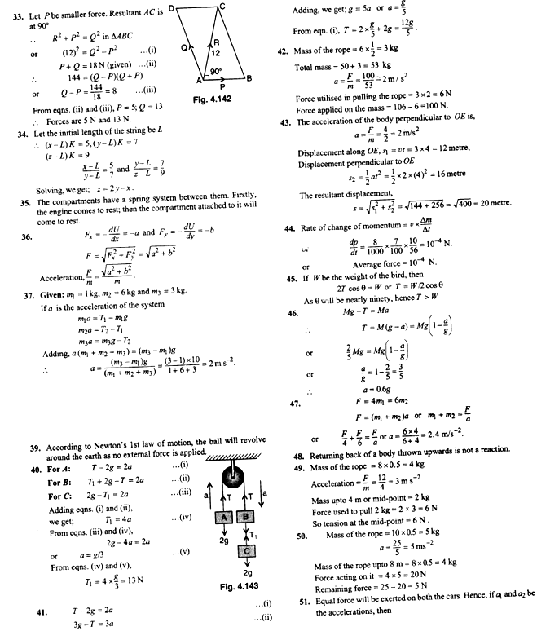

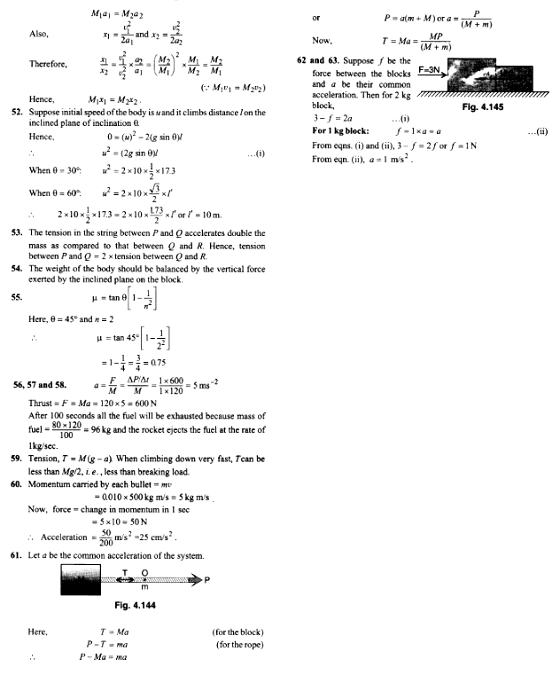

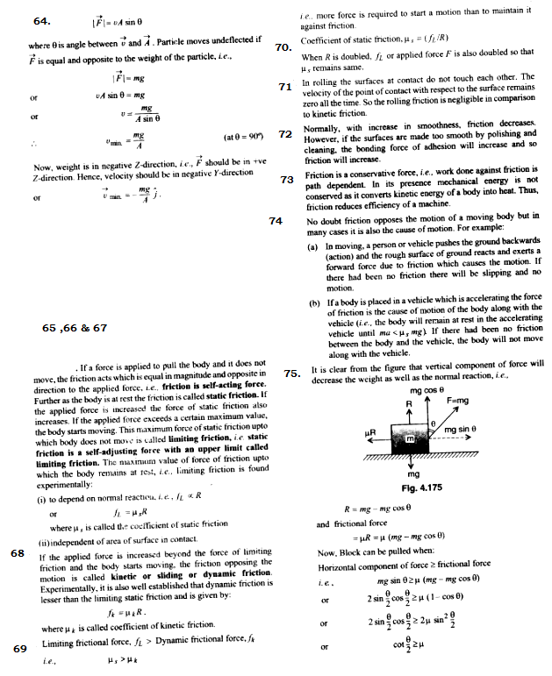

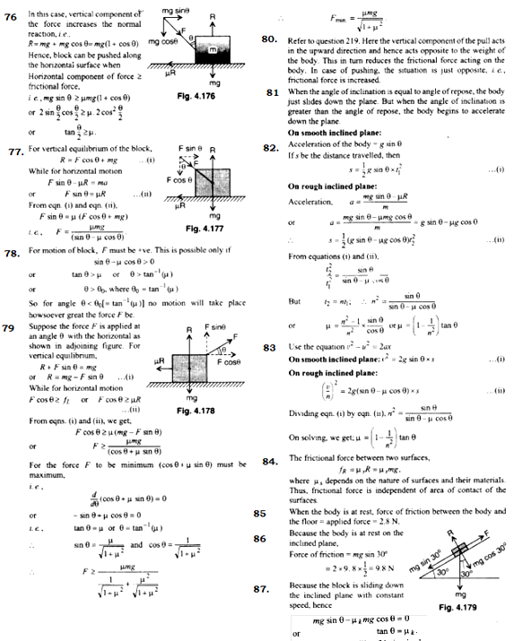

88. μ_{s} > μ_{k} > μ_{r} Rolling friction is always less than sliding friction that is why it is easy to move a heavy load from one place to another by rolling it over the surface instead of sliding it over the same surface. Moreover it is quite obvious that static friction is always greater than kinetic friction.

89.Tyres are made circular to reduce the frictional force because rolling friction < sliding friction.

90.Proper inflation of the tyres reduces the area of contact between the tyre and road which in turn helps in decreasing the force of adhesion between two surfaces.

91.When a man walks on a rough surface, it is the frictional force which is responsible for motion, i.e. required angle between frictional force and instantaneous velocity is zero.

92.The mass m is not moving with respect to the lift. Hence, friction force acting on it is equal to zero.

93.Because the lift is falling freely, the effective weight and hence the normal reaction on the block is zero. Therefore, the force of friction is also zero.

94. Again, the effective value of acceleration due to gravity will be zero; hence acceleration of the block will be zero.

95. Vehicles are streamlined to reduce the frictional force offered by the surrounding air i.e. reduce the fluid friction (also called WET friction). Friction between fluid and solid is called as wet friction.

96. and 97 .Though sliding and rolling friction are independent of velocity but fluid friction increases with increase in velocity.

98.When the surface is made very smooth, the distance between any two molecules lying on the surface coming in contact is so much reduced that molecular forces come into play which give rise to increase in frictional force.

99.Ball bearings are helpful in converting the sliding friction into rolling friction. Remember rolling friction is negligible as compared to sliding friction.

100. Rotation of an axle in a sleeve is an example of sliding friction

101. μ_{rc} < μ_{sc} ((where, μ_{rc} = Coefficient of friction between rubber concrete, μ_{sc}: Coefficient of friction between steel and concrete) .

102. As limiting friction > dynamic friction , hence force required to start the motion is higher than the force required to maintain it against force of friction.

