**“Plan Your Work and Work Your Plan”**

**Chapter -6 Work, Energy And Power**

1. **Work** :

(i) Work is said to be done by a force when the point of application of the force is displaced along same direction.

(ii) Work depends upon two factors:

(a) force applied and

(b) distance travelled by the body in the direction of force.

(iii) The work done by the force is measured by the product of magnitude of force and the displacement of the point of application in the direction of force, i.e., W = Fs.

(iv) If the distance s moved by the body is not in the direction of force but makes an angle θ with it, then work done is given by: W = F(s cos θ) = **F.s**

(v) If the force and displacement are at right angles to each other, the work done is zero.

(vi) If the angle between **F** and **s** is, acute (θ < 900),then work done is positive. But, if the angle between **F** and **s** is obtuse (θ>900), then the work done is negative. For example, when an object is pulled on a rough surface, the work done by the pulling force is positive, while work done by frictional force is negative.

(vii) The formula W = Fs represents mechanical work. It is performed only when body is displaced. If there is no displacement no mechanical work is performed, e.g., if we push hard against a wall with our hands, no work is done from the point of view of physics, although our body uses chemical energy in its tissues and muscles to hold our hands against the wall. As the body uses this energy, it becomes tired but in terms of mechanical energy, no work is done.

(viii) If the **applied force is variable** and s1 and s2 be the magnitudes of initial and final displacements of a body with respect to some reference point, then work done under varying force **F** is

,where ds is the small displacement of the body between s1 and s2.

(ix) If the **force and displacement both are variable** quantities, then the work done is represented by the area under force-displacement graph added with sign.

(x) If the work done does not depend on path followed, then the force is called **conservative**. The gravitational and electrostatic forces are conservative forces.

(xi) In a uniform circular motion of a body, the work done by centripetal force is zero. That is why the speed or KE remains constant.

(xii) The magnetic force on a charged moving particle is always perpendicular therefore, work done by magnetic force on a moving charge is zero.

(xiii) The SI unit of work is joule (J). Other units are erg,eV, MeV, kwh.

(a) I joule - 107 erg, (b) I erg = l0-7 joules (c) l eV =1.6 x 10-19 J,

(d) I joule = 6.25 x 1018 eV, (e) I MeV = 1.6 x 10-13 J (f) 1J = 6.25 x 1012 MeV

(g) I kWh = 3.6 x 106 J

2. Energy:

(i) The energy of a body is defined as the capacity of doing work. The unit of energy is same as that of work, i.e., joule.

(ii) Energy can be classified further into various well defined forms such as : (a) mechanical, (b) heat, (c) electrical, (d) chemical, (e) atomic energy, etc.

(iii) In many processes that occur in nature energy may be transformed from one form to other.

(iv) Mass can also be transformed into energy and vice-versa.

(v) In dynamics, we are mainly concerned with purely mechanical energy which may be kinetic or potential.

3. **Kinetic energy**:

(i) The energy possessed by a body by virtue of its motion is known as kinetic energy (KE).

(ii) The KE of a moving body is equal to the amount of work that must be done to bring a body from rest into the state of motion. Conversely, the amount of work that we must do in order to bring a moving body to rest is equal to the negative of the kinetic energy of the body, i.e.,

**KE = work done to put the body into motion = - work done to bring the body to a stop**

(iii) KE is always positive. **The KE is a scalar quantity**.

(iv) (a) Suppose a block is at rest on a frictionless surface and a constant net force F acts on the block. If u be velocity acquired by the block after travelling a distance x, then KE is:

K = W= F*x* = ma*x* =½mv2

(b) If the block is already in motion when the constant force is applied to it, then the work done is equal to change in KE of the body, i.e.,

∆K =Kf - Ki = W = F*x* = ma*x* =½mv2 - ½mu2

(v) KE depends on the frame of reference, e.g., KE of a person of mass m sitting in a train moving with speed

u is zero w.r.t. frame of train but ½mu2  w.r.t. frame of reference of the earth.

(vi) In terms of momentum p (= mv), KE of a particle can be expressed as: K = ½mv2 =p2/2m

**This implies that L body cannot possess KE without having momentum and vice-versa.**



(vii) If velocity u of a body is comparable to speed of light in vacuum (: 3 x 108m/s;, then according to Einstein's theory of relativity,

(viii) If I be the moment of inertia of a body rotating with an angular velocity w about some axis, then rotational KE = (½) Iw2 .

4. **Potential energy:**

(i) The energy possessed by a body or a system by virtue of its configuration or its position in a field is called its **potential energy**.

(ii) The potential energy of a particle at a point is defined as the amount of work done by an external force in moving the particle from infinity to that point.

(iii) If the configuration of a system is changed under the action of a **conservative force**, then the change in potential energy is defined as; ∆U = -W, i.e., **the change in potential energy is the negative of the work done by the conservative force.**

(iv) If a and b represent initial and final positions of a body, then



**the conservative force is the negative gradient of potential energy.**

(v) **Potential energy can be defined only for conservative forces. It does not exist for non-conservative forces.**

(vi) (a) If the particle moves opposite to the conservative field, work done by the field will be negative and so change in potential energy will be positive, i.e., potential energy will increase.

(b) If the particle moves in the direction of conservative field, work done will be positive and so change in potential energy will be negative, i.e., potential energy will decrease.

(vii) The PE does not have an absolute value. It may be positive, negative or zero. The value depends on the choice of reference level or where the zero of potential energy is taken. For example, if zero of U is taken at the surface of the earth, then PE of mass m at a height h (when h<< Re) is; U = mgh. But if the zero of PE is chosen when mass m is at an infinite separation from the earth's centre, then

U = -GMem/(Re +h)

(viii) **If the force of interaction between two objects is attractive, then the PE is negative**. For example, gravitational PE between two masses m1 and m2 separated by a distance r is; U= -(Gm1m2/r).

-The PE between two opposite charges +q1 and -q2 is; U = -(Kq1q2/r). For attractive forces PE increases with increase in r.

(ix) **If the force of interaction between two objects is repulsive, then PE is positive**. For example, for two

positive charges +q1 and +q2, the PE is; U = +(Kq1q2/r)For repulsive forces, PE decreases with increase in r.

(x) The PE of a diatomic molecule may be written as: U = a/r12 - b/r6

where r is the interatomic separation. Here, U is found to be positive for small values of r but negative for some other values. PE is minimum at r = 0. At this point F : 0.

(xi) Potential energy can be of any of the following forms:

(a) chemical potential energy, (b) gravitational PE,(c) electric PE, (d) magnetic PE, (e) nuclear PE, etc.

(xii) If a compressed metal spring is placed in an acid, then when the spring dissolves, its PE is transferred to kinetic energy of molecules, thereby increasing its temperature.

5. **Work-Energy theorem:**

(i) The net work done by the forces acting on a particle is equal to the change in the KE of the particle.

w = ∆K = Kf - Ki = ½mv2 - ½mu2

(ii) When the magnitude of the velocity of a particle is constant, there is no change in KE. For example, for a particle moving in a circular path with uniform speed, the direction of velocity vector keeps on changing, but since the force is perpendicular to the displacement, no work is done. As a result, the magnitude of velocity does not change and KE remains constant.

(iii) If a body moving with velocity v and if by the action of a retarding force the body comes to rest after travelling a distance s, then W =Fs = ½mv2

or Stopping distance = initial KE / retarding force

If retarding force is frictional force (= μmg), then s = v2/2μg

6. **Mechanical energy:**

(i) Mechanical energy E of a particle, object or system is defined as the sum of kinetic energy K and potential energy U, i.e., E = K +U. lt is a scalar quantity having Sl unit joule.

(ii) It depends on frame of reference.

(iii) **A body can have mechanical energy without having either kinetic energy or potential energy**. However, if both kinetic and potential energies are zero, mechanical energy will be zero. The converse may or may not be true, i.e., if E = 0 either both PE and KE are zero or PE negative and KE positive such that KE + PE = 0.

(iv) Mechanical energy E = K +U, i.e., E -U = K. As K is always +ve, E - U ≥ 0, i.e., for existence of a particle in the field, E ≥ U .

(v) As E = K + U and K is always +ve, so, if U is +ve, E will be +ve. However, if PE U is -ve (a) E will be positive if K > |UI and (b) E will be negative if K< IUI, i.e. ,mechanical energy of a body or a system can be negative and negative mechanical energy implies that potential energy is negative and in magnitude it is more than KE. Such a state is called bound state.

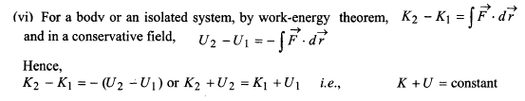i.e., in presence of conservative forces, the sum of kinetic and potential energies at any point remains constant throughout the motion. This is known as the **law of conservation of mechanical energy**.

(vii) Examples: Law of conservation of mechanical energy

(a) **Freely falling body(fig 5.1)**: At the highest point, total energy is in the form of potential energy. At an intermediate point, energy is in the form of both PE and KE. At the lowest point, total energy is in the form of only KE.





(b) **Body projected vertically upwards(fig 5.2):** At the starting point total energy is in the form of KE only, at an intermediate point energy is in the form of both PE and KE and at the highest point total energy is in the form of only PE.



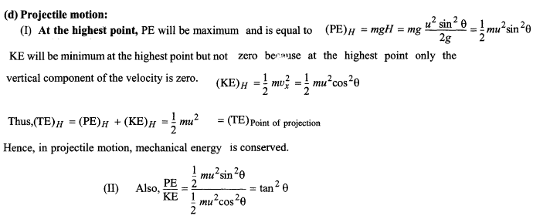

7.

**Law of conservation of energy:**

**energy may be transformed from one kind to another but it cannot be created or destroyed. The total energy in an isolated system is constant. This is known as law of conservation of energy.**

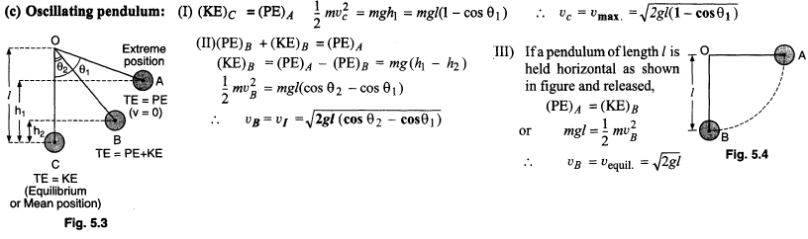

8. **Power**:

(i) Rate of doing work is called power. It is a scalar quantity. If velocity vector makes an angle θ with the force vector, then P = **F.v** = Fv cos θ

(ii) In rotatory motion: P = τdθ/dt =τ *w*

(iii) Units: (a) CGS system: erg/sec (b) FPS system : horse power (= 746watt) (c) SI : J/sec or watt

(iv) (a) If a block of mass m is pulled along the smooth inclined plane of angle θ, with constant velocity v, then the power spent is: P = (mg sin θ)*v*.

(b) If the same block is pulled along rough inclined plane, then the power is: P = (mg sinθ + μmg cosθ)v

(v) If a machine gun fires n bullets per second, each of mass m and velocity v then the power of gun is:

P=½mnv2

(vi) (a) When water is coming out from a hose pipe of area of cross-section A, with a velocity v and hits a wall normally and slides along the wall, then force exerted by the water on the wall is Av2ρ.

Then, power of water is: P = Fv = Av2ρv = Av3ρ

(b) If in the above case, water reflects with the same velocity v after striking the wall, then F = 2 Av2ρ

and P = Fv = 2 Av3ρ.

(vii) If a body moves along a rough horizontal surface, with a constant velocity v, then the power required is

P = μmgv.

**9. Momentum:**

(i) The linear momentum of a body is defined as the product of the mass of the body and its velocity, i.e.,

**p** = m**v** . It is a vector and points in the same direction as the velocity vector.

(ii) In terms of momentum, Newton's second law can be expressed as: **F** = d**p**/dt. When a resultant applied force **F** acts on a body, it causes the linear momentum of that body to change with time.

(iii) Linear momentum depends on frame of reference, e.g., Linear momentum of a body at rest in a moving train, is zero relative to a man sitting in the train, while is not zero for a man standing on the ground.

(iv) As p2 = m2v2 and K =½mv2 ,so p =√(2mK).This shows that a body cannot have momentum without having KE or vice-versa.

(v) A body cannot have momentum without energy (as whenever a body possesses momentum, it also possesses KE) but the body may have energy (i.e., potential energy) without momentum.

(vi) KE of a body cannot be negative ('.' K α p2) but momentum of a body may be negative depending on direction of velocity.

(vii) KE of a body is independent of direction of motion of the body, but momentum depends upon the direction of motion.

(viii) A single external force acting on a particle need not necessarily change its KE but it changes the momentum.

(ix) (a) The slope of p versus t curve gives the force.

(b) The area under F versus t curve gives the change in momentum

10. **Conservation of momentum:**

(i) The law of conservation of linear momentum states that if the total external force acting on a system is equal to zero, then the final value of the total momentum of the system is equal to the initial value of the total momentum of the system, i.e.,

if Fext.=0 ; then Fext.=(dp/dt) i.e. dp =0 or momentum is constant.

(ii) The law of conservation of linear momentum is a consequence of Newton's third law.

(iii) Law of conservation of momentum always holds good for a closed system (a system without external forces).

(iv) Law of conservation of linear momentum is independent of frame of reference though linear momentum depends on frame of reference.

(v) The law of conservation of momentum, like the law of conservation of energy, is independent of the type of interaction between the particles or bodies.

11. **Examples of conservation of linear momentum:**

(i) Firing a gun or cannon:

(a) Before firing, the gun and the bullet are at rest. The initial total momentum is zero, i.e., pi =0

Vg = - mb Vb/mg ; heavier is the gun, smaller is the recoil velocity.

As K = p2/2m hence Kg/Kb = mb/mg therefore Kg < Kb

(ii) Motion of two masses connected by a spring:

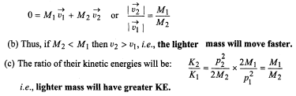(a) Let two masses M1 and M2 be connected by a spring of spring constant K. Let the spring be compressed by x and the two masses be tied by a string. The initial momentum of the system is zero. Now if the string is burned, the spring relaxes and the masses acquire velocities. Let these be v1 and v2 .Then, conservation of momentum requires:

12. **Collisions:**

(i) In a collision, a relatively large force acts on each colliding particle for a relatively short time.

(ii)In collision, it is not necessary that the colliding particles come in contact physically. For example, in collision of α-particle with nucleus, due to electromagnetic interaction, α-particle is scattered away without physical contact.

(iii) In a collision if the motion of colliding particles before and after the collision is along the same line, the collision is said to be **head on** or **one** dimensional.

(iv) The law of conservation of momentum holds good for any type of collision (elastic, inelastic or perfectly inelastic). The total momentum of the system after the collision must be equal to the total momentum of the system before collision. Although the momentum of individual particles within the system may be changed, but the total momentum remains constant.

(v) **A perfectly elastic collision**: If in a collision, along with momentum KE is also conserved, the collision is said to be perfectly elastic.

(vi) An **inelastic collision**: If in a collision, some kinetic energy is lost, the collision is said to be inelastic. All real collisions belong to this category. Here, KE appears in other forms.

(vii) A **perfectly inelastic collision**: If in a collision two bodies stick together or move with same velocity after the collision, the collision is said to be perfectly inelastic, e.g., the collision between a bullet and a block of wood into which it is fired is completely inelastic, when the bullet remains embedded in the block.

(viii) The conservation of momentum and the conservation of total energy holds for all the three types of collisions, but KE conservation law hold only for perfectly elastic collision.

(ix) The collisions of elementary particles like electrons, protons with the nucleus are examples of nearly perfectly elastic collisions. In real collisions, like collision of a ball with a wall, etc., some KE is lost in the form of heat and sound. However, these are usually neglected and collisions are treated as elastic collisions.

13. **Elastic collision in one dimension:**

(i) Consider collision of two bodies of unequal masses m1 and m2 moving with initial velocities u1 and u2. Let these bodies move with velocities u1 and u2 after the collision. For a perfectly elastic collision, the conservation of momentum and KE gives:

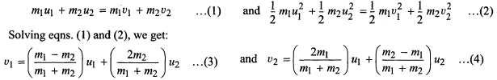

(ii) **Special cases:**

(a) **If masses are equal**: v1 = u2 and v2= u1, i.e., **when two bodies of equal masses collide head on elastically,** **their velocities are mutually interchanged**.

- Further if u2 = 0, then v1 = 0 and v2 = u1; i.e., if a body collides head on elastically with another body of same mass at rest, the moving body stops and the body at rest starts moving with same velocity.

(b) **If target particle is massive**: If m2 >>m1,then v1 = - u1 + 2u2 and v2 = u2 .If the massive target is moving slowly or is at rest, i.e., u2 approaches to 0, then v1 = - u1 and v2 = 0, i.e., **when a light particle collides head on elastically with a very heavy particle at rest, the light particle recoils with almost same speed while heavy target remains practically at rest.**

(c) **If projectile particle is massive**: If m1>>m2 then v1 ≈ u1 and v2 =2u1 - u2.lf the target is initially at rest (u2 = 0), then v1 ≈ u1 and v2 = 2u1, i.e., **when a heavy projectile collides head on elastically with a light target at rest, the motion of a heavy projectile is almost unaffected while the light body flies away at speed twice that of heavier.**

14. **Coefficient of restitution:** The coefficient of restitution in a collision of two bodies is defined as:

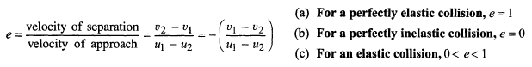

15. **Inelastic collision of a ball with the earth**: Let ho be the initial height of the ball w.r.t. the earth. Since, the earth is massive, the initial and final velocities of the earth can be assumed to be zero.

(a) When the ball hits the ground first time, its velocity before collision is u1 = √(2gho). After collision,v1≈eu1

The height h1 attained after first impact should be h1= (v12/2g) = e2 ho. [e=√(h1/ho)].

The velocity just after second impact,v2 = ev1 = e2u1 and height attained after second impact, h2 = (v22/2g) = e4ho. Hence, **the height attained after n impacts ,hn = e2nho.**

(b) Total distance travelled by the ball before coming to rest is:



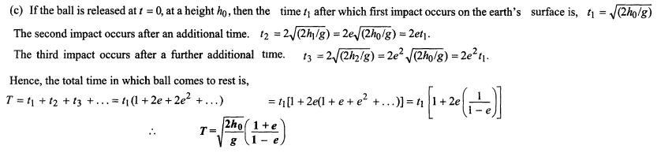

(d) **Momentum transfer to floor**: Let the momentum of the ball when it hits the floor first time is p = mu1

(downwards). Then, momentum of the rebounding ball is p1= mv1 = ep (upwards). Thus, momentum change (transfer) in first (one) collision is:

∆p1= p – (-ep) = p(1+e)

Similarly, for the second impact, momentum transfer is: ∆p2= ep – (-ep2) = ep(1+e)

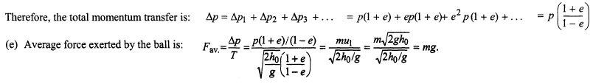

16.**Loss of kinetic energy:**

**(i) Elastic collisions:** The total KE in an elastic collision is conserved. However, individual particles may gain or lose KE. Suppose a particle of mass m1, moving with velocity u1 collides with a particle of mass m2 at rest.

The KE of particle 1 before collision is: Ki = ½m1u12 ; The KE of particle 1 after collision is, Kf = ½m1v12

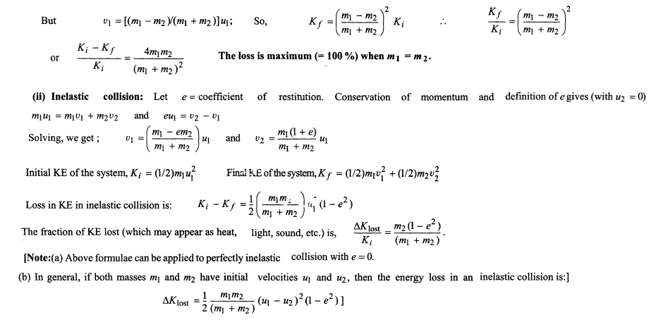

**Home Assignment- Work & Energy**

**Pardeep**

1. Define Work alongwith it’s expression, unit and nature scalar/vector?
2. Can the component of a force that gives an object a centripetal acceleration can do any work on the object? (One such force is that exerted by the Sun on the Earth that holds the Earth in a circular orbit around the Sun.)
3. A person lifts a heavy box of mass *m* a vertical distance *h* and then walks horizontally a distance *d* while holding the box, Determine (a) the work he does on the box and

(b) the work done on the box by the force of gravity.

1. If the dot product of two vectors is positive, must the vectors have positive rectangular components?
2. Derive an expression for Kinetic energy using ‘Work –Energy theorem’?
3. Can frictional forces ever *increase* an object’s kinetic energy?
4. Define elastic potential energy and also derive an expression for it?
5. Define conservative and non-conservative forces?
6. Derive a relationship between conservative Force and potential Energy ?
7. What does the slope of a graph of *U*(*x*) versus *x* represent?
8. What do you mean by power ,also write it’s expression and unit?
9. Is momentum conserved in a collision?
10. As a ball falls toward the Earth, the ball’s momentum increases because its speed increases. Does this mean that momentum is not conserved in this situation?
11. Define and give examples for (a) Elastic collision (b) Inelastic collision & it’s different types?
12. “Momentum is constant in all collisions, but kinetic energy is constant only in elastic collisions”, Comment on the statement?
13. Prove the law of conservation of mechanical energy for an object of mass ‘m’ dropped from a height ‘h’ ?
14. What do you mean by collision?
15. Define Coefficient of restitution or coefficient of resilience?
16. Find expressions for the final velocity in Elastic collision in one dimension and also discuss the following cases (i)When masses of two bodies are equal (ii) When second body is initially at rest?
17. Find expressions for the final velocity in inelastic collision in one dimension?
18. Prove that in a perfectly inelastic collision in two dimensions between two particles of same mass, the two particles move along mutually perpendicular directions after the collision?
19. A body of mass 0.8kg is moving with initial velocity 4i+ 3j m/s which changes into -6j + 2k m/s.Calculate change in K. E.?
20. A particle of rest mass mo with a speed c/2. Calculate its (i) mass (ii) momentum (iii) total energy (iv) K.E.
21. Is it possible that a body be in accelerated motion under a force acting on a body ,yet no work is being done by the force.Give example?
22. A light object and a heavy object have same linear momentum. Which one has greater kinetic energy?
23. A light object and a heavy object have same kinetic energy. Which one has greater linear momentum?
24. A truck and a car moving with same K.E. are stopped by applying same retarding force by means of brakes.Which one will stop at a smaller distance?
25. A spring of force constant k is cut into two pieces of lengths *l1* and *l2*.Calculate force constant of each part?
26. What should be the angle between force and displacement for max and minimum work?
27. Two springs A & B are identical but A is harder than B(KA>KB).On which spring more work will be done if (a) they are stretched thru the same distance (b) they are stretched by the same force?
28. Can kinetic energy of a system be changed without changing its momentum?
29. Can momentum of a system be changed without changing its kinetic energy?
30. Can an object have mechanical energy even when its momentum is zero?

**NCERT**

1. Find the angle between force F = (3i + 4j -5k) unit and displacement d = (5i + 4j + 3k) unit. Also find the projection of F on d.
2. The sign of work done by a force on a body is important to understand. State carefully if the following quantities are positive or negative:
   1. work done by a man in lifting a bucket out of a well by means of a rope tied to the bucket.
   2. work done by gravitational force in the above case,
   3. work done by friction on a body sliding down an inclined plane,
   4. work done by an applied force on a body moving on a rough horizontal plane with uniform velocity,
   5. work done by the resistive force of air on a vibrating pendulum in bringing it to rest.
3. A body of mass 2 kg initially at rest moves under the action of an applied horizontal force of 7 N on a table with coefficient of kinetic friction = 0.1. Compute the

(a) work done by the applied force in 10 s, (b) work done by friction in 10 s,

(c) work done by the net force on the body in 10 s,

(d) change in kinetic energy of the body in 10 s, and interpret your results.

1. Answer the following :
   1. The casing of a rocket in flight burns up due to friction. At whose expense is the heat energy required for burning obtained? The rocket or the atmosphere?
   2. Comets move around the sun in highly elliptical orbits. The gravitational force on the comet due to the sun is not normal to the comet’s velocity in general. Yet the work done by the gravitational force over every complete orbit of the comet is zero. Why ?
   3. An artificial satellite orbiting the earth in very thin atmosphere loses its energy gradually due to dissipation against atmospheric resistance, however small. Why then does its speed increase progressively as it comes closer and closer to the earth ?
2. Answer carefully, with reasons :
   1. In an elastic collision of two billiard balls, is the total kinetic energy conserved during the short time of collision of the balls (i.e. when they are in contact) ?
   2. Is the total linear momentum conserved during the short time of an elastic collision of two balls ?
   3. What are the answers to (a) and (b) for an inelastic collision ?
   4. If the potential energy of two billiard balls depends only on the separation distance between their centres, is the collision elastic or inelastic ? (Note, we are talking here of potential energy corresponding to the force during collision, not gravitational potential energy).
3. A body of mass 0.5 kg travels in a straight line with velocity *v* =*a x*3/2 where *a =* 5 m–1/2 s–1. What is the work done by the net force during its displacement from *x* = 0 to *x* = 2 m ?

**Exemplar**

1. A rough inclined plane is placed on a cart moving with a constant velocity *u* on horizontal ground. A block of mass *M* rests on the incline. Is any work done by force of friction between the block and incline? Is there then a dissipation of energy?
2. Why is electrical power required at all when the elevator is descending? Why should there be a limit on the number of passengers in this case?
3. A body is being raised to a height *h* from the surface of earth. What is the sign of work done by

(a) applied force (b) gravitational force?

1. Calculate the work done by a car against gravity in moving along a straight horizontal road. The mass of the car is 400 kg and the distance moved is 2m.
2. A body falls towards earth in air. Will its total mechanical energy be conserved during the fall? Justify.
3. A body is moved along a closed loop. Is the work done in moving the body necessarily zero? If not, state the condition under which work done over a closed path is always zero.
4. In an elastic collision of two billiard balls, which of the following quantities remain conserved during the short time of collision of the balls (i.e., when they are in contact).

(a) Kinetic energy. (b) Total linear momentum? Give reason for your answer in each case.

**Objective –Work Power & Energy**

1. Work is done only when: (a) applied force is strong (b) applied force generates motion

(c) applied force is normal to the displacement (d) force is applied

2. In order to do work:

(a) force must act at any angle to the displacement

(b) force may not act along the same direction as is the displacement

(c) must act along the direction of displacement (d) must act normal to the direction of displacement

3. If a body is placed on another body and is moving with it, then work done by frictional force on the upper body relative to ground is: (a) –ve (b) zero (c) +ve (d) unity

4. lf a number of forces act on a body and the body is in static or dynamic equilibrium, then:

(a) work done by individual forces must be zero (b) net work done is +ve

(c) net work done is –ve (d) net work done is zero

5. If we lift a body from rest to a height *h* and the body is in static equilibrium, then net work done is:

(a) +ve (b) –ve (c) zero (d) unity

6. If a body is moving on a horizontal rough road and the body is in dynamic equilibrium then net work done is: (a) +ve (b) –ve (c) zero (d) unity

7, A man pushes a wall and fails to displace it. He does

(a) negative work (b) positive but not maximum work

(c) no work at all (d) maximum work

8. A weightlifter lifts a weight off the ground and holds it up:

(a) work is done in lifting as well as holding the weight

(b) no work is done in both lifting and holding the weight

(c) work is done in lifting the weight but no work is required to be done in holding it up

(d) no work is done in lifting the weight but work is required to be done in holding it up

9. When a body moves in a circular path, no work is done by the force since:

(a) there is no net force (b) there is no displacement

(c) force is always away from the centre (d) force and displacement are perpendicular to each other

10. When the bob of a simple pendulum swings, the work done by tension in the string is:

(a) >o (b)<0 (c) zero (d) maximum

11. In case of motion of a charged particle in a magnetic field, work done by the magnetic force is always:

(a) zero (b)>0 (c) <o (d) minimum

12. When the force retards the motion of a body, the work done is : (a) zero (b) -ve

(c) +ve (d) +ve or -ve depending upon the magnitude of force and displacement

13. A person holds a bucket of weight 60 N. He walks 7 m along the horizontal path and then climbs up a vertical distance of 5 m. The work done by the man is:

(a) 300 N-m (b) 420 N-m (c) 720 N-m (d) none of these

14. A man Ml of mass 80 kg runs up a staircase in l5 s. Another man M2 also of mass 80 kg runs up the same staircase in 20 s. The ratio of the power developed by them will be:

(a) 1 (b) 4/3 (c) 16/9 (d) none of these

15. Two masses of 1g and 9 g are moving with equal kinetic energies. The ratio of the magnitudes of their respective linear momenta is: (a)1:9 (b)9:l (c)1:3 (d)3:1

16. A ball of mass 2 kg and another of mass 4 kg are dropped together from a 60 feet tall building. After a fall of 30 feet each towards the earth, their respective kinetic energies will be in the ratio of :

(a)√2:1 (b)1:4 (c)1:2 (d)1:√2

17. The kinetic energy of a body is increased by 300%. The momentum of the body would increase by:

(a) 50% (b) 100% (c) 150% (d) 300%

18. Work done in time t on a body of mass m which is accelerated from rest to a speed v in time t1 as a function of time t is given by:



19. A force **F** = (5i + 3j +2k)N is applied over a particle which displaces it from its origin to the point **r** = (2i – j)m .The work done on the particle in joules is (a) -7 (b) +7 (c) +10 (d) +13 [AIEEE 2004]

20. On microscopic level, all forms of energy may be studied as:

(a) potential (b) kinetic (c) potential or kinetic (d) nuclear

21. If a porter with a suitcase on his head moves up a staircase, work done by the upward lifting force relative to him will be: (a) +mgh (b) –mgh (c) zero (d) none of these



22. If a person is pushing a box inside a moving fain, the work done in the frame of the earth will be:



23. If we shift a body in equilibrium from A to C in a gravitational field via path AC or ABC fig 5.5 (a) the work done by the force **F** for both paths will be same

(b) WAC > WABC (c) WAC < WABC (d) none of the above

24. Which of the following statements is false?

(a) Area under force/displacement curve with proper algebraic sign represents work done by the force.

(b) Area under the P -V graph represents the work done in case of expansion or compression of a gas.

(c) In a conservative field work is path independent.

(d) Work does not depend on the frame of reference.

25.Work-energy theorem is valid in the presence of:

(a) external forces only (b) internal forces only

(c) conservative forces only (d) non-conservative forces only (e) all types of forces

26.Under the action of a force, a 2kg body moves such that its position *x* as a function of time is given by:, *x* = t3/3, where x is in metre and t in seconds. The work done by the force in the first two seconds is:

(a) 1.6 J (b) 16J (c) 160 J (d) 1600J

27. Two bodies with masses M1 and M2 have equal kinetic energies. If P1 and P2 are their respective momenta, then P1/P2 is equal to: (a) M1: M2 (b) M21: M22 (c) M2: M1  (d) √M1: √M2

28. An electric pump is used to fill an overhead tank of capacity 9 m3 kept at a height of l0 m above the ground. If the pump takes 5 minutes to fill the tank by consuming 10 kW power, the efficiency of the pump should be: (Take g = 10 ms-2) (a) 60% (b) 40% (c) 20% (d) 30%

29. A pump motor is used to deliver water at a certain rate from a given pipe. To obtain, twice as much water from the same pipe, in the same time, the power of motor has to be increased to

(a) 2 times (b) 4 times (c) 8 times (d) 16 times

30. Sand drops vertically at the rate of 2 kg/sec on to a conveyor belt moving horizontally with a velocity of 0.2 m/sec. Then the extra force required to keep the belt moving is:

(a) 0.4 N (b) 0.08 N (c) 0.04 N (d) 0.2 N

31.Sand drops vertically at the rate of 2 kg/sec on to a conveyor belt moving horizontally with a velocity of 0.2 m/sec. the extra power required is: (a) 0.4 W (b) 0.08 W (c) 0.04 W (d) 0.2 W

32. Sand drops vertically at the rate of 2 kg/sec on to a conveyor belt moving horizontally with a velocity of 0.2 m/sec. The rate of change of kinetic energy is:(a) 0.4 j/s (b) 0.08 j/s (c) 0.04 j/s (d) 0.2 j/s

33. A bullet when fired at a target has its velocity decreased to 50% after penetrating 30 cm into it. Then the additional thickness it will penetrate before coming to rest is: (AIEEE 2005) (a) 10 cm (b) 30 cm (c) 40 cm (d) 60 cm

34. A bullet when fired at a target with a velocity of 100 m/sec penetrates one metre into it. If the bullet is fired at a similar target with a thickness 0.5 metre, then it will emerge from it with a velocity of:

(a) 50√2 m/s (b) 50/√2 m/s (c) 50 m/s (d) 10 m/s

35. A rope ladder with a length *l* carrying a man with a mass m at its end is attached to the basket of a balloon with a mass M. The entire system is in equilibrium in the air. As the man climbs up the ladder into the balloon, the balloon descends by a height h. Then the potential energy of the man:

(a) increases by mg(*l* - h) (b) increases by mg*l*

(c) increases by mgh (d) increases by mg(2*l* - h)

36. A rope ladder with a length *l* carrying a man with a mass m at its end is attached to the basket of a balloon with a mass M. The entire system is in equilibrium in the air. As the man climbs up the ladder into the balloon, the balloon descends by a height h. Then the potential energy of the balloon:

(a) decreases by mgh (b) increases by mg*h*

(c) increases by mg(*l-h*) (d) increases by mg*l*

37.A rope ladder with a length *l* carrying a man with a mass m at its end is attached to the basket of a balloon with a mass M. The entire system is in equilibrium in the air. As the man climbs up the ladder into the balloon, the balloon descends by a height h. Then the work done by the man is:

(a) mg*l* (b) mgh (c) mg*l*/2 (d) mg(*l*-h)

38. A uniform chain has a mass m and length *l*. It is held on a frictionless table with one-sixth of its length hanging over the edge. The work done in just pulling the hanging part back on the table is: (AIEEE 2002)

(a) mg*l/72* (b) mg*l/36* (c) mg*l*/12 (d) mg*l/6*

39. The displacement *x* in metre of a particle of mass m kg moving in one dimension under the action of a force is related to the time r in seconds by the equation: t = √x +3 ; Then the displacement of the particle, when its velocity is zero, is: (a) 3 m (b) zero (c) 6 m (d) none of these

40.The displacement *x* in metre of a particle of mass m kg moving in one dimension under the action of a force is related to the time r in seconds by the equation: t = √x +3 ; the work done in first six seconds is:

(a) 18 mJ (b) zero (c) 9/2 mJ (d) 36 mJ

41.The displacement *x* in metre of a particle of mass m kg moving in one dimension under the action of a force is related to the time r in seconds by the equation: t = √x +3 ; the kinetic energies in joule at t=0 and t = 6 sec are respectively: (a) 0 and 0 (b) 18 m and 18 m (c) 0 and 18 m (d) 18 m and 0

42. A ball is thrown vertically upwards with a velocity of l0 m/s. It returns to the ground with a velocity of 9 m/s. If g = 9.8 m/sec2,then the maximum height attained by the ball is nearly:

(a) 5.1 m (b) 4.l m (c) 4.61 m (d) 5.0 m

43. A 2 kg block drops vertically from a height of 40 cm on a spring whose force constant K is 1960 newton per metre. Then the maximum compression of the spring is: (a) 40 cm (b) 25 cm (c) l0 cm (d) 5 cm

44. A spring is compressed between two toy carts of masses m1 and m2. When the toy carts are released the spring exerts on each toy cart equal and opposite forces for the same time t. If the coefficients of friction μ between the ground and the toy carts are equal, then the displacements of the toy carts are in the ratio:

(a) s1/s2 = m2/m1 (b) s1/s2 = - m1/m2 (c) s1/s2 = - (m2/m1)2 (d) s1/s2 = - (m1/m2)2

45. A car is moving on a straight horizontal road with a speed *v*. If the coefficient of friction between the tyres and the road is μ, the shortest distance in which the car can be stopped is:

(a) v2/2μg (b) v2/μg (c) (v/μg) 2 (d) v2/μ

46. Two trucks, one loaded (A) and the other unloaded (B ) are moving and have same kinetic energy. The mass of A is double that of B. Brakes are applied to both and are brought to rest. If distance covered by A before coming to rest is s1 and that by B is s2, then: (a) s1= s2 (b) s1= 2 s2 (c) 2s1= s2 (d) s1= 4s2

47. The distance covered by a body to come to rest when it is moving with a speed of 4m/s is *s* when a retarding force F is applied. If the KE is doubled, the distance covered by it to come to rest for the same retarding force F is: (a) 4s (b) 6s (c) 2s (d) 8s

48. A bus can be stopped by applying a retarding force F when it is moving with a speed *v* on a level road. The distance covered by it before coming to rest is *s*. If the load of the bus increases by 50% because of passengers, for the same speed and same retarding force, the distance covered by the bus to come to rest shall be: (a) 1.5s (b) 2s (c) 1s (d) 2.5s

49. A body of mass 1 kg is thrown upwards with a velocity 20 m/s. It momentarily comes to rest after attaining a height of 18 m. How much energy is lost due to air friction? (g = 10m/s2)

(a) 30 J (b) 40 J (c) l0 J (d) 20 J

50. The potential energy of a certain spring when stretched through a distance *s* is 10 joule. The amount of work (in joule) that must be done on this spring to stretch it through additional distance *s* will be:

(a) 30 (b) 40 (c) 10 (d) 20

51. A smooth sphere of radius R is made to translate in a straight line with a constant acceleration a = g. A particle kept on the top of the sphere is released from there at zero velocity with respect to the sphere. The speed of the particle with respect to the sphere as a function of angle θ as it slides down is



52.An object of mass m is allowed to fall from rest along a rough inclined plane. The speed of the object on reaching the bottom of the plane is proportional to: :(a) m0 (b) m (c) m2 (d) m-1



53. Velocity-time graph of a particle moving in a straight line is as shown in figure 5.9. Mass of the particle is 2 kg. Work done by all the forces acting on the particle in time interval between t =0 to t=10s is:

(a) 300 J (b) - 300 J (c) 400 J (d) -400 J

**Conservation Laws and Collisions**

54. A bullet of mass m is fired from a rifle of mass M. if **v** be the velocity of the bullet, then velocity acquired by the rifle is:



55. In case of rifle shooting the kick will be minimum when:

(a) a light rifle is held loosely against shoulder (b) a light rifle is held tightly against shoulder

(c) a heavy rifle is held loosely against shoulder (d) a heavy rifle is held tightly against shoulder

56. A bullet weighing 50 gm leaves the gun with a velocity of 30 m/s. If the recoil speed imparted to the gun is 1 m/s, the mass of the gun is: (a) 15 kg (b) 30 kg (c) l.5 kg (d) 20 kg

57. A bullet of mass m is fired from a rifle of mass M. if KR and KB be the kinetic energies of rifle and bullet respectively, then:

58. A bullet of mass m is fired from a rifle of mass M. if KI and KF represent the initial and final kinetic energies of the system respectively, then:



59. If a ball is thrown upwards from the surface of the earth:

(a) the earth remains stationary white the ball moves upwards

(b) the ball remains stationary while the earth moves downwards

(c) the ball and the earth move towards each other (d) the ball and the earth both move away from each other

60. If a ball is ball is thrown towards the surface of the earth:

(a) the earth remains stationary while the ball moves downwards

(b) the ball remains stationary while the earth moves upwards

(c) the ball and the earth move towards each other (d) the ball and the earth move away from each other

61. Whenever a ball is thrown upwards or downwards from the surface of earth, the speed of the earth is:

(a) zero (b) equal to that of the ball

(c) greater than that of the ball (d) much less than that of the ball

62. A cubical vessel of height I m is full of water. what is the amount of work done in pumping water out of vessel? (Take g= l0 m s-2)

(a) 1250 J (b) 5000 J (c) 1000 J (d) 2500 J

63. Whenever a ball is thrown upwards or downwards from the surface of earth, out of the following which energy of system is conserved?

(a) Kinetic energy (b) Potential energy (c) Mechanical energy (d) None of these

64. Two unequal masses are tied together with a compressed spring. When the cord is burnt with a match releasing the spring the two masses fly apart with equal:

(a) kinetic energy (b) speed (c) momentum (d) acceleration

65. Two unequal masses are tied together with a compressed spring. When the cord is burnt with a match releasing the spring the two masses fly apart and:

(a) both masses will have equal KE (b) lighter block will have greater KE

(c) heavier block will have greater KE (d) none of above answers is correct

66. Two unequal masses are tied together with a compressed spring. When the cord is burnt with a match releasing the spring the two masses fly apart , which of the following energies is conserved for the system?

(a) Kinetic energy (c) Mechanical energy (b) Potential energy (d) None of these

67 Which of the following statements is correct?

(a) Kinetic energy of a system can be changed without changing its momentum.

(b) Kinetic energy of a system cannot be changed without changing its momentum.

(c) Momentum of a system cannot be changed without changing its kinetic energy.

(d) Body cannot have energy without having momentum.

68. On a stationary sail boat air is blown from a fan attached to the boat. The boat will:

(a) not move (b) spin around

(c) move in the direction in which air is blown (d) move in a direction opposite to that in which air is blown.

69. A bird resting on the floor of an airtight box which is being carried by a boy, starts flying. The boy feels that now the box: (a) is heavier (b) is lighter

(c) shows no change in weight (d) is lighter in the beginning and heavier later

70. A parrot is in a cage which is hanging from a spring balance. Initially the parrot sits in the cage and in the second instance the parrot flies about inside the cage.

(a) The reading of the balance will be greater when the parrot flies in the cage.

(b) The reading of the balance remains unchanged.

(c) The reading of the balance will be less when the parrot flies. (d)None of the above

71. A particle at rest suddenly disintegrates into two particles of equal masses which start moving. The two fragments will:

(a) move in the same direction with equal speeds (b) move in any direction with any speed

(c) move in opposite directions with equal speeds (d) move in opposite directions with unequal speeds

72. A shell explodes and many pieces fly off in different directions. Which of the following is conserved?

(a) Kinetic energy (b) Momentum (c) Neither momentum nor KE (d) Momentum and KE

73.A nuclide at rest emits an α-particle. In this process:

(a) α-particle moves with large velocity and the nucleus remains at rest

(b) both α-particle and nucleus move with equal speed in opposite directions

(c) both move in opposite directions but nucleus with greater speed

(d) both move in opposite directions but α-particle with greater speed

74. A spacecraft of mass M moves with velocity V in free space at first, then it explodes breaking into two pieces. If after explosion a piece of mass m comes to rest, the other piece of spacecraft will have a velocity:

(a) MV/(M-m) (b) MV/(M+m) (c) mV/(M-m) (d) mV/(M+m)

75. A bomb of mass 9 kg explodes into two pieces of masses 3kg and 6 kg. The velocity of mass 3 kg is l6 m/s. The KE of mass 6 kg (in joule) is: (a) 96 (b) 384 (c) 192 (d) 768

76. A cannon ball is fired with a velocity of 200 m/s at an angle of 600 with the horizontal. At the highest point of its flight it explodes into 3 equal fragments, one going vertically upwards with a velocity of 100 m/s, the second one falling vertically downwards with a velocity of 100 m/s. The third fragment will be moving with a velocity of: (a) 100 m/s in the horizontal direction (b) 300 m/s in the horizontal direction

(c) 300 m/s in a direction making an angle of 600 with the horizontal

(d) 200 m/s in a direction making an angle of 600 with the horizontal

77. A body of mass 1 kg initially at rest, explodes and breaks into three fragments of masses in the ratio 1 : 1 : 3. The two pieces of equal mass fly-off perpendicular to each other, with a speed of 15 m/s each. The speed of the heavier fragment is: (a) 5√2 m/s (b) 45 m/s (c) 5 m/s (d) 15 m/s

78. A body of mass M at rest explodes into three pieces, two of which of mass (M/4) each are thrown-off in perpendicular directions with velocities of 3 m s-l and 4 m/s respectively. The third piece will be thrown-off with a velocity of: (a) 1.5 m/s (b) 2 m/s (c) 2.5 m/s (d) 3 m/s

79. A 5 kg shell kept at rest suddenly splits up into three parts. If two parts of mass 2kg each are found flying due north and east with a velocity of 5 m/s each, what is the velocity of the third part after explosion :

(a) 10 m/s due north -east (b) 10/√2 m/s due south east (c) 10√2 m/s due south west (d) 10√2 m/s due south east

80. A vessel at rest explodes breaking it into three pieces. Two pieces having equal mass fly-off perpendicular to one another with the same speed of 30 m/s. The third piece has three times the mass of each other piece. What is the direction and magnitude of its velocity immediately after the explosion?

(a) 10√2 m/s 1350 (b) 10/√2 m/s 900 (c) 10√2 m/s 600 (d) 10√2 m/s 300

81.A shell is fired from a cannon with velocity v m/s at an angle θ with the horizontal direction, At the highest point in its path it explodes into two pieces of equal mass. One of the pieces retraces its path to the cannon and the speed (in m/s) of the other piece immediately after the explosion is:

(a) 3*v* cosθ (b) 2*v* cosθ (c) (3*v* cosθ)/2 (d) (√3*v* cosθ)/2

82. A particle of mass 4 m which is at rest explodes into three fragments. Two of the fragments each of mass m are found to move with a speed of *v* each in perpendicular directions. What is the total energy released in the process? (a) 3m*v2* (b) 7m*v2*/2 (c) 3m*v2*/2 (d) 4m*v2*

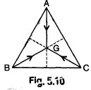

83. Three particles A, B and C of equal mass move with equal speed *v* along the medians of an equilateral triangle as shown in fig 5.10. They collide at the centroid of the triangle G. After the collision A comes to rest, while B retraces its path with speed v. What is the velocity of C ?(a) 2*v* (b) *v* (c) zero (d) *v/2*

84. Two balls A and B of mass 0.10 kg and 0.25 kg respectively are connected by a stretched spring of negligible mass and placed on a smooth table. when the balls are released simultaneously the initial acceleration of ball B is l0 cm/s2 westward. The magnitude and direction of acceleration of the ball A are: (a) 2.5 cm/s2, westward

(b)) 2.5 cm/s2, eastward (c) 25 cm/s2, westward (d) 25 cm/s2, eastward

85. A u238 nucleus initially at rest emits an α-particle and is converted into Th234. If the KE of α-particle be 4.1 MeV, the KE of the residual Th234 nucleus is:

(a) 6.8 MeV (b)0.68 MeV (c) 0.07008 MeV (d) 0.0068 MeV

86. At certain point, the potential and kinetic energies of a body of mass 100 gm projected vertically up are 3.6 x 107 erg and 6.2 x 107 erg respectively. The maximum height reached by the body and the velocity with which it is projected from the ground are

(a) 10 m, 14 m/s (b) 15 m, 19 m/s (c) 10 m,24m/s (d) 20 m, 17 m/s

87. At her maximum height, a girl in a swing is 3 m above the ground and at the lowest point she is 2 m above the ground. What is her maximum velocity?

(a) √29.4 m/s (b) √9.8 m/s (c) √19.6 m/s (d) 9.8 m/s

88. A ball falls under gravity from a height of 10 m with an initial downwards velocity Vo. It collides with the ground, loses 50% of its energy in collision and then rises back to the same height. Find : (i) The initial velocity Vo and (ii) The height to which the ball would rise after collision if the initial velocity Vo was directed upwards instead of downwards? (a) l4 m/s,5 m (b)14 m/s,10m (c) 7 m/s,5 m (d)7m/s,10m

89. A bullet of mass 50 gm is fired from a gun of mass 2 kg. If the total KE produced is 2050 J, the energy of the bullet and the gun separately are: (a) 200 J,5 J (b) 2000 J,50J (c) 5 J,200 J (d) 50J,2000J

90. The string of a pendulum is of length L It is made horizontal and, then left. A nail is located at a distance d below the point of suspension. For the ball to completely swing around in a circle centred on the nail, the value of d in terms of length L is: (a) 0.5L (b) 0.6L (c) 0.4L (d) 0.25L

91. A stone projected up with a velocity u reaches a maximum height h. When it is at a height of 3h/4 from the ground, the ratio of KE and PE at that point is :(a) 3: I (b)l:1 (c)l:3 (d)1:2

92. A tennis ball falls freely from a height H onto an inclined smooth plane making an angle 450 with horizontal. After bouncing the ball falls on the plane again. The distance between the two points striking the plane is: (a) 4√2 H (b) H/√2 (c) H√2 (d) zero

93. A simple pendulum of length L is moved aside till the string makes an angle θ1, with the vertical. If the acceleration due to gravity is g, the kinetic energy of the bob when the string is inclined at θ2 to the vertical is: (a) mgLcos(θ1 -θ2) (b) mgL[cos(θ2) - cos(θ1)] (c) mgL[cos(θ1) - cos(θ2)] (d) mgLsin(θ1 -θ2)

94. A ball is dropped from height 20 m. If coefficient of restitution is 0.9, what will be the height attained after first bounce? (a) 1.62 m (b) 16.2 m (c) 18 m (d) 14m

95. The velocity of a particle at which the kinetic energy is equal to it’s rest energy is :

(a) 3c/2 (b) 3c/√2 (c) [√(3c)]/2 (d) c√3/2

96. Force of 4 N is applied on a body of mass 20 kg. The work done in 3rd second is:

(a) 2J (b) 4J (c) 16J (d) 1.2J

97. A vertical spring with force constant *k* is fixed on a table. A ball of mass m at a height h above the free upper end of the spring falls vertically on the spring so that the spring is compressed by a distance d. The net work done in the process is :

98. A man of 50 kg is standing at one end on a boat of length 25 m and mass 200 kg. If he starts running and when he reaches the other end, he has a velocity 2 m/s with respect to the boat. The final velocity (in m/s) of the boat is : (a) 2/5 (b) 2/3 (c) 8/5 (d) 8/3

99. For a system to follow the law of conservation of linear momentum during a collision, the condition is:

(i) total external force acting on the system is zero.

(ii) total external force acting on the system is finite and time of collision is negligible.

(iii)total internal force acting on the system is zero

(a) (i) only (b) (ii) only (c) (iii) only (d) (i) or (ii)

100. In two separate collisions, the coefficients of restitutions 'e1’ and 'e2' are in the ratio 3 : 1. In the first collision the relative velocity of approach is twice the relative velocity of separation. Then the ratio between the relative velocity of approach and relative velocity of separation in the second collision is:

(a)1:6 (b)2:3 (c) 3:2 (d) 6:1

101. A uniform chain has a mass m and length *l*. It is placed on a frictionless table with a length *lo* hanging over the edge. The chain begins to slide down. What is the velocity v with which the end slides away from the edge :

102. At time t =0s particle starts moving along the x-axis. If its kinetic energy increases uniformly with time t, the net force acting on it must be proportional to

(a)√t (b)constant (c) t (d) 1/√t [AIEEE 2011]

103. A block of mass 0.50 kg is moving with a speed of 2 m/s on a smooth surface. It strikes another mass of 1.00 kg and then they move together as a single body. The energy loss during the collision is:

(a) 0.16 J (b) l J (c) 0.67 J (d) 0.34 J

104. Two bodies A and B have masses 20 kg and 5 kg respectively. Each one is acted upon by a force of 4 kg-wt. If they acquire the same kinetic energy in times tA and tB s , then the ratio tA/tB is:

(a) 1/2 (b) 2 (c) 2/5 (d) 5/6 (e)1/5

105. A cannon after firing recoils due to: (a) conservation of energy (b) backward thrust of gases produced

(c) Newton's third law of motion (d) Newton's first law of motion

106. A rock of mass M is dropped to the ground from a height h. A second rock with mass 2M is dropped from the same height. When second rock strikes the ground, what is its kinetic energy?

(a) Twice that of the first rock (b) Four times that of the first rock

(c) The same as that of the first rock (d) Half that of the first rock

107. If we throw a body upwards with velocity of 4 m/s, at what height does its kinetic energy reduce to half of the initial value? (g=10m/s2) (a)4m (b)2m (c) I m (d)0.4m

108. The kinetic energy of a body becomes four times its initial value. The new momentum will be:

(a) same as the initial value (b) twice the initial value

(c) thrice the initial value (d) half of its initial value

109. Two bodies, having masses in the ratio 1:4, have kinetic energies in the ratio 4:1. The ratio of their linear momentum is: (a) 1 :1 (b)1:2 (c)2:1 (d)1:4

110. Two spheres of same size, one of mass 2 kg and another of mass 4 kg, are dropped simultaneously from the top of Qutab Minar (height =72m).When they are 1 m above the ground, the two spheres have the same

(a) momentum (b) kinetic energy (c) potential energy (d) acceleration

**Answers Objective (Work Power Energy)**

|  |  |  |  |  |  |
| --- | --- | --- | --- | --- | --- |
| 1. B | 1. B | 1. C | 1. D | 1. C | 1. C |
| 1. C | 1. C | 1. D | 1. C | 1. A | 1. B |
| 1. A | 1. B | 1. C | 1. C | 1. B | 1. D |
| 1. B | 1. C | 1. C | 1. C | 1. A | 1. D |
| 1. E | 1. B | 1. D | 1. D | 1. C | 1. A |
| 1. B | 1. C | 1. A | 1. A | 1. A | 1. B |
| 1. A | 1. A | 1. B | 1. B | 1. B | 1. C |
| 1. C | 1. C | 1. A | 1. A | 1. C | 1. A |
| 1. D | 1. A | 1. D | 1. A | 1. A | 1. B |
| 1. D | 1. C | 1. B | 1. C | 1. D | 1. C |
| 1. D | 1. B | 1. C | 1. C | 1. B | 1. C |
| 1. A | 1. A | 1. C | 1. C | 1. C | 1. B |
| 1. D | 1. A | 1. C | 1. B | 1. A | 1. C |
| 1. C | 1. A | 1. A | 1. C | 1. B | 1. D |
| 1. C | 1. A | 1. C | 1. B | 1. B | 1. B |
| 1. C | 1. A | 1. B | 1. B | 1. D | 1. A |
| 1. A | 1. A | 1. A | 1. D | 1. C | 1. D |
| 1. C | 1. B | 1. C | 1. A | 1. D | 1. B |
| 1. A | 1. D |  |  |  |  |

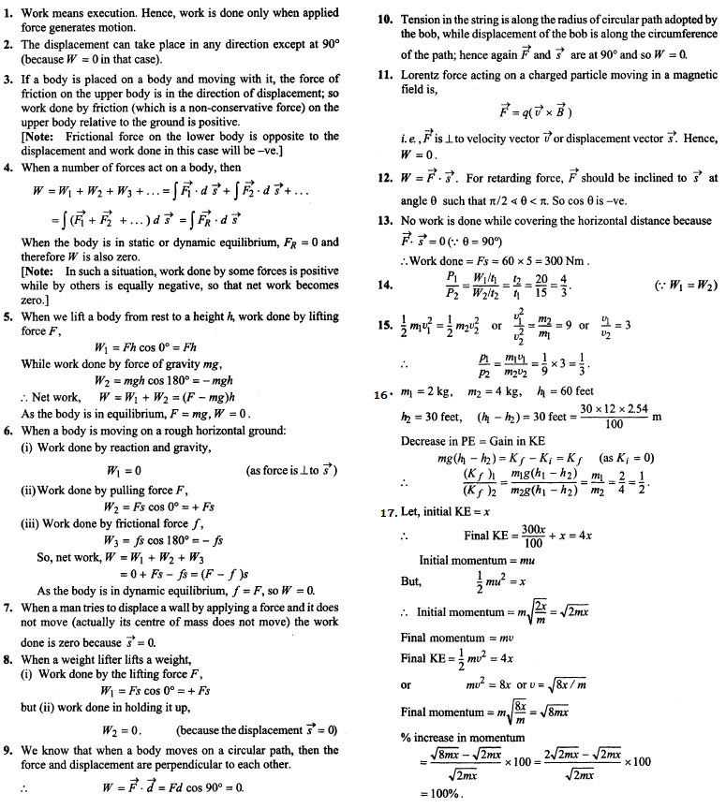**Explanations and Answers for Work Power & Energy**

