**Electromagnetic Induction**

**Magnetic flux:**

- The magnetic flux through a small area **dA**, placed in a magnetic field B is dϕ =B dA cosθ .

-The SI unit of magnetic flux is weber. The cgs unit is maxwell. (1 weber =108 maxwell).

Also 1 weber =1tesla x metre2. The dimensions of magnetic flux are:[ϕ] = [M1L2 T-2 A-1 ]

- The magnetic flux can be positive, negative or zero depending on the angle θ.The magnetic flux is taken as negative if field lines enter the area and positive if field lines leave the area.



- The magnetic flux through a curved surface is given by the integral



- The magnetic flux through a closed surface is always zero, i.e.,



-The statement that is the **Gauss' theorem for magnetostatics**. It is equivalent to the fact that isolated magnetic monopoles do not exist.



-The magnetic flux is a measure of the total number of lines of **B** through a given area. also means that **lines of B are continuous, i.e., do not end at south pole of magnet but pass through**

**the magnet coming out of the north pole**

2. **Electromagnetic induction** **and Faraday's experiments**

(i) E.M. induction is the phenomenon of production of induced electric current and induced emf in a conducting loop whenever the magnetic flux linked with the loop is changed. This phenomenon was discovered by Faraday.

(ii) Whenever there is a **relative motion** between coil connected with a galvanometer and the magnet, induced emf is produced in the coil and induced current flows in the circuit.

(iii) The induced current exists till there is a relative motion. The magnitude of induced current or emf is large if relative velocity is large. The polarity of induced emf changes if the relative velocity is reversed in direction.

(iv) Whenever current is switched on or off in a coil, there arises induced emf and induced current in another coil placed nearby.

3. **Laws of electromagnetic induction:**

(i) **First law**: Whenever there occurs a change in the magnetic flux linked with a coil, there is produced an induced emf in the coil. The induced emf lasts so long as the change in flux is taking place. There is an induced current only when coil circuit is complete.

(ii) **Second law**: The magnitude of induced emf is directly proportional to the rate of change in the magnetic flux, i.e., e α (dϕ/dt). For N turns, e = -N (dϕ/dt).

(iii) **Third law, i.e., Lenz's law**: The direction of the induced current is such that it tends to oppose the cause to which it is due.

(a) Combining the second and third law: e = -N (dϕ/dt).

(b) Lenz's law is based on law of conservation of energy

4. **Direction of induced current**: Fleming's right hand rule: Stretch the thumb and two nearby fingers of your right hand in three mutually perpendicular directions such that if the forefinger points along the direction of magnetic field and thumb along the direction of motion of the conductor, then the central finger points in the direction of induced current

5. **Some other important points**:

(i) When there is an increase in the magnetic flux in the coil, then the induced current is in the inverse direction and when there is a decrease in the magnetic flux in the coil, then the induced current is in the direct direction.

(ii) Induced emf and induced current are in no way different from the emfs and currents provided by a battery connected to a conducting loop.

(iii) **The induced emf in a circuit does not depend on the resistance** of the circuit as e=-(dϕ/dt). However, the induced current in the circuit does depend on the resistance.

I = e/R

(iv) **The induced charge** that flows in the circuit depends on the change of flux only and not on how fast or slow the flux changes



On integrating, the total charge that flows in the circuit is found to be:

**Thus, q does not depend on rate of change of the flux but it depends on total flux change and R in the circuit.**

If the number of turns in the coil is N, then the charge that flows through the coil is: q= [N(ϕ1 - ϕ2)]/R

3**. Induced EMF across a conducting rod:**

(i) **Conducting rod moving in a uniform magnetic field**: When a conducting rod of length *l* moves with a velocity *v* in a uniform magnetic field of induction B such that the plane containing *v* and *l* makes an angle θ with **B**, then the magnitude of the average induced emf e is given by:

e = *v*B*l* sinθ

(ii) **Conducting rod rotating with angular velocity** *w* in a uniform magnetic field: When a rod of length *l* rotates with angular velocity *w* in a uniform magnetic field B, then induced emf across the ends of the rotating rod is:

e = ½ Bw*l2* =BAf

where A=π*l*2 --area swept by the rod in one rotation and f is the frequency of rotation

4. **Self-inductance**:

(i) When a current I flows through a coil, it produces a magnetic flux ϕ through it. Then, ϕ α I or ϕ =LI where L is a constant, called the coefficient of self-induction or self inductance of the coil.

(ii) The unit of L in MKS system is henry while in CGS system is ab-henry. One henry = 109 ab-henry

(iii) Further, e = -(dϕ/dt) = -LdI/dt

(iv) Self-inductance L of a solenoid of N turns, length *l*, area of cross-section A, with a core material of relative permeability μr is given by :

(v)The role of self-inductance L in an electrical circuit is the same as that of inertia in mechanical motion. Analogous mechanical and electrical quantities are:

(a) displacement - charge q (b) velocity – current (c) mass – self inductance

(d)momentum - magnetic flux LI (e) force - induced emf (f)kinetic energy - magnetic energy

5.**Mutual inductance**:

(i) When a current I flowing in the primary coil produces a magnetic flux ϕ in the secondary coil, then ϕ = MI, where M is a constant, called the coefficient of mutual induction or mutual inductance.

(ii) e = -dϕ/dt = -MdI/dt



(iii) Mutual inductance M of two co axial solenoids is given by :

where n1 and n2 represent the total number of turns in the primary coil and the secondary coil.

6. **Series and parallel combination of inductances:**

(i) Two inductors of self-inductances L1 and L2 are kept so far apart that their mutual inductance is zero.

These are connected in series. Then, the equivalent inductance is: L = L1 +L2

(ii) Two inductors of self-inductances L1 and L2 are connected in series and they have mutual inductance M. Then, the equivalent inductance of the combination is: L = L1 +L2 ± 2M

The plus sign occurs if windings in the two coils are in the same sense, while minus sign occurs if windings are in opposite sense.

(iii) Two inductors of self-inductances L1 and L2 are connected in parallel. The inductors are so far apart that their mutual inductance is negligible. Then, their equivalent inductance is:



(iv) If two coils of self-inductances L1 and L2 are wound over each other, the mutual inductance is given by:

M = K√(L1L2) (where K is called coupling constant).

- K is equal to zero if there is no coupling.

-It is equal to 1 for maximum coupling.

The maximum coupling occurs when the two coils are wound over each other, over a ferromagnetic core.

7. **Growth and decay of current in L-R circuit:**

-When a switch in an L-R circuit is closed, the current does not become maximum immediately but it takes

some time, i.e., there is a time lag.

- If during the growth of current ,I be the current at any instant and(dI/dt) be the rate of growth of current at

that instant then induced emf at that instant

e = -LdI/dt

and effective potential difference = E - LdI/dt

- If R be the resistance present in the circuit, then current I at any instant is given by: IR = E - LdI/dt

(a) At start, I = 0, so (dI/dt) is maximum and (dI/dt)max = E/L

(b) Finally, (dI/dt) =0,therefore I is maximum and Imax= E/R i.e.final current in the circuit is independent of L



-The instantaneous current in the circuit during its growth is given by:

Here, (L/R) =time constant of L-R circuit**. The time constant is the time in which current rises to 0.6321 times the maximum current which is equal to (E/R).**

-When the switch in an L-R circuit is opened, the instantaneous current is given by:

**Hence, the time constant of an L-R circuit may also be defined as the time in which the current falls to 0.3679 times of its initial current.**

-Decay or growth of current in L-R circuit is fast when L/R is small and slow when (L/R) is large.

8. **Eddy Currents :** circulating currents called eddy currents are induced in bulk pieces of metal moving through a magnetic field.

Eddy currents are used to advantage in certain applications like

(i) *Magnetic braking in trains* (ii) *Electromagnetic damping*

(iii) *Induction furnace* (iv) *Electric power meters*

9. **Energy In A Magnetic Field (U) = LI2/2**

|  |  |  |  |  |
| --- | --- | --- | --- | --- |
| **Quantity** | **Symbol** | **Units** | **Dimensions** | **Equations** |
| Magnetic Flux | ϕB | Wb(weber) | [ML2T-2 A-1] | ϕB=B.A |
| EMF | ∈ | V(Volt) | [ML2T-3 A-1] | ∈ =-d(NϕB)/dt |
| Mutual Inductance | M | H(Henry) | [ML2T-2 A-2] | ∈ = - M12(dI2/dt) |
| Self Inductance | L | H(Henry) | [ML2T-2 A-2] | ∈ = - L(dI/dt) |

**Transformers**

(i) The transformer was inverted by Henry. It works on the **principle of mutual induction** and is used in AC only. It suitably changes the peak value of AC voltage.

(ii) A transformer consists of a

(a) primary coil of turns NP

(b) secondary coil of turns NS and

(c) a laminated soft iron core.

(iii) lf VP and VS, denote the voltage across the primary coil and the secondary coil respectively, then

(VS/VP) =(NS/NP).

(iv) In an actual transformer, Output power < input power; but in an ideal transformer,Output power = input power

i.e. (VSIS) =( VPIP) , where IP and IS are currents in primary and secondary coils.

or VS/VP = NS/NP = IP/IS

(v) There are two types of transformers:

(a) Step-up transformers: Here, Ns >NP, so VS > VP and IP > IS

(b) Step-down transformers: Here, Ns < NP, so VS < VP and IP < IS

**Home assignment – Electromagnetic Induction**

1. What do you mean by EMI ?
2. Define Magnetic flux with an expression and SI unit?
3. State Faraday’s Laws of EMI alongwith expression?
4. State Lenz’ Law ?
5. Can Lenz’s law be explained on the basis of Law of Conservation of energy ?
6. What are different methods of producing EMI?
7. Derive an expression for motional emf in a straight conductor?
8. Derive an expression for motional emf in a conductor rotating in a uniform magnetic field?
9. Derive an expression for power dissipated in a conductor moved in a magnetic field?
10. What do you mean by eddy currents?
11. Name some applications where eddy currents are used?
12. List some disadvantages of eddy currents?
13. How can we minimize eddy currents?
14. What do you mean by self induction?
15. Derive an expression for Coefficient of Self Induction alongwith it’s SI unit?
16. Derive an expression for self Inductance of a long Solenoid?
17. Write an expression for equivalent Self Inductance of multiple inductors joined in series and parallel.
18. What do you mean by mutual induction?
19. Derive an expression for Coefficient of mutual Induction alongwith it’s SI unit?
20. Derive an expression for mutual Inductance of two long co axial solenoids?
21. What do you mean by coefficient of coupling ?
22. Two circular coils , one of small radius r1 and other of very large radius r2, are placed co-axially with centres coinciding. Obtain an expression for mutual inductance of the arrangement?

**NCERT Solved**

1. A square loop of side 10 cm and resistance 0.5 Ω is placed vertically in the east-west plane. A uniform magnetic field of 0.10 T is set up across the plane in the north-east direction. The magnetic field is decreased to zero in 0.70 s at a steady rate. Determine the magnitudes of induced emf and current during this time-interval.

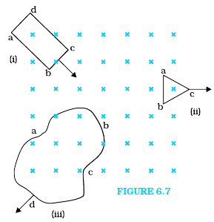

1. A circular coil of radius 10 cm, 500 turns and resistance 2 Ω is placed with its plane perpendicular to the horizontal component of the earth’s magnetic field. It is rotated about its vertical diameter through 180° in 0.25 s. Estimate the magnitudes of the emf and current induced in the coil. Horizontal component of the earth’s magnetic field at the place is 3.0 × 10–5 T.
2. Figure 6.7 shows planar loops of different shapes moving out of or into a region of a magnetic field which is directed normal to the plane of the loop away from the reader. Determine the direction of induced current in each loop using Lenz’s law.
   1. A closed loop is held stationary in the magnetic field between the north and south poles of two permanent magnets held fixed. Can we hope to generate current in the loop by using very strong magnets?
   2. A closed loop moves normal to the constant electric field between the plates of a large capacitor. Is a current induced in the loop
3. when it is wholly inside the region between the capacitor plates
4. when it is partially outside the plates of the capacitor? The electric field is normal to the plane of the loop.
   1. 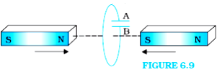A rectangular loop and a circular loop are moving out of a uniform magnetic field region (Fig. 6.8) to a field-free region with a *constant velocity* **v**. In which loop do you expect the induced emf to be constant *during* the passage out of the field region? The field is normal to the loops.
   2. Predict the polarity of the capacitor in the situation described by Fig. 6.9.
5. A wheel with 10 metallic spokes each 0.5 m long is rotated with a speed of 120 rev/min in a plane normal to the horizontal component of earth’s magnetic field *HE* at a place. If *HE* = 0.4 G at the place, what is the induced emf between the axle and the rim of the wheel? Note that 1 G = 10–4 T.

**NCERT Unsolved**

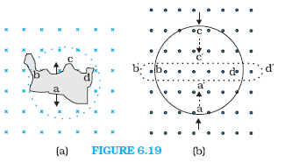

1. Use Lenz’s law to determine the direction of induced current in the situations described by Fig. 6.19:
   1. A wire of irregular shape turning into a circular shape;
   2. A circular loop being deformed into a narrow straight wire.
2. Current in a circuit falls from 5.0 A to 0.0 A in 0.1 s. If an average emf of 200 V induced, give an estimate of the self-inductance of the circuit.

**Exemplar**

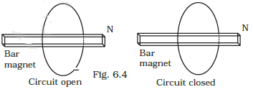

1. Consider a magnet surrounded by a wire with an on/off switch S (Fig 6.4). If the switch is thrown from the off position (open circuit) to the on position (closed circuit), will a current flow in the circuit? Explain.
2. A wire in the form of a tightly wound solenoid is connected to a DC source, and carries a current. If the coil is stretched so that there are gaps between successive elements of the spiral coil, will the current increase or decrease? Explain.
3. A solenoid is connected to a battery so that a steady current flows through it. If an iron core is inserted into the solenoid, will the current increase or decrease? Explain.
4. Consider a metallic pipe with an inner radius of 1 cm. If a cylindrical bar magnet of radius 0.8cm is dropped through the pipe, it takes more time to come down than it takes for a similar unmagnetised cylindrical iron bar dropped through the metallic pipe. Explain.

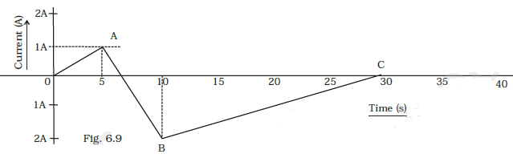

1. A (current vs time) graph of the current passing through a solenoid is shown in Fig 6.9. For which time is the back electromotive force (*u*) a maximum. If the back emf at *t* = 3s is *e*, find the back emf at *t* = 7 s, 15s and 40s. OA, AB and BC are straight line segments.

**Multiple choice questions**

1. Lenz's law is a consequence of the law of conservation of: (a) charge (b) mass (c) momentum (d) energy

2. A horizontal straight conductor when placed along south-north direction falls under gravity; there is:

(a) an induced current from south to north direction (b) an induced current from north to south direction

(c) no induced emf along the length of the conductor (d) an induced emf along the length of the conductor

3. A horizontal straight conductor (otherwise placed in a closed circuit) along east-west direction falls under gravity; then there is:

(a) no induced emf along the length (b) no induced current along the length

(c) an induced current from west to east (d) an induced current from east to west

4. Two circular, similar, coaxial loops carry equal currents in the same direction. If the loops are brought nearer, what will happen?

(a) Current will increase in each loop (b) Current will decrease in each loop

(c) Current will remain same in each loop (d) Current will increase in one and decrease in the other

5. A car moves on a plane road. Induced emf produced across the axle is maximum when it moves:

(a) at the poles (b) moves at equator (c) remains stationary (d) no emf is induced at all

6. When a metallic plate swings between the poles of a magnet

(a) no effect on the plate (b) eddy currents are set up inside the plate and the direction

of the current is along the motion of the plate

(c) eddy currents are set up inside the plate and the direction of the current oppose the motion of the plate

(d) eddy currents are set up inside the plate

7.Two similar circular loops carry equal currents in the same direction. On moving loops further apart, the electric current will :

(a) increase in both (b) decrease in both

(c) remain unaltered (d) increase in one and decrease in the second

8. An electron moves along the line AB which lies in the same plane as a circular loop of conducting wire as shown in figure (35.2). What will be the direction of the current induced if any in the loop?

(a) No current will be induced (b) The current will be clockwise

(c) The current will be anticlockwise

(d) The current will change direction as the electron passes by

9. Flux ϕ (in weber) in a closed circuit of resistance 10 ohm varies with time t (in sec) according to the equation: ϕ = 6t2 -5t +1. What is the magnitude of the induced current at t = 0.25 sec?

(a) 1.2 A (b) 0.8 A (c) 0.6 A (d) 0.2 A

10. A solenoid has 2000 turns wound over a length of 0.3 m. The area of its cross-section is 1.2 x 10-3 m2. Around its central portion a coil of 300 turns is wound. If an initial current of 2 amp in the solenoid is reversed in 0.25 sec, the emf induced in the coil is equal to:

(a) 6x10-4 V (c) 6x10-2 V (b) 48 mV (d) 48 kV

11.The core of a transformer is laminated so that:

(a) ratio of voltage in the primary and secondary may be increased

(b) energy losses due to eddy currents may be minimised

(c) weight of transformer may be reduced (d) rusting may be prevented

12. A metallic ring with a cut is held horizontally and a magnet is allowed to fall vertically through the ring. Then the acceleration of the magnet is:

(a) equal to g (b) less than g (c) more than g (d) sometimes less and sometimes more than g

13. A resistance coil is held horizontally and a magnet is allowed to fall vertically through it. Then, the acceleration of the magnet is:

(a) equal to g (b) non-uniform and less than g (c) uniform and less than g (d) more than g

14. A 10 ohm resistance coil has 1000 turns. It is placed in a magnetic field of magnetic induction 5 x 10-4 tesla in 0.1sec. If the area of cross-section is one square metre, then the induced emf is:

(a) 5 volt (b) 0.5 volt (c) 0.05 volt (d) 0.005 volt

15. A 10 ohm resistance coil has 1000 turns. It is placed in a magnetic field of magnetic induction 5 x 10-4 tesla in 0.1sec. If the area of cross-section is one square metre, then the induced current is:

(a) 0.5 amp (b) 0.05 amp (c) 0.005 amp (d) 0.0005 amp

16. A 10 ohm resistance coil has 1000 turns. It is placed in a magnetic field of magnetic induction 5 x 10-4 tesla in 0.1sec. If the area of cross-section is one square metre, then the induced charge is:

(a) 5 x10-2 coulomb (b) 5 x10-3 coulomb (c)5 x 10-4 coulomb (d) 5 x10-5 coulomb

17. A coil of 20x20 cm having 30 turns is making 30 rps in a magnetic field of induction 1 tesla. The peak value of the induced emf is approximately:

(a) 452 volt (b) 226 volt (c) 113 volt (d) 339 volt

18. A coil of resistance 10 ohm and inductance 5 henry is connected to a 100 volt battery. Then, the energy stored in the coil is: (a) 250 joule (b) 250 erg (c) l25 joule (d) 125 erg



19.A magnet NS is suspended from a spring and while it oscillates the magnet moves in and out of the coil C. If the coil is now connected to a galvanometer G as shown in fig (35.3) then as the magnet oscillates G shows :

(a) no deflection (b) deflection on one side (c) deflection on both left and right side with constant amplitude (d) deflection on both left and right side but amplitude steadily decreases

20. An electric generator is based on:

(a) Faraday’s law of electromagnetic induction

(b) motion of charged particles in electromagnetic field

(c) Newton's laws of motion (d) fission of uranium by slow neutrons

21. When the number of turns in a coil is doubled without any change in the length of the coil, its self-inductance becomes: (a) four times (b) doubled (c) halved (d) squared

22. When a metallic plate swings between the poles of a magnet: (a) no effect on the plate

(b) eddy currents are set up inside the plate and the direction of the current is along the motion of the plate

(c) eddy currents are set up inside the plate and the direction of the current oppose the motion of the plate

(d) Eddy currents are set up inside the plate

23. A coil having an area AO is placed in a magnetic field which changes from Bo to 4Bo in time interval t. The emf induced in the coil will be: (a) 3AoBo/t (b) 4AoBo/t (c) 3Bo/Aot (d) 4Bo/Aot

24. Figure(35.5) shows two bulbs B1 and B2, resistor R and an inductor L. When the switch S is turned off:

(a) both B1 and B2 die out promptly

(b) both B1 , and B2 die out with some delay

(c) B1 dies out promptly but B2 with some delay

(d) B2 dies out promptly but B1 with some delay

25. In the circuit of figure (35.6) the bulb will become suddenly bright if:

(a) contact is made or broken (b) contact is made (c) contact is broken

(d) would not become bright at all

26. A conducting square loop of side L and resistance R moves in its plane with a uniform velocity *v* perpendicular to one of its sides. A magnetic induction **B**, constant in time and space, pointing perpendicular and into the plane of the loop exists everywhere fig (35.7). The current induced in the loop is:

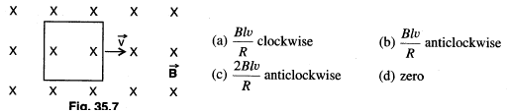



27. A conductor rod AB moves parallel to x-axis in a uniform magnetic field, pointing in the positive Z-direction (FIG 35.8). The end A of the rod gets:

(a) positively charged (b) negatively charged

(c) neutral

(d) first positively charged and then negatively charged

28. Figure 35.9 shows a solenoid connected with a resistance R, a bulb B and a source of emf. The resistance R is adjusted so that when the key K is closed, the bulb just glows. Then, the switch

K is suddenly opened. The bulb B will: (a) remain as before (b) go out

(c) glow very brightly (d) none of these

29. The north pole of a long horizontal bar magnet is being brought closer to a vertical conducting plane along the perpendicular direction. The direction of the induced current in the conducting plane will be:

(a) horizontal (b) vertical (c) clockwise (d) anticlockwise

30. A circuit has a self-inductance of 1 henry and carries a current of 2 A. To prevent sparking when the circuit is switched off, a capacitor which can withstand 400 V is used. The least capacitance of the capacitor connected across the switch must be equal to: (a) 50μF (b) 25 μF (c) 100μF (d) 12.5 μF

31. A step-down transformer transforms a supply line voltage of 2200 volt into 220volt. The primary coil has 5000 turns. The efficiency and power transmitted by the transformer are 90% and 8 kilowatt respectively. Then, the number of turns in the secondary is: (a) 5000 (b) 50 (c) 500 (d) 5

32. A step-down transformer transforms a supply line voltage of 2200 volt into 220volt. The primary coil has 5000 turns. The efficiency and power transmitted by the transformer are 90% and 8 kilowatt respectively.

The power supplied is: (a) 9.89 kilowatt (b) 8.89 kilowatt (c) 88.9 kilowatt (d) 889 kilowatt

33. Two identical circular loops of metal wire laying on a table without touching each other. Loop A carries a current which increases with time. In response the loop B

(a) remains stationary (b) is attracted by loop A

(c) is repelled by loop A (d) rotates about CM with CM fixed

34. A metallic ring is attached to the wall room. When the north pole of a magnet is brought near the ring, the induced current in the ring is: (a) zero (b) in clockwise direction

(c) in anticlockwise direction (d) infinite

35. Two coils X and Y are placed in a circuit such that the current changes by 4 amp in coil X and the magnetic flux changes by 0.4 wb in Y. The value of mutual inductance of the coils in Henry is :

(a)0.2 (b) 5 (c) 0.8 (d) 0.1

36. A coil of wire of a certain radius has 600 turns and a self-inductance of 108 mH. The self-inductance of a second similar coil ( same area) of 500 turns will be: (a) 74 mH (b) 75 mH (c) 76 mH (d) 77 mH

37. When the current in a coil changes from 8 ampere to 2 ampere in 3 x l0-2 sec, the emf induced in the coil is 2 volt. The self-inductance of the coil (in mH) is:(a)1 (b) 5 (c) 20 (d) l0

38. An electric bulb in series with a large inductor when connected across a DC source takes a little time before reaching a stable glow. If an iron core is inserted into the inductor the , delay will

(a)Increase (b) decrease (c) remain the same

(d) may change in either direction depending upon the values of inductance and resistance

39. A simple electric motor has an armature resistance of one ohm and runs from a DC source of 12V.When unloaded it draws a current of 2 ampere. When a certain load is connected, it’s speed becomes one –half of unloaded value. Then the current it draws in ampere is: (a) 7 (b) 6 (c) 2 (d) 4

40. The armature current in a DC motor is maximum when the motor has

(a) picked up maximum speed (b) just started

(c) intermediate speed (d)just been switched-off

41. According to Lenz's law of electromagnetic induction:

(a) the induced emf is not in the direction opposing the change in magnetic flux

(b) the relative motion between the coil and magnet produces change in magnetic flux

(c) only the magnet should be moved towards coil

(d) only the coil should be moved towards magnet

42. A galvanometer is connected to the secondary coil. The galvanometer shows an instantaneous deflection of 7divisions when current is started in the primary coil of the solenoid. Now, if the primary coil is suddenly rotated through 1800, then the new instantaneous deflection will be:

(a) 7 unit (b) 14 unit (c) 0 unit (d) 21 unit

43. The armature of a DC motor has 20 ohm resistance. It draws a current of 1.5 amp when run by 220 volt DC supply. The value of back emf induced in it will be

(a)150V (b) l70V (c) 180V (d) l90V

44.A 50Hz Hz alternating current of peak value I ampere flows thru the primary coil of a transformer. If the mutual inductance between the primary and secondary is 1.5 Henry, then the mean value of the induced voltage is : (a)75 V (b) l50 V (c) 225 V (d) 300V

45. According to phenomenon of mutual inductance:

(a) the mutual inductance does not depend on geometry of two coils involved

(b) the mutual inductance depends on the intrinsic magnetic property, like relative permeability of material

(c) the mutual inductance is independent of the magnetic property of the material

(d). ratio of magnetic flux produced by the coil 1 at the place of the coil 2 and the current in the coil 2 will be different from that of the ratio defined by interchanging the coils

46. Two coils of self-inductances L1 and L2 are placed so close to each other that the effective flux in one coil is completely linked with the other; then the mutual inductance M between them is given by:

(a)M =√(L1L2) (b) M = (L1- L2) (c) M = (L1/L2) (d) M = (L1 + L2)



47. In the circuit shown in the following figure(35.10) E =10V, R1= 2 ohm, R2 = 3 ohm and R3 = 6 ohm and L=5 henry. The current I1 just after pressing the switch S is:

(a) (10/4) amp (b) (10/5) amp

(c) (10/12) amp (d) (10/6) amp

48. In the circuit shown in the following figure(35.10) E =10V, R1= 2 ohm, R2 = 3 ohm and R3 = 6 ohm and L=5 henry. The current I1 long after pressing the switch S is: (a) (10/4) amp (b) (10/5) amp (c) (10/12) amp (d) (10/6) amp

49. A metal ring is held horizontally and a bar magnet is dropped through the ring with its length along the axis of the ring. The acceleration of the falling magnet is:(a) equal to g (b) less than g

(c) more than g (d) depends on the diameter of the ring and length of magnet

50.A long solenoid of length L, cross-section A having N1 turns has wound about its centre a small coil of N2 turns. Then, the mutual inductance of the two circuits is:



51. A horizontal telegraph wire 0.5 km long running east and west is a part of a circuit whose resistance is 2.5 ohm. The wire falls to the ground from a height of 5 m. If g = 10.0 m/s2 and B=2x10-5 wb/m2, then the current induced in the circuit is : (a) 0.7 amp (b) 0.04 amp (c) 0.02amp (d) 0.01 amp

52. A transformer is used to light 140 watt 24 volt lamp from 240 volt AC mains; the current in the main cable is 0.7 amp. The efficiency of the transformer is: (a) 63.8% (b) 84% (c) 83.3% (d) 48%

53. The primary winding of a transformer has 500 turns whereas its secondary has 5000 turns. The primary is connected to an AC supply of 20 V, 50 Hz. The secondary will have an output of:

(a) 200 V, 50 Hz (b) 200 v, 500 Hz (c) 2 V, 50 Hz (d)2v,5Hz

54. The mutual inductance of a pair of coils if a current of 3 ampere in, one coil causes the flux in the second coil of 2000 turns to change by 6 x 10-4 weber per turn of the secondary coil:

(a) 4 x 10-4 Henry (b) 2 x 10-4 Henry (c) 0.4 Henry (d) 4 Henry

55. A metal disc of radius R rotates with an angular velocity *w* about an axis perpendicular to its plane passing through its centre in a magnetic field of induction B acting perpendicular to the plane of the disc. The induced emf between the rim and the axis of the disc is

a) –BπR2 (b) –2Bπ2R2/*w* (c) –BπR2*w* (d) –B*w*R2/2

56. An electric motor has a back emf of 110 volt and armature current of 90 amp. The armature is making 2.5 rps. Then, the power developed in watts is:

(a) 110 x 25 (b) 110 x 90 (c) 90 x 25 (d) 90 x 25 x 2π

57. An electric motor has a back emf of 110 volt and armature current of 90 amp. The armature is making 2.5 rps. Then, the torque on the armature in N-m is: (a) 396 (b) 198 (c) 63 (d) 126

58. An electric motor runs on a DC source of emf 200 volt and draws a current of 10 ampere. If the efficiency is 40%, then the resistance of the armature is: (a) 5 ohm (b) 12 ohm (c) 120 ohm (d) 160 ohm

59. An inductor is connected to a battery through a switch. Induced emf is e1 when the switch is pressed and e2 when the switch is opened. Then(a) e1 = e2 (b) e1 > e2 (c) e1 < e2 (d) e1 > 1< e2

60. A conducting circular loop is placed in a uniform magnetic field of induction B tesla with its plane normal to the field. Now the radius of the loop starts shrinking at the rate(dr/dt). Then, the induced emf at the instant when the radius is r, is:

(a) πrB(dr/dt) (b) 2πrB(dr/dt) (c) πr2(dB/dt) (d) π[r2/2]B(dr/dt)

61. Two circular coils of radii R1 and R2, turns N1 and N2 are placed concentrically in the same plane. lf R2<<R1, then the mutual inductance between them is equal to:



62.A rod of length L rotates with a uniform angular velocity *w* about an axis passing through its middle point but normal to its length in a uniform magnetic field of induction B with its direction parallel to the axis of rotation. The induced emf between the two ends of the rods is:

(a) BL2*w*/2 (b) zero (c) BL2*w*/8 (d) 2BL2*w*

63. Two similar circular loops carry equal currents in the same direction. On moving loops further apart, the electric current will (a) increase in both (b) decrease in both

(c) remain unaltered (d) increase in one and decrease in the second

64. A L-R combination is connected to a battery of emf 4 volt. If L = 0.l H and R = 4 ohm, then the time taken to reach a current of 0.6321ampere is: (a) (1/40) sec (b) 0.4 sec (c) 1.6 sec (d) 0.63 sec

65.A long solenoid having 200 turns per cm carries a current of 1.5 amp. At the centre of it is placed a coil of 100 turns of cross-sectional area 3.14 x l0-4 m2 having its axis parallel to the field produced by the solenoid. When the direction of current in the solenoid is reversed within 0.05 sec, the induced emf in the coil is:

(a) 0.48 V (b) 0.048 v (c)0.0048 V (d) 48 V

66. An ideal coil of 10 henry is joined in series with a resistance of 5 ohm and a battery of 5 volt. After two seconds joining, the current flowing in ampere in the circuit will be:

(a) e-1 (b) (1- e-1) (c) 1 - e (d) e

67. When a circular coil of radius 1 m and 100 tums is rotated in a horizontal uniform magnetic field, the peak value of emf induced is 100 V. The coil is unwound and then rewound into a circular coil of radius 2 m. If it is rotated, now, with the same speed under similar conditions, the new peak value of emf developed is:

(a) 50 V (b) 25 V (c)100 V (d) 150 V (e) 200V

68. A wheel having metal spokes of 1 m long between its axle and rim is rotating in a magnetic field of flux density 5 x 10-5 T normal to the plane of the wheel. An emf of 22/7 mV is produced between the rim and the axle of the wheel. The rate of rotation of the wheel in radians per second is

(a) 10 (b) 20 (c) 30 (d) 40

69. In a transformer, the number of turns of primary coil and secondary coil are 5 and 4 respectively. If 220 V is applied on the primary coil, then the ratio of primary current to the secondary current is:

(a)4:5 (b)5:4 (c)5:9 (d)9:5

70.A motor having an armature of resistance 2 ohm is designed to operate at 220 V mains. At full speed, it develops a back emf of 210 V. When the motor is running at full speed, the current in the armature is:

(a)3A (b)5A (c)7A (d) 10 A

71.If rotational velocity of a dynamo armature is doubled, then induced emf will become:

(a) half (b) two times (c) four times (d) unchanged

72. If a coil of metal wire is kept stationary in a non-uniform magnetic field, then:

(a) an emf is induced in the coil (b) a current is induced in the coil

(c) neither emf nor current is induced (d) both emf and current is induced

73. Two coils A and B having turns 300 and 600 respectively are placed near each other. On passing a current of 3.0 ampere in A, the flux linked with Aisl.2x10a Wb and with B it is 9.0 x 10-5 Wb. The mutual inductance of the system is:(a) 4 x 10-5 Henry (b) 3 x 10-5 Henry

(c) 2 x 10-5 Henry (d) 1.8 x 10-2 Henry

74. An inductance of 2H and a resistance of 10 ohm are connected in series to a battery of 5 V. The initial rate of change of current in amp/sec is: (a) 2.5 (b) 2.0 (c) 0.5 (d) 0.25

75. Use of eddy currents is done in the following except:

(a) moving coil galvanometer (b) electric brakes (c) induction motor (d) dynamo

76. The pointer of a dead-beat galvanometer gives a steady deflection because:

(a) eddy currents are produced in the conducting frame over which the coil is wound

(b) its magnet is very strong (c) its pointer is very light (d) its frame is made of ebonite

77. A long horizontal metallic rod with length along the east-west direction is falling freely under gravity. The

potential difference between its two ends will:

(a) be zero (b) be constant (c) increase with time (d) decrease with time

78. A copper disc is rotated rapidly below a freely suspended magnetic needle. The magnetic needle starts rotating with: (a) speed equal to that of disc but in opposite direction

(b) speed equal to that of disc and in the same direction

(c) speed less than that of disc but in same direction

(d) speed less than that of disc but in opposite direction

79. The coil of a dynamo is rotating in a magnetic field. The developed induced emf changes and the number of magnetic lines of force also changes. Which of the following conditions is correct?

(a) Lines of force minimum but induced emf is zero (b) Lines of force maximum but induced emf is zero

(c) Lines of force maximum but induced emf is not zero (d) Lines of force maximum but induced emf is also

maximum

80. Energy is stored in the choke coil in the form of :

(a) heat (b) electric energy (c) magnetic energy (d) e.m. energy

81. The self-inductance of a coil is: (a) directly proportional to the current flowing through it

(b) independent of current (c) inversely proportional to current

(d) inversely proportional to the square of number of turns

82. Eddy currents are favourable in which of the following electrical instruments?

(a) Induction furnace (b) Electric motor (c) Transformer (d) AC generator

83. Two circular coils have their centres at the same point. The mutual inductance between them will be maximum when their axes are: (a) perpendicular to each other (b) at 600 to each other

(c) at 450 to each other (d) parallel to each other

84. A step-down transformer transforms 220 volt to 11 volt. If the currents in primary and secondary coils are 5A and 90A respectively, efficiency of transformer is: (a) 70% (b) 40% (c) 20% (d) 90%

85. A circular coil of radius 0.1 m has 80 turns of wire. If the magnetic field through the coil increases from 0 to 2 tesla in 0.4 sec and the coil is connected to a 11 ohm resistor, what is the current (in A) through the resistor during the 0.4 sec? (a) (8/7) A (b) (7/8) A (c) 8 A (d) 7 A

86. Two coils have self-inductance L1 = 4 mH and L2 = 1 mH respectively. The currents in the two coils are increased at the same rate. At a certain instant of time both coils are given the same power. If I1 and I2 are the currents in the two coils at that instant of time respectively, then the value of I1/I2 is:

(a) ⅛ (b) ¼ (c) ½ (d) 1

87. Two coils are placed close to each other. The mutual inductance of the pair of coils depends upon

(a) currents in the coils (b) materials of the wires of the coils

(c) relative position and orientation of the coils (d) rates at which the currents are changing in the coils

88. Induction furnace is based on the heating effect of:

(a) electric field (b) eddy current (c) magnetic field (d) gravitational field

89. A coil having n turns and resistance R ohm is connected with a galvanometer of resistance 4R ohm. This combination is moved in time, t seconds from a magnetic field W1 weber to W2 weber. The induced current in the circuit is:(a) – (W2 –W1)/5Rnt (b) – n (W2 –W1)/5Rt (c) – (W2 –W1)/ Rnt (d)– n(W2 –W1)/Rt

90. In a uniform magnetic field of induction B a wire in the form of a semicircle of radius r rotates about the diameter of the circle with angular frequency *w*. The axis of rotation is perpendicular to the field. If the total resistance of the circuit is R, the mean power generated per period of rotation is:

(a) Bπr2*w*/2R (b) [Bπr2*w*]2/8R (c) (Bπr*w*) 2/2R (d) [Bπr*w*2]2/8R

91.A metal conductor of length I m rotates vertically about one of its ends at angular velocity 5 radians per second. If the horizontal component of the earth's magnetic field is 0.2 x10-4 T, then the emf developed between the two ends of the conductor is (a) 5 μV (b) 50 μV (c) 5 mV (d) 50 mV



92. Shown in the figure (35.18) is a circular loop of radius r and resistance R. A variable magnetic field of induction B = Boe-t is established inside the coil. If the key (K) is closed, the electrical power developed right after closing the switch is equal to: (a) Bo2πr2/R (b) Bo10r3/R (c) Bo2π2r4R/5 (d) Bo2π2r4/ R

93. Shown in the figure(35.19 is a small loop that is kept coaxially with the bigger loop. If the slider moves from A to B, then:

(a) current flow in both the loops will be in opposite senses

(b) clockwise current in loop 1 and anticlockwise current in loop 2 will flow

(c) no current flows in loop 2

(d) clockwise current flows in loop 2



94. When a magnet is released from rest along the axis of a hollow conducting cylinder situated vertically as shown in figure (35.20), then:

(a) the direction of induced current in the cylinder is anticlockwise as seen from the figure

(b) the magnet moves with an acceleration more than g

(c) the cylinder gets heated

(d) the speed of the magnet goes on increasing continuously if the cylinder is very long

95. A conducting loop is pulled with a constant velocity towards a region of uniform magnetic field of induction B as shown in the figure (35.21). Then, the current involved in the loop is (d> r):

(a) clockwise while entering

(b) anticlockwise while entering

(c) zero when partially outside

(d) anticlockwise while leaving

96. A conducting bar is pulled with a constant speed u on a smooth conducting rail. The region has a steady magnetic field of induction B as shown in the figure(35.22). If the speed of the bar is doubled then the rate of heat dissipation will:

(a) remain constant

(b) become quarter of the initial value

(c) become four fold

(d) get doubled

97. A loop is kept so that its centre lies at the origin of the coordinate system. A magnetic field has the induction B along z-axis as shown in the figure (35.23):

(a) an emf and current will be induced in the loop if it rotates about the z-axis

(b) no emf is induced and no current flows if the loop is a fiber when it rotates about y axis

(c) emf is induced and induced current flows in the loop if the loop is made of copper and is rotated about y axis

(d) if the loop moves about z-axis with constant velocity current flows in it

98. Shown in the figure (35.24) is a R - L circuit. Just after the key (K) is closed:

(a) a current starts flowing in the circuit

(b) a potential difference is developed across the resistance

(c) emf developed across the inductor equals the emf of the battery

(d) a heat is dissipated in the circuit

99. A conducting loop of resistance R and radius r has its centre at the origin of the coordinate system in a magnetic field of induction B fig (35.25). When it is rotated about y axis through 900, net charge flown in the loop is directly proportional to:

(a) B-1 (b) R (c) r2 (d) r

100. An infinitely long cylindrical conducting wire is kept parallel to uniform magnetic field along positive z-axis. The current induced on the surface of conducting wire is: (IIT 2005)

(a) along the direction of magnetic field (b) zero

(c) circulated in anticlockwise direction when viewed from z-axis

(d) circulated in clockwise direction when viewed from z-axis

101. One conducting U tube can slide inside another as shown in figure (35.26), maintaining electrical contacts between the tubes. The magnetic field B is perpendicular to the plane of the figure. If each tube moves towards the other at a constant, speed *v*, then the emf induced in the circuit in terms of B, L, *v* (L is the width of each tube) will be:

(a) zero (b) 2BL*v* (c) BL*v* (d) - BL*v* (IIT 2005)

102. A coil of inductance 300 mH and resistance 2 ohm is connected to a source of voltage 2 V. The current reaches half of its steady state value in: (a) 0.15s (b) 0.3 s (c) 0.05 s (d) 0.1 s (AIEEE 2005)

103. Two coils of self-inductance 2 mH and 8 mH are placed so close together that the effective flux in one coil is completely linked with the other. The mutual inductance between these coils is:

(a) 16 mH (b) 10 mH (c) 6 mH (d) 4 mH

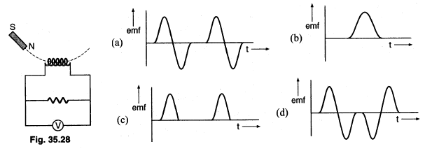

104. A magnet is made to oscillate with a particular frequency, passing through a coil as shown in figure (35.28). The time variation of the magnitude of emf generated across the coil during one cycle is:

105.The equivalent quantity of mass in electricity is:

(a) current (b) self-inductance (c) potential (d) charge

106. A transformer has an efficiency of 80%.It works at 4 kW and 100 V. If secondary voltage is 240 V, the current in the primary coil is: (a) 10 amp (b) 4 amp (c) 0.4 amp (d) 40 amp

107. The flux linked with a coil at any instant t is given by ϕ = 10t2 -50t +250. The induced emf at t =3 sec is: (a) 190 volt (b) -190 volt (c) -10 volt (d) 10 volt (AIEEE 2006)

108.An inductor (L = 100 mH), a resistor (R = 100 ohm) and a battery (E = 100 volt) are initially connected in series as shown in the figure (35.29). After a long time, the battery is disconnected after short circuiting the points A and B. The current in the circuit 1 ms after the short circuit is: (AIEEE 2006)

(a) 1 amp (b) l/e amp (c) e amp (d) 0.1 amp

109. A metallic ring is dropped down, keeping its plane perpendicular to a constant and horizontal magnetic field. The ring enters in the region of magnetic field at t = 0 and completely emerges out at t =T sec. The current in the ring varies as:



110. When a low flying aircraft passes over head, we sometimes notice a slight shaking of the picture on our TV screen. This is due to:

(a) diffraction of the signal received from the antenna

(b) interference of the direct signal received by the antenna with the weak signal reflected by the passing aircraft

(c) change of magnetic flux occurring due to the passage of aircraft

(d) vibration created by the passage of aircraft

111. A copper disc of radius 0.1 m is rotated about its centre with 20 revolutions per second in a uniform magnetic field of 0.1 T with its plane perpendicular to the field. The emf induced across the radius of the disc is: (a) π/20 V (b) π/10 V (c) 20π mV (d) 10π mV (e) 2π mV

112. A varying magnetic flux linking a coil is given by: ϕ = xt2 .lf at a time t = 3 s, the emf induced is 9 V, then the value of X in wb/s2 is : (a) 0.66 (b) 1.5 (c) – 0.66 (d) -1.5 (e) – 0.33

113. A solenoid of length 30 cm with l0 turns per centimetre and area of cross-section 40 cm2 completely surrounds another co-axial solenoid of same length, area of cross-section 20 cm2 with 40 turns per centimetre. The mutual inductance of the system is: IPET (Kerala) 20061

(a) 10H (b) 8H (c) 3mH (d) 30 μH (e) 0.301 mH

114. The efficiency of a transformer is very high because:

(a) there is no moving parts in the transformer (b) it produces a very high voltage

(c) it produces a very low voltage (d) none of the above

115. when a motor car is started, its head light becomes slight dim, because potential drop

(a) increases (b) decreases (c) remains same (d) first (a) then (b)

116. Fleming's left and right hand rules are used in:

(a) DC motor and AC generator (b) DC generator and AC motor

(c) DC motor and DC generator (d) both rules are same, any one can be used

117. Two conductors identical in shape and size but one of copper and the other of aluminium (which is less conducting), are both placed in an identical electric field. In which metal will more charge be induced?

(a) Copper (b) Aluminium (c) Same in both metals (d) No charge is induced

118. Whenever there is a relative motion between a coil and a magnet, the magnitude of induced emf set up in the coil does not depend upon the:

(a) relative speed between the coil and magnet (b) magnetic moment of the coil

(c) resistance of the coil (d) number of turns in the coil

119. whenever there is a relative motion between a coil and a magnet, the magnitude of induced emf set up in the coil does not depend upon the:

(a) relative speed between the coil and magnet (b) magnetic moment of the coil

(c) resistance of the coil (d) number of turns in the coil

120. Pick out the 'false' statement from the following.

(a) The direction of eddy current is given by Fleming's right hand rule.

(b) A choke coil is a pure inductor used for controlling current in an A.C. circuit.

(c) The energy stored in a conductor of capacitance C having a charge Q is Q2C/2

(d) The magnetic energy stored in a coil of self inductance L carrying current I, is LI2/2

(e) Induction coil is a powerful equipment used for generating high voltages.

**Answers Objective ( Electromagnetic Induction)**

|  |  |  |  |  |  |
| --- | --- | --- | --- | --- | --- |
| 1. D | 1. C | 1. C | 1. B | 1. A | 1. C |
| 1. A | 1. D | 1. D | 1. B | 1. B | 1. A |
| 1. B | 1. A | 1. A | 1. A | 1. B | 1. A |
| 1. D | 1. A | 1. B | 1. C | 1. A | 1. C |
| 1. C | 1. D | 1. B | 1. C | 1. D | 1. B |
| 1. C | 1. B | 1. C | 1. C | 1. D | 1. B |
| 1. D | 1. A | 1. A | 1. D | 1. B | 1. B |
| 1. D | 1. D | 1. B | 1. A | 1. B | 1. A |
| 1. B | 1. B | 1. C | 1. C | 1. A | 1. C |
| 1. D | 1. B | 1. C | 1. B | 1. C | 1. B |
| 1. B | 1. B | 1. A | 1. A | 1. B | 1. B |
| 1. E | 1. B | 1. B | 1. B | 1. B | 1. C |
| 1. D | 1. A | 1. D | 1. A | 1. C | 1. C |
| 1. B | 1. C | 1. B | 1. A | 1. D | 1. D |
| 1. A | 1. B | 1. C | 1. B | 1. B | 1. B |
| 1. B | 1. D | 1. B | 1. A | 1. B | 1. C |
| 1. C | 1. C | 1. C | 1. B | 1. A | 1. D |
| 1. D | 1. A | 1. B | 1. D | 1. C | 1. B |
| 1. B | 1. C | 1. C | 1. D | 1. C | 1. D |
| 1. B | 1. C | 1. C | 1. C | 1. C | 1. E |

**Explanations Objective ( Electromagnetic Induction)**

2. No induced current is set-up as the magnetic field lines of the earth are not cut by the falling conductor.

3. when straight conductor along east-west direction falls under gravity, it cuts the horizontal component of The earth's magnetic field. Applying **F** = q(**V** x **B**)on the conductor, it is found that the charge moves from west to east.

4. When the loops are brought nearer, magnetic flux linked with each loop increases. Thus, the current will be induced in each loop in a direction opposite to its own current in order to oppose increase in magnetic flux. This is in accordance with Lenz's law. So, the current will decrease in each loop.

5. At the poles, θ = 900 e = *v*B*l* sinθ = *v*B*l ,*So, when the car moves on a plane road at poles, the induced emf produced across the axle is maximum.

8. As the electron moves from left to right, the flux linked with the loop (which is into the page) will first increase and then decrease. So, the induced current in the loop will be first anticlockwise and will change direction (1.e., will become clockwise) as the electron passes by.

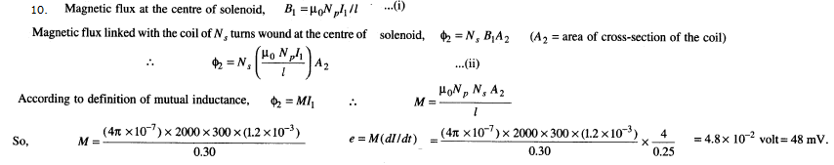11. Laminations reduce energy loss due to eddy currents

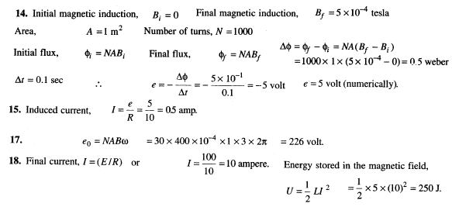

19.We know that when south pole of a magnet moves downward through the coil, then current induced in the coil flows clockwise non-linearly, which opposes the downward motion of the magnet. And when the south pole of a magnet moves upward, then the current induced in the coil flows anticlockwise non-linearly, which opposes the upward motion of the magnet. Thus, the current and its amplitude are changing with the motion of magnet. Therefore as the magnet oscillates, G shows deflection to the left and right, but the amplitude steadily decreases.

21. L =μoN2πr/2 ; When the number of turns in a coil is doubled without changing the length of the coil, the radius of the coil is reduced to half. Hence



24. Here, the bulb B1 will die out promptly but B2 with some delay. The reason is that the branch of bulb B2 contains inductance. Due to the effect of inductance, the current in this branch continues to flow for some time even when the switch S is turned off.

29. The induced emf will oppose the motion of the magnet. Applying the right hand rule, the direction of induced current will be anticlockwise.

30. CV2/2 =LI2/2 or C = LI2/V2  =25μF

31. es/ep =Ns/Np  Ns= 500

32. Poutput = 8kW efficiency =90% Pinput = 8x 100/9 = 8.89kW

33. Current flowing through loop A, causes a change of magnetic flux through other loop B, thereby inducing current in loop B. Due to Lenz's law. the direction of induced current is in such a direction so as to oppose the cause, which is the growth of magnetic flux through B. This happens ,if the second loop is repelled by loop A.

35. We know that, the magnetic flux associated with coil Y is directly proportional to current flowing in X coil

i.e. ϕy α I x

Here ϕy = change in magnetic flux in coil Y , Ix = change in current in coil X, M = mutual Inductance

or ϕy = M I x

Now it is given that Ix =4A ;ϕy= 0.4wb ; therefore M =0.1H

38. By inserting iron core, L increases (electrical inertia increases), so delay time increases

39.I = (V-e)/R 2 =(12-e)/1 or e= 10 V ( where e = back emf)

When speed become one-half e also becomes half of its previous value, i.e e’ =5 V

hence I = (12-5)/1 =7 ampere

42. When current is started, change in current is from O to 1. On suddenly rotating through 180", change in current is from I to -I or change in current is 2I.

ϕs = M∆I and Is = Vs/R = dϕ/Rdt

As Is is doubled it becomes 14 units

43. I = (V-e)/R 1.5 =(220-e)/20 or e= 190 V

44.Time period of AC T =1/n = 1/50 second

Time interval ∆t for current to decrease from peak value of 1 amp to zero amp = T/4



45. M12 = M21 = μoμrπr12/2r2

where πr12 isthe overlapping area, i.e. that of smaller coil. This formula is valid under ideal conditions if coupling is maximum. This depends on μr. the intrinsic magnetic property of the core.

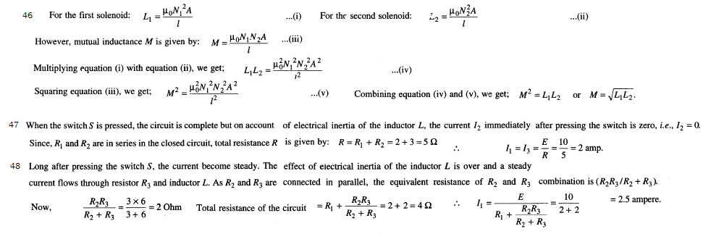

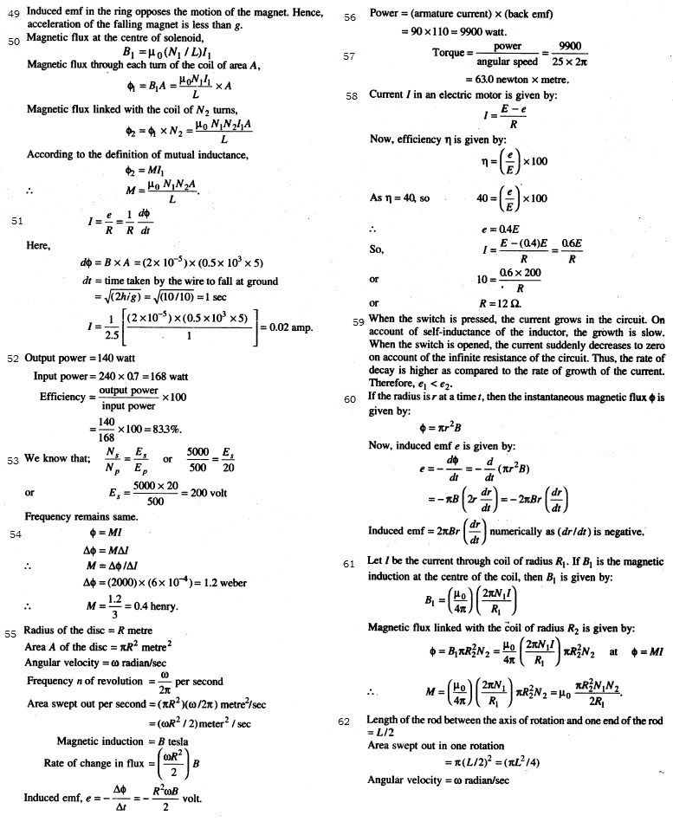

( because emf = NABw)

