**Week-06**

1. **Organize role play for requirement activities**

**Diseny+Hotstar**

Disney+ Hotstar is a streaming service that offers a wide range of content, including movies, TV shows, and original productions. It is a subsidiary of The Walt Disney Company and operates in multiple countries, providing content in various languages and catering to diverse audiences.

**Requirements**

* Device Compatibility
* Internet Connection
* Account
* Subscription
* App Download
* Region Availability

**Applications Requirements**

* Simple login and registration using phone number or social media accounts
* Allowing a permission
* Choose preferred language to watch upon
* Creating a user profile customized [profiles or kids]
* Search box
* Recent Searches
* Home tab
* Categories
* New and hot releases
* Downloads
* Multi streaming
* Multi language series or movies
* Settings
* Live streaming
* Connect for Cast devices
* App language
* Account settings
* Parental Controls
* Help and Support
* Viewed Content
* Watchlist

**Role play for Disney+Hotstar**

**Ranjan:** Hey, have you heard about Disney+Hotstar? I was thinking about giving it a try.

**Kiran:** Oh, really? I've heard about it, but I haven't used it yet. What made you interested in trying it out?

**Ranjan:** Well, I've heard they have a vast library of Disney, Pixar, Marvel, and Star Wars content. I'm a huge fan of those, and I thought it could be a great way to catch up on all the shows and movies.

**Kiran:** That sounds awesome! I love Disney and Marvel too. How do you plan to use it? Is it easy to navigate?

**Ranjan:** Yeah, from what I've seen, it seems pretty user-friendly. You can watch all your favorite shows and movies, and they even have a bunch of original content that's exclusive to Disney+Hotstar. I heard they have a variety of genres, so there's something for everyone.

**Kiran:** Nice! And how about the subscription plans? Is it affordable?

**Ranjan:** Yeah, they have different plans to choose from. I was checking out their options, and it seems reasonable, especially considering the amount of content they offer. Plus, you can get access to all the content without any ads, which is a big plus for me.

**Kiran:** That's a good point. I hate interruptions when I'm watching something exciting. Do they have any free trials or discounts?

**Ranjan:** Yeah, I noticed they have a free trial period for new users. We can give it a shot and see if it's worth subscribing to. I think it's a good way to explore the platform and see if it aligns with our preferences.

**Kiran:** Sounds like a plan! Let's give it a try together. We can binge-watch some Disney classics or catch up on the latest Marvel series. When are you thinking of starting the trial?

**Ranjan:** How about this weekend? We can make it a movie night and explore all the features together.

**Kiran:** Perfect! I'm in. Let's get the popcorn ready and dive into the magical world of Disney+Hotstar this weekend.

**2) Identify a Problem and Prepare Requirement Document or Epics and user stories: -**

**Problem faced by Diseny+Hotstar:**

1. **Technical Glitches:** Users may encounter technical problems such as buffering, playback errors, or app crashes, which can negatively impact their streaming experience.
2. **Content Availability:** The availability of content varies across different regions due to licensing agreements and regional restrictions. Some users may be disappointed with the limited content library in certain locations.
3. **Subscription Pricing:** Pricing strategies and subscription plans can be a concern for users, as some may find the service expensive or may not be satisfied with the value offered for the cost.
4. **Competition:** The streaming industry is highly competitive, with several platforms vying for subscribers. Disney+ Hotstar faces competition from other major players like Netflix, Amazon Prime Video, and local/regional streaming services.
5. **Device Compatibility:** Ensuring the availability and smooth functioning of the app across a wide range of devices and platforms is essential. Compatibility issues with certain devices can result in a less-than-optimal user experience.

**User Stories:**

1. **Splash Screen**

**Task:**

* Disney+Hotstar
* User profile customization

1. **Login**

**Task:**

* Mobile Number
* OTP verification
* Create a work space

1. **Home Tab**

**Task:**

* Continue Watching for your workspace
* Latest Releases
* Categories
* Top 10 in your country shows or movies
* Coming soon
* Watchlist
* Broad cast channels
* Casting devices
* Populare languages
* Populare movies
* Hotstar special
* Populare channels
* Populare shows
* Tv, Movies, Sports

1. **Search**

**Task:**

* People search for
* Recent searched
* Most viewed

1. **New & Hot**

**Task:**

* Coming soon
* Latest Releases
* Remind me

1. **Downloads**

**Task:**

* Show the downloaded movies or shows

1. **My Space**

**Task:**

* Profiles
* Watchlist
* Continue Watching For your workspace
* Help & Settings
* Account Settings
* Downloads only on Wi-Fi for this device
* Default Download quality
* App language
* Parental control or lock
* Help & support
* Logout

**3) Configure JIRA for the managing the project to solve the identified problem**

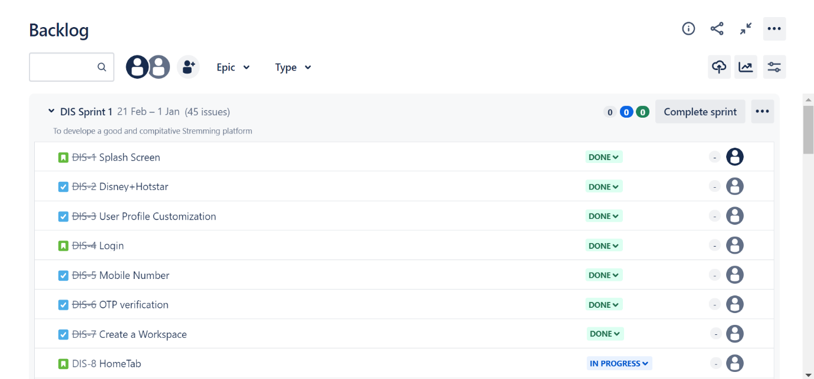

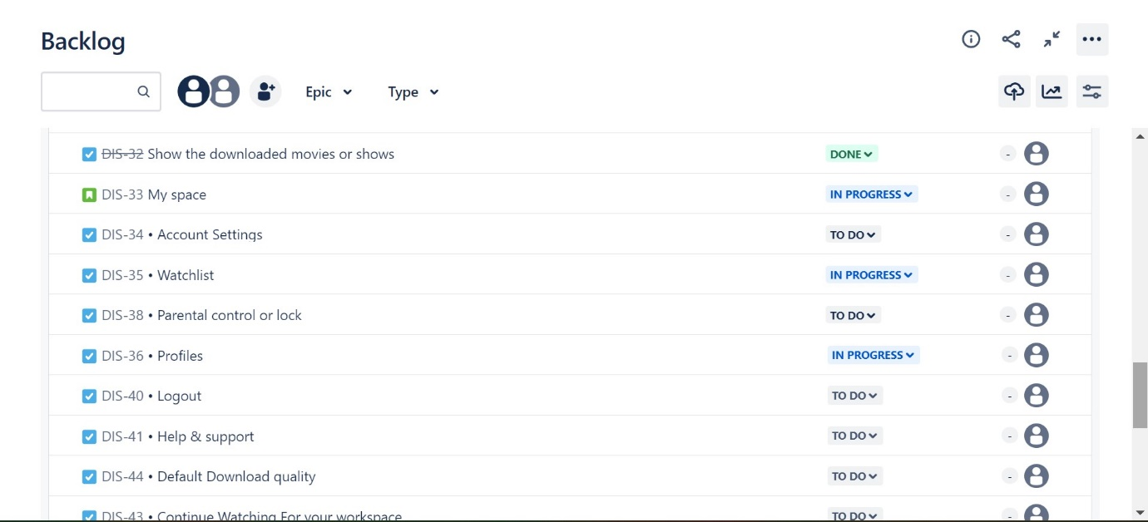

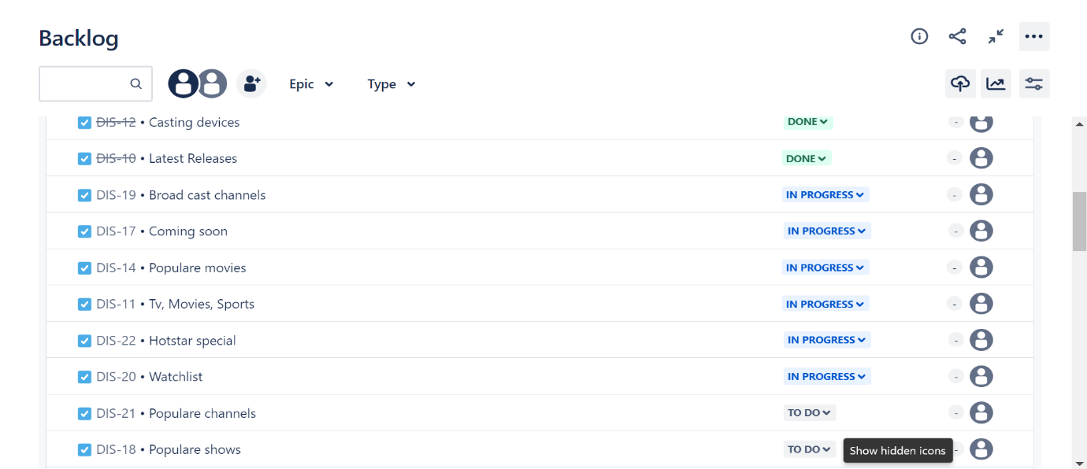

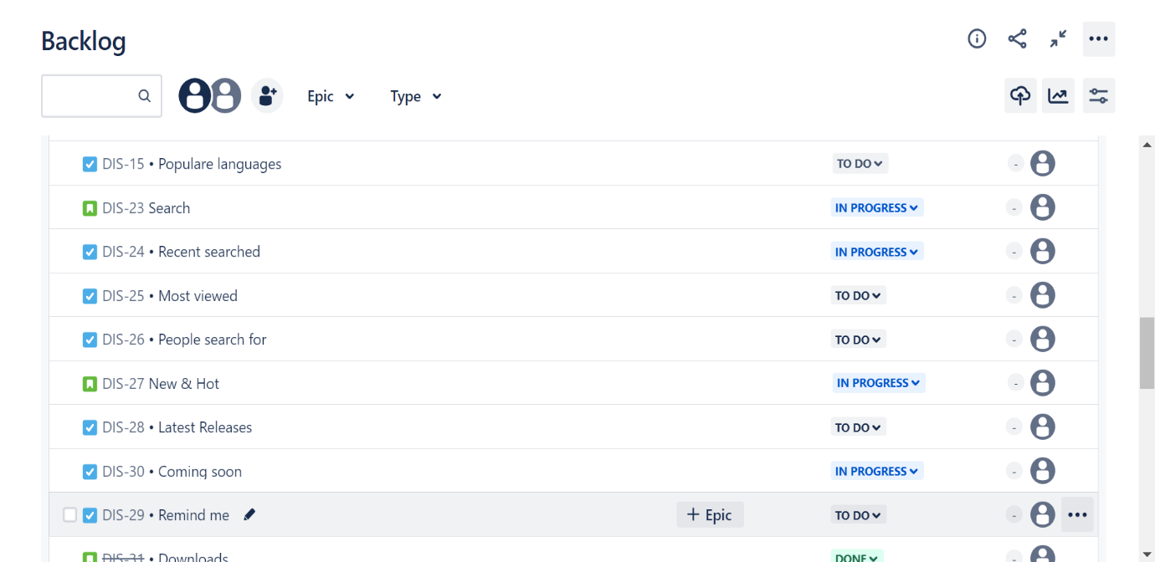

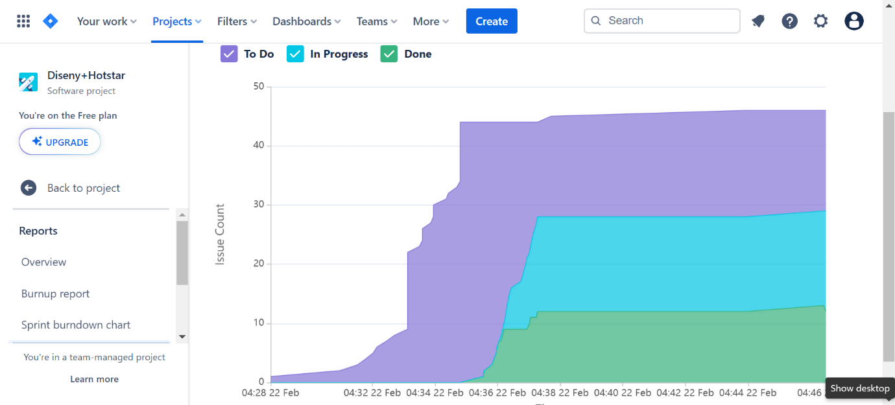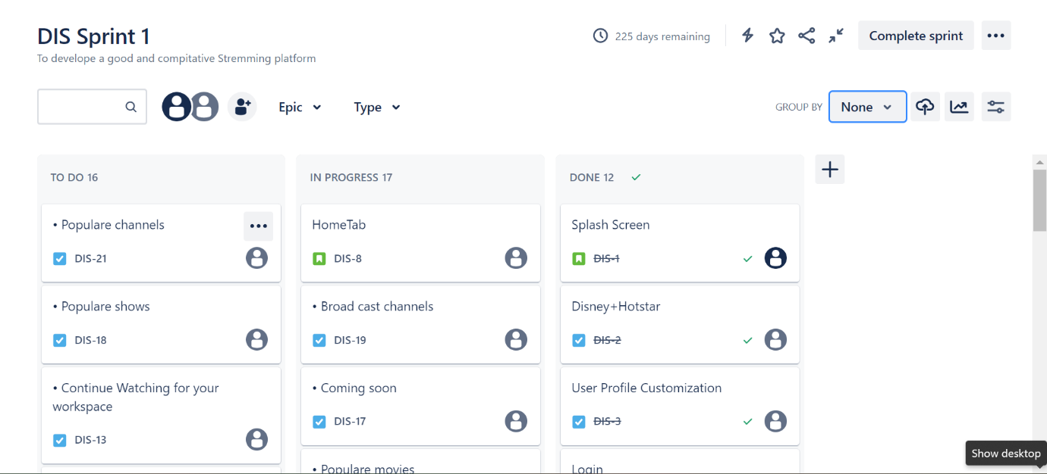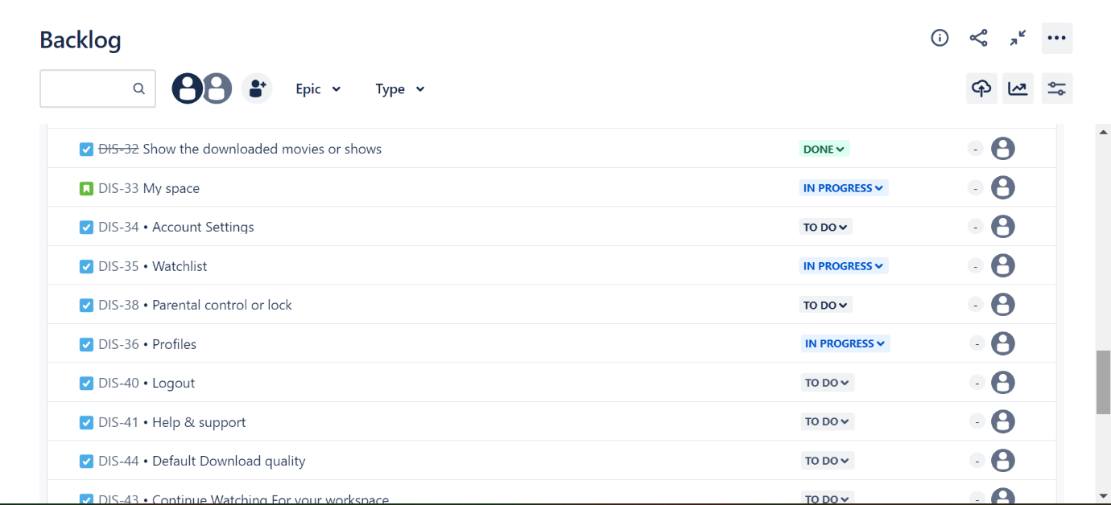

**4) Draw UML diagram for given use case**

