SOFTWARE CONFIGURATION MANAGEMENT

Final Review Report
Certificate Automation and Verification System
Review outcome
The v1.3.0 baseline is tagged on main. The latest Jenkins run checked out commit b62c814 and passed backend tests, the frontend build, and both Docker image builds. The prototype demonstrates the applicant-to-officer decision workflow. Formal CCB minutes and a GitHub remote are not present in the local repository.

Report detail | Value
Course | ISWE403L - Software Configuration Management, VIT Vellore
Team | V.Harish Kumar (24MIS0031)  M.Leela Avinash (24MIS0198)  S.H.Sheik Fareed (24MIS0262)
Reviewed baseline | v1.3.0 - release commit 0ea2458 on main
Latest CI run | Jenkins run for commit b62c814 on feature/docker-jenkins-admin
Report date | 21 October 2026
Report status | Final review record prepared for team and faculty review; formal sign-off is not represented as complete.

1 Project summary
What the system delivers and the evidence supporting the release
The Certificate Automation and Verification System is a local web prototype for submitting certificate applications, checking fields and uploaded files, showing advisory findings, and recording an officer's decision. The released scope covers Income, EWS, Community, Residence, and Domicile applications.
Release snapshot | Evidence
Git baseline | Annotated v1.3.0 tag points to release commit 0ea2458 on main.
Latest Jenkins run | Commit b62c814; six backend suites and 32 tests passed.
Frontend build | Vite production build succeeded; 499 modules transformed.
Container images | certificate-backend:v1.3.0 and certificate-frontend:v1.3.0 built successfully.
Manual demonstration | Project owner confirmed submission, MongoDB persistence, officer review, document opening, approval, and decision history in local Docker.

Problem and purpose
Certificate applications require applicants to assemble details and supporting documents while reviewers must inspect submissions and record outcomes. This prototype centralizes submission, basic validation, advisory review information, and decision history in one local application.

Objectives
- Digitize application submission for five certificate types and their required documents.
- Validate application fields and uploaded file metadata at the API boundary.
- Calculate a transparent, advisory risk score for officer attention.
- Let an officer review applicant data and files, then approve or reject once.
- Retain a read-only record of the decision, score, remarks, and timestamp.

Development approach
Review-I identifies Agile development. The repository demonstrates iterative delivery through feature and fix branches, no-fast-forward merges, and tagged releases. Sprint plans and meeting records were not included, so this report does not claim that ceremonies were formally recorded.

Users and system boundary
The prototype has applicant, officer, and read-only administrator views. It does not authenticate identities or enforce role permissions. Administrator account, rule, and certificate management are outside the implemented scope. This is a local course demonstration, not a government service or production eligibility system.

2 System scope and configuration hierarchy
The hierarchy follows the eight configuration-item groups in Review-I

Implemented workflow
Step | System behavior
1. Apply | Applicant selects a certificate type, enters details, and uploads the requested files.
2. Validate | Express checks fields, file extensions, size limits, and document-type pairing; MongoDB stores records and uploads use local or Docker-volume storage.
3. Assess | The rule engine returns an advisory score and remarks. It does not decide eligibility.
4. Review | Officer queue shows UNDER_REVIEW applications; the officer can inspect details and open linked documents.
5. Decide | Officer approves or rejects. A completed decision is locked; another attempt returns HTTP 409.
6. Record | Decision history displays the decision, demo officer label, score, remarks, and time.

Architecture
React and Vite provide the browser interface. Nginx serves the production frontend and proxies /api to the Express API. The API uses Mongoose with MongoDB and serves uploaded files only through an application-scoped route. Jenkins checks out the local Git repository, installs dependencies, tests the backend, builds the frontend, and builds Docker images. Docker Compose runs MongoDB, backend, and frontend services.

Configuration-item hierarchy
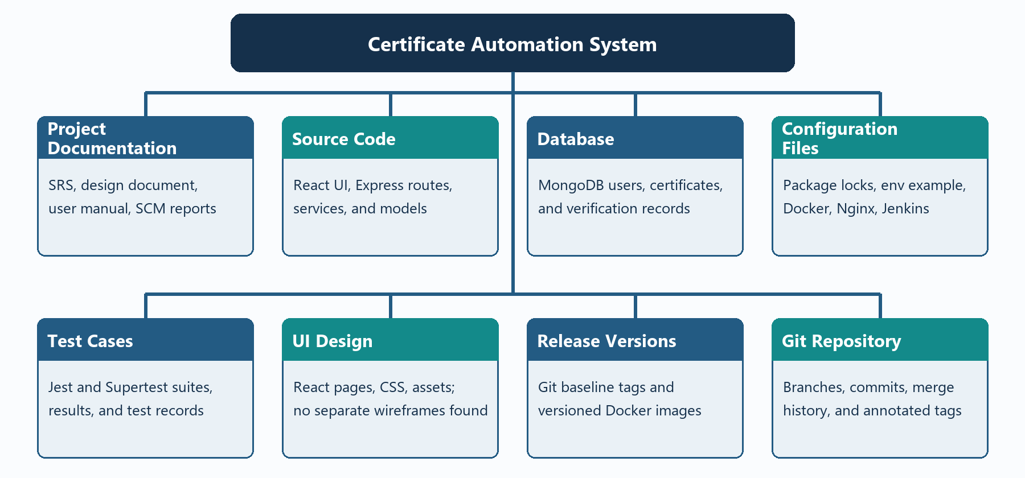
Figure 1. Configuration items grouped under the project baseline.

Naming and version conventions
The repository uses lowercase source folders (components, models, routes, services), PascalCase React component files, camelCase JavaScript services and routes, lowercase CSS filenames, and standard configuration filenames. Release tags follow vMAJOR.MINOR.PATCH. Feature releases increment MINOR; fixes increment PATCH.

3 Configuration status accounting
Eight Review-I configuration-item groups are reconciled against the v1.3.0 Git baseline
Status interpretation
Released means the item is present in the annotated v1.3.0 Git baseline. It does not by itself prove CCB approval or signed document review. The repository contains no separate CCB minutes or individual CI approval records.

ID | Review-I CI | Repository location | Current status at review
CI-01 | Project Documentation | documentation/; README.md | Supporting documents are in v1.3.0; this report is a post-release supplement. Formal sign-off not recorded.
CI-02 | Source Code | frontend/src; backend/ | v1.3.0 released; applicant, officer, admin overview, and advisory workflow present.
CI-03 | Database | backend/models/ | v1.3.0 released; users, certificates, and verificationrecords models.
CI-04 | Configuration Files | package files, .env.example, Docker and Jenkins files | v1.3.0 released; local environment values remain outside Git.
CI-05 | Test Cases | backend/tests/ | v1.3.0 released; latest Jenkins run passed 32 tests in six suites.
CI-06 | UI Design | frontend components, CSS, assets | v1.3.0 released; implemented UI is present; no separate wireframes were found.
CI-07 | Release Versions | Git tags and Docker image tags | v1.0.0, v1.1.0, v1.2.0, and v1.3.0 annotated tags exist.
CI-08 | Git Repository | Git history, branches, and tags | v1.3.0 merged to main; local working branch returned to develop. No remote is configured.

Configuration status report
Measure | Review-II snapshot | Current state after release
CIs | Six rows in its CSA; Review-I identifies eight groups. | All eight Review-I groups are mapped; supporting CI artifacts are included in v1.3.0.
Approved / released | Four of six CI rows marked Approved in source snapshot. | Git baselines v1.0.0-v1.3.0 exist. Formal CCB sign-off for final release is not evidenced.
Under review / draft | Two of six CI rows marked Reviewed or Draft. | Some supporting documents retain Draft labels; final team/faculty review is appropriate.
Open changes | Status report says three; change table shows four not completed. | Five of five requests have implementation evidence; approvals for CR-04/05 are not evidenced.

4 Change requests and reconciliation
Historical Review-II states are preserved alongside implementation evidence at v1.3.0
ID | Request | Review-II snapshot | Current implementation | CCB evidence
CR-01 | Modify application form | High; Approved; Completed | Implemented in applicant portal; present since v1.0.0. | Review-II reports approval; no separate minutes found.
CR-02 | Add document validation | High; Approved; In progress | Field/file checks and document pairing implemented; missing types can be advisory findings. | Review-II reports approval; no separate minutes found.
CR-03 | Improve rule-engine risk assessment | High; Approved; In progress | Advisory rules and officer-facing score/remarks implemented by v1.1.0/v1.2.0. | Review-II reports approval; no separate minutes found.
CR-04 | Add decision-history enhancement | Medium; Pending; Not started | Decision records and history page implemented in v1.2.0. | Pending in Review-II; later CCB approval not evidenced.
CR-05 | Change UI theme and layout | Low; Pending; Not started | Current responsive portal styling is implemented; no separate CR-specific commit identified. | Pending in Review-II; later CCB approval not evidenced.

Reconciliation
Review-II's request table records one completed change, two in progress, and two not started. Four requests were therefore incomplete in that table, while its status report says three open changes. Its summary totals five requests as one completed, two in progress, and two pending. This report preserves those source figures as a historical snapshot rather than silently changing them.
At v1.3.0, all five requests have implementation evidence in the repository. Implementation and Git merges do not prove CCB approval. Review-II records CR-01 through CR-03 as approved at that time, and CR-04/CR-05 as pending; later signed CCB decisions were not found.

Change-control practice
The team used feature and fix branches, conventional commit messages, no-fast-forward merges, Jenkins verification, and annotated Git release tags. No issue tracker or dated CCB decision log is present. Add a final CCB record only if an actual decision or approval occurred.

5 Release baselines and SCM automation
The Git release history and Jenkins run provide the primary technical evidence
Release | Baseline contents | Git status
Release 1 - v1.0.0 | Applicant form, certificate selection, document upload | Annotated tag on main
Release 2 - v1.1.0 | Rule-based validation, officer queue, application review and decisions | Annotated tag on main
Release 3 - v1.2.0 | Risk assessment and decision history | Annotated tag on main
Release 4 - v1.3.0 | Read-only admin overview, Docker Compose, Jenkins pipeline, and SCM documentation | Annotated tag on main; release commit 0ea2458

SCM tools
Tool | Actual use | Evidence and limit
Git | Feature/fix branches, commits, merge history, annotated release tags. | Local repository history contains tags v1.0.0-v1.3.0. No GitHub remote configured.
Jenkins | Windows pipeline checks out a local file URL, installs packages, tests backend, builds frontend and Docker images. | Latest run checked out b62c814 and finished SUCCESS. It was started manually; an automatic push trigger is not evidenced.
Docker | Builds backend and frontend images; Compose runs MongoDB, API, and UI. | Images tagged certificate-backend:v1.3.0 and certificate-frontend:v1.3.0; owner confirmed Docker UI flow.

Latest Jenkins result
Stage | Recorded result
Checkout | Checked out feature/docker-jenkins-admin commit b62c814.
Install | Backend and frontend dependency installation completed.
Backend tests | Six suites passed; 32 tests passed; zero snapshots.
Frontend | Vite 8.3.4 production build succeeded; 499 modules transformed.
Docker | Both v1.3.0 images built and tagged successfully.
Overall | Finished: SUCCESS.

Negative-path route tests intentionally print simulated database/history errors while confirming error handling; those traces did not fail the suite. The Jenkins run reported 22 backend dependency audit findings (19 moderate and 3 high) and a Docker legacy-builder deprecation warning. Neither warning failed the build; both should be reviewed before public deployment.

CMMI configuration-management practices
Practice | Application in this project | Evidence or gap
Identify configuration items | Track the eight Review-I CI groups. | CI register in Section 3.
Establish a configuration management system | Use Git for version history and retrieval. | Local repository; no remote is configured.
Create or release baselines | Tag the four integrated releases. | Git tags v1.0.0 through v1.3.0.
Track change requests | Reconcile the five Review-II requests. | Section 4; no issue tracker configured.
Control configuration items | Integrate work through feature/fix branches and merges. | Git history and Jenkins; final CCB minutes not found.
Maintain configuration records | Record CI status, releases, and test results. | Sections 3, 5, and 6.
Perform configuration audits | Compare implementation, tests, releases, and deliverables. | FCA/PCA tables in Section 6; formal sign-off open.

6 Verification and audit
Results distinguish automated checks, manual demonstrations, and unverified formal controls

Verification checklist
Check | Result | Evidence or qualification
Unique CI names and versions | Verified | Eight Review-I groups mapped; tagged release history recorded.
CCB approval before baseline merge | Not fully verifiable | Review-II records selected approvals; no minutes or final sign-off located.
Implementation against requirements/design | Partly verified | SRS/design describe current system; written after implementation and without signed review.
Automated tests/build | Verified | Latest Jenkins run b62c814: 32 backend tests and Vite build passed.
Repository/image/release consistency | Verified with timing note | Images built from b62c814 before merge/tag; tested code is included in v1.3.0 at 0ea2458.
User manual | Available; review advised | Manual describes the local demo; no formal approval record located.

Functional Configuration Audit
Audit question | Finding
Are required applicant and officer functions present? | Yes for prototype scope: submit, validate, assess, inspect documents, decide, and view history.
Are functional tests available and executed? | Yes for backend: 32 tests pass. Frontend build and manual flows were reported; no automated browser suite exists.
Are major defects closed? | Not formally established. No severity-ranked defect register or independent exit review was located.
Do features match approved requirements? | Partly verifiable. Requirements/design match current behavior but lack signed approval evidence.
Are all five requested changes implemented? | Implementation evidence exists for all five; CCB decisions for CR-04/05 remain unverified.

Physical Configuration Audit
Item | Present in v1.3.0 | Finding
Source code and database models | Yes | Git baseline includes React/Express code and MongoDB models.
SRS, design, SCM records, manual | Yes | Files are present; some retain Draft labels and should receive team review.
Test results and release labels | Yes | Jenkins output records 32 tests, frontend build, image tags; Git v1.3.0 tag exists.
Evidence screenshots | Partial | Three Jenkins build #3 images exist. UI, MongoDB, Docker images/containers, and Git-history screenshots remain uncollected.

7 Rules, limitations, and open actions
The prototype keeps final decisions with the officer

Advisory rule assumptions
The rule engine supplies a score and remarks for the officer. It never approves or rejects an application. All weights and the EWS income threshold below are project assumptions, not official government policy.
Rule | Project assumption | Implementation note
Age below 18 | +60 | Defensive rule; validator normally rejects applicants under 18.
Missing EWS income | +50 | Validator normally requires EWS income.
EWS income above threshold | +50 | Assumed threshold ₹8,00,000; no official-policy claim.
Missing Income-certificate income | +30 | Validator normally requires Income certificate income.
Missing required document type | +40 | One finding lists missing document types.
Possible duplicate | +30 | Simple heuristic: same email and certificate type.

Scores are capped at 100. Income certificates have no upper-income rule. The UI requests required documents; the backend can still accept a missing document type so the advisory missing-document rule remains reachable.

Open actions before public deployment or formal approval
ID | Action
A-01 | Update the supporting README and SCM/verification records from pre-release status to v1.3.0 at 0ea2458, and record Jenkins commit b62c814.
A-02 | Record actual team/faculty and CCB sign-off if required; do not backfill unheld meetings.
A-03 | Review and resolve the 19 moderate and 3 high backend dependency audit findings before public exposure.
A-04 | Add a GitHub remote if central backup/collaboration is desired; keep the repo private unless course rules permit public source.
A-05 | Collect remaining evidence: Git history/tags, Docker images and running containers, browser workflow, and synthetic MongoDB record.
A-06 | Replace workstation-specific Jenkins local checkout and Docker PATH configuration before using a shared CI agent.
A-07 | Implement authentication, authorization, secure deployment, malware/content scanning, and admin management before real use.

Final assessment
The v1.3.0 baseline is technically complete for the local course prototype. The latest Jenkins run passed backend tests, frontend build, and Docker image builds; the project owner also confirmed the end-to-end local demonstration. Formal CCB approval, user authentication, a configured GitHub remote, and complete screenshot evidence are not established by the available records. Keep the system limited to synthetic data until identity and security controls are implemented.

Team review and sign-off
Name | Register number | Review / signature | Date
V.Harish Kumar | 24MIS0031 | ________________________ | ____________
M.Leela Avinash | 24MIS0198 | ________________________ | ____________
S.H.Sheik Fareed | 24MIS0262 | ________________________ | ____________

Signature and date fields are blank for the team to complete. This report does not imply that approval has already occurred.

Appendix A Jenkins evidence
These screenshots show build #3 for commit 95c8f40; the later b62c814 result is recorded in Section 5 from its console output
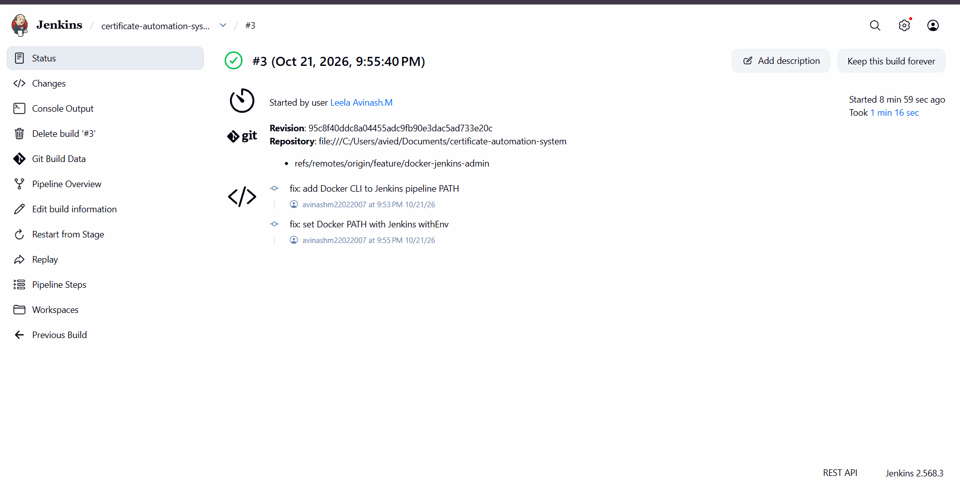
Figure A1. Jenkins build #3 summary, marked successful for commit 95c8f40.
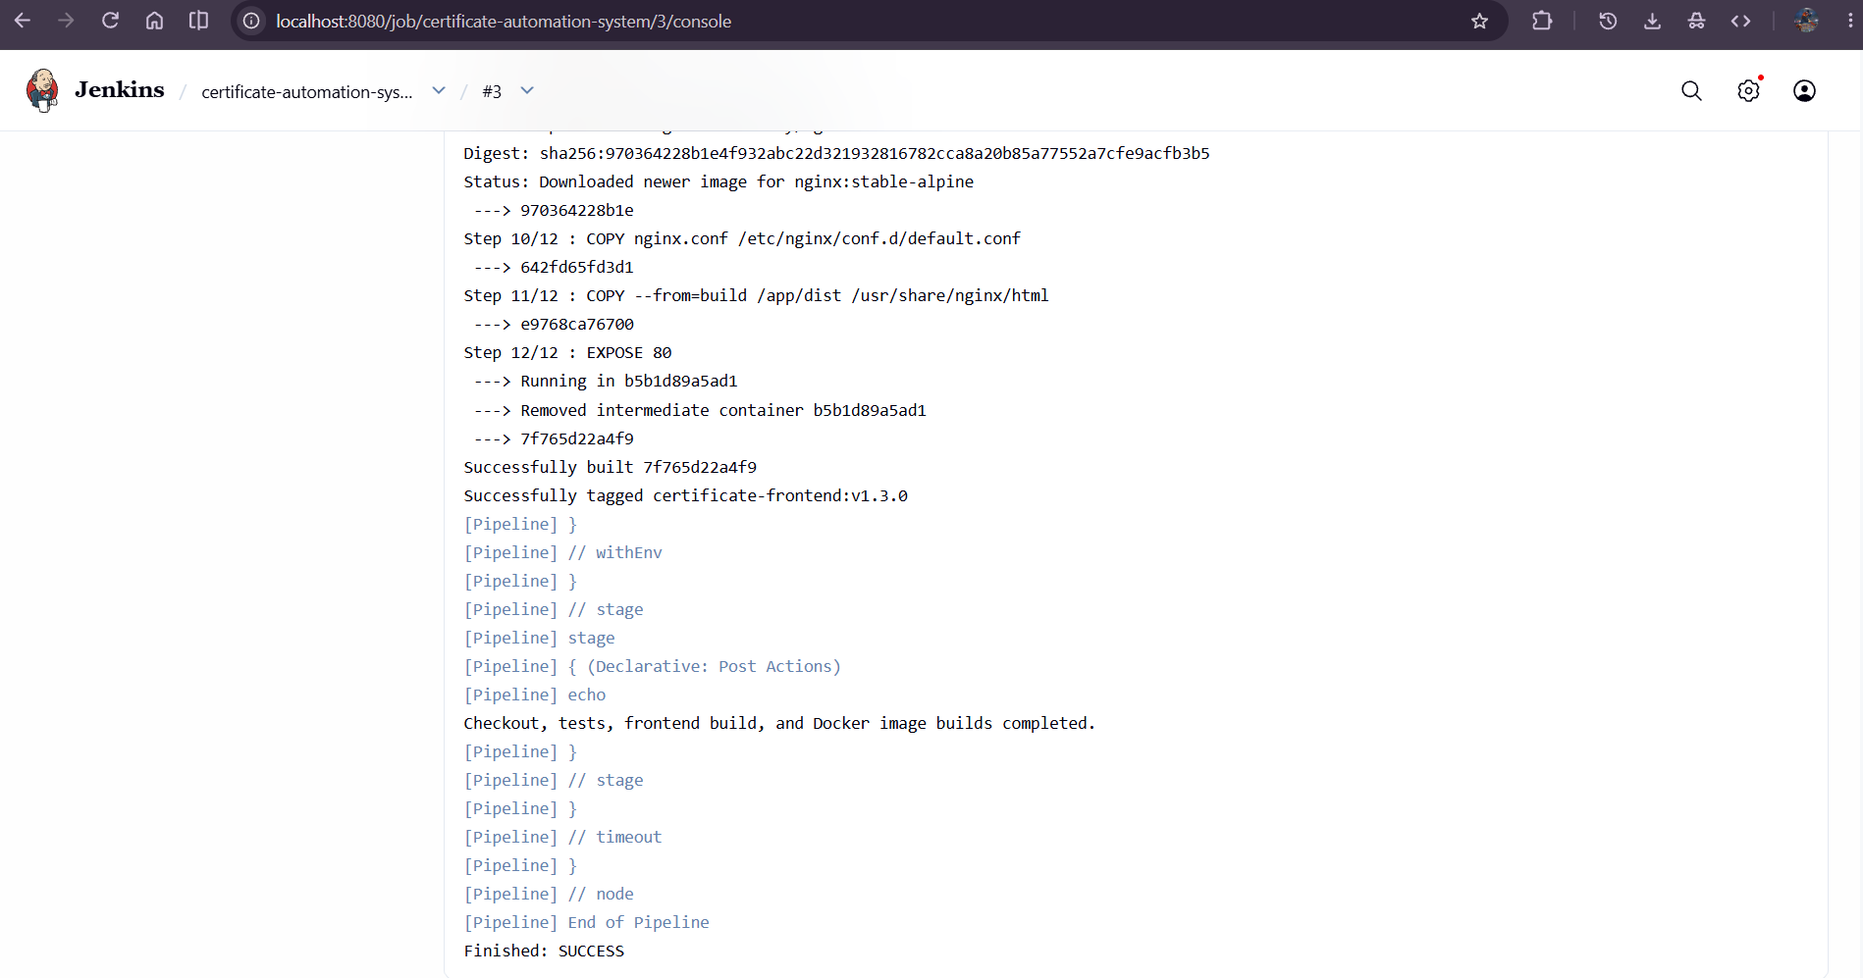
Figure A2. Jenkins build #3 console end, including the frontend image tag and Finished: SUCCESS.

Evidence sources
- Review-I: project requirements, objectives, CI groups, naming conventions, and hierarchy expectations.
- Review-II: CSA snapshot, five change requests, release descriptions, status reports, and audit expectations.
- Git history: annotated tags v1.0.0, v1.1.0, v1.2.0, v1.3.0; release commit 0ea2458.
- Jenkins console output supplied for b62c814: successful checkout, 32 backend tests, frontend build, and both Docker image builds.
- Project-owner confirmations: local submission, MongoDB persistence, officer review, file opening, decision, and history flows.
- SCM FINAL REVIEW.pdf was used only as a format example; its project-specific facts were not applied.

