- Grade Checker
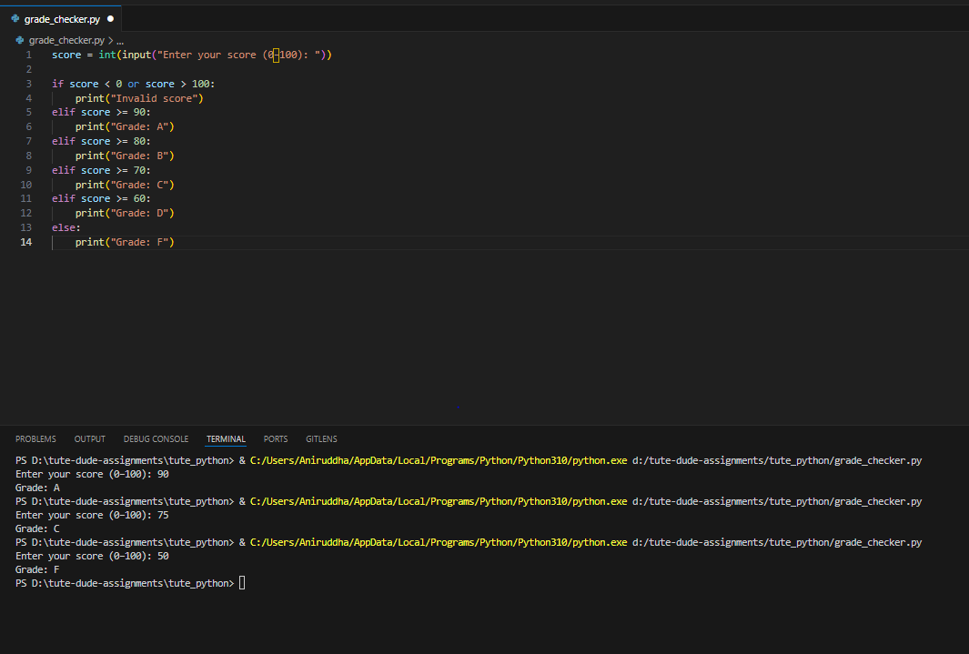
I have run code in vs code and attached the terminal input/output.
- Student Grades
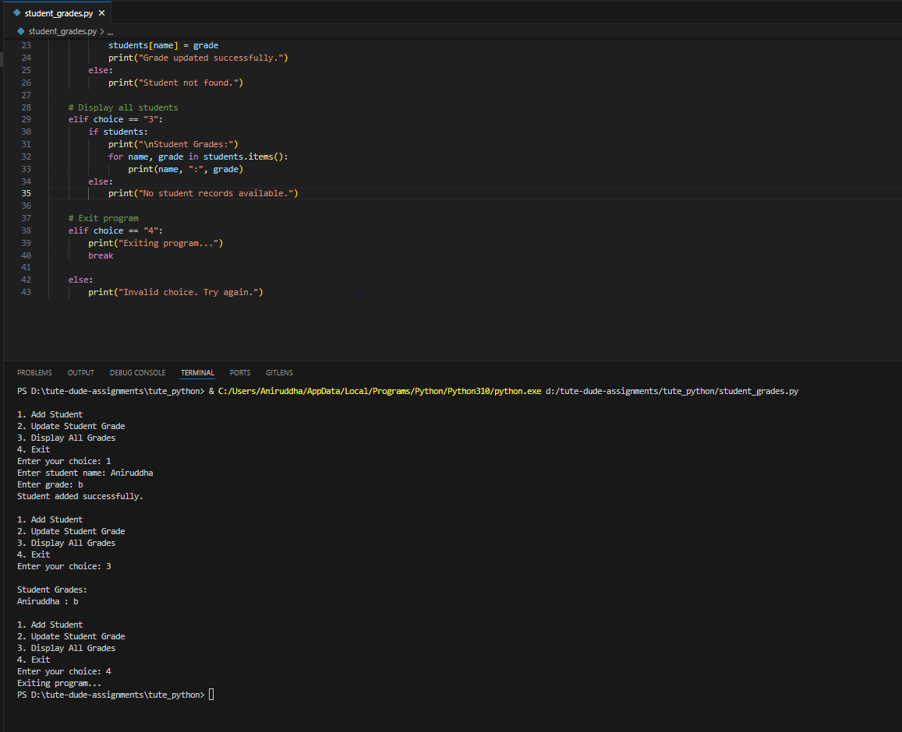
I have run code in vs code and attached the terminal input/output.
- Write to a File
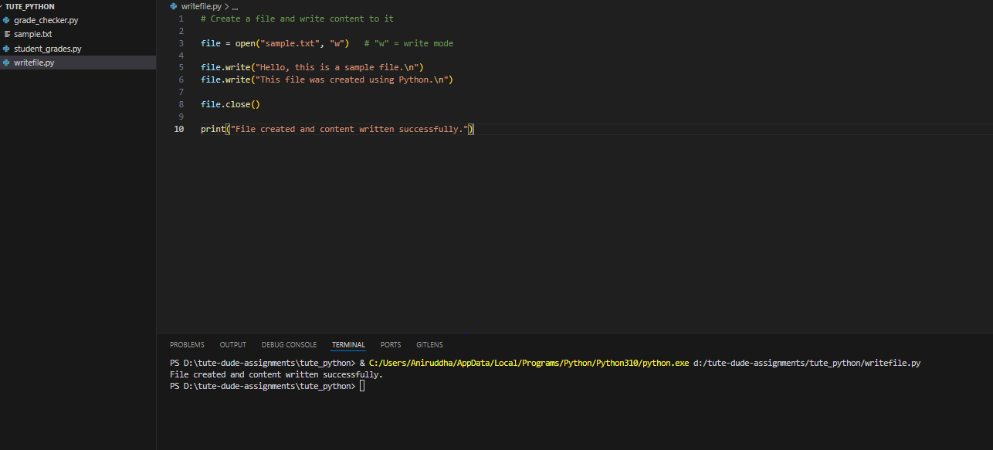
Sample.txt file is generated
4. Read from a File
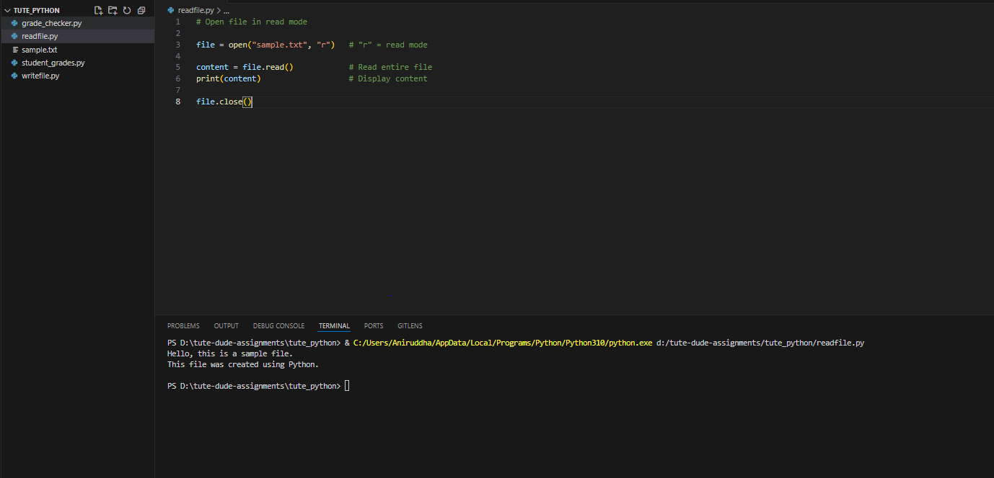
Content of file is printed on console.

