1. Create a new GitHub repository.
- Clone the repository to your local machine using SSH (generate an SSH key if needed, add the public key to your GitHub account).
- Create a new branch named after your username (e.g., Tutedude).
- Add your Flask project files to this branch.
Commit the changes and merge the branch into the main branch
Ans:
I have created a new repo : https://github.com/Avi291/Tute-dude-assignment.git
git push -u origin main

Output:
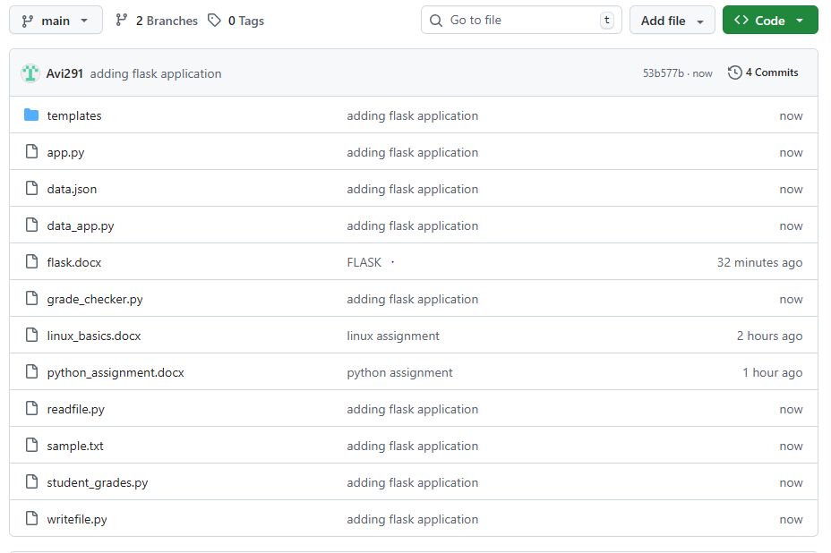
2.
2. Create a new branch named <your_name>_new (e.g., Tutedude_new).
- Update the content of the JSON file used for the /api route in this branch.
- Merge the <your_name>_new branch into the main branch.
- If there are conflicts during the merge, resolve them by accepting the changes from the <your_name>_new branch.
- Add the resolved changes to the staging area, commit them, and push the updates to the remote repository.
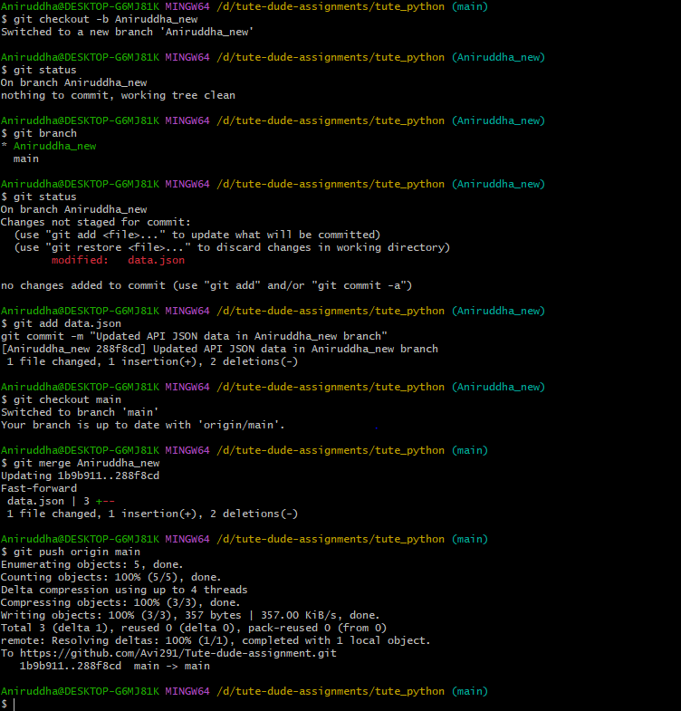
Commands:
Aniruddha@DESKTOP-G6MJ81K MINGW64 /d/tute-dude-assignments/tute_python (main)
$ git checkout -b Aniruddha_new
Switched to a new branch 'Aniruddha_new'

Aniruddha@DESKTOP-G6MJ81K MINGW64 /d/tute-dude-assignments/tute_python (Aniruddha_new)
$ git status
On branch Aniruddha_new
nothing to commit, working tree clean

Aniruddha@DESKTOP-G6MJ81K MINGW64 /d/tute-dude-assignments/tute_python (Aniruddha_new)
$ git branch
* Aniruddha_new
main

Aniruddha@DESKTOP-G6MJ81K MINGW64 /d/tute-dude-assignments/tute_python (Aniruddha_new)
$ git status
On branch Aniruddha_new
Changes not staged for commit:
(use "git add <file>..." to update what will be committed)
(use "git restore <file>..." to discard changes in working directory)
modified: data.json

no changes added to commit (use "git add" and/or "git commit -a")

Aniruddha@DESKTOP-G6MJ81K MINGW64 /d/tute-dude-assignments/tute_python (Aniruddha_new)
$ git add data.json
git commit -m "Updated API JSON data in Aniruddha_new branch"
[Aniruddha_new 288f8cd] Updated API JSON data in Aniruddha_new branch
1 file changed, 1 insertion(+), 2 deletions(-)

Aniruddha@DESKTOP-G6MJ81K MINGW64 /d/tute-dude-assignments/tute_python (Aniruddha_new)
$ git checkout main
Switched to branch 'main'
Your branch is up to date with 'origin/main'.

Aniruddha@DESKTOP-G6MJ81K MINGW64 /d/tute-dude-assignments/tute_python (main)
$ git merge Aniruddha_new
Updating 1b9b911..288f8cd
Fast-forward
data.json | 3 +--
1 file changed, 1 insertion(+), 2 deletions(-)

Aniruddha@DESKTOP-G6MJ81K MINGW64 /d/tute-dude-assignments/tute_python (main)
$ git push origin main
Enumerating objects: 5, done.
Counting objects: 100% (5/5), done.
Delta compression using up to 4 threads
Compressing objects: 100% (3/3), done.
Writing objects: 100% (3/3), 357 bytes | 357.00 KiB/s, done.
Total 3 (delta 1), reused 0 (delta 0), pack-reused 0 (from 0)
remote: Resolving deltas: 100% (1/1), completed with 1 local object.
To https://github.com/Avi291/Tute-dude-assignment.git
3.
3. Branch Creation:
- Create two branches: master_1 and master_2 from the main branch.
- Feature Development in master_1:
- In the master_1 branch, create a To-Do Page in the frontend.
  - The page should contain a form with the following fields:
    - Item Name
    - Item Description
- Backend API in master_2:
- In the master_2 branch, create a backend route named /submittodoitem.
- This route will:
  - Accept itemName and itemDescription via a POST request.
  - Store these details in a MongoDB database.
- Merging Changes:
Merge the changes from both master_1 and master_2 into the main branch.
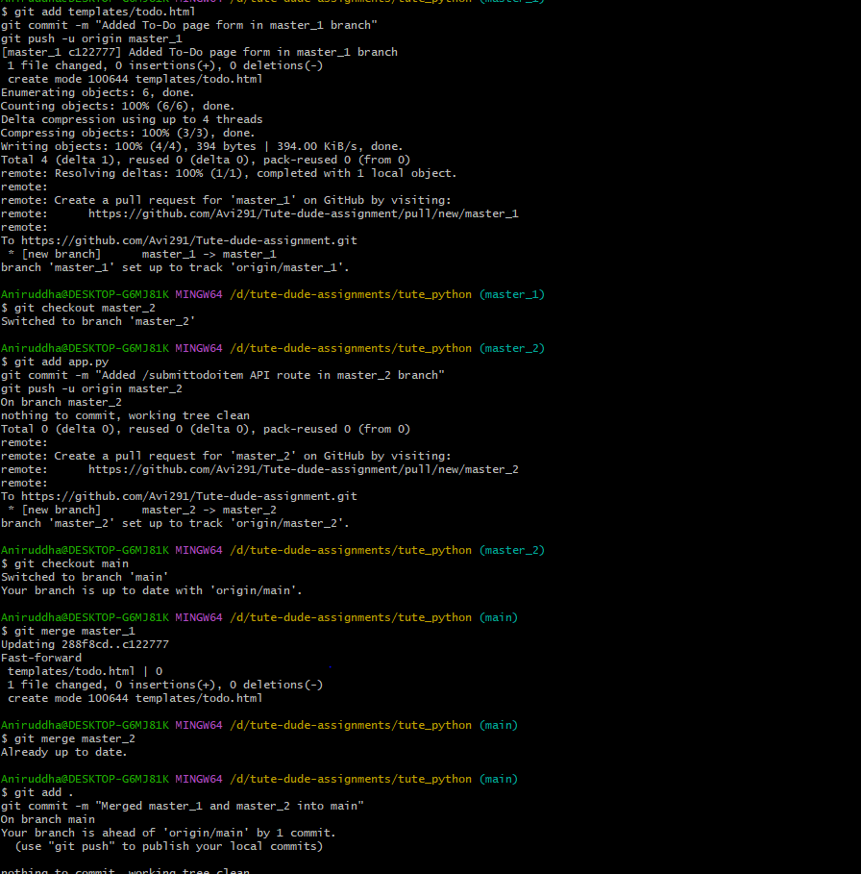
Commands:
Aniruddha@DESKTOP-G6MJ81K MINGW64 /d/tute-dude-assignments/tute_python (main)
$ git checkout main
git pull origin main # make sure main is up-to-date
Already on 'main'
Your branch is up to date with 'origin/main'.
From https://github.com/Avi291/Tute-dude-assignment
* branch main -> FETCH_HEAD
Already up to date.

Aniruddha@DESKTOP-G6MJ81K MINGW64 /d/tute-dude-assignments/tute_python (main)
$ git checkout main
git pull origin main # make sure main is up-to-date
Already on 'main'
Your branch is up to date with 'origin/main'.
From https://github.com/Avi291/Tute-dude-assignment
* branch main -> FETCH_HEAD
Already up to date.

Aniruddha@DESKTOP-G6MJ81K MINGW64 /d/tute-dude-assignments/tute_python (main)
$ git checkout -b master_1
git checkout main
git checkout -b master_2
git checkout main
Switched to a new branch 'master_1'
Switched to branch 'main'
Your branch is up to date with 'origin/main'.
Switched to a new branch 'master_2'
Switched to branch 'main'
Your branch is up to date with 'origin/main'.

Aniruddha@DESKTOP-G6MJ81K MINGW64 /d/tute-dude-assignments/tute_python (main)
$ git checkout master_1
Switched to branch 'master_1'

Aniruddha@DESKTOP-G6MJ81K MINGW64 /d/tute-dude-assignments/tute_python (master_1)
$ git add templates/todo.html
git commit -m "Added To-Do page form in master_1 branch"
git push -u origin master_1
[master_1 c122777] Added To-Do page form in master_1 branch
1 file changed, 0 insertions(+), 0 deletions(-)
create mode 100644 templates/todo.html
Enumerating objects: 6, done.
Counting objects: 100% (6/6), done.
Delta compression using up to 4 threads
Compressing objects: 100% (3/3), done.
Writing objects: 100% (4/4), 394 bytes | 394.00 KiB/s, done.
Total 4 (delta 1), reused 0 (delta 0), pack-reused 0 (from 0)
remote: Resolving deltas: 100% (1/1), completed with 1 local object.
remote:
remote: Create a pull request for 'master_1' on GitHub by visiting:
remote: https://github.com/Avi291/Tute-dude-assignment/pull/new/master_1
remote:
To https://github.com/Avi291/Tute-dude-assignment.git
* [new branch] master_1 -> master_1
branch 'master_1' set up to track 'origin/master_1'.

Aniruddha@DESKTOP-G6MJ81K MINGW64 /d/tute-dude-assignments/tute_python (master_1)
$ git checkout master_2
Switched to branch 'master_2'

Aniruddha@DESKTOP-G6MJ81K MINGW64 /d/tute-dude-assignments/tute_python (master_2)
$ git add app.py
git commit -m "Added /submittodoitem API route in master_2 branch"
git push -u origin master_2
On branch master_2
nothing to commit, working tree clean
Total 0 (delta 0), reused 0 (delta 0), pack-reused 0 (from 0)
remote:
remote: Create a pull request for 'master_2' on GitHub by visiting:
remote: https://github.com/Avi291/Tute-dude-assignment/pull/new/master_2
remote:
To https://github.com/Avi291/Tute-dude-assignment.git
* [new branch] master_2 -> master_2
branch 'master_2' set up to track 'origin/master_2'.

Aniruddha@DESKTOP-G6MJ81K MINGW64 /d/tute-dude-assignments/tute_python (master_2)
$ git checkout main
Switched to branch 'main'
Your branch is up to date with 'origin/main'.

Aniruddha@DESKTOP-G6MJ81K MINGW64 /d/tute-dude-assignments/tute_python (main)
$ git merge master_1
Updating 288f8cd..c122777
Fast-forward
templates/todo.html | 0
1 file changed, 0 insertions(+), 0 deletions(-)
create mode 100644 templates/todo.html

Aniruddha@DESKTOP-G6MJ81K MINGW64 /d/tute-dude-assignments/tute_python (main)
$ git merge master_2
Already up to date.

Aniruddha@DESKTOP-G6MJ81K MINGW64 /d/tute-dude-assignments/tute_python (main)
$ git add .
git commit -m "Merged master_1 and master_2 into main"
On branch main
Your branch is ahead of 'origin/main' by 1 commit.
(use "git push" to publish your local commits)

nothing to commit, working tree clean

Aniruddha@DESKTOP-G6MJ81K MINGW64 /d/tute-dude-assignments/tute_python (main)
$ git push origin main
Total 0 (delta 0), reused 0 (delta 0), pack-reused 0 (from 0)
To https://github.com/Avi291/Tute-dude-assignment.git
288f8cd..c122777 main -> main

Aniruddha@DESKTOP-G6MJ81K MINGW64 /d/tute-dude-assignments/tute_python (main)
$ git branch -d master_1
git branch -d master_2
git push origin --delete master_1
git push origin --delete master_2
Deleted branch master_1 (was c122777).
Deleted branch master_2 (was 288f8cd).
To https://github.com/Avi291/Tute-dude-assignment.git
- [deleted] master_1
To https://github.com/Avi291/Tute-dude-assignment.git
- [deleted] master_2
This workflow :
- master_1 → Frontend form
- master_2 → Backend API
- main → Merged stable branch with both frontend + backend
4. Enhancing the To-Do Form in master_1
Aniruddha@DESKTOP-G6MJ81K MINGW64 /d/tute-dude-assignments/tute_python (main)
$ git checkout -b master_1
git checkout main
git checkout -b master_2
git checkout main
Switched to a new branch 'master_1'
M app.py
Switched to branch 'main'
Your branch is up to date with 'origin/main'.
Switched to a new branch 'master_2'
M app.py
Switched to branch 'main'
Your branch is up to date with 'origin/main'.

Aniruddha@DESKTOP-G6MJ81K MINGW64 /d/tute-dude-assignments/tute_python (main)
$ git checkout master_1
git pull origin master_1
M app.py
Switched to branch 'master_1'
fatal: couldn't find remote ref master_1

Aniruddha@DESKTOP-G6MJ81K MINGW64 /d/tute-dude-assignments/tute_python (master_1)
$ git add templates/todo.html
git commit -m "Added Item ID field to To-Do form"
[master_1 1ac226b] Added Item ID field to To-Do form
1 file changed, 8 insertions(+)

Aniruddha@DESKTOP-G6MJ81K MINGW64 /d/tute-dude-assignments/tute_python (master_1)
$ git add templates/todo.html
git commit -m "Added Item UUID field to To-Do form"
On branch master_1
Changes not staged for commit:
(use "git add <file>..." to update what will be committed)
(use "git restore <file>..." to discard changes in working directory)
modified: app.py

no changes added to commit (use "git add" and/or "git commit -a")

Aniruddha@DESKTOP-G6MJ81K MINGW64 /d/tute-dude-assignments/tute_python (master_1)
$ git add templates/todo.html
git commit -m "Added Item Hash field to To-Do form"
On branch master_1
Changes not staged for commit:
(use "git add <file>..." to update what will be committed)
(use "git restore <file>..." to discard changes in working directory)
modified: app.py

no changes added to commit (use "git add" and/or "git commit -a")

Aniruddha@DESKTOP-G6MJ81K MINGW64 /d/tute-dude-assignments/tute_python (master_1)
$ git checkout main
git pull origin main
git merge master_1
M app.py
Switched to branch 'main'
Your branch is up to date with 'origin/main'.
$ git status
On branch master_1
Changes to be committed:
(use "git restore --staged <file>..." to unstage)
modified: app.py

Aniruddha@DESKTOP-G6MJ81K MINGW64 /d/tute-dude-assignments/tute_python (master_1)
$ git commit -m "app.py"
[master_1 d9b2bab] app.py
1 file changed, 18 insertions(+), 2 deletions(-)

Aniruddha@DESKTOP-G6MJ81K MINGW64 /d/tute-dude-assignments/tute_python (master_1)
$ git push
fatal: The current branch master_1 has no upstream branch.
To push the current branch and set the remote as upstream, use

git push --set-upstream origin master_1

To have this happen automatically for branches without a tracking
upstream, see 'push.autoSetupRemote' in 'git help config'.

Aniruddha@DESKTOP-G6MJ81K MINGW64 /d/tute-dude-assignments/tute_python (master_1)
$ git restore app.py

Aniruddha@DESKTOP-G6MJ81K MINGW64 /d/tute-dude-assignments/tute_python (master_1)
$ git status
On branch master_1
nothing to commit, working tree clean

Aniruddha@DESKTOP-G6MJ81K MINGW64 /d/tute-dude-assignments/tute_python (master_1)
$ git rebase main master_1
Current branch master_1 is up to date.

Aniruddha@DESKTOP-G6MJ81K MINGW64 /d/tute-dude-assignments/tute_python (master_1)
$ git push origin main
git push origin master_1
Everything up-to-date
Enumerating objects: 5, done.
Counting objects: 100% (5/5), done.
Delta compression using up to 4 threads
Compressing objects: 100% (3/3), done.
Writing objects: 100% (3/3), 593 bytes | 593.00 KiB/s, done.
Total 3 (delta 2), reused 0 (delta 0), pack-reused 0 (from 0)
remote: Resolving deltas: 100% (2/2), completed with 2 local objects.
remote:
remote: Create a pull request for 'master_1' on GitHub by visiting:
remote: https://github.com/Avi291/Tute-dude-assignment/pull/new/master_1
remote:
To https://github.com/Avi291/Tute-dude-assignment.git
* [new branch] master_1 -> master_1

