- Creating and Renaming Files/Directories
Ans:
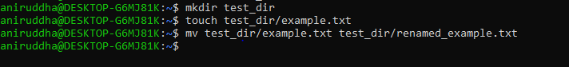
Using commands in screenshot. I have created the .txt file.
- Viewing File Contents
Ans:
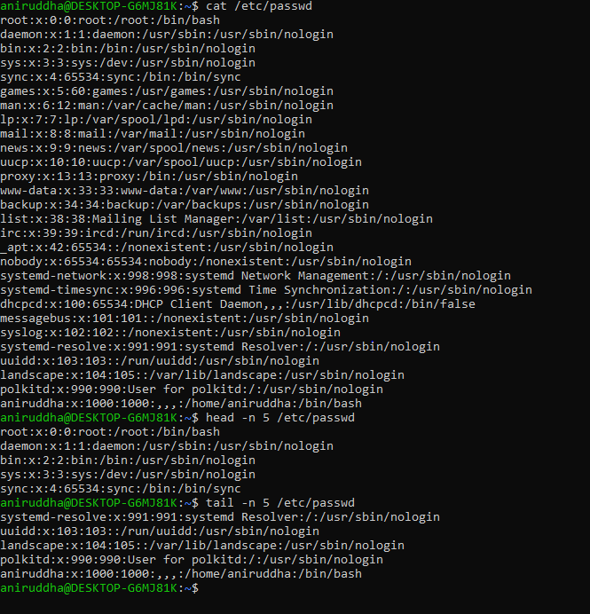
Information about all users on the system.
- Searching for Patterns
Using grep command to find root.

- Zipping and Unzipping
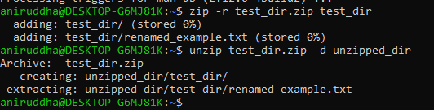
As from screenshot using zip and unzip command
- Downloading file
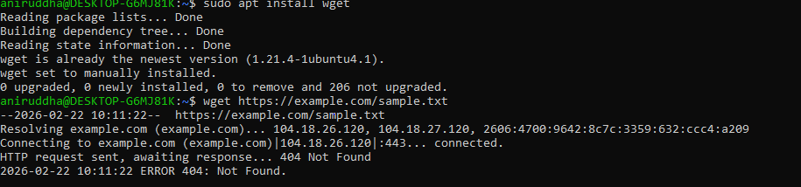
Install wget and run the command as well since it is not valid url no file downloaded
- Changing Permissions
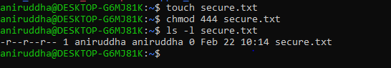
444 for read only
- Working with Environment Variables
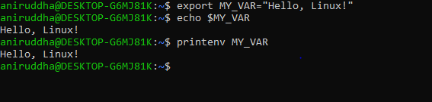
Variable exists only in current terminal session and Closing terminal will remove it

