Insight Stream

Project Submitted to the
SRM University AP, Andhra Pradesh
for the partial fulfillment of the requirements to award the degree of
Bachelor of Technology in
Computer Science & Engineering
School of Engineering & Sciences
Submitted by
Ch. Varshitha (AP23110011244)
Ch.V.R.L Madhav (AP23110011281)
B. Avinash Reddy (AP23110011266)
M. Anudeep Chowdary (AP23110011278)


Department of Computer Science & Engineering
SRM University-AP
Neerukonda, Mangalgiri, Guntur
Andhra Pradesh – 522 240
DEC 2025

Table Of Contents

Table Of Contents: 1
Introduction:- 2
Scenario-Based Intro:- 3
Target Audience:- 4
Project Goals and Objectives:- 4
Primary Goal 4
Objectives 5
Pre-Requisites:- 8
1. Node.js & npm 8
2. React.js 8
3. HTML, CSS, JavaScript 9
4. Version Control – Git/GitHub 9
5. Development Environment 9
Project Structure:- 9
PROJECT FLOW:- 10
Milestone 1: Setup & Configuration 10
Milestone 2: Web Development 11
1. Setup React Application 11
Project Execution 21

Introduction:-

Welcome to InsightStream, a modern and intelligent news aggregation platform built using the power of React.js and Vite. Designed with a clean, responsive, and user-centric interface, InsightStream transforms the way users browse, personalize, and consume global news.
Crafted for modern readers, the platform merges real-time data aggregation with a beautifully engineered theme system enabling users to completely personalize their reading environment. Whether exploring breaking news, saving articles, or customizing the interface with vibrant themes, InsightStream ensures a smooth and delightful experience across devices.
Powered by React’s component-driven architecture and Vite’s lightning-fast bundling, users enjoy a seamless, highly responsive browsing experience. From article discovery to dark mode reading, every feature is optimized for clarity, speed, and personalization.
Say goodbye to generic news feeds — InsightStream delivers a tailored reading journey for every user. Welcome to the future of intelligent news consumption.

Scenario-Based Intro:-
Imagine it's early morning. You wake up, grab your phone, and open InsightStream. The platform welcomes you with a soothing Gold Light theme, showing top headlines curated just for your country and preferences.
You switch to Midnight Dark mode for a comfortable reading experience while traveling. As you scroll, global news, technology updates, and trending stories appear instantly from multiple trusted sources.
You find an interesting article and bookmark it with a single tap. Later at work, you open InsightStream on your laptop. Thanks to theme and data persistence, everything — your theme, bookmarks, and preferences — sync perfectly.
With its clean typography, intelligent contrast in dark themes, and smooth navigation across Home, Saved, and Profile pages, InsightStream gives you a personalized news journey—all in one place.

Target Audience:-
InsightStream is tailored for:
Frequent News Readers
Individuals who want quick access to accurate, well-organized news.
Customization Lovers
Users who love adjusting themes and personalizing UI.
Global Users
Readers who want news filtered by country, language, and category.
Multi-Device Users
People who read on mobile & desktop and want consistent experiences.

Project Goals and Objectives:-

Primary Goal
The primary goal of our project is to create a modern and personalized news-reading platform that provides users with a smooth, fast, and engaging experience. The platform focuses on performance, customization, and intelligent content discovery. By allowing users to select themes, adjust the look and feel, and choose their preferred countries or regions, the app ensures that every user receives news tailored to their interests. Additionally, the system is designed to deliver quick-loading articles, real-time updates, and an intuitive interface that encourages effortless navigation through news categories.
Our primary goal is to build a fast, modern, and customizable news platform where users can personalize themes and discover news from different countries, ensuring a highly tailored and smooth reading experience.

Objectives
1. User-Friendly Interface
The project aims to design a highly intuitive and easy-to-use interface that enhances the reading experience. This includes:
- Smooth navigation with well-organized menus and category sections so users can quickly find the news they want.
- Clear typography and readable layouts to reduce eye strain during long reading sessions.
- Responsive design, ensuring the platform adapts seamlessly to mobile, tablet, and desktop screens.
Overall, this objective ensures that the platform feels modern, comfortable, and accessible for all users.

2. Advanced Theme System
We want to offer users a deep level of visual customization through a powerful theme system. This includes:
- 8 predefined, professionally-designed themes (such as Light, Dark, Solarized, Minimal, etc.) for quick selection.
- A Custom Theme Creator, where users can personalize colors, fonts, and background styling according to their preferences.
- Full persistence, meaning all theme choices are saved locally and automatically applied every time the user returns.
This objective ensures that users have full control over how their news app looks and feels.

3. Personalization Tools
The platform provides several features that make the news experience unique for each user. These include:
- Saving and bookmarking articles for later reading.
- Managing user preferences, such as category interests (e.g., sports, tech, politics).
- Switching between languages and countries, allowing users to explore global news with ease.
This objective focuses on giving users the freedom to tailor the content to match their reading habits and cultural preferences.

4. Modern Technology Use
To ensure high performance, reliability, and scalability, the project uses a modern tech stack:
- React 18 for efficient component rendering and a smooth user experience.
- Vite for fast development, instant hot reloads, and optimized production builds.
- Zustand for lightweight and scalable state management that avoids unnecessary re-renders.
- Tailwind CSS for rapidly building responsive and consistent UI layouts.
- News API Integrations for fetching real-time news content from different countries and categories.
This objective ensures that the platform remains fast, maintainable, and future-ready.

Key Features:
1.News Aggregation
The platform’s core functionality is to act as a central hub for news by gathering articles from a wide range of trusted online sources. Instead of users visiting multiple websites or apps, the system automatically collects news and presents it in one unified interface.

2. 8+ Built-in Themes
Including:
- Gold Light (Default)
- Gold Dark
- Ocean Blue
- Forest Green
- Sunset Orange
- Purple Dream
- Rose Pink
- Midnight Dark

3. Dark Theme Fixes & Optimization
Improved contrast, readability, and UI visibility.

4. Bookmark System
Save and manage articles for later reading.

5. Responsive UI
Mobile-first interface with adaptive layouts.

6. Multi-language & Country Selector
Users can get news based on region and preferred language.

7. Custom Theme Creator
Users can create personal color palettes that persist.

Pre-Requisites:-

Node.js & npm
Required for React and Vite.
Download: https://nodejs.org/en/download/

React.js
Library for building the UI using components.
Create project:
npm create vite@latest
cd project-name
npm install
npm run dev

HTML, CSS, JavaScript
These form the foundation of the web application.

HTML is used to structure the content of the news platform, such as article cards, navigation bars, and layout sections.

CSS helps style these components, ensuring the UI looks visually appealing, responsive, and consistent across devices.

JavaScript adds interactivity — for example, handling button clicks, switching themes, updating news feeds dynamically, and integrating API data..

Version Control – Git/GitHub
Used for code management and collaboration.

Development Environment
Recommended editors:
- VS Code
- WebStorm
- Sublime Text

Project Structure:-
src/
├── components/ # Reusable UI components (Navbar, NewsCard, ThemeSelector)
├── pages/ # Home, Saved, Profile, ArticleReader
├── store/ # Zustand stores for theme, bookmarks, preferences
├── themes/ # Predefined theme files + custom theme logic
├── hooks/ # Custom hooks (useTheme, useNewsAPI)
├── utils/ # API helpers, theme validators, formatters
└── api/ # News API service functions

PROJECT FLOW:-
Project demo:
Before starting to work on this project, let’s see the demo.
Demo link: https://drive.google.com/file/d/1MO3sckNQaEGTAuFQeuz1SNHNtasOtNkz/view?usp=sharing
Use the code in: https://drive.google.com/file/d/1NtocpBCrNrvV0alUa5dKq_I2mqm2EJ1d/view?usp=sharing

Milestone 1: Setup & Configuration
- Installed required tools:
  - React JS
  - Vite
  - Tailwind CSS
  - Zustand
  - React Router
  - React Icons
- Created base folder structure
- Configured theme provider & global state
- Integrated News API services

Milestone 2: Web Development

Setup React Application
- Create React application.
- Configure Routing.
- Install required libraries.
js component.
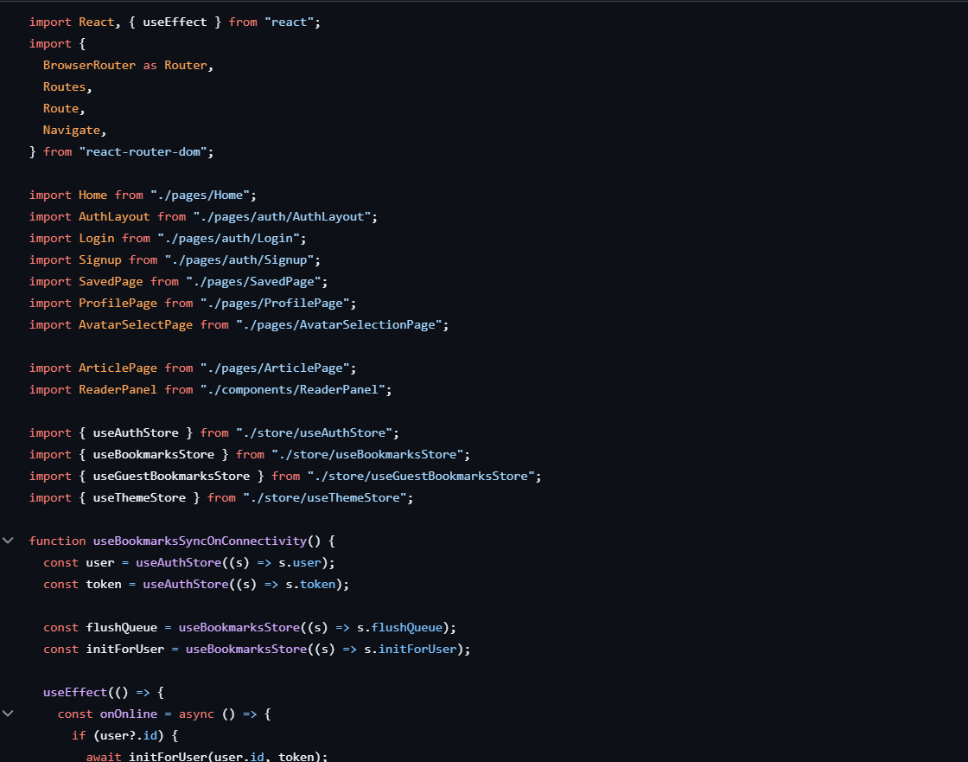
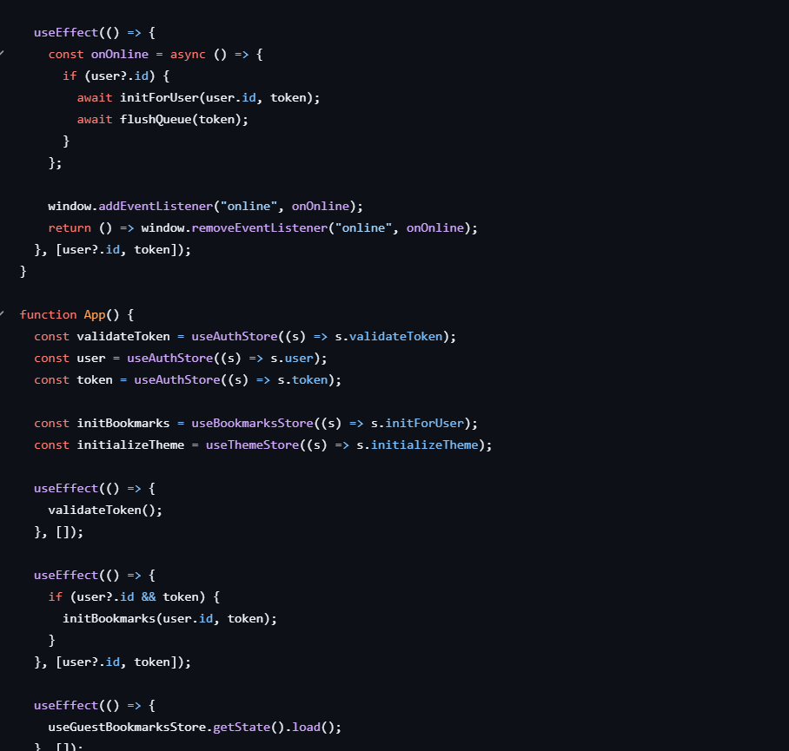
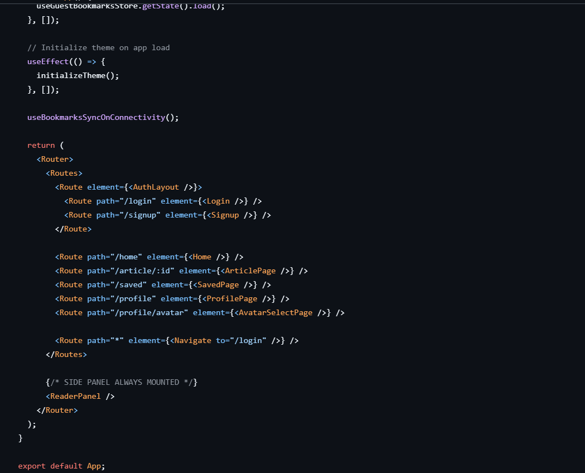
Code Description:-
- This file sets up routing for the entire React app using react-router-dom, including pages like Login, Signup, Home, Article, Saved, and Profile.
- It checks and validates the user’s login token on app load and initializes user-specific bookmarks when the user is logged in.
- It also loads guest bookmarks for users who are not logged in.
- The app syncs bookmarks automatically when the internet connection is restored using the online event listener.
- The theme (dark/light mode) is initialized on startup, and the ReaderPanel is always mounted for continuous reading support.

2. Design UI components:
• Create Components.
• Implement layout and styling.
• Add navigation.
3. Implement frontend logic:
• Integration with API endpoints.
• Implement data binding.

Data Provider:-
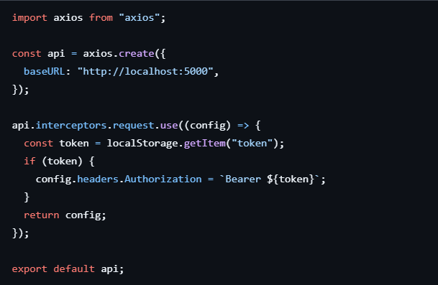

Code Description:-
- Creates a DataContext using createContext(null) to hold the context for HTML, CSS, and JavaScript code snippets.
- Defines a DataProvider component that wraps around other components to provide context values.
- Uses useState hooks to create state variables html, css, and js and their corresponding setters setHtml, setCss, and setJs, initializing each with an empty string.
- Returns a DataContext.Provider with a value prop containing the state variables and their setters, enabling any child component to access and update the context values.
- Exports the DataProvider component as the default export for use in other parts of the application.
- Wrap the DataProvider around components that need access to the context.
- Access and manipulate the context values in nested components using the useContext hook.
Code Component:-
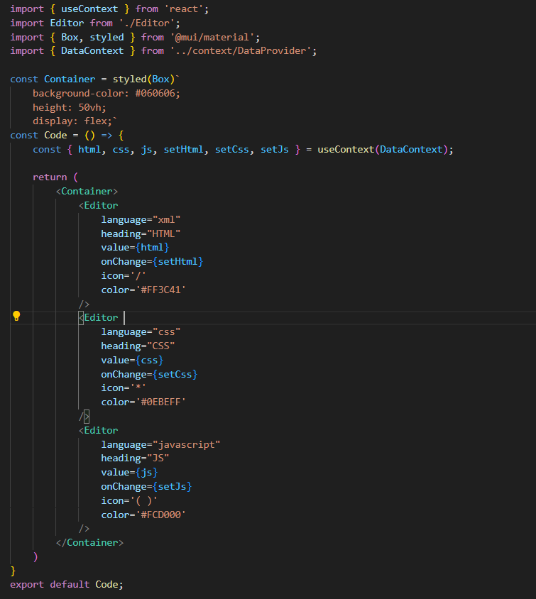
Code Description:-
- Imports useContext from React to use the context.
- Imports Editor component and Box and styled from Material-UI for styling.
- Imports DataContext from the custom DataProvider to access the shared context values.
- Creates a styled component Container using Material-UI's styled and Box.
- Styles Container with a black background color, height of 50vh, and flex display to align its children.
- Defines the Code component which uses useContext to access the html, css, js, setHtml, setCss, and setJs values from DataContext.
- Renders three Editor components within the Container.
- Each Editor is configured with:
  - language prop for syntax highlighting (xml, css, javascript).
  - heading prop for labeling the editor (HTML, CSS, JS).
  - value prop bound to the respective state (html, css, js).
  - onChange prop bound to the respective state setter functions (setHtml, setCss, setJs).
  - icon prop for displaying an icon (/, *, ( )).
  - color prop for setting a custom color for the heading (#FF3C41, #0EBEFF, #FCD000).
- Exports the Code component as the default export for use in other parts of the application.
Code-Editor Component:-
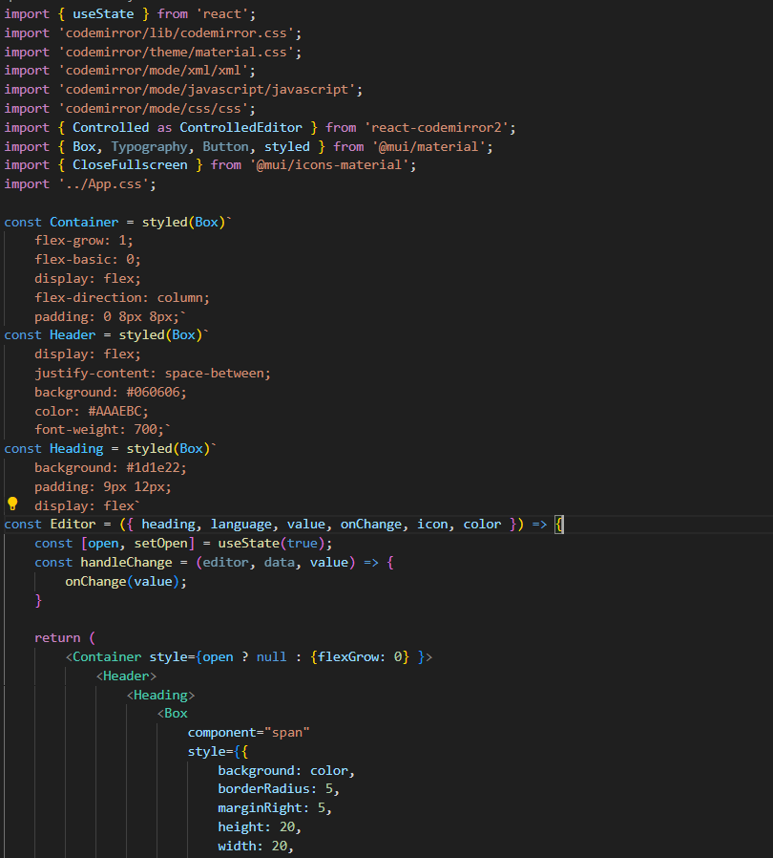
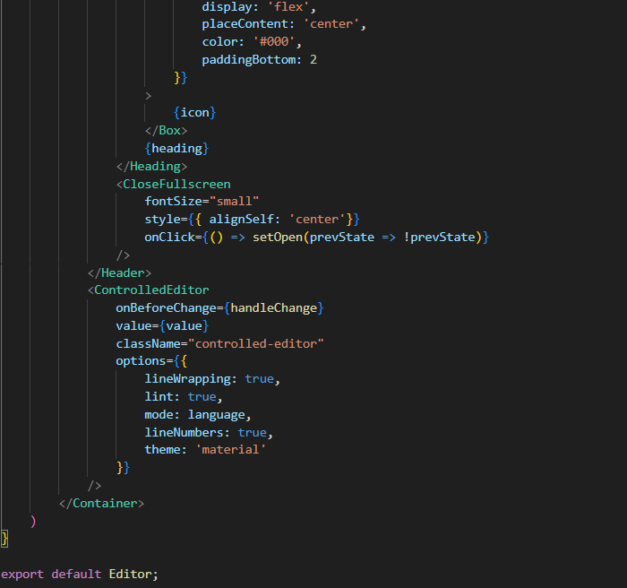
Code Description:-
- Imports useState from React to manage the component's local state.
- Imports necessary styles and modes from CodeMirror for the code editor.
- Imports ControlledEditor from react-codemirror2 for creating a controlled code editor.
- Imports Box, Typography, Button, and styled from Material-UI for styling components.
- Imports CloseFullscreen icon from Material-UI for the fullscreen toggle button.
- Imports custom CSS from '../App.css'.
- Creates a styled component Container using Material-UI's styled and Box, setting it up for flexible layout and padding.
- Creates a styled component Header using Material-UI's styled and Box, with styles for display, background, color, and font weight.
- Creates a styled component Heading using Material-UI's styled and Box, with styles for background, padding, and display.
- Defines the Editor component which accepts props: heading, language, value, onChange, icon, and color.
- Manages the open state using useState to toggle the editor's visibility.
- Defines handleChange function that updates the editor's value by calling the onChange prop function with the new value.
- Returns the Container component, conditionally adjusting its flexGrow style based on the open state.
- Renders the ControlledEditor component from react-codemirror2, passing props to configure the editor's behavior and appearance:
  - onBeforeChange is set to handleChange.
  - value is the current value of the editor.
  - className is set to controlled-editor.
  - options object configures the editor with line wrapping, linting, language mode, line numbers, and theme.
- Exports the Editor component as the default export for use in other parts of the application.

Project Execution

After completing development, start the application:
npm run dev
Open browser at:
http://localhost:5173
OUTPUT SCREENSHOTS:
- Login Page
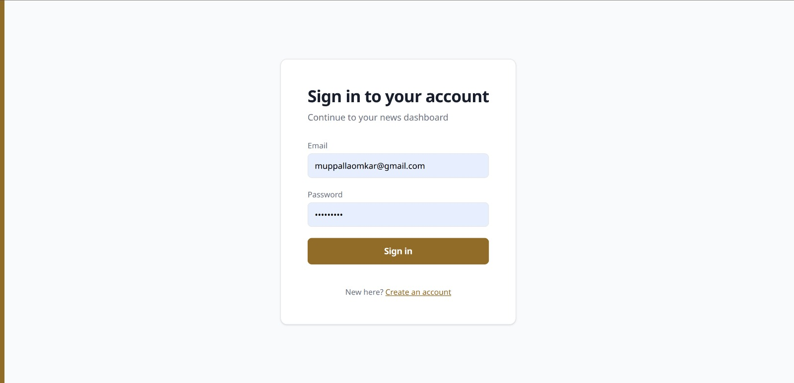
- Home Page UI

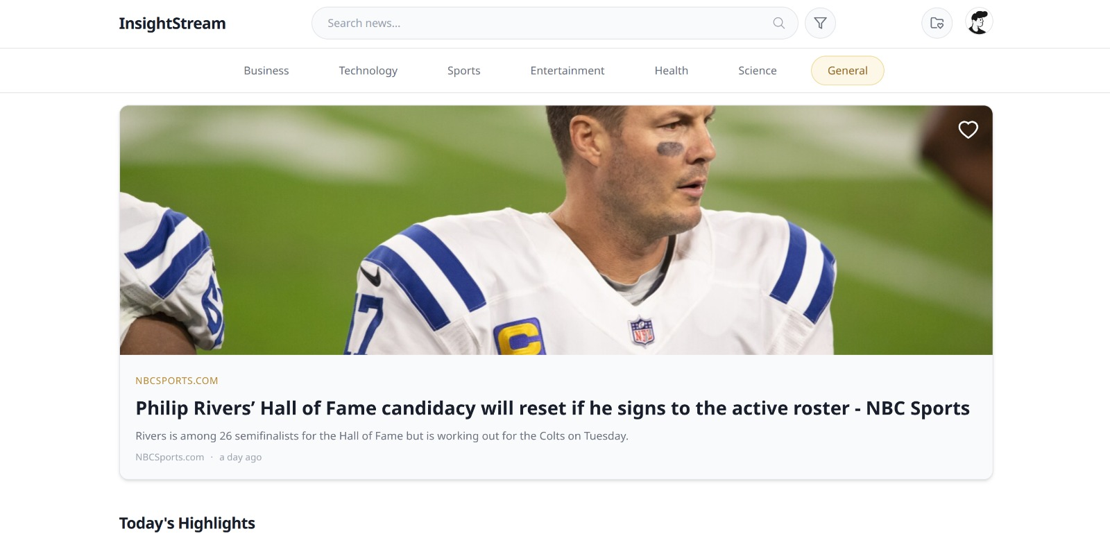

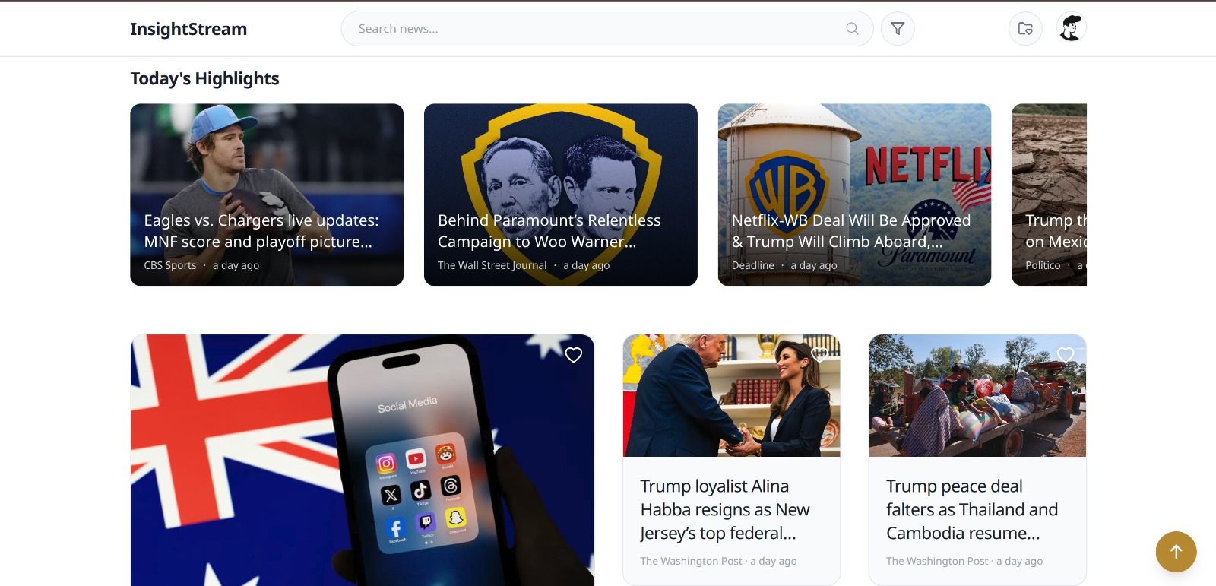
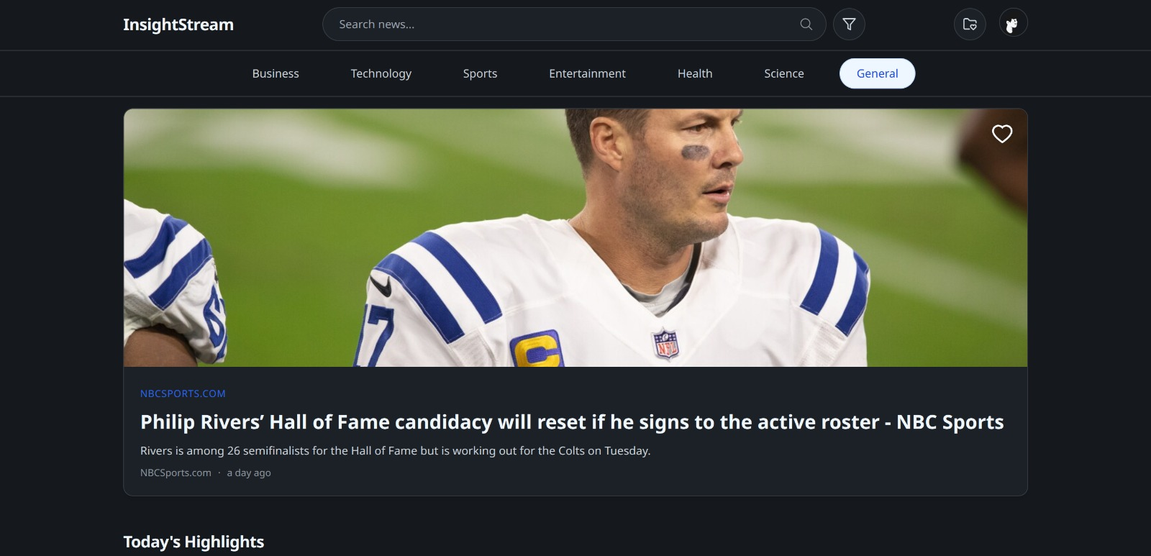

- Theme Selection Page

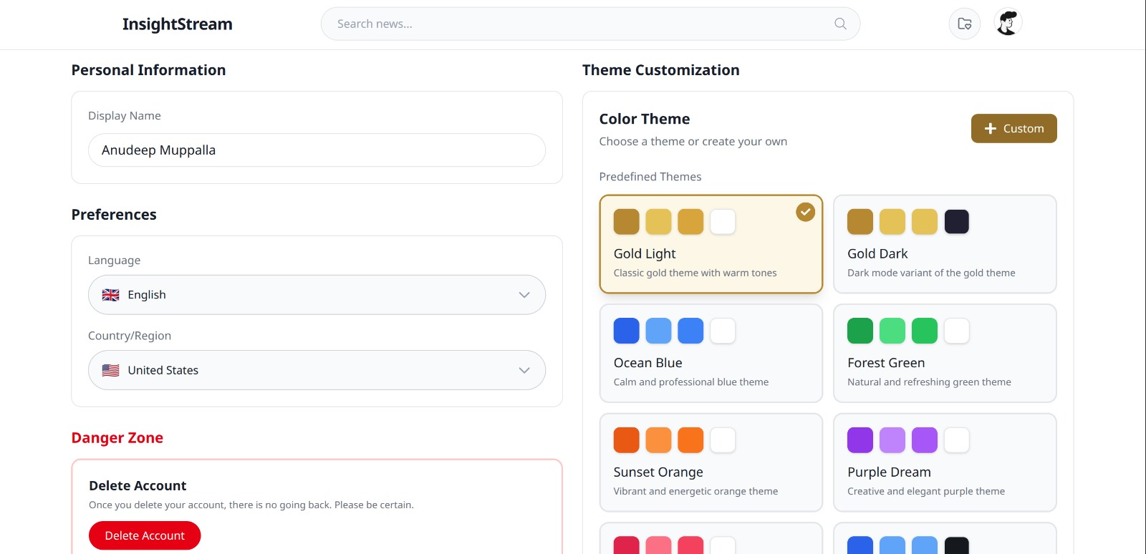

- Filter Page

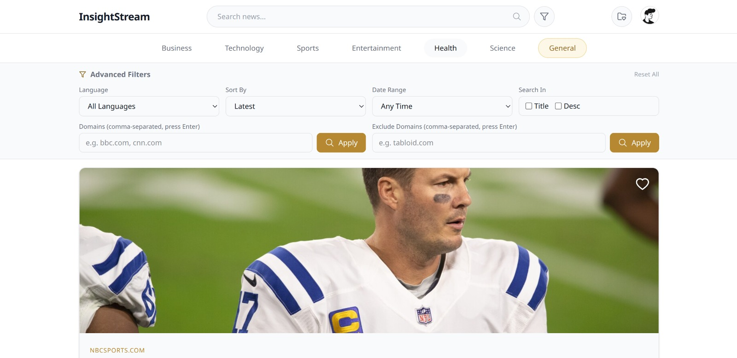

- Profile Page

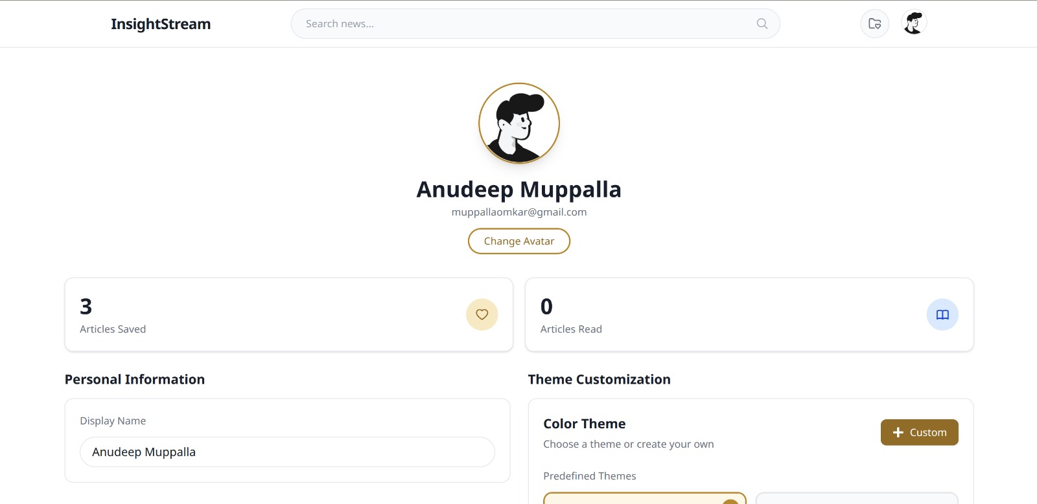

- Bookmark Page

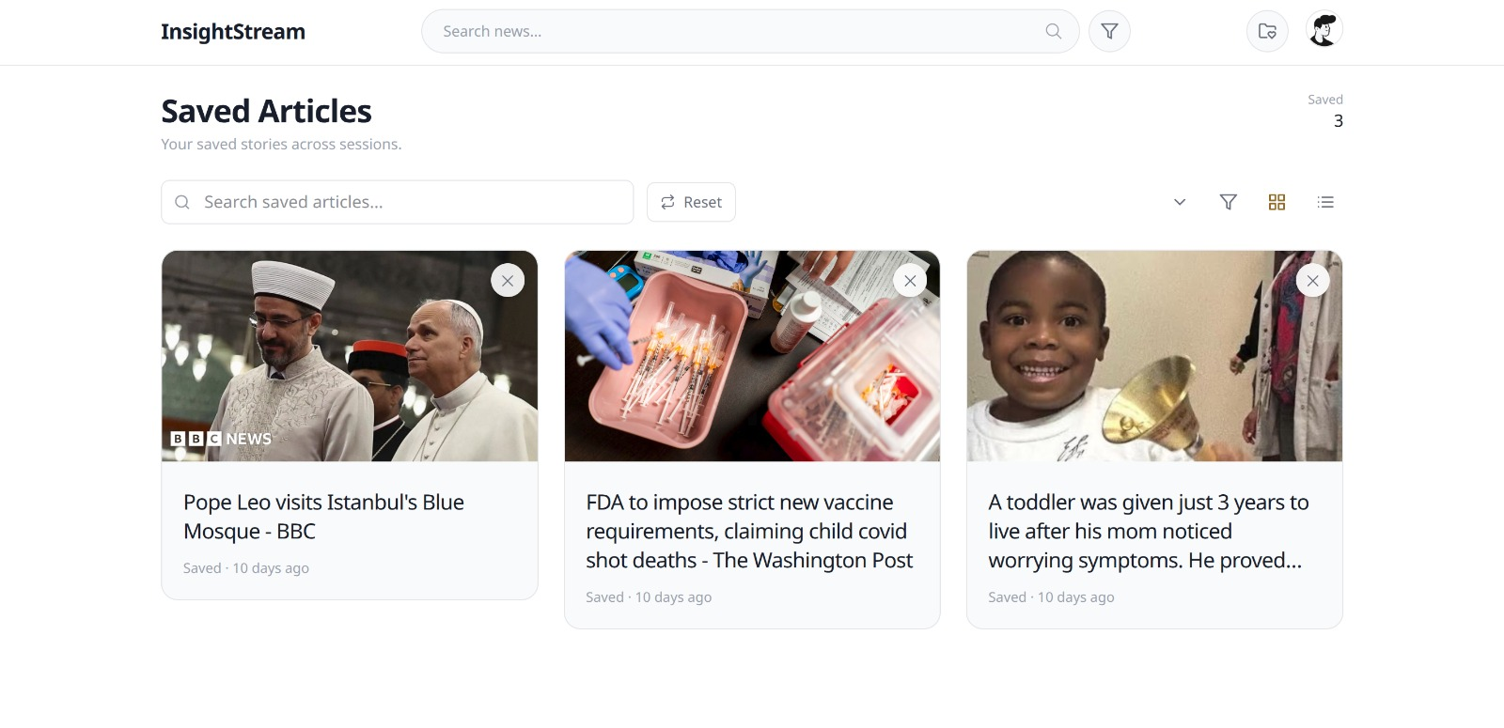

- Create Custome Theme Page

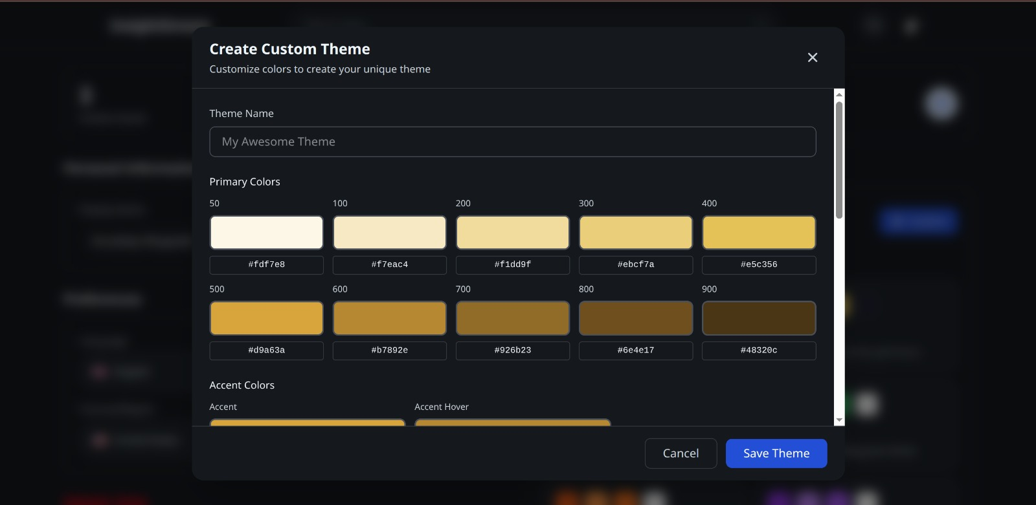

- Avatar Change

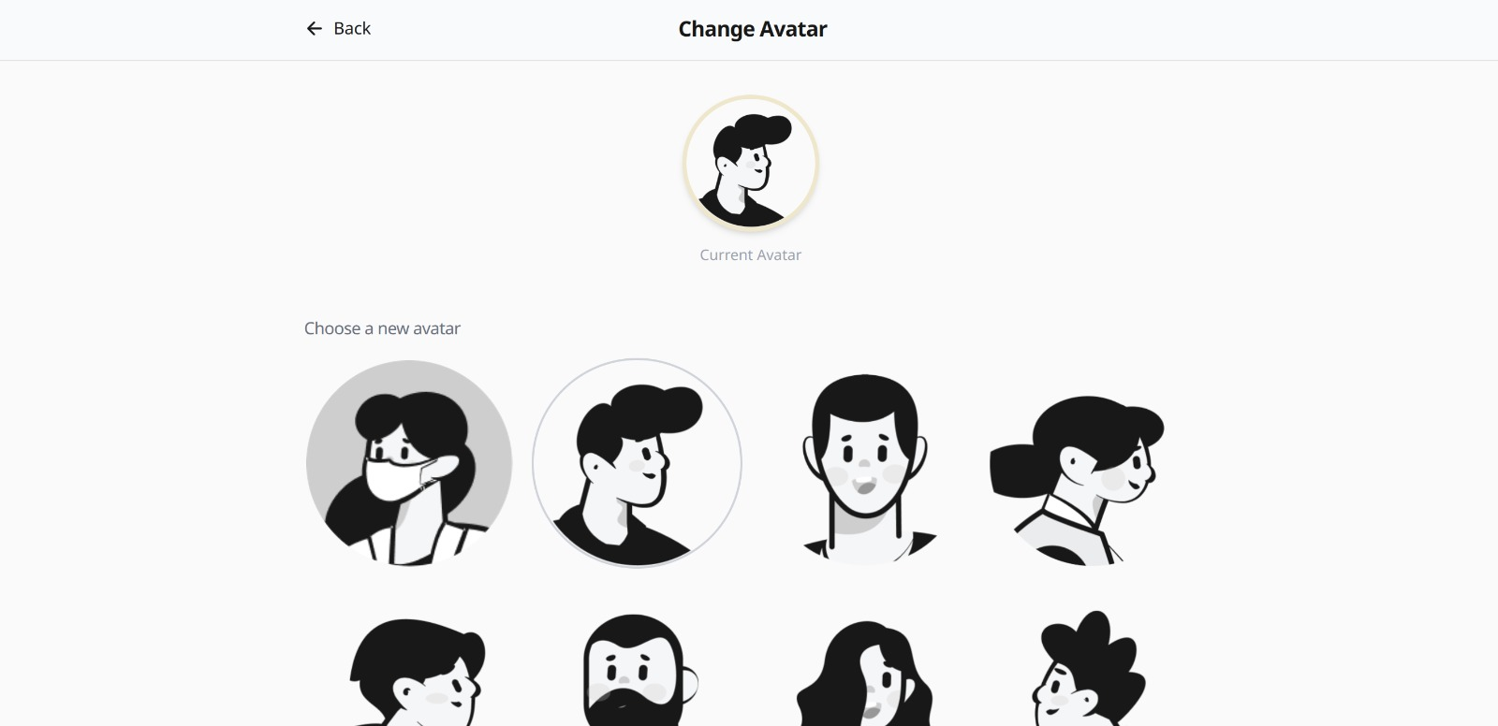

Conclusion
InsightStream showcases how modern frontend technologies, thoughtful design principles, and user-centric features can come together to create a truly engaging digital experience. The platform not only delivers fast and efficient news aggregation but also empowers users through its customizable theme system, multi-language support, and highly responsive interface. By prioritizing personalization, accessibility, and seamless interaction, InsightStream elevates the way users consume information. Overall, the application reflects the potential of next-generation web development to transform everyday reading into a more intuitive, adaptable, and immersive experience..

