SAR Narrative Generator with Audit Trail

Avdhoot Patil, Hiba Patel, Mahi Parmar, Baswajeet Patil –

VISHWAKARMA INSTITUTE OF TECHNOLOGY, PUNE

ABSTRACT
Financial institutions such as Barclays face a major challenge in combating financial crime because Suspicious Activity Reports (SARs) are created manually, requiring analysts to spend 5–6 hours converting scattered data into compliant narratives, which can lead to inconsistencies and human error. Our solution is an enterprise-grade, role-based AI system that automates SAR drafting while ensuring strict data-access control and preventing cross-domain leakage. It uses a multi-agent LLM architecture with Graph Retrieval-Augmented Generation and a verified Neo4j knowledge graph so every statement is grounded in validated transaction data, reducing hallucinations and bias. Four agents—Investigator, Scout, Drafter, and Auditor—replicate a Financial Intelligence Unit workflow and generate regulatory-format drafts that analysts can edit. An interactive interface shows a full audit trail of how each report is produced and provides intelligent alerts. This approach improves transparency, maintains compliance, and reduces drafting time by up to 90% while ensuring secure, explainable, and consistent reporting.

SYSTEM ARCHITECTURE
Our solution utilizes a Multi-Agent Swarm orchestrated via LangGraph, where specialized agents collaborate to analyse alerts and draft reports. This architecture is designed to be modular, ensuring that the "Reasoning" layer is separate from the "Drafting" layer.

THE MULTI-AGENT FRAMEWORK:

THE INVESTIGATOR PERSONA [DATA HUNTER]:
  - Role: Connects to the Neo4j Graph Database to execute Cypher queries. It retrieves the K-hop subgraph surrounding the suspicious entity (e.g., identifying circular flows or shared IP addresses).
  - Scope: Beyond transaction nodes, it ingests Customer KYC data (e.g., occupation, expected volume) and Case Management history to provide contextual risk profiles.
  - Interaction: Receives the raw Alert ID and Outputs a structured Graph JSON (Nodes & Edges).

THE TYPOLOGY SCOUT [PATTERN ANALYST]:
  - Role: Analyses the subgraph against a Vector Database (Azure AI Search) containing known AML typologies (e.g., Structuring, Smurfing, Layering).
  - Pattern Matching: It calculates a Similarity/Confidence Score for each matched typology (e.g., 92% match for "Structuring")
  - Interaction: Inputs Graph JSON and Outputs a Reasoning Object.

THE DRAFTER [NARRATIVE ARCHITECT]:
  - Role: Generates the SAR narrative using Claude 3.5 Sonnet. It is constrained to only make claims backed by specific Node IDs from the Reasoning Object.
  - Interaction: Inputs Reasoning Object and Outputs a Draft SAR Narrative with inline citations.

THE AUDITOR [GOVERNANCE CREATOR]:
  - Role: A lightweight "Critic" model (Mistral 7B) that cross-verifies the Draft against the original Graph Data. It checks for hallucinations, tone neutrality, and "Barclays Lens" compliance.
  - Interaction: Inputs Draft + Raw Data and Outputs a Quality Score and flags for Human Review.
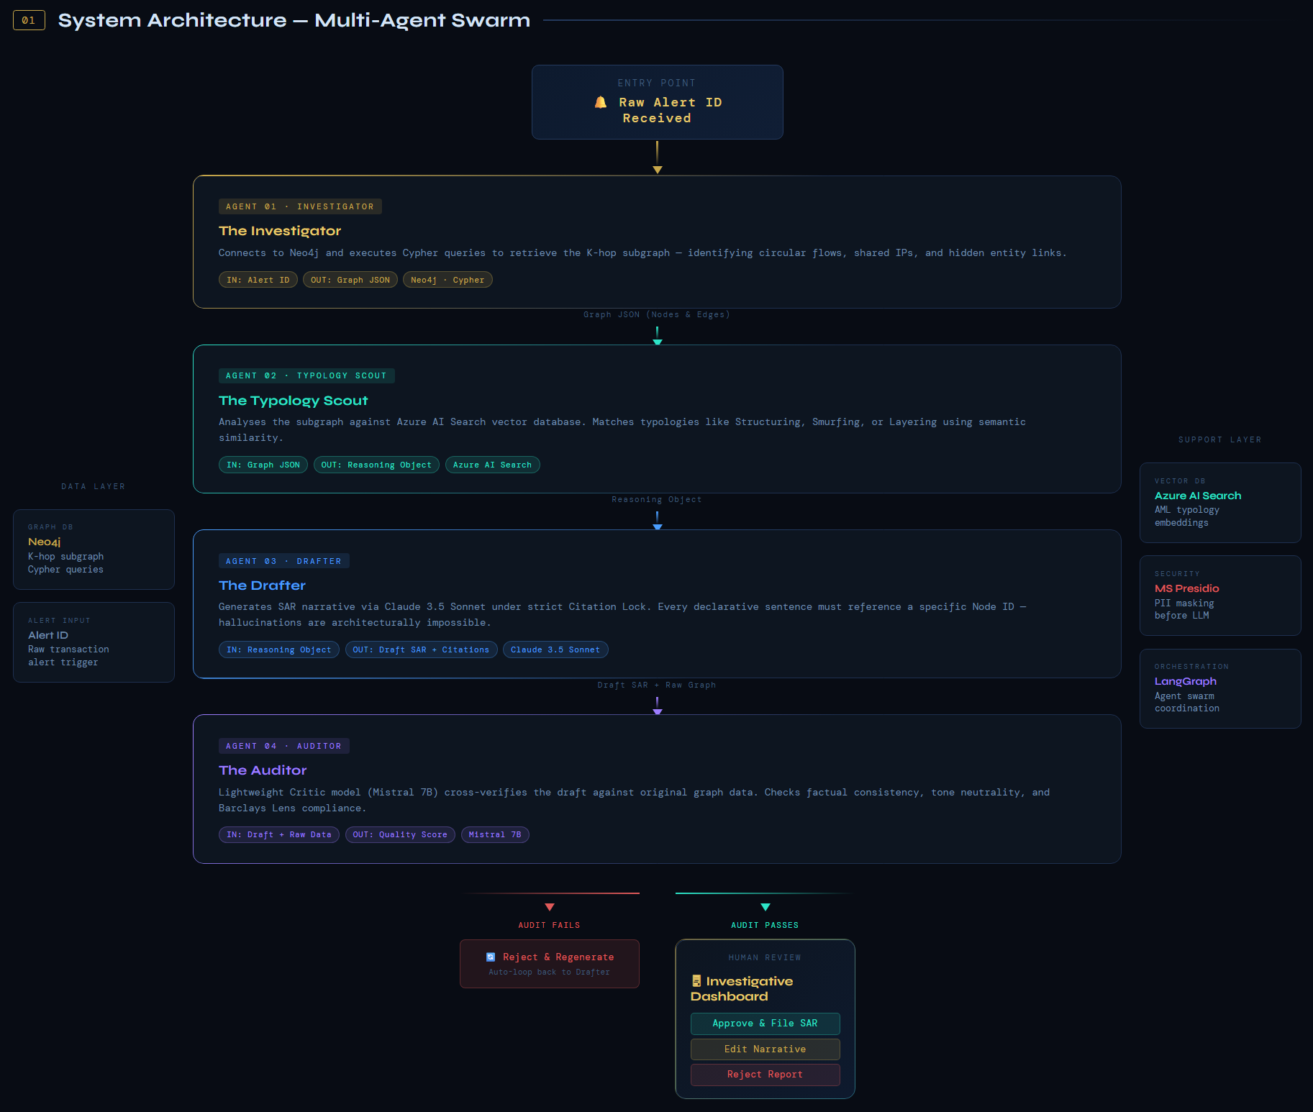
Figure 1: Multi-Agent Swarm Architecture for Automated SAR Generation

HOW WE ENSURE ROLE BASED ACCESS CONTROL IN OUR SYSTEM:
To maintain institutional integrity and strict data compartmentalization, our system implements a granular RBAC framework across three primary administrative tiers, managed via a secure React-based Investigative Dashboard.
1. The Analyst (Operational Tier):
- Scoped Access: Analysts are restricted to a "need-to-know" data view. The backend ensures they can only retrieve and visualize Neo4j subgraphs and narratives specifically assigned to their Case ID.
2. The Supervisor (Governance & Orchestration Tier)
- Dynamic Workload Management: All the alerts/cases will be sent to the supervisor first and then be equally distributed amongst analysts under them. To ensure the supervisor has control they can drag-and-drop cases and assign them to various analysts, ensuring an equitable load balance across the investigator swarm.
- Administrative Oversight: The Supervisor retains "Global View" permissions, allowing them to monitor all subgraphs, audit trails, and draft narratives produced within their department.
- High-Value Gatekeeping: A mandatory "Approval Gate" is enforced for High-Value SARs. These reports remain in a "Pending" state until the Supervisor provides a final digital sign-off, ensuring secondary human verification for high-risk cases.
3. The IT Admin (Infrastructure Tier)
- System Health: Tasked with monitoring the Azure Red Hat OpenShift (ARO) environment and ensuring the FastAPI backend maintains low-latency performance.
- Scalability Oversight: Admins manage the scaling of microservices (Investigator, Drafter, Auditor) to handle transaction spikes without accessing sensitive financial data.

METHODOLOGY
Our approach fundamentally shifts SAR generation from a linear text-generation task to a Graph-Grounded Retrieval Augmented Generation (Graph RAG) workflow. This methodology ensures that every narrative claim is mathematically verifiable against transaction data, addressing the "black box" nature of standard LLMs. The RBAC framework governing data access throughout this pipeline is detailed in the section below.
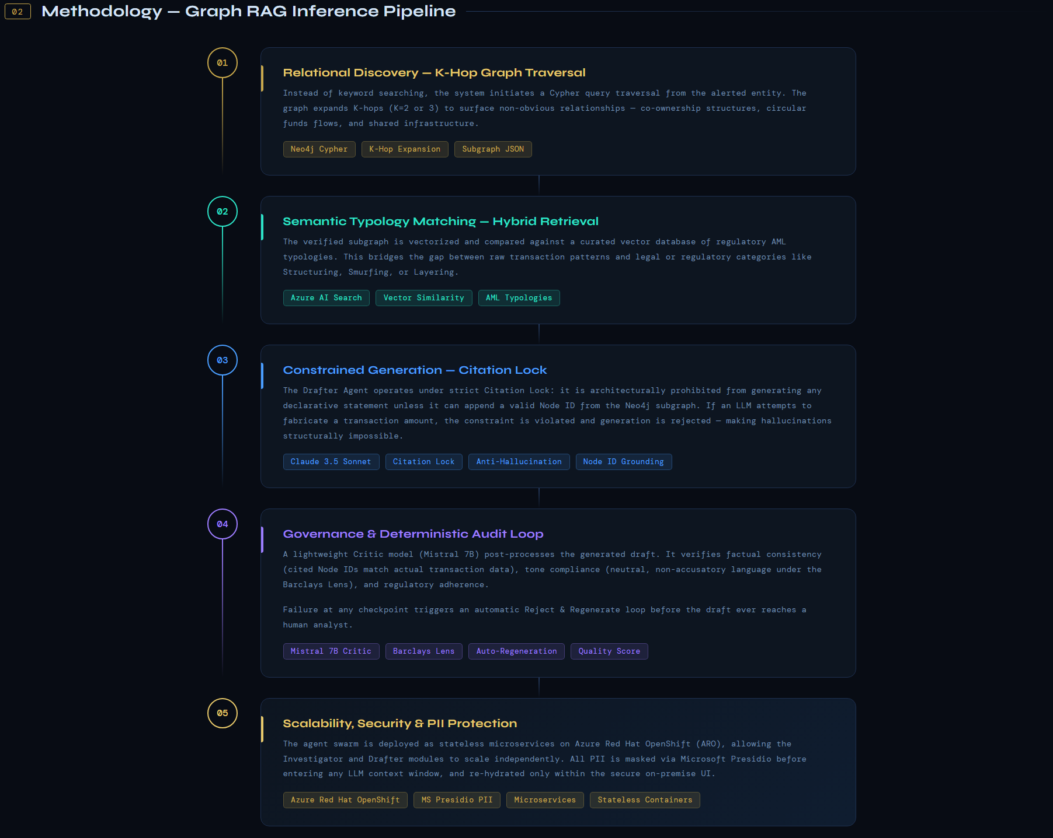

Figure 2: Graph RAG Inference Pipeline — From Alert Ingestion to SAR Draft

1. The Graph RAG Inference Pipeline:
Unlike standard RAG, which retrieves documents based on semantic similarity, our methodology employs a Hybrid Retrieval Strategy that combines structured logic with unstructured regulatory context:
- Step 1: Relational Discovery (The "K-Hop" Expansion)
Instead of keyword searching, the system initiates a Cypher query traversal starting from the alerted entity. The system expands K-hops (where K= 2 or 3) to identify non-obvious relationships, such as shared IP addresses between ostensibly unrelated accounts or circular fund flows. This creates a "verified subgraph" that serves as the ground truth for the investigation.
- Step 2: Semantic Typology Matching
The verified subgraph is then vectorized and compared against a Vector Database (Azure AI Search) containing regulatory typologies (e.g., "Structuring" or "Layering"). This step bridges the gap between mathematical patterns (the graph) and legal definitions (the vector store), allowing the system to classify complex behaviours that simple rules-based engines miss.
- Step 3: Constrained Generation (The "Citation Lock")
To eliminate hallucinations, the Drafter Agent operates under a strict "Citation Lock" constraint. The model is effectively forbidden from generating a declarative sentence unless it can append a specific Node ID from the subgraph as evidence. This enforces a 1:1 mapping between the narrative and the underlying data.

2. Role Based Access Control:

1. Analyst (FIU Investigator - BA4)
Analyst is the "boots on the ground" investigator responsible for the primary workflow.
- Permissions:
  - Trigger the Investigator Agent to pull subgraphs for assigned cases.
  - Review and edit the Drafter Agent's SAR narratives.
  - Interact with the Neo4j Graph Visualization to verify evidence.
- Restrictions: Cannot approve their own SARs for final filing and cannot edit or delete the Audit Trail.
2. Supervisor (Quality Assurance - AVP/VP)
The Supervisor acts as the governance gatekeeper, ensuring the system remains a tool for augmentation rather than a "black box".
- Permissions:
  - Full visibility into the Risk-Based Dynamic Case Queue.
  - Final authority to Approve or Reject SAR drafts after reviewing the Auditor Agent’s quality score.
  - Can manually reassign cases or override the Effective Priority Score.
- Restrictions: Does not typically perform the initial investigation but oversees the integrity of the process.
3. Admin (System Architect - IT/Sec)
The Admin manages the technical infrastructure and ensures the system is compliant with security standards.
- Permissions:
  - Manage user access and role assignments.
  - Configure the Risk Score thresholds and the Aging Mechanism formulas.
  - Monitor the Azure Red Hat OpenShift (ARO) deployment and Neo4j health.

- Restrictions: Strictly prohibited from viewing sensitive Personally Identifiable Information (PII) or reading the narrative content of the SAR reports.
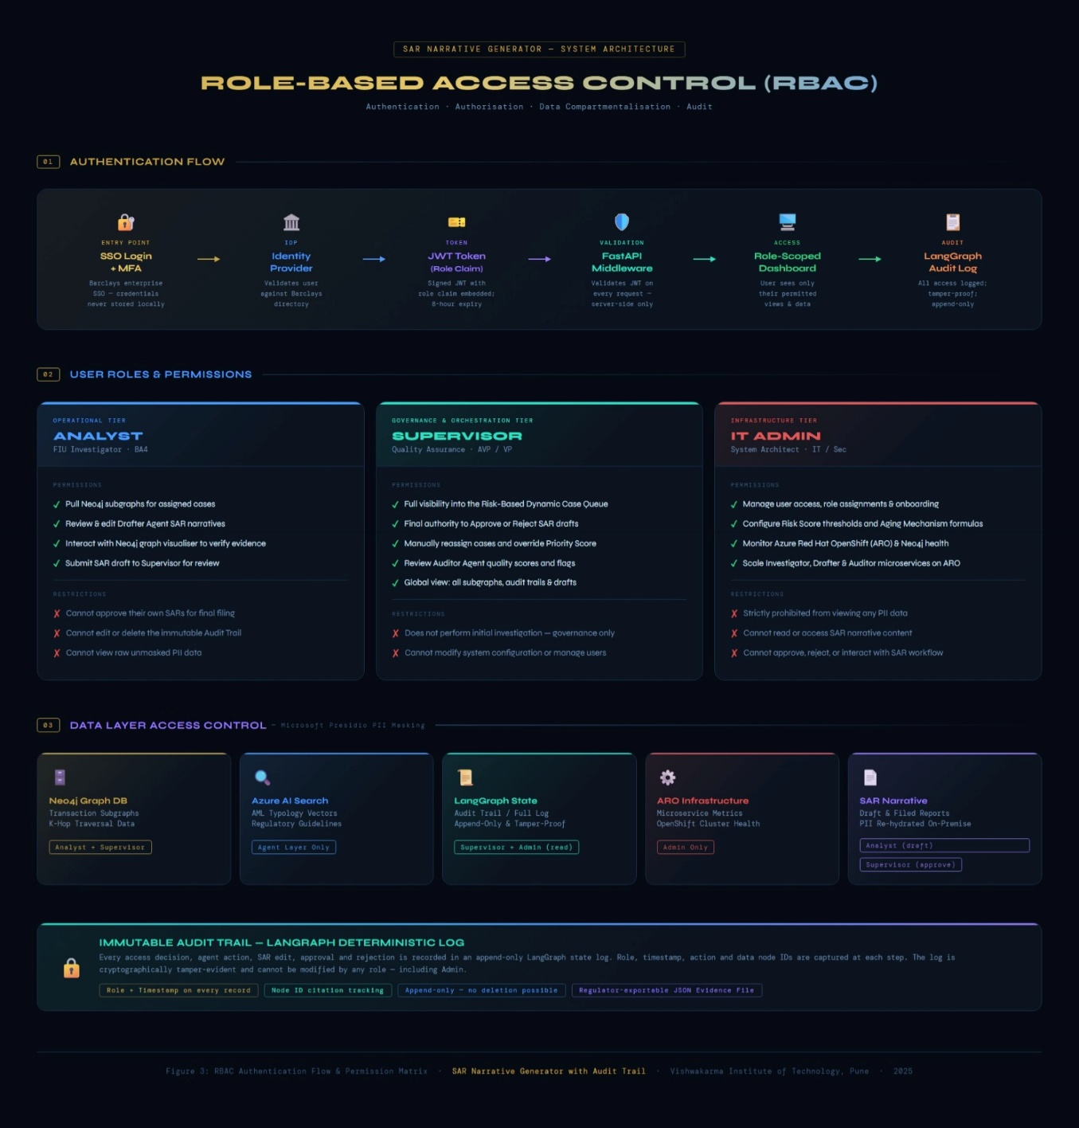

Figure 3: RBAC Authentication Flow & Permission Matrix — SAR Narrative Generator

3. Governance & Audit Loop

We implement a Deterministic Audit Layer using a lightweight "Critic" model. This layer functions as a post-processing filter that parses the generated draft to verify:
- Factual Consistency: Does the cited Node ID actually contain the transaction amount mentioned in the text?
- Tone Compliance: Does the language adhere to the "Barclays Lens" (neutral, objective, and non-accusatory)?
Any failure at this stage triggers an automatic "Reject and Regenerate" loop before the draft ever reaches the human analyst.

4. Scalability & Security:

- Containerized Microservices: The agent swarm is deployed as stateless microservices on Azure Red Hat OpenShift (ARO), allowing the "Investigator" and "Drafter" modules to scale independently based on alert volume.
- Regulatory Defensibility (Evidence File): Every generated subgraph is archived as a JSON Evidence File. This allows Barclays to provide regulators with a mathematically verifiable "snapshot" of the data used for the SAR, ensuring 100% auditability.
- Data Masking & Tokenization: All Personally Identifiable Information (PII) is masked via Microsoft Presidio prior to entering the LLM context window. The LLM (Claude) only sees Tokenized IDs (e.g., "Customer A"), while the secure UI re-hydrates the data for the human analyst ensuring zero data leakage to public model APIs.

Layer | Technology Selected | Justification for Barclays Environment
Cloud Infrastructure | Microsoft Azure + Azure Red Hat OpenShift (ARO) | Scalability: It automatically adds more computing power during busy times (like Black Friday) so the system never crashes.  Feasibility: It allows Barclays to easily move the system between the public cloud and private data centres without rewriting any code.
Graph Database | Neo4j | Performance: It finds hidden connections between accounts instantly. Standard databases struggle with this, but Neo4j is built specifically to "follow the money.  Feasibility: It is the industry standard for banking investigations, so compliance teams already trust it.
Vector Database | Azure AI Search | Performance: It allows the AI to "read" and match thousands of regulatory documents in split-seconds.  Scalability: It handles the heavy lifting of searching text, keeping the main AI model fast and efficient.
Orchestration | LangGraph | Feasibility (Audit): It tracks every single step the AI takes. This creates the "Audit Trail" required by regulators, proving exactly why a decision was made.  Performance: It allows multiple agents to work at the same time (e.g., one mapping the network while another checks the rules), cutting wait times in half.
AI Model | Claude 3.5 Sonnet | Feasibility: These models are excellent at writing professional, "regulator-ready" text. Crucially, our system is not locked to one provider—we can swap models easily if a better one comes out.  Scalability: We access them via API, so thousands of analysts can use the tool simultaneously without slowdowns.
Backend API | Python (Fast API) | Performance: It is designed to be extremely fast, handling hundreds of requests at once without lag.  Feasibility: It automatically creates documentation for the code, making it easy for Barclays' security teams to review and approve it.
Frontend UI | React + Vite | Performance: It ensures the dashboard is snappy and responsive, even when visualizing complex networks of 50+ accounts.  Feasibility: React is widely used at Barclays, so existing internal teams can easily maintain and update the tool.

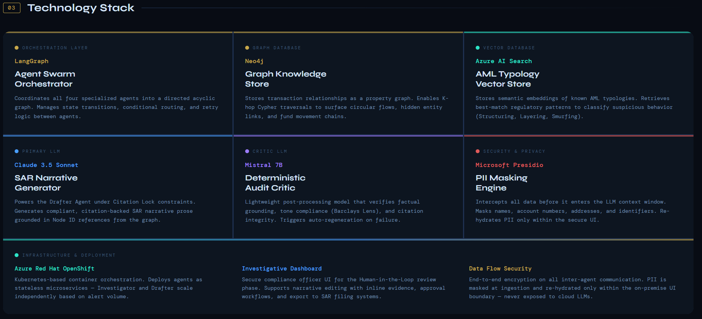
Figure 4: Technology Stack and Infrastructure Layers of the SAR Narrative Generator

QUESTION & ANSWERS
Q: Generative AI is probabilistic by nature. How can you mathematically guarantee 100% accuracy in the transaction details mentioned in the SAR?
A: We achieve this through Constrained Generation rather than open-ended generation.
- The Mechanism: The "Drafter Agent" is architecturally restricted. It cannot generate a declarative sentence about a transaction unless it can append a valid Node ID from the Neo4j subgraph.
- The Guardrail: If the LLM attempts to mention a transaction amount (e.g., "₹50,000") that does not exist as a property in the retrieved graph nodes, the Auditor Agent (our deterministic code-based critic) instantly rejects the draft. This ensures that every fact in the narrative is a direct mirror of the hard data.
Q: How does the processing time compare to the current human benchmark?
A: Our system targets a reduction from 5–6 hours to under 3 minutes per SAR — roughly a 25× efficiency gain. The biggest gains come from replacing manual SQL/Excel data collection with Neo4j graph traversal (~99% faster) and replacing the manual writing phase with LLM streaming (~98% faster). Human review time is reduced but intentionally preserved: the analyst still reviews evidence, edits the narrative, and provides sign-off, keeping a human in the loop as required by regulators. The full step-by-step breakdown is shown in the table below.
Process Step | Human Benchmark (Current) | Sentinel Benchmark (Target) | Improvement
Data Collection | 60 - 90 mins (Manual SQL/Excel) | 400 ms (Neo4j Graph Traversal) | ~99% Faster
Pattern Analysis | 45 - 60 mins (Mental correlation) | 800 ms (Vector + Rule Matching) | ~99% Faster
Narrative Drafting | 120 - 180 mins (Writing & Editing) | 45 - 60 seconds (LLM Streaming) | ~98% Faster
Review & Audit | 30 - 60 mins | 5 - 10 mins (HITL Verification) | ~80% Faster
Total Turnaround | ~5 - 6 Hours per SAR | < 3 Minutes per SAR | ~25x Efficiency Gain

Q: How does a human analyst efficiently audit the AI's work without re-doing the entire investigation?
A: We utilize a "Glass Box" Citation System in the Review Dashboard.
- The Workflow: The final SAR draft appears on the left side of the screen. Every key claim (dates, amounts, names) is hyperlinked.
- The Interaction: When an employee clicks a citation (e.g., [Ref: Node-402]), the system highlights the corresponding transaction node in the visual graph on the right. This allows for Instant Verification—the analyst validates the evidence chain in seconds rather than digging through raw logs for hours.

Q: In a global bank, a 3-hop expansion from a major merchant could return 50,000 nodes. You can't fit that into an LLM's context window. How do you prune the graph?
We don't do a 'Blind K-Hop.' Our Investigator Persona uses Contextual Cypher Queries. It applies a Transaction Threshold Filter and a Super node Bypass Policy. This ensures we only feed 'High-Signal' subgraphs into Claude 3.5, keeping our context window lean and our reasoning focused on the suspicious flow, not the merchant noise.

Q. If one agent gives a wrong output, how do you ensure it doesn't ruin the final report?
The implementation of our strict "Maker-Checker" rule protects us because it operates the same way as banking institutions. The system operates as a complete system which includes multiple pathways for incorrect operations to develop into severe failures, while it maintains operational security through its Auditor Agent component. The Drafter Agent (the writer) has two restrictions because it needs to create sentences which require database identification through the specific ID system. The first restriction prevents him from creating imaginary content. The Auditor Agent (the critic) conducts a draft evaluation after the writing process completes by comparing it to the original hard data. If the Auditor system detects a writing error because the author declared a transaction value of "$50,000" while the database recorded the actual amount as "$500." The Auditor system automatically detects this mistake at the draft stage which leads to rejection before a human reviewer examines the document.

Q. Claude 3.5 and Mistral are third-party models. If Anthropic or Mistral AI updates their model weights tomorrow and the narrative style changes, our regulatory filing consistency is ruined. How do you handle Model Drift?
To tackle this problem, we use Frozen Model Versions (e.g., specific snapshots) on Azure AI so that we have a "Golden Test Set" of 100 historical SARs. Every time a model is updated, we run the system against the "Golden Set" to ensure the output remains identical.

FUTURE SCOPE

Our architecture is designed for Cross-Domain Learning and global expansion. Future iterations will implement a Positive Feedback Loop, where human-approved edits in the "Glass Box" dashboard are fed back into the Auditor Agent to refine its "Barclays Lens" standards and reduce future false positives. Additionally, the system's modularity allows it to scale into other regulatory domains, such as Fraud Detection or Internal Risk Assessment, by simply updating the Typology Scout’s vector store with new regulatory guidelines.

Note: Full interactive flowcharts are available at the project GitHub repository: https://github.com/AviCodes22/Hack-To-Hire-Angry-Scientist-s

