Lab 2 Introduction Visual C++

Introduction to Computer Science I

# Objectives:

After performing this lab, the students should be able to

* explain the purposes of an IDE as well as of the main components of an IDE
* create console projects using Visual C++ 2010/2013/2015

# Names of Lab Group Members: Avi Cueva

## Activity

### Part I

Read the section “What is the Integrated Development Environment” in Chapter 1: Programming with Visual C++ 2010 by Ivor Horton, available on <http://msdn.microsoft.com/en-us/library/hh147275(v=vs.88).aspx#WhatIsTheInteg>

Then answer the following questions:

1. **What is the purpose of an IDE?**

 An IDE is a completely self-contained environment for creating, compiling, linking, and testing your programs.

1. **Which part of an IDE is used to create and edit C++ source code?**

The editor

1. **What does a compiler do?**

The compiler converts your source code into object code, and detects and reports errors in the compilation process. The compiler can detect a wide range of errors caused by invalid or unrecognized program code, as well as structural errors, such as parts of a program that can never be executed. The object code output from the compiler is stored in files called object files that have names with the extension .obj.

1. **What is a library?**

A library is simply a collection of prewritten routines that supports and extends the C++ language by providing standard professionally-produced code units that you can incorporate into your programs to carry out common operations.

### Part II

Read the section “Using the IDE” in Chapter 1: Programming with Visual C++ 2010 by Ivor Horton, available <http://msdn.microsoft.com/en-us/library/hh147275(v=vs.88).aspx#UsingtheIDE>

Note: You only need to do the sections **Try it Out: Creating a Project for a Win32 Console Application** and **Try it Out: Creating an Empty Console Project.**

Answer the following questions?

1. **Explain what a project is.**

Creating a project is the starting point for all applications and components that you develop with Visual C++.

A project is a container for all the things that make up a program of some kind

1. **Explain what a solution is. What is the relationsh­­ip between a solution and a project?**

The idea of a solution is expressed by its name, in that it is a mechanism for bringing together all the programs and other resources that represent a solution to a particular data-processing problem.

Now that you have tried the exercises **Try it Out: Creating an Empty Console Project**, create an empty console project that announces to the world your first c++ program to the screen: using the Ex1_02.cpp as a reference, use the statement std::cout << “Hello world”; to display your announcement.

1. **Copy your C++ source code below.**

// lab2_AviCueva.cpp : Defines the entry point for the console application.

//

#include "stdafx.h"

#include <iostream> // Basic input and output library

int main()

{

std::cout << "Hello World" << std::endl;

return 0; // Return to the operating system

}

1. **Take a screenshot of your program output. To do so, with the output window active, press Alt+PrtScr on your keyboard. This keyboard shortcut will copy the active window to the copyboard. Paste the window below.**

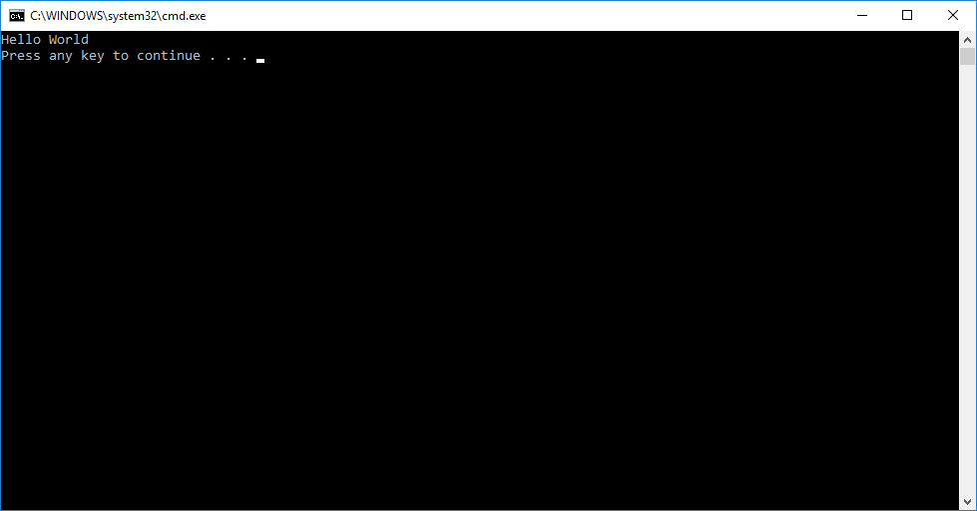

Congratulations on creating your first C++ programs!

Notify the instructor to get checked off. Be prepared to discuss what you have learned in this lab.