CSCI 110

M, W, 7:00 PM

Avi Cueva

Pseudo Code:

/\* Psuedo-code

1. Figure out initial n, using random between 10 and 21.

2. Randomly pick either computer or human

3. Alternate picking how many stones to remove, 3, 2, or 1.

4. Repeat until someone has taken the last stone. They are the loser.

\*/

Screen shots:

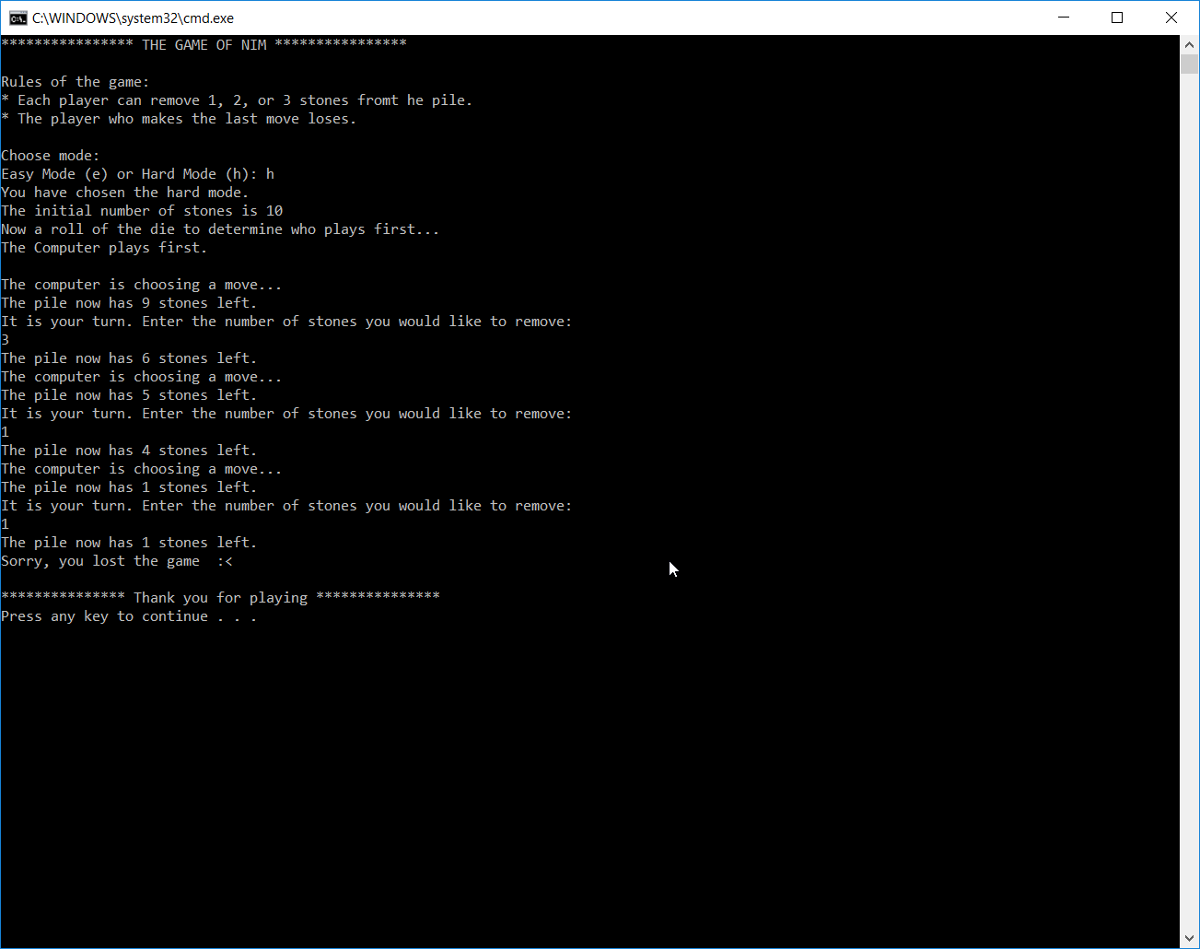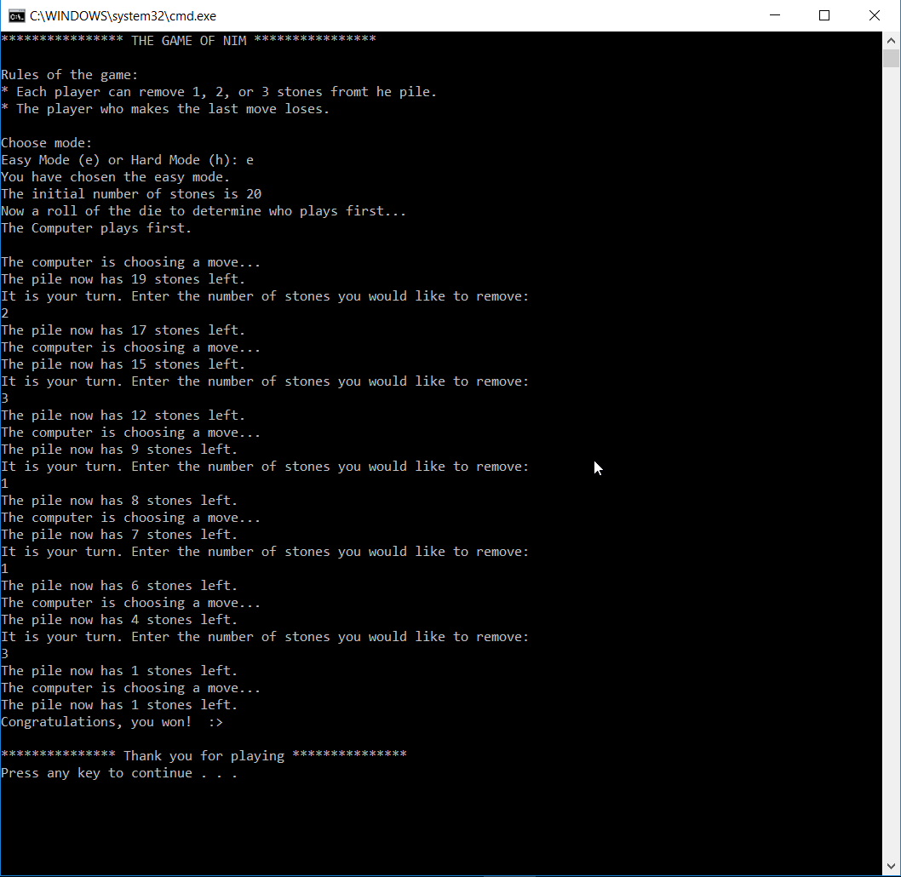

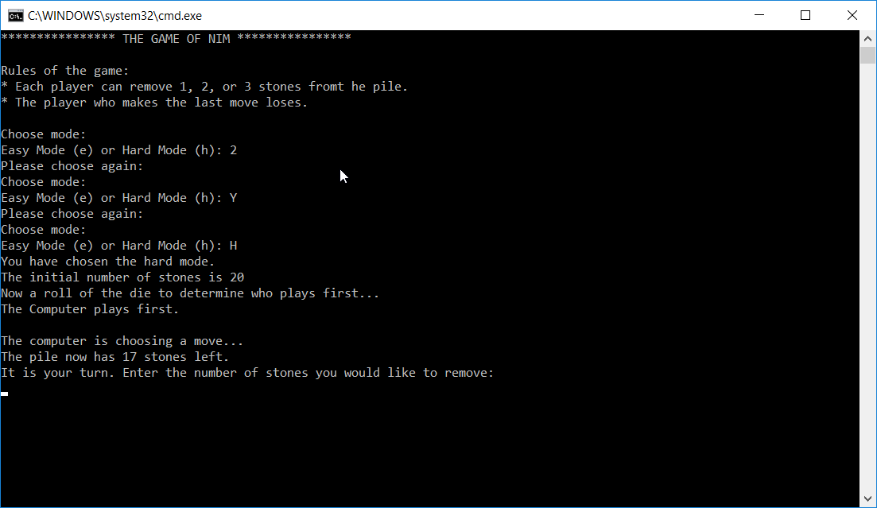

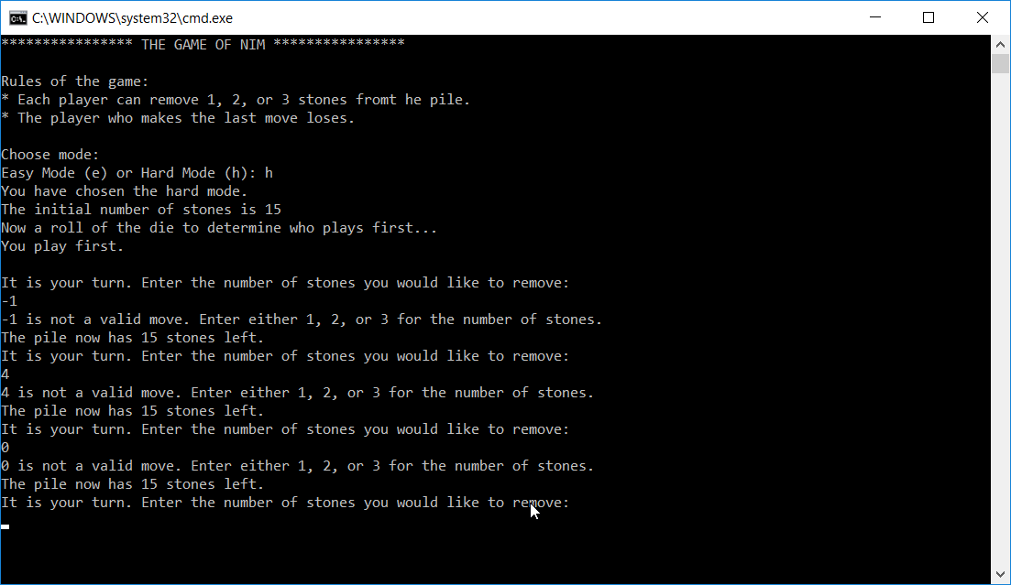

1

A brief discussion of the project experience:

Did you enjoy the project? What problems did you encounter?

Yes, Had some issues with the looping on easy mode. The way I got it to work was to get a random number between 1-3 to remove. In cases where stonesRemaining was low, 1 or 2. I would have the program generate a new random number. The issue is it would also print out the number of items left in the pile. Depending on how many times it would take behind the scene it would also print out the number of items in the pile, until it met the criteria.  
  
What did you get out of the project?

I got some more experience with functions. Yes, I know we haven’t gotten there yet, just thought it was cool I was able to isolate each function to return just what I needed from it. Made the program more modular and allowed me to take a more step by step approach and not be overwhelmed by trying to put together a large project all within main.

How did you find the project?

I found this project to be rewarding difficult. Yes, it was tricky, but it’s like a puzzle, once you get it, it feels really good.

What type of help/references did you use in your project?

Primarily searched zybooks. I searched the topics to get the proper syntax. Not much internet searching for this one.