## Vehicle Loan Payment Calculator

#### Overview

In this project, you will develop a vehicle loan payment calculator program in C++. The calculator program asks the user for information about the vehicle and the loan, including vehicle make and model, purchase price, sales tax, down payment amount, trade-in value, annual interest rate, and length of the loan in years. Given the information, the program calculates the amount of sales tax, loan principal, and monthly payment. The program displays a summary of the vehicle and loan information. It also displays a payoff summary table for the first twelve months of the loan, including the amount of principal and interest contributed by the monthly payment, as well as the loan balance for each month until the loan is paid off. The following is an example of the calculator’s program output:

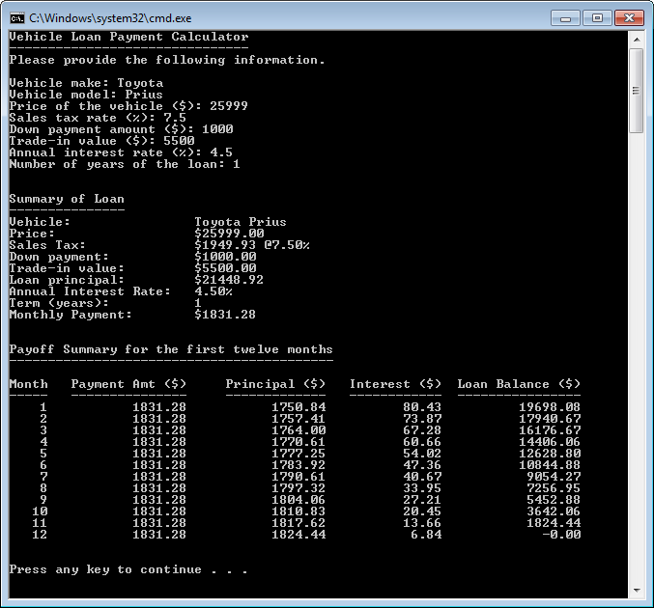

#### Detailed Project Requirements

1. The program should prompt the user to enter the following information about the vehicle and loan:
   * vehicle make and model
   * purchase price ($)
   * sales tax rate (%)
   * down payment amount ($)
   * trade-in value ($)
   * annual interest rate (%)
   * length of loan in years
2. After getting the above information from the user, the program should display a summary of the information given by the user (i.e. those listed under item 1 above). In addition, it should calculate and display the following in the vehicle and loan summary:
   * *sales tax* = *price* x *sales tax rate*
   * *loan principal* = *price* + *sales tax* – *down payment* – *trade-in value*
   * *monthly payment = $\frac{\left(loan principal\right)× (monthly interest rate)}{1-{(1+monthly interest rate)}^{-(length of loan in months)}}$* 
     + Note: *monthly interest rate* is (*annual interest rate*) / 12
     + Note: *length of loan in months* is (*length of loan in years*) x 12
3. The program should also display a payment summary for each month until the loan is paid off, including the following information:
   * month number
   * *monthly payment* amount ($)
     + Note: this is described in item 2 above
   * *interest contributed by that month’s payment amount* ($) = (*loan balance from the previous month*) x (*monthly interest rate*)
   * *principal contributed by that month’s payment amount* ($) = (*monthly payment*) – (*interest contributed by that month’s payment amount*)
   * loan balance ($) after that month’s payment = (*loan balance from the previous month*) – (*principal contributed by that month’s payment amount*)

**Hint**: To display outputs in columns of fixed width, use the setw function from the <iomanip> library. For example, to display a variable named number in a field of 10 characters wide (with the text right aligned in the field), do the following:

#include <iomanip>

…

int main() {

…

cout << setw(10) << number;

…

}