Database Management Systems (DBMS)
Lab Assignment 5 Project Report
Dynamic Web Application with Java, JDBC, and Oracle Database

GitHub Repository: https://github.com/AviDhandhania/dbms-lab-assignment-5

Submitted by: Avi Dhandhania

1. System Architecture & Technologies Used
The architecture follows a Three-Tier client-server model, optimized for dynamic data handling.

1.1 Presentation Tier (Frontend)
Implemented as a Single Page Application (SPA) using HTML5, CSS3, and modern JavaScript (ES6+). No heavy frameworks were used to ensure low dependency overhead.

1.2 Application Tier (Backend API)
Developed using Java 11+. It utilizes the built-in com.sun.net.httpserver.HttpServer module to route requests to specific handlers without Spring Boot.

1.3 Data Tier (Database)
Oracle Database handles persistence. Communication is facilitated via the Oracle Thin JDBC Driver (ojdbc6).

2. Graphical User Interface (GUI) & Screenshots
This section showcases the dynamic features of the web application in detail.

2.1 Dynamic Table Manager Dashboard
The Table Manager dynamically queries the Oracle database to find all tables accessible by the user. When a table is selected, the system automatically fetches its schema and data rows, rendering them dynamically.
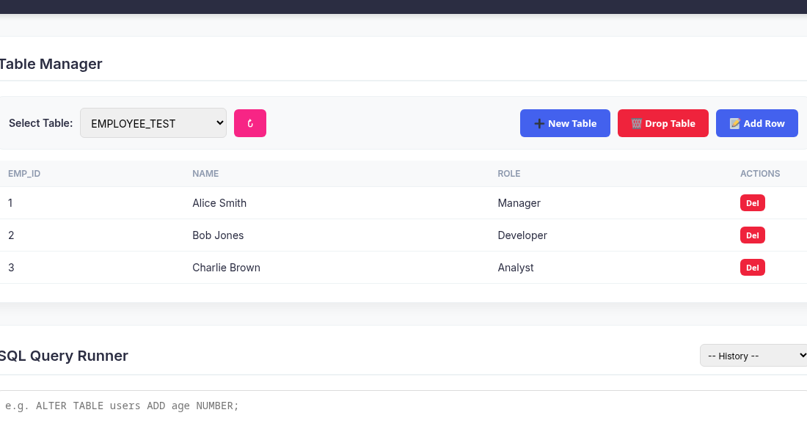

2.2 Dynamic Table Selection Dropdown
The system dynamically queries the user_tables metadata view in Oracle to populate the dropdown. This ensures that any table created externally or through the app is immediately available.
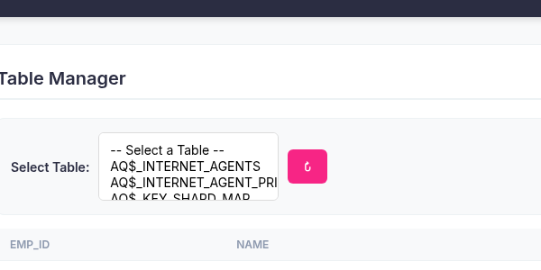

2.3 DDL Operations: Create Table Interface
Users can click 'New Table' to define a new table name and its column definitions using standard Oracle SQL syntax. This directly triggers a CREATE TABLE statement in the backend.
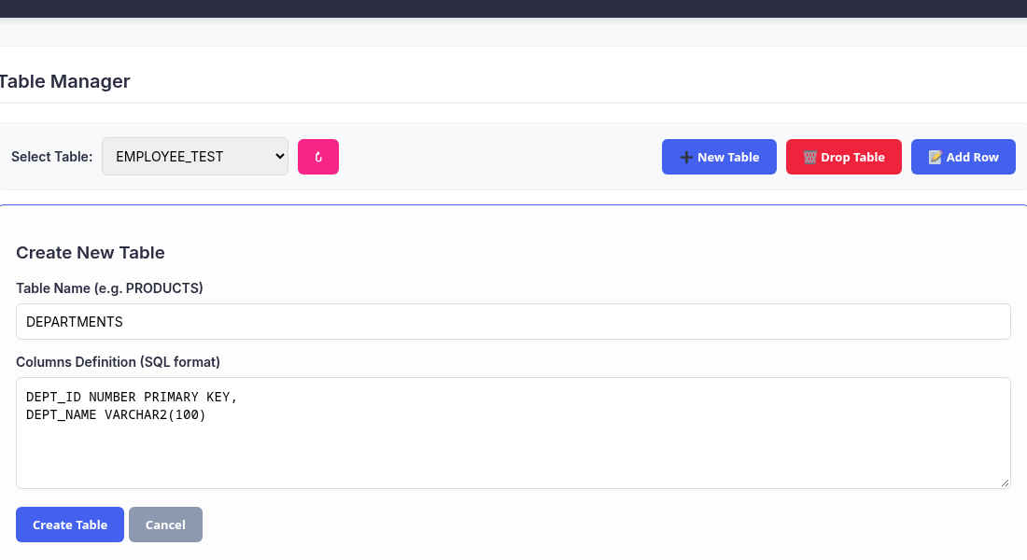

2.4 Dynamic Row Insertion
When 'Add Row' is clicked on an existing table, the system dynamically iterates over the fetched column metadata and generates an input field for each column. The form adapts perfectly regardless of the schema.
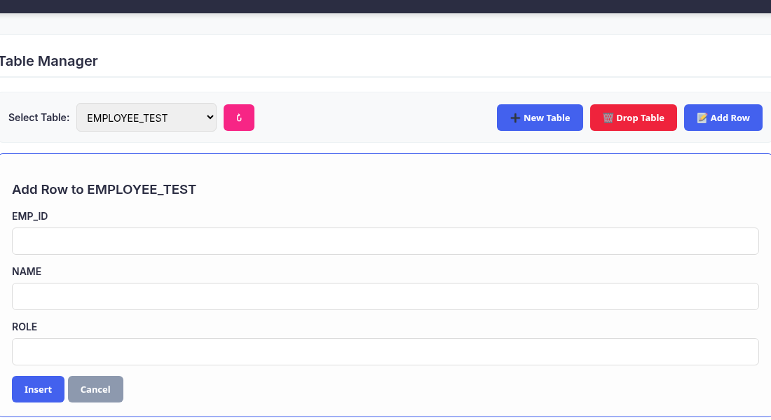

2.5 SQL Runner: Executing DML Statements
For complex operations, the SQL Runner provides a raw terminal interface. Here, an INSERT statement is executed directly. The backend parses this as a non-ResultSet query and returns the success status.
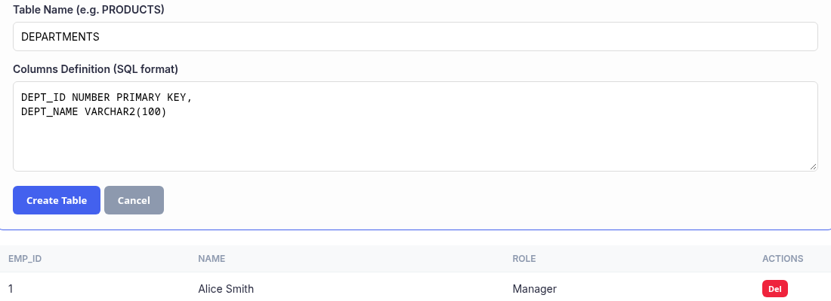

2.6 SQL Runner: Executing DQL and CSV Export
When a SELECT statement is executed, the backend dynamically processes the ResultSet. The frontend detects the data and generates an HTML table. An 'Export CSV' button dynamically appears for data download.
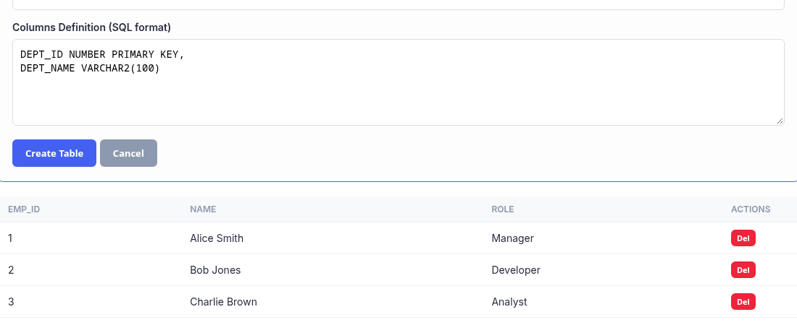

2.7 LocalStorage Query History
Every executed query is saved into the browser's localStorage. The History dropdown allows the user to instantly recall the last 10 queries executed during their session.
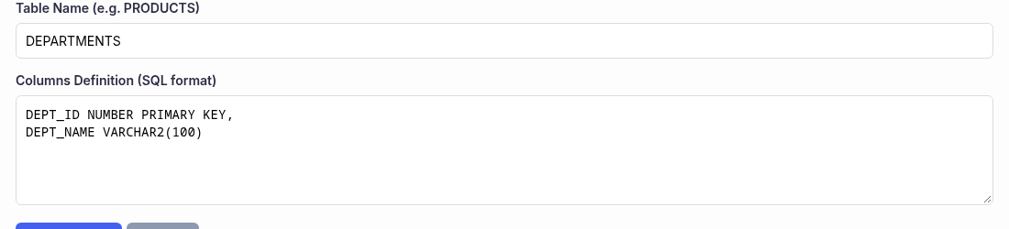

3. In-Depth Frontend Code Analysis
The index.html file contains the structure, styles, and logic in a single file.

3.1 Asynchronous Data Fetching
The core logic relies on the asynchronous executeSQL function. This function abstracts the Fetch API call to the Java backend. By accepting a raw SQL string, it acts as a universal bridge for all database operations.
async function executeSQL(query) {
const response = await fetch(QUERY_URL, {
method: 'POST',
headers: { 'Content-Type': 'application/x-www-form-urlencoded' },
body: `query=${encodeURIComponent(query)}`
});
return response.json();
}

3.2 Dynamic Table Rendering Logic
To render tables dynamically, the frontend first queries the Oracle system view user_tab_cols to get the column metadata. It then constructs the table header string. Subsequently, it queries the actual table data and iterates over the JSON array to construct the table rows.
const colRes = await executeSQL(`SELECT column_name FROM user_tab_cols WHERE table_name = '${t}' ORDER BY column_id`);
currentColumns = colRes.data.map(c => c.COLUMN_NAME);
let headRow = '<tr>';
currentColumns.forEach(c => headRow += `<th>${c}</th>`);
dataRes.data.forEach(row => {
let tr = '<tr>';
currentColumns.forEach(c => {
tr += `<td>${row[c] !== null ? row[c] : 'null'}</td>`;
});
tb.innerHTML += tr;
});

4. In-Depth Backend Code Analysis
The Java backend is designed for extreme efficiency and low latency.

4.1 The HTTP Server Setup
The BackendCRUD.java file initializes the built-in HttpServer. It binds to port 8080 and creates a context path /api/query mapped to a custom HttpHandler.
HttpServer server = HttpServer.create(new InetSocketAddress(8080), 0);
server.createContext("/api/query", new QueryHandler());
server.setExecutor(null);
server.start();

4.2 Handling CORS and HTTP Methods
Because the frontend and backend might be hosted on different origins during development, the QueryHandler explicitly sets Cross-Origin Resource Sharing (CORS) headers.
exchange.getResponseHeaders().add("Access-Control-Allow-Origin", "*");
exchange.getResponseHeaders().add("Access-Control-Allow-Methods", "POST, OPTIONS");
if ("OPTIONS".equals(exchange.getRequestMethod())) {
exchange.sendResponseHeaders(204, -1);
return;
}

5. Database Connectivity (JDBC) & SQL Engine
The SQL execution engine uses JDBC to interact with Oracle dynamically.

5.1 Connection Management
The application employs the modern Java 'try-with-resources' statement to prevent connection leaks.
try (Connection conn = DriverManager.getConnection(DB_URL, USER, PASS)) {
// Logic here
} catch (SQLException e) {
e.printStackTrace();
}

5.2 Dynamic SQL Execution
The core logic utilizes Statement.execute(query). It returns true if the result is a ResultSet (SELECT query), and false if it is an update count (INSERT, UPDATE, DELETE).
boolean isResultSet = stmt.execute(query);
if (isResultSet) {
// SELECT query
} else {
// DML/DDL query
int updateCount = stmt.getUpdateCount();
}

5.3 Metadata Reflection and JSON Serialization
The backend uses ResultSetMetaData to dynamically inspect columns, ensuring it can serialize any database result into JSON.
ResultSetMetaData rsmd = rs.getMetaData();
int colCount = rsmd.getColumnCount();
while (rs.next()) {
sb.append("{");
for (int i = 1; i <= colCount; i++) {
sb.append("\"").append(rsmd.getColumnName(i)).append("\":\"");
String val = rs.getString(i);
sb.append(val != null ? val.replace("\\", "\\\\") : "");
sb.append("\"");
}
sb.append("}");
}

