Warehouse and Supply Chain Management System
Digital Assignment 1 (DA1)
ER / EER Model and Normalization up to BCNF

Database Management Systems
Vellore Institute of Technology, Chennai

Submitted by
Safwaan Mohamed S — 25BCE1188
Avi Dhandhania — 25BCE1207
Priyal Bhalla — 25BCE1261

Submission deadline: 31 July 2026

1. Problem Statement, Objectives and Scope

1.1 Problem Statement
A warehouse business has to know three things at all times: what stock it holds and where, who supplies each product, and where every customer order has reached. In most small and mid-sized operations these three answers live in separate places — a purchase register, a stock sheet on the warehouse floor, and a delivery log kept by the transport team. Nothing keeps the three in agreement.
The result is that the same fact ends up written down in several places. A customer's address appears on every order they have ever placed, and a product's name appears on every order line that includes it. When one copy is corrected and another is missed, the data starts contradicting itself, and the following problems follow directly:
- A new supplier or customer cannot be recorded until they appear on an order.
- Deleting the last order for a customer erases that customer completely.
- Correcting a product name or an address means editing many rows, and any row that is missed leaves the database in two minds.
- Nobody can say reliably how much of a product is on hand, because the figure is kept in more than one place.
These are known as insert, delete and update anomalies. They are not caused by missing data — they are caused by the same data being stored more than once. Normalization is the process that removes that duplication, and this assignment applies it step by step.

1.2 Objectives
- O1. Identify the entities, attributes and relationships the system needs.
- O2. Draw an ER model for the design using Chen notation.
- O3. Extend that same model into an EER model, adding specialization, a weak entity, and multivalued, composite and derived attributes.
- O4. Convert the EER model into relational tables using the standard mapping rules.
- O5. Normalize every table step by step from UNF through 1NF, 2NF and 3NF up to BCNF, showing the tables at each stage.
- O6. Confirm that no table in the final design can hold a contradiction.

1.3 Scope
In scope: seven entities covering warehouses, products, suppliers, customers, orders, shipments and employees; the relationships between them; the conversion of the design into tables; and normalization up to BCNF.
Out of scope for DA1: writing the SQL and PL/SQL (that is DA2), and rebuilding the project on a modern database technology (that is DA3). Billing, tax, user logins and demand forecasting are left out of the design altogether so that the model stays small enough to explain in full.

2. Entities and Attributes
The design uses seven entities. The key attribute of each one is the column that identifies a single row, and it is shown underlined in every diagram in this report.
Entity | Key attribute | Other attributes
WAREHOUSE | WarehouseID | WName, City, Capacity
PRODUCT | ProductID | PName, Category, UnitPrice
SUPPLIER | SupplierID | SName, City, Phone (many per supplier)
CUSTOMER | CustomerID | CName, Address (Street + City + Pincode), Phone
ORDERS | OrderID | OrderDate, Status, TotalAmt (calculated)
SHIPMENT | ShipmentID | DispatchDate, DeliveryDate, Status
EMPLOYEE | EmpID | EName, Role, Salary

3. Relationships
Seven relationships connect the entities. '1:N' means one row on the left can be linked to many rows on the right. 'M:N' means many on both sides.
Relationship | Between | Type | Meaning
SUPPLIES | SUPPLIER – PRODUCT | M:N | A supplier supplies many products; a product comes from many suppliers. Carries LeadTimeDays.
STORED_IN | PRODUCT – WAREHOUSE | M:N | A product is stocked in many warehouses. Carries Quantity.
CONTAINS | PRODUCT – ORDERS | M:N | An order contains many products. Carries Qty.
WORKS_AT | WAREHOUSE – EMPLOYEE | 1:N | Every employee is posted to exactly one warehouse.
PLACES | CUSTOMER – ORDERS | 1:N | Every order belongs to exactly one customer.
SHIPPED_BY | ORDERS – SHIPMENT | 1:N | One order can go out in more than one shipment.
DISPATCHED_FROM | WAREHOUSE – SHIPMENT | 1:N | Every shipment leaves from one warehouse.

4. ER Model
The figure below shows the whole design as one ER diagram in Chen notation: rectangles are entities, diamonds are relationships and ellipses are attributes. The 1, M and N marks on each line say how many rows can take part, and a double line means taking part is compulsory — for example, every order must belong to a customer.
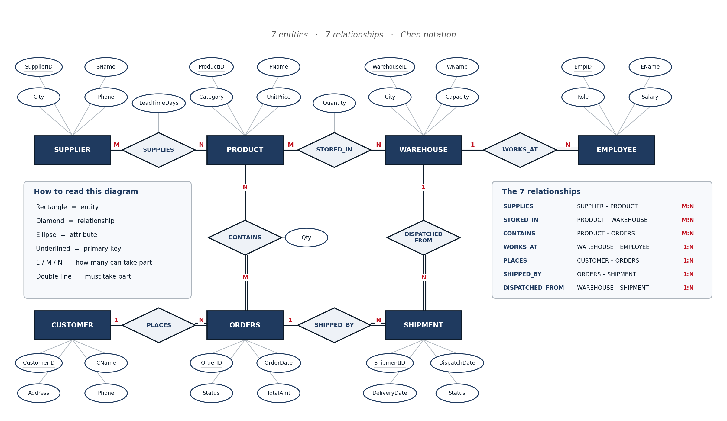
Figure 1 — ER model: 7 entities and 7 relationships

5. EER Model
An EER model is the same ER model with a few extra ideas added, so it can describe situations plain ER cannot. Figure 2 is the identical design from Figure 1 with those additions marked in green.
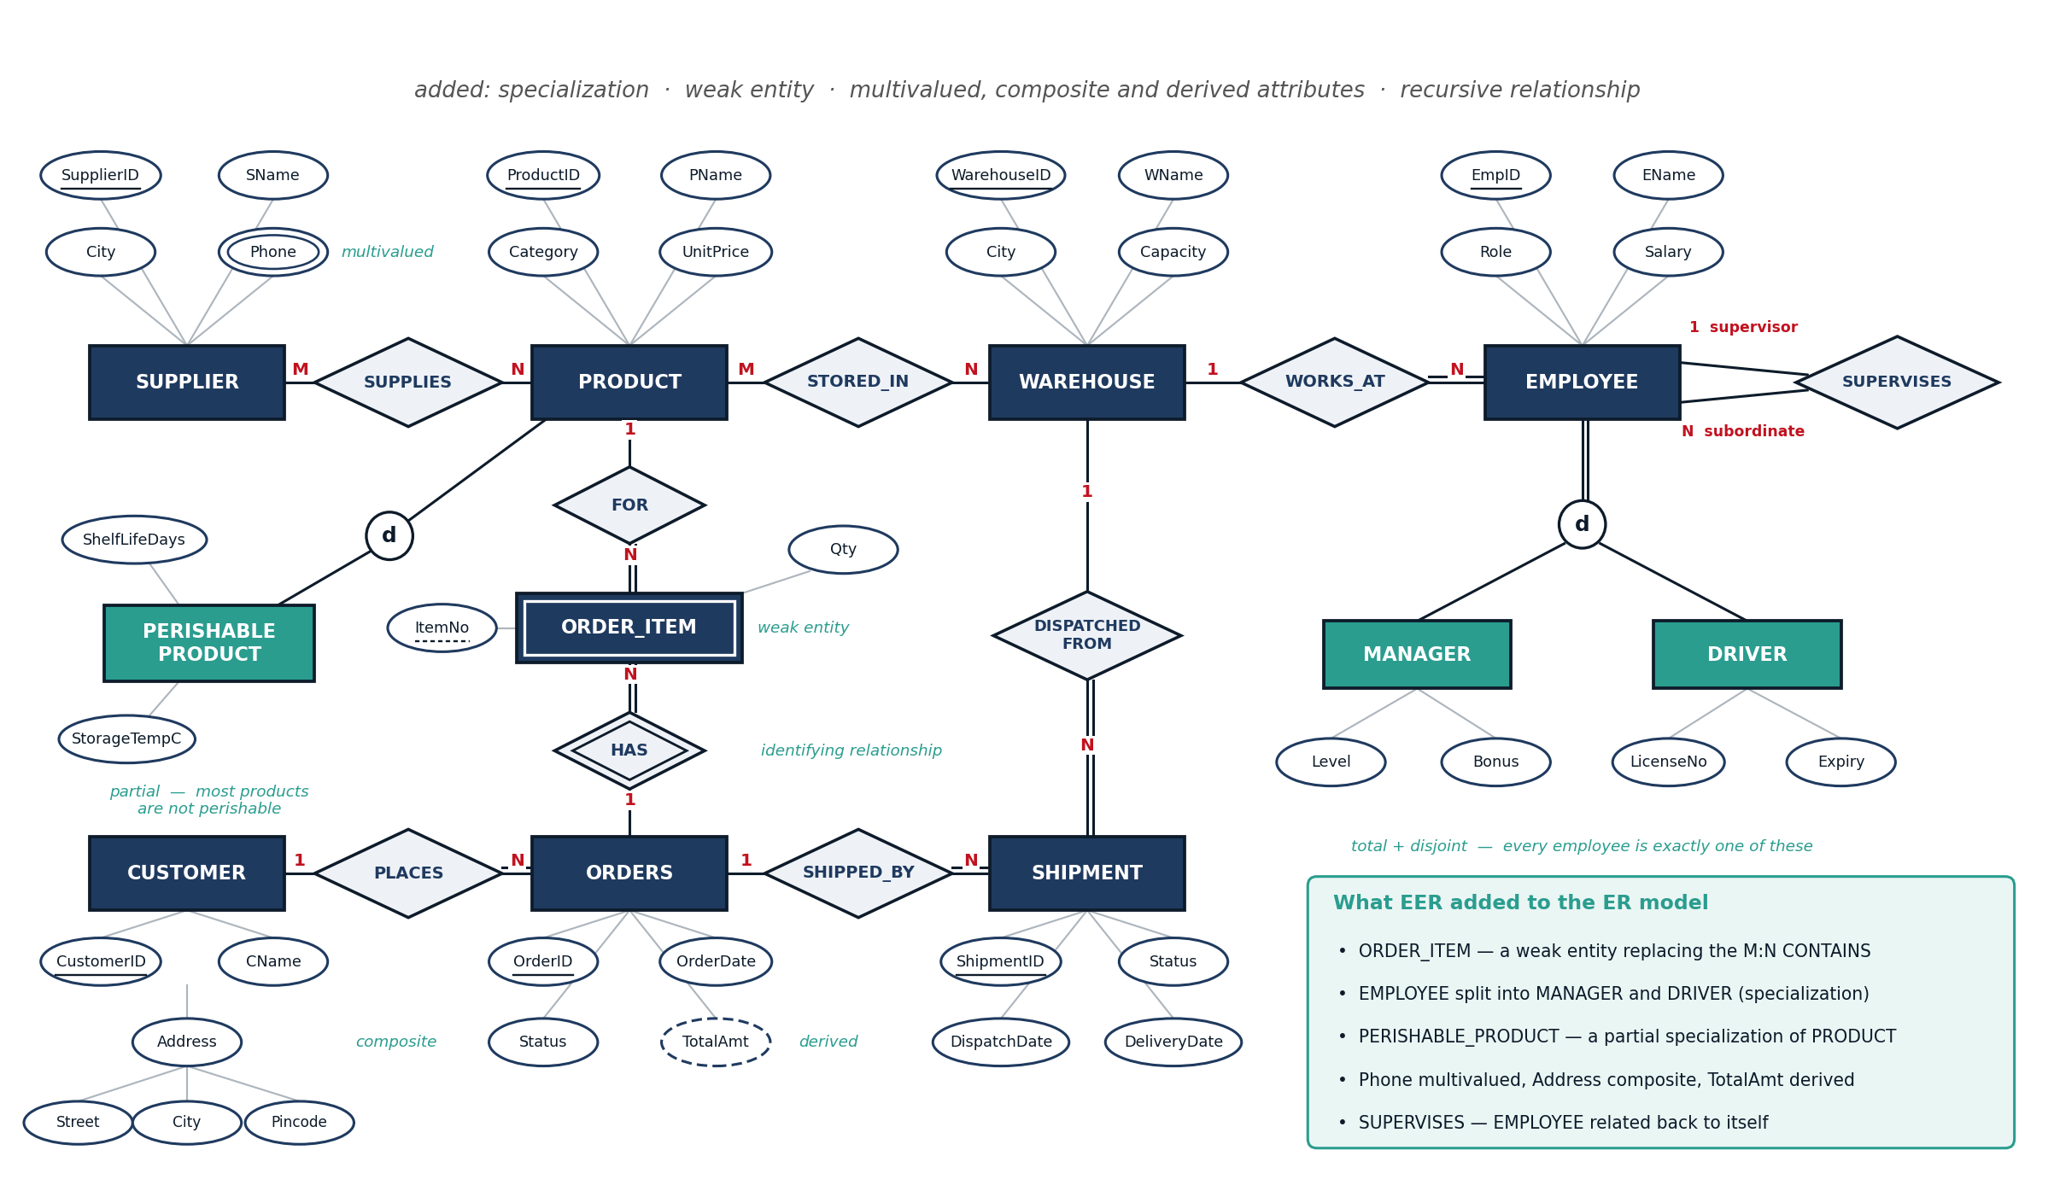
Figure 2 — the same model, extended with EER features

5.1 What EER Added and Why
EER feature | Where | Why it is needed
Weak entity | ORDER_ITEM | An order line means nothing without its order, and ItemNo (1, 2, 3 …) is only unique inside one order. So its key is OrderID + ItemNo. This replaces the M:N CONTAINS relationship.
Specialization  (total, disjoint) | EMPLOYEE →  MANAGER, DRIVER | Every employee is exactly one of the two, never both and never neither. A manager has Level and Bonus; a driver has LicenseNo and Expiry.
Specialization  (partial) | PRODUCT →  PERISHABLE_PRODUCT | Only some products are perishable. Only those need ShelfLifeDays and StorageTempC, so the rest are not forced to store empty columns.
Multivalued attribute | SUPPLIER.Phone | One supplier can have several phone numbers.
Composite attribute | CUSTOMER.Address | Address is made of Street, City and Pincode, which we sometimes need separately.
Derived attribute | ORDERS.TotalAmt | It can always be worked out by adding up the order lines, so storing it would only create a second copy that can go stale.
Recursive relationship | EMPLOYEE  SUPERVISES EMPLOYEE | An employee reports to another employee, so the relationship joins one entity to itself.
The weak entity is worth singling out. ORDER_ITEM is drawn with a double border because it cannot exist on its own, and the diamond joining it to ORDERS is drawn as a double diamond to show that this is the relationship that gives it its identity. Its partial key, ItemNo, is underlined with a dashed line because it is only unique within one order.

6. Converting the EER Model into Tables
The EER model is converted into relational tables using the standard mapping rules:
- Each entity becomes one table, and its key attribute becomes the primary key.
- Each 1:N relationship becomes a foreign key stored on the 'many' side.
- Each M:N relationship becomes a new table whose primary key is the two keys put together.
- Each multivalued attribute becomes its own small table.
- Each composite attribute becomes one column per part.
- A derived attribute is not stored at all; it is calculated when needed.
- A weak entity becomes a table keyed by its owner's key plus its own partial key.
- A specialization becomes one table per subclass, each sharing the superclass's key.
Applying these rules produces 16 tables. Those tables are the starting point for the normalization in the next section, and the finished set is shown in Figure 8.

7. Normalization
Normalization is done by starting from one badly designed table and splitting it, one rule at a time, until no table can store the same fact twice. Each step below shows the tables before and after the split, with the exact dependency that forced it.
A functional dependency, written X → Y, means that if you know X then Y is fixed. For example CustID → CName: once you know the customer's ID, the name is decided. Every normal form is a rule about which dependencies are allowed to exist in a table.

7.1 Where we start — Unnormalized Form (UNF)
Everything sits in one wide table, the way a clerk would keep it in a spreadsheet. One cell holds several phone numbers, and another holds a whole group of product lines. Because customer details are repeated on every order row, the same fact is stored many times — and that is what causes the insert, delete and update problems listed in the figure.
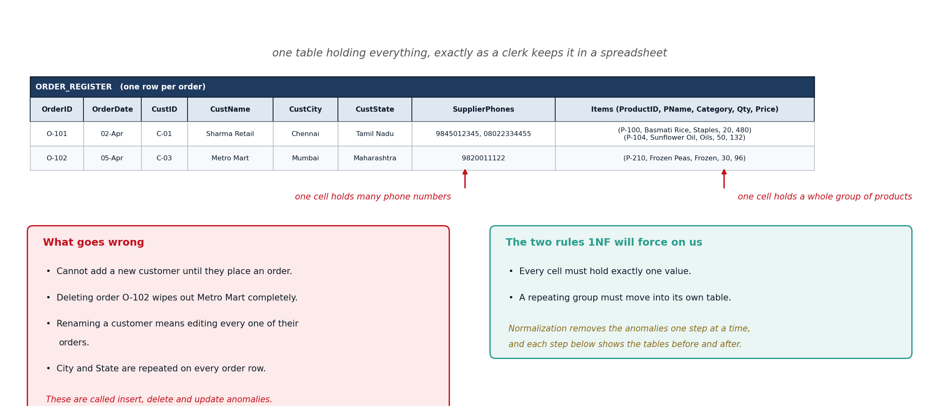
Figure 3 — Where we start — Unnormalized Form (UNF)

7.2 First Normal Form (1NF)
1NF asks for two things: every cell must hold exactly one value, and a repeating group must move into its own table. So the product lines become ORDER_ITEM and the phone numbers become SUPPLIER_PHONE. ORDER_ITEM needs OrderID and ProductID together as its key, because neither one alone identifies a row.
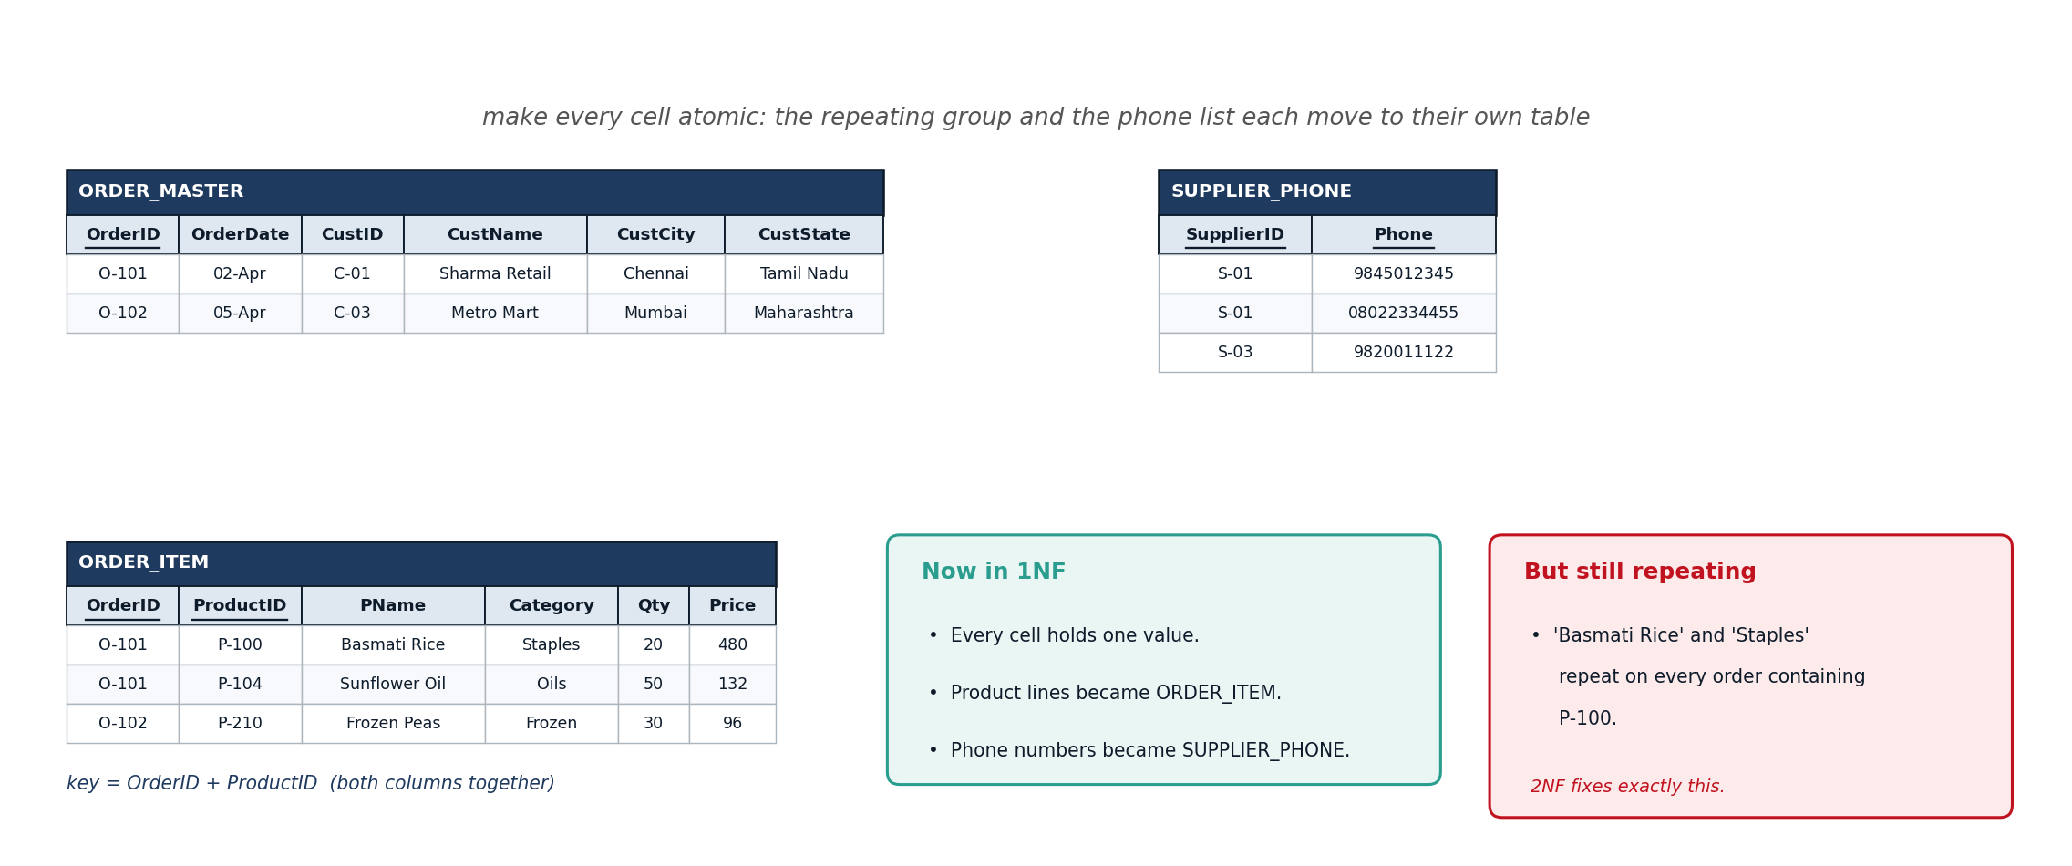
Figure 4 — First Normal Form (1NF)

7.3 Second Normal Form (2NF)
2NF removes partial dependency, which means a column must depend on the whole key and not just a part of it. In ORDER_ITEM the key is {OrderID, ProductID}, but PName and Category depend on ProductID alone. They describe the product, not the order, so they move into a new PRODUCT table. A product name is now written down exactly once.
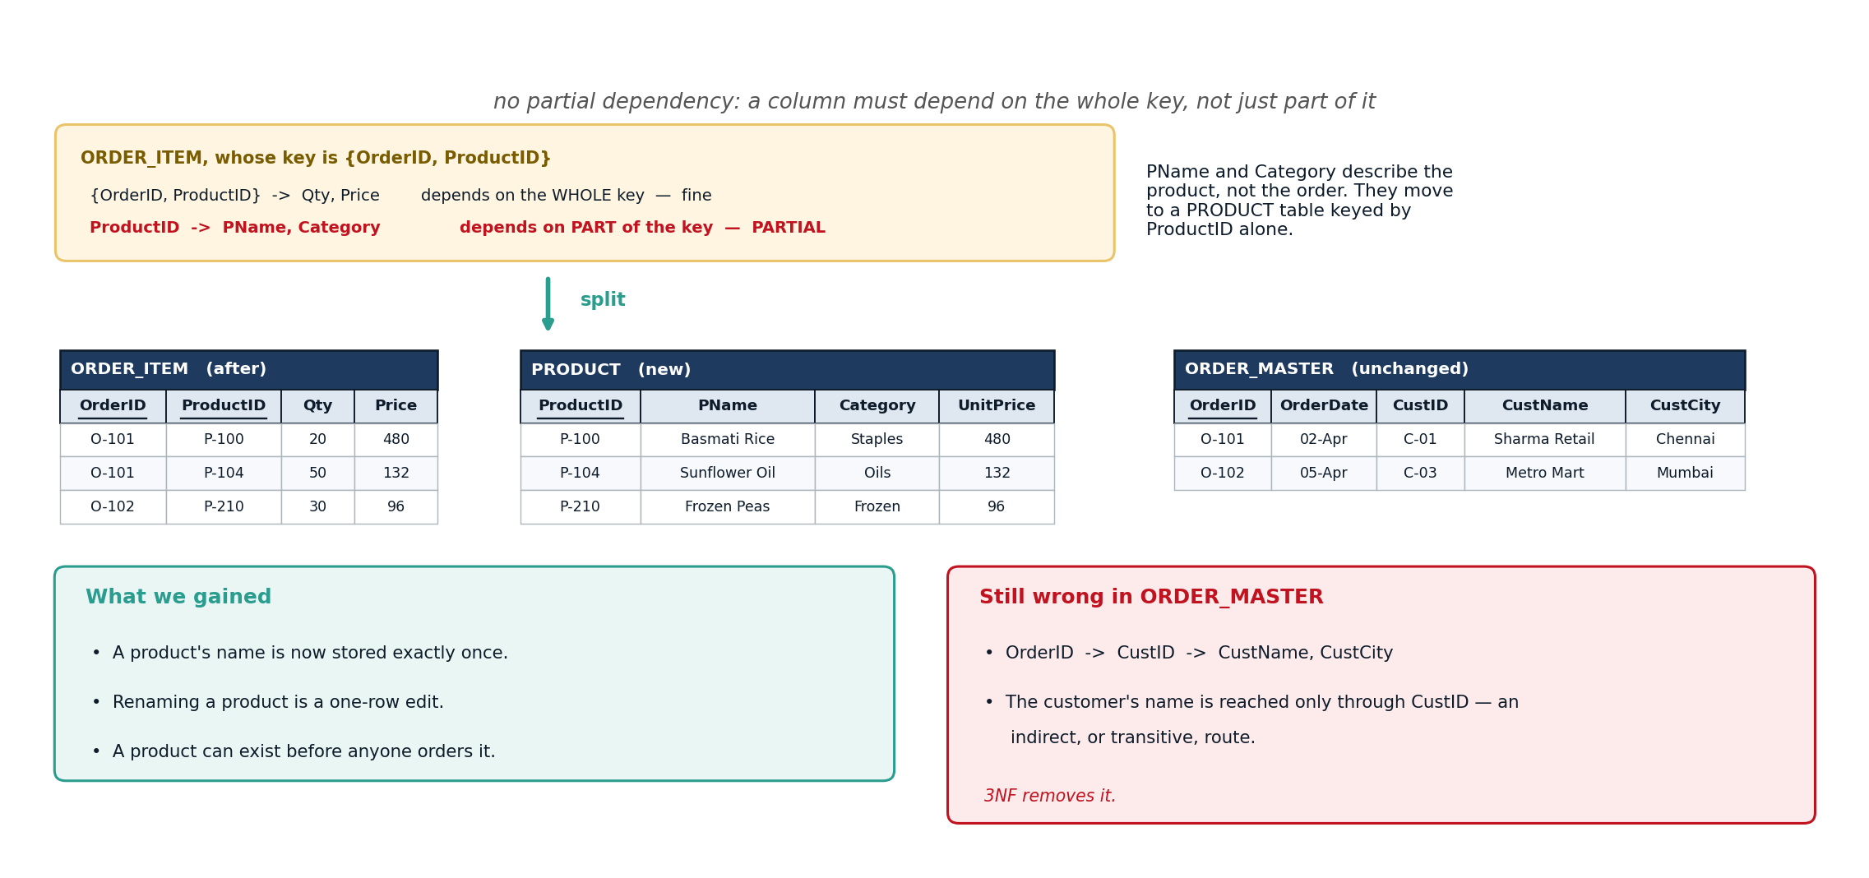
Figure 5 — Second Normal Form (2NF)

7.4 Third Normal Form (3NF)
3NF removes transitive dependency, which means one ordinary column must not decide another. In ORDER_MASTER the customer's name is reached only through CustID, and the state is reached only through the city. Both indirect routes are pulled out into CUSTOMER and CITY. After this step every one of our 16 tables is in 3NF.
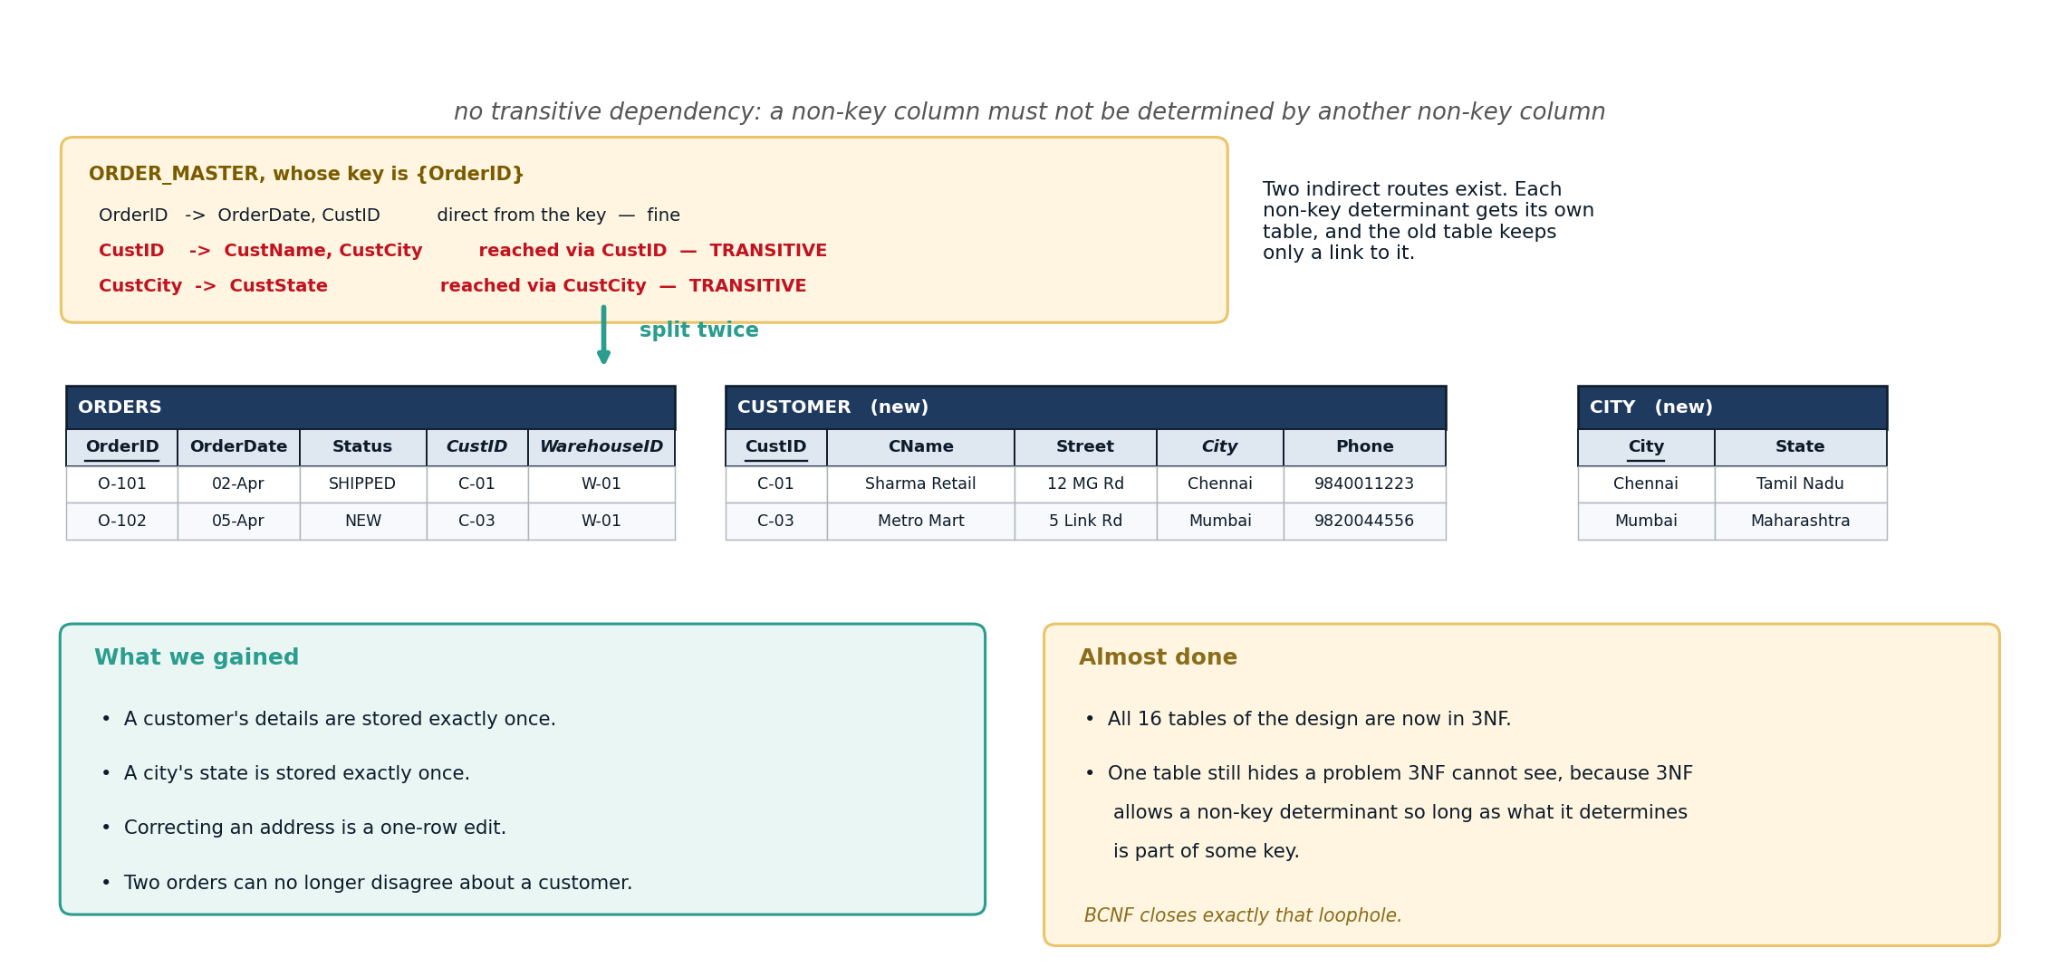
Figure 6 — Third Normal Form (3NF)

7.5 Boyce-Codd Normal Form (BCNF)
BCNF applies one strict rule: the left-hand side of every dependency must be a key. DELIVERY_DUTY passes 3NF only because every column happens to belong to some key, yet DriverID still decides City while not being a key itself — so a driver's city is stored twice and the two copies can disagree. Splitting on that dependency gives DRIVER_CITY and ORDER_DRIVER, and the join on DriverID rebuilds the original rows exactly, so nothing is lost.
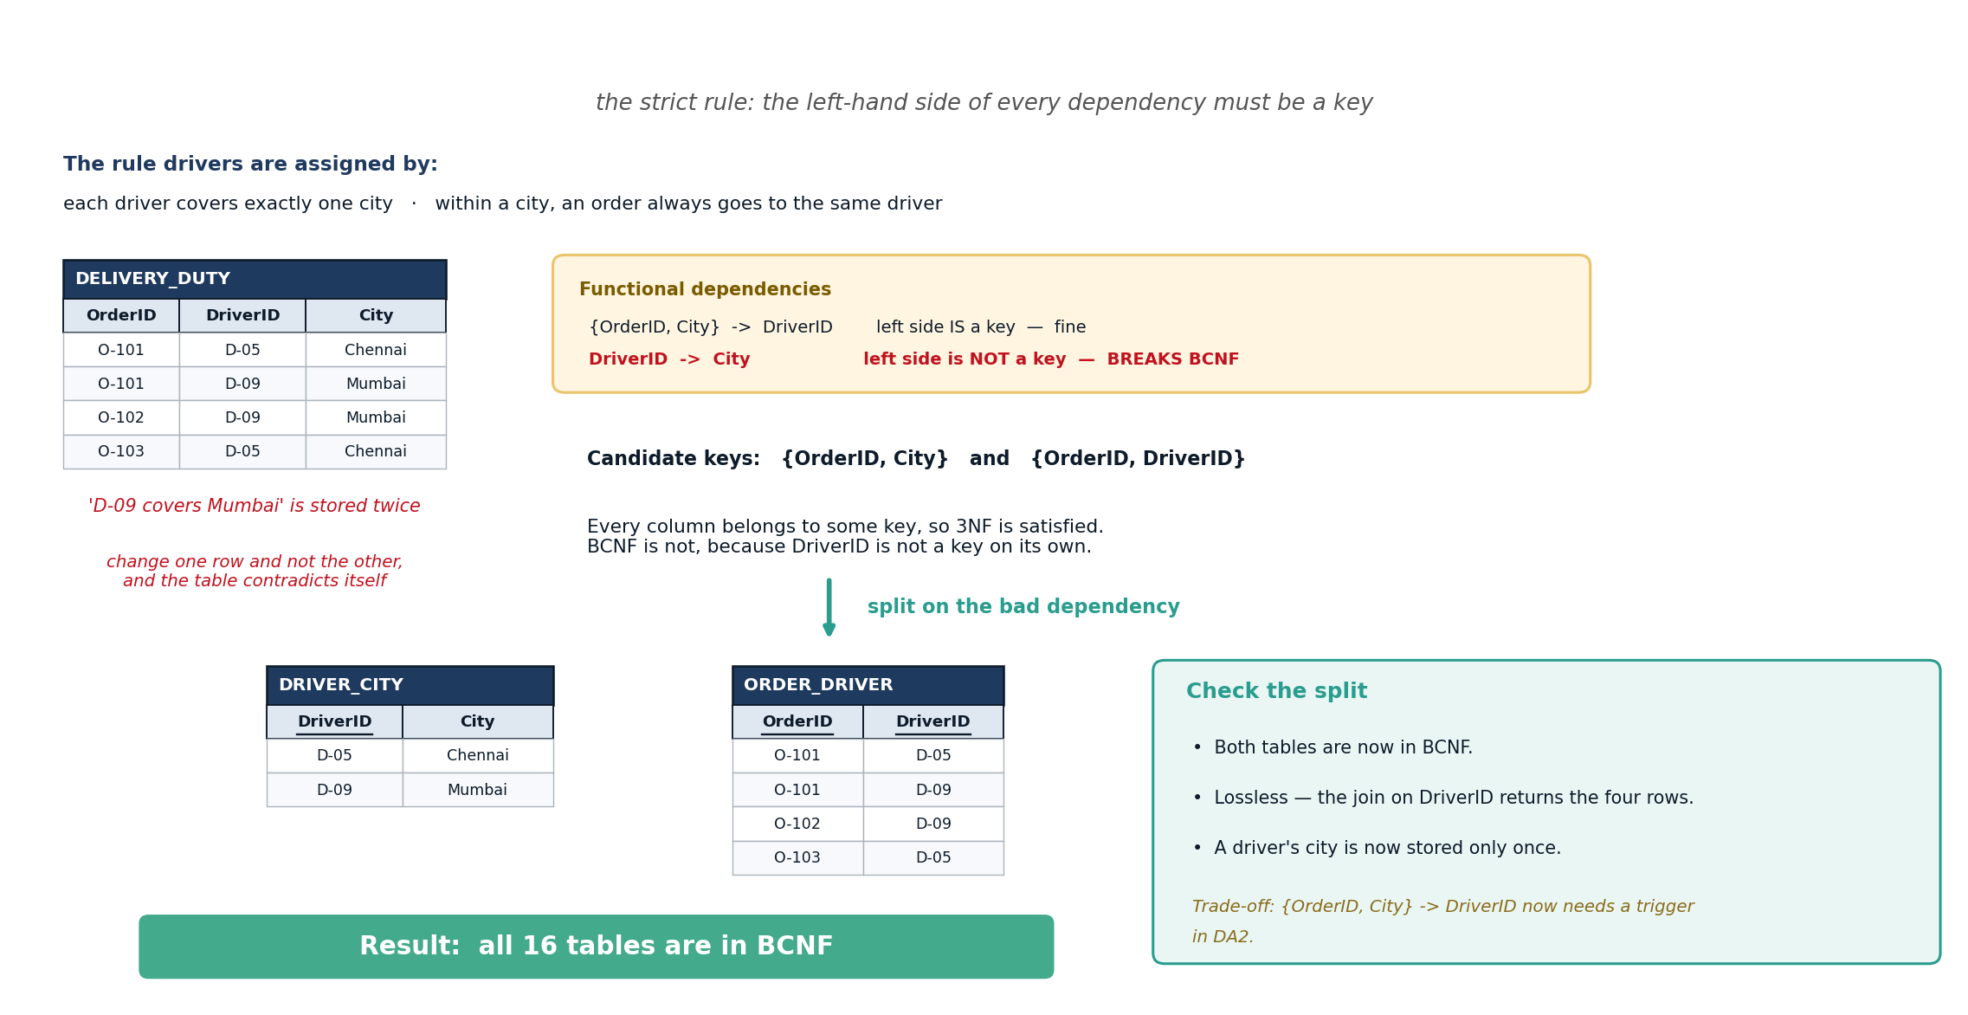
Figure 7 — Boyce-Codd Normal Form (BCNF)

8. Final Schema
The finished design has 16 tables and every one of them is in BCNF, which also means every one is in 1NF, 2NF and 3NF.
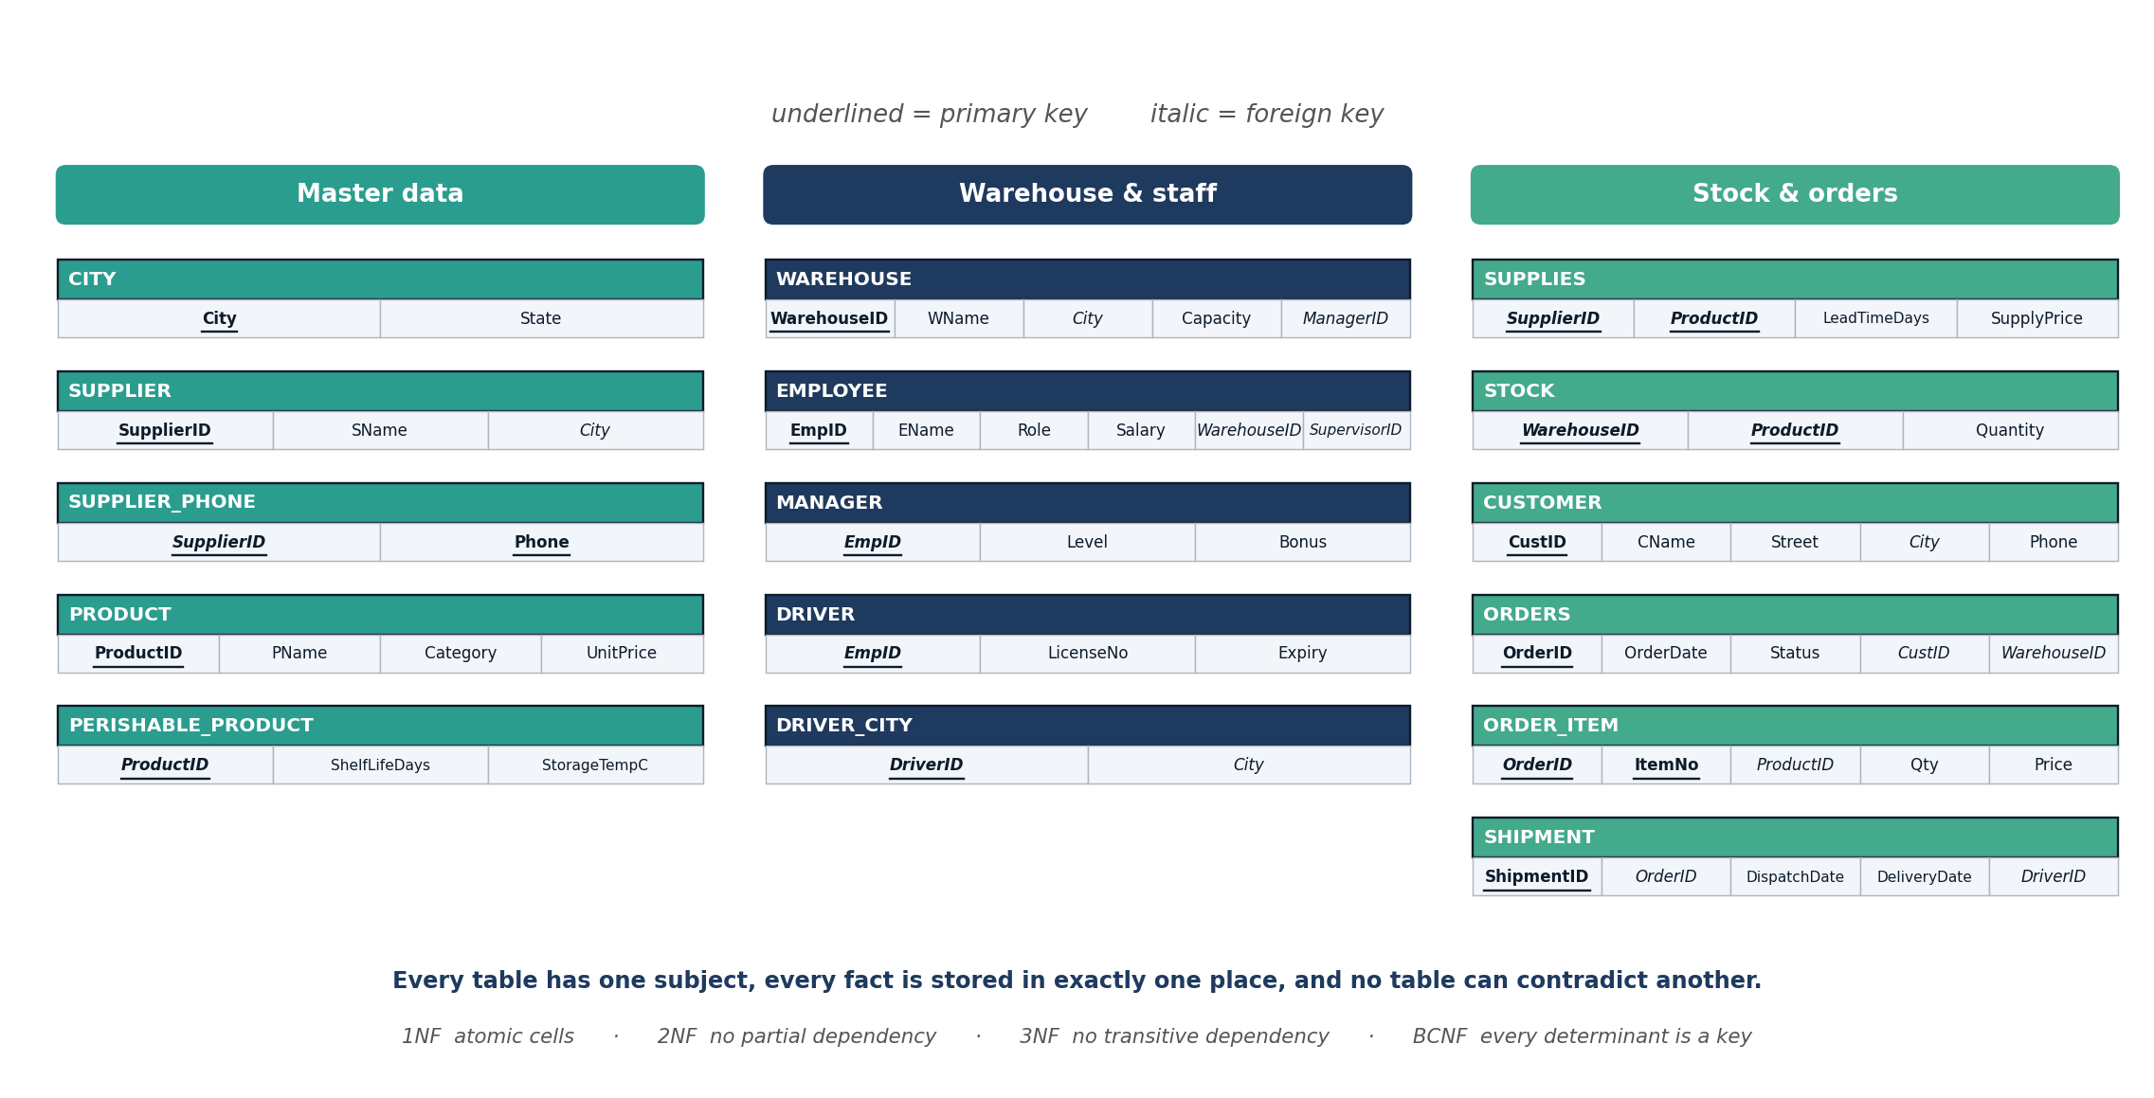
Figure 8 — final relational schema, all 16 tables in BCNF

8.1 Keys of Every Table
Table | Primary key | Foreign keys
CITY | City | —
SUPPLIER | SupplierID | City
SUPPLIER_PHONE | SupplierID + Phone | SupplierID
PRODUCT | ProductID | —
PERISHABLE_PRODUCT | ProductID | ProductID
WAREHOUSE | WarehouseID | City, ManagerID
EMPLOYEE | EmpID | WarehouseID, SupervisorID
MANAGER | EmpID | EmpID
DRIVER | EmpID | EmpID
DRIVER_CITY | DriverID | DriverID, City
SUPPLIES | SupplierID + ProductID | SupplierID, ProductID
STOCK | WarehouseID + ProductID | WarehouseID, ProductID
CUSTOMER | CustID | City
ORDERS | OrderID | CustID, WarehouseID
ORDER_ITEM | OrderID + ItemNo | OrderID, ProductID
SHIPMENT | ShipmentID | OrderID, DriverID
Every figure in this report is also supplied as a full-resolution image in the diagrams folder, and each one fills a whole slide in the accompanying presentation.

8.2 Why the Design Is Now Safe
- Every fact is stored in exactly one place, so two rows can never disagree.
- Correcting a product name, a customer address or a city's state is a single-row edit.
- A supplier, product or customer can be added before it appears on any order.
- Deleting an order cannot wipe out the customer who placed it.
- TotalAmt is calculated from the order lines rather than stored, so it can never fall out of step with them.
One trade-off is worth recording. Splitting DELIVERY_DUTY into DRIVER_CITY and ORDER_DRIVER means the rule '{OrderID, City} → DriverID' can no longer be checked inside a single table. It will be enforced by a trigger in DA2. This is the normal price of BCNF, and it is worth paying here because the alternative allows a driver to be recorded against two different cities at once.

9. Conclusion and Next Steps
DA1 delivered an ER model of seven entities and seven relationships, the same model extended into an EER model with specialization, a weak entity and multivalued, composite and derived attributes, and a full normalization from UNF to BCNF in which every step is shown with the tables before and after. The result is 16 tables, all in BCNF.
DA2 (due 18 September 2026): create the 16 tables in SQL with their keys and constraints, load sample data, add the trigger that enforces the dependency lost at BCNF, and write PL/SQL procedures for receiving stock and dispatching an order.
DA3 (due 23 October 2026): rebuild the same project on one modern database technology. The current plan is a graph database (Neo4j), because tracing a delivery back through shipment, order, warehouse and supplier is a chain of hops that a graph query expresses in one line, whereas SQL needs a fresh join for every extra step.

