Atlanta Population

1. use db.zipcodes.find() to filter results to only the results where city is ATLANTA and state is GA.

:db.zipcodes.find({city:’ATLANTA’,state:’GA’}).pretty()

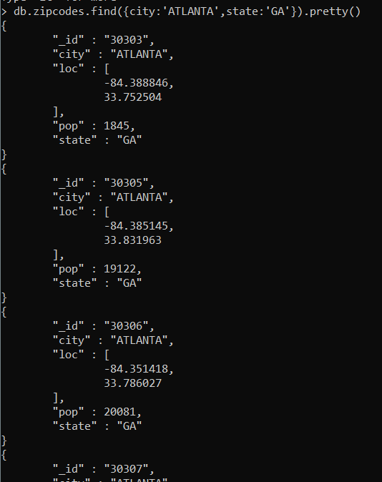

1. use db.zipcodes.aggregate with $match to do the same as above.

:db.zipcodes.aggregate([{$match:{city:’ATLANTA’,state:’GA’}}]).pretty()

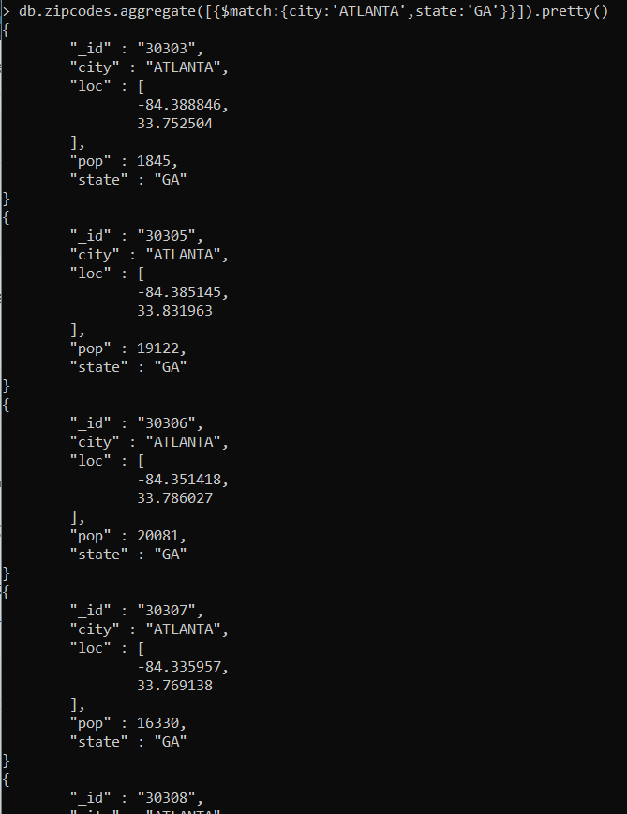

1. use $group to count the number of zip codes in Atlanta.

:db.zipcodes.aggregate([{$match:{city:’ATLANTA’}},{$group:{_id:null,count:{$sum:1}}}])

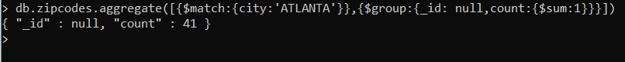

1. use $group to find the total population in Atlanta.

: db.zipcodes.aggregate([{$match:{city:’ATLANTA’}},{$group:{_id:null,count:{$sum:’$pop’}}}])



Population By State

1. use aggregate to calculate the total population for each state

:db.zipcodes.aggregate([{$group:{_id:’$state’,total:{$sum:’$pop’}}}])

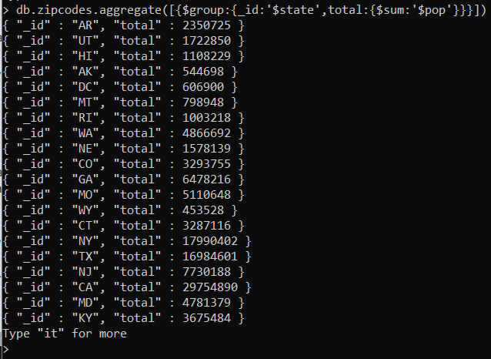

1. sort the results by population, highest first

:db.zipcodes.aggregate([{$group:{_id:’$state’,total:’{$sum:’$pop’}}},{$sort:{total:-1}}])

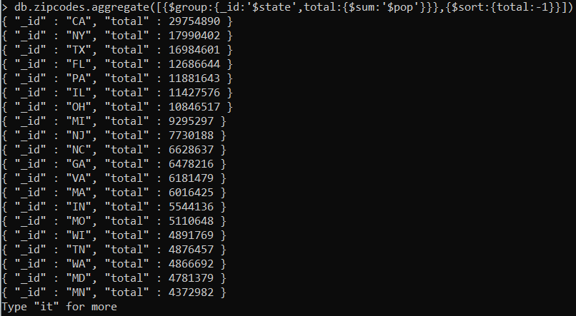

1. limit the results to just the first 3 results. What are the top 3 states in population?

: db.zipcodes.aggregate([{$group:{_id:’$state’,total:’{$sum:’$pop’}}},{$sort:{total:-1}},{$limit:3}])

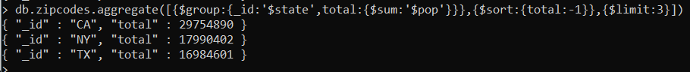

Populations by City

1. use aggregate to calculate the total population for each city (you have to use city/state combination). You can use a combination for the _id of the $group: { city: '$city', state: '$state' }

:db.zipcodes.aggregate([{$group:{_id:{city:’$city’,state:’$state’},total:{$sum:’$pop’}}}])

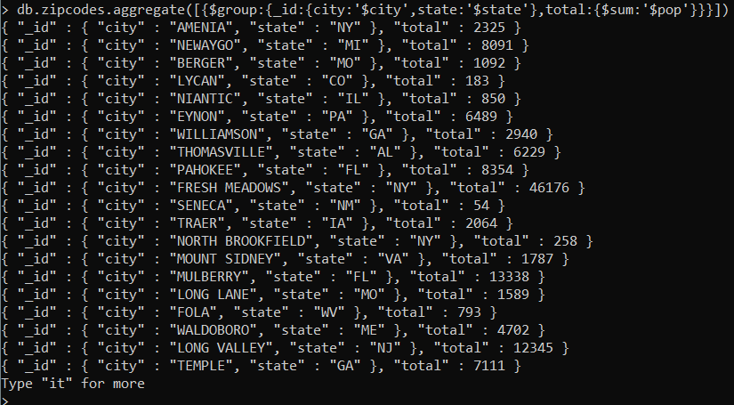

1. sort the results by population, highest first

: db.zipcodes.aggregate([{$group:{_id:{city:’$city’,state:’$state’},total:{$sum:’$pop’}}},{$sort:{total:-1}])

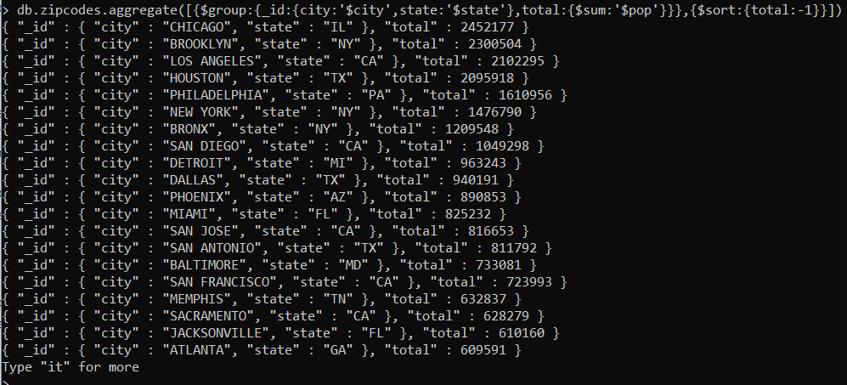

1. limit the results to just the first 3 results. What are the top 3 cities in population?

: db.zipcodes.aggregate([{$group:{_id:{city:’$city’,state:’$state’},total:{$sum:’$pop’}}},{$sort:{total:-1},{$limit:3}])



1. What are the top 3 cities in population in Texas?

:db.zipcodes.aggregate([{$match:{state:’TX’}},{$group:{_id:{city:’$city’},total:{$sum:’$pop’}}},{$sort:{total:-1}},{$limit:3}])



Bonus

1. Write a query to get the average city population for each state.

: db.zipcode.aggregate([{$group:{_id:{state:’$state’},Average_population:{$avg:’$pop’}}}])

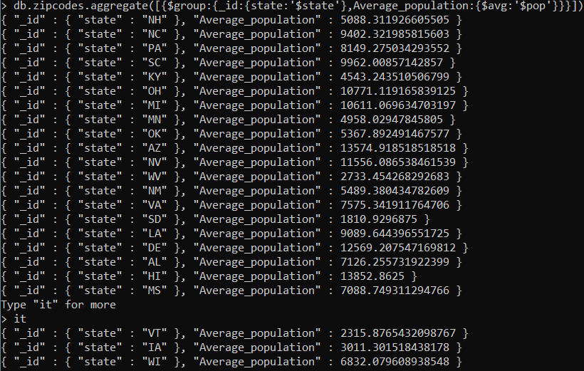

1. What are the top 3 states in terms of average city population?

:db.zipcode.aggregate([{$group:{_id:{state:’$state’},Average_population:{$avg:’$pop’}}},

{$sort:{Average_population:-1}},{$limit:3}])

