After importing the file:

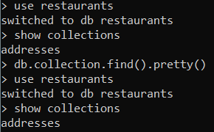

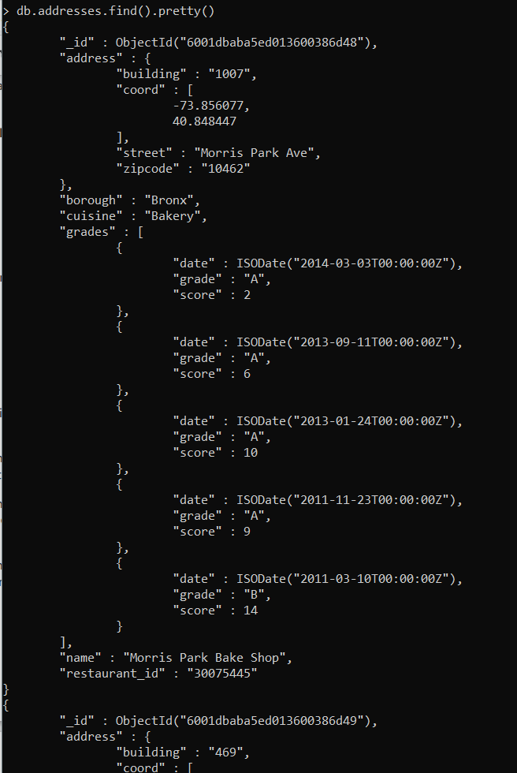

Exercise Questions

1. Write a MongoDB query to display all the documents in the collection restaurants.

:db.addresses.find()



1. Write a MongoDB query to display the fields restaurant_id, name, borough and cuisine for all the documents in the collection restaurant.

:db.addresses.find({},{‘restaurant_id’:1,’name’:1,’borough’:1,’cuisine’:1})

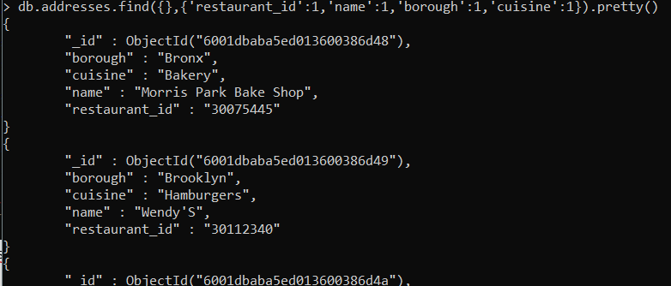

1. Write a MongoDB query to display the fields restaurant_id, name, borough and cuisine, but exclude the field _id for all the documents in the collection restaurant.

: db.addresses.find({},{‘restaurant_id’:1,’name’:1,’borough’:1,’cuisine’:1,’_id’:0})

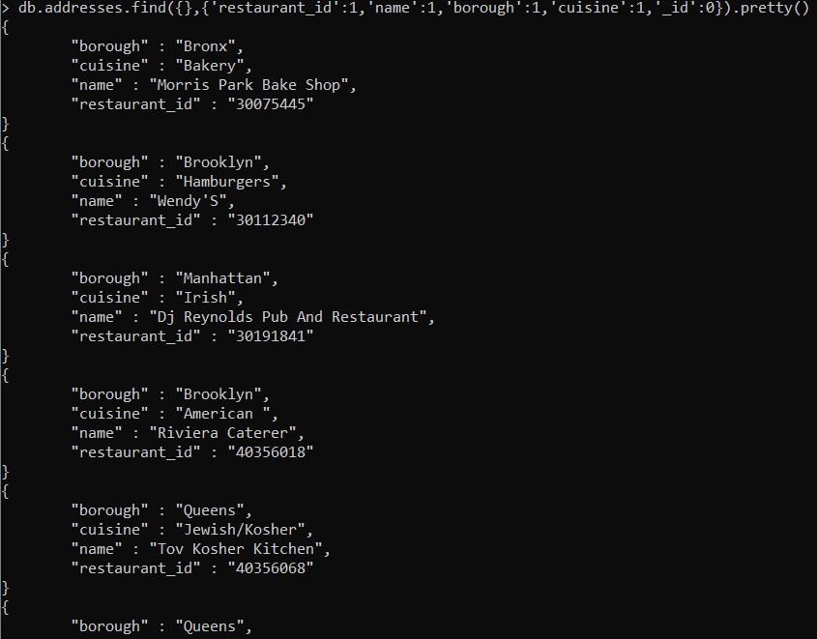

1. Write a MongoDB query to display the fields restaurant_id, name, borough and zip code, but exclude the field _id for all the documents in the collection restaurant.

: db.addresses.find({},{‘restaurant_id’:1,’name’:1,’borough’:1,’address.zipcode’:1,’_id’:0})

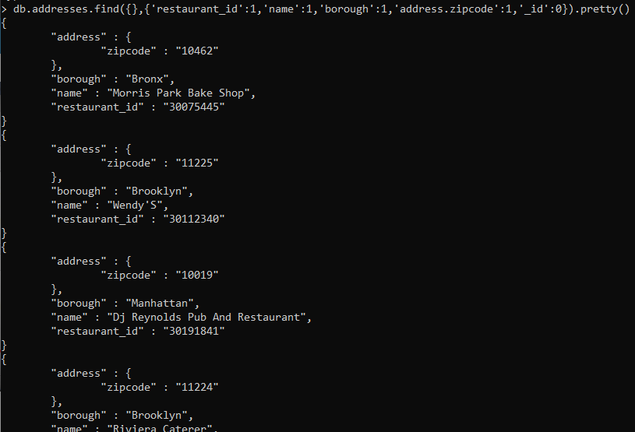

1. Write a MongoDB query to display the first 5 restaurant which is in the borough Bronx.

: db.addresses.find({borough:’Bronx’}).limit(5).pretty()

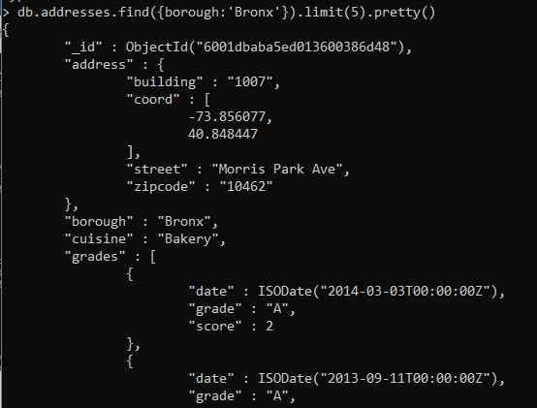

1. Write a MongoDB query to display all the restaurant which is in the borough Bronx.

: db.addresses.find({borough:’Bronx’}).pretty()

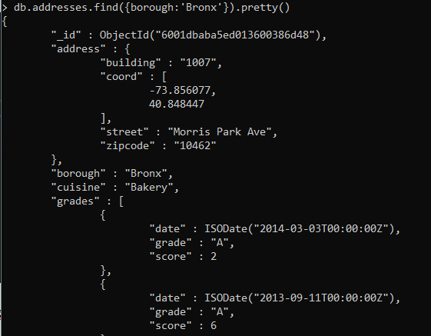

1. Write a MongoDB query to display the next 5 restaurants after skipping first 5 which are in the borough Bronx.

: db.addresses.find({borough:’Bronx’}).skip(5).limit(5).pretty()

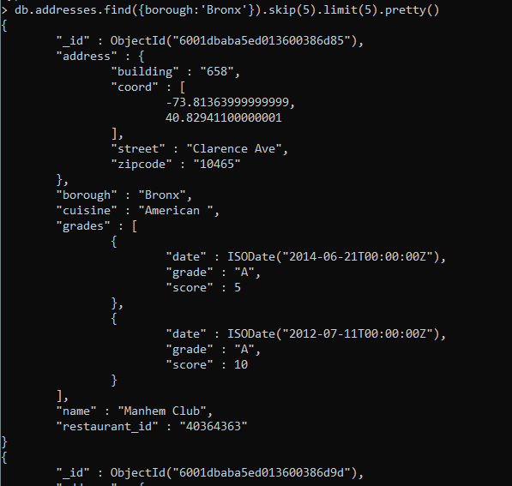

1. Write a MongoDB query to find the restaurants who achieved a score more than 90.

:db.addresses.find({‘grades.score’:{$gt:90}})

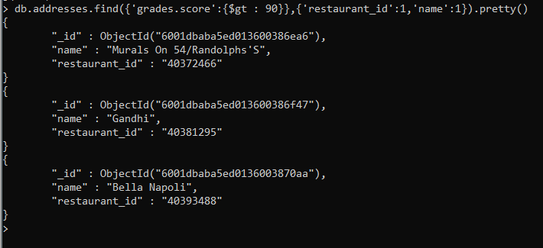

**Projecting for better representation**

1. Write a MongoDB query to find the restaurants that achieved a score, more than 80 but less than 100.

: db.addresses.find({‘grades’:{$elemMatch:{‘score’:{$gt:80 , $lt:100}}}})

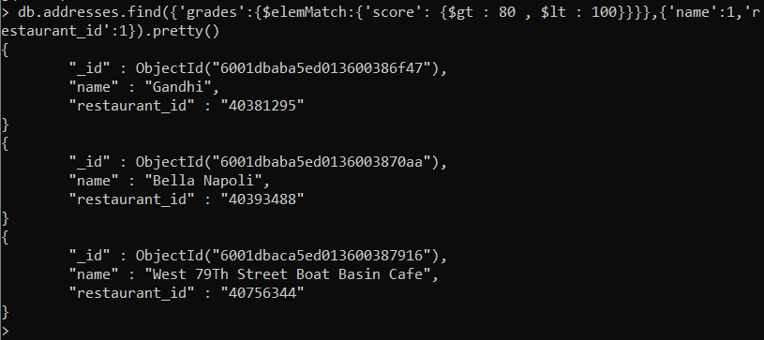

1. Write a MongoDB query to find the restaurants which locate in latitude value less than -95.754168.

: db.addresses.find({'address.coord.0':{$lt : -95.754168}})

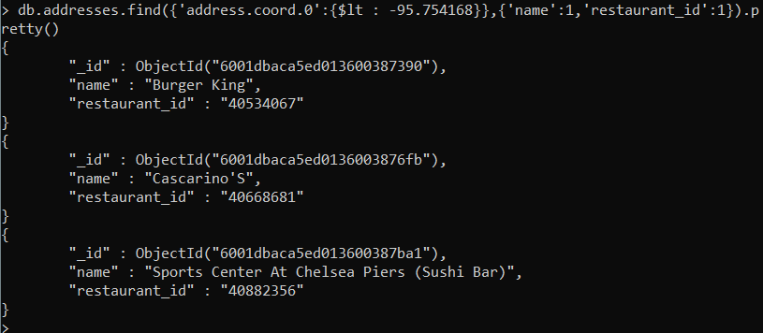

1. Write a MongoDB query to find the restaurants that do not prepare any cuisine of 'American' and their grade score more than 70 and latitude less than -65.754168.

: db.addresses.find({'grades.score':{$gt : 90},

'address.coord.0':{$lt : -65.754168},'cuisine':{$not:/American/}})

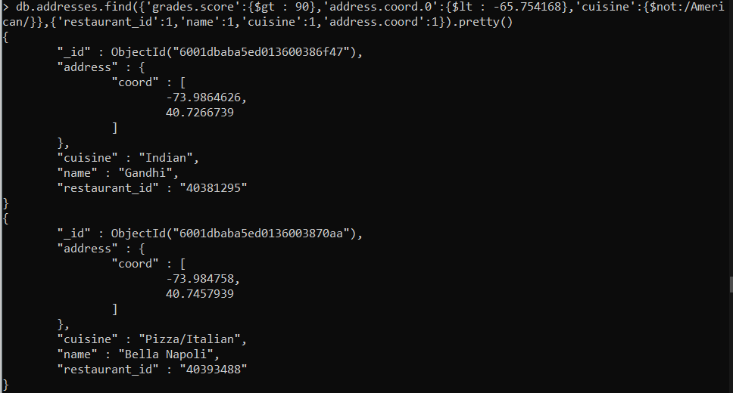

1. Write a MongoDB query to find the restaurants which do not prepare any cuisine of 'American' and achieved a score more than 70 and located in the longitude less than -65.754168.

:**Same as Q no. 11**

1. Write a MongoDB query to find the restaurants which do not prepare any cuisine of 'American ' and achieved a grade point 'A' not belongs to the borough Brooklyn. The document must be displayed according to the cuisine in descending order.

: db.addresses.find({'grades.grade':'A','borough':{$not:/Brooklyn/},'cuisine':{$not:/American/}}).

sort({cuisine:-1})

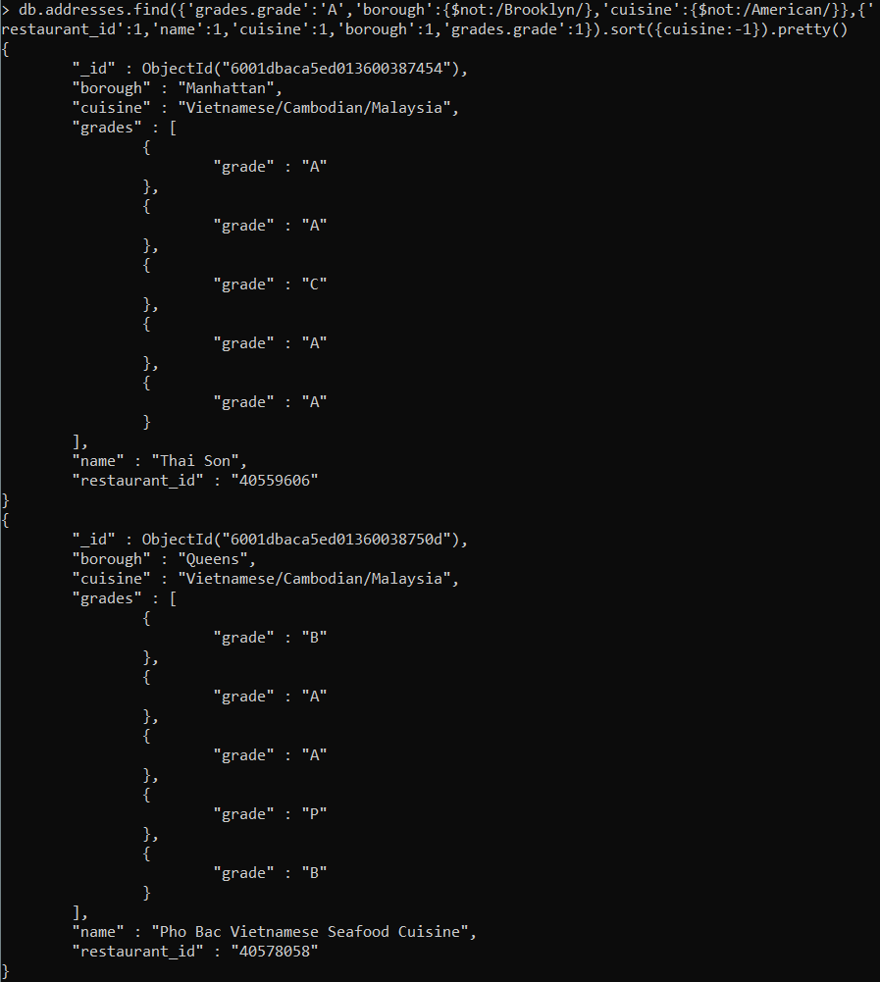

1. Write a MongoDB query to find the restaurant Id, name, borough and cuisine for those restaurants which contain 'Wil' as first three letters for its name.

: db.addresses.find({name:/^Wil/},{'restaurant_id':1,'name':1,'cuisine':1,'borough':1}).pretty()

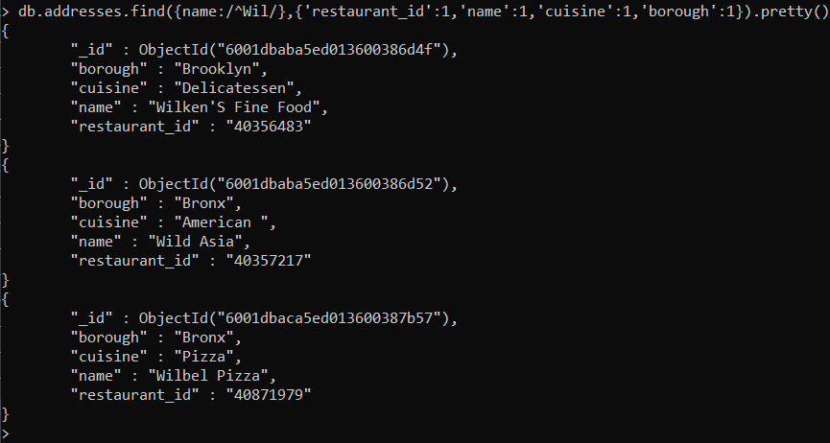

1. Write a MongoDB query to find the restaurant Id, name, borough and cuisine for those restaurants which contain 'ces' as last three letters for its name.

: db.addresses.find({name:/ces$/},{'restaurant_id':1,'name':1,'cuisine':1,'borough':1})

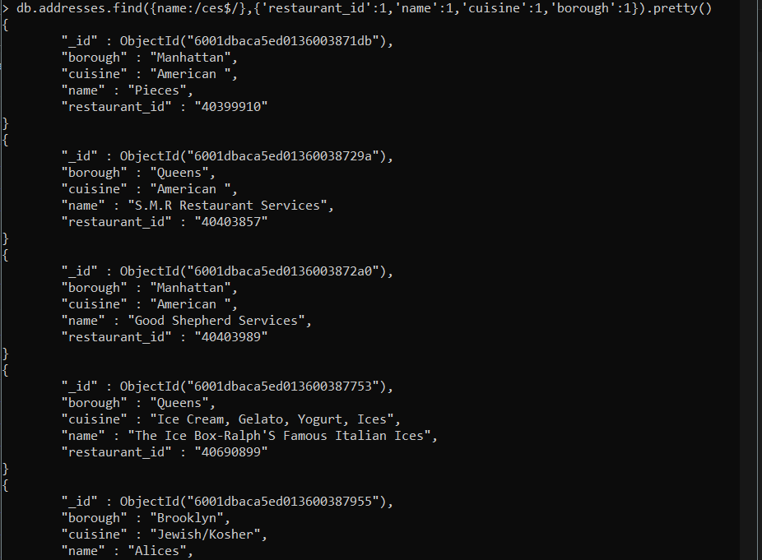

1. Write a MongoDB query to find the restaurant Id, name, borough and cuisine for those restaurants which contain 'Reg' as three letters somewhere in its name.

: db.addresses.find({name:/Reg/},{'restaurant_id':1,'name':1,'cuisine':1,'borough':1})

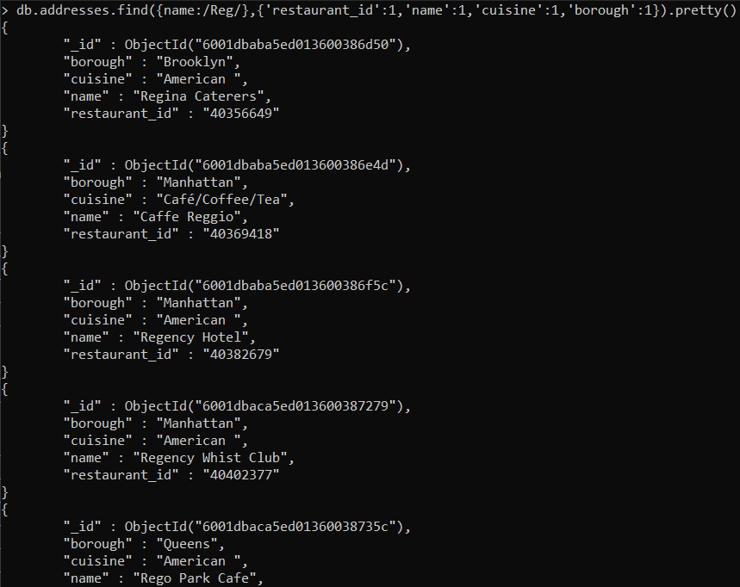

1. Write a MongoDB query to find the restaurants which belong to the borough Bronx and prepared either American or Chinese dish.

: db.addresses.find({borough:'Bronx',cuisine:{$in:[/American/,/Chinese/]}})

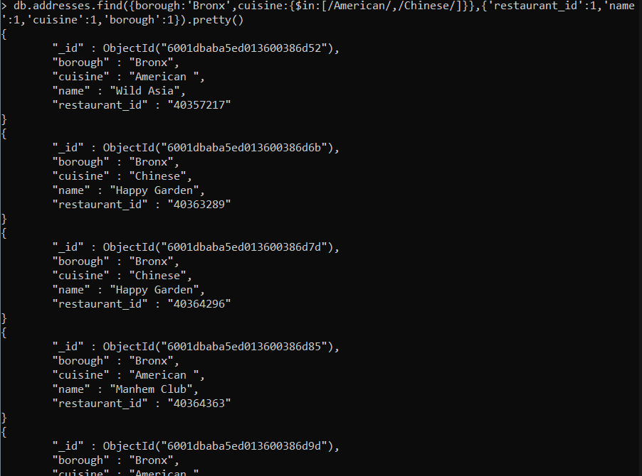

1. Write a MongoDB query to find the restaurant Id, name, borough and cuisine for those restaurants which belong to the borough Staten Island or Queens or Bronxor Brooklyn.

: db.addresses.find({borough:{$in:[/Staten Island/,/Queens/,/Bronx/, /Brooklyn/]}})

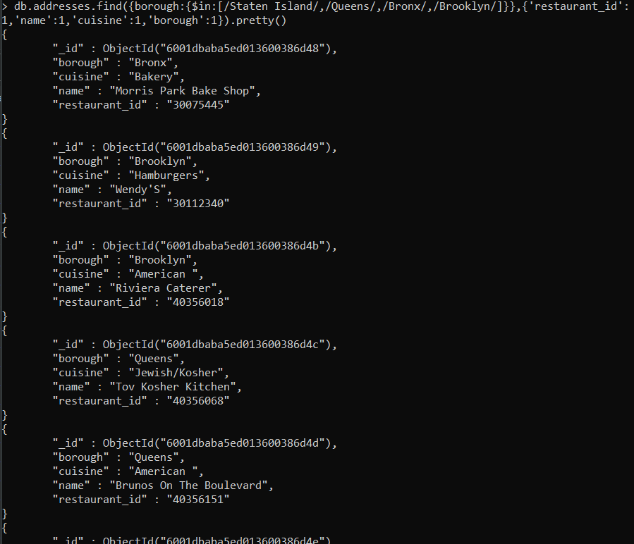

1. Write a MongoDB query to find the restaurant Id, name, borough and cuisine for those restaurants which are not belonging to the borough Staten Island or Queens or Bronxor Brooklyn.

: db.addresses.find({borough:{$not:{$in:[/Staten Island/,/Queens/,/Bronx/, /Brooklyn/]}}})

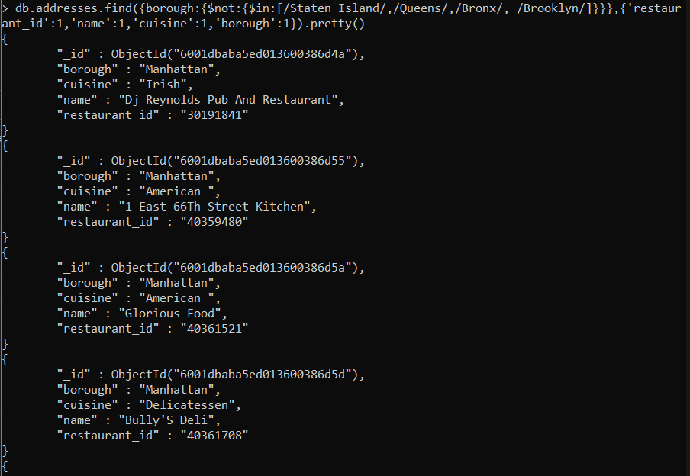

1. Write a MongoDB query to find the restaurant Id, name, borough and cuisine for those restaurants which achieved a score which is not more than 10.

: db.addresses.find({'grades.score':{$lt :10}})

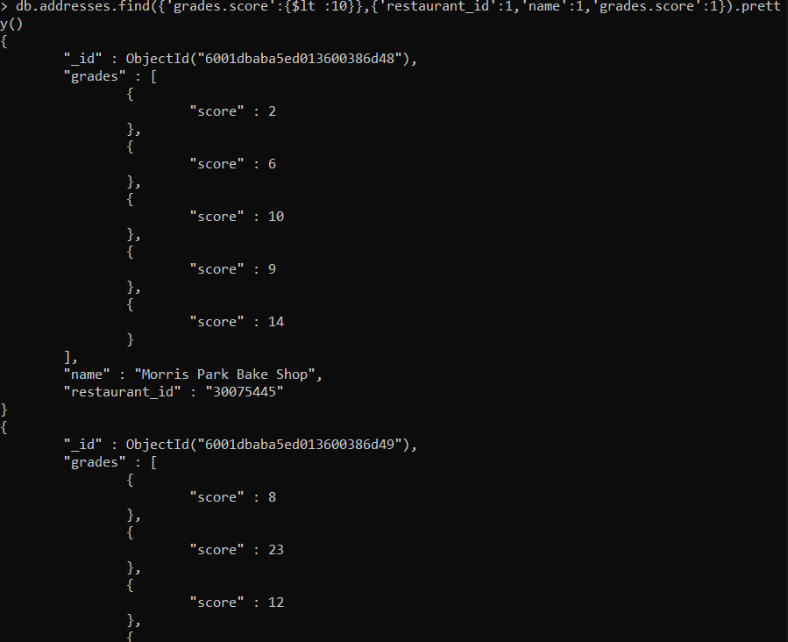

1. Write a MongoDB query to find the restaurant Id, name, borough and cuisine for those restaurants which prepared dish except 'American' and 'Chinees' or restaurant's name begins with letter 'Wil'.

: db.addresses.find({$or:[{name:/^Wil/},{cuisine:{$not:{$in:[/American/,/Chinese/]}}}]})

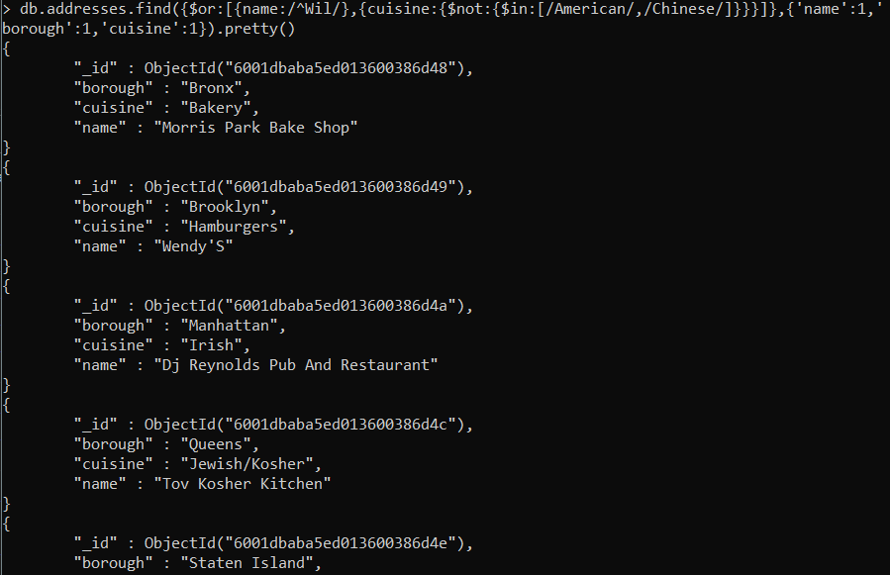

1. Write a MongoDB query to find the restaurant Id, name, and grades for those restaurants which achieved a grade of "A" and scored 11 on an ISODate "2014-08-11T00:00:00Z" among many of survey dates..

: db.addresses.find({grades:{$elemMatch:{grade:'A',date:ISODate("2014-08-11T00:00:00Z"),score:11}}},{'restaurant_id':1,'name':1,'grades':1})

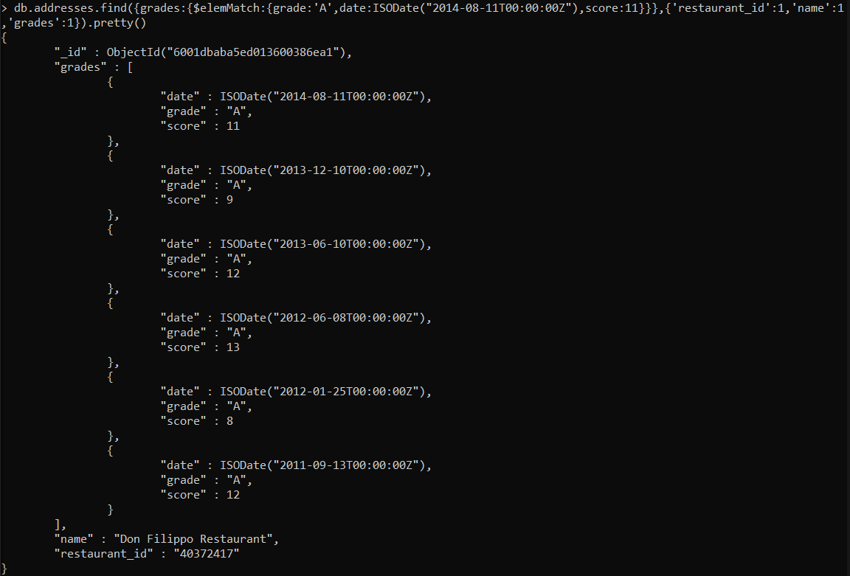

1. Write a MongoDB query to find the restaurant Id, name and grades for those restaurants where the 2nd element of grades array contains a grade of "A" and score 9 on an ISODate "2014-08-11T00:00:00Z"

: db.addresses.find({'grades.1.grade':'A','grades.1.score':9,'grades.1.date':ISODate("2014-08-11T00:00:00Z") }, {'restaurant_id':1,'name':1,'grades':1})

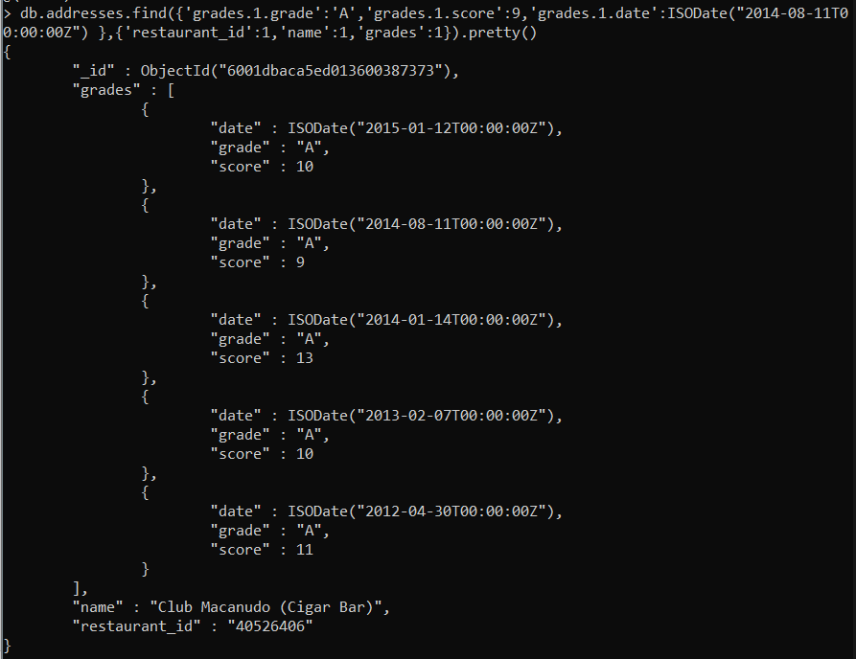

1. Write a MongoDB query to find the restaurant Id, name, address and geographical location for those restaurants where 2nd element of coord array contains a value which is more than 42 and upto 52..

:db.addresses.find({'address.coord.1':{$gt:42,$lte:52}},{'restaurant_id':1,'name':1,'address':1}).pretty()

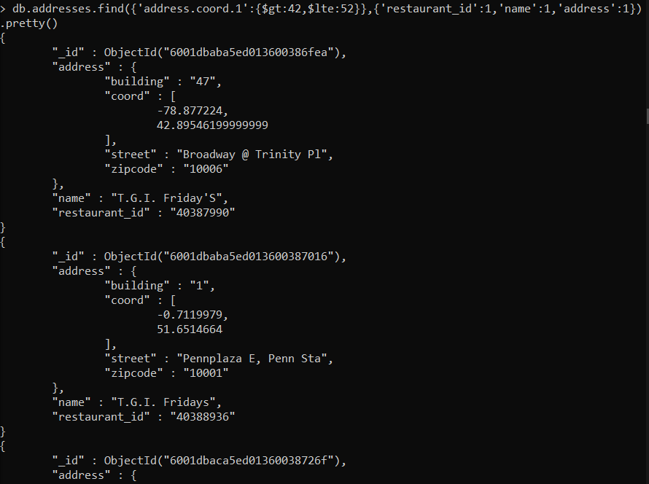

1. Write a MongoDB query to arrange the name of the restaurants in ascending order along with all the columns.

: db.addresses.find().sort({'name':1})

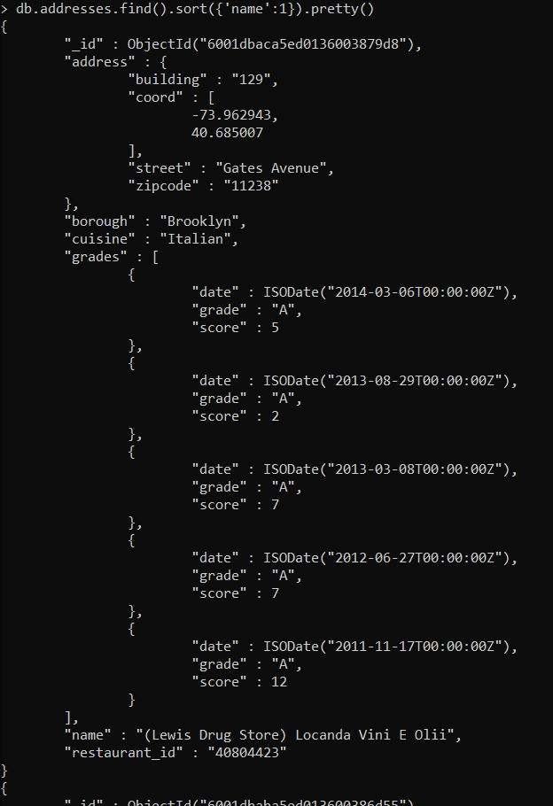

1. Write a MongoDB query to arrange the name of the restaurants in descending along with all the columns.

: db.addresses.find().sort({'name':-1})

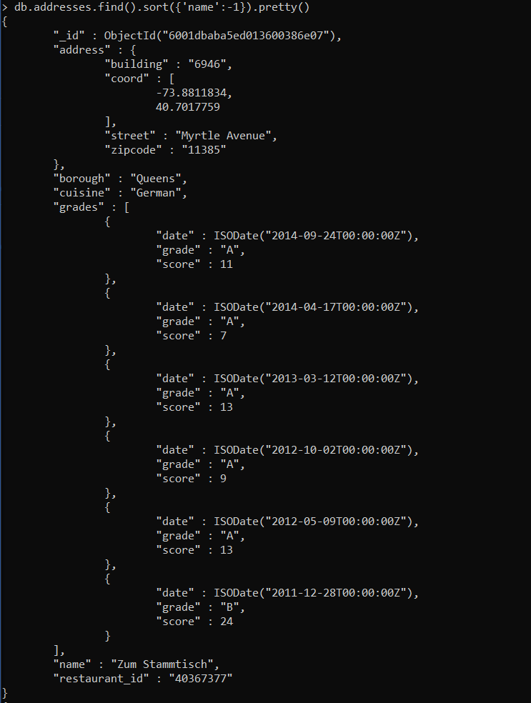

1. Write a MongoDB query to arranged the name of the cuisine in ascending order and for that same cuisine borough should be in descending order.

: db.addresses.find().sort({'cuisine':1,'borough':-1})

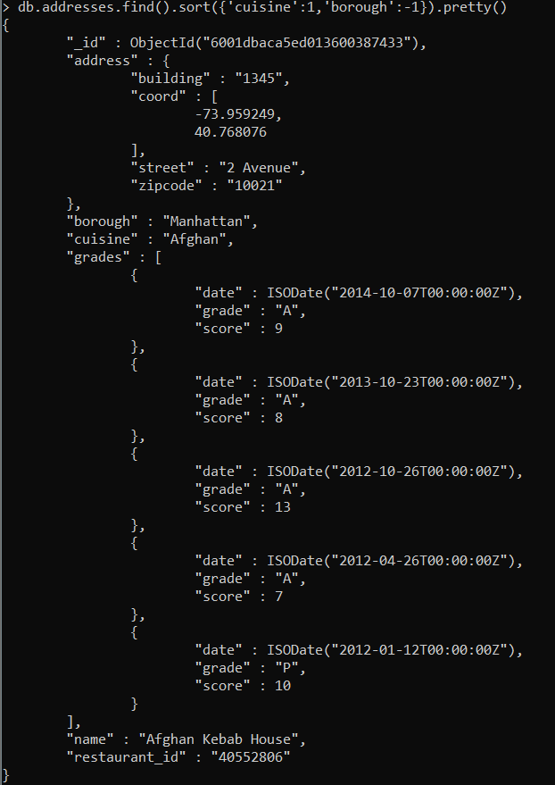

1. Write a MongoDB query to know whether all the addresses contains the street or not.

:db.addressed.find({‘address.street’:{$exists:false}})



**No output means all the documents have street field**

1. Write a MongoDB query which will select all documents in the restaurants collection where the coord field value is Double.

: db.addresses.find({'address.coord':{$type:'double'}})

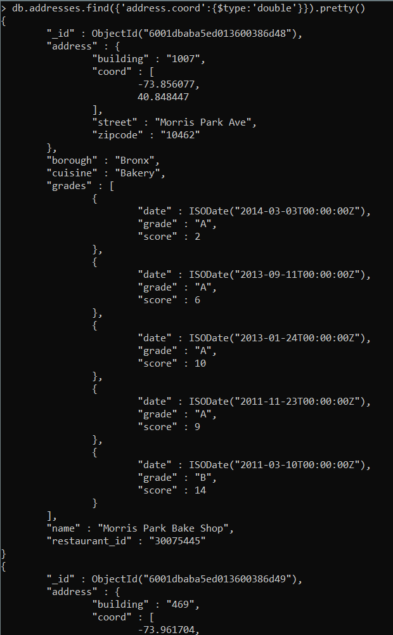

1. Write a MongoDB query which will select the restaurant Id, name and grades for those restaurants

which returns 0 as a remainder after dividing the score by 7.

: db.addresses.find({'grades.score':{$mod:[7,0]}},{'restaurant_id':1,'name':1,'grades':1}).pretty()

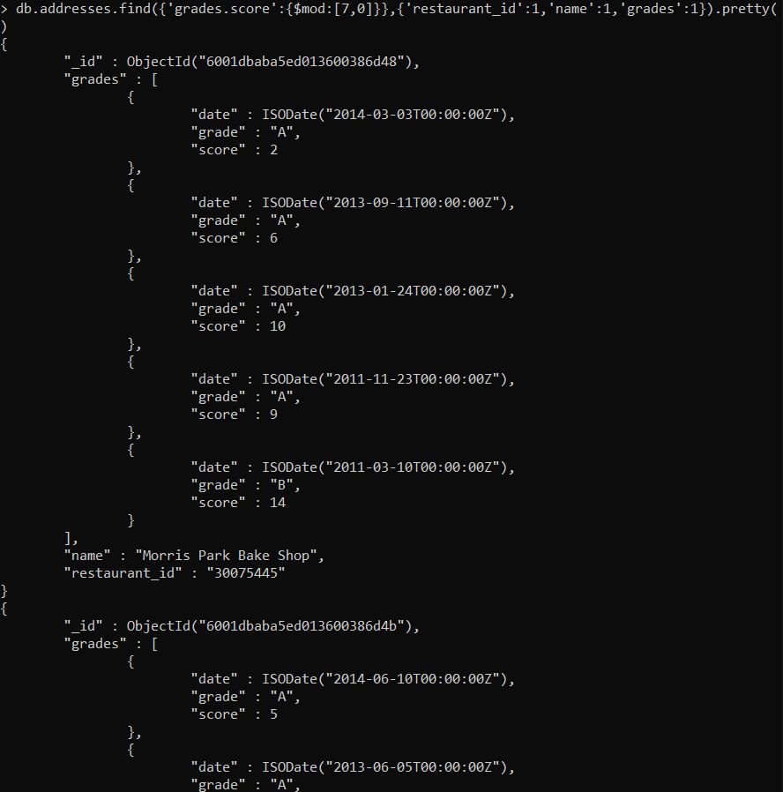

1. Write a MongoDB query to find the restaurant name, borough, longitude and attitude and cuisine for those restaurants which contains 'mon' as three letters somewhere in its name.

: db.addresses.find({name:/mon/},{'name':1,'cuisine':1,'borough':1,'address.coord':1})

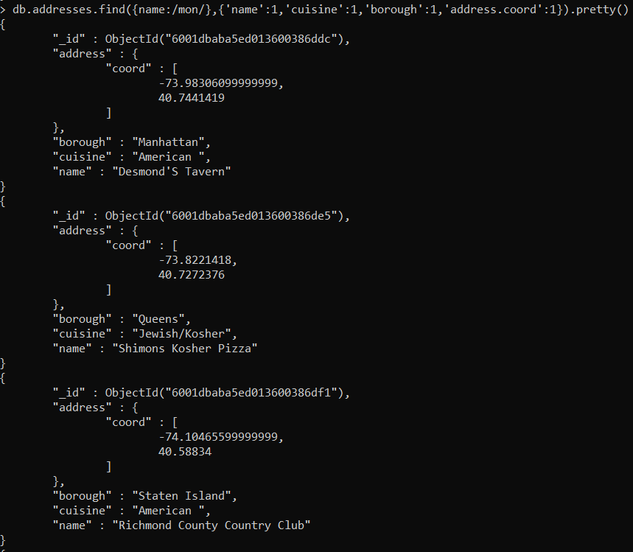

1. Write a MongoDB query to find the restaurant name, borough, longitude and latitude and cuisine for those restaurants which contain 'Mad' as first three letters of its name.

: db.addresses.find({name:/^Mad/},{'name':1,'cuisine':1,'borough':1,'address.coord':1})

