1. **Election Winner Analysis**

import pandas as pd

import numpy as np

import matplotlib.pyplot as plt

import seaborn as sns

df=pd.read_csv(r"C:\Users\ASUS\Downloads\python Dataset 2.csv")

**a) Identify the winning candidate based on the highest votes**

winner = df.loc[df['votes'].idxmax(), ['candidate_name', 'party', 'votes']]

print("Election Winner:")

print(winner)

**(b) Display the margin and margin percentage by which the candidate won**

winner_margin = df.loc[df['votes'].idxmax(), ['margin', 'margin_percentage']]

print("Winning Margin Details:")

print(winner_margin)

(c) Find the runner-up candidate and their vote margin from the winner

sorted_candidates = df.sort_values(by='votes', ascending=False)

runner_up = sorted_candidates.iloc[1][['candidate_name', 'party', 'votes', 'margin']]

print("Runner-up Candidate:")

print(runner_up)

(d) Calculate the percentage difference in votes between the winner and runner-up

vote_difference = ((sorted_candidates.iloc[0]['votes'] - sorted_candidates.iloc[1]['votes']) / sorted_candidates.iloc[0]['votes']) * 100

print(f"Percentage Difference in Votes: {vote_difference:.2f}%")

**Code:**

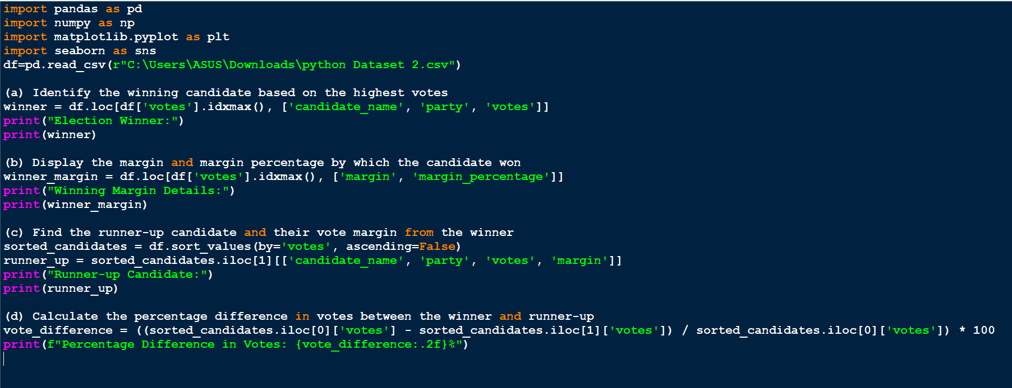

**Output:**

