**Angular 10/9/8 Firebase CRUD Operations with Reactive Forms**

I am going to share with you how to **create CRUD Operations using Angular 10/9/8 and Firebase real-time NoSQL cloud database**. We’ll be using Angular’s Reactive Forms service for managing the user submitted data in our web application.

For the demo purpose, we’ll be creating a basic student record management system in which a school admin can perform following tasks:

* Create Student
* Read Student
* Update Student
* Delete Student

#### Step by step Explanation

1. [Tutorial Health Check](https://www.positronx.io/angular-7-firebase-5-crud-operations-with-reactive-forms/#tc_480_01)
2. [Complete GitHub Project Files](https://www.positronx.io/angular-7-firebase-5-crud-operations-with-reactive-forms/#tc_480_02)
3. [Prerequisite](https://www.positronx.io/angular-7-firebase-5-crud-operations-with-reactive-forms/#tc_480_03)
4. [Angular Project Set up with Bootstrap 4 and Font Awesome](https://www.positronx.io/angular-7-firebase-5-crud-operations-with-reactive-forms/#tc_480_04)
5. [Firebase Account Set up and AngularFire2 Library Integration](https://www.positronx.io/angular-7-firebase-5-crud-operations-with-reactive-forms/#tc_480_05)
6. [Create CRUD Operations with Firebase API](https://www.positronx.io/angular-7-firebase-5-crud-operations-with-reactive-forms/#tc_480_06)
7. [Generate Angular Components for Adding, Updating & Creating Student Data](https://www.positronx.io/angular-7-firebase-5-crud-operations-with-reactive-forms/#tc_480_07)
8. [Router Service Set up for Navigation](https://www.positronx.io/angular-7-firebase-5-crud-operations-with-reactive-forms/#tc_480_08)
9. [How to Show Alert Messages in Angular 10/9/8 using NGX-Toastr NPM Module?](https://www.positronx.io/angular-7-firebase-5-crud-operations-with-reactive-forms/#tc_480_09)
10. [Use Reactive Form to Add Student in Firebase Database using CRUD Services](https://www.positronx.io/angular-7-firebase-5-crud-operations-with-reactive-forms/#tc_480_10)
11. [Set up and Usage of NGX Pagination Module](https://www.positronx.io/angular-7-firebase-5-crud-operations-with-reactive-forms/#tc_480_11)
12. [Show Students List and Delete Student Object using CRUD API](https://www.positronx.io/angular-7-firebase-5-crud-operations-with-reactive-forms/#tc_480_12)
13. [Create Edit Functionality for Students Data using CRUD Services](https://www.positronx.io/angular-7-firebase-5-crud-operations-with-reactive-forms/#tc_480_13)

### 2. Complete GitHub Project Files

Click on below button to get the complete project files,

<https://github.com/SinghDigamber/angularfirebase-student-app>

## 3. Prerequisite

#### – Setup Node JS development environment

Before we move ahead I’m assuming you already have **Node JS development environment** set up in your system.

Please follow this link [How to Set up Node JS Development Environment?](https://nodejs.org/en/download/)

#### – Install Angular CLI

Install Angular CLI, Ignore if Angular CLI is already installed.

**npm install -g @angular/cli**

## 4. Angular Project Set up with Bootstrap 4 and Font Awesome

Let’s set up a fresh new Angular 7|8|9 project with Bootstrap 4 and Font Awesome for our basic student record management system CRUD app.

**ng new angularfirebase-student-app**

Once the project is installed then get into the project’s directory by following the following command.

**cd angularfirebase-student-app**

Now its time to setup Bootstrap CSS framework in your Angular project. Use the mentioned command to install the latest version of the Bootstrap framework.

**npm install bootstrap**

Install [Font Awesome free icons](https://www.npmjs.com/package/@fortawesome/fontawesome-free) set library using Angular CLI

**npm i @fortawesome/fontawesome-free**

Go to src > angular.json file to register Bootstrap and FontAwesome CSS in styles array.

**"styles": [**

**"node\_modules/bootstrap/dist/css/bootstrap.min.css",**

**"src/styles.css",**

**"node\_modules/@fortawesome/fontawesome-free/css/all.css"**

**]**

**Ng serve - -open**

## 5. Firebase Account Set up + AngularFire2 Library Integration

[Go to Firebase website](https://console.firebase.google.com/) and login using your email id, when you see given below screen click on **Add Project** section.

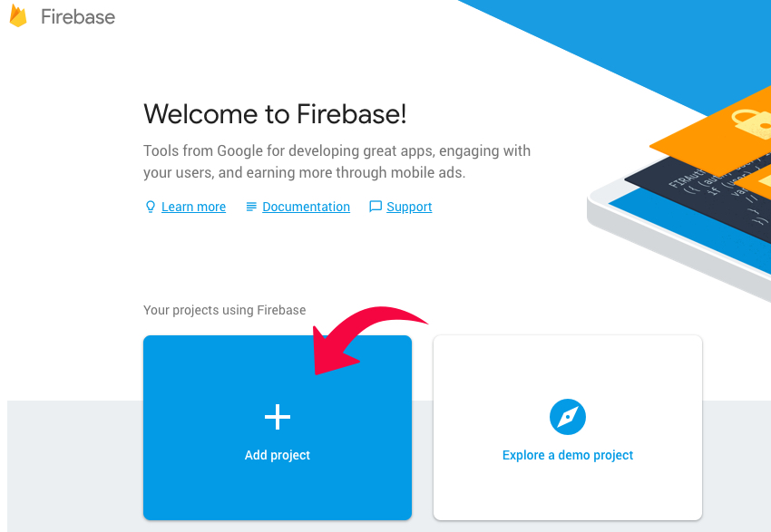

Enter your project name, accept the terms and condition and click on **Create project button.**

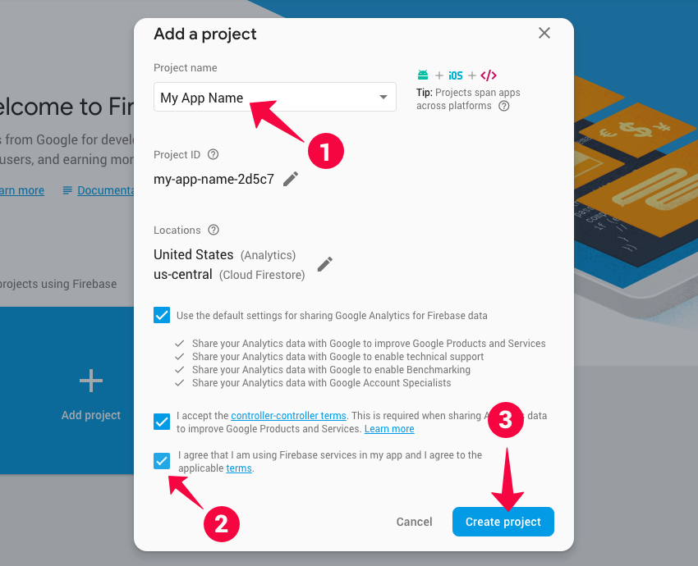

Click on your project then you’ll enter in your Firebase dashboard.

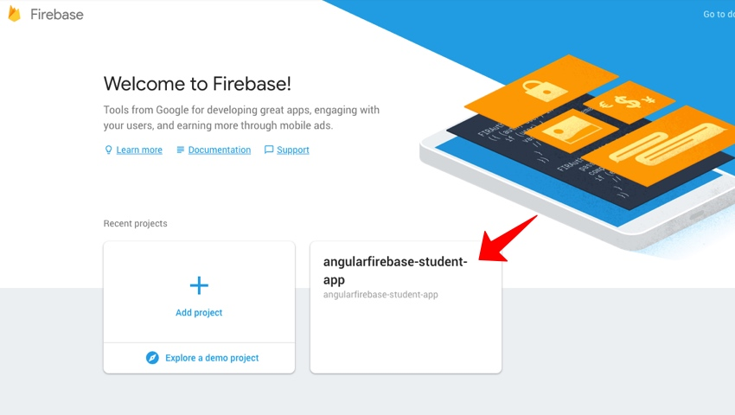

Navigate to Develop > Authentication > Web setup then click on the **Web setup** button, and a popup will appear along with your firebase credentials.

Copy these **Firebase credentials**, you will have to paste these credentials in your src/environments/enviorment.ts file to make the connection between Firebase and your Angular app.

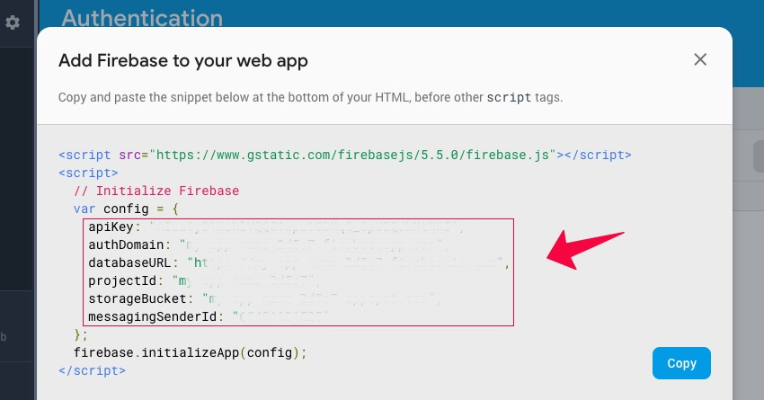

#### Create Database for Student Records Angular App

Firebase offers Real-time Database and Cloud Firestore, for this tutorial we are going to use Real-time Database.

Click on **create database** button.

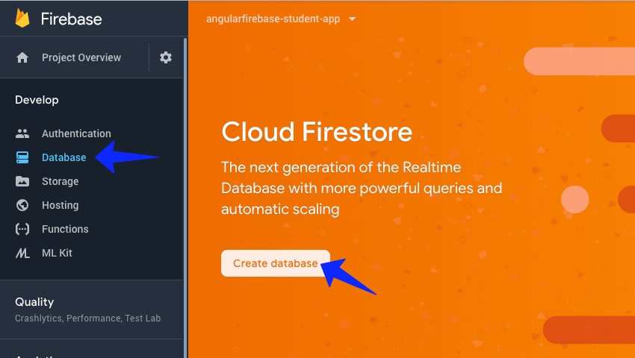

For the demo purpose we will be using **Start in test mode** security rules option and click on enable button.

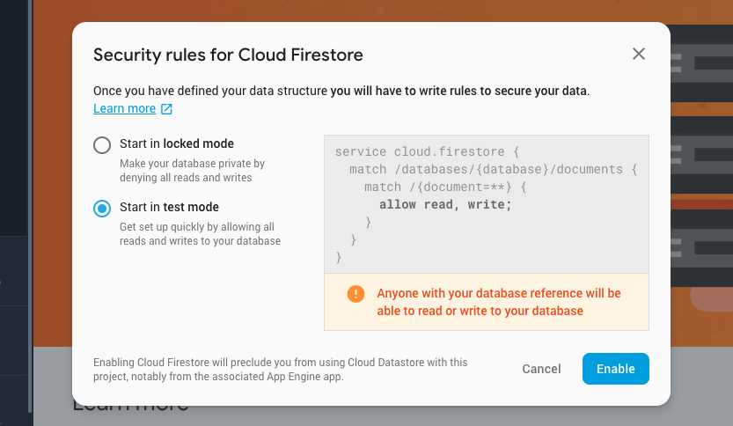

After that, we will see the database screen click on Cloud Firestore button and select Realtime Database option.

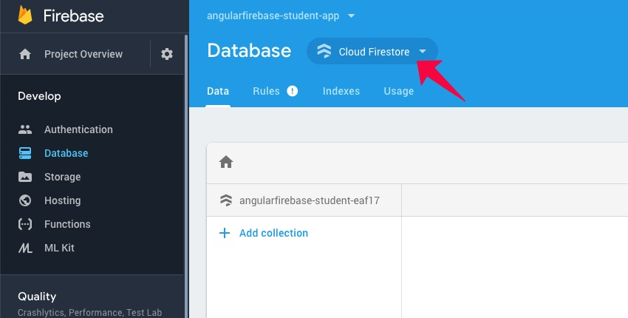

Select Realtime Database from the options like given below.

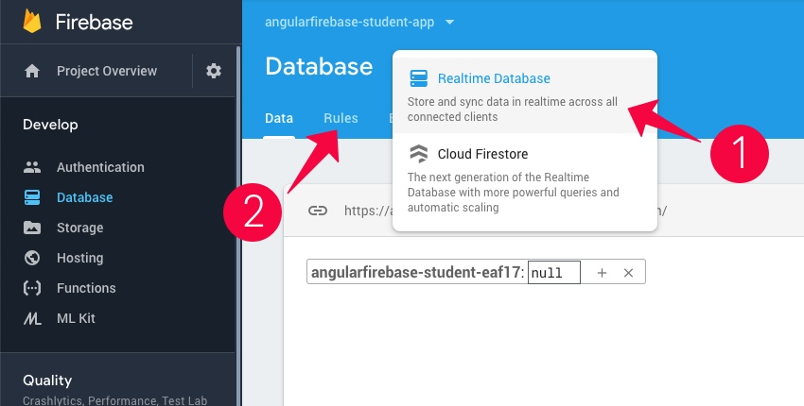

Don’t forget to change your Firebase database rules, go to Database > Rules. Otherwise, you won’t be able to access the data without authentication. Paste these security rules in your Realtime Database’s Rules tab.

**{"rules": {".read": true, ".write": true }}**

**Note:** Don’t forget to change these rules when you are building a real app for your clients.

#### Setup Firebase (AngularFire2 library) in your Angular project.

Run the given below cmd in Angular CLI.

**npm install firebase @angular/fire –save**

**Let’s connect the AngularFire2 library to your Angular project.**

Go to src/environments/enviorment.ts and enviorment.prod.ts files in your project’s **enviornments folder**, then add **your firebase configuration details**in both the environment files as given below.

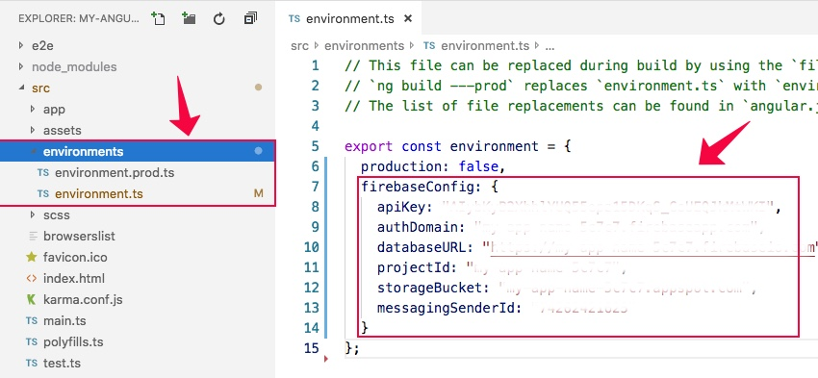

Open app.module.ts file and register the Firebase required services.

**// Firebase Modules**

**import { AngularFireModule } from '@angular/fire';**

**import { AngularFireDatabaseModule } from '@angular/fire/database';**

**import { environment } from '../environments/environment';**

**@NgModule({**

**imports: [**

**AngularFireModule.initializeApp(environment.firebase), // Main Angular fire module**

**AngularFireDatabaseModule // Firebase database module**

**]**

**})**

We’ve successfully set up the Angular project with Firebase NoSQL real-time database.

## 6. Create CRUD operations with Firebase API

Before writing the CRUD operations we must create a separate folder by the name of shared within src > app > shared and create crud.service.ts (Service) and student.ts (Interface Class) into it.

Run the following command to generate student interface class for setting up data types.

**ng g i shared/student // Generates student interface class within shared folder**

Afterwards, go to src > app > shared > student.ts file and add the following code into it.

**export interface Student {**

**$key: string;**

**firstName: string;**

**lastName: string;**

**email: string**

**mobileNumber: Number;**

**}**

Run the following command to generate a CRUD service file.

**ng g s shared/crud // Generates CRUD service within shared folder**

Go to src > app > shared > crud.service.ts file and add the given below code to create CRUD operations with Firebase API

**import { Injectable } from '@angular/core';**

**import { Student } from '../shared/student'; // Student data type interface class**

**import { AngularFireDatabase, AngularFireList, AngularFireObject } from '@angular/fire/database'; // Firebase modules for Database, Data list and Single object**

**@Injectable({**

**providedIn: 'root'**

**})**

**export class CrudService {**

**studentsRef: AngularFireList<any>; // Reference to Student data list, its an Observable**

**studentRef: AngularFireObject<any>; // Reference to Student object, its an Observable too**

**// Inject AngularFireDatabase Dependency in Constructor**

**constructor(private db: AngularFireDatabase) { }**

**// Create Student**

**AddStudent(student: Student) {**

**this.studentsRef.push({**

**firstName: student.firstName,**

**lastName: student.lastName,**

**email: student.email,**

**mobileNumber: student.mobileNumber**

**})**

**}**

**// Fetch Single Student Object**

**GetStudent(id: string) {**

**this.studentRef = this.db.object('students-list/' + id);**

**return this.studentRef;**

**}**

**// Fetch Students List**

**GetStudentsList() {**

**this.studentsRef = this.db.list('students-list');**

**return this.studentsRef;**

**}**

**// Update Student Object**

**UpdateStudent(student: Student) {**

**this.studentRef.update({**

**firstName: student.firstName,**

**lastName: student.lastName,**

**email: student.email,**

**mobileNumber: student.mobileNumber**

**})**

**}**

**// Delete Student Object**

**DeleteStudent(id: string) {**

**this.studentRef = this.db.object('students-list/'+id);**

**this.studentRef.remove();**

**}**

**}**

## 7. Generate Angular Components for Adding, Updating & Creating Student Data

**ng g c add-student**

**ng g c edit-student**

**ng g c student-list**

Now we are able to write our app logic in these components.

## 8. Router Service Set up for Navigation

Generate app routing module for navigation using below command

* –flat adds the file in src/app instead of its own folder.
* –module=app orders Angular CLI to register it in the imports array of the AppModule.

**ng generate module app-routing --flat --module=app**

Once the app-routing module is created then Go to src > app > app-routing.modules.ts file and add the given below code.

**import { NgModule } from '@angular/core';**

**import { CommonModule } from '@angular/common';**

**// Use RouterModule, Routes for activating routing in angular**

**import { RouterModule, Routes } from '@angular/router';**

**// Include components for in which router service to be used**

**import { AddStudentComponent } from './add-student/add-student.component';**

**import { StudentsListComponent } from './students-list/students-list.component';**

**import { EditStudentComponent } from './edit-student/edit-student.component';**

**// Routes array define component along with the path name for url**

**const routes: Routes = [**

**{ path: '', redirectTo: '/register-student', pathMatch: 'full' },**

**{ path: 'register-student', component: AddStudentComponent },**

**{ path: 'view-students', component: StudentsListComponent },**

**{ path: 'edit-student/:id', component: EditStudentComponent }**

**];**

**// Import RouterModule and inject routes array in it and dont forget to export the RouterModule**

**@NgModule({**

**imports: [CommonModule,RouterModule.forRoot(routes)],**

**exports: [RouterModule],**

**declarations: []**

**})**

**export class AppRoutingModule { }**

Afterwards, Go to src > app > app.modules.ts and add the following code into app.module.ts

**import { AppRoutingModule } from './/app-routing.module'; // AppRoutingModule Module**

**@NgModule({**

**imports: [**

**AppRoutingModule // Declare AppRoutingModule into imports array**

**]**

**})**

Now go to src > app > app.component.html file to activate router service and layout for the student demo app.

**<!-- Top navigation -->**

**<nav class="navbar navbar-dark fixed-top bg-dark flex-md-nowrap p-0 shadow">**

**<a class="navbar-brand col-sm-3 col-md-2 mr-0" routerLink="/register-student">**

**<img class="brand-logo" src="assets/logo-positronx-white.svg" alt="positronX.io Logo">**

**<span class="dasboard-text">Dashboard</span>**

**</a>**

**<ul class="navbar-nav px-3">**

**<li class="nav-item text-nowrap">**

**<a class="nav-link" routerLink="/register-student">**

**<span class="user-image" style="background-image: url('assets/user.jpg')"></span>**

**Hello Admin**

**</a>**

**</li>**

**</ul>**

**</nav>**

**<!-- Sidebar navigation -->**

**<div class="container-fluid">**

**<div class="row">**

**<nav class="col-md-2 d-md-block bg-light sidebar">**

**<div class="sidebar-sticky">**

**<ul class="nav flex-column">**

**<!-- routerLink="/register-student" to navigate to view-students component -->**

**<li class="nav-item">**

**<a class="nav-link" routerLink="/register-student" routerLinkActive="active">**

**<i class="fas fa-plus"></i>Add Student**

**</a>**

**</li>**

**<!-- routerLink="/view-students" to navigate to view-students component -->**

**<!-- routerLinkActive="active" activates active class for component-->**

**<li class="nav-item">**

**<a class="nav-link" routerLink="/view-students" routerLinkActive="active">**

**<i class="fas fa-list-ul"></i>Students List**

**</a>**

**</li>**

**</ul>**

**</div>**

**</nav>**

**<!-- Main content -->**

**<main role="main" class="col-md-9 ml-sm-auto col-lg-10 px-4">**

**<div class="inner-adjust">**

**<!-- Use router template to show the components for which router service is activated -->**

**<router-outlet></router-outlet>**

**</div>**

**</main>**

**</div>**

**</div>**

## 09. How to Show Alert Messages in Angular 7|8|9 using NGX-Toastr NPM Module?

We’ll be requiring **NGX Toastr NPM module** to show alert messages when an update occurs in student’s data. In order to install NGX Toastr, we’ll be using the following command.

**npm install ngx-toastr --save**

**// @angular/animations package is a required dependency for the default toast**

**npm install @angular/animations –save**

Then go to angular.json and add the following code in styles array.

**"styles": [**

**"node\_modules/ngx-toastr/toastr.css" // Includes ngx-toastr's css**

**]**

Go to app.moudule.ts file and include this code for NGX Toastr

**// Import below modules for NGX Toastr**

**import { BrowserAnimationsModule } from '@angular/platform-browser/animations';**

**import { ToastrModule } from 'ngx-toastr';**

**@NgModule({**

**imports: [**

**BrowserAnimationsModule, // required animations module**

**ToastrModule.forRoot() // ToastrModule added**

**]**

**})**

**class MainModule {}**

#### How to use NGX-Toastr in the ANgular Component?

**import { ToastrService } from 'ngx-toastr';**

**@Component({...})**

**export class YourComponent {**

**constructor(private toastr: ToastrService) {}**

**showSuccess() {**

**this.toastr.success('You've Got It Successfully!');**

**}**

**}**

To know more about [ngx-toastr NPM module and its API please click on this link](https://www.npmjs.com/package/ngx-toastr" \t "_blank).

## 10. Use Reactive Form to Add Student in Firebase Database using CRUD Services

Go to src > app > app.module.ts file and add the given below code within app.module.ts file to activate Reactive Forms service in your Angular project.

**// Reactive Form Module**

**import { ReactiveFormsModule } from '@angular/forms';**

**@NgModule({**

**ReactiveFormsModule // Reactive forms module**

**]**

Then go to src > app > add-student.component.html file and paste the following code. This code will help us to setup the basic layout of our form, we are also using getter method to access the form object to show errors.

**<div class="pt-3 pb-2 mb-3 border-bottom">**

**<h1 class="h2">Add Student</h1>**

**<p class="custom-text">A demo CRUD app for <strong>student record management system</strong> built with <strong>Angular7**

**and Firebase5</strong></p>**

**</div>**

**<!-- Student form -->**

**<form [formGroup]="studentForm" (ngSubmit)="submitStudentData()" novalidate>**

**<div class="row">**

**<div class="col-lg-5 col-md-12 col-sm-12">**

**<div class="row">**

**<div class="col-md-12 mb-3">**

**<label>First name</label>**

**<input type="text" formControlName="firstName" class="form-control" required>**

**<!-- Showing errors using getter method -->**

**<p \*ngIf="firstName.touched && firstName.invalid" class="error"><sup>\*</sup>Please enter atleast first name</p>**

**<p \*ngIf="firstName.errors?.minlength" class="error"><sup>\*</sup>Name shouldn't be less than 2 words</p>**

**</div>**

**<div class="col-md-12 mb-3">**

**<label>Last name</label>**

**<input type="text" formControlName="lastName" class="form-control">**

**</div>**

**</div>**

**<div class="row">**

**<div class="col-md-12 mb-3">**

**<label>Email</label>**

**<input type="email" formControlName="email" class="form-control" required>**

**<!-- Showing errors using getter method -->**

**<p \*ngIf="email.touched && email.invalid" class="error"><sup>\*</sup>Please provide email</p>**

**<p \*ngIf="email.errors?.pattern" class="error"><sup>\*</sup>Please enter correct email</p>**

**</div>**

**<div class="col-md-12 mb-3">**

**<label>Mobile number</label>**

**<input type="text" formControlName="mobileNumber" class="form-control" required>**

**<!-- Showing errors using getter method -->**

**<p \*ngIf="mobileNumber.touched && mobileNumber.invalid" class="error"><sup>\*</sup>Please provide contact**

**number</p>**

**<p \*ngIf="mobileNumber.errors?.pattern" class="error"><sup>\*</sup>Use numbers only**

**number</p>**

**</div>**

**</div>**

**<div class="form-group text-right">**

**<button type="button" class="btn btn-secondary gap-right" (click)="ResetForm()">Reset</button>**

**<button type="submit" class="btn btn-success" [disabled]="!studentForm.valid">Add Student</button>**

**</div>**

**</div>**

**</div>**

**</form><!-- Student form ends-->**

Afterwards, go to src > app > add-student.component.ts file and add the given below code. It contains Reactive Forms Logic, Getter method to access FormGroup’s properties, Reactive Form validation logic, Form Reset method and Toastr service for showing alert messages.

**import { Component, OnInit } from '@angular/core';**

**import { CrudService } from '../shared/crud.service'; // CRUD services API**

**import { FormBuilder, FormGroup, FormControl, Validators } from '@angular/forms'; // Reactive form services**

**import { ToastrService } from 'ngx-toastr'; // Alert message using NGX toastr**

**@Component({**

**selector: 'app-add-student',**

**templateUrl: './add-student.component.html',**

**styleUrls: ['./add-student.component.css']**

**})**

**export class AddStudentComponent implements OnInit {**

**public studentForm: FormGroup; // Define FormGroup to student's form**

**constructor(**

**public crudApi: CrudService, // CRUD API services**

**public fb: FormBuilder, // Form Builder service for Reactive forms**

**public toastr: ToastrService // Toastr service for alert message**

**) { }**

**ngOnInit() {**

**this.crudApi.GetStudentsList(); // Call GetStudentsList() before main form is being called**

**this.studenForm(); // Call student form when component is ready**

**}**

**// Reactive student form**

**studenForm() {**

**this.studentForm = this.fb.group({**

**firstName: ['', [Validators.required, Validators.minLength(2)]],**

**lastName: [''],**

**email: ['', [Validators.required, Validators.pattern('^[a-zA-Z0-9\_.+-]+@[a-zA-Z0-9-]+.[a-zA-Z0-9-.]+$')]],**

**mobileNumber: ['', [Validators.required, Validators.pattern('^[0-9]+$')]]**

**})**

**}**

**// Accessing form control using getters**

**get firstName() {**

**return this.studentForm.get('firstName');**

**}**

**get lastName() {**

**return this.studentForm.get('lastName');**

**}**

**get email() {**

**return this.studentForm.get('email');**

**}**

**get mobileNumber() {**

**return this.studentForm.get('mobileNumber');**

**}**

**// Reset student form's values**

**ResetForm() {**

**this.studentForm.reset();**

**}**

**submitStudentData() {**

**this.crudApi.AddStudent(this.studentForm.value); // Submit student data using CRUD API**

**this.toastr.success(this.studentForm.controls['firstName'].value + ' successfully added!'); // Show success message when data is successfully submited**

**this.ResetForm(); // Reset form when clicked on reset button**

**};**

**}**

## 11. Set up and Usage of NGX Pagination Module

Run below command in Angular CLI to install NGX Pagination NPM module.

**npm install ngx-pagination –save**

Open src > app > app.module.ts file and add the given below code.

**// NGX Pagination**

**import { NgxPaginationModule } from 'ngx-pagination';**

**@NgModule({**

**imports: [**

**NgxPaginationModule // Include it in imports array**

**]**

**})**

#### How to use NGX Pagination?

**// your.component.ts example**

**import {Component} from '@angular/core';**

**@Component({**

**selector: 'my-component',**

**template: `**

**<ul>**

**<li \*ngFor="let item of collection | paginate: { itemsPerPage: 07, currentPage: p }"> ... </li>**

**</ul>**

**<pagination-controls (pageChange)="p = $event"></pagination-controls>**

**`**

**})**

**export class MyComponent {**

**p: number = 1;**

**collection: any[] = someArrayOfThings;**

**}**

To learn more about [ngx-pagination and its API please visit Pagination for Angular (v2+)](https://www.npmjs.com/package/ngx-pagination" \t "_blank)

## 12. Show Students List and Delete Student Object using CRUD API

I am going to fetch students data list using crud.service.ts, afterwards, I’ll be creating student delete functionality and integrate NGX pagination to show pagination in student’s data list.

Go to src > app > students-list > student-list.component.html file then add the following code.

**<div class="d-flex justify-content-between flex-wrap flex-md-nowrap align-items-center pt-3 pb-2 mb-3 border-bottom">**

**<h1 class="h2">Students List</h1>**

**<!-- It won't show if there is no student data -->**

**<a routerLink="/register-student" class="btn btn-success" \*ngIf="hideWhenNoStudent">**

**<i class="fas fa-plus custom-fa-plus"></i>**

**Add Student**

**</a>**

**</div>**

**<div class="pricing-header mx-auto">**

**<!-- Preloader shows before the data loads-->**

**<div class="no-data text-center" \*ngIf="preLoader">**

**<img src="assets/preloader.gif" class="preloader-icon" alt="No student">**

**</div>**

**<!-- No data shows when their is no student data available -->**

**<div class="no-data text-center" \*ngIf="noData">**

**<img src="assets/no-student.svg" class="nodata-msg" alt="No student">**

**<p class="nodata-msg">No student added yet!</p>**

**<a routerLink="/register-student" class="btn btn-success">**

**<i class="fas fa-plus custom-fa-plus"></i>**

**Add Student**

**</a>**

**</div>**

**<!-- Showing students data -->**

**<div class="table-responsive" \*ngIf="hideWhenNoStudent">**

**<table class="table table-bordered table-responsive-sm table-responsive-md table-responsive-lg">**

**<thead>**

**<tr>**

**<th scope="col">Student Id</th>**

**<th scope="col">Student name</th>**

**<th scope="col">Email</th>**

**<th scope="col">Mobile number</th>**

**<th class="text-center" scope="col">Edit</th>**

**</tr>**

**</thead>**

**<tbody>**

**<!-- \*ngFor loop iterates over Student array and fetch the student's data -->**

**<!-- paginate pipe will add pagination in student's list, it won't show if items are less then 7 -->**

**<tr \*ngFor="let student of Student | paginate: { itemsPerPage: 7, currentPage: p }; let i = index;">**

**<th scope="row">{{student.$key}}</th>**

**<td>{{student.firstName}} {{student.lastName}}</td>**

**<td>{{student.email}}</td>**

**<td>{{student.mobileNumber}}</td>**

**<td class="text-center action-block">**

**<!-- routerLink="/edit-student/{{student.$key}}" is refered to { path: 'edit-student/:id', component: EditStudentComponent } in app-routing.moudles.ts -->**

**<i class="far fa-edit" routerLink="/edit-student/{{student.$key}}"></i>**

**<i class="far fa-trash-alt" (click)="deleteStudent(student)"></i></td>**

**</tr>**

**</tbody>**

**</table>**

**</div>**

**<!-- Pagination -->**

**<pagination-controls (pageChange)="p = $event" autoHide="true" responsive="true"></pagination-controls>**

**</div>**

Go to src > app > students-list > student-list.component.ts file.

**import { Component, OnInit } from '@angular/core';**

**import { CrudService } from '../shared/crud.service'; // CRUD API service class**

**import { Student } from './../shared/student'; // Student interface class for Data types.**

**import { ToastrService } from 'ngx-toastr'; // Alert message using NGX toastr**

**@Component({**

**selector: 'app-students-list',**

**templateUrl: './students-list.component.html',**

**styleUrls: ['./students-list.component.css']**

**})**

**export class StudentsListComponent implements OnInit {**

**p: number = 1; // Settup up pagination variable**

**Student: Student[]; // Save students data in Student's array.**

**hideWhenNoStudent: boolean = false; // Hide students data table when no student.**

**noData: boolean = false; // Showing No Student Message, when no student in database.**

**preLoader: boolean = true; // Showing Preloader to show user data is coming for you from thre server(A tiny UX Shit)**

**constructor(**

**public crudApi: CrudService, // Inject student CRUD services in constructor.**

**public toastr: ToastrService // Toastr service for alert message**

**){ }**

**ngOnInit() {**

**this.dataState(); // Initialize student's list, when component is ready**

**let s = this.crudApi.GetStudentsList();**

**s.snapshotChanges().subscribe(data => { // Using snapshotChanges() method to retrieve list of data along with metadata($key)**

**this.Student = [];**

**data.forEach(item => {**

**let a = item.payload.toJSON();**

**a['$key'] = item.key;**

**this.Student.push(a as Student);**

**})**

**})**

**}**

**// Using valueChanges() method to fetch simple list of students data. It updates the state of hideWhenNoStudent, noData & preLoader variables when any changes occurs in student data list in real-time.**

**dataState() {**

**this.crudApi.GetStudentsList().valueChanges().subscribe(data => {**

**this.preLoader = false;**

**if(data.length <= 0){**

**this.hideWhenNoStudent = false;**

**this.noData = true;**

**} else {**

**this.hideWhenNoStudent = true;**

**this.noData = false;**

**}**

**})**

**}**

**// Method to delete student object**

**deleteStudent(student) {**

**if (window.confirm('Are sure you want to delete this student ?')) { // Asking from user before Deleting student data.**

**this.crudApi.DeleteStudent(student.$key) // Using Delete student API to delete student.**

**this.toastr.success(student.firstName + ' successfully deleted!'); // Alert message will show up when student successfully deleted.**

**}**

**}**

**}**

## 13. Create Edit Functionality for Students Data using CRUD Services

Go to src > app > edit-student.component.html Create the edit form using HTML and Reactive Form’s attributes then add form validation block within HTML layout.

**<div class="d-flex justify-content-between flex-wrap flex-md-nowrap align-items-center pt-3 pb-2 mb-3 border-bottom">**

**<h1 class="h2">Edit Student Details</h1>**

**<div class="btn-toolbar mb-2 mb-md-0">**

**<div class="btn-group">**

**<!-- goBack() methos to back to previous component -->**

**<button class="btn btn-sm btn-outline-secondary" (click)="goBack()">Go Back</button>**

**</div>**

**</div>**

**</div>**

**<div class="row">**

**<div class="col-lg-12">**

**<div class="pricing-header form-block mx-auto">**

**<!-- Student's Edit Form -->**

**<form [formGroup]="editForm" (ngSubmit)="updateForm()" novalidate>**

**<div class="row">**

**<div class="col-lg-5 col-md-12 col-sm-12">**

**<div class="row">**

**<div class="col-md-12 mb-3">**

**<label>First name</label>**

**<input type="text" formControlName="firstName" class="form-control" required>**

**<p \*ngIf="firstName.touched && firstName.invalid" class="error">**

**<sup>\*</sup>Please enter firstname**

**</p>**

**<p \*ngIf="firstName.errors?.minlength" class="error">**

**<sup>\*</sup>Name shouldn't be less than 2 words**

**</p>**

**</div>**

**<div class="col-md-12 mb-3">**

**<label>Last name</label>**

**<input type="text" formControlName="lastName" class="form-control">**

**</div>**

**</div>**

**<div class="row">**

**<div class="col-md-12 mb-3">**

**<label>Email</label>**

**<input type="email" formControlName="email" class="form-control" required>**

**<p \*ngIf="email.touched && email.invalid" class="error"><sup>\*</sup>Please provide email</p>**

**<p \*ngIf="email.errors?.pattern" class="error"><sup>\*</sup>Please enter correct email</p>**

**</div>**

**<div class="col-md-12 mb-3">**

**<label>Mobile number</label>**

**<input type="text" formControlName="mobileNumber" class="form-control" required>**

**<p \*ngIf="mobileNumber.touched && mobileNumber.invalid" class="error">**

**<sup>\*</sup>Please provide contact number**

**</p>**

**<p \*ngIf="mobileNumber.errors?.pattern" class="error">**

**<sup>\*</sup>Use numbers only number**

**</p>**

**</div>**

**</div>**

**<div class="form-group text-right">**

**<button type="submit" class="btn btn-success btn-block" [disabled]="!editForm.valid">**

**Update Student**

**</button>**

**</div>**

**</div>**

**</div>**

**</form>**

**<!-- Student's Edit Form ends-->**

**</div>**

**</div>**

**</div>**

Go to src > app > edit-student.component.ts file and write the edit form logic using Activated Route in the same order as mentioned below.

**import { Component, OnInit, AfterViewInit } from '@angular/core';**

**import { FormGroup, FormBuilder, Validators } from '@angular/forms';**

**import { CrudService } from '../shared/crud.service';**

**import { ActivatedRoute, Router } from "@angular/router"; // ActivatedRoue is used to get the current associated components information.**

**import { Location } from '@angular/common'; // Location service is used to go back to previous component**

**import { ToastrService } from 'ngx-toastr';**

**@Component({**

**selector: 'app-edit-student',**

**templateUrl: './edit-student.component.html',**

**styleUrls: ['./edit-student.component.css']**

**})**

**export class EditStudentComponent implements OnInit {**

**editForm: FormGroup; // Define FormGroup to student's edit form**

**constructor(**

**private crudApi: CrudService, // Inject CRUD API in constructor**

**private fb: FormBuilder, // Inject Form Builder service for Reactive forms**

**private location: Location, // Location service to go back to previous component**

**private actRoute: ActivatedRoute, // Activated route to get the current component's inforamation**

**private router: Router, // Router service to navigate to specific component**

**private toastr: ToastrService // Toastr service for alert message**

**){ }**

**ngOnInit() {**

**this.updateStudentData(); // Call updateStudentData() as soon as the component is ready**

**const id = this.actRoute.snapshot.paramMap.get('id'); // Getting current component's id or information using ActivatedRoute service**

**this.crudApi.GetStudent(id).valueChanges().subscribe(data => {**

**this.editForm.setValue(data) // Using SetValue() method, It's a ReactiveForm's API to store intial value of reactive form**

**})**

**}**

**// Accessing form control using getters**

**get firstName() {**

**return this.editForm.get('firstName');**

**}**

**get lastName() {**

**return this.editForm.get('lastName');**

**}**

**get email() {**

**return this.editForm.get('email');**

**}**

**get mobileNumber() {**

**return this.editForm.get('mobileNumber');**

**}**

**// Contains Reactive Form logic**

**updateStudentData() {**

**this.editForm = this.fb.group({**

**firstName: ['', [Validators.required, Validators.minLength(2)]],**

**lastName: [''],**

**email: ['', [Validators.required, Validators.pattern('^[a-zA-Z0-9\_.+-]+@[a-zA-Z0-9-]+.[a-zA-Z0-9-.]+$')]],**

**mobileNumber: ['', [Validators.required, Validators.pattern('^[0-9]+$')]]**

**})**

**}**

**// Go back to previous component**

**goBack() {**

**this.location.back();**

**}**

**// Below methods fire when somebody click on submit button**

**updateForm(){**

**this.crudApi.UpdateStudent(this.editForm.value); // Update student data using CRUD API**

**this.toastr.success(this.editForm.controls['firstName'].value + ' updated successfully'); // Show succes message when data is successfully submited**

**this.router.navigate(['view-students']); // Navigate to student's list page when student data is updated**

**}**

**}**

**That’s it for now…**  
If this tutorial has been helpful to you then must share it with others. If you have any suggestion or wanna request a tutorial then [drop me a mail.](https://www.positronx.io/contact/)