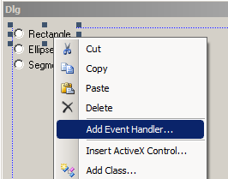
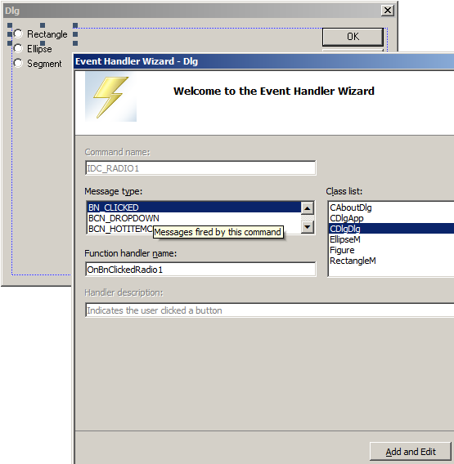

class CDlgDlg : public CDialog
{
//!!2
enum FIGURES{RECTANGLE,ELLIPSE,SEGMENT};
FIGURES futureFigKIND;
…………………………..
CDlgDlg::CDlgDlg(CWnd* pParent /*=NULL*/)
: CDialog(CDlgDlg::IDD, pParent)
{
//!!2
futureFigKIND=RECTANGLE;
……………………………

void CDlgDlg::OnBnClickedRadio1()
{
// TODO: Add your control notification handler code here
futureFigKIND=RECTANGLE;
}

void CDlgDlg::OnBnClickedRadio2()
{
// TODO: Add your control notification handler code here
futureFigKIND=ELLIPSE;
}

void CDlgDlg::OnBnClickedRadio3()
{
// TODO: Add your control notification handler code here
futureFigKIND=SEGMENT;
}

