**ASSIGNMENT 01**

**1. SEMANTIC HTML TAGS OR ELEMENTS**

A semantic element clearly describes its meaning to both the browser and the developer.

Examples of **non-semantic** elements: <div> and <span> - Tells nothing about its content.

Examples of **semantic** elements: <form>, <table>, and <article> - Clearly defines its content.

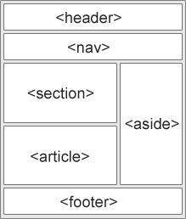

For sighted users, it’s easy to identify the various parts of a webpage. Headers, footers, and the main content are all immediately visually apparent.

However, it is not that easy for users who are blind or visually impaired and rely on screen readers.

The proper use of HTML semantic tags will allow these readers to understand your content better because their screen readers will communicate your content more accurately.

**2. CLIENT SERVER ARCHITECTURE**

Definition:

A computer network architecture, in which clients are those nodes that make request for the service that they don't have and the servers are those nodes that respond to the service requested by the client.  
  
The Client Server Architecture is a model/design/structure in which the Client makes the request for any service and the server provides that service or responds to that request.

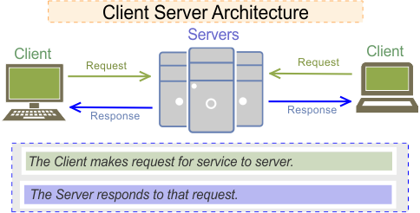

**3. HTTP AND HTTPS**

***HTTP: HyperText Transfer Protocol***

***HTTPS: HyperText Transfer Protocol Secure***

Both HTTP and HTTPS help web users transfer and receive information over the Internet. But there is a slight difference in them in terms of safety standards/ protocols or security layer.

HTTPS with its secure information transfer, however, is particularly important for sites where sensitive information is sent, such as ecommerce sites where users submit payment information like billing addresses, phone numbers and credit card data. HTTPS works with the protocol known as Transport Layer Security (TLS), or previously Secure Sockets Layer (SSL), to encrypt sensitive data, prevent the alteration or corruption of data during transfer, and authenticate certain users to communicate with the website.

Google’s recommendations, sites that make the switch to HTTPS often find that customers regard their site as more authentic. The site is also more protected from damages that can occur from third parties. More recently, Google warned Chrome users that the web browser will begin redflagging sites that are still on HTTP: “Beginning in October 2017, Chrome will show the ‘Not secure’ warning in two additional situations: when users enter data on an HTTP page, and on all HTTP pages visited in Incognito mode.”

******************* END OF PAGE *********************