Assignment 3: Web Application with Database Integration and Automated Testing using Selenium

Akash Tharindu

Part 1: Web Application Development – Django web application

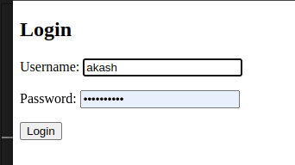

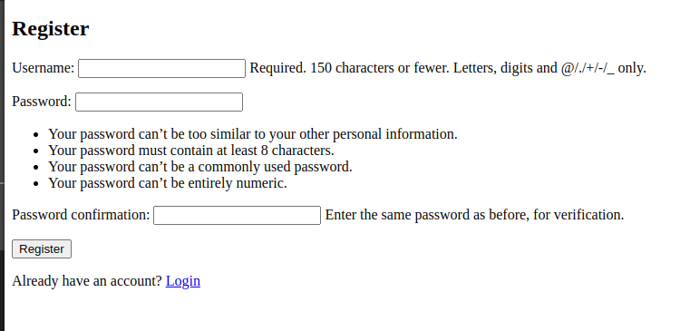

Part 2: Database Setup
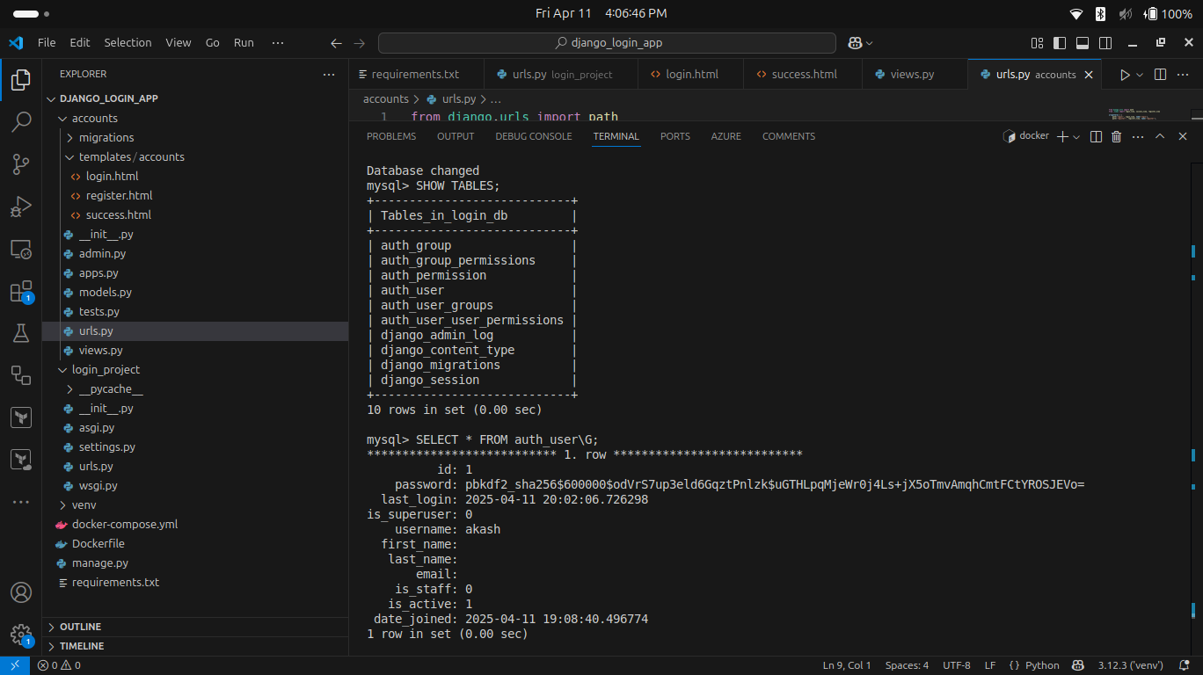

Part 3: Selenium Integration
code
