Cryptography
Lab Assignment 4
Github Link : https://github.com/AviatrixK/Uni-Assignments/tree/main/Crypto-assignments/Advanced_Crypto_Assignment_Kiruthika

blockchain_sim.py
"""
Q4: Blockchain Cryptography Simulation
Demonstrates hashing, digital signatures, block chaining, and tamper-proofing
"""

import hashlib
import json
import time
from cryptography.hazmat.primitives.asymmetric import rsa, padding
from cryptography.hazmat.primitives import hashes, serialization
from cryptography.hazmat.backends import default_backend
import base64

class MerkleTree:
"""Implements Merkle Tree for efficient transaction verification"""

@staticmethod
def hash_data(data):
"""Hash a piece of data"""
return hashlib.sha256(data.encode() if isinstance(data, str) else data).hexdigest()

@staticmethod
def build_tree(transactions):
"""Build Merkle tree from transactions"""
if not transactions:
return None

# Hash all transactions
current_level = [MerkleTree.hash_data(tx) for tx in transactions]

# Build tree bottom-up
tree = [current_level[:]]

while len(current_level) > 1:
next_level = []

# Process pairs
for i in range(0, len(current_level), 2):
left = current_level[i]
right = current_level[i + 1] if i + 1 < len(current_level) else left

combined = left + right
parent_hash = MerkleTree.hash_data(combined)
next_level.append(parent_hash)

tree.append(next_level)
current_level = next_level

return tree

@staticmethod
def get_root(tree):
"""Get Merkle root (top of tree)"""
return tree[-1][0] if tree else None

@staticmethod
def get_proof(tree, transaction_index):
"""Get Merkle proof for a transaction"""
proof = []
index = transaction_index

for level in tree[:-1]:
if index % 2 == 0:
sibling_index = index + 1
if sibling_index < len(level):
proof.append(('right', level[sibling_index]))
else:
sibling_index = index - 1
proof.append(('left', level[sibling_index]))

index = index // 2

return proof

class Block:
"""Represents a single block in the blockchain"""

def __init__(self, index, transactions, previous_hash, timestamp=None):
self.index = index
self.timestamp = timestamp or time.time()
self.transactions = transactions
self.previous_hash = previous_hash
self.nonce = 0
self.merkle_root = self._calculate_merkle_root()
self.hash = self.calculate_hash()

def _calculate_merkle_root(self):
"""Calculate Merkle root of transactions"""
if not self.transactions:
return "0" * 64

tree = MerkleTree.build_tree([json.dumps(tx, sort_keys=True) for tx in self.transactions])
return MerkleTree.get_root(tree)

def calculate_hash(self):
"""Calculate block hash"""
block_string = json.dumps({
"index": self.index,
"timestamp": self.timestamp,
"transactions": self.transactions,
"previous_hash": self.previous_hash,
"merkle_root": self.merkle_root,
"nonce": self.nonce
}, sort_keys=True)

return hashlib.sha256(block_string.encode()).hexdigest()

def mine_block(self, difficulty):
"""Proof of Work mining"""
target = "0" * difficulty

print(f" Mining block {self.index}...", end="")
start_time = time.time()

while self.hash[:difficulty] != target:
self.nonce += 1
self.hash = self.calculate_hash()

elapsed = time.time() - start_time
print(f" Mined! Hash: {self.hash} (Nonce: {self.nonce}, Time: {elapsed:.2f}s)")

def to_dict(self):
"""Convert block to dictionary"""
return {
"index": self.index,
"timestamp": self.timestamp,
"transactions": self.transactions,
"previous_hash": self.previous_hash,
"merkle_root": self.merkle_root,
"nonce": self.nonce,
"hash": self.hash
}

class Wallet:
"""Cryptocurrency wallet with public/private key pair"""

def __init__(self, name):
self.name = name
self.private_key = rsa.generate_private_key(
public_exponent=65537,
key_size=2048,
backend=default_backend()
)
self.public_key = self.private_key.public_key()
self.address = self._generate_address()

def _generate_address(self):
"""Generate wallet address from public key"""
public_bytes = self.public_key.public_bytes(
encoding=serialization.Encoding.DER,
format=serialization.PublicFormat.SubjectPublicKeyInfo
)
return hashlib.sha256(public_bytes).hexdigest()[:40]

def sign_transaction(self, transaction):
"""Sign a transaction"""
tx_string = json.dumps(transaction, sort_keys=True)
signature = self.private_key.sign(
tx_string.encode(),
padding.PSS(
mgf=padding.MGF1(hashes.SHA256()),
salt_length=padding.PSS.MAX_LENGTH
),
hashes.SHA256()
)
return base64.b64encode(signature).decode()

@staticmethod
def verify_signature(public_key, transaction, signature):
"""Verify transaction signature"""
try:
tx_string = json.dumps(transaction, sort_keys=True)
public_key.verify(
base64.b64decode(signature),
tx_string.encode(),
padding.PSS(
mgf=padding.MGF1(hashes.SHA256()),
salt_length=padding.PSS.MAX_LENGTH
),
hashes.SHA256()
)
return True
except:
return False

class Blockchain:
"""Simple blockchain implementation"""

def __init__(self, difficulty=4):
self.chain = []
self.difficulty = difficulty
self.pending_transactions = []
self.mining_reward = 50
self.wallets = {}

# Create genesis block
self.create_genesis_block()

def create_genesis_block(self):
"""Create the first block"""
genesis_block = Block(0, [{"type": "genesis", "data": "Genesis Block"}], "0")
genesis_block.mine_block(self.difficulty)
self.chain.append(genesis_block)
print(f" Genesis block created: {genesis_block.hash}")

def get_latest_block(self):
"""Get the most recent block"""
return self.chain[-1]

def add_transaction(self, transaction):
"""Add a transaction to pending transactions"""
self.pending_transactions.append(transaction)
print(f" Transaction added: {transaction['from'][:10]} → {transaction['to'][:10]} ({transaction['amount']} coins)")

def mine_pending_transactions(self, miner_address):
"""Mine pending transactions into a new block"""
# Create new block with pending transactions
block = Block(
index=len(self.chain),
transactions=self.pending_transactions,
previous_hash=self.get_latest_block().hash
)

# Mine the block
block.mine_block(self.difficulty)

# Add to chain
self.chain.append(block)

# Reset pending transactions and add mining reward
self.pending_transactions = [
{
"from": "NETWORK",
"to": miner_address,
"amount": self.mining_reward,
"type": "mining_reward"
}
]

print(f" Block {block.index} added to chain")

def is_chain_valid(self):
"""Validate entire blockchain"""
for i in range(1, len(self.chain)):
current_block = self.chain[i]
previous_block = self.chain[i - 1]

# Check hash integrity
if current_block.hash != current_block.calculate_hash():
print(f" Block {i} has been tampered with!")
return False

# Check chain linkage
if current_block.previous_hash != previous_block.hash:
print(f" Block {i} previous_hash doesn't match!")
return False

# Check proof of work
if not current_block.hash.startswith("0" * self.difficulty):
print(f" Block {i} doesn't meet difficulty requirement!")
return False

print(" Blockchain is valid!")
return True

def get_balance(self, address):
"""Calculate balance for an address"""
balance = 0

for block in self.chain:
for transaction in block.transactions:
if transaction.get('from') == address:
balance -= transaction.get('amount', 0)
if transaction.get('to') == address:
balance += transaction.get('amount', 0)

return balance

def demonstrate_tampering(self):
"""Show what happens when blockchain is tampered with"""
print("\n" + "=" * 70)
print("TAMPER DETECTION DEMONSTRATION")
print("=" * 70)

print("\n Original blockchain state:")
self.print_chain()

print("\n Tampering with block 1...")
# Try to change a transaction in block 1
if len(self.chain) > 1:
original_tx = self.chain[1].transactions[0].copy()
self.chain[1].transactions[0]['amount'] = 999999

print(f" Changed amount from {original_tx.get('amount')} to 999999")
print("\n Validating blockchain after tampering...")

self.is_chain_valid()

# Restore
self.chain[1].transactions[0] = original_tx

def print_chain(self):
"""Print blockchain summary"""
print(f"\n{'Block':<8} {'Hash':<20} {'Previous Hash':<20} {'Transactions':<15}")
print("-" * 70)
for block in self.chain:
print(f"{block.index:<8} {block.hash[:16]:<20} {block.previous_hash[:16]:<20} {len(block.transactions):<15}")

def demonstrate_blockchain():
"""Main blockchain demonstration"""

print("=" * 70)
print("BLOCKCHAIN CRYPTOGRAPHY DEMONSTRATION")
print("=" * 70)

# Create blockchain with difficulty 3 (for faster demo)
blockchain = Blockchain(difficulty=3)

# Create wallets
alice = Wallet("Alice")
bob = Wallet("Bob")
miner = Wallet("Miner")

print(f"\n Alice's address: {alice.address}")
print(f" Bob's address: {bob.address}")
print(f" Miner's address: {miner.address}")

print("\n" + "=" * 70)
print("TRANSACTION CREATION AND SIGNING")
print("=" * 70)

# Create and sign transaction
transaction1 = {
"from": alice.address,
"to": bob.address,
"amount": 30,
"timestamp": time.time()
}

signature1 = alice.sign_transaction(transaction1)
transaction1["signature"] = signature1

print(f" Alice signed transaction")
print(f" Signature: {signature1[:50]}...")

# Verify signature
verified = Wallet.verify_signature(alice.public_key,
{k: v for k, v in transaction1.items() if k != 'signature'},
signature1)
print(f" Verification: {' Valid' if verified else ' Invalid'}")

# Add transactions
blockchain.add_transaction(transaction1)

transaction2 = {
"from": alice.address,
"to": bob.address,
"amount": 20,
"timestamp": time.time()
}
blockchain.add_transaction(transaction2)

# Mine block
print("\n" + "=" * 70)
print("MINING BLOCK")
print("=" * 70)
blockchain.mine_pending_transactions(miner.address)

# Add more transactions
transaction3 = {
"from": bob.address,
"to": alice.address,
"amount": 10,
"timestamp": time.time()
}
blockchain.add_transaction(transaction3)

blockchain.mine_pending_transactions(miner.address)

# Print blockchain
print("\n" + "=" * 70)
print("BLOCKCHAIN STATE")
print("=" * 70)
blockchain.print_chain()

# Check balances
print("\n" + "=" * 70)
print("ACCOUNT BALANCES")
print("=" * 70)
print(f"Alice: {blockchain.get_balance(alice.address)} coins")
print(f"Bob: {blockchain.get_balance(bob.address)} coins")
print(f"Miner: {blockchain.get_balance(miner.address)} coins")

# Validate blockchain
print("\n" + "=" * 70)
print("BLOCKCHAIN VALIDATION")
print("=" * 70)
blockchain.is_chain_valid()

# Demonstrate tampering
blockchain.demonstrate_tampering()

# Merkle Tree demonstration
print("\n" + "=" * 70)
print("MERKLE TREE DEMONSTRATION")
print("=" * 70)

transactions = ["tx1", "tx2", "tx3", "tx4", "tx5"]
tree = MerkleTree.build_tree(transactions)
root = MerkleTree.get_root(tree)

print(f"Transactions: {transactions}")
print(f"Merkle Root: {root}")
print(f"\nMerkle Tree Structure:")
for i, level in enumerate(reversed(tree)):
print(f" Level {len(tree) - i - 1}: {level}")

# Get proof for transaction
proof = MerkleTree.get_proof(tree, 0)
print(f"\nMerkle Proof for tx1: {proof}")

print("\n" + "=" * 70)
print("CONSENSUS MECHANISMS")
print("=" * 70)

consensus_info = """
1. PROOF OF WORK (PoW) - Used by Bitcoin
- Miners compete to solve cryptographic puzzle
- First to solve gets to add block and receive reward
- Difficulty adjusts to maintain block time
- Pros: Secure, battle-tested
- Cons: Energy intensive

2. PROOF OF STAKE (PoS) - Used by Ethereum 2.0
- Validators chosen based on stake amount
- More energy efficient
- Risk of "rich get richer"
- Pros: Energy efficient, faster
- Cons: Less proven, potential centralization

3. DELEGATED PROOF OF STAKE (DPoS)
- Token holders vote for delegates
- Delegates validate blocks
- Faster but more centralized

4. PRACTICAL BYZANTINE FAULT TOLERANCE (PBFT)
- Used in permissioned blockchains
- Nodes reach consensus through voting
- Fast but requires known validators
"""

print(consensus_info)

# Save blockchain to file
print("\n Saving blockchain to file...")
blockchain_data = {
"chain": [block.to_dict() for block in blockchain.chain],
"difficulty": blockchain.difficulty
}

with open("blockchain_data.json", "w") as f:
json.dump(blockchain_data, f, indent=2)

print(" Blockchain saved to blockchain_data.json")

if __name__ == "__main__":
demonstrate_blockchain()

Output:
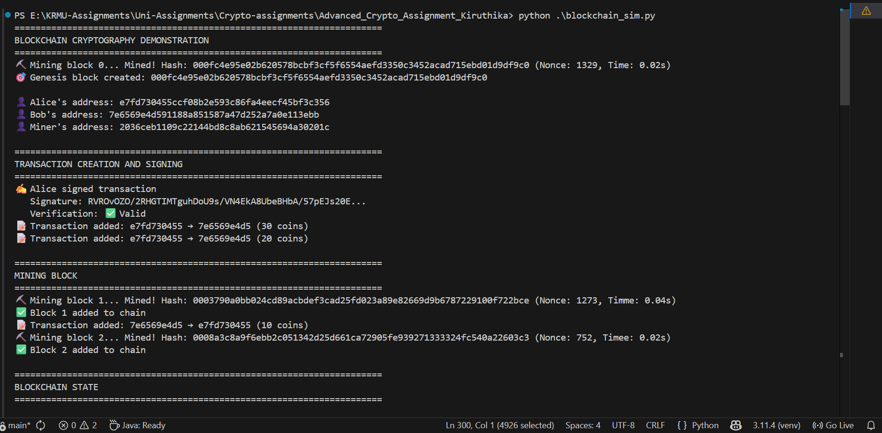

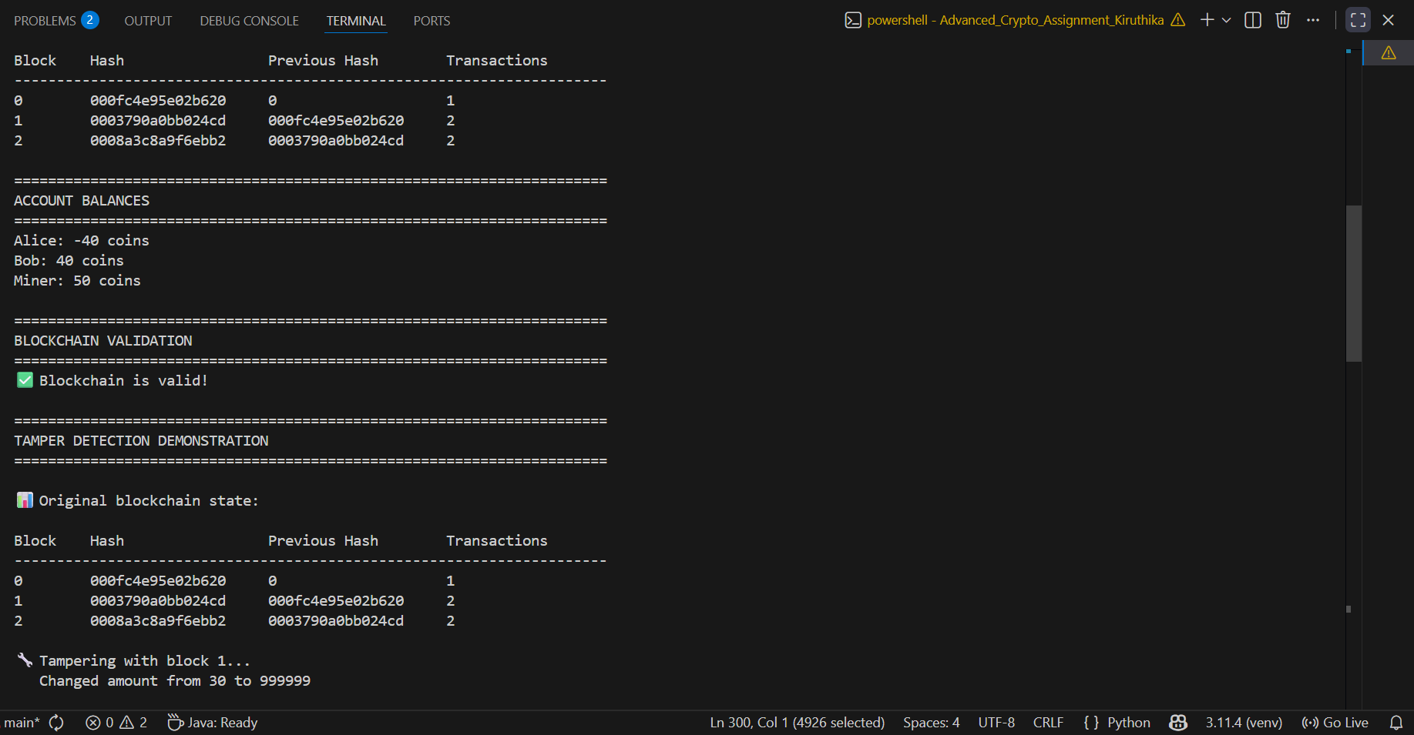
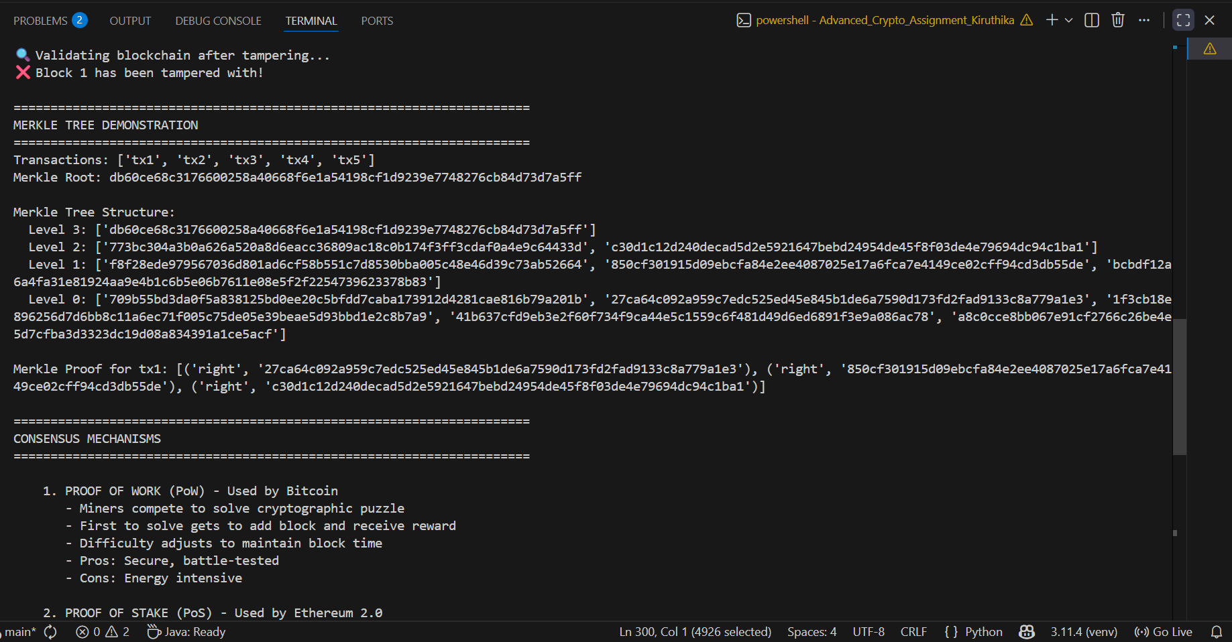
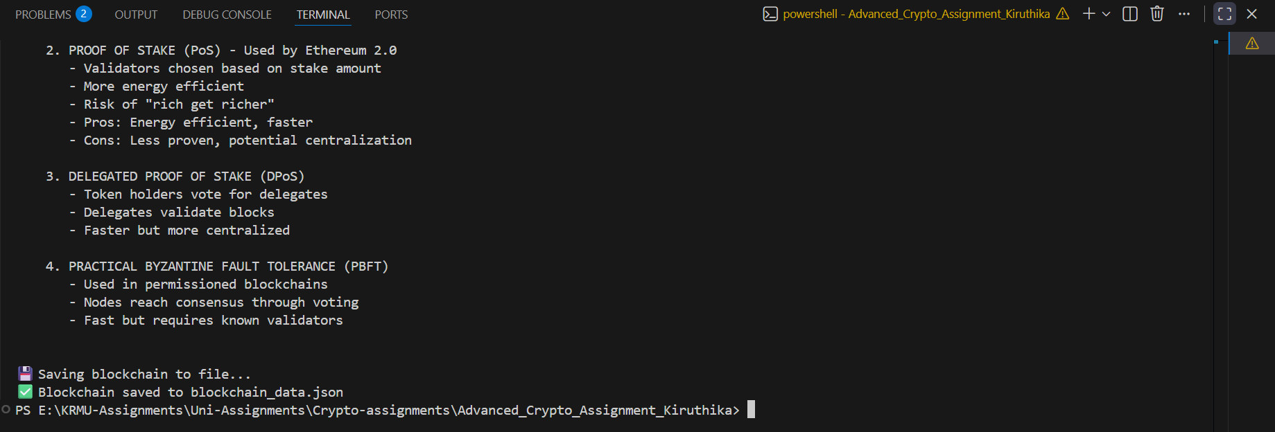

key_distribution.py
"""
Q1: Key Management and Distribution System
Simulates a Key Distribution Center (KDC) for symmetric key distribution
"""

import os
import json
import time
from cryptography.hazmat.primitives.ciphers import Cipher, algorithms, modes
from cryptography.hazmat.primitives import hashes, serialization
from cryptography.hazmat.primitives.asymmetric import rsa, padding
from cryptography.hazmat.backends import default_backend
import base64

class KeyDistributionCenter:
"""Simulates a trusted KDC for key management"""

def __init__(self):
self.registered_users = {}
self.session_keys = {}
self.key_versions = {} # For key rotation
print(" Key Distribution Center Initialized")

def register_user(self, user_id, master_key):
"""Register a user with their master key"""
self.registered_users[user_id] = master_key
self.key_versions[user_id] = 1
print(f" User '{user_id}' registered with KDC")

def generate_session_key(self, user_a, user_b):
"""Generate a session key for communication between two users"""
if user_a not in self.registered_users or user_b not in self.registered_users:
raise ValueError("One or both users not registered!")

# Generate random session key
session_key = os.urandom(32) # 256-bit key
session_id = f"{user_a}_{user_b}_{int(time.time())}"

# Encrypt session key with each user's master key
encrypted_for_a = self.encrypt_with_master_key(session_key, user_a)
encrypted_for_b = self.encrypt_with_master_key(session_key, user_b)

self.session_keys[session_id] = {
'session_key': session_key,
'created_at': time.time(),
'users': [user_a, user_b]
}

print(f" Session key generated for {user_a} ↔ {user_b}")
return {
'session_id': session_id,
'key_for_a': encrypted_for_a,
'key_for_b': encrypted_for_b
}

def encrypt_with_master_key(self, data, user_id):
"""Encrypt data using user's master key (AES-256)"""
master_key = self.registered_users[user_id]
iv = os.urandom(16)
cipher = Cipher(algorithms.AES(master_key), modes.CBC(iv), backend=default_backend())
encryptor = cipher.encryptor()

# Pad data to 16-byte boundary
padded_data = data + b'\x00' * (16 - len(data) % 16)
encrypted = encryptor.update(padded_data) + encryptor.finalize()

return base64.b64encode(iv + encrypted).decode()

def decrypt_with_master_key(self, encrypted_data, user_id):
"""Decrypt data using user's master key"""
master_key = self.registered_users[user_id]
decoded = base64.b64decode(encrypted_data)
iv = decoded[:16]
ciphertext = decoded[16:]

cipher = Cipher(algorithms.AES(master_key), modes.CBC(iv), backend=default_backend())
decryptor = cipher.decryptor()
decrypted = decryptor.update(ciphertext) + decryptor.finalize()

return decrypted.rstrip(b'\x00')

def rotate_key(self, user_id):
"""Simulate key rotation for a user"""
if user_id not in self.registered_users:
raise ValueError("User not registered!")

old_version = self.key_versions[user_id]
new_master_key = os.urandom(32)

# Archive old key (in real system, you'd have proper key archival)
old_key = self.registered_users[user_id]

self.registered_users[user_id] = new_master_key
self.key_versions[user_id] += 1

print(f" Key rotated for '{user_id}': v{old_version} → v{self.key_versions[user_id]}")
return new_master_key

class AsymmetricKeyDistribution:
"""Demonstrates asymmetric key distribution (PKI model)"""

def __init__(self):
self.public_keys = {}
self.private_keys = {}

def generate_key_pair(self, user_id):
"""Generate RSA key pair for a user"""
private_key = rsa.generate_private_key(
public_exponent=65537,
key_size=2048,
backend=default_backend()
)
public_key = private_key.public_key()

self.private_keys[user_id] = private_key
self.public_keys[user_id] = public_key

print(f" RSA key pair generated for '{user_id}'")
return public_key

def encrypt_message(self, message, recipient_id):
"""Encrypt message using recipient's public key"""
if recipient_id not in self.public_keys:
raise ValueError("Recipient's public key not available!")

public_key = self.public_keys[recipient_id]
encrypted = public_key.encrypt(
message.encode(),
padding.OAEP(
mgf=padding.MGF1(algorithm=hashes.SHA256()),
algorithm=hashes.SHA256(),
label=None
)
)
return base64.b64encode(encrypted).decode()

def decrypt_message(self, encrypted_message, recipient_id):
"""Decrypt message using recipient's private key"""
private_key = self.private_keys[recipient_id]
encrypted = base64.b64decode(encrypted_message)

decrypted = private_key.decrypt(
encrypted,
padding.OAEP(
mgf=padding.MGF1(algorithm=hashes.SHA256()),
algorithm=hashes.SHA256(),
label=None
)
)
return decrypted.decode()

def demonstrate_key_distribution():
"""Main demonstration of key distribution systems"""

print("=" * 70)
print("SYMMETRIC KEY DISTRIBUTION WITH KDC")
print("=" * 70)

# Initialize KDC
kdc = KeyDistributionCenter()

# Register users with master keys
alice_master = os.urandom(32)
bob_master = os.urandom(32)

kdc.register_user("Alice", alice_master)
kdc.register_user("Bob", bob_master)

# Generate session key
session_info = kdc.generate_session_key("Alice", "Bob")

# Alice decrypts her copy of the session key
alice_session_key = kdc.decrypt_with_master_key(session_info['key_for_a'], "Alice")
bob_session_key = kdc.decrypt_with_master_key(session_info['key_for_b'], "Bob")

print(f" Alice's session key: {alice_session_key.hex()[:32]}...")
print(f" Bob's session key: {bob_session_key.hex()[:32]}...")
print(f" Keys match: {alice_session_key == bob_session_key}")

# Demonstrate key rotation
print("\n" + "=" * 70)
print("KEY ROTATION DEMONSTRATION")
print("=" * 70)
kdc.rotate_key("Alice")
kdc.rotate_key("Alice") # Rotate twice

print("\n" + "=" * 70)
print("ASYMMETRIC KEY DISTRIBUTION (PKI)")
print("=" * 70)

# Asymmetric key distribution
pki = AsymmetricKeyDistribution()

# Generate key pairs
pki.generate_key_pair("Alice")
pki.generate_key_pair("Bob")

# Alice sends encrypted message to Bob
message = "Hello Bob, this is a secret message!"
encrypted = pki.encrypt_message(message, "Bob")
print(f"\n Encrypted message: {encrypted[:50]}...")

decrypted = pki.decrypt_message(encrypted, "Bob")
print(f" Decrypted message: {decrypted}")

print("\n" + "=" * 70)
print("KEY MANAGEMENT CHALLENGES")
print("=" * 70)
print("""
1. KEY ESCROW:
- Allows authorized third parties to access encrypted data
- Controversial due to privacy concerns
- Used in some enterprise and government settings

2. KEY ROTATION:
- Regular key updates reduce exposure from compromised keys
- Challenges: Coordinating updates across distributed systems
- Best practice: Rotate keys every 90 days or after incidents

3. LARGE-SCALE CHALLENGES (Cloud/IoT):
- IoT: Limited computational resources for complex crypto
- Cloud: Multi-tenancy requires strict key isolation
- Scale: Managing millions of keys requires automation
- Lifecycle: Key generation, distribution, storage, rotation, revocation
""")

if __name__ == "__main__":
demonstrate_key_distribution()

print("\n Saving configuration...")
config = {
"kdc_type": "symmetric",
"key_algorithm": "AES-256",
"asymmetric_algorithm": "RSA-2048",
"key_rotation_period": "90 days"
}

with open("key_config.json", "w") as f:
json.dump(config, f, indent=2)

print(" Configuration saved to key_config.json")

Output:
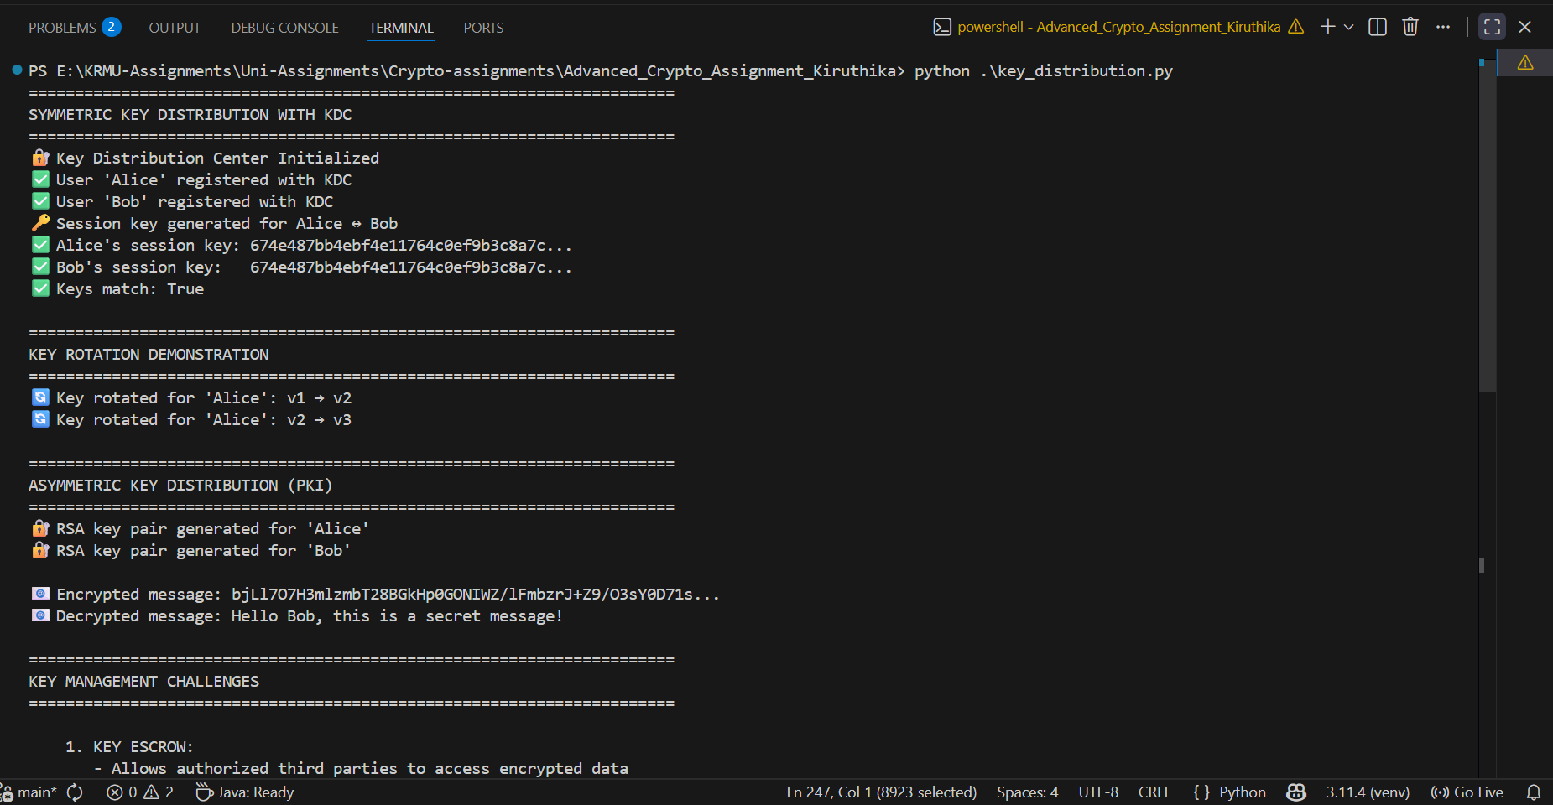
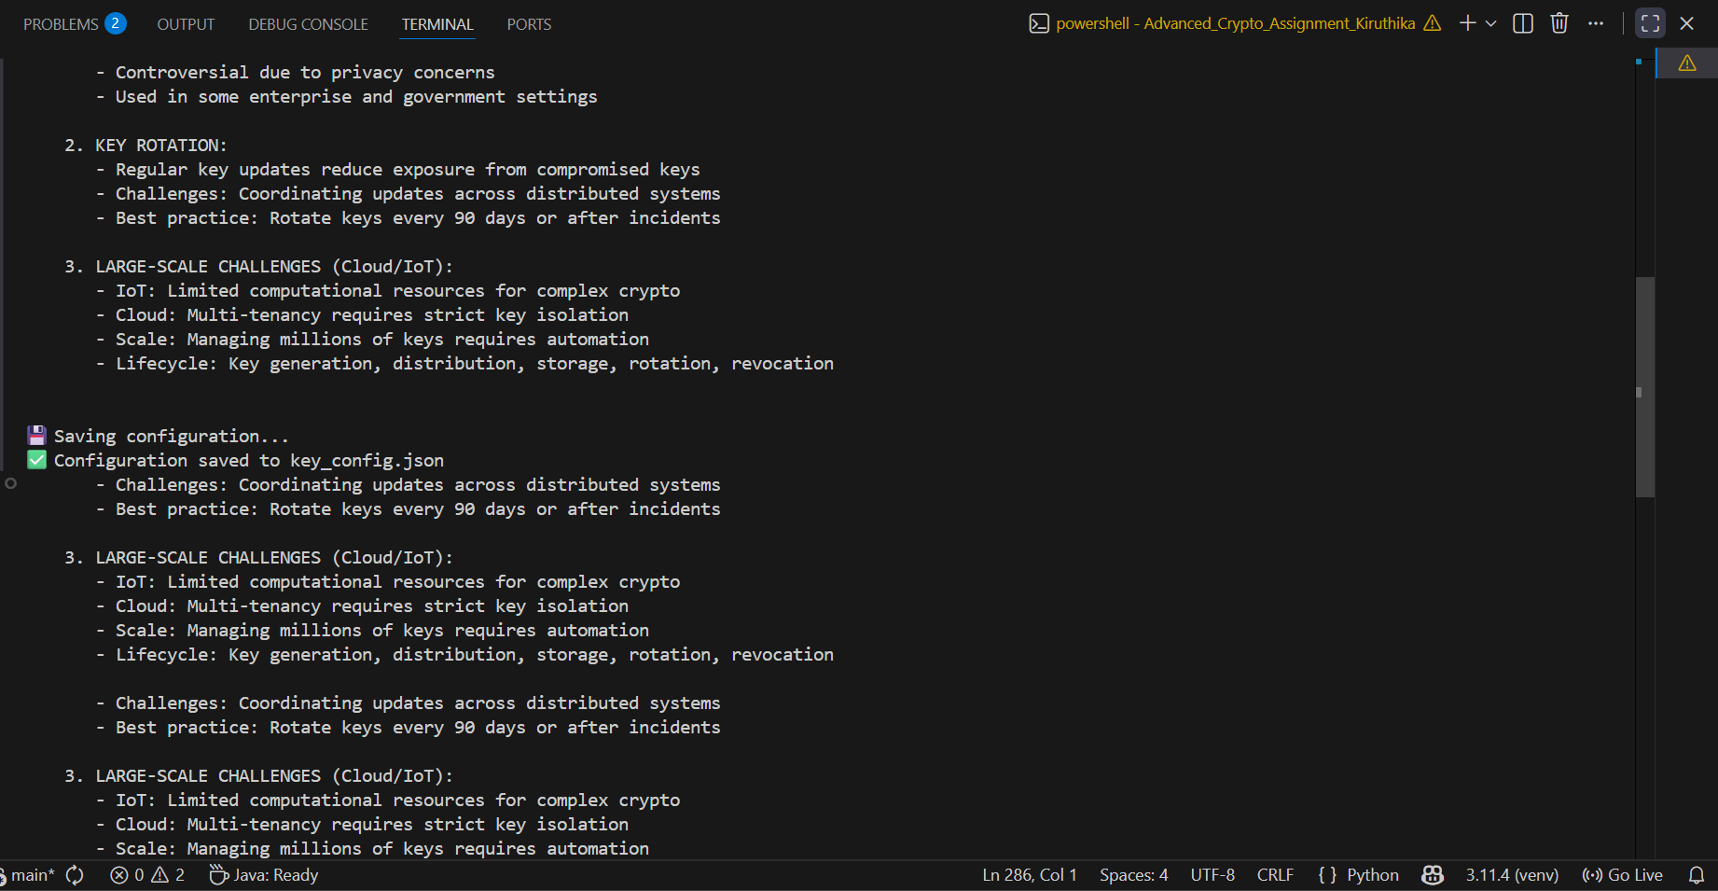
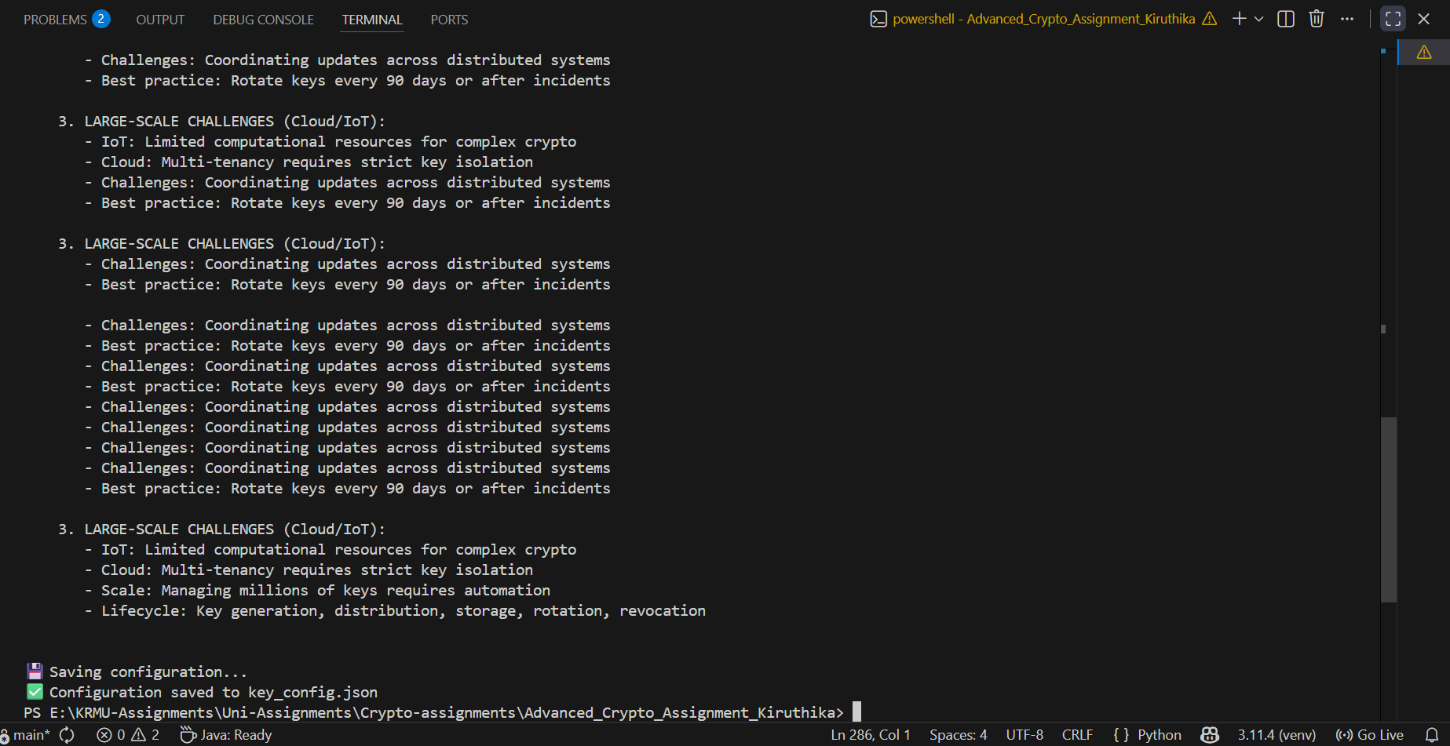

pgp_demo.py
"""
Q2: Secure Email Using PGP/GPG
Demonstrates PGP-style encryption, decryption, and digital signatures
"""

import base64
import os
import datetime

from cryptography.hazmat.primitives import hashes, serialization
from cryptography.hazmat.primitives.asymmetric import rsa, padding
from cryptography.hazmat.backends import default_backend
from cryptography.hazmat.primitives.ciphers import Cipher, algorithms, modes

class PGPSimulator:
"""Simulates PGP encryption, signing, decryption, and verification"""

def __init__(self):
self.private_keys = {}
self.public_keys = {}
print(" PGP Simulator Initialized")

def generate_keypair(self, name, email):
"""Generate RSA keypair for a user"""
private_key = rsa.generate_private_key(
public_exponent=65537,
key_size=2048,
backend=default_backend()
)
public_key = private_key.public_key()

user_id = f"{name} <{email}>"
self.private_keys[user_id] = private_key
self.public_keys[user_id] = public_key

print(f" Key pair generated for {user_id}")

private_pem = private_key.private_bytes(
encoding=serialization.Encoding.PEM,
format=serialization.PrivateFormat.PKCS8,
encryption_algorithm=serialization.NoEncryption()
)

public_pem = public_key.public_bytes(
encoding=serialization.Encoding.PEM,
format=serialization.PublicFormat.SubjectPublicKeyInfo
)

return {
'user_id': user_id,
'private_key': private_pem.decode(),
'public_key': public_pem.decode()
}

# ------------------------------------------------------------------
# HYBRID AES + RSA ENCRYPTION
# ------------------------------------------------------------------

def encrypt_email(self, message, recipient_id):
"""Encrypt large message using hybrid RSA + AES"""
if recipient_id not in self.public_keys:
raise ValueError(f"No public key for {recipient_id}")

public_key = self.public_keys[recipient_id]

# 1. Generate AES key + IV
aes_key = os.urandom(32) # 256-bit AES
iv = os.urandom(16)

# 2. AES encrypt message
cipher = Cipher(algorithms.AES(aes_key), modes.CFB(iv))
encryptor = cipher.encryptor()
ciphertext = encryptor.update(message.encode()) + encryptor.finalize()

# 3. RSA encrypt AES key
encrypted_key = public_key.encrypt(
aes_key,
padding.OAEP(
mgf=padding.MGF1(algorithm=hashes.SHA256()),
algorithm=hashes.SHA256(),
label=None
)
)

pgp_message = f"""-----BEGIN PGP MESSAGE-----
Version: PGPSimulator 1.0

{base64.b64encode(encrypted_key).decode()}
{base64.b64encode(iv).decode()}
{base64.b64encode(ciphertext).decode()}
-----END PGP MESSAGE-----"""

print(f" Message encrypted for {recipient_id}")
return pgp_message

# ------------------------------------------------------------------
# HYBRID DECRYPTION
# ------------------------------------------------------------------

def decrypt_email(self, encrypted_message, recipient_id):
"""Decrypt hybrid AES+RSA encrypted message"""
if recipient_id not in self.private_keys:
raise ValueError(f"No private key for {recipient_id}")

private_key = self.private_keys[recipient_id]

lines = encrypted_message.split("\n")
data = [l for l in lines if not l.startswith("-----") and not l.startswith("Version") and l.strip()]

encrypted_key = base64.b64decode(data[0])
iv = base64.b64decode(data[1])
ciphertext = base64.b64decode(data[2])

# RSA decrypt AES key
aes_key = private_key.decrypt(
encrypted_key,
padding.OAEP(
mgf=padding.MGF1(algorithm=hashes.SHA256()),
algorithm=hashes.SHA256(),
label=None
)
)

# AES decrypt message
cipher = Cipher(algorithms.AES(aes_key), modes.CFB(iv))
decryptor = cipher.decryptor()
plaintext = decryptor.update(ciphertext) + decryptor.finalize()

print(f" Message decrypted by {recipient_id}")
return plaintext.decode()

# ------------------------------------------------------------------
# SIGNING
# ------------------------------------------------------------------

def sign_message(self, message, signer_id):
"""Create digital signature"""
if signer_id not in self.private_keys:
raise ValueError(f"No private key for {signer_id}")

private_key = self.private_keys[signer_id]

signature = private_key.sign(
message.encode(),
padding.PSS(
mgf=padding.MGF1(hashes.SHA256()),
salt_length=padding.PSS.MAX_LENGTH
),
hashes.SHA256()
)

signature_b64 = base64.b64encode(signature).decode()

signed_message = f"""-----BEGIN PGP SIGNED MESSAGE-----
Hash: SHA256

{message}
-----BEGIN PGP SIGNATURE-----

{signature_b64}
-----END PGP SIGNATURE-----"""

print(f" Message signed by {signer_id}")
return signed_message

# ------------------------------------------------------------------
# VERIFICATION
# ------------------------------------------------------------------

def verify_signature(self, signed_message, signer_id):
"""Verify digital signature"""
if signer_id not in self.public_keys:
raise ValueError(f"No public key for {signer_id}")

public_key = self.public_keys[signer_id]

lines = signed_message.split("\n")
message_lines = []
signature_lines = []
in_message = False
in_signature = False

for line in lines:
if line.startswith("-----BEGIN PGP SIGNED MESSAGE"):
in_message = True
continue
elif line.startswith("-----BEGIN PGP SIGNATURE"):
in_message = False
in_signature = True
continue
elif line.startswith("-----END"):
in_signature = False
continue
elif line.startswith("Hash:"):
continue

if in_message and line:
message_lines.append(line)
elif in_signature:
signature_lines.append(line)

message = "\n".join(message_lines)
signature = base64.b64decode("".join(signature_lines))

try:
public_key.verify(
signature,
message.encode(),
padding.PSS(
mgf=padding.MGF1(hashes.SHA256()),
salt_length=padding.PSS.MAX_LENGTH
),
hashes.SHA256()
)
print(f" Signature verified for {signer_id}")
return True, message

except Exception as e:
print(f" Signature verification failed: {e}")
return False, None

# ------------------------------------------------------------------
# COMBINED OPERATION
# ------------------------------------------------------------------

def encrypt_and_sign(self, message, sender_id, recipient_id):
"""Sign first, then encrypt (PGP workflow)"""
signed = self.sign_message(message, sender_id)
encrypted = self.encrypt_email(signed, recipient_id)
print(f" Message encrypted and signed: {sender_id} → {recipient_id}")
return encrypted

# ----------------------------------------------------------------------
# DEMO FUNCTION
# ----------------------------------------------------------------------

def demonstrate_pgp():
print("=" * 70)
print("PGP SECURE EMAIL DEMONSTRATION")
print("=" * 70)

pgp = PGPSimulator()

# Generate key pairs
alice_keys = pgp.generate_keypair("Alice Smith", "alice@example.com")
bob_keys = pgp.generate_keypair("Bob Jones", "bob@example.com")

alice_id = alice_keys['user_id']
bob_id = bob_keys['user_id']

print("\n" + "=" * 70)
print("ENCRYPTION DEMO")
print("=" * 70)

email_message = """Subject: Confidential Project Update
From: Alice <alice@example.com>
To: Bob <bob@example.com>

Dear Bob,

The project deadline has been moved to next Friday.
Please ensure all deliverables are updated before the new deadline.

Best regards,
Alice
"""

encrypted = pgp.encrypt_and_sign(email_message, alice_id, bob_id)
print("\nEncrypted message:\n", encrypted)

decrypted = pgp.decrypt_email(encrypted, bob_id)
print("\nDecrypted (signed) message:\n", decrypted)

verified, original = pgp.verify_signature(decrypted, alice_id)
print("\nSignature verified:", verified)
if verified:
print("\nOriginal message:\n", original)

print("\nDemo complete.")

if __name__ == "__main__":
demonstrate_pgp()

Output:
