###### **IoT PROJECT REPORT**

###### **SUBJECT TITLE : INTERNET OF THINGS**

**SUBJECT CODE: 15IT422E**

**SUBMITTED TO: Dr. Kayalvizhi Jayavel**

Water Quality with pH measurement

**G.AVINASH REDDY**

**RA1611008010061**

**LINKS TO GITHUB AND YOUTUBE:**

**YouTube:**

**Github:**

<https://github.com/Aviavatar/WaterQuality-measurement-using-pH-sensor>

**ACKNOWLEDGEMENT**

I would like to express my sincere gratitude to our IoT Faculty Dr. Kayalvizhi Jayavel for being out there at every step of my course and guiding us all along the way to be capable of moldings our ideas into smart projects and helping us enhance our skills.

I would also like to thank my parents, without whom I wouldn’t be able to anything in any regard.

**ABSTRACT**

**HARDWARE REQUIRED:**

* Nodemcu ESP8266 module.
* 4 in 1 pH sensor board
* Jumper Wires
* Breadboard
* A Smartphone
* A Computer.
* Micro USB cable

**SOFTWARE REQUIRED :**

* Arduino IDE.
* ESP8266 library.
* Google Firebase connectivity

**MISCELLANEOUS:**

* WiFi Internet Connection

**TOTAL COST OF COMPONENTS :- Rs.800 - Rs.900.**

Node MCU ESP8266- Rs.380

4 in 1 pH sensor board- 350

Breadboard-70

Jumper wires- Rs.20

**SYSTEM OVERVIEW**

4 in 1 pH sensor Board is the multipurpose component which gives the pH of liquid, level of liquid, surrounding temperature, and light intensity. It uses Tx and Rx pins for the transmission of data and takes 3.3 volts input.

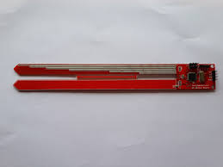

NodeMCU ESP8266 is a Microcontroller unit that have an inbuilt WIFI module. In this model we used this micro controller so that to make a connectivity of WIFI to transfer and retrieve the data from the cloud. Here we use the Google firebase cloud services to store the real-time data i.e., it shows the distance that calculated by the Ultrasonic Sensor.

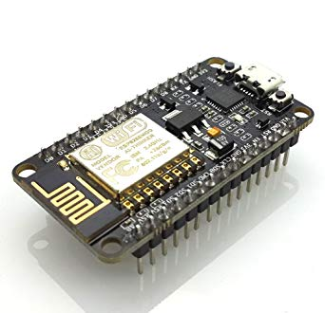

**Programming NodeMCU and setting up ThingSpeak Dashboard :**

* Make all the necessary circuit connections.
* Import ESP8266WiFi.h Library to the Arduino IDE
* Create an account in Google firebase and start a project set the details and save the firebase authentication and firebase host.
* Upload the pH sensor code into your NodeMCU.
* Setup your firebase console real time database.
* Run your code in aurdino ide.
* Once the code is running open COM3 port where all your readings are shown.
* These readings are reflected on firebase database and the same results are in the serial monitor.

**CODE**

**pH sensor**

**#include <ESP8266WiFi.h>**

**#include <FirebaseArduino.h>**

**// Set these to run example.**

**#define FIREBASE_HOST "speedy-nodemcu.firebaseio.com"**

**#define FIREBASE_AUTH "yymxIQPbnInvnvLS0fc1tkA9UzPZuSbmTZGTlqv5"**

**#define WIFI_SSID "Aviavatar"**

**#define WIFI_PASSWORD "qwertyui"**

**void setup() {**

**Serial.begin(9600);**

**// connect to wifi.**

**WiFi.begin(WIFI_SSID, WIFI_PASSWORD);**

**Serial.print("connecting");**

**while (WiFi.status() != WL_CONNECTED) {**

**Serial.print(".");**

**delay(500);**

**}**

**Serial.println();**

**Serial.print("connected: ");**

**Serial.println(WiFi.localIP());**

**Firebase.begin(FIREBASE_HOST, FIREBASE_AUTH);**

**}**

**int n = 0;**

**void loop() {**

**for(int i=1; i<=10; i++) {**

**String phdata = Serial.readStringUntil(':');**

**Serial.println(phdata);**

**if(phdata != ""){**

**String ph = Serial.readStringUntil('$');**

**Serial.println(ph);**

**float phvalue=ph.toFloat();**

**Serial.println();**

**Serial.println("PH Value");**

**Serial.println(phvalue);**

**Firebase.setFloat("pH value",phvalue);**

**Firebase.setString("details",phdata);**

**}**

**}**

**}**

**Result :**

Water Quality is tested based on the pH of it using the NodeMCU and with the help of pH sensoris successfully implemented. The connectivity to google firebase is been set to take the result from the nodeMCU into the cloud database.