Yelp cuisine classification data analysis
  - Deliverable 2 Part 1
Our project uses the Yelp Open Dataset to predict a restaurant's cuisine from a review. Each datapoint is one review, and the output is one of 18 cuisine labels derived from that restaurant's Yelp categories. The final capped dataset used for the prepared feature sets contains 293,819 rows and nine CSV columns. Its cuisine classes are nearly balanced.

Dataset size and splits
After cuisine labeling and filtering, the natural dataset contains 3,158,018 reviews. A smaller capped version was created by randomly sampling reviews within each class and split. All reviews from the same business are assigned to one split, targeting approximately 80% training, 10% development, and 10% testing before sampling.
Split | Natural dataset | Capped dataset
Training | 2,526,284 | 235,306
Development | 316,051 | 29,283
Test | 315,683 | 29,230
Total | 3,158,018 | 293,819

Columns and their use
Each final dataset CSV has nine columns. Review text supplies the word-count features, and label is the prediction target. The other columns provide identifiers, preprocessing information, or metadata.
Column | Meaning and use
review_id | Unique review identifier for tracking examples.
business_id | Restaurant identifier used to keep businesses in separate splits.
business_name | Restaurant name; its words are removed from review text.
city | Restaurant city; not used as a model feature.
state | Restaurant state or province; not used as a model feature.
stars | Review rating; not used as a model feature.
date | Review date; not used as a model feature.
label | Cuisine category that the classifier should predict.
text | Review text used to generate the input features.

Selection and preprocessing
The pipeline first keeps reviews of businesses tagged Restaurants. It maps national and regional cuisine categories into broader labels, such as combining American New and American Traditional under American. Dish, restaurant-format, dietary, and meal categories are excluded. Businesses with no matching cuisine are removed. A business tagged American plus exactly one other cuisine receives the more specific label; other cases with multiple cuisine labels are removed.
Cuisine labels with fewer than 15,000 reviews are then removed. African, Eastern European, and Spanish fall below this threshold. The 18 retained labels are American, British & Irish, Cajun/Creole, Caribbean, Chinese, Eastern Mediterranean, French, German, Hawaiian, Italian, Japanese, Korean, Latin American, Mexican, South Asian, Southern, Thai, and Vietnamese.
Text is lowercased, URLs are removed, and characters outside a-z, spaces, and apostrophes are stripped. NLTK tokenizes the text, and stopwords, one-character tokens, and words from the reviewed business's name are removed. The vocabulary is learned from training reviews only and then applied to development and test reviews. A term must occur in at least five training reviews to enter the vocabulary. Features store occurrence counts, rather than TF-IDF weights.

Prepared feature sets
Five feature sets were generated from the same capped splits. Unigrams are individual words; bigrams and trigrams are sequences of two and three tokens in the preprocessed text. None of the sets reaches the configured limit of 1,000,000 features.
Feature set | Number of features
Unigrams | 28,742
Unigrams and bigrams | 360,366
Unigrams, bigrams, and trigrams | 497,393
Bigrams only | 331,624
Trigrams only | 137,027

These vocabulary counts describe the number of columns in each vectorized representation. The source dataset still has nine CSV columns. The vocabulary sizes alone do not show which feature set predicts cuisine most accurately.

Dataset distributions
The chart compares cuisine proportions in the natural and capped datasets across training, development, and test. Each percentage uses the total for its own dataset.
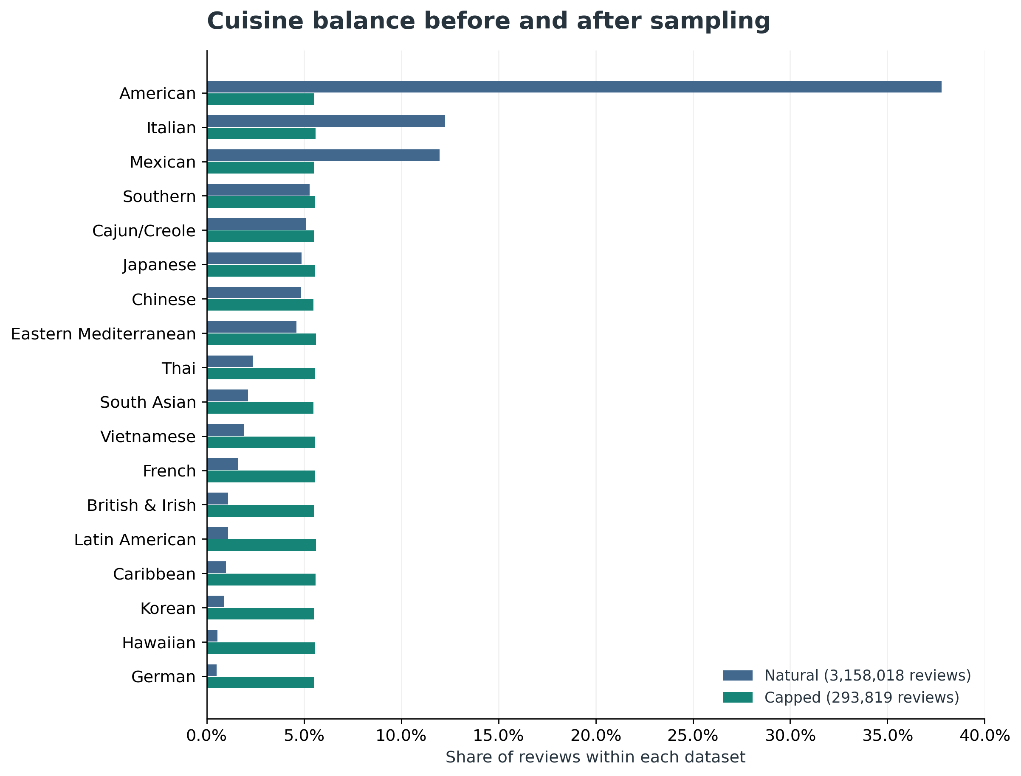
Figure 1. Downsampling reduces the large differences in cuisine frequency. Source: dataset_distribution.txt.
American accounts for 37.8% of reviews in the natural dataset. After sampling, each cuisine represents approximately 5.5% to 5.6% of the final capped dataset. Final class totals range from 16,123 Chinese reviews to 16,497 Eastern Mediterranean reviews. The sampling targets about 13,060 training reviews per class; the actual counts vary because reviews are selected probabilistically.
This reduces the dominance of common cuisines, but it retains only about 9.3% of the labeled natural dataset. The balanced development and test sets represent roughly equal cuisine frequencies, so their results will not directly describe the original Yelp distribution. Dropping small classes and ambiguous restaurants also limits coverage. The labels describe restaurant categories; an individual review may not clearly mention that cuisine.
Analysis sources: yelp_pipeline.py, dataset_distribution.txt, label_map.txt, and feature_stats.txt supplied for the project. Additional figures and exact count tables accompany this section.

