## Clustering Restaurants and Food Stalls in Yogyakarta

## Introduction

* 1. Yogyakarta is home to a myriad of heritage buildings, landmarks and important monuments. Because of its proximity to the Borobudur and Prambanan temples, and presence of the Javanese court Kraton culture of Kraton Yogyakarta, Yogyakarta hosts a sizeable tourist industry. Kotagede, the capital of Mataram Sultanate is also located in the city. Many tourists come to Yogyakarta as an accommodation base to visit Borobudur and Prambanan.
  2. As a tourist city, many tourists visit Yogyakarta. Trying local food is one of the attractions for tourists. But tourists cannot explore all food stalls and restaurants in one day. Knowing the food center is important for tourists who are on a culinary tour in Yogyakarta

## Data

The data used is data from the Foursquare API. Location data is obtained by searching using the API with the category 'Food'

## Methodology

1. Get data from the Foursquare API

After registering in the Foursquare developer account, we can use the API to get location data. There are many types of API usage. What I use this time is the API to search for locations in the Food category close to the city of Yogyakarta

2. Cllustering

The next step is to determine the cluster based on where the food stalls and restaurants are located.

Location data will be collected and clustering will be done using the K-Means method. Determination of the number of k using the elbow method

## Results

With outliers

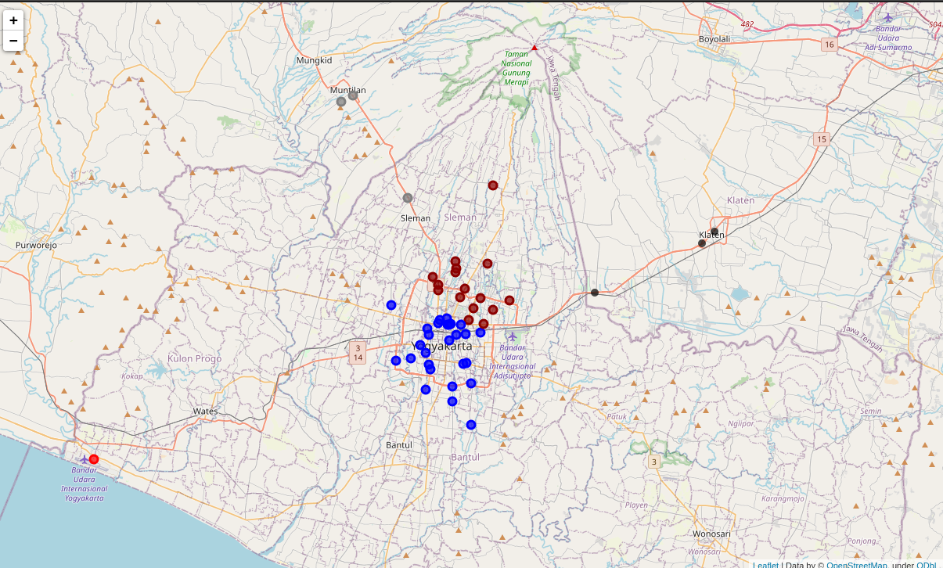

Without Outlier

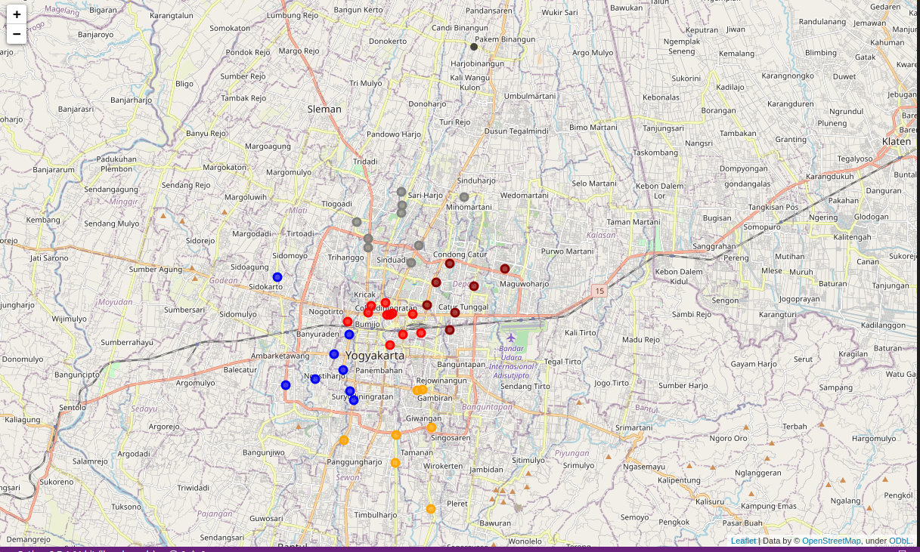

## Discussion

From the picture it can be seen that the food stalls and restaurants in Yogyakarta are divided into 5 clusters. However, if observed, only two clusters are close to the city center. In this project we will ignore it.

After eliminating outliers, we can see clusters better. There are six food stalls and restaurants in Yogyakarta that are ready for tourists to explore

## Conclusion

* 1. By ignoring clusters that are far from the city of Yogyakarta, it can be concluded that food stalls and restaurants in the city of Yogyakarta can be divided into six clusters. It is expected that these results can be considered by tourists if they want to have a culinary tour