

Faculty of Sciences - Department of Data Sciences
M.Sc. Final Project
Analysis of Ultrasonic Vocalization of Mice for Autism Detection
Chen Aharon · Aviel Bitton
305672255 204415418
Advisor: Dr. Dror Lederman
(Holon Institute of Technology, Faculty of Engineering)
In collaboration with Dr. Hava M. Golan
Biology lead researcher & data owner - Ben-Gurion University of the Negev
2026

Table of Contents
Table of Contents 2
List of Tables 4
List of Figures 5
List of Abbreviations 6
Abstract 7
1. Introduction 8
1.1 Motivation 8
1.2 The starting point: an inherited, non-runnable pipeline 8
1.3 Research questions 8
1.4 Contributions 9
1.5 Research project structure 9
2. Background and Related Work 11
2.1 Autism spectrum disorder and the Mthfr model 11
2.2 Ultrasonic vocalizations as a behavioral biomarker 11
2.3 Automated USV analysis and machine learning 11
2.4 The prior project in this lineage 12
2.5 Machine-learning methods used in this work 12
2.6 Model evaluation and metrics 14
2.7 Where this work fits 14
3. Data 15
3.1 Provenance and recording rig 15
3.2 Cohort composition 15
3.3 From recordings to syllables 16
3.4 The baseline dataset and class balance 18
3.5 Single source of truth and a data-integrity correction 19
4. Methods 20
4.1 Segmentation and syllable typing 20
4.2 Two preprocessing representations 21
4.3 Models 21
4.4 Class imbalance and metrics 22
4.5 Evaluation protocol: the heart of the study 23
5. Experiments and Results 25
5.1 Master results - tabular models (pooled) 25
5.2 The corrected baseline: a data-integrity result 26
5.3 Generalization, ranking, and minority-class behavior 27
5.4 Sequence models and cross-validation deflation 30
5.5 Decision-threshold tuning 31
5.6 Per-strain analysis 33
5.7 Which features matter 33
5.8 Best model per scenario 34
6. Discussion 36
6.1 What works, and in which regime 36
6.2 Why minority precision is capped 36
6.3 Sequence order did not help at this scale 36
6.4 The strain confound 37
6.5 The contribution in perspective 37
7. Reproducibility and Engineering Contribution 38
7.1 The starting point: a broken inheritance 38
7.2 Inherited versus new 38
7.3 Single source of truth and data provenance 39
7.4 The graphical segmentation app 39
7.5 End-to-end reproducibility 40
8. Limitations 42
9. Conclusions and Future Work 44
9.1 Conclusions 44
9.2 Future work 44
References 46
Appendix 48
A.1 Project timelines 48
A.2 The graphical segmentation tool 48
A.3 Code availability 48

List of Tables
Table 1. Tabular model configurations 22
Table 2. Sequence model architectures 22
Table 3. Tabular models, pooled baseline (recording level) 25
Table 4. Sequence models, pooled baseline (session level) 30
Table 5. Best model per scenario 34
Table 6. Inherited versus new capabilities 38

List of Figures
Figure 1. TabPFN in-context inference vs conventional training 13
Figure 2. Dataset composition (small multiples) 15
Figure 3. Class balance and syllables-per-subject 16
Figure 4. Annotated segmentation example 17
Figure 5. Syllable-type taxonomy (real spectrograms) 17
Figure 6. Syllable-type distribution 18
Figure 7. Acoustic-feature distributions by genotype 18
Figure 8. Data provenance & single source of truth 19
Figure 9. End-to-end USV-to-decision pipeline 20
Figure 10. Experimental-design matrix 24
Figure 11. Master performance - dependent vs independent 25
Figure 12. Corrected baseline and recovery (within-subject vs across-subject) 27
Figure 13. ROC curves (headline tabular models) 28
Figure 14. Precision–Recall curves (HT class) 28
Figure 15. Generalization gap (HT recall & precision) 29
Figure 16. Confusion matrices (headline models) 30
Figure 17. HT-precision wall 31
Figure 18. Sequence-model lever sweep and CV deflation 32
Figure 19. Threshold-objective operating points 33
Figure 20. Per-strain comparison 34
Figure 21. Feature importance (XGBoost) 35
Figure 22. Commit-derived work timeline 39
Figure 23. Model taxonomy - inherited vs new 40
Figure 24. The USV Segmentation desktop application (main window) 41
Figure 25. Project timeline / Gantt (interim plan) 49
Figure 26. The download page of the graphical segmentation tool on Zenodo 50
Figure 27. The public repository in GitHub for the full pipeline 50
Figure 28. The public repository in GitHub for the graphical segmentation tool 51

List of Abbreviations
Abbreviation | Meaning
ASD | Autism Spectrum Disorder
USV | Ultrasonic Vocalization
WT | Wild-Type (control genotype)
HET / HT | Heterozygous (Mthfr ASD-model genotype - positive class)
UNK | Undetermined genotype
Mthfr | Methylenetetrahydrofolate reductase
CNN | Convolutional Neural Network
BiT | Big Transfer (transfer-learning architecture)
BiLSTM | Bidirectional Long Short-Term Memory network
1D-CNN | One-Dimensional Convolutional Neural Network
TabPFN | Tabular Prior-data Fitted Network
XGBoost | Extreme Gradient Boosting
ISI | Inter-Syllable Interval
ROC-AUC | Area Under the Receiver-Operating-Characteristic Curve
PR-AUC / AP | Area Under the Precision–Recall Curve / Average Precision
MCC | Matthews Correlation Coefficient
CV | Cross-Validation
GUI | Graphical User Interface
P4-P12 | Postnatal days 4-12
HIT | Holon Institute of Technology

Abstract
Autism Spectrum Disorder (ASD) is diagnosed behaviorally, which motivates the search for objective early biomarkers. In mouse models, pup ultrasonic vocalizations (USVs) are an established, non-invasive candidate. This project asks whether ASD-model mice (Mthfr heterozygotes) can be distinguished from wild-type controls by their USVs, and equally importantly how well such a classifier generalizes to unseen animals.
The work began from an inherited, non-runnable pipeline whose only model was a single subject-dependent XGBoost classifier. A central contribution is therefore the reconstruction of this prototype into a versioned, documented, end-to-end-reproducible system with a single source of truth, supported by a graphical segmentation tool that lets the biology researcher curate the data in parallel. During curation, an undocumented genotype-labelling error in the prior data was discovered and corrected (14 mice, 2,495 rows, HET → WT).
On a corpus of 125,576 syllables from 126 pups (35 dams, five recording years), two representations were built recording-level acoustic aggregates and ordered per-session syllable sequences and evaluated under two complementary regimes: subject-dependent (within-subject: classifying a new recording of an already-seen animal) and subject-independent (across-subject: generalizing to entirely unseen animals). Tabular models (XGBoost, tuned XGBoost, TabPFN) were compared with neural sequence models (BiLSTM, 1D-CNN, Transformer).
TabPFN is the strongest tabular model in both regimes, reaching 0.781 within-subject accuracy (up to 0.801 per cohort) and 0.729 across-subject accuracy (weighted F1 0.743, ROC-AUC 0.783) on entirely unseen mice. Clinically most important, HT (ASD-model) recall stays high across the regime change the tuned XGBoost catches 0.869 of true ASD-model pups on unseen animals so the model rarely misses a positive case. A previously reported accuracy of 0.829 is clarified as an uncorrected within-subject figure: a data-integrity correction lowers the inherited within-subject baseline to 0.733, and TabPFN then exceeds it (0.781), the within-subject vs across-subject gap is the expected difference between two legitimate questions. Minority-class precision is capped near 0.50 across all models a feature-level ceiling, not an estimator limit and sequence models do not improve on the tabular aggregates at this data scale, with a promising single-split result (0.704 balanced accuracy) deflating to 0.563 ± 0.063 under cross-validation. Per-strain results are strongly confounded by cohort. The project delivers a reproducible pipeline and a calibrated account, under both evaluation regimes, of what USVs can and cannot support.

1. Introduction

1.1 Motivation
Autism Spectrum Disorder (ASD) is a neurodevelopmental condition defined by difficulties in social communication together with restricted and repetitive behavior. Diagnosis in humans rests on expert behavioral assessment, which is time-consuming, requires trained clinicians, and is especially hard to apply reliably in early infancy precisely the window in which early intervention is most valuable. This motivates a search for objective, quantitative, and early biomarkers of atypical neurodevelopment.
Mouse models are a central tool in preclinical ASD research. When isolated from the nest, mouse pups emit ultrasonic vocalizations (USVs) calls in the 35-125 kHz range that are inaudible to humans, produced naturally, and recordable non-invasively. These isolation calls are sensitive to genetic and environmental manipulations relevant to neurodevelopment, and their temporal and spectral structure has been proposed as an early, communication-related biomarker of ASD-like phenotypes [1], [2], [5]. Because mouse USVs share several organizational features with human speech temporal patterning, frequency modulation, and sensitivity to developmental disruption they offer a tractable bridge between molecular models and communication phenotypes [7].
Most prior USV studies remain descriptive: they report group-level differences in call rate or in a handful of acoustic features. A smaller and more recent body of work asks the harder predictive question whether the differences between an ASD-model group and a wild-type group are large and consistent enough to classify an individual animal from its calls [8], [3], [15]. This project belongs to the predictive tradition and inherits a concrete experimental lineage: a long-running collaboration that recorded Mthfr (methylenetetrahydrofolate reductase) ASD-model mice and wild-type controls under a standardized isolation paradigm [17], [18].

1.2 The starting point: an inherited, non-runnable pipeline
This iteration of the project did not begin from a blank page, nor from a working system. It began from an inherited code base that did not run. At handoff, the repository contained a single monolithic prototype with hard-coded paths and a single, basic, subject-dependent XGBoost classifier and nothing else. Reaching a state in which even that one model could be reproduced required rebuilding the whole pipeline: data ingestion, segmentation, feature extraction, training, and evaluation.
This shapes the entire research project. A central, genuine contribution of this work is therefore not only a set of model results but the reconstruction of a broken, undocumented pipeline into a versioned, end-to-end-reproducible system with a single source of truth for the data, accompanied by a graphical tool that lets the biology researcher curate the underlying recordings in parallel. Everything beyond the inherited subject-dependent XGBoost the tuned XGBoost, the TabPFN tabular model, the three neural-network sequence models, the subject-independent evaluation, and the per-strain analysis was added by this project. Figure 23 makes this inherited-versus-new distinction explicit.

1.3 Research questions
The research questions were not fixed at the outset. The interim proposal framed the project broadly: improve the inherited predictive model, identify which USV characteristics matter most, and assess whether USVs can reliably flag ASD-like traits. As the rebuilt pipeline made systematic experimentation possible, the questions were refined in consultation with the project advisor, Dr. Dror Lederman, toward the directions the new infrastructure could actually answer:
- RQ1 - New models. Do models that did not previously exist in this project the TabPFN tabular foundation model and the neural-network sequence models (BiLSTM, 1D-CNN, Transformer) improve classification of ASD-model (Mthfr-HET) versus wild-type pups over the inherited XGBoost baseline?
- RQ2 - Which features. Which acoustic characteristics drive the classification, and do a small number (two or three) of consistent features emerge?
- RQ3 - Evaluation regime and generalization. How does the data grouping and evaluation regime subject-dependent versus subject-independent splits, and per-strain versus pooled cohorts affect classification performance and, above all, generalization to unseen mice?
- Engineering question - Can the inherited, broken pipeline be rebuilt into a versioned, reproducible, end-to-end system with a single source of truth, enabling the biology researcher to curate data in parallel?

1.4 Contributions
This research project makes the following contributions:
- A reproducible, documented pipeline that takes raw 250 kHz recordings to trained classifiers and evaluation reports, replacing an inherited prototype that could not be run from a clean checkout (Chapter 7).
- A single source of truth for the data, consolidated through a purpose-built graphical segmentation tool and a versioned baseline manifest, including the discovery and correction of an undocumented genotype-labelling error in the prior data (Chapters 3 and 7).
- A systematic model comparison spanning tabular models (XGBoost, tuned XGBoost, TabPFN) and neural sequence models (BiLSTM, 1D-CNN, Transformer), under a controlled evaluation protocol (Chapters 4 and 5).
- A dual-regime characterization of performance, reporting within-subject accuracy (on already-seen animals) and across-subject accuracy (generalization to unseen animals) side by side as two complementary, legitimate questions, and exposing a feature-level ceiling on minority-class precision (Chapters 5 and 6).
- A faithful account of the data-integrity finding, showing that the inherited within-subject baseline is lower once genotype labels are corrected, that the new models nonetheless exceed it, and decomposing the difference from a previously reported figure into a data-correction effect and a within-vs-across-subject effect (Figure 12).

1.5 Research project structure
Chapter 2 reviews ASD, USVs, and the relevant machine-learning literature, and situates this work within its research lineage. Chapter 3 describes the data: provenance, recording rig, cohorts, composition, and the single-source-of-truth story. Chapter 4 details the methods: segmentation and syllable typing, the two preprocessing representations, the models, and the evaluation protocol. Chapter 5 reports the experiments and results, including the master results table and the best model per scenario. Chapter 6 discusses what the results mean which features matter, how well the models generalize, and why. Chapter 7 presents the reproducibility and engineering contribution. Chapter 8 states the limitations, and Chapter 9 concludes with future work.

2. Background and Related Work

2.1 Autism spectrum disorder and the Mthfr model
ASD is a heterogeneous neurodevelopmental disorder with a strong but complex genetic component, interacting with environmental and metabolic factors. One metabolic pathway repeatedly implicated in neurodevelopment is one-carbon (folate) metabolism, of which the enzyme methylenetetrahydrofolate reductase (Mthfr) is a key component. Reduced Mthfr activity perturbs methylation reactions required for normal brain development, and Mthfr-deficient mice exhibit ASD-relevant behavioral and physiological alterations. The data analyzed in this project come from a genetic ASD model based on Mthfr haploinsufficiency maintained on a BALB/c background. The cohort actually spans two strain labels that share this BALB/c base: a pure BALB/c line (the 2015 and 2018 recordings) and a line with a mixed BALB/c x C57BL/6 background (the 2022-2024 recordings) a distinction detailed in Section 3.2 that later acts as an important cohort confound (Sections 5.6 and 6.4). In both, the genetic cross is the same: wild-type (WT) dams crossed with WT sires, or heterozygous (HET) dams crossed with WT sires, producing pups whose individual genotype is WT or HET. The HET pups constitute the ASD-model (positive) class, the WT pups are controls [17], [18].

2.2 Ultrasonic vocalizations as a behavioral biomarker
Rodent USVs have become a standard tool for behavioral phenotyping of neurodevelopmental and neuropsychiatric models [1], [2], [5], [6]. Pup isolation calls, emitted when a pup is separated from dam and littermates, are among the earliest measurable communicative behaviors and are sensitive to genotype, sex, and developmental stage. Caruso et al. [2] and Premoli et al. [5] review the use of USVs across ASD rodent models and argue for richer, automated analyses beyond simple call counts.
Two studies from the research lineage of this project are particularly important because they characterize the specific dataset paradigm analyzed here:
Shekel et al. (2021) [17] applied unsupervised clustering to the spectral properties of isolation syllables in environmental (chlorpyrifos) and genetic (Mthfr) ASD models. They reported that start frequency, bandwidth, and duration were the most ASD-sensitive syllable features, and documented sex differences and strain (C57Bl/6 vs BALB/c) baseline differences that act as confounds. This single-session isolation paradigm and its feature set directly motivate the acoustic features used in the present tabular pipeline.
Gal et al. (2023) [18] studied the temporal dynamics of isolation calls under a two-session (maternal-potentiation) paradigm an isolation session, a reunion, and a second isolation session. They found dynamic, within-subject and between-session modulation of call quantity and spectral structure, with both ASD models increasing their use of harmonic calls over time, and interpreted altered dynamics as impaired regulation of vocalization. This finding that temporal organization of calls carries phenotypic information motivates the sequence-modelling track of the present work.

2.3 Automated USV analysis and machine learning
Automated USV analysis has progressed from manual spectrogram inspection toward computer-vision and deep-learning pipelines. Tools such as VocalMat [10] and the deep-learning segmentation studies of Baggi et al. [11] detect and classify syllables from spectrograms, TrackUSF [12] and ARBUR [16] integrate detection with downstream behavioral analysis in rats, and Scott et al. [14] and Johnson et al. [13] address training-data scarcity through synthetic data and semi-automated labelling. On the prediction side, Qian et al. [8] piloted detection of ASD-model mice from USVs ("the sound of silence"), Wu et al. [15] extended this with empirical mode decomposition, and the INTERSPEECH MADUV challenge [3] established a public benchmark for mouse-ASD detection from ultrasound. Beyond rodents, deep-learning vocal biomarkers have also been explored for human infant ASD screening [4]. Yao et al. [7] connect mouse USVs to human speech, reinforcing the translational rationale.
The present project sits within this predictive line but is distinguished by its engineering and evaluation rigour: a single, versioned data source, an explicit, side-by-side evaluation under both within-subject and across-subject regimes, and a careful treatment of minority-class behavior rather than headline accuracy alone.

2.4 The prior project in this lineage
A previous M.Sc. project in the same research line on the same topic and supervised by the same advisor, Dr. Dror Lederman [19] approached the problem with pretrained audio neural networks (PANNs) operating on spectrograms and with a majority-voting scheme. That prior project is prior art and a structural reference only, none of its methods or results are reused or claimed here. The present work takes a different methodological route interpretable per-recording acoustic aggregates with tree-based models, and ordered syllable sequences with recurrent/convolutional/attention models and contributes the reproducible-pipeline and data-integrity work that the earlier iteration lacked. Framing the two together simply reflects the continuity of the advisor's research line.

2.5 Machine-learning methods used in this work
This section briefly introduces the model families and concepts used later, so that the methods and results chapters can be read without external references. Two broad approaches are compared: tabular models, which operate on a fixed vector of per-recording features, and neural sequence models, which operate on the ordered stream of syllables.
Gradient-boosted trees (XGBoost) - A decision tree splits the feature space with a sequence of threshold tests and predicts a value in each resulting region. A single tree is weak, gradient boosting builds an ensemble of shallow trees in sequence, where each new tree is fit to the errors (gradients of the loss) of the ensemble so far, so that the trees progressively correct one another. XGBoost is an efficient, regularized implementation of this idea and a standard strong baseline for tabular data. It handles heterogeneous features (frequencies, durations, categorical metadata) without scaling, is relatively interpretable through per-feature "gain" importance (Section 5.7), and addresses class imbalance through a scale_pos_weight factor that up-weights the minority class. XGBoost is the model inherited with this project and therefore serves as the reference baseline.
Prior-fitted transformers (TabPFN) - TabPFN (Tabular Prior-data Fitted Network) is the methodological centerpiece of the new models and represents a fundamentally different paradigm from XGBoost. Rather than being trained on the project's data, TabPFN is a transformer network that was pre-fitted once, offline, on millions of synthetic tabular datasets drawn from a structured prior over plausible data-generating processes. At use time it performs in-context learning: the entire labelled training set and the unlabeled test rows are fed together through a single forward pass, and the network's attention mechanism compares each test row against the training examples to output a calibrated posterior predictive probability an approximation of Bayesian inference over the prior. Crucially, no gradient training and no hyperparameter tuning occur on the project's data, the model is used essentially "as is". This makes TabPFN fast, tuning-free, and well suited to tabular problems such as the recording-level matrix here. Figure 1 contrasts this in-context scheme with the fit-on-your-data workflow of XGBoost. This project uses TabPFN-3 (the Prior Labs tabpfn package), a newer version that supports far larger inputs than the original TabPFN on the order of a million rows so the 12,323-row recording matrix (48 features) sits comfortably within range, the full training split is used, and the model's built-in class-imbalance correction replaces the manual class weighting applied to XGBoost.

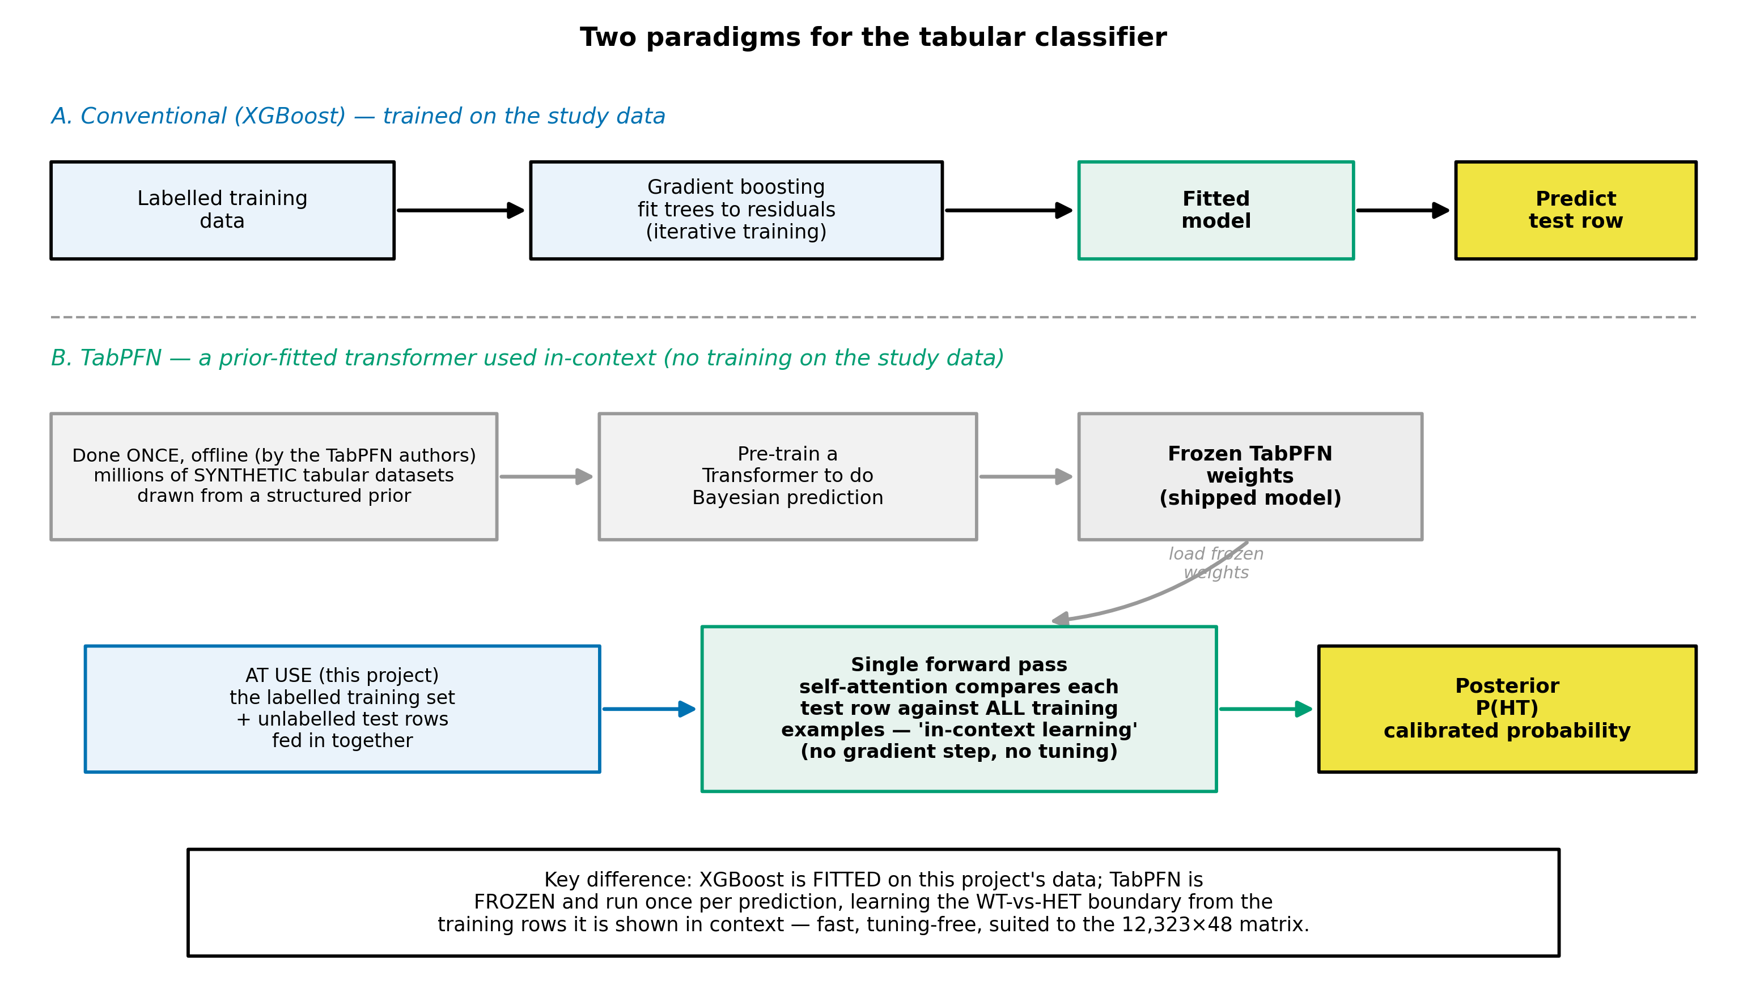
Figure 1
The methodological novelty among the new models. XGBoost (A) is trained on the project's data by iterative gradient boosting. TabPFN (B) is a transformer pre-fitted once, offline, on millions of synthetic datasets, at use it is frozen and performs in-context learning — the labelled training set and the test rows are passed together through a single forward pass whose attention compares each test row against the training examples to output a calibrated P(HT), with no gradient training or hyperparameter tuning on the project's data.

Neural sequence models - To test whether the temporal order of syllables carries phenotypic information (motivated by Gal et al. [18]), three architectures process each session as an ordered sequence of per-syllable feature vectors. A bidirectional LSTM (BiLSTM) is a recurrent network that reads the sequence in both directions, maintaining a memory state that accumulates context, it is well suited to variable-length temporal data. A one-dimensional convolutional network (1D-CNN) slides learned filters along the time axis to detect local motifs (short patterns of consecutive syllables), pooling them into a fixed representation. A Transformer encoder replaces recurrence with self-attention: every syllable position computes weighted connections to every other position, so the model can relate distant syllables directly and learn which parts of the sequence matter, a learned "CLS" summary token aggregates the sequence for classification. Attention is the same mechanism that underlies TabPFN and modern language models, applied here across syllable positions rather than across training examples.

2.6 Model evaluation and metrics
Because the results depend as much on how models are evaluated as on the models themselves, the key evaluation concepts are defined here.
Data splitting and cross-validation - Data are partitioned into a training set (to fit the model), a validation set (to choose settings and operating thresholds), and a held-out test set (to estimate performance on unseen data). When test sets are small, a single split is noisy, so k-fold cross-validation repeats the procedure over k disjoint folds and averages the results, yielding a mean and a standard deviation that quantify stability. A critical refinement for this project is grouped splitting: when several rows belong to the same animal, the split must keep an animal wholly within one fold, or performance on unseen animals is overestimated the central evaluation issue developed in Section 4.5.
Metrics under class imbalance - With a ~3:1 WT:HET class ratio, plain accuracy (fraction correct) is misleading, because always predicting the majority class already scores ~0.75. The research project therefore foregrounds imbalance-robust measures. Precision for the HET class is the fraction of "predicted HET" that are truly HET (false-alarm control), recall (sensitivity) is the fraction of true HET that are detected (catching ASD-model pups), their harmonic mean is the F1 score. Balanced accuracy averages the per-class recalls, so it is not inflated by the majority class. ROC-AUC measures threshold-free ranking quality the probability that a random HET is scored above a random WT while PR-AUC / average precision focuses on the minority class specifically. Reporting this suite, rather than accuracy alone, is what exposes the minority-class behavior (the "HT-precision wall") that dominates the discussion in Chapters 5 and 6.

2.7 Where this work fits
In summary, the biological grounding (USVs as an early ASD biomarker, the Mthfr model, the isolation paradigm) is well established [1], [2], [5], [17], [18], automated detection of ASD-model mice from USVs is an active and still-open problem [3], [8], [15], and the chief gaps this research project addresses are reproducibility, data integrity, and a rigorous dual-regime (within-subject and across-subject) evaluation of which models and which features drive classification and generalization to unseen animals.

3. Data

3.1 Provenance and recording rig
The corpus consists of pup-isolation USV recordings collected over five years (2015, 2018, 2022, 2023, 2024) in the laboratory of Dr. Hava M. Golan, the biology lead researcher and data owner for this project. Animals are Mthfr mice maintained on a BALB/c background that spans two strain labels a pure BALB/c line and a mixed BALB/c + C57BL/6 line, detailed in Section 3.2, the ASD-model (positive) class is the heterozygous (HET) pup and the control class is the wild-type (WT) pup, as described in Section 2.1 and in the project's data documentation.
Recordings were made with an Avisoft ultrasonic system: an UltraSoundGate 116Hm interface and a CM16/CMPA condenser microphone placed approximately 10 cm above the pup, sampling at 250 kHz (Nyquist 125 kHz, comfortably covering the 35-125 kHz mouse-USV band). Pups were recorded under an isolation paradigm at postnatal days P4-P12, in a single-session protocol [17] and, in later cohorts, a two-session maternal-potentiation protocol [18].

3.2 Cohort composition
The raw corpus comprises 125,576 detected syllables from 126 pups born to 35 dams, across the five recording years. At the level of unique animals, the offspring-genotype composition is 91 WT, 29 HET, and 6 of undetermined genotype (UNK), the UNK pups are dropped from analysis. Figure 2 summarizes the composition across genotype, year, strain, sex, and postnatal day, and Figure 3 shows the class balance and the per-mouse syllable counts.

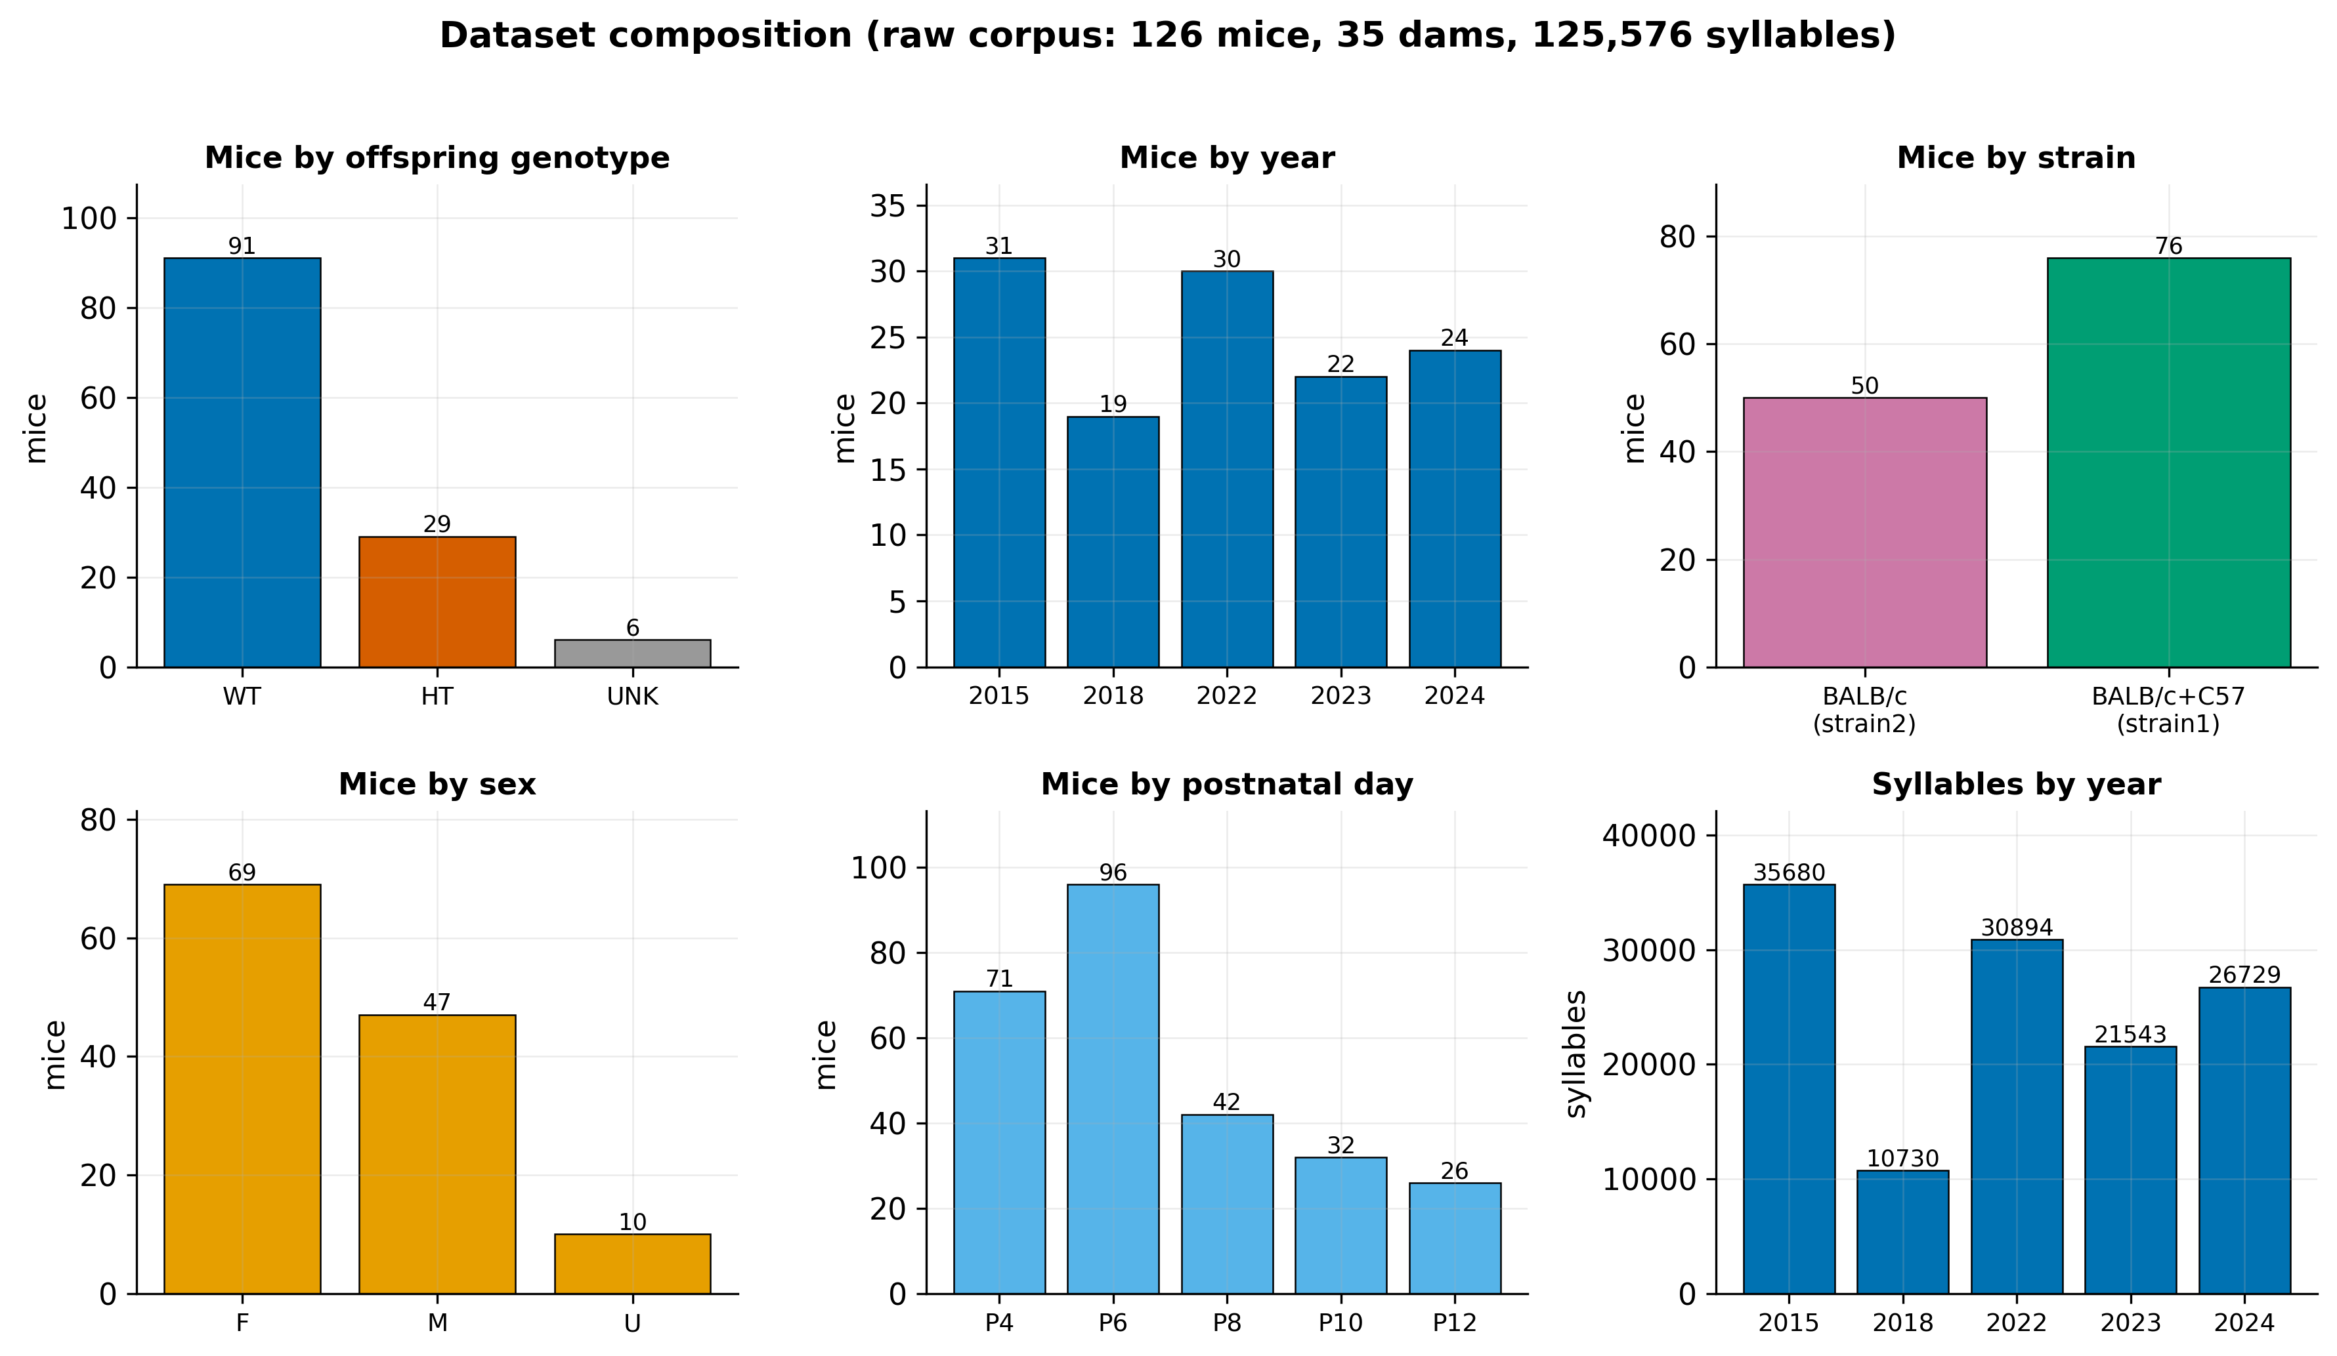
Figure 2
Counts of mice and syllables across genotype, year, strain, sex, and postnatal day for the raw corpus. The cohort is WT-skewed (~3:1) and longitudinal (P4/P6 dominate).

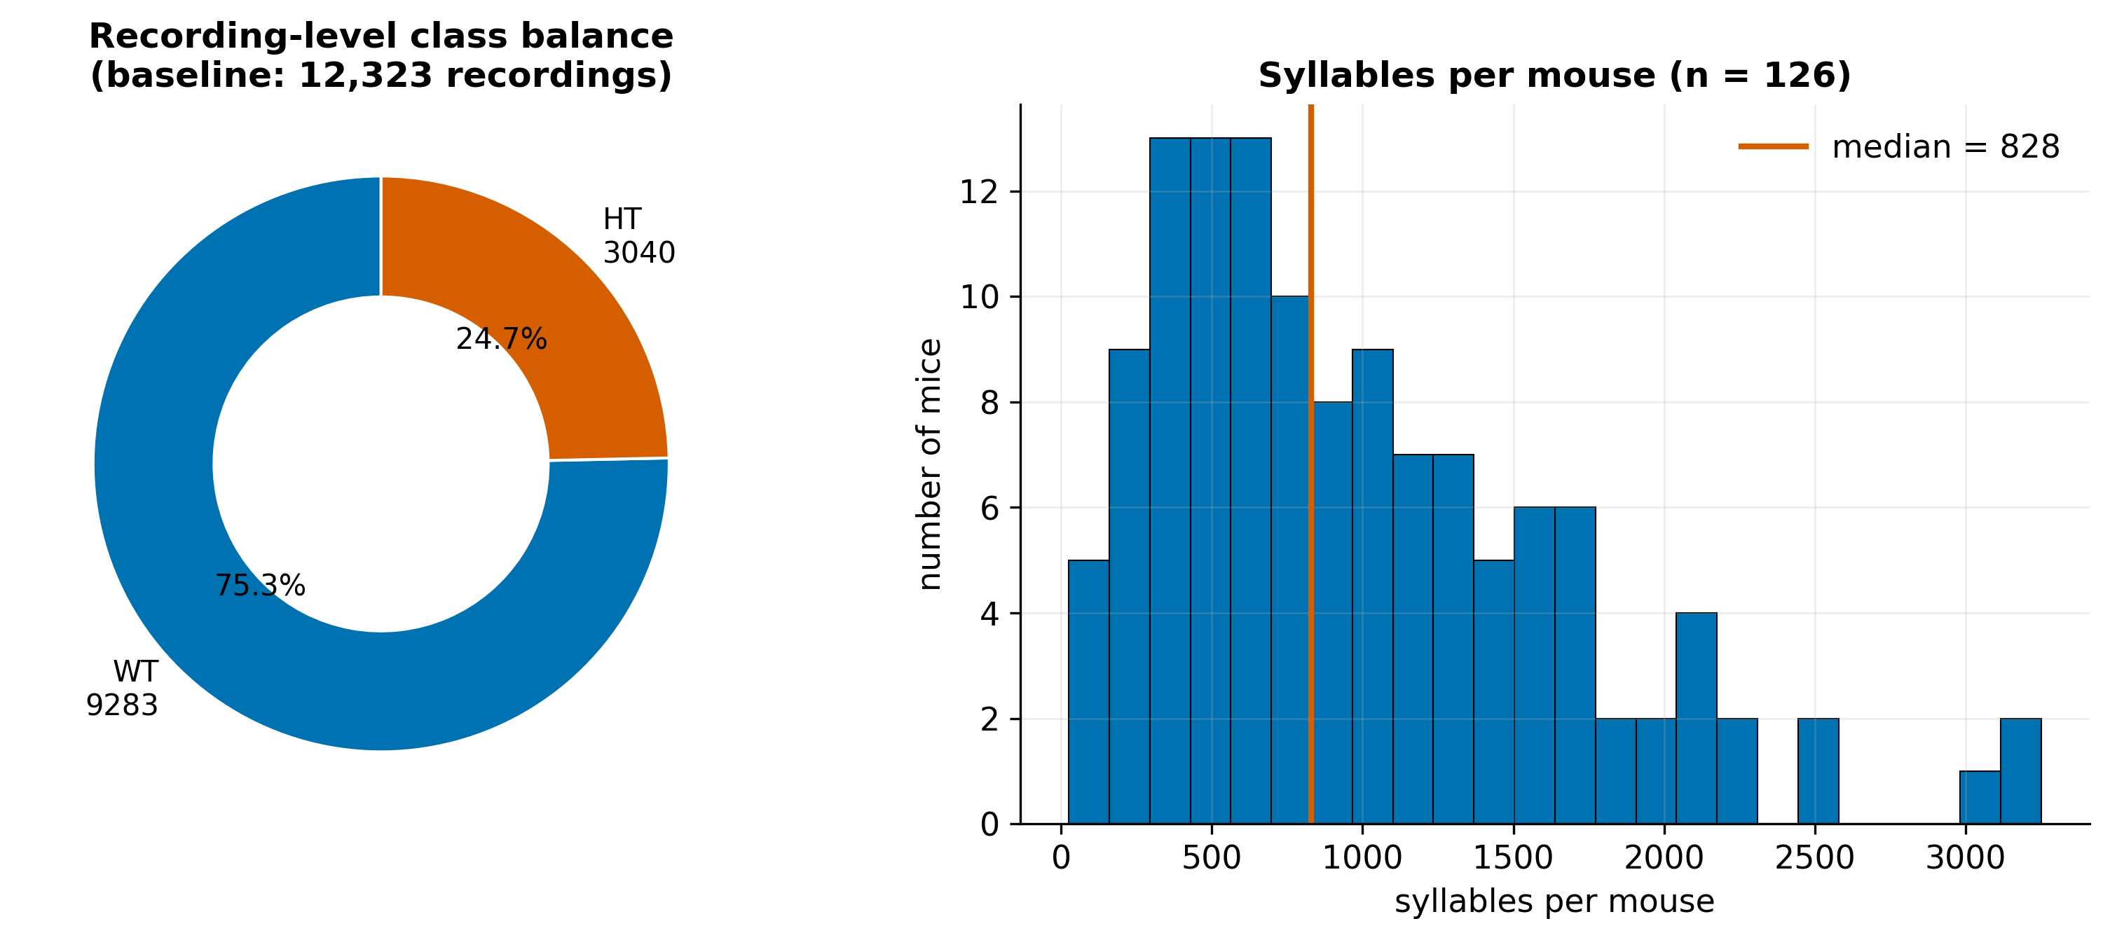
Figure 3
Left: recording-level class balance (9,283 WT / 3,040 HT, ~3:1). Right: per-mouse syllable counts (median 828), showing the strongly longitudinal structure that motivates subject-grouped evaluation.

Two structural features of the cohort are important for everything that follows. First, the cohort is WT-skewed: at the recording level the baseline class balance is roughly three WT to one HET (Section 3.4). Second, the cohort is strongly longitudinal: each pup contributes many recordings across multiple ages and sessions (a median of several hundred syllables per pup), so syllables and recordings from the same animal are highly correlated. This longitudinal structure is the single most important fact for the evaluation design (Section 4.5): a naive row-level split lets the same animal appear in both training and test data, inflating apparent performance.
A further cohort distinction is strain/background, used as a cohort scope in the experiments: the 2015 and 2018 recordings are labelled pure BALB/c ("strain2"), while the 2022–2024 recordings are labelled with a mixed BALB/c + C57 background ("strain1"). This label reflects a genuine genetic cross onto a C57BL/6 background (confirmed with the biology team), so strain1 and strain2 differ in genetic background as well as recording era which makes the cohort a real biological confound with genotype and must be treated with care (Chapter 8).

3.3 From recordings to syllables
Each WAV recording is processed into a table of syllables, one row per detected call, carrying the animal metadata (genotype, sex, day, session, strain), the call's timing (start, end, duration, inter-syllable interval), two boundary-frequency features (start and end frequency in Hz), a CNN-assigned syllable type, and a noise flag. The detection and typing algorithm is described in Section 4.1, Figure 4 shows a representative recording with its detected syllables overlaid. The ten confidently-typed classes range from simple single-vowel calls (upward and downward sweeps, flat and short calls, the chevron arch) through multi-component calls ("frequency steps", "two syllables") to harmonic calls (composite and harmonic stacks), Figure 5 shows a representative real spectrogram of each. The corpus is dominated by frequency-modulated call types "Frequency steps" alone accounts for 44,547 syllables with a long tail of rarer types and a post-hoc "Undefined" class for low-confidence detections (Figure 6). At the syllable level, the spectral and temporal features (start/end frequency, duration, inter-syllable interval) differ between WT and HET pups in the directions reported by Shekel et al. [17] (Figure 7).

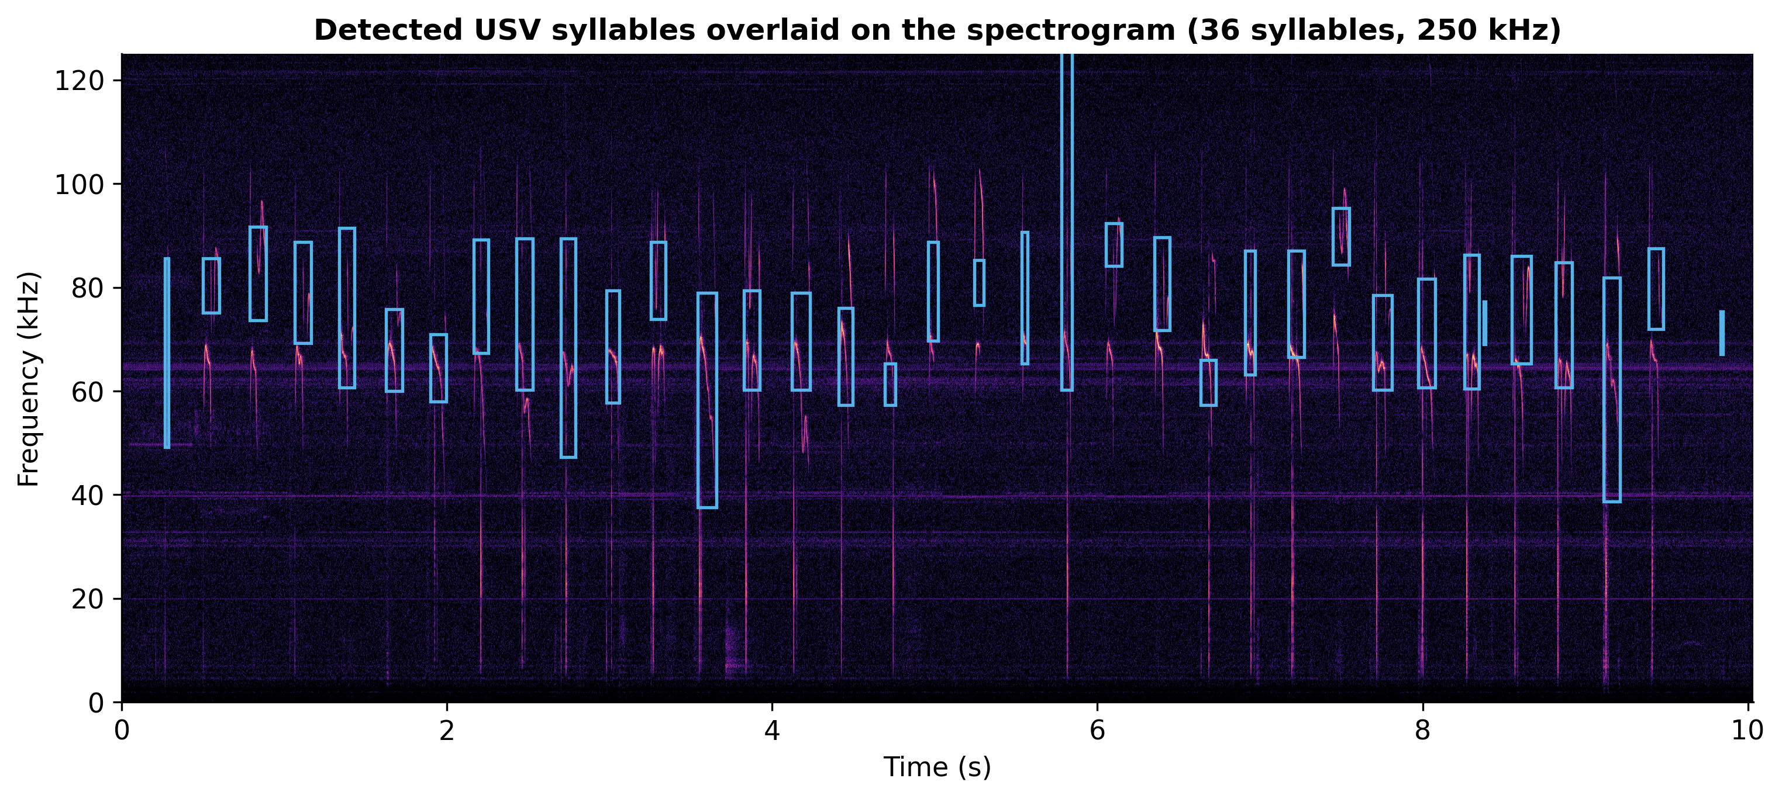
Figure 4
Spectrogram of a representative pup recording with the 36 automatically detected syllables overlaid (blue boxes span each call's time extent and start/end-frequency band).

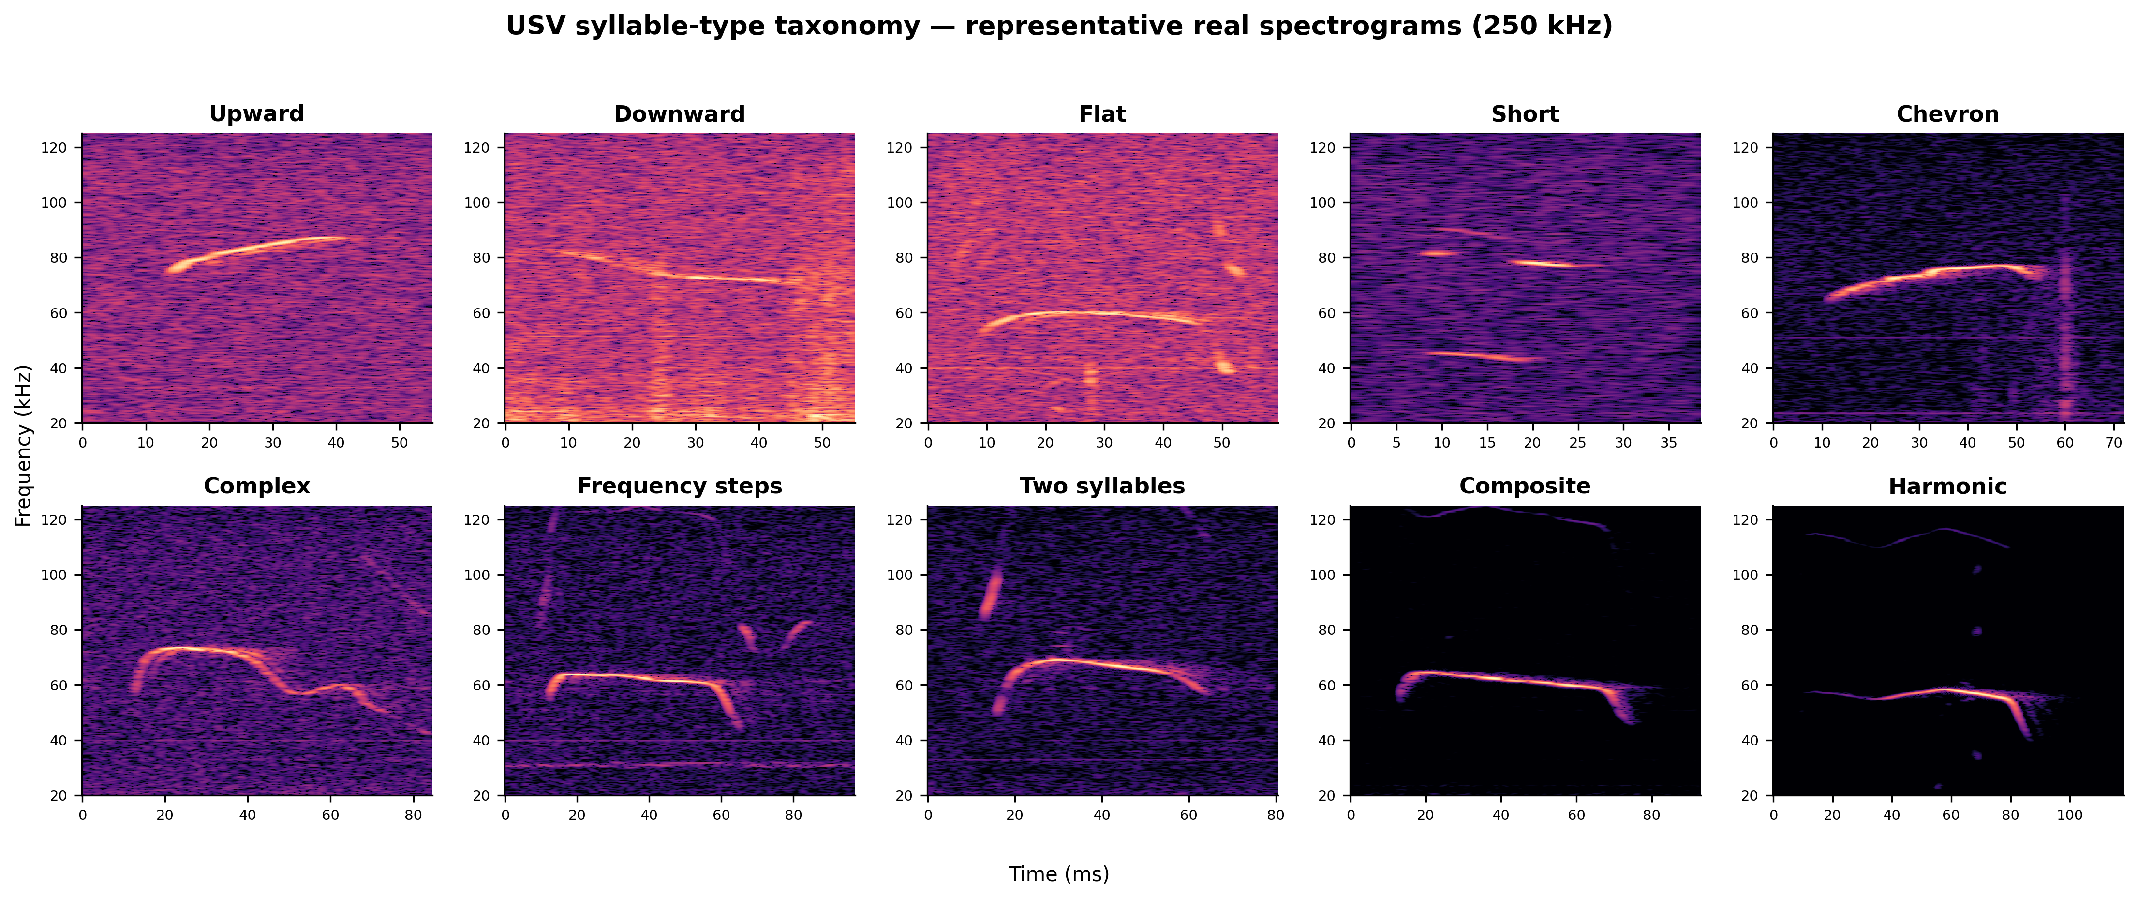
Figure 5
One representative real spectrogram for each of the ten confidently-typed syllable classes (the example nearest each type's median duration), ordered from simple single-vowel calls to multi-component and harmonic calls. The characteristic morphology is visible: upward/downward sweeps, flat and short calls, the chevron arch, stepped 'frequency steps', and the harmonic stacks of composite/harmonic calls. These are the shapes the CNN typer assigns and that the acoustic features summarize.

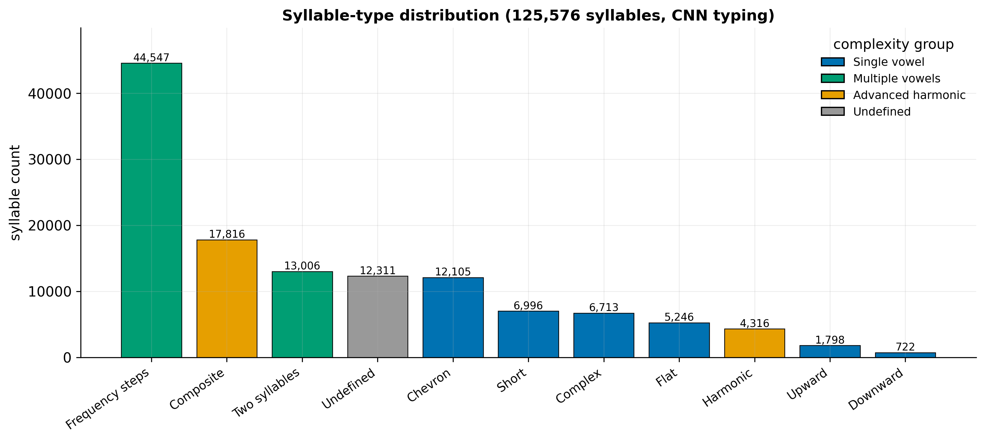
Figure 6
Distribution of the 10 confidently-typed classes plus the post-hoc low-confidence 'Undefined' class, colored by complexity group. 'Frequency steps' dominates, 'Undefined' (~10%) is dropped in the tabular track but retained in the sequence track.

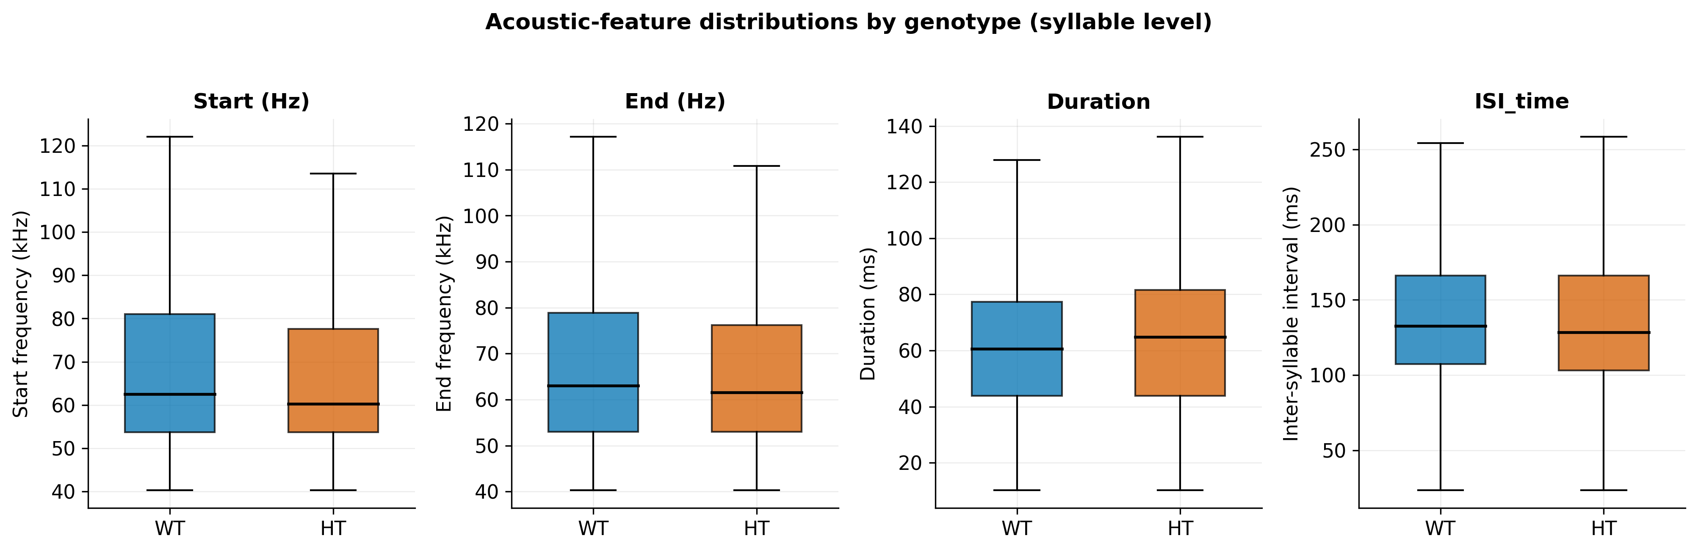
Figure 7
Per-syllable start/end frequency, duration and inter-syllable interval for WT vs HT (outliers hidden, display-clipped). These are the spectral/temporal features Shekel et al. (2021) reported as most ASD-sensitive.

3.4 The baseline dataset and class balance
Not all syllables enter model training. A documented filtering pipeline defines the baseline dataset: rows with invalid genotype or invalid sex are removed, and the separate dietary-supplement experimental arm is excluded, while noise-flagged rows are retained. This yields a baseline pool of 112,234 syllables from 106 mice, aggregated to 12,323 recording-level rows for the tabular models (the unlabeled aggregate exports 12,322 rows, the one-row difference is an export artefact and does not affect training). At the recording level the baseline class balance is 9,283 WT and 3,040 HET recordings about 75% / 25%, the ~3:1 imbalance that governs metric choice throughout. For the sequence models the same baseline is grouped into 408 isolation sessions.

3.5 Single source of truth and a data-integrity correction
A defining feature of this project is that all model training draws from one canonical data file the segmentation output segmentation_classification_all_data.xlsx rather than from scattered, undocumented spreadsheets. This file is produced by the graphical segmentation tool (Section 7.4) and is versioned through a baseline data manifest that records the exact input, the filter stages, and the resulting row counts. The provenance chain is shown in Figure 8.

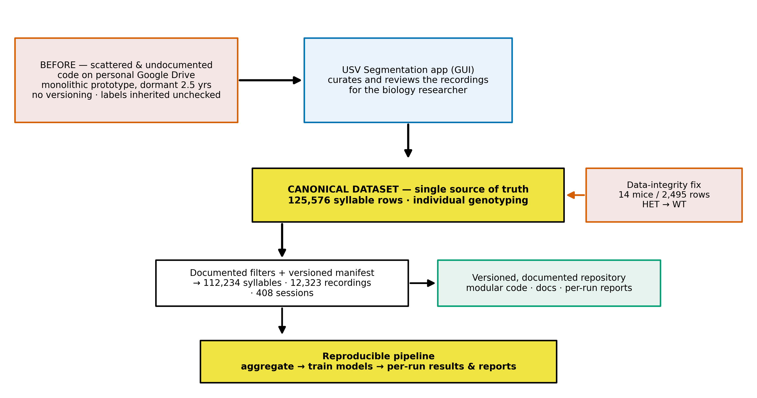
Figure 8
From scattered, undocumented inputs to a curated canonical dataset (single source of truth) with a versioned manifest and a reproducible pipeline, the genotype data-integrity correction is applied at the canonical-file stage.

During the curation of this canonical file, the project discovered and corrected an undocumented genotype-labelling error in the prior data: in six metadata files, some pups had been given their dam's HET genotype rather than their own, so a number of genetically WT pups of HET dams were labelled HET. Using individual genotyping, 14 such mice (2,495 metadata rows) were identified and corrected from HET to WT. This is a genetically necessary fix a HET x WT cross yields roughly half WT offspring and a localized correction, not a systematic relabeling: most WT pups of HET dams (37 in total) were already recorded correctly. This correction, applied at the canonical-file stage, is one reason the project's clean baseline differs from previously reported numbers a point developed quantitatively in Section 5.2 and Figure 12. We treat this as a data-integrity result, not a regression: the corrected labels are the genetically correct ones, and the lower within-subject baseline they produce is the correct reference against which the new models are measured (Section 5.2).

4. Methods
The end-to-end pipeline is summarized in Figure 9: from the recording rig and raw WAV files, through segmentation and CNN syllable typing, to two parallel preprocessing representations (tabular and sequence), the model families, the evaluation protocol, and interpretation. This chapter describes each stage.
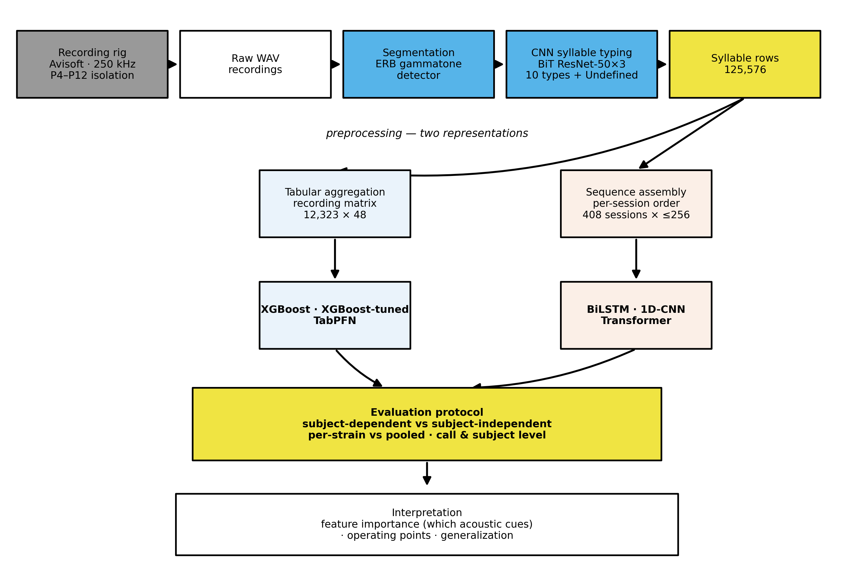
Figure 9
Signature figure: the full pipeline from the recording rig through segmentation and CNN syllable typing to the two preprocessing representations (tabular and sequence), the model families, the evaluation protocol, and interpretation.

4.1 Segmentation and syllable typing
Segmentation detects syllable boundaries with a classical signal-processing detector operating on a cochlear (gammatone) filterbank of 90 ERB-spaced filters covering 35-125 kHz. Audio is analyzed in short overlapping frames, a tonality criterion (energy concentrated in few channels) flags candidate syllables, short silent gaps are bridged so that frequency-modulated sweeps are not split, and calls shorter than 10 ms or closer than 20 ms are merged or discarded. Each detected syllable yields a start time, end time, and duration. The detector is deterministic, fast, and tuned to this laboratory's rig, it is comparable in spirit to MUPET/USVSEG-style detectors and predates fully learned detectors such as DeepSqueak and VocalMat. Its thresholds are fixed constants, and it has not been validated against hand-labelled ground truth limitations noted in Chapter 8.
For each syllable, two boundary-frequency features (start and end frequency) are estimated by Welch power-spectral-density peak-picking in a short window centered on each boundary, restricted to the > 40 kHz band, and the inter-syllable interval (ISI) is computed as the gap to the previous syllable in the same recording (undefined for the first syllable).
Syllable typing assigns each syllable to one of ten classes using a convolutional neural network. The recovered architecture is a Big-Transfer (BiT) ResNet-50×3 backbone, pretrained on ImageNet-21k and fine-tuned on 128×128 spectrogram images of individual syllables, with a 10-way softmax head. Predictions whose maximum probability falls below 0.5 are relabeled "Undefined" (an eleventh, post-hoc class). The ten classes plus Undefined and their corpus counts appear in Figure 6, the dominant type is "Frequency steps". No published model card accompanies the typing network (training set and per-class accuracy are unknown), a limitation carried to Chapter 8.

4.2 Two preprocessing representations
The syllable table feeds two independent representations, which differ in what they preserve:
Tabular (recording-level) - Each recording is reduced to a fixed 48-column vector: for each of the ten syllable types, the mean start frequency, mean end frequency, relative frequency (the type's share of the recording's syllables), and mean duration (4 × 10 = 40 features), plus the average ISI, the pup's sex, age (postnatal day), session, strain, and the mother's genotype, plus the label (pup genotype) and a mouse index used only for grouping. This representation averages away temporal order. The first syllable of each recording (which has an undefined ISI) and Undefined-typed syllables are dropped before aggregation. The baseline tabular matrix has 12,323 rows (Section 3.4). Tabular models are XGBoost and TabPFN.
Sequence (session-level). Each isolation session is represented as an ordered sequence of its syllables, padded or truncated to 256 time-steps, with a 14-dimensional feature vector per step: four continuous features (start frequency, end frequency, duration, ISI, standard-scaled on the training set), a learned 8-dimensional embedding of the syllable type, a noise flag, and a recording-boundary flag. This representation preserves temporal order and keeps the Undefined type (as an embedding index). The baseline yields 408 sessions. Sequence models are BiLSTM, 1D-CNN, and Transformer.
Because the two tracks make different decisions (recording vs session grain, dropping vs keeping first and Undefined syllables), any comparison between them is a comparison of representation plus model, not of model alone a caveat respected throughout Chapter 5.

4.3 Models
XGBoost (inherited baseline) - A gradient-boosted tree ensemble using the legacy untuned recipe inherited with the project, with class imbalance handled by scale_pos_weight = n_WT / n_HT (≈3.1). This is the only model that existed at handoff and serves as the reference baseline.
Tuned XGBoost (new) - A 200-trial randomized hyperparameter search with cross-validation, selecting a recipe per split regime. Because the best recipes differ between the dependent and independent regimes, the tuned results are reported as separate per-regime models, not as one model improving across regimes. The final per-regime recipes contrast sharply the subject-dependent model is deep (96 trees, depth 8) while the subject-independent model is shallow and heavily regularized (20 trees, depth 3, min_child_weight 20), reflecting the smaller, data-limited independent split.
TabPFN-3 (new) - A prior-data-fitted transformer for tabular data that performs in-context Bayesian inference in a single forward pass with no hyperparameter tuning. TabPFN merges its validation split into training, so it sees more data than XGBoost (≈80% vs 60%), this is noted wherever the two are compared.

Table 1
Tabular model configurations. The tuned XGBoost recipes are the winners of the 200-trial random search, reported separately per split regime, TabPFN-3 is tuning-free.
Model | Key hyperparameters
XGBoost (inherited baseline) | 50 trees, max_depth 5, learning rate 0.1, scale_pos_weight = n_WT/n_HT (~3.1)
XGBoost-tuned (subject-dependent) | 96 trees, max_depth 8, lr 0.08, min_child_weight 2, reg_lambda 3.0, reg_alpha 1.0, subsample 0.6, colsample_bytree 0.7
XGBoost-tuned (subject-independent) | 20 trees, max_depth 3, lr 0.10, min_child_weight 20, reg_lambda 3.0, reg_alpha 0.05, subsample 0.6, colsample_bytree 0.6
TabPFN-3 | No tuning (prior-fitted transformer), balance_probabilities enabled, pretraining-limit guard disabled

Sequence models (new). Three architectures over the ordered syllable sequences: a two-layer BiLSTM (≈149k parameters), a three-block 1D-CNN (≈86k), and a small Transformer encoder with a learned CLS token (≈73k). All use BCEWithLogitsLoss with pos_weight = n_WT / n_HT (≈3.2), the Adam optimizer, learning-rate reduction and early stopping on validation AUC, gradient clipping, and a fixed seed. A family of imbalance-handling levers (loss weighting, balanced sampling, focal loss, regularization, augmentation) is explored in Section 5.4.

Table 2
Sequence model architectures. The three models share a single training configuration (bottom row).
Model | Architecture | ~Params
BiLSTM | 2 layers, hidden size 64, bidirectional | 149k
1D-CNN | 3 convolutional blocks (64 -> 128 -> 128), kernel size 3 | 86k
Transformer | d_model 64, 4 attention heads, 2 layers, feed-forward 128, learned CLS token | 73k

The model taxonomy and the inherited-versus-new split are shown in Figure 23.

4.4 Class imbalance and metrics
Under a ~3:1 class imbalance, raw accuracy is misleading: a constant "predict WT" classifier already scores ~0.75. We therefore report a suite of metrics and foreground imbalance-robust ones:
- Accuracy and weighted F1 for overall performance (comparable to prior reports),
- Balanced accuracy (mean of per-class recall) as the primary imbalance-robust score,
- ROC-AUC (threshold-free ranking) and PR-AUC / average precision (focused on the minority HET class),
- Per-class precision, recall, and F1 for WT and HT separately the clinically meaningful breakdown, since HT recall is "catching ASD-model pups" and HT precision is the false-alarm rate.
Throughout, the positive class is HET.

4.5 Evaluation protocol: the heart of the study
Two split regimes are used, and the distinction between them is the central methodological point of the research project:
Subject-dependent: a random 60/20/20 split at the row/session level. Because the cohort is longitudinal, the same animal may appear in training and test. This answers the within-subject question: how accurately can a new recording of an already-seen animal be classified?
Subject-independent: a 60/20/20 split grouped by mouse, with stratification on the label and explicit disjointness checks, so that no animal appears in two sets. This answers the across-subject (generalization) question: how accurately can an entirely unseen animal be classified?
These two regimes are complementary and both legitimate, they simply answer different questions. The within-subject (subject-dependent) setting is the standard, valid evaluation for a personalized model and is directly comparable to the prior work in this line, which reported subject-dependent results. The across-subject (subject-independent) setting is the stricter test relevant to this project's stated goal flagging a new, unseen animal and is expected to score lower because it cannot use any animal-specific information seen in training. The distinction between record-wise (within-subject) and subject-wise (across-subject) evaluation, and the fact that the two answer different questions, is well established in clinical machine learning [21]. Reporting both side by side, rather than either alone, is a deliberate methodological choice of this research project: the within-subject number states best-case accuracy on known animals, and the across-subject number states expected accuracy on new ones.
In addition, models are evaluated pooled across all cohorts and per-strain (strain1 = 2022-2024, strain2 = 2015/2018), to probe whether a learned signal is genotype or cohort. The full grid of what was run is shown in Figure 10.
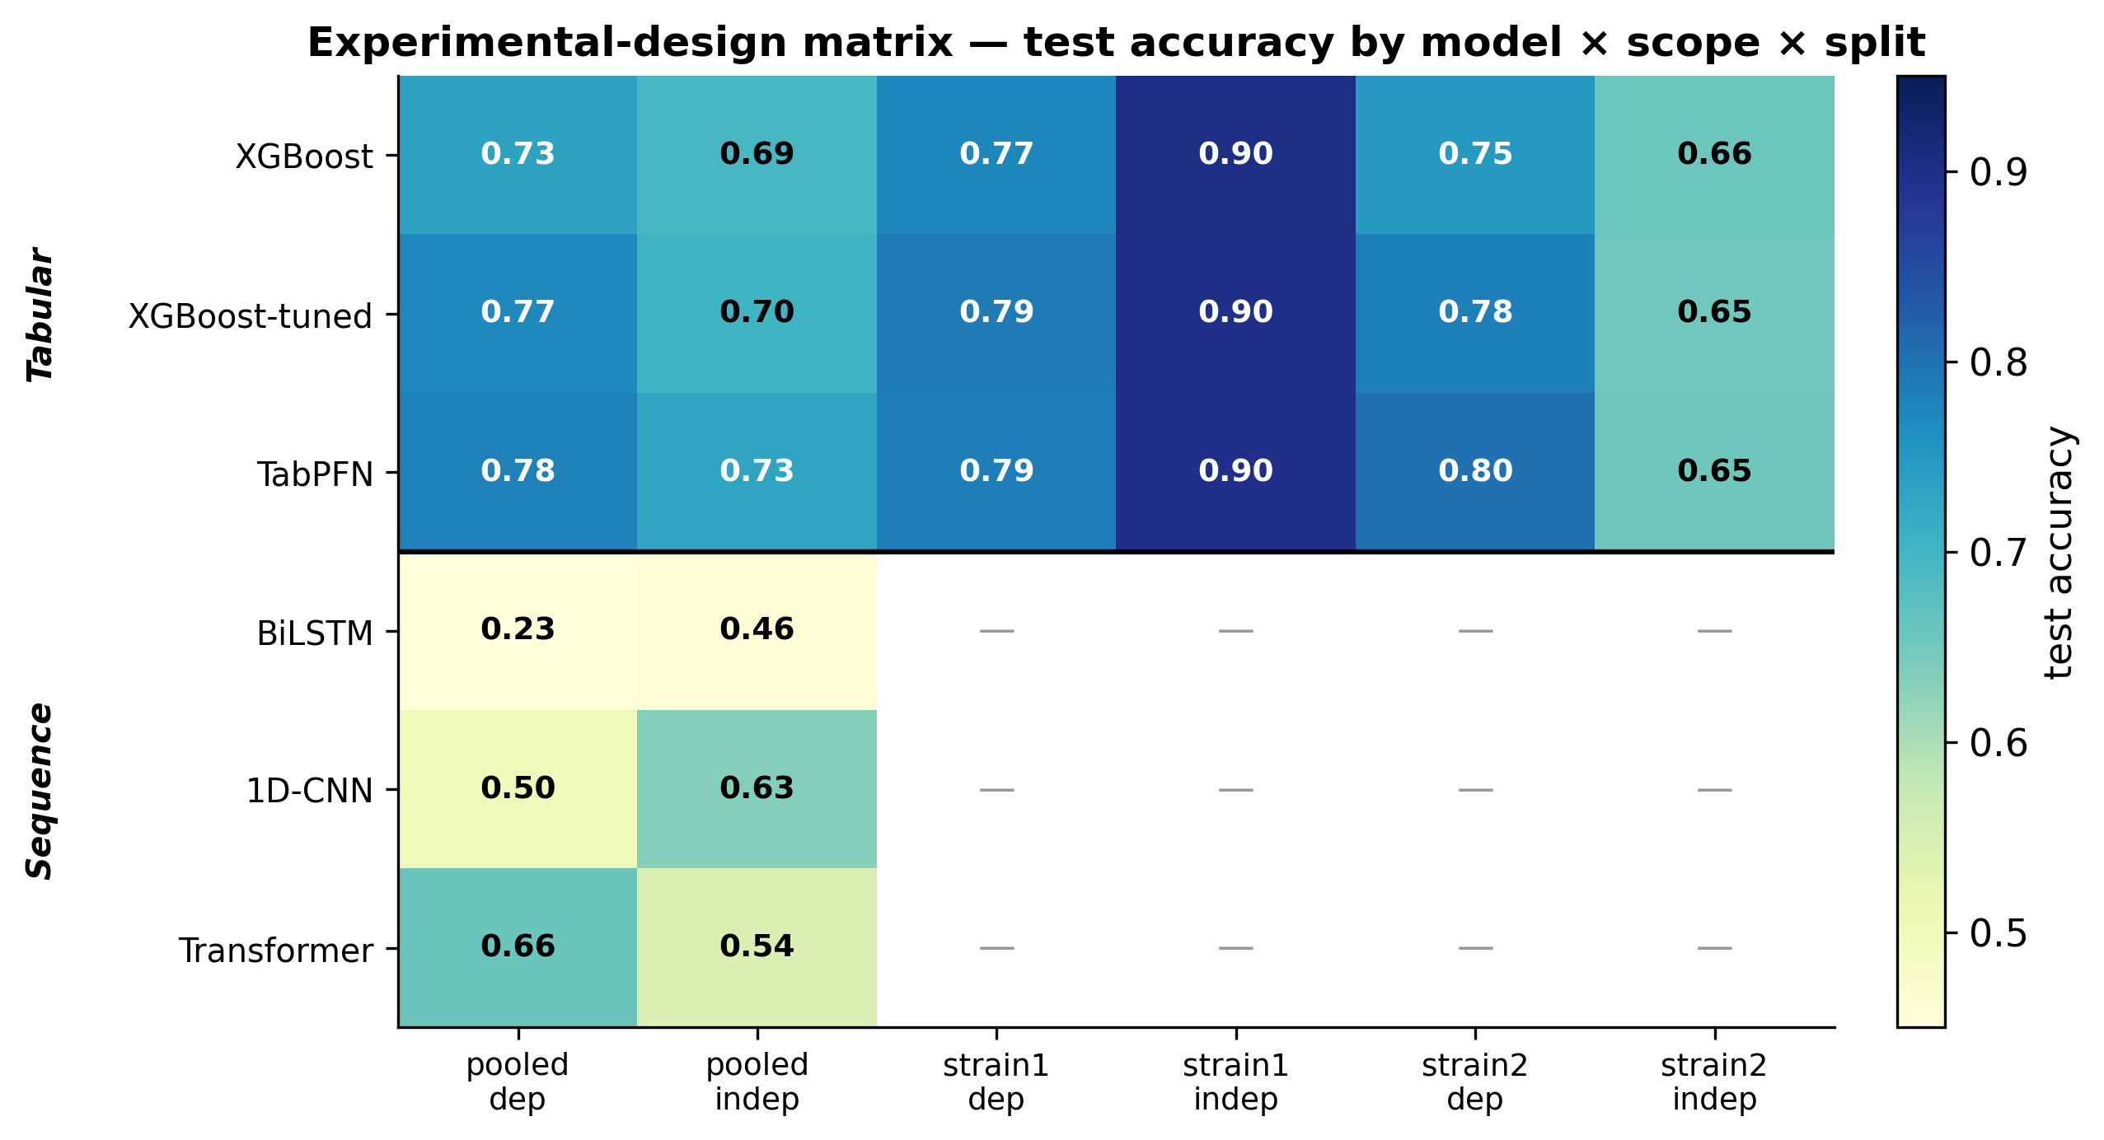
Figure 10
Which model/representation was evaluated under which split and cohort scope, cells show test accuracy (— = not run). Tabular models are evaluated at recording level, sequence models at session level.

Tabular models are evaluated at the recording level and sequence models at the session level, the test sets therefore differ in size and grain, so cross-track numbers are directional rather than like-for-like. For the small sequence test sets, single-split estimates are supplemented by 5-fold grouped cross-validation (Section 5.4).
A separate decision-threshold tuning step (Section 5.5) derives an operating threshold on the held-out validation split and freezes it before touching the test set, it relocates the operating point but cannot change AUC.

5. Experiments and Results
The positive class is HET throughout, and "dependent"/"independent" denote the subject-dependent and subject-independent split regimes defined in Section 4.5.

5.1 Master results - tabular models (pooled)
Table 3 reports the three tabular models on the pooled baseline, in both split regimes. Figure 11 visualizes the same numbers as dependent-versus-independent dumbbells for accuracy, weighted F1, and AUC.

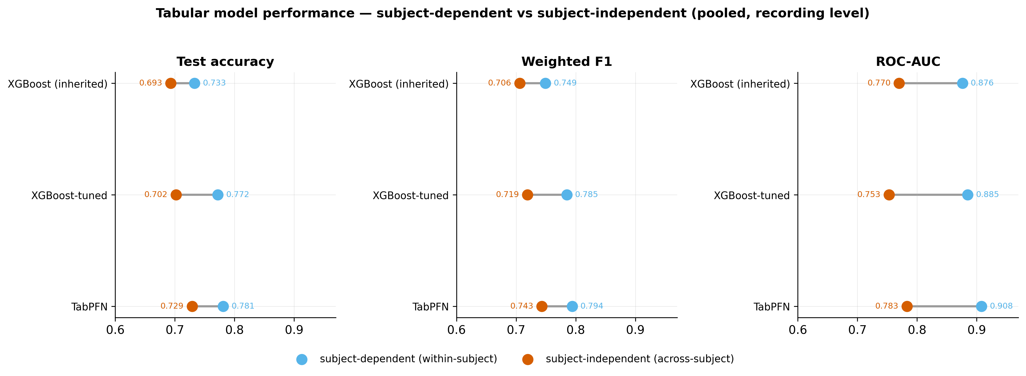
Figure 11
Headline comparison of the three tabular models on the pooled baseline. Each dumbbell links the within-subject score (blue, known animals) to the across-subject score (orange, unseen animals). TabPFN is best on both, the within → across-subject drop is the difference between the two questions.

Table 3
Tabular models, pooled baseline (recording level). Best dependent and independent rows in bold.
Model | Split | Accuracy | Weighted F1 | Balanced acc. | ROC-AUC | HT recall | HT precision | HT F1
XGBoost (inherited) | dependent | 0.733 | 0.749 | 0.795 | 0.876 | 0.940 | 0.496 | 0.649
XGBoost (inherited) | independent | 0.693 | 0.706 | 0.678 | 0.770 | 0.637 | 0.452 | 0.529
XGBoost-tuned | dependent | 0.772 | 0.785 | 0.798 | 0.885 | 0.844 | 0.543 | 0.661
XGBoost-tuned | independent | 0.702 | 0.719 | 0.725 | 0.753 | 0.869 | 0.473 | 0.612
TabPFN | dependent | 0.781 | 0.794 | 0.828 | 0.908 | 0.918 | 0.550 | 0.688
TabPFN | independent | 0.729 | 0.743 | 0.662 | 0.783 | 0.782 | 0.499 | 0.610

Three findings stand out. First, TabPFN is the strongest tabular model in both regimes on overall accuracy and weighted F1, answering RQ1 in the affirmative for the tabular foundation model: it beats the inherited XGBoost within-subject (0.781 vs 0.733 accuracy) and across-subject (0.729 vs 0.693). The within-subject 0.781 accuracy / 0.794 weighted F1 is a strong result on known animals, and TabPFN reaches even higher within-subject accuracy on the individual cohorts (up to 0.801, Section 5.6). Second, the within → across-subject drop is real and model-dependent: the inherited XGBoost loses the most (accuracy 0.733 → 0.693, HT recall 0.940 → 0.637), whereas TabPFN transfers best, its across-subject accuracy (0.729) essentially matching the within-subject accuracy of the inherited baseline (0.733). Third, and most important clinically, HT recall the ability to catch ASD-model pups stays high across the regime change: the tuned XGBoost keeps HT recall at 0.869 on entirely unseen mice (balanced accuracy 0.725, the best across-subject), and TabPFN holds HT recall at 0.782. Because a screening tool must above all not miss true cases, this sustained recall is a key positive result, "best model" therefore depends on the objective overall accuracy (TabPFN) versus minority-class sensitivity (tuned XGBoost) a trade-off revisited in Sections 5.5 and Chapter 6.

The corrected baseline: a data-integrity result
A previously reported subject-dependent accuracy of 0.829 (the prior baseline in this research line) is not reproduced by the corrected pipeline for the inherited XGBoost model. Figure 12 decomposes the difference into two separable, well-understood effects and, crucially, shows that the new models more than recover it:
Data-integrity correction (within-subject regime): 0.829 → 0.733. Correcting the genotype mislabeling (Section 3.5) and the class-weighting computation lowers the inherited XGBoost within-subject accuracy to 0.733. This is not a performance regression, the earlier figure was inflated by mislabeled data, and 0.733 is the corrected, genetically-valid within-subject baseline.
Within-subject vs across-subject question (regime change): 0.733 → 0.693. Evaluating the same inherited model on unseen animals (subject-independent) rather than known ones (subject-dependent) costs a further ~0.04 in accuracy. This is not an error being removed but the expected difference between two legitimate questions (Section 4.5): known-animal accuracy versus new-animal accuracy.
Two points reframe this positively. First, the new models restore and exceed the corrected within-subject baseline: TabPFN reaches 0.781 within-subject (0.801 on strain2), well above the corrected XGBoost's 0.733 so after fixing the data, a stronger model was still obtained. Second, the best across-subject model, TabPFN, generalizes to 0.729 accuracy on entirely unseen mice, essentially matching the within-subject accuracy of the old baseline. The headline of this project is therefore twofold and calibrated: a strong within-subject model (~0.78–0.80 accuracy on known animals) and a realistic across-subject estimate (~0.73 accuracy / 0.74 weighted F1 / 0.78 ROC-AUC on new animals), with the prior 0.829 now understood as an uncorrected, within-subject figure.
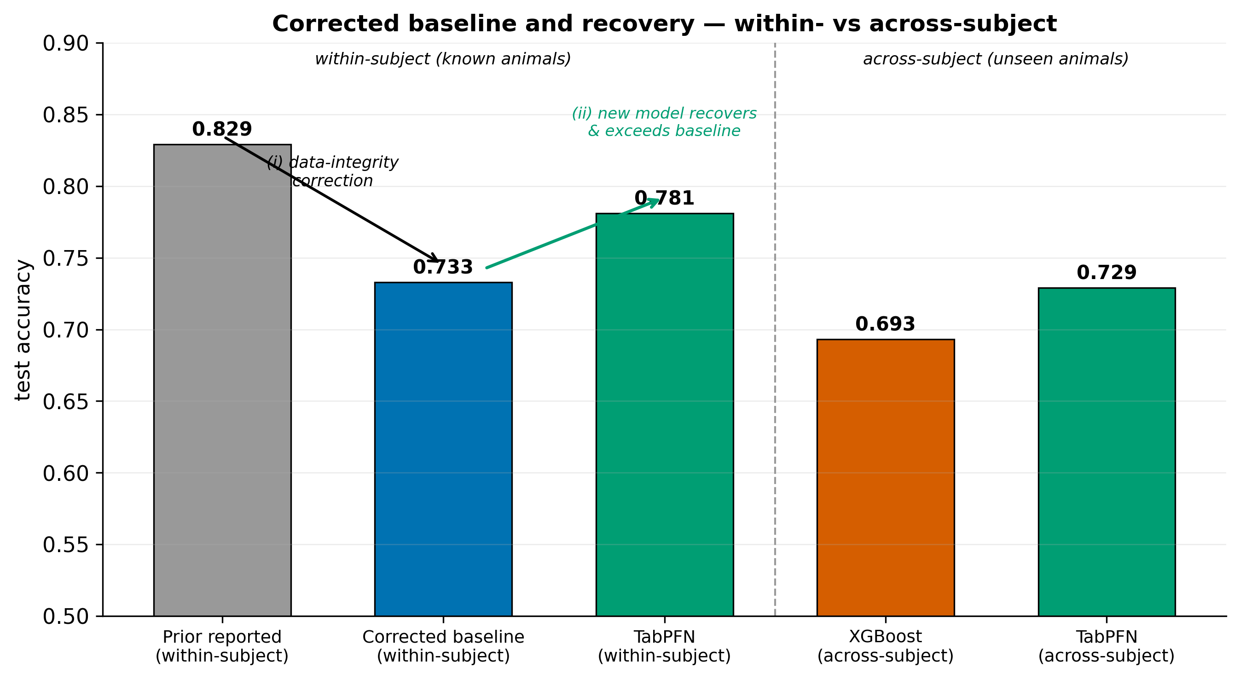
Figure 12
The previously reported accuracy (0.829) was an uncorrected within-subject figure. (i) Correcting the genotype labels lowers the inherited within-subject baseline to 0.733, (ii) the new model (TabPFN) recovers and exceeds it, reaching 0.781 within-subject. Evaluated across-subject (on entirely unseen animals) the models score lower 0.693 for XGBoost and 0.729 for TabPFN which is the expected difference between the within-subject and across-subject questions, not a defect.

5.3 Generalization, ranking, and minority-class behavior
Figure 13 (ROC) and Figure 14 (precision–recall) confirm the ranking and quantify the regime cost from held-out probabilities. ROC-AUC falls from the dependent to the independent split for every model (e.g. TabPFN 0.908 → 0.783), and the precision–recall curves show that minority-class precision degrades sharply at high recall on the independent split.
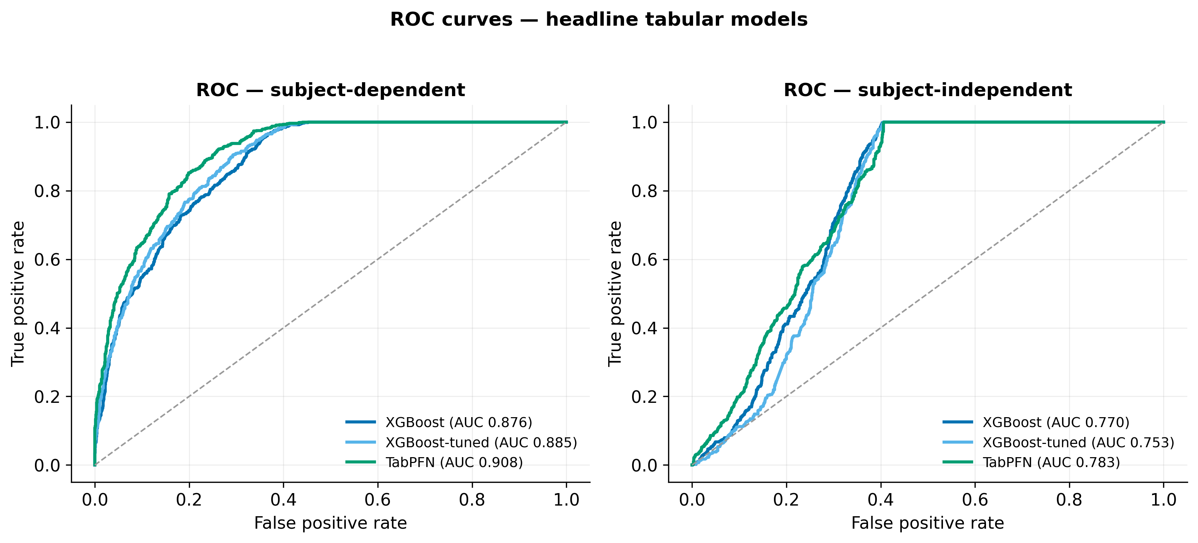
Figure 13
ROC for XGBoost, XGBoost-tuned and TabPFN, recomputed from held-out test probabilities. AUC drops from the within-subject to the across-subject split, quantifying the gap between known-animal and unseen-animal performance.

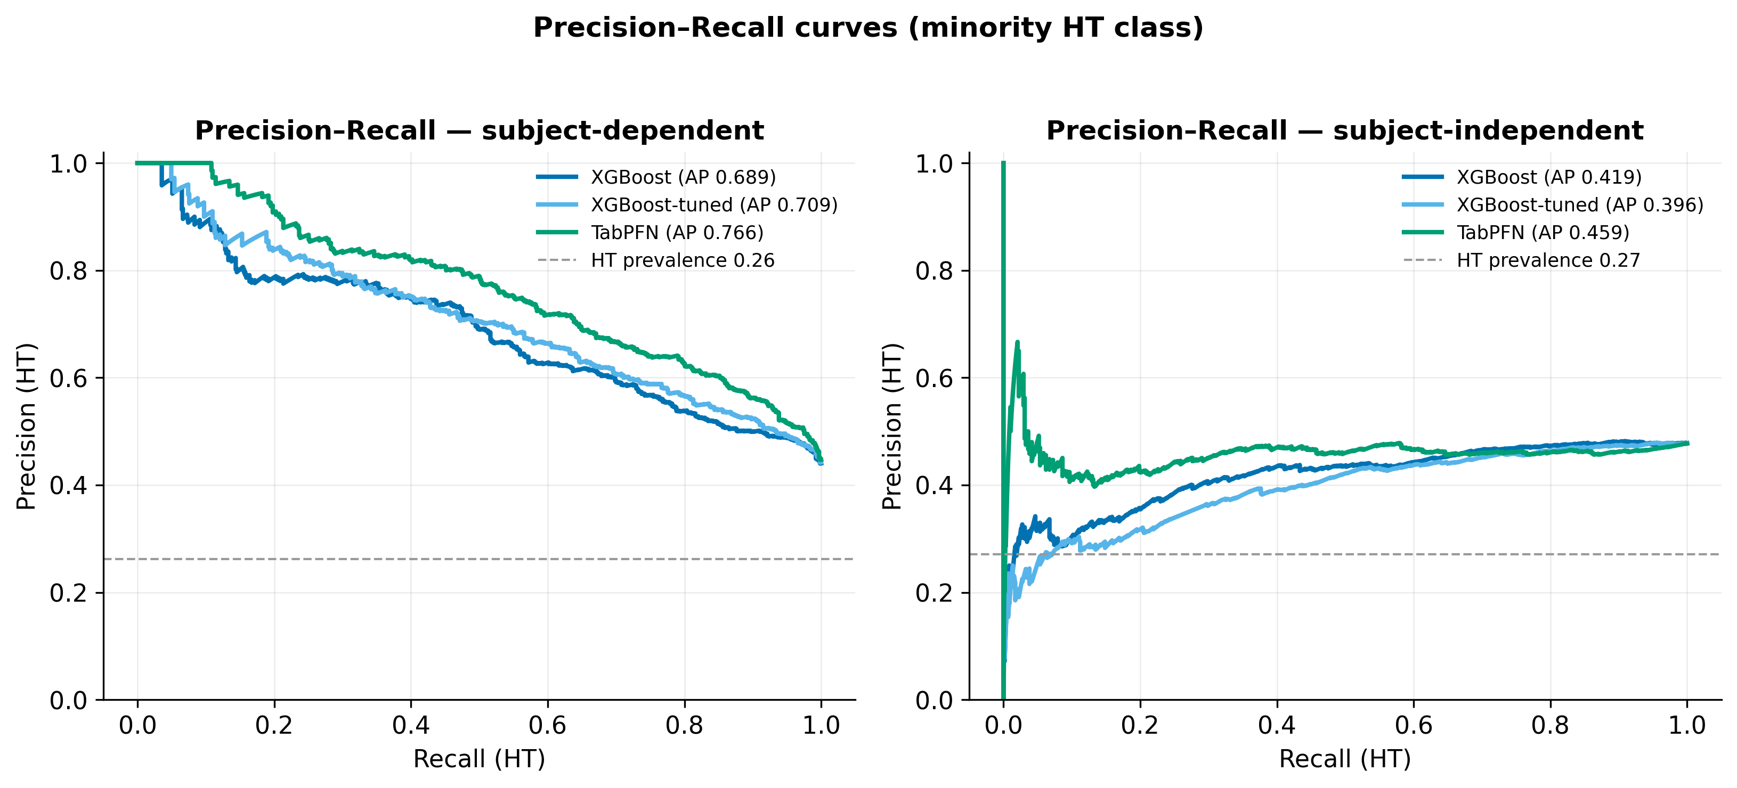
Figure 14
Precision–recall for the HT (ASD-model) minority class. The dashed line is HT prevalence (no-skill). Precision degrades sharply at high recall on the independent split.

Figure 15 makes the minority-class story explicit. As evaluation moves from dependent to independent, HT precision stays pinned near 0.50 for every tabular model (0.452-0.550), regardless of model family, tuning, or regime. We call this the HT-precision wall (Figure 17): at the default threshold, roughly half of all positive (HT) calls are false alarms. The confusion matrices in Figure 16 show the same thing structurally the dominant error in every panel is WT recordings predicted HT. Because the wall survives every estimator and every split, it is a property of the features, not of the classifier (Section 6.2), and answers part of RQ2: the current per-recording acoustic aggregates carry only enough information to rank well (AUC up to 0.78 on unseen mice) but not to achieve high-purity positive calls.

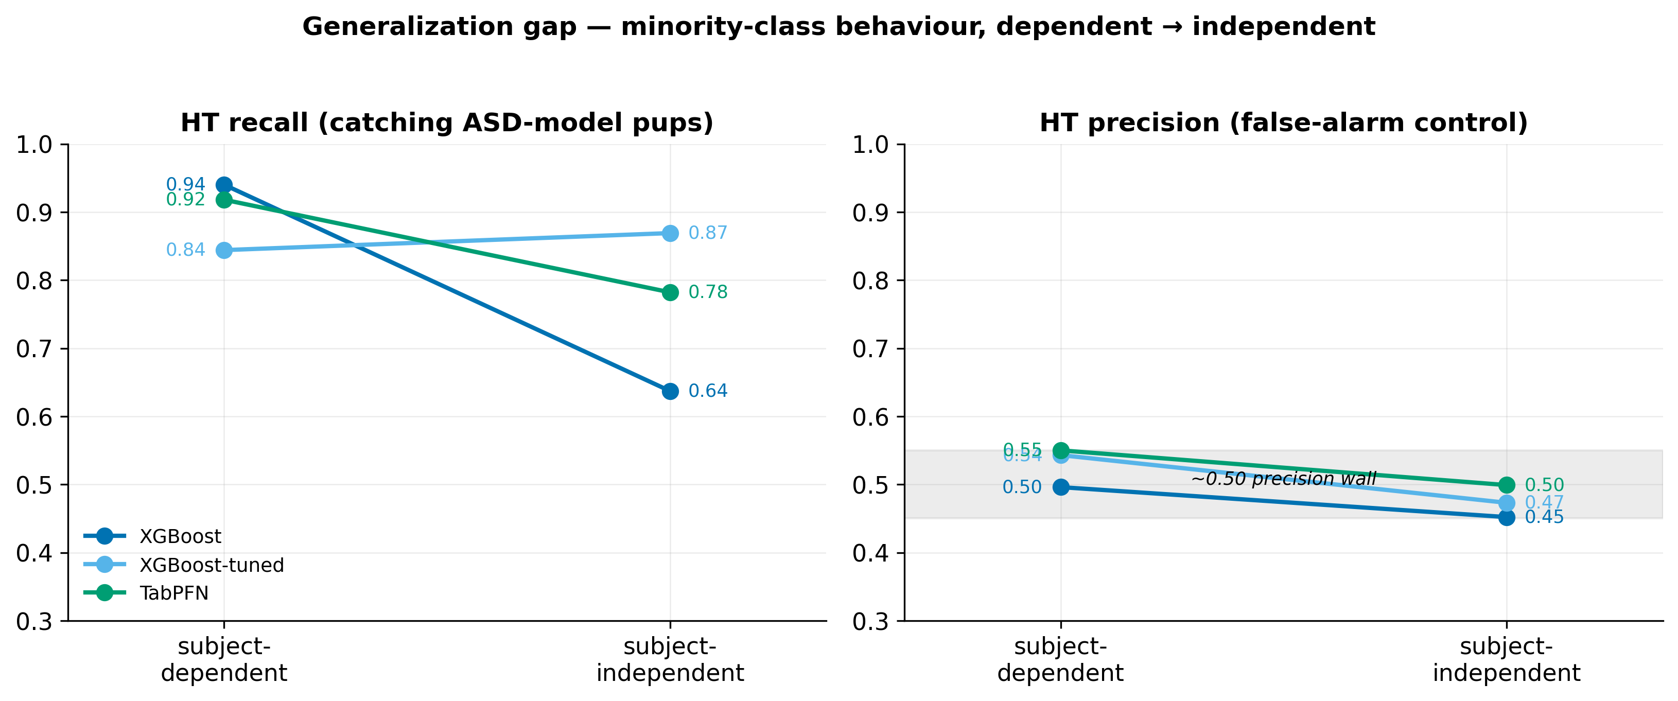
Figure 15
Slope chart of HT recall and HT precision as evaluation moves from subject-dependent to subject-independent. HT precision stays pinned near 0.50 for every model a property of the features, not the estimator.

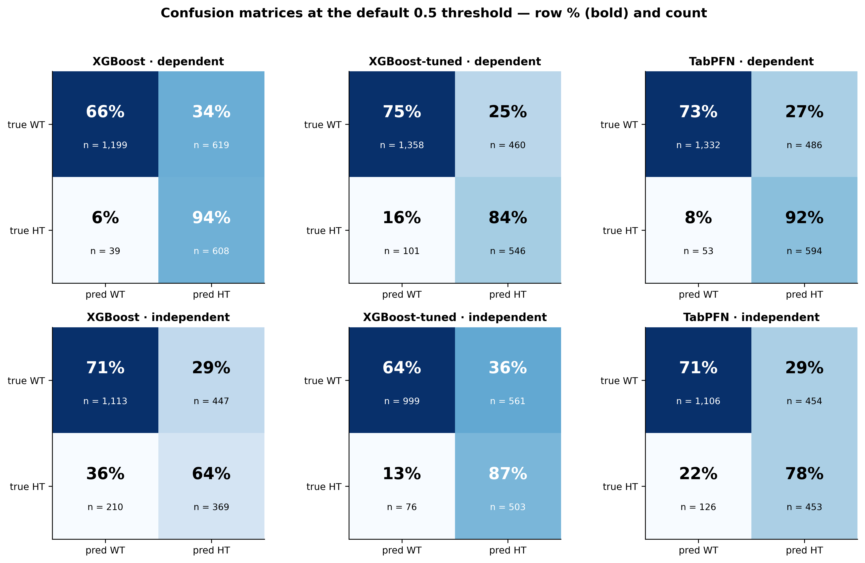
Figure 16
Test-set confusion matrices at threshold 0.5. The dominant error in every panel is WT recordings predicted HT (false positives), consistent with the ~0.50 HT-precision ceiling.

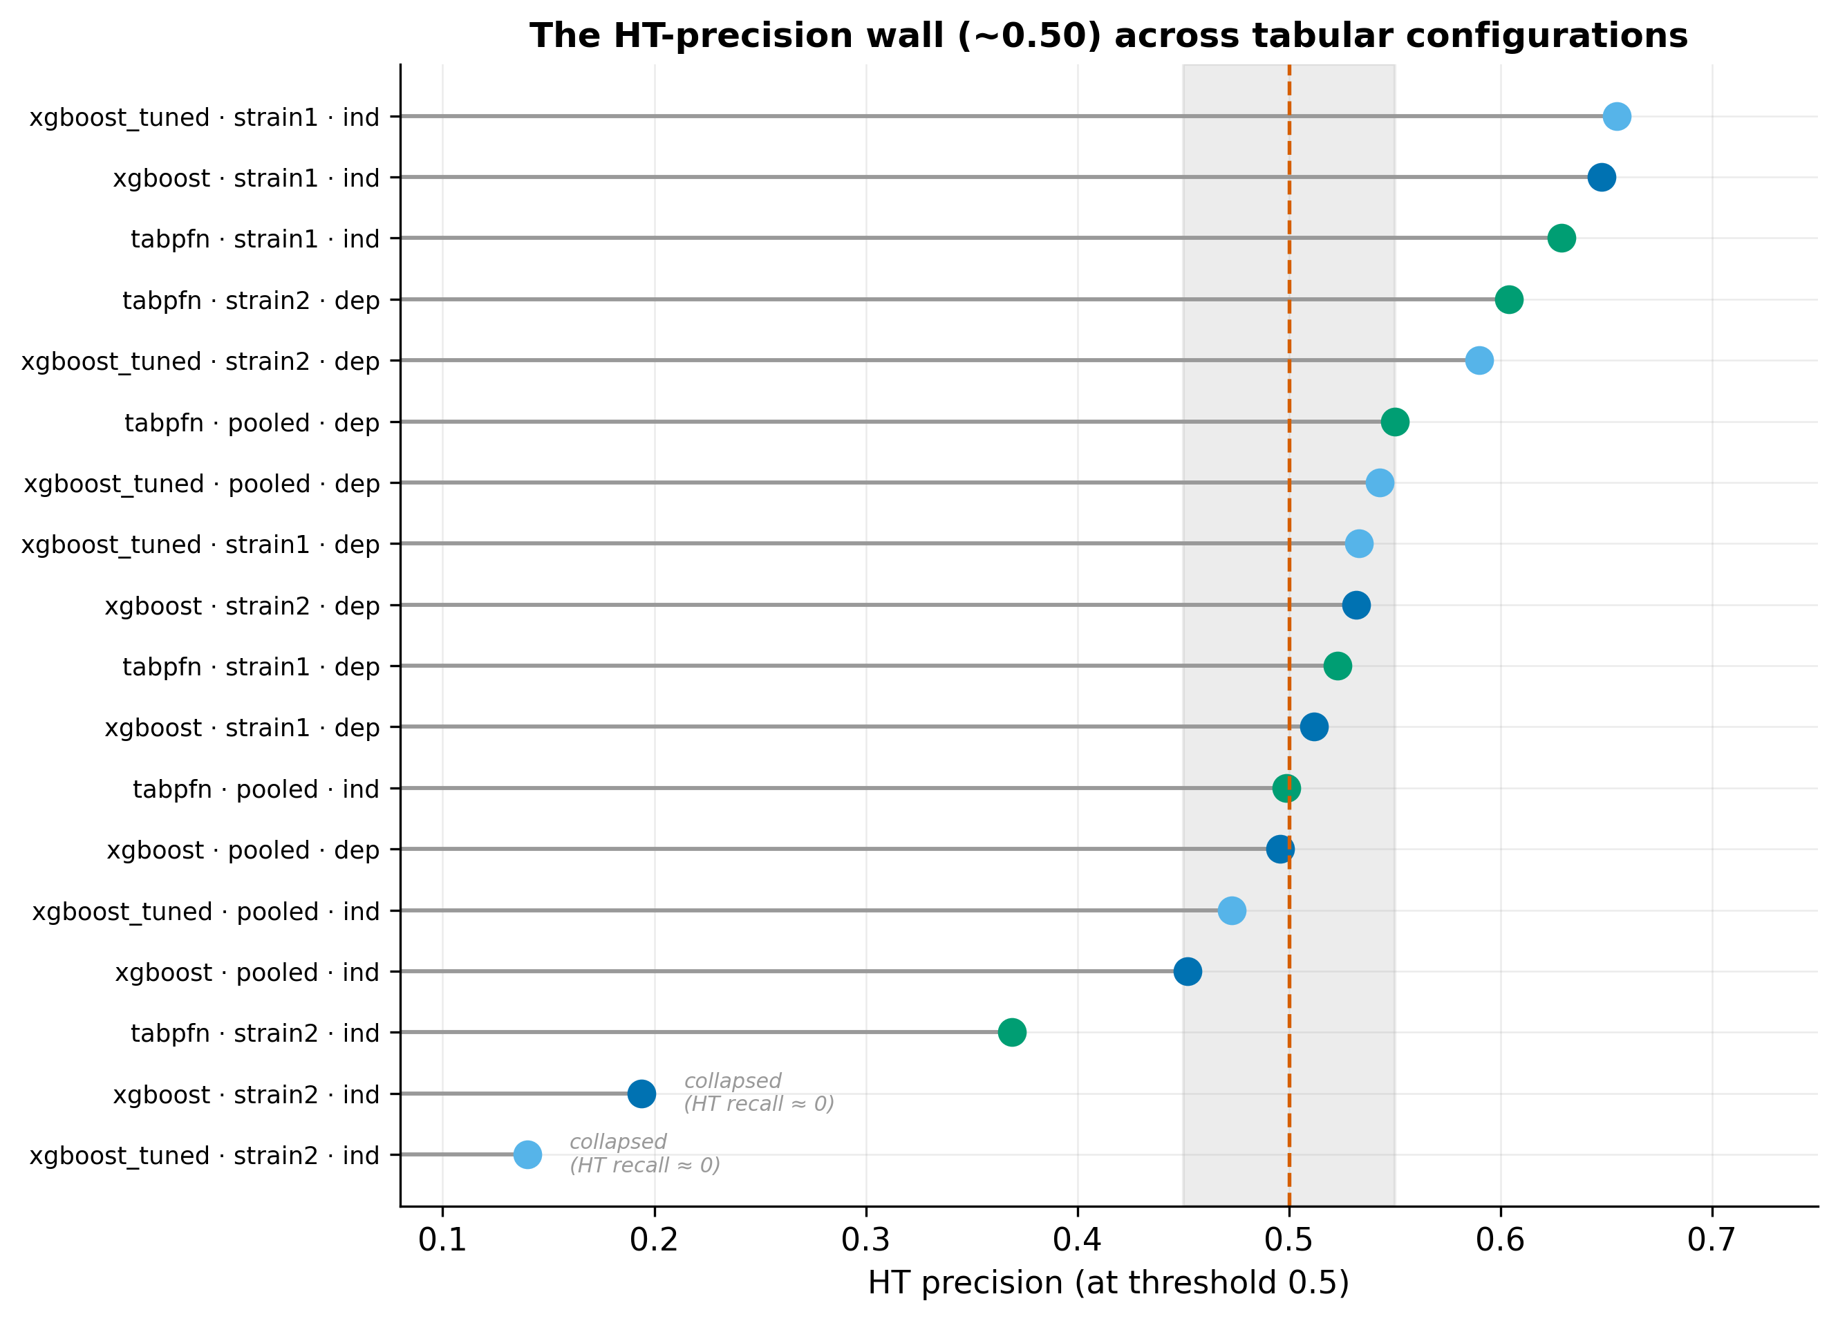
Figure 17
HT precision at the default threshold across every tabular configuration clusters near 0.50 (grey band), the easier strain1 cohort escapes upward. The strain2-independent configurations fall below the band most severely XGBoost and tuned-XGBoost, which collapse on the minority class (near-zero HT recall), so their precision is not meaningful. For the pooled and dependent configurations, about half of all positive calls are false alarms a ceiling set by the features.

5.4 Sequence models and cross-validation deflation
Table 4 reports the three sequence models on the pooled baseline (session level, 82 dependent and 90 independent test sessions, of which 19 are HT). These numbers are not like-for-like with the tabular models, which are evaluated at the recording level on far larger test sets.

Table 4
Sequence models, pooled baseline (session level).
Model | Split | Accuracy | Balanced acc. | ROC-AUC | HT recall | HT precision | HT F1
BiLSTM | dependent | 0.232 | 0.500 | 0.790 | 1.000 | 0.232 | 0.376
BiLSTM | independent | 0.456 | 0.655 | 0.749 | 1.000 | 0.279 | 0.437
1D-CNN | dependent | 0.500 | 0.564 | 0.604 | 0.684 | 0.271 | 0.388
1D-CNN | independent | 0.633 | 0.517 | 0.609 | 0.316 | 0.231 | 0.267
Transformer | dependent | 0.659 | 0.668 | 0.655 | 0.684 | 0.371 | 0.481
Transformer | independent | 0.544 | 0.634 | 0.675 | 0.789 | 0.288 | 0.423

The sequence models are markedly weaker and prone to collapse. The clearest pathology is the BiLSTM on the dependent split: it predicts HT for all 82 test sessions (accuracy 0.232 = the HT base rate, WT recall 0, balanced accuracy 0.500), yet its ROC-AUC is 0.790 the ranking is informative but the operating point is broken, a failure that only the imbalance-robust metrics expose. The Transformer is the most stable baseline (balanced accuracy 0.668 dependent, 0.634 independent) but does not approach the tabular models.
A sweep of eight imbalance-handling levers (A-H) was run across the three architectures (Figure 18, left). The best single-split result was a BiLSTM with a balanced minibatch sampler reaching independent balanced accuracy 0.704. However, 5-fold grouped cross-validation of this configuration deflates the estimate to 0.563 ± 0.063 (independent) and 0.609 ± 0.055 (dependent) (Figure 18, right). The single 0.704 was a lucky fold, the true sequence-model signal is weak and data-limited (≈19 HT test sessions), and is not recoverable by configuration changes. This answers RQ3 for the sequence track: at the current data scale, temporal call order does not yield a reliable gain over the tabular aggregates.

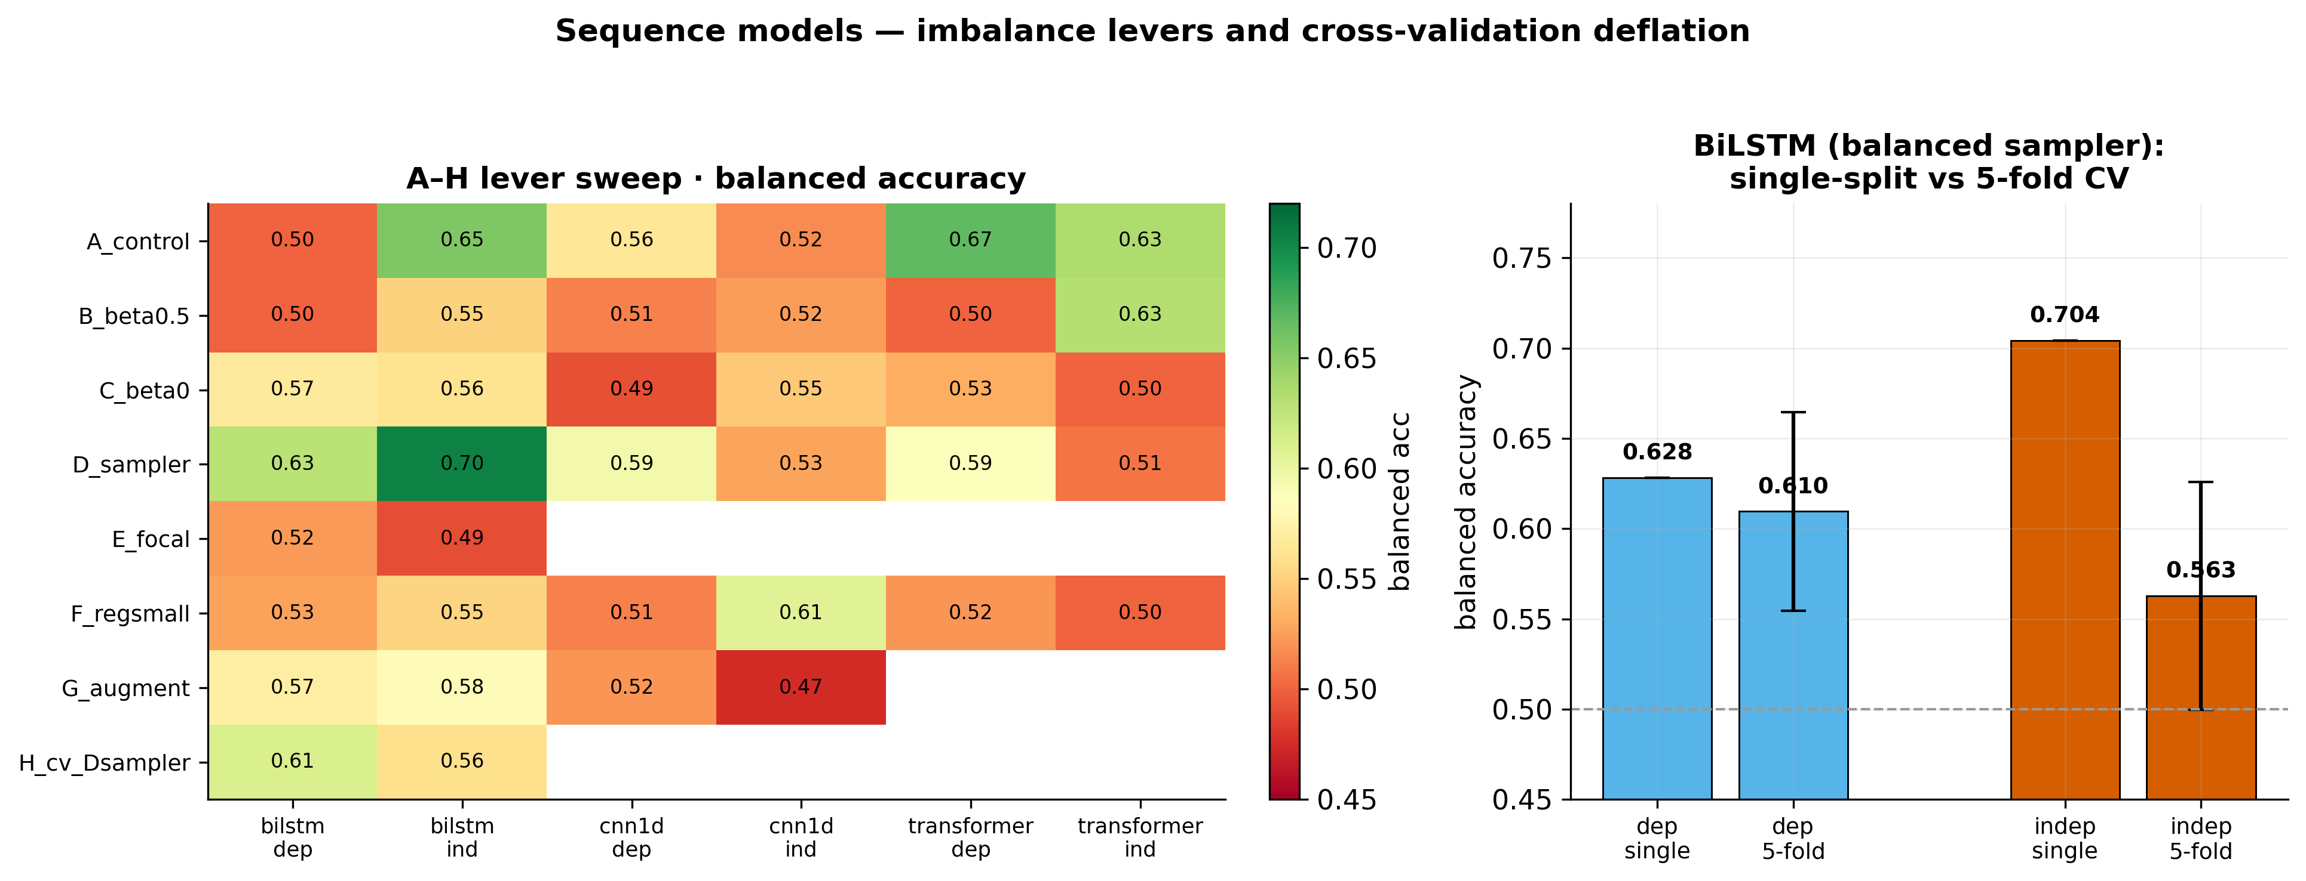
Figure 18
Left: balanced accuracy across the A-H imbalance-handling levers (E run only for BiLSTM). Right: the lucky single-split BiLSTM independent score (0.704) deflates to 0.563 ± 0.063 under 5-fold grouped CV the true sequence-model signal is weak and data-limited.

5.5 Decision-threshold tuning
Threshold tuning derives an operating point on the validation split and freezes it before the test set, it cannot change AUC but can move the precision/recall trade-off. Figure 19 shows the effect on TabPFN. On the dependent split, an F1- or target-recall objective lifts HT precision to ~0.62 (from 0.55) while holding HT recall ~0.81, and raises accuracy to ~0.82 the only operating point that meaningfully exceeds the 0.50 precision wall, and then only within-subject. On the independent split, the Youden and balanced objectives degenerate (threshold collapses toward 0, HT recall → 1, precision pinned ~0.48), a target-recall objective (recall floor ≈0.80) is the sensible choice for a screening tool, keeping HT recall ~0.86 at precision ~0.46 deliberately favoring sensitivity (catching ASD-model pups) over false-alarm control. Threshold tuning is thus best understood as principled operating-point hygiene, not as a way to break the feature-level ceiling.

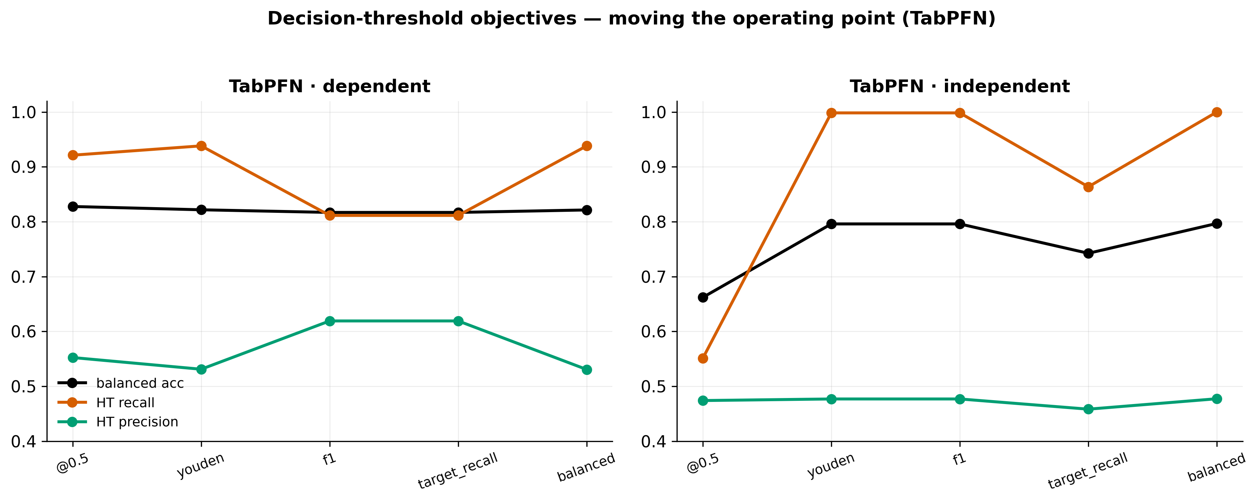
Figure 19
Effect of the threshold objective on TabPFN. On the dependent split, f1/target_recall lift HT precision to ~0.62 while holding recall ~0.81, on the independent split, Youden/balanced degenerate (recall → 1, precision pinned ~0.48), so target_recall is the only sensible objective.

5.6 Per-strain analysis
Splitting the cohort by strain reveals a strong interaction (Figure 20). On the strain1 cohort (2022-2024, mixed background) all three tabular models are highly separable even across-subject independent accuracy around 0.90 for each (XGBoost 0.903, XGBoost-tuned 0.899, TabPFN 0.897, weighted F1 ~0.90), higher than the pooled within-subject baseline. On the strain2 cohort (2015/2018, pure BALB/c, only 47 mice) the picture is model-dependent under the independent split: the tree models collapse on the minority class (XGBoost HT recall 0.089 / HT F1 0.122, XGBoost-tuned 0.057 / 0.081), while TabPFN avoids full collapse but stays weak (HT recall 0.410, HT F1 0.388, accuracy 0.654).

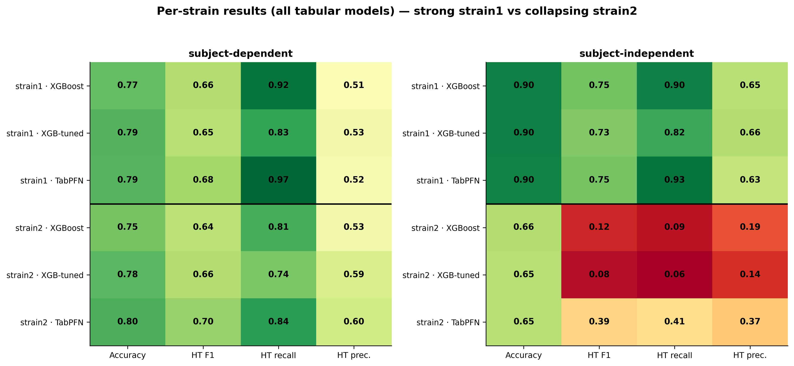
Figure 20
Per-strain results for all three tabular models. strain1 (recent mixed-background cohort) is highly separable across-subject for every model (~0.90), whereas on strain2 (small pure-BALB/c cohort) the tree models collapse on the minority class under the independent split while TabPFN stays weak but does not fully collapse evidence that strain/cohort confounds genotype.

This is the project's most important cautionary result. The exceptional strain1-independent score should not be read as a general headline: strain1 is a more recent, lower-HT-prevalence, more separable cohort, and because strain/background is confounded with genotype, a model trained on it may be reading cohort membership rather than the ASD phenotype. The strain2-independent breakdown a full collapse for the tree models and a steep drop for TabPFN despite subject-grouping, reflects both the small cohort and this confound. A genuine cross-cohort test (train on one strain, test on the other) is the definitive validation and is left to future work.

5.7 Which features matter
Figure 21 shows the top-15 features by XGBoost gain importance, averaged over the dependent and independent models.
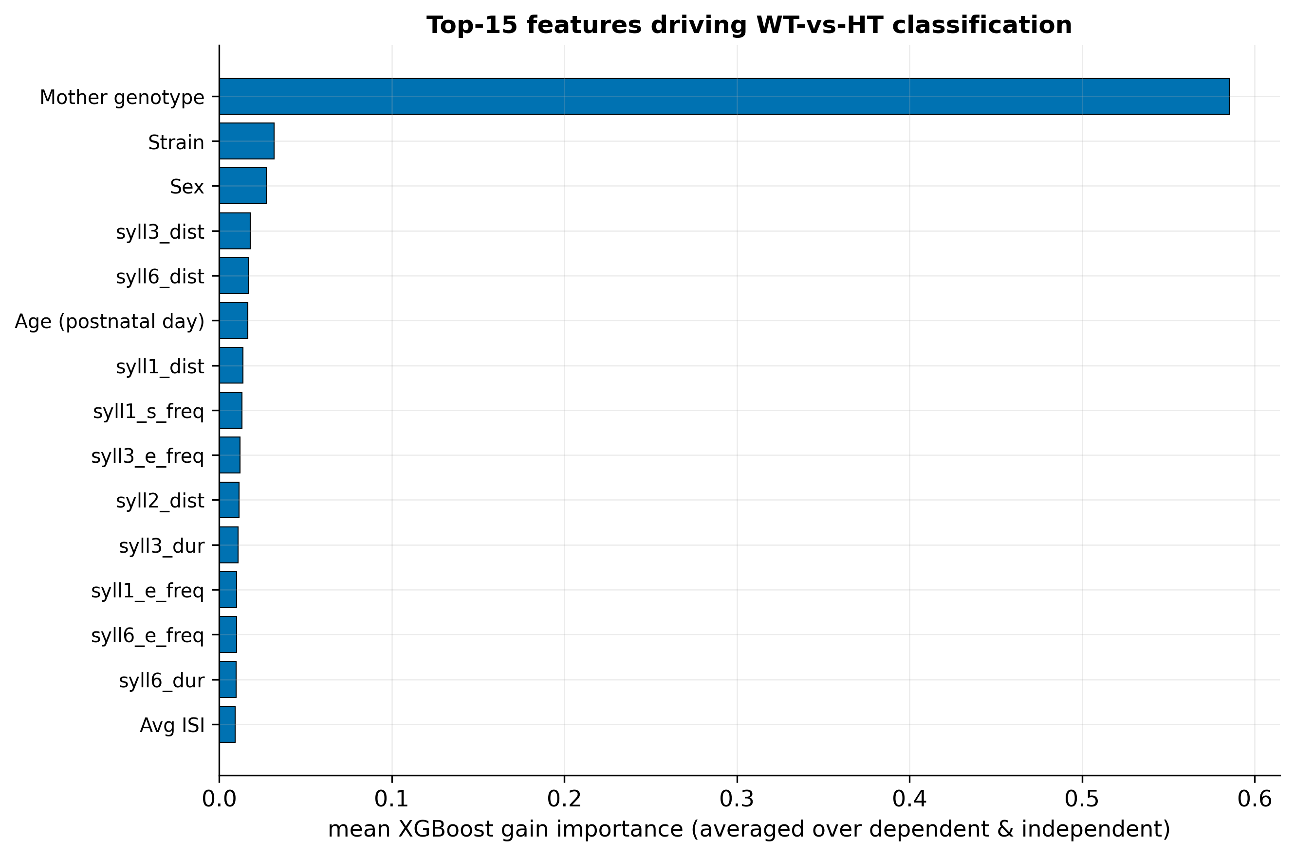
Figure 21
Top-15 features by XGBoost gain importance, averaged across the dependent and independent models. Per-syllable-type start/end frequencies and durations dominate consistent with Shekel et al. (2021), note the syllN columns map type N → slot via a documented off-by-one.

The classification is driven overwhelmingly by the per-syllable-type start- and end-frequency aggregates and durations, with metadata features (age, session, strain) and the average ISI playing secondary roles. This is consistent with Shekel et al. (2021) [17], who identified start frequency, bandwidth, and duration as the most ASD-sensitive syllable features. The result partially answers RQ2: a small set of spectral/temporal feature families (boundary frequencies and durations) dominates, rather than any single feature and the absence of a richer per-call descriptor (e.g. full frequency contour, bandwidth, frequency-modulation depth) is the most plausible explanation for the HT-precision wall (Section 6.2).

5.8 Best model per scenario
Table 5 collects the best model for each scenario. The pattern is consistent: TabPFN is best on the pooled cohort in both regimes (by accuracy/weighted F1), strain1 is highly separable, strain2 does not generalize, and tabular models dominate sequence models at this data scale.

Table 5
Best model per scenario (by weighted F1 / accuracy).
Cohort | Split | Best model | Accuracy | Weighted F1 | HT F1
pooled | dependent | TabPFN | 0.781 | 0.794 | 0.688
pooled | independent | TabPFN | 0.729 | 0.743 | 0.610
strain1 | dependent | XGBoost-tuned | 0.789 | 0.802 | 0.649
strain1 | independent | XGBoost | 0.903 | 0.909 | 0.753
strain2 | dependent | TabPFN | 0.801 | 0.809 | 0.703
strain2 | independent | TabPFN | 0.654 | 0.659 | 0.388
pooled (sequence) | dependent | Transformer | 0.659 | — | 0.481
pooled (sequence) | independent | 1D-CNN | 0.633 | — | 0.267

6. Discussion

6.1 What works, and in which regime
The results give a clear, calibrated answer to RQ1 and RQ3. Among the new models, TabPFN is the best tabular model in both regimes: it reaches a strong 0.781 within-subject accuracy on the pooled cohort (up to 0.801 per cohort) and generalizes to 0.729 accuracy / 0.743 weighted F1 / 0.783 ROC-AUC on entirely unseen mice a genuine improvement over the inherited XGBoost (0.693 / 0.706 / 0.770), and an across-subject score that matches the inherited model's within-subject accuracy (0.733). The tuned XGBoost is the best minority-aware model, with the highest across-subject balanced accuracy (0.725) and, clinically most important, HT recall of 0.869 on unseen mice. The choice between them is a deployment decision: if the goal is overall correctness, TabPFN, if the goal is a screening tool that catches as many ASD-model pups as possible (high HT recall) at the cost of more false alarms, the tuned XGBoost or a target-recall threshold (Section 5.5).
The single most decision-relevant methodological finding is the size of the within → across-subject gap. Within-subject evaluation answers "how well does the model do on animals it has seen?", across-subject evaluation answers "how well on new animals?" and on the pooled cohort the two differ by roughly 4-7 accuracy points and, more dramatically, by up to 0.30 in HT recall for the inherited model. Reporting both distinguishes best-case from generalization performance. Any USV-classification result reported under only one regime should be read with the other in mind. This is the practical payoff of the dual-regime protocol that this project adopted.

6.2 Why minority precision is capped
The HT-precision wall near 0.50 (Sections 5.3, 5.5) is the most informative negative result. It appears for every model tried it does not change whether the classifier is a gradient-boosted tree ensemble (XGBoost) or a pre-trained transformer (TabPFN), whether the trees are tuned or not, or whether evaluation is within- or across-subject and it survives threshold relocation across-subject (within-subject, an F1 objective can trade recall for precision up to ~0.62, but this only moves along a fixed ROC curve and cannot raise AUC). The natural conclusion is that the ceiling is set by the representation, not the estimator: the per-recording aggregates (mean start/end frequency, relative frequency, and mean duration per syllable type, plus a few metadata fields) summarize each recording into 46 numbers that rank WT and HT well (AUC up to 0.78 on unseen mice) but do not separate the two cleanly at the individual level. The feature-importance analysis (Section 5.7) points in the same direction: the model leans on boundary frequencies and durations exactly the features Shekel et al. [17] flagged but lacks richer per-call descriptors such as full frequency contours, bandwidth, and frequency-modulation depth. Enriching the per-call feature set is therefore the most promising route to breaking the wall, more so than larger models.

6.3 Sequence order did not help at this scale
RQ3 asked whether temporal call order adds signal. The sequence models, motivated by Gal et al.'s [18] finding that call dynamics carry phenotypic information, did not beat the tabular aggregates, and several collapsed to degenerate predictors despite informative AUCs. Cross-validation deflated the most promising configuration from a single-split 0.704 to 0.563 ± 0.063 balanced accuracy. The most likely explanation is data scale: the session-level representation reduces the corpus to 408 sessions with ~19 HT sessions in an independent test fold, far too few for ~70k–150k-parameter networks to learn temporal structure reliably. This is a statement about the present dataset, not about the hypothesis: Gal et al.'s dynamics may well be real and learnable with more animals or with per-mouse aggregation of session predictions. We therefore frame the sequence result as "not supported at this data scale" rather than "temporal order is uninformative".

6.4 The strain confound
The per-strain analysis (Section 5.6) is a caution against over-claiming. Strain1 is almost perfectly separable across-subject for every model (~0.90), while on strain2 the minority class collapses for the tree models (HT recall 0.089 for XGBoost and 0.057 for the tuned XGBoost) and drops steeply for TabPFN (0.410). Because strain/background, recording year, and HT prevalence all covary with genotype, a model trained within or across strains may be exploiting cohort membership rather than the ASD phenotype. The pooled across-subject numbers (Section 5.1) are the most defensible single summary precisely because they average across this confound, but even they cannot fully disentangle phenotype from cohort. The definitive test train on one strain, evaluate on the other is identified as future work (Chapter 9).

6.5 The contribution in perspective
Read together, the scientific results are solid and calibrated: USVs support a strong within-subject classifier (~0.78–0.80 accuracy) and above-chance, AUC-0.78 generalization to unseen Mthfr mice, driven by spectral and temporal syllable features, with sustained minority-class recall (up to 0.87 on unseen animals), a clear feature-level ceiling on precision, and no benefit from sequence modelling at this scale. The larger contribution of this iteration is methodological and infrastructural: a reproducible pipeline, a single source of truth, the discovery and correction of a data error that had inflated a prior result, and a dual-regime evaluation protocol that reports within-subject and across-subject performance side by side. In a field where descriptive, single-regime analyses are common, establishing what can be claimed for known animals versus new ones and making it reproducible is itself a result.

7. Reproducibility and Engineering Contribution
This chapter documents the project's principal engineering contribution: turning an inherited, non-runnable prototype into a versioned, documented, end-to-end-reproducible system with a single source of truth, and building a graphical tool that lets the biology researcher curate the data in parallel.

7.1 The starting point: a broken inheritance
At handoff the repository was a monolithic prototype with hard-coded paths, authored years earlier and then left dormant. It contained a single classifier a basic, subject-dependent XGBoost and no other models, no modular structure, no documentation of the data, and no way to run the pipeline from a clean checkout. Reaching a state in which even that one model could be reproduced required rebuilding the whole pipeline. Figure 22 reconstructs the timeline of this work from the project's version-control history, from the inherited prototype through the takeover, the whole-pipeline refactor, the addition of across-subject (subject-independent) evaluation, the genotype correction, and the successive additions of models.

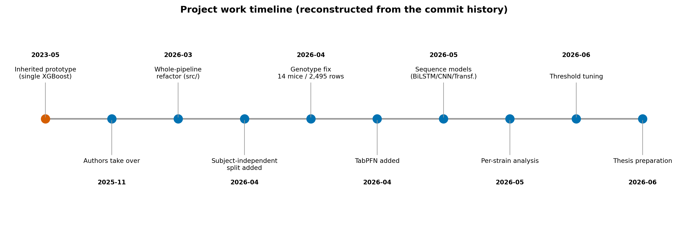
Figure 22
Milestones reconstructed from the local git history (chronology only - no metrics). From the inherited single-model prototype to the final multi-model, dual-regime pipeline.

7.2 Inherited versus new
A precise accounting of what was inherited and what this project built is given in Table 6 and visualized in Figure 23. The distinction matters for both the scientific narrative (everything beyond the inherited model is a new result) and the assessment of the engineering contribution.

Table 6
Inherited versus new capabilities.
Capability | Status
Basic subject-dependent XGBoost | Inherited (only model at handoff)
Modular, runnable pipeline (src/preprocessing, src/classification) | New
Subject-independent / group-aware evaluation | New
Tuned XGBoost (hyperparameter search) | New
TabPFN tabular model | New
Sequence models (BiLSTM, 1D-CNN, Transformer) | New
Per-strain cohort analysis | New
Decision-threshold tuning (held-out, multi-objective) | New
Canonical external data source + baseline manifest | New
Genotype data-integrity correction | New
Graphical segmentation app for the researcher | New

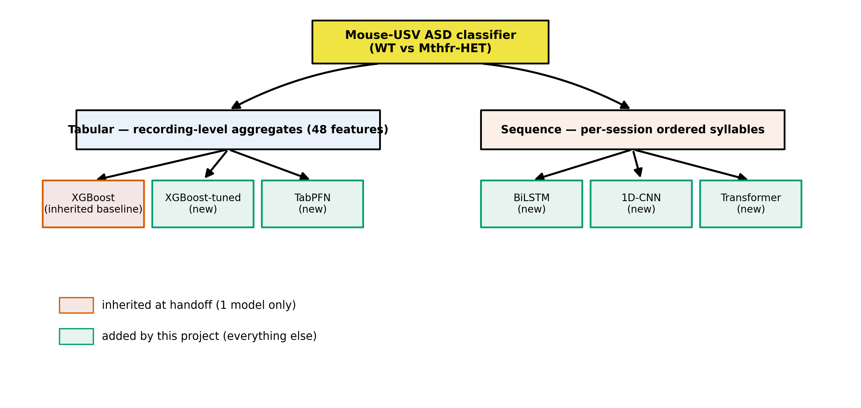
Figure 23
Model families tried, by representation. Only the single subject-dependent XGBoost existed at handoff, the tuned XGBoost, TabPFN, and all three sequence models were added by this project.

7.3 Single source of truth and data provenance
The data-integrity backbone of the rebuilt system is a single canonical input file with a versioned manifest, replacing the previous practice of scattered, undocumented spreadsheets. The provenance chain (Figure 8) runs: raw recordings → metadata extraction → the graphical segmentation tool → the canonical segmentation_classification_all_data.xlsx → baseline filters and manifest → the aggregated tabular and sequence training matrices → per-run result directories. Each stage has a documented script and, for the data, a manifest recording the exact input, the filter rules, and the resulting row counts (Section 3.4).
Two integrity findings emerged from this work and are recorded honestly in the research project: the genotype mislabeling (14 mice / 2,495 rows corrected from HET to WT, Section 3.5) and the resulting, correct, lower baseline (Section 5.2). Both are consequences of having established a single, auditable source of truth where previously there was none.

7.4 The graphical segmentation app
To let the biology researcher (Dr. Hava Golan) curate and review the USV data without using the command line, the project built a graphical segmentation application that wraps the existing segmentation and typing algorithms behind a simple interface (select data and output folders, choose recording years, run, and inspect results). Its main window (Figure 24) lists each recording year with its detected recording-file count and an auto-detected metadata status, and lets the user browse the year → pup → recording → day → session hierarchy before running. The tool runs the same algorithms as the Python pipeline and produces the canonical segmentation file that all model training consumes, it is the mechanism by which the data-curation process (and the discovery of the prior-data errors) was carried out in parallel with the modelling work. It is distributed as a one-click Windows installer and a portable build, and published as a citable artifact: USV Segmentation (v1.0.2), Zenodo, doi:10.5281/zenodo.20096810 [20].

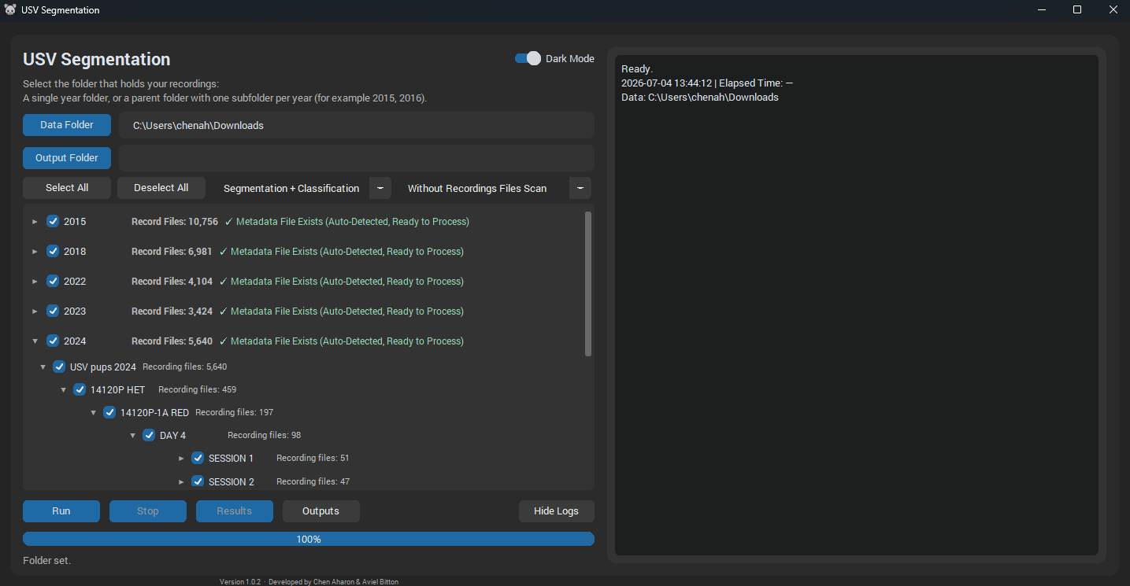
Figure 24
Main window of the USV Segmentation application. The researcher selects a data folder (here the recordings root) and an output folder, the app then lists each recording year with its detected recording-file count and an auto-detected metadata status, browsable as an expandable year -> pup -> recording -> day -> session tree. A run mode (e.g. "Segmentation + Classification") is chosen and "Run" executes the same pipeline as the command-line tool, with a live progress bar and log. The tool produces the canonical segmentation file consumed by all model training. Version 1.0.2, published on Zenodo [20].

7.5 End-to-end reproducibility
The rebuilt system is runnable end-to-end from a clean checkout of the public repository [22]. Environment setup is pinned (a requirements file and a Dockerfile), the preprocessing pipeline is decomposed into documented steps (ingestion, segmentation, feature computation, typing, enrichment, aggregation), and training is driven by documented command-line flags that select the model, the split regime (--independent), the cohort scope (--strain), and the baseline data. Every run writes a result directory with its configuration, metrics, plots, and a human-readable README, so that each number in this research project is traceable to a specific, reproducible run. The documentation set itself the data manifest, the segmentation and preprocessing references, the CLI reference, and the per-run reports is a deliverable of the project, and is what makes the integrity claims in this research project checkable.

8. Limitations
This work is deliberately explicit about what it cannot claim.
Data scale and cohort - The corpus is 126 pups (29 HET) from one laboratory and one genetic model (Mthfr, on a BALB/c background spanning two strain labels a pure BALB/c line and a BALB/c × C57BL/6 line). After subject-grouped splitting, an independent test fold contains only a few dozen mice, and the sequence representation reduces to ~19 HT test sessions. This limits the power of any model especially the neural sequence models and means confidence intervals on the headline numbers are wide. The single-fold sequence results in particular must be read together with their cross-validated, deflated estimates (Section 5.4).
Strain/cohort confound - Recording year, strain/background label, and HT prevalence covary with genotype (Section 6.4). The strong strain1-independent result (~0.90 for every model) reflects this confound, while the strain2-independent breakdown a collapse for the tree models and a steep drop for TabPFN reflects both the small cohort and the same confound. Without a cross-cohort experiment, we cannot fully separate a learned ASD phenotype from learned cohort membership. The difference between the 2018 and 2022 cohorts is a confirmed genetic cross onto a C57BL/6 background a real genetic-background difference, not a labelling artefact which makes the cohort confound genuine and reinforces the need for a cross-cohort test.
Evaluation grain - Metrics are reported at the recording level (tabular) and session level (sequence), they are not aggregated to a single per-mouse decision. A per-subject vote (e.g. majority over a mouse's recordings) might change both the numbers and their interpretation and is left to future work. Consequently, tabular and sequence results are directional, not like-for-like.
Feature representation - The tabular features are per-syllable-type aggregates of boundary frequencies, relative frequencies, and durations. They lack richer per-call descriptors (full frequency contour, bandwidth, frequency-modulation depth). Section 6.2 argues this is the most likely cause of the HT-precision wall, it is a limitation of the inherited feature set, not a fundamental limit of USV-based classification.
Segmentation and typing provenance - The segmentation detector uses fixed, hand-set thresholds and has not been validated against hand-labelled ground truth, so its precision/recall and boundary accuracy are unquantified. The CNN syllable-typer has no published model card (training set, class balance, and per-class accuracy are unknown), and a weight shard is absent from the public checkout. Downstream features inherit any errors from these stages.
Preprocessing choices - The tabular track silently drops each recording's first syllable (undefined ISI) and all Undefined-typed syllables, the sequence track keeps both. These undocumented-in-prior-work choices were surfaced during the rebuild and are reasonable but not validated (e.g. ISI could be imputed instead of dropped).
Methodological scope vs. the original plan - The interim report proposed spectrogram-based CNN classifiers, the delivered system instead uses tabular tree-based models and syllable-sequence networks. This was a deliberate, advisor-guided pivot toward what the rebuilt, dual-regime infrastructure could evaluate rigorously, but it means the spectrogram-CNN approach of the original plan (and of the prior project [19]) is not evaluated here.

9. Conclusions and Future Work

9.1 Conclusions
This project rebuilt an inherited, non-runnable USV-classification prototype into a versioned, documented, end-to-end-reproducible system with a single source of truth, and used it to evaluate under both the within-subject and across-subject regimes whether ASD-model (Mthfr-HET) mice can be distinguished from wild-type controls by their ultrasonic vocalizations.
Returning to the research questions:
RQ1 (new models) - Yes: TabPFN improves on the inherited XGBoost in both regimes the strongest within-subject model (accuracy 0.781, up to 0.801 per cohort) and the best across-subject model (accuracy 0.729, weighted F1 0.743, ROC-AUC 0.783). The tuned XGBoost is the best minority-aware model, sustaining HT recall 0.869 on unseen mice (across-subject balanced accuracy 0.725) a strong sensitivity for a screening use-case.
RQ2 (features) - Classification is driven by per-syllable-type boundary frequencies and durations consistent with Shekel et al. [17] but minority-class precision is capped near 0.50 across all models, a ceiling we attribute to the feature representation rather than the estimator.
RQ3 (regime and generalization) - The evaluation regime matters decisively: within-subject accuracy (on known animals) exceeds across-subject accuracy (on new animals) by several points and up to ~0.30 in HT recall, so the two must be reported separately. Per-strain results are strongly confounded by cohort (strain1 across-subject 0.903 vs strain2 collapse). Sequence models did not beat the tabular aggregates at this data scale, the most promising configuration deflated from 0.704 to 0.563 ± 0.063 under cross-validation.
Engineering question - Yes: the pipeline is now reproducible end-to-end, with a single canonical data source, a versioned manifest, a graphical curation tool for the researcher, and per-run reports that make every number in this research project traceable. The rebuild also surfaced and corrected an undocumented genotype error that had inflated a prior baseline.
The headline is therefore twofold and calibrated: USVs support a strong within-subject classifier (~0.78–0.80 accuracy) on known animals and above-chance, AUC-0.78 generalization to unseen Mthfr mice, with high minority-class recall, a clear feature-level precision ceiling, and a strong cohort confound findings that are now reproducible and auditable.

9.2 Future work
The results point to concrete next steps, in roughly descending order of expected value:
- Richer per-call features - Add full frequency-contour descriptors (mean/min/max/slope, bandwidth, frequency-modulation depth) to the tabular representation to test whether the HT-precision wall is broken the highest-leverage experiment.
- A genuine cross-cohort test - Train on one strain and evaluate on the other to separate the learned ASD phenotype from cohort membership, and control for the confirmed genetic-background difference (BALB/c × C57BL/6) between the 2018 and 2022 cohorts.
- Per-subject decisions - Aggregate recording/session predictions into a single per-mouse vote and report subject-level metrics, which is the clinically meaningful grain.
- More data for sequence models - Re-test the temporal-dynamics hypothesis [18] with more animals or with per-mouse aggregation, before concluding on whether call order helps.
- Validate the front end - Quantify the segmentation detector against hand-labelled ground truth and publish a model card for the syllable-typing CNN, so that downstream feature quality is characterized.
- Threshold-calibrated deployment - If the tool is used to flag candidate ASD-model pups, adopt a target-recall operating point and report the expected false-alarm rate explicitly.

References
[1] M. L. Scattoni, J. Crawley, and L. Ricceri, "Ultrasonic vocalizations: a tool for behavioural phenotyping of mouse models of neurodevelopmental disorders," Neuroscience and Biobehavioral Reviews, vol. 33, no. 4, pp. 508–515, 2009. doi:10.1016/j.neubiorev.2008.08.003.
[2] A. Caruso, L. Ricceri, and M. L. Scattoni, "Ultrasonic vocalizations as a fundamental tool for early and adult behavioral phenotyping of Autism Spectrum Disorder rodent models," Neuroscience and Biobehavioral Reviews, vol. 116, pp. 31–43, 2020. doi:10.1016/j.neubiorev.2020.06.011.
[3] Z. Yang et al., "MADUV: The 1st INTERSPEECH Mice Autism Detection via Ultrasound Vocalization Challenge," in Proc. INTERSPEECH, 2025, pp. 1718–1722. doi:10.21437/Interspeech.2025-127.
[4] J. H. Lee, G. W. Lee, G. Bong, H. J. Yoo, and H. K. Kim, "Deep-Learning-Based Detection of Infants with Autism Spectrum Disorder Using Auto-Encoder Feature Representation," Sensors, vol. 20, no. 23, 6762, 2020. doi:10.3390/s20236762.
[5] M. Premoli, S. Pietropaolo, M. Wöhr, N. Simola, and S. A. Bonini, "Mouse and rat ultrasonic vocalizations in neuroscience and neuropharmacology: State of the art and future applications," European Journal of Neuroscience, vol. 57, no. 12, pp. 2062–2096, 2023. doi:10.1111/ejn.15957.
[6] A. Venkatraman et al., "Stress-Induced Ultrasonic Vocalization in Laboratory Rats and Mice: A Scoping Review," Brain Sciences, vol. 14, no. 11, 1109, 2024. doi:10.3390/brainsci14111109.
[7] K. Yao, M. Bergamasco, M. L. Scattoni, and A. P. Vogel, "A review of ultrasonic vocalizations in mice and how they relate to human speech," Journal of the Acoustical Society of America, vol. 154, no. 2, pp. 650–660, 2023. doi:10.1121/10.0020544.
[8] K. Qian, T. Koike, K. Tamada, T. Takumi, B. W. Schuller, and Y. Yamamoto, "Sensing the Sounds of Silence: A Pilot Study on the Detection of Model Mice of Autism Spectrum Disorder from Ultrasonic Vocalisations," in Proc. IEEE EMBC, 2021, pp. 68–71. doi:10.1109/EMBC46164.2021.9630793.
[9] A. C. Shembel, A. M. Johnson, M. R. Ciucci, C. L. Lunaris, R. A. Morrison, and D. M. Rudisch, "The role of ultrasonic vocalizations in rat laryngological investigations," Physiology & Behavior, vol. 294, 114887, 2025. doi:10.1016/j.physbeh.2025.114887.
[10] A. H. Fonseca, G. M. Santana, G. M. Bosque Ortiz, S. Bampi, and M. O. Dietrich, "Analysis of ultrasonic vocalizations from mice using computer vision and machine learning," eLife, vol. 10, e59161, 2021. doi:10.7554/eLife.59161.
[11] D. Baggi, M. Premoli, A. Gnutti, S. A. Bonini, R. Leonardi, M. Memo, and P. Migliorati, "Extended performance analysis of deep-learning algorithms for mice vocalization segmentation," Scientific Reports, vol. 13, no. 1, 11238, 2023. doi:10.1038/s41598-023-38186-7.
[12] S. Netser et al., "TrackUSF, a novel tool for automated ultrasonic vocalization analysis, reveals modified calls in a rat model of autism," BMC Biology, vol. 20, no. 1, 159, 2022. doi:10.1186/s12915-022-01299-y.
[13] A. M. Johnson, C. Lenell, E. Severa, D. M. Rudisch, R. A. Morrison, and A. C. Shembel, "Semi-automated training of rat ultrasonic vocalizations," Frontiers in Behavioral Neuroscience, vol. 16, 826550, 2022. doi:10.3389/fnbeh.2022.826550.
[14] K. J. Scott, L. J. Speers, and D. K. Bilkey, "Utilizing synthetic training data for the supervised classification of rat ultrasonic vocalizations," Journal of the Acoustical Society of America, vol. 155, no. 1, pp. 306–314, 2024. doi:10.1121/10.0024340.
[15] C. Wu et al., "Exploring the Power of Empirical Mode Decomposition for Sensing the Sound of Silence: A Pilot Study on Mice Autism Detection via Ultrasonic Vocalisation," in Proc. INTERSPEECH, 2025, pp. 1708–1712. doi:10.21437/Interspeech.2025-571.
[16] Z. Chen et al., "ARBUR, a machine learning-based analysis system for relating behaviors and ultrasonic vocalizations of rats," iScience, vol. 27, no. 6, 109998, 2024. doi:10.1016/j.isci.2024.109998.
[17] I. Shekel, S. Giladi, E. Raykin, M. Weiner, V. Chalifa-Caspi, D. Lederman, O. Kofman, and H. M. Golan, "Isolation-Induced Ultrasonic Vocalization in Environmental and Genetic Mice Models of Autism," Frontiers in Neuroscience, vol. 15, 769670, 2021. doi:10.3389/fnins.2021.769670.
[18] A. Gal, E. Raykin, S. Giladi, D. Lederman, O. Kofman, and H. M. Golan, "Temporal dynamics of isolation calls emitted by pups in environmental and genetic mouse models of autism spectrum disorder," Frontiers in Neuroscience, vol. 17, 1274039, 2023. doi:10.3389/fnins.2023.1274039.
[19] Prior HIT M.Sc. project, "Analysis of ultrasonic vocalization in mice for the diagnosis of autism," advisor D. Lederman, Holon Institute of Technology, Department of Data Sciences, 2024.
[20] C. Aharon and A. Bitton, USV Segmentation (v1.0.2) [Software]. Zenodo, 2026. doi:10.5281/zenodo.20096810. https://zenodo.org/records/20096810
[21] S. Saeb, L. Lonini, A. Jayaraman, D. C. Mohr, and K. P. Kording, "The need to approximate the use-case in clinical machine learning," GigaScience, vol. 6, no. 5, pp. 1–9, 2017. doi:10.1093/gigascience/gix019.
[22] C. Aharon and A. Bitton, Mouse-USV ASD Pipeline [Source code]. GitHub. Available: https://github.com/AvielBitton/mouse-usv-asd-pipeline
[23] C. Aharon and A. Bitton, USV Segmentation App [Source code]. GitHub. Available: https://github.com/chenaharon/usv-segmentation-app

Appendix

A.1 Project timelines
The Gantt chart redraws the planned schedule from the interim report. The work-timeline figure reconstructs the actual work chronology from the project's version-control history: from the inherited single-model prototype, through the takeover and whole-pipeline refactor, the addition of across-subject (subject-independent) evaluation, the genotype correction, and the successive additions of the tuned XGBoost, TabPFN, the sequence models, per-strain analysis, and threshold tuning.

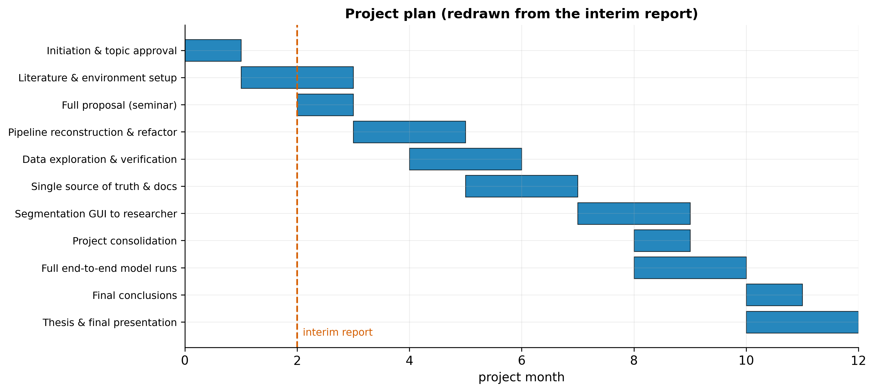
Figure 25
Planned project schedule redrawn from the interim report's work plan, the dashed line marks the interim-report milestone.

A.2 The graphical segmentation tool
The USV Segmentation application (v1.0.2, Zenodo doi:10.5281/zenodo.20096810 [20]) is described in Section 7.4 and its main window is shown in the corresponding figure. It was the vehicle for the parallel data-curation work by the biology researcher, including the review that surfaced the genotype-labelling error.

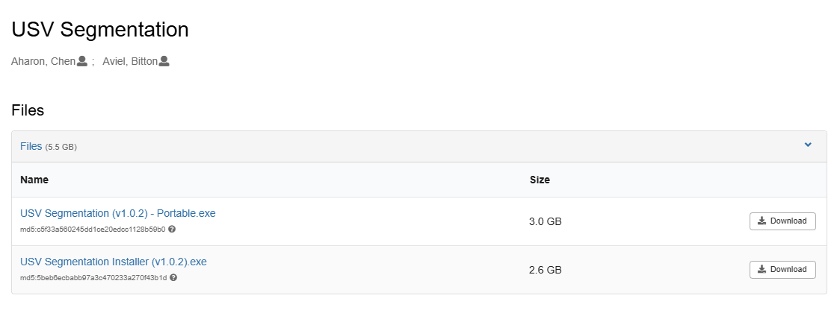
Figure 26
The download page of the graphical segmentation tool on Zenodo for the latest version.

A.3 Code availability
The pipeline source code is available at https://github.com/AvielBitton/mouse-usv-asd-pipeline [22].
The graphical segmentation application source code is available at https://github.com/chenaharon/usv-segmentation-app [23].

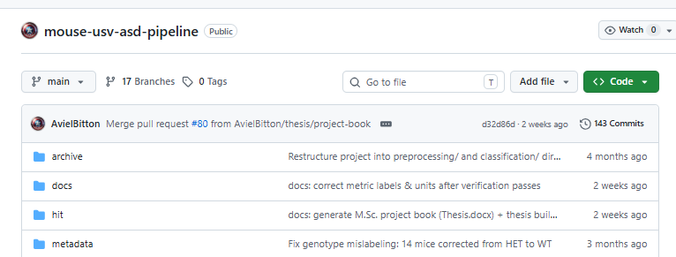
Figure 27
The public repository in GitHub for the full pipeline.
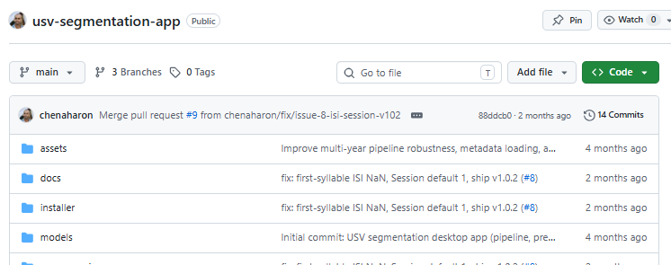
Figure 28
The public repository in GitHub for the graphical segmentation tool.

