Holon Institute of Technology
Faculty of Sciences — Department of Data Sciences
M.Sc. Final Project
Analysis of Ultrasonic Vocalization of Mice for Autism Detection
ניתוח קולות על-שמע של עכברים לאבחון אוטיזם
Chen Aharon · Aviel Bitton
Advisor: Dr. Dror Lederman
(Holon Institute of Technology, Faculty of Engineering)
In collaboration with Dr. Hava M. Golan
Biology lead researcher & data owner — Ben-Gurion University of the Negev
2026

תקציר
אבחון הפרעת הספקטרום האוטיסטי (ASD) מתבסס על הערכה התנהגותית, ומכאן הצורך בסמנים ביולוגיים אובייקטיביים ומוקדמים. במודלים של עכברים, קולות העל-שמע (USV) שמשמיעים גורי עכבר בעת בידוד מהווים מועמד לא-פולשני ומבוסס. הפרויקט בוחן האם ניתן להבחין בין עכברי מודל-אוטיזם (נשאים הטרוזיגוטים לגן Mthfr) לבין עכברי בקרה מסוג בר על סמך קולות העל-שמע שלהם, ובאיזו מידה מסווג כזה מצליח להכליל לחיות שלא נראו באימון.
העבודה החלה ממערכת שעברה בירושה, לא ניתנת להרצה, שכללה מודל יחיד בלבד — מסווג XGBoost תלוי-נבדק. תרומה מרכזית היא לפיכך שיקום המערכת למערכת מתועדת, מנוהלת-גרסאות וניתנת להרצה מקצה לקצה, עם מקור אמת יחיד לנתונים, ובליווי כלי סגמנטציה גרפי המאפשר לחוקרת הביולוגית לאצור את הנתונים במקביל. במהלך האצירה התגלתה ותוקנה שגיאת תיוג גנוטיפ בלתי-מתועדת בנתוני המחקר הקודם.
על מאגר של 125,576 הברות מ-126 גורים, נבנו שני ייצוגים — מצרפים אקוסטיים ברמת ההקלטה ורצפי הברות מסודרים ברמת הסשן — והוערכו תחת פרוטוקול המפריד בין חלוקה תלוית-נבדק אופטימית לבין חלוקה בלתי-תלויה-בנבדק נטולת-דליפה. מודלים טבלאיים מבוססי-עצים (XGBoost, XGBoost מכוונן, TabPFN) הושוו למודלים נוירוניים רצפיים (BiLSTM, ‏1D-CNN, ‏Transformer).
התוצאה הכנה הטובה ביותר היא TabPFN בחלוקה הבלתי-תלויה-בנבדק: דיוק 0.729, ‏F1 משוקלל 0.743, ‏ROC-AUC 0.783. תוצאה קודמת שדווחה (0.829) מוסברת כשילוב של שגיאת נתונים ושל דליפת-נבדק. דיוק המחלקה המיעוטית חסום סביב 0.50 בכל המודלים — תקרה הנובעת מן הייצוג ולא מן המסווג — והמודלים הרצפיים אינם משתפרים על המצרפים הטבלאיים בקנה-המידה הנוכחי. התוצאות הפר-זניות מוטות בשל בלבול עם קוהורט. הפרויקט מספק מערכת רפרודוקטיבית וניתוח כן ומודע-לדליפה של מה שקולות העל-שמע יכולים ואינם יכולים לתמוך בו.

Abstract
Autism Spectrum Disorder (ASD) is diagnosed behaviourally, which motivates the search for objective early biomarkers. In mouse models, pup ultrasonic vocalizations (USVs) are an established, non-invasive candidate. This project asks whether ASD-model mice (Mthfr heterozygotes) can be distinguished from wild-type controls by their USVs, and — equally importantly — how well such a classifier generalizes to unseen animals.
The work began from an inherited, non-runnable pipeline whose only model was a single subject-dependent XGBoost classifier. A central contribution is therefore the reconstruction of this prototype into a versioned, documented, end-to-end-reproducible system with a single source of truth, supported by a graphical segmentation tool that lets the biology researcher curate the data in parallel. During curation, an undocumented genotype-labelling error in the prior data was discovered and corrected (14 mice, 2,495 rows, HET→WT).
On a corpus of 125,576 syllables from 126 pups (35 dams, five recording years), two representations were built — recording-level acoustic aggregates and ordered per-session syllable sequences — and evaluated under a strict protocol that separates optimistic subject-dependent splits from leak-free subject-independent splits. Tree-based tabular models (XGBoost, tuned XGBoost, TabPFN) were compared with neural sequence models (BiLSTM, 1D-CNN, Transformer).
The best honest result is TabPFN on the subject-independent split: accuracy 0.729, weighted F1 0.743, ROC-AUC 0.783. A previously reported accuracy of 0.829 is shown to be the product of two correctable effects — a data-integrity error (which lowers the corrected subject-dependent baseline to 0.733) and subject leakage (which the independent split removes). Minority-class precision is capped near 0.50 across all models — a feature-level ceiling, not an estimator limit — and sequence models do not improve on the tabular aggregates at this data scale, with a promising single-split result (0.704 balanced accuracy) deflating to 0.563 ± 0.063 under cross-validation. Per-strain results are strongly confounded by cohort. The thesis delivers a reproducible pipeline and an honest, leakage-aware account of what USVs can and cannot support.
Keywords: ultrasonic vocalization, autism spectrum disorder, mouse model, Mthfr, machine learning, TabPFN, XGBoost, subject-independent evaluation, reproducibility, data integrity.

List of Abbreviations
Abbreviation | Meaning
ASD | Autism Spectrum Disorder
USV | Ultrasonic Vocalization
WT | Wild-Type (control genotype)
HET / HT | Heterozygous (Mthfr ASD-model genotype; positive class)
UNK | Undetermined genotype
Mthfr | Methylenetetrahydrofolate reductase
CNN | Convolutional Neural Network
BiT | Big Transfer (transfer-learning architecture)
BiLSTM | Bidirectional Long Short-Term Memory network
1D-CNN | One-Dimensional Convolutional Neural Network
TabPFN | Tabular Prior-data Fitted Network
XGBoost | Extreme Gradient Boosting
ISI | Inter-Syllable Interval
ROC-AUC | Area Under the Receiver-Operating-Characteristic Curve
PR-AUC / AP | Area Under the Precision–Recall Curve / Average Precision
MCC | Matthews Correlation Coefficient
CV | Cross-Validation
GUI | Graphical User Interface
P4–P12 | Postnatal days 4–12
HIT | Holon Institute of Technology

Table of Contents
Update this field to generate the table of contents.
(Open in Word and choose “Update Field” to populate the contents and page numbers.)

List of Figures
Figure 1. Dataset composition (small multiples)
Figure 2. Class balance and syllables-per-subject
Figure 3. Annotated segmentation example
Figure 4. Syllable-type distribution
Figure 5. Acoustic-feature distributions by genotype
Figure 6. Data provenance & single source of truth
Figure 7. End-to-end USV-to-decision pipeline
Figure 8. Experimental-design matrix
Figure 9. Master performance — dependent vs independent
Figure 10. Reported-vs-corrected baseline
Figure 11. ROC curves (headline tabular models)
Figure 12. Precision–Recall curves (HT class)
Figure 13. Generalization gap (HT recall & precision)
Figure 14. Confusion matrices (headline models)
Figure 15. HT-precision wall
Figure 16. Sequence-model lever sweep and CV deflation
Figure 17. Threshold-objective operating points
Figure 18. Per-strain comparison
Figure 19. Feature importance (XGBoost)
Figure 20. Commit-derived work timeline
Figure 21. Model taxonomy — inherited vs new
Figure 22. Project timeline / Gantt (interim plan)

1. Introduction

1.1 Motivation
Autism Spectrum Disorder (ASD) is a neurodevelopmental condition defined by difficulties in social communication together with restricted and repetitive behaviour. Diagnosis in humans rests on expert behavioural assessment, which is time-consuming, requires trained clinicians, and is especially hard to apply reliably in early infancy — precisely the window in which early intervention is most valuable. This motivates a search for objective, quantitative, and early biomarkers of atypical neurodevelopment.
Mouse models are a central tool in preclinical ASD research. When isolated from the nest, mouse pups emit ultrasonic vocalizations (USVs) — calls in the 35–125 kHz range that are inaudible to humans, produced naturally, and recordable non-invasively. These isolation calls are sensitive to genetic and environmental manipulations relevant to neurodevelopment, and their temporal and spectral structure has been proposed as an early, communication-related biomarker of ASD-like phenotypes [1], [2], [5]. Because mouse USVs share several organisational features with human speech — temporal patterning, frequency modulation, and sensitivity to developmental disruption — they offer a tractable bridge between molecular models and communication phenotypes [7].
Most prior USV studies remain descriptive: they report group-level differences in call rate or in a handful of acoustic features. A smaller and more recent body of work asks the harder predictive question — whether the differences between an ASD-model group and a wild-type group are large and consistent enough to classify an individual animal from its calls [8], [3], [15]. This project belongs to the predictive tradition and inherits a concrete experimental lineage: a long-running collaboration that recorded Mthfr (methylenetetrahydrofolate reductase) ASD-model mice and wild-type controls under a standardised isolation paradigm [17], [18].

1.2 The starting point: an inherited, non-runnable pipeline
This iteration of the project did not begin from a blank page, nor from a working system. It began from an inherited code base that did not run. At handoff, the repository contained a single monolithic prototype with hard-coded paths and a single, basic, subject-dependent XGBoost classifier — and nothing else. Reaching a state in which even that one model could be reproduced required rebuilding the whole pipeline: data ingestion, segmentation, feature extraction, training, and evaluation.
This shapes the entire thesis. A central, genuine contribution of this work is therefore not only a set of model results but the reconstruction of a broken, undocumented pipeline into a versioned, end-to-end-reproducible system with a single source of truth for the data, accompanied by a graphical tool that lets the biology researcher curate the underlying recordings in parallel. Everything beyond the inherited subject-dependent XGBoost — the tuned XGBoost, the TabPFN tabular model, the three neural-network sequence models, the subject-independent evaluation, and the per-strain analysis — was added by this project. Figure 21 makes this inherited-versus-new distinction explicit.

1.3 Research questions
The research questions were not fixed at the outset. The interim proposal framed the project broadly: improve the inherited predictive model, identify which USV characteristics matter most, and assess whether USVs can reliably flag ASD-like traits. As the rebuilt pipeline made systematic experimentation possible, the questions were refined in consultation with the project advisor, Dr. Dror Lederman, toward the directions the new infrastructure could actually answer:
- RQ1 — New models. Do models that did not previously exist in this project — the TabPFN tabular foundation model and the neural-network sequence models (BiLSTM, 1D-CNN, Transformer) — improve classification of ASD-model (Mthfr-HET) versus wild-type pups over the inherited XGBoost baseline?
- RQ2 — Which features. Which acoustic characteristics drive the classification, and do a small number (two or three) of consistent features emerge?
- RQ3 — Evaluation regime and generalization. How does the data grouping and evaluation regime — subject-dependent versus subject-independent splits, and per-strain versus pooled cohorts — affect classification performance and, above all, generalization to unseen mice?
- Engineering question. Can the inherited, broken pipeline be rebuilt into a versioned, reproducible, end-to-end system with a single source of truth, enabling the biology researcher to curate data in parallel?

1.4 Contributions
This thesis makes the following contributions:
- A reproducible, documented pipeline that takes raw 250 kHz recordings to trained classifiers and evaluation reports, replacing an inherited prototype that could not be run from a clean checkout (Chapter 7).
- A single source of truth for the data, consolidated through a purpose-built graphical segmentation tool and a versioned baseline manifest, including the discovery and correction of an undocumented genotype-labelling error in the prior data (Chapters 3 and 7).
- A systematic model comparison spanning tree-based tabular models (XGBoost, tuned XGBoost, TabPFN) and neural sequence models (BiLSTM, 1D-CNN, Transformer), under a controlled evaluation protocol (Chapters 4 and 5).
- An honest characterisation of generalization, separating optimistic subject-dependent performance from leak-free subject-independent performance, and exposing a feature-level ceiling on minority-class precision (Chapters 5 and 6).
- A faithful account of the data-integrity finding that the project's clean baseline is lower than a previously reported figure, and an analysis decomposing that difference into a data-correction effect and a leakage-removal effect (Figure 10).

1.5 Thesis structure
Chapter 2 reviews ASD, USVs, and the relevant machine-learning literature, and situates this work within its research lineage. Chapter 3 describes the data: provenance, recording rig, cohorts, composition, and the single-source-of-truth story. Chapter 4 details the methods: segmentation and syllable typing, the two preprocessing representations, the models, and the evaluation protocol. Chapter 5 reports the experiments and results, including the master results table and the best model per scenario. Chapter 6 discusses what the results mean — which features matter, how well the models generalize, and why. Chapter 7 presents the reproducibility and engineering contribution. Chapter 8 states the limitations, and Chapter 9 concludes with future work.

2. Background and Related Work

2.1 Autism spectrum disorder and the *Mthfr* model
ASD is a heterogeneous neurodevelopmental disorder with a strong but complex genetic component, interacting with environmental and metabolic factors. One metabolic pathway repeatedly implicated in neurodevelopment is one-carbon (folate) metabolism, of which the enzyme methylenetetrahydrofolate reductase (*Mthfr*) is a key component. Reduced Mthfr activity perturbs methylation reactions required for normal brain development, and Mthfr-deficient mice exhibit ASD-relevant behavioural and physiological alterations. The data analysed in this thesis come from a genetic ASD model based on Mthfr haploinsufficiency on a BALB/c background: wild-type (WT) dams crossed with WT sires, or heterozygous (HET) dams crossed with WT sires, producing pups whose individual genotype is WT or HET. The HET pups constitute the ASD-model (positive) class; the WT pups are controls [17], [18].

2.2 Ultrasonic vocalizations as a behavioural biomarker
Rodent USVs have become a standard tool for behavioural phenotyping of neurodevelopmental and neuropsychiatric models [1], [2], [5], [6]. Pup isolation calls, emitted when a pup is separated from dam and littermates, are among the earliest measurable communicative behaviours and are sensitive to genotype, sex, and developmental stage. Caruso et al. [2] and Premoli et al. [5] review the use of USVs across ASD rodent models and argue for richer, automated analyses beyond simple call counts.
Two studies from the research lineage of this project are particularly important because they characterise the specific dataset paradigm analysed here:
- Shekel et al. (2021) [17] applied unsupervised clustering to the spectral properties of isolation syllables in environmental (chlorpyrifos) and genetic (Mthfr) ASD models. They reported that start frequency, bandwidth, and duration were the most ASD-sensitive syllable features, and documented sex differences and strain (C57Bl/6 vs BALB/c) baseline differences that act as confounds. This single-session isolation paradigm and its feature set directly motivate the acoustic features used in the present tabular pipeline.
- Gal et al. (2023) [18] studied the temporal dynamics of isolation calls under a two-session (maternal-potentiation) paradigm — an isolation session, a reunion, and a second isolation session. They found dynamic, within- and between-session modulation of call quantity and spectral structure, with both ASD models increasing their use of harmonic calls over time, and interpreted altered dynamics as impaired regulation of vocalization. This finding that temporal organisation of calls carries phenotypic information motivates the sequence-modelling track of the present work.

2.3 Automated USV analysis and machine learning
Automated USV analysis has progressed from manual spectrogram inspection toward computer-vision and deep-learning pipelines. Tools such as VocalMat [10] and the deep-learning segmentation studies of Baggi et al. [11] detect and classify syllables from spectrograms; TrackUSF [12] and ARBUR [16] integrate detection with downstream behavioural analysis in rats; and Scott et al. [14] and Johnson et al. [13] address training-data scarcity through synthetic data and semi-automated labelling. On the prediction side, Qian et al. [8] piloted detection of ASD-model mice from USVs ("the sound of silence"), Wu et al. [15] extended this with empirical mode decomposition, and the INTERSPEECH MADUV challenge [3] established a public benchmark for mouse-ASD detection from ultrasound. Beyond rodents, deep-learning vocal biomarkers have also been explored for human infant ASD screening [4]. Yao et al. [7] connect mouse USVs to human speech, reinforcing the translational rationale.
The present project sits within this predictive line but is distinguished by its engineering and evaluation rigour: a single, versioned data source; an explicit separation of subject-dependent from subject-independent evaluation; and an honest treatment of minority-class behaviour rather than headline accuracy alone.

2.4 The prior project in this lineage
A previous M.Sc. project in the same research line — on the same topic and supervised by the same advisor, Dr. Dror Lederman [19] — approached the problem with pretrained audio neural networks (PANNs) operating on spectrograms and with a majority-voting scheme. That prior project is prior art and a structural reference only; none of its methods or results are reused or claimed here. The present work takes a different methodological route — interpretable per-recording acoustic aggregates with tree-based models, and ordered syllable sequences with recurrent/convolutional/attention models — and contributes the reproducible-pipeline and data-integrity work that the earlier iteration lacked. Framing the two together simply reflects the continuity of the advisor's research line.

2.5 Where this work fits
In summary, the biological grounding (USVs as an early ASD biomarker; the Mthfr model; the isolation paradigm) is well established [1], [2], [5], [17], [18]; automated detection of ASD-model mice from USVs is an active and still-open problem [3], [8], [15]; and the chief gaps this thesis addresses are reproducibility, data integrity, and an honest, leakage-aware evaluation of which models and which features actually generalize to unseen animals.

3. Data

3.1 Provenance and recording rig
The corpus consists of pup-isolation USV recordings collected over five years (2015, 2018, 2022, 2023, 2024) in the laboratory of Dr. Hava M. Golan, the biology lead researcher and data owner for this project. Animals are Mthfr mice on a BALB/c background; the ASD-model (positive) class is the heterozygous (HET) pup and the control class is the wild-type (WT) pup, as described in Section 2.1 and in the project's data documentation.
Recordings were made with an Avisoft ultrasonic system: an UltraSoundGate 116Hm interface and a CM16/CMPA condenser microphone placed approximately 10 cm above the pup, sampling at 250 kHz (Nyquist 125 kHz, comfortably covering the 35–125 kHz mouse-USV band). Pups were recorded under an isolation paradigm at postnatal days P4–P12, in a single-session protocol [17] and, in later cohorts, a two-session maternal-potentiation protocol [18].

3.2 Cohort composition
The raw corpus comprises 125,576 detected syllables from 126 pups born to 35 dams, across the five recording years. At the level of unique animals, the offspring-genotype composition is 91 WT, 29 HET, and 6 of undetermined genotype (UNK); the UNK pups are dropped from analysis. Figure 1 summarises the composition across genotype, year, strain, sex, and postnatal day, and Figure 2 shows the class balance and the per-mouse syllable counts.
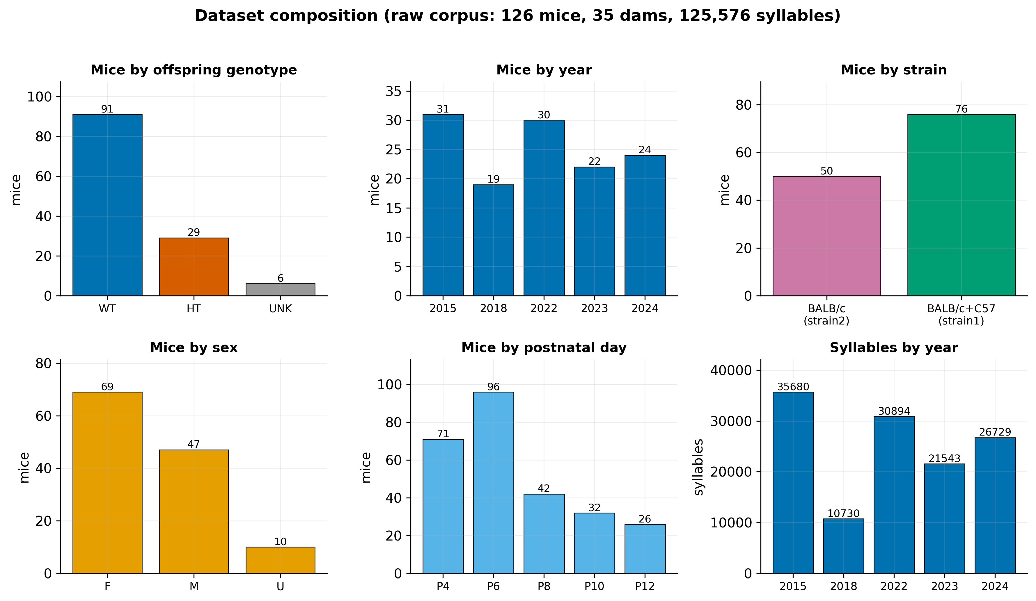
Figure 1. Counts of mice and syllables across genotype, year, strain, sex, and postnatal day for the raw corpus. The cohort is WT-skewed (~3:1) and longitudinal (P4/P6 dominate).

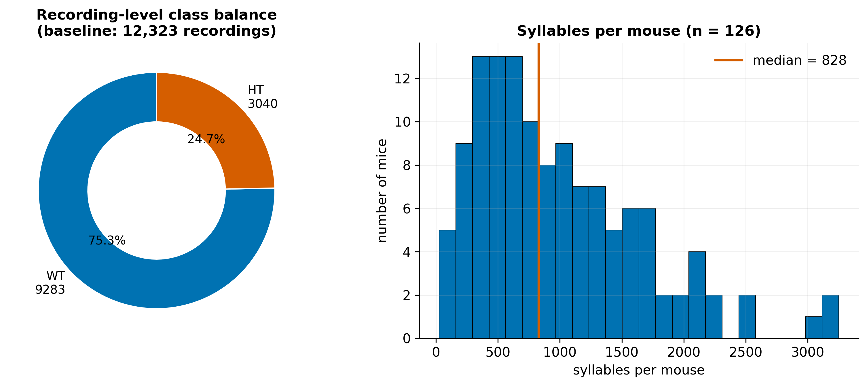
Figure 2. Left: recording-level class balance (9,283 WT / 3,040 HT, ~3:1). Right: per-mouse syllable counts (median 828), showing the strongly longitudinal structure that motivates subject-grouped evaluation.

Two structural features of the cohort are important for everything that follows. First, the cohort is WT-skewed: at the recording level the baseline class balance is roughly three WT to one HET (Section 3.4). Second, the cohort is strongly longitudinal: each pup contributes many recordings across multiple ages and sessions (a median of several hundred syllables per pup), so syllables and recordings from the same animal are highly correlated. This longitudinal structure is the single most important fact for the evaluation design (Section 4.5): a naive row-level split lets the same animal appear in both training and test data, inflating apparent performance.
A further cohort distinction is strain/background, used as a cohort scope in the experiments: the 2015 and 2018 recordings are labelled pure BALB/c ("strain2"), while the 2022–2024 recordings are labelled with a mixed BALB/c+C57 background ("strain1"). Whether this label reflects a genuine genetic cross or a labelling-convention change is an open question carried forward to the limitations (Section 8); regardless, it confounds genotype with cohort and must be treated with care.

3.3 From recordings to syllables
Each WAV recording is processed into a table of syllables, one row per detected call, carrying the animal metadata (genotype, sex, day, session, strain), the call's timing (start, end, duration, inter-syllable interval), two boundary-frequency features (start and end frequency in Hz), a CNN-assigned syllable type, and a noise flag. The detection and typing algorithm is described in Section 4.1; Figure 3 shows a representative recording with its detected syllables overlaid. The corpus is dominated by frequency-modulated call types — "Frequency steps" alone accounts for 44,547 syllables — with a long tail of rarer types and a post-hoc "Undefined" class for low-confidence detections (Figure 4). At the syllable level, the spectral and temporal features (start/end frequency, duration, inter-syllable interval) differ between WT and HET pups in the directions reported by Shekel et al. [17] (Figure 5).
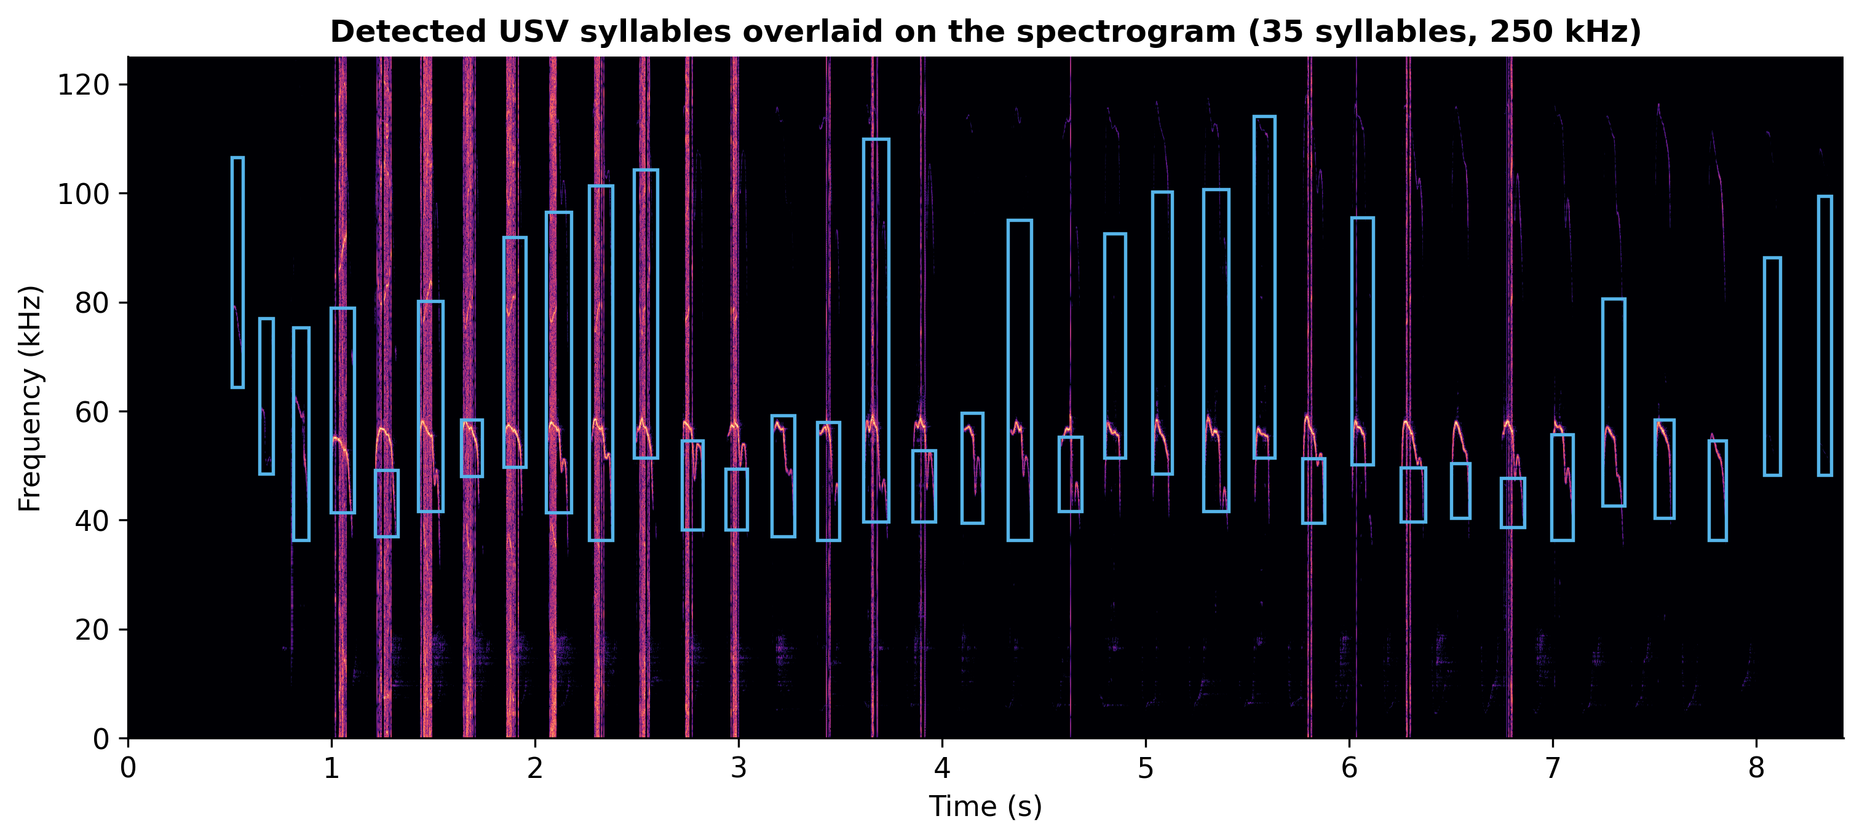
Figure 3. Spectrogram of a representative pup recording with the 35 automatically detected syllables overlaid (blue boxes span each call's time extent and start/end-frequency band). Source: USV_Recordings/2015/08009N_HT/08139-2L_HT/day_6/session2/T0000019.WAV.

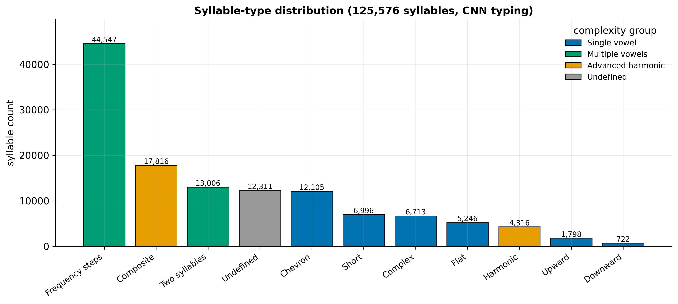
Figure 4. Distribution of the 10 confidently-typed classes plus the post-hoc low-confidence 'Undefined' class, coloured by complexity group. 'Frequency steps' dominates; 'Undefined' (~10%) is dropped in the tabular track but retained in the sequence track.

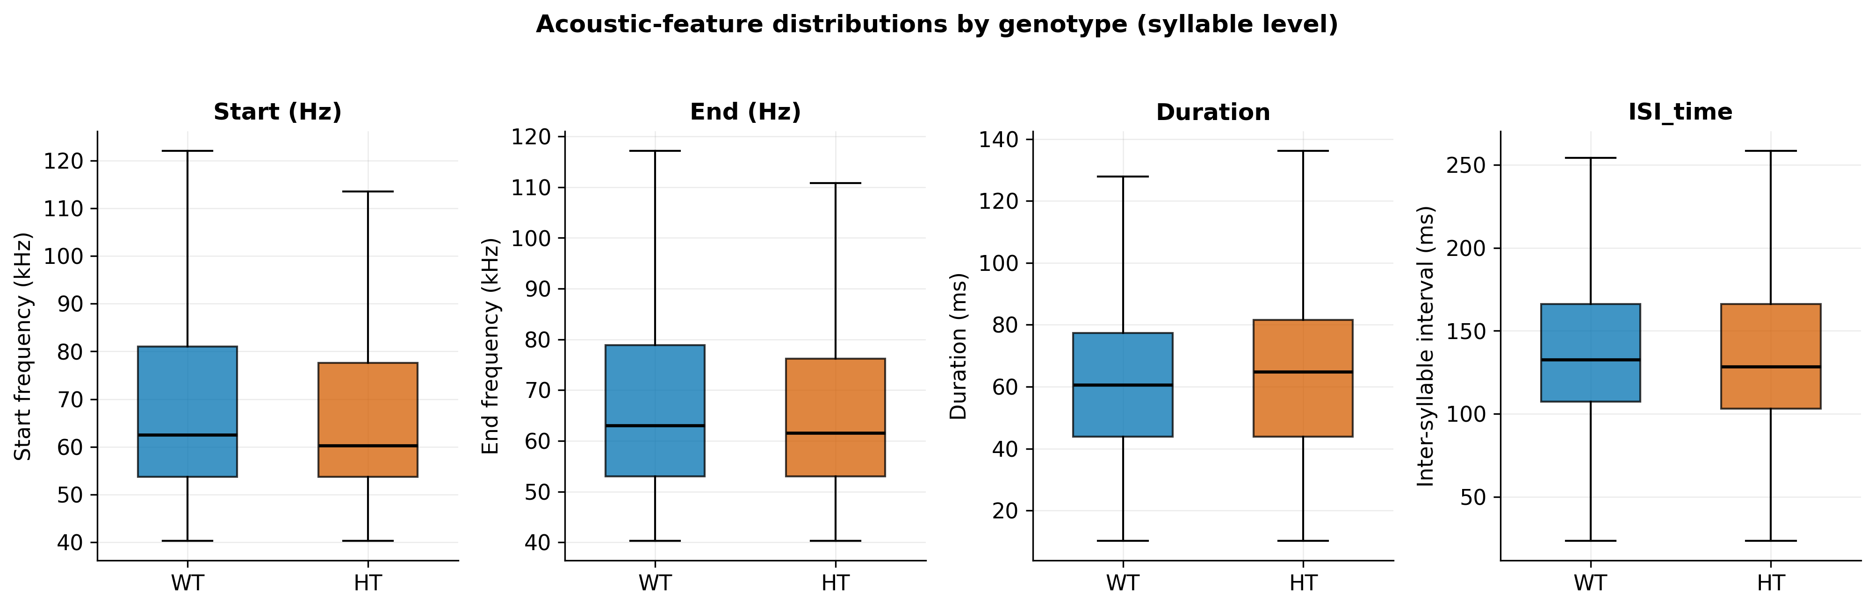
Figure 5. Per-syllable start/end frequency, duration and inter-syllable interval for WT vs HT (outliers hidden, display-clipped). These are the spectral/temporal features Shekel et al. (2021) reported as most ASD-sensitive.

3.4 The baseline dataset and class balance
Not all syllables enter model training. A documented filtering pipeline defines the baseline dataset: rows with invalid genotype or invalid sex are removed, and the separate dietary-supplement experimental arm is excluded, while noise-flagged rows are retained. This yields a baseline pool of 112,234 syllables from 106 mice, aggregated to 12,323 recording-level rows for the tabular models (the unlabelled aggregate exports 12,322 rows; the one-row difference is an export artefact and does not affect training). At the recording level the baseline class balance is 9,283 WT and 3,040 HET recordings — about 75% / 25%, the ~3:1 imbalance that governs metric choice throughout. For the sequence models the same baseline is grouped into 408 isolation sessions.

3.5 Single source of truth and a data-integrity correction
A defining feature of this project is that all model training draws from one canonical data file — the segmentation output segmentation_classification_all_data.xlsx — rather than from scattered, undocumented spreadsheets. This file is produced by the graphical segmentation tool (Section 7.4) and is versioned through a baseline data manifest that records the exact input, the filter stages, and the resulting row counts. The provenance chain is shown in Figure 6.
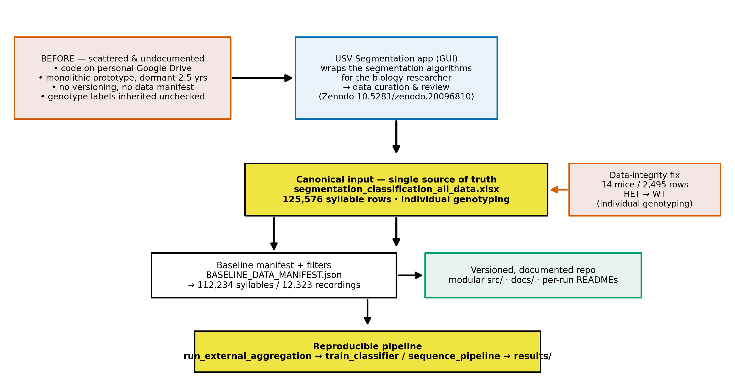
Figure 6. From scattered, undocumented inputs to a curated canonical dataset (single source of truth) with a versioned manifest and a reproducible pipeline; the genotype data-integrity correction is applied at the canonical-file stage.

During the curation of this canonical file, the project discovered and corrected an undocumented genotype-labelling error in the prior data: the original metadata had labelled all pups of a HET dam as HET, which is genetically impossible (a HET × WT cross yields roughly half HET and half WT offspring). Using individual genotyping, 14 mice (2,495 metadata rows) were corrected from HET to WT. This correction, applied at the canonical-file stage, is one reason the project's clean baseline differs from previously reported numbers — a point developed quantitatively in Section 5.2 and Figure 10. We treat this as a data-integrity result, not a regression: the corrected labels are the genetically correct ones, and the lower accuracy they produce is the honest one.

4. Methods
The end-to-end pipeline is summarised in Figure 7: from the recording rig and raw WAV files, through segmentation and CNN syllable typing, to two parallel preprocessing representations (tabular and sequence), the model families, the evaluation protocol, and interpretation. This chapter describes each stage.
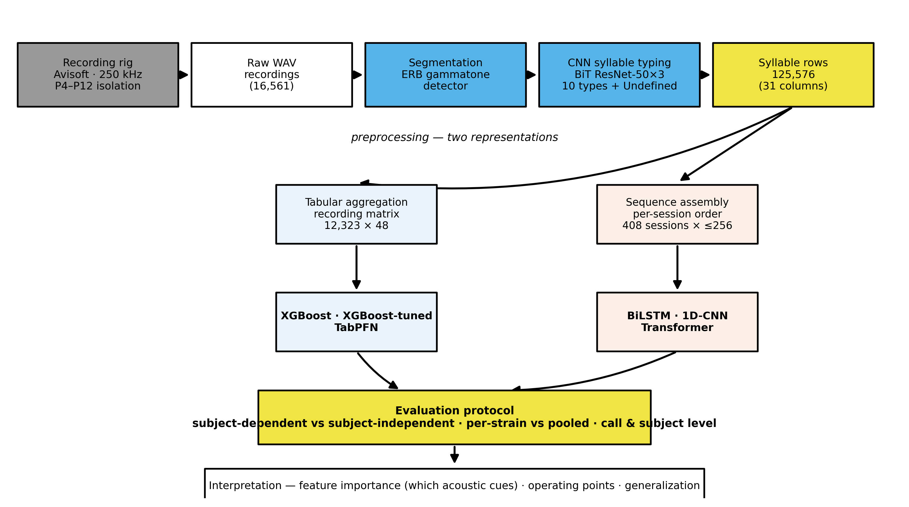
Figure 7. Signature figure: the full pipeline from the recording rig through segmentation and CNN syllable typing to the two preprocessing representations (tabular and sequence), the model families, the evaluation protocol, and interpretation.

4.1 Segmentation and syllable typing
Segmentation detects syllable boundaries with a classical signal-processing detector operating on a cochlear (gammatone) filterbank of 90 ERB-spaced filters covering 35–125 kHz. Audio is analysed in short overlapping frames; a tonality criterion (energy concentrated in few channels) flags candidate syllables, short silent gaps are bridged so that frequency-modulated sweeps are not split, and calls shorter than 10 ms or closer than 20 ms are merged or discarded. Each detected syllable yields a start time, end time, and duration. The detector is deterministic, fast, and tuned to this laboratory's rig; it is comparable in spirit to MUPET/USVSEG-style detectors and predates fully learned detectors such as DeepSqueak and VocalMat. Its thresholds are fixed constants, and it has not been validated against hand-labelled ground truth — limitations noted in Chapter 8.
For each syllable, two boundary-frequency features (start and end frequency) are estimated by Welch power-spectral-density peak-picking in a short window centred on each boundary, restricted to the >40 kHz band, and the inter-syllable interval (ISI) is computed as the gap to the previous syllable in the same recording (undefined for the first syllable).
Syllable typing assigns each syllable to one of ten classes using a convolutional neural network. The recovered architecture is a Big-Transfer (BiT) ResNet-50×3 backbone, pretrained on ImageNet-21k and fine-tuned on 128×128 spectrogram images of individual syllables, with a 10-way softmax head. Predictions whose maximum probability falls below 0.5 are relabelled "Undefined" (an eleventh, post-hoc class). The ten classes plus Undefined and their corpus counts appear in Figure 4; the dominant type is "Frequency steps". No published model card accompanies the typing network (training set and per-class accuracy are unknown), a limitation carried to Chapter 8.

4.2 Two preprocessing representations
The syllable table feeds two independent representations, which differ in what they preserve:
Tabular (recording-level). Each recording is reduced to a fixed 48-column vector: for each of the ten syllable types, the mean start frequency, mean end frequency, relative frequency (the type's share of the recording's syllables), and mean duration (4 × 10 = 40 features), plus the average ISI, the pup's sex, age (postnatal day), session, strain, and the mother's genotype, plus the label (pup genotype) and a mouse index used only for grouping. This representation averages away temporal order. The first syllable of each recording (which has an undefined ISI) and Undefined-typed syllables are dropped before aggregation. The baseline tabular matrix has 12,323 rows (Section 3.4). Tabular models are XGBoost and TabPFN.
Sequence (session-level). Each isolation session is represented as an ordered sequence of its syllables, padded or truncated to 256 time-steps, with a 14-dimensional feature vector per step: four continuous features (start frequency, end frequency, duration, ISI, standard-scaled on the training set), a learned 8-dimensional embedding of the syllable type, a noise flag, and a recording-boundary flag. This representation preserves temporal order and keeps the Undefined type (as an embedding index). The baseline yields 408 sessions. Sequence models are BiLSTM, 1D-CNN, and Transformer.
Because the two tracks make different decisions (recording vs session grain; dropping vs keeping first and Undefined syllables), any comparison between them is a comparison of representation plus model, not of model alone — a caveat respected throughout Chapter 5.

4.3 Models
XGBoost (inherited baseline). A gradient-boosted tree ensemble using the legacy untuned recipe inherited with the project, with class imbalance handled by scale_pos_weight = n_WT / n_HT (≈3.1). This is the only model that existed at handoff and serves as the reference baseline.
Tuned XGBoost (new). A 200-trial randomised hyperparameter search with cross-validation, selecting a recipe per split regime. Because the best recipes differ between the dependent and independent regimes, the tuned results are reported as separate per-regime models, not as one model improving across regimes.
TabPFN (new). A prior-data-fitted transformer for tabular data that performs in-context Bayesian inference in a single forward pass with no hyperparameter tuning. TabPFN merges its validation split into training, so it sees more data than XGBoost (≈80% vs 60%); this is noted wherever the two are compared.
Sequence models (new). Three architectures over the ordered syllable sequences: a two-layer BiLSTM (≈149k parameters), a three-block 1D-CNN (≈86k), and a small Transformer encoder with a learned CLS token (≈73k). All use BCEWithLogitsLoss with pos_weight = n_WT / n_HT (≈3.2), the Adam optimiser, learning-rate reduction and early stopping on validation AUC, gradient clipping, and a fixed seed. A family of imbalance-handling levers (loss weighting, balanced sampling, focal loss, regularisation, augmentation) is explored in Section 5.4.
The model taxonomy and the inherited-versus-new split are shown in Figure 21.

4.4 Class imbalance and metrics
Under a ~3:1 class imbalance, raw accuracy is misleading: a constant "predict WT" classifier already scores ~0.75. We therefore report a suite of metrics and foreground imbalance-robust ones:
- Accuracy and weighted F1 for overall performance (comparable to prior reports);
- Balanced accuracy (mean of per-class recall) as the primary imbalance-robust score;
- ROC-AUC (threshold-free ranking) and PR-AUC / average precision (focused on the minority HET class);
- Per-class precision, recall, and F1 for WT and HT separately — the clinically meaningful breakdown, since HT recall is "catching ASD-model pups" and HT precision is the false-alarm rate.
Throughout, the positive class is HET.

4.5 Evaluation protocol: the heart of the study
Two split regimes are used, and the distinction between them is the central methodological point of the thesis:
- Subject-dependent (default): a random 60/20/20 split at the row/session level. Because the cohort is longitudinal, the same animal appears in training and test. This yields an optimistic upper bound, not a generalization estimate.
- Subject-independent (--independent): a 60/20/20 split grouped by mouse, with stratification on the label and explicit disjointness checks, so that no animal appears in two sets. This is the honest "generalize to unseen mice" setting.
In addition, models are evaluated pooled across all cohorts and per-strain (strain1 = 2022–2024; strain2 = 2015/2018), to probe whether a learned signal is genotype or cohort. The full grid of what was run is shown in Figure 8.
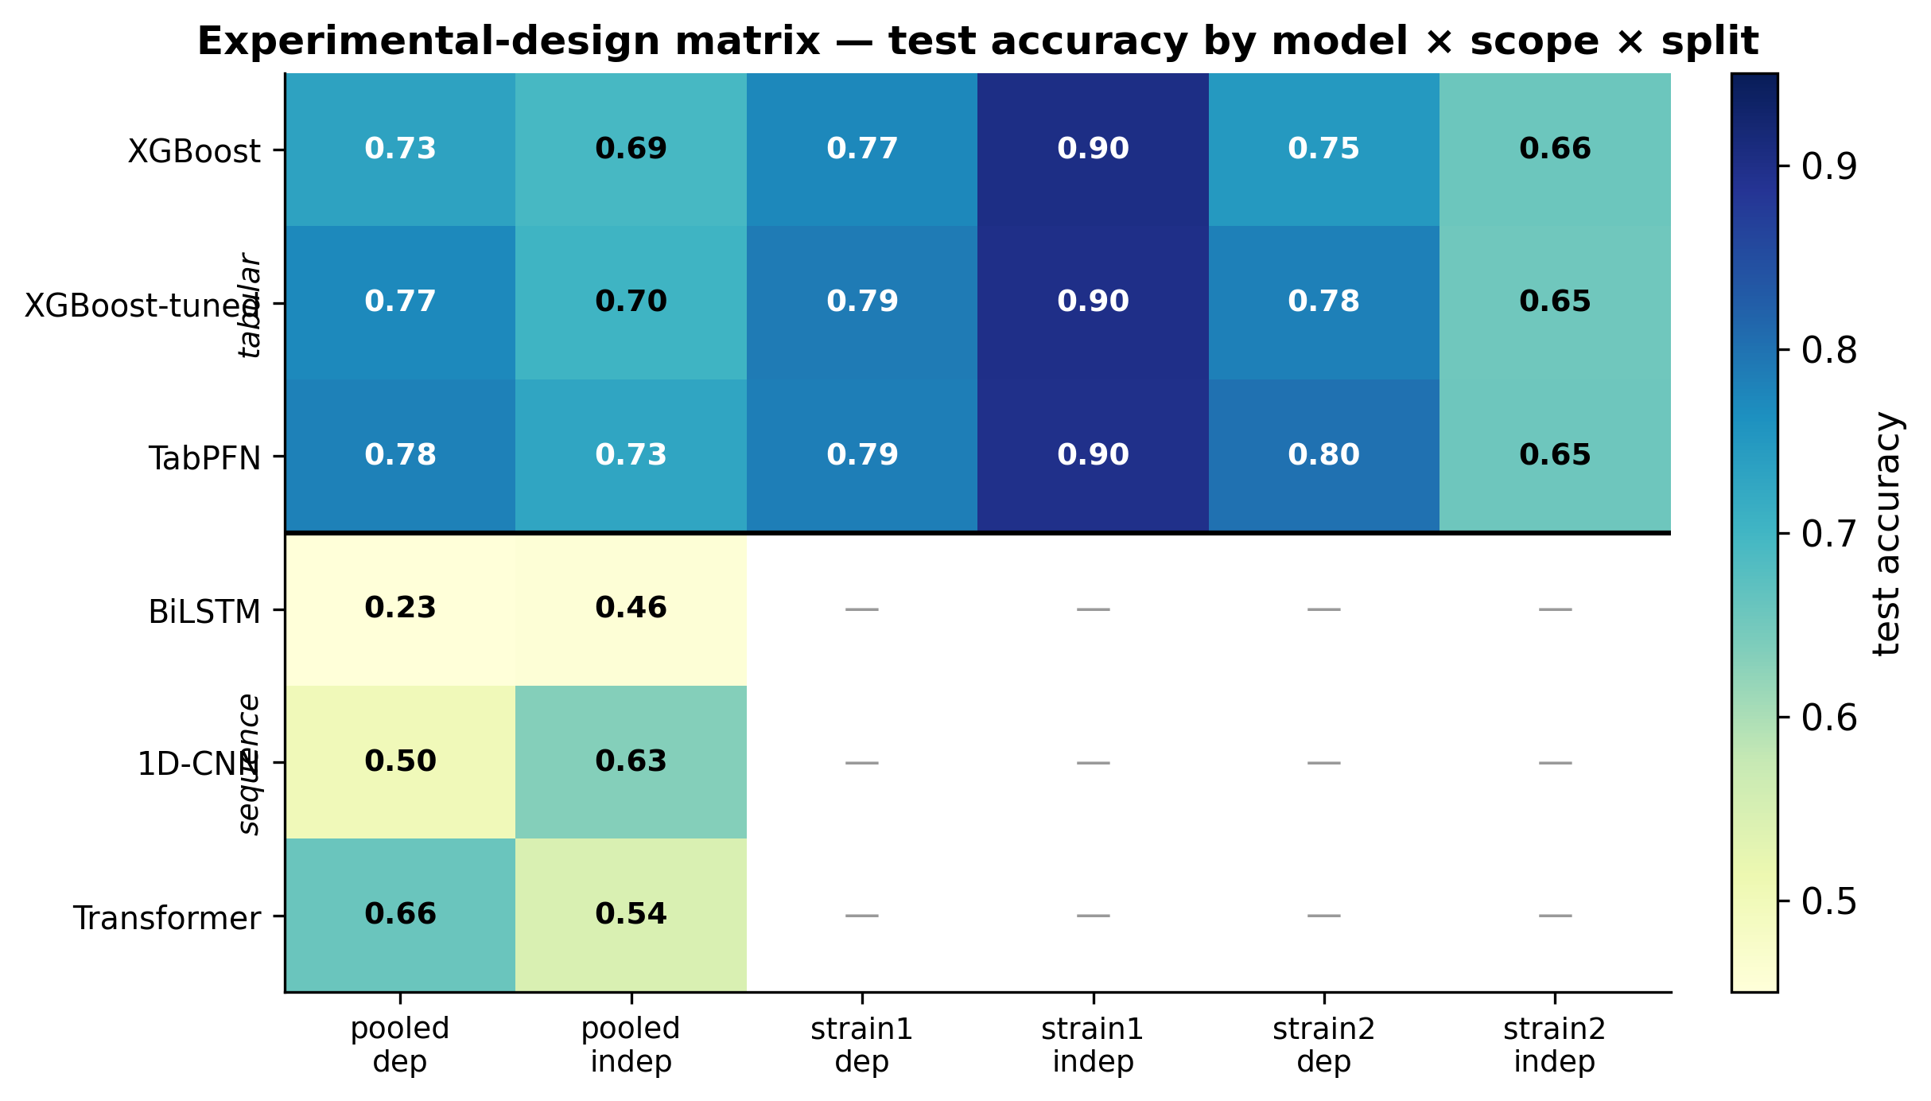
Figure 8. Which model/representation was evaluated under which split and cohort scope; cells show test accuracy (— = not run). Tabular models are evaluated at recording level, sequence models at session level.

Tabular models are evaluated at the recording level and sequence models at the session level; the test sets therefore differ in size and grain, so cross-track numbers are directional rather than like-for-like. For the small sequence test sets, single-split estimates are supplemented by 5-fold grouped cross-validation (Section 5.4).
A separate, leak-free decision-threshold tuning step (Section 5.5) derives an operating threshold on the validation split and freezes it before touching the test set; it relocates the operating point but cannot change AUC.

5. Experiments and Results
All numbers in this chapter are taken from the per-run result reports and the derived master results table; the data sources are listed in the traceability appendix. The positive class is HET throughout, and "dependent"/"independent" denote the subject-dependent and subject-independent split regimes defined in Section 4.5.

5.1 Master results — tabular models (pooled)
Table 1 reports the three tabular models on the pooled baseline, in both split regimes. Figure 9 visualises the same numbers as dependent-versus-independent dumbbells for accuracy, weighted F1, and AUC.
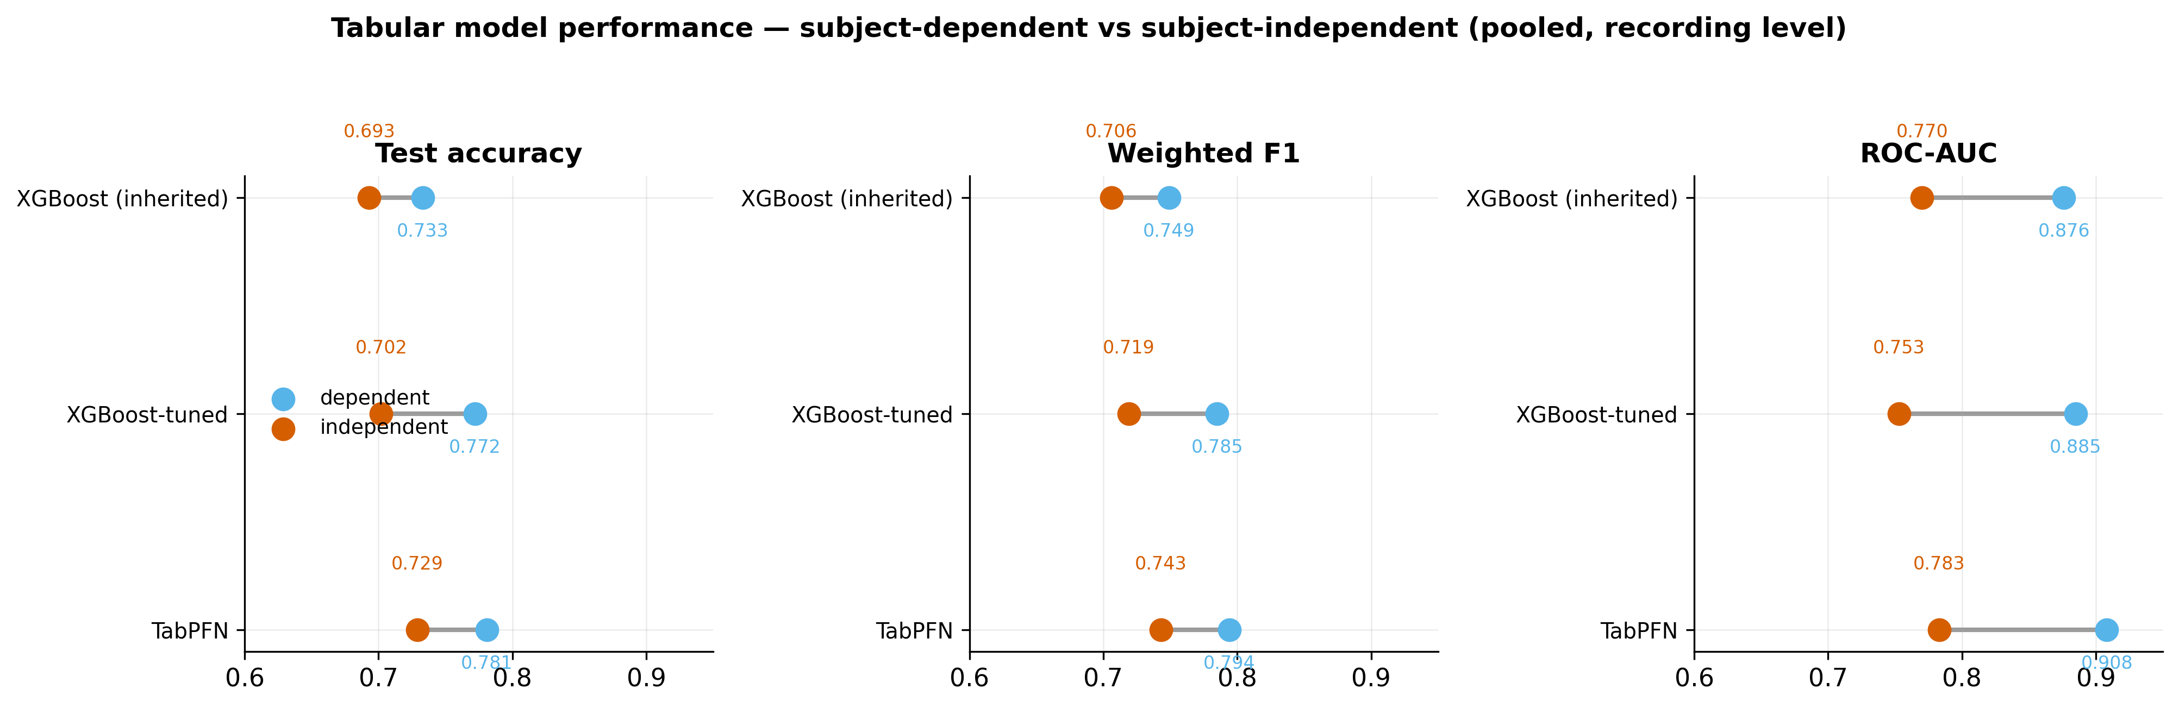
Figure 9. Headline comparison of the three tabular models on the pooled baseline. Each dumbbell links the optimistic subject-dependent score (light) to the honest subject-independent score (dark). TabPFN is best on both; the dependent→independent drop is the cost of generalizing to unseen mice.

Table 1 — Tabular models, pooled baseline (recording level). Best independent row in bold.
Model | Split | Accuracy | Weighted F1 | Balanced acc. | ROC-AUC | HT recall | HT precision | HT F1
XGBoost (inherited) | dependent | 0.733 | 0.749 | 0.795 | 0.876 | 0.940 | 0.496 | 0.649
XGBoost (inherited) | independent | 0.693 | 0.706 | 0.678 | 0.770 | 0.637 | 0.452 | 0.529
XGBoost-tuned | dependent | 0.772 | 0.785 | 0.798 | 0.885 | 0.844 | 0.543 | 0.661
XGBoost-tuned | independent | 0.702 | 0.719 | 0.725 | 0.753 | 0.869 | 0.473 | 0.612
TabPFN | dependent | 0.781 | 0.794 | 0.828 | 0.908 | 0.918 | 0.550 | 0.688
TabPFN | independent | 0.729 | 0.743 | 0.662 | 0.783 | 0.782 | 0.499 | 0.610

Two findings stand out. First, TabPFN is the strongest tabular model in both regimes on overall accuracy and weighted F1, answering RQ1 in the affirmative for the tabular foundation model: it beats the inherited XGBoost on the dependent split (0.781 vs 0.733 accuracy) and, more importantly, on the honest independent split (0.729 vs 0.693). Second, the dependent→independent drop is real and model-dependent. The inherited XGBoost loses the most (accuracy 0.733→0.693, HT recall 0.940→0.637); TabPFN absorbs the regime change best, with independent accuracy (0.729) essentially matching the dependent accuracy of the inherited model (0.733). Note, however, that on balanced accuracy the tuned XGBoost independent model (0.725) exceeds TabPFN independent (0.662), because it keeps HT recall high (0.869); "best" therefore depends on whether overall accuracy or minority-class balance is the objective — a point we return to in Sections 5.5 and 6.

5.2 The corrected baseline: a data-integrity result
A previously reported subject-dependent accuracy of 0.829 is not reproduced by the corrected, leak-free pipeline. Figure 10 decomposes the difference into two separable effects:
- Data-integrity correction (within the dependent regime): 0.829 → 0.733. Correcting the genotype mislabelling (Section 3.5) and the class-weighting computation lowers the subject-dependent XGBoost accuracy to 0.733. This is not a performance regression; the earlier figure was inflated by mislabelled data.
- Leakage removal (regime change): 0.733 → 0.693. Moving from the subject-dependent to the honest subject-independent split costs a further ~0.04 in accuracy for the inherited XGBoost, exposing the optimism of evaluating on recordings from animals also seen in training.
The best honest model, TabPFN on the independent split, recovers much of this: 0.729 accuracy on entirely unseen mice. The headline of this project is therefore not a single large number but a calibrated one: roughly 0.73 accuracy / 0.74 weighted F1 / 0.78 ROC-AUC for generalization to unseen animals, with the prior 0.829 understood as an artefact of data errors and leakage.
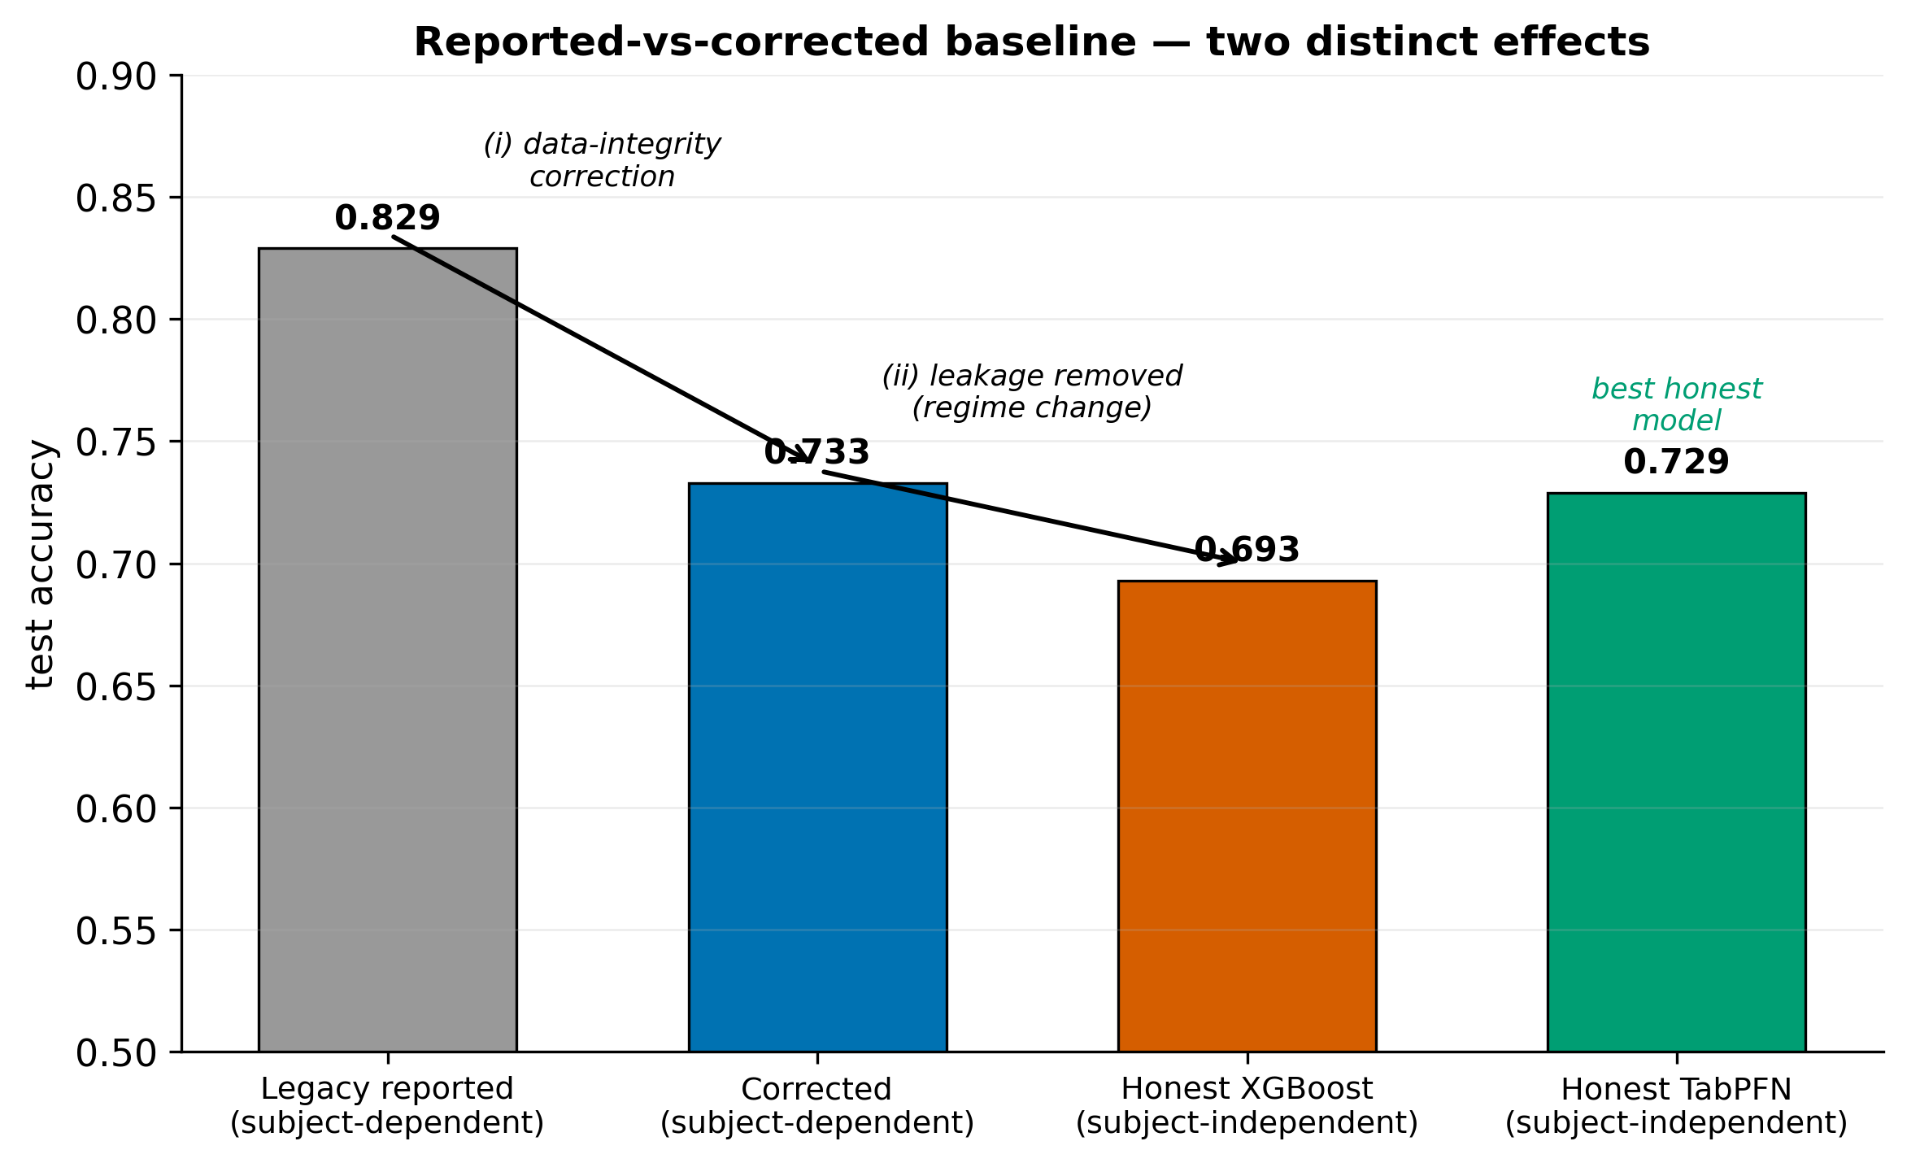
Figure 10. The previously reported subject-dependent accuracy (0.829) is not reproduced by the corrected, leak-free pipeline. Two separable effects: (i) data-integrity correction within the subject-dependent regime (0.829→0.733), and (ii) honest generalization under the subject-independent split (0.733→0.693 for XGBoost; the best honest model, TabPFN, reaches 0.729).

5.3 Generalization, ranking, and minority-class behaviour
Figure 11 (ROC) and Figure 12 (precision–recall) confirm the ranking and quantify the regime cost from held-out probabilities. ROC-AUC falls from the dependent to the independent split for every model (e.g. TabPFN 0.908→0.783), and the precision–recall curves show that minority-class precision degrades sharply at high recall on the independent split.
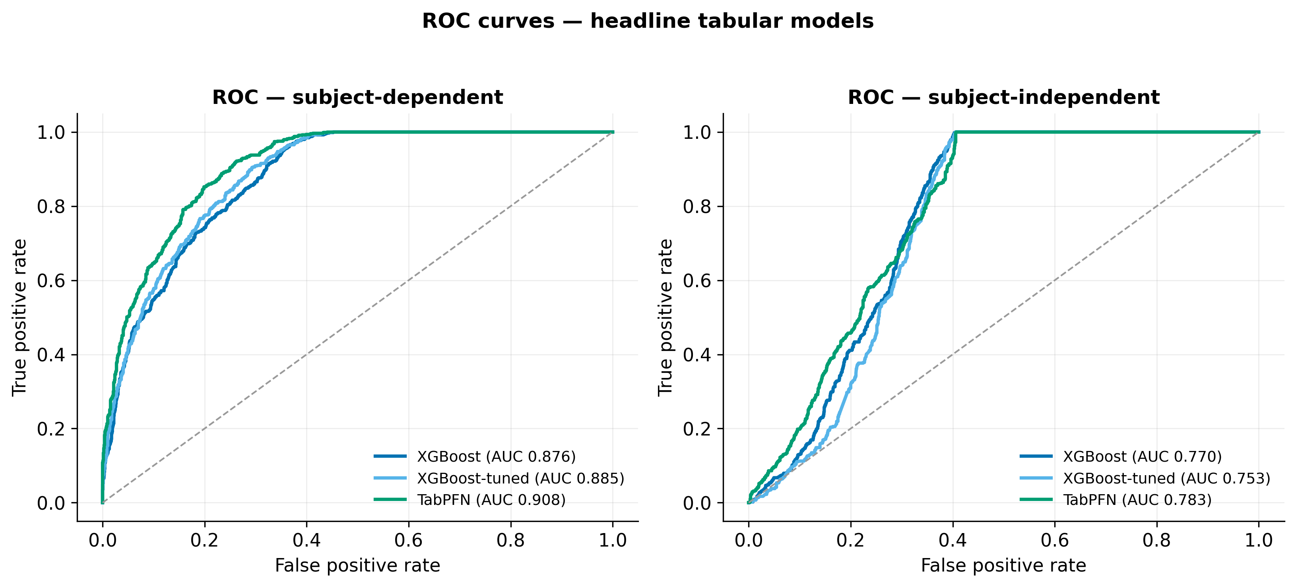
Figure 11. ROC for XGBoost, XGBoost-tuned and TabPFN, recomputed from held-out test probabilities. AUC drops markedly from the dependent to the independent split, quantifying the leakage in the optimistic regime.

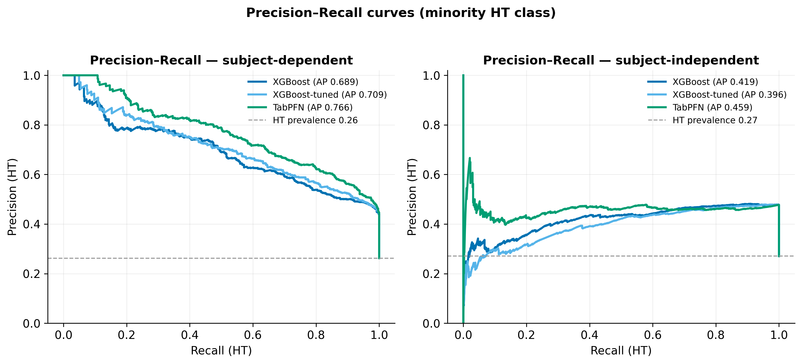
Figure 12. Precision–recall for the HT (ASD-model) minority class. The dashed line is HT prevalence (no-skill). Precision degrades sharply at high recall on the independent split.

Figure 13 makes the minority-class story explicit. As evaluation moves from dependent to independent, HT precision stays pinned near 0.50 for every tabular model (0.452–0.550), regardless of model family, tuning, or regime. We call this the HT-precision wall (Figure 15): at the default threshold, roughly half of all positive (HT) calls are false alarms. The confusion matrices in Figure 14 show the same thing structurally — the dominant error in every panel is WT recordings predicted HT. Because the wall survives every estimator and every split, it is a property of the features, not of the classifier (Section 6.2), and answers part of RQ2: the current per-recording acoustic aggregates carry only enough information to rank well (AUC up to 0.78 on unseen mice) but not to achieve high-purity positive calls.
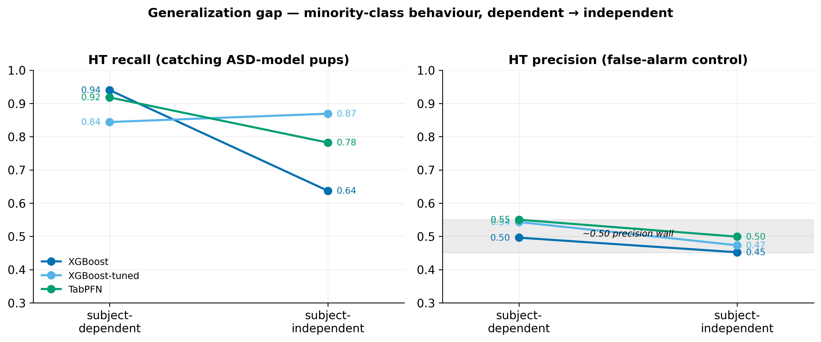
Figure 13. Slope chart of HT recall and HT precision as evaluation moves from subject-dependent to subject-independent. HT precision stays pinned near 0.50 for every model — a property of the features, not the estimator.

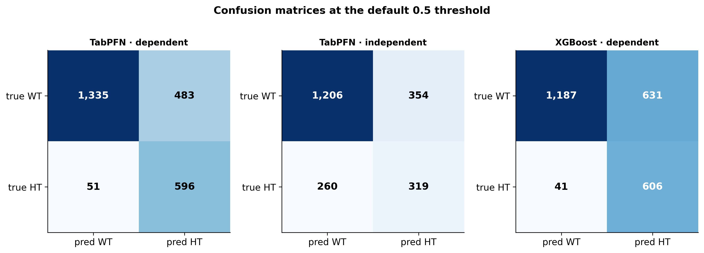
Figure 14. Test-set confusion matrices at threshold 0.5. The dominant error in every panel is WT recordings predicted HT (false positives), consistent with the ~0.50 HT-precision ceiling.

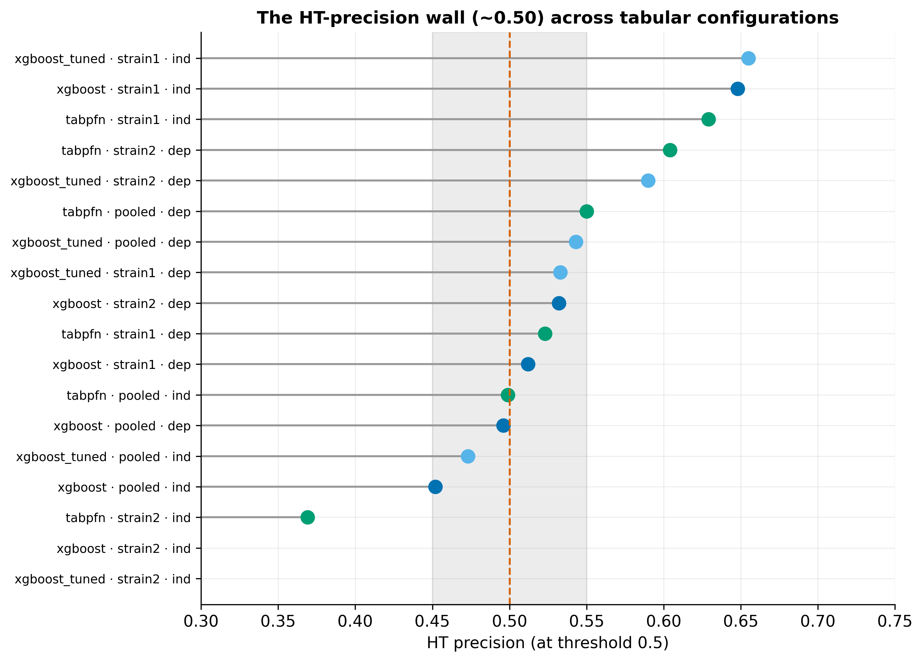
Figure 15. HT precision at the default threshold across every tabular configuration clusters near 0.50 (only the easier strain1 cohort escapes). About half of all positive calls are false alarms — a ceiling set by the features.

5.4 Sequence models and cross-validation deflation
Table 2 reports the three sequence models on the pooled baseline (session level; 82 dependent and 90 independent test sessions, of which 19 are HT). These numbers are not like-for-like with the tabular models, which are evaluated at the recording level on far larger test sets.
Table 2 — Sequence models, pooled baseline (session level).
Model | Split | Accuracy | Balanced acc. | ROC-AUC | HT recall | HT precision | HT F1
BiLSTM | dependent | 0.232 | 0.500 | 0.790 | 1.000 | 0.232 | 0.376
BiLSTM | independent | 0.456 | 0.655 | 0.749 | 1.000 | 0.279 | 0.437
1D-CNN | dependent | 0.500 | 0.564 | 0.604 | 0.684 | 0.271 | 0.388
1D-CNN | independent | 0.633 | 0.517 | 0.609 | 0.316 | 0.231 | 0.267
Transformer | dependent | 0.659 | 0.668 | 0.655 | 0.684 | 0.371 | 0.481
Transformer | independent | 0.544 | 0.634 | 0.675 | 0.789 | 0.288 | 0.423

The sequence models are markedly weaker and prone to collapse. The clearest pathology is the BiLSTM on the dependent split: it predicts HT for all 82 test sessions (accuracy 0.232 = the HT base rate, WT recall 0; balanced accuracy 0.500), yet its ROC-AUC is 0.790 — the ranking is informative but the operating point is broken, a failure that only the imbalance-robust metrics expose. The Transformer is the most stable baseline (balanced accuracy 0.668 dependent, 0.634 independent) but does not approach the tabular models.
A sweep of eight imbalance-handling levers (A–H) was run across the three architectures (Figure 16, left). The best single-split result was a BiLSTM with a balanced minibatch sampler reaching independent balanced accuracy 0.704. However, 5-fold grouped cross-validation of this configuration deflates the estimate to 0.563 ± 0.063 (independent) and 0.609 ± 0.055 (dependent) (Figure 16, right). The single 0.704 was a lucky fold; the honest sequence-model signal is weak and data-limited (≈19 HT test sessions), and is not recoverable by configuration changes. This answers RQ3 for the sequence track: at the current data scale, temporal call order does not yield a reliable gain over the tabular aggregates.
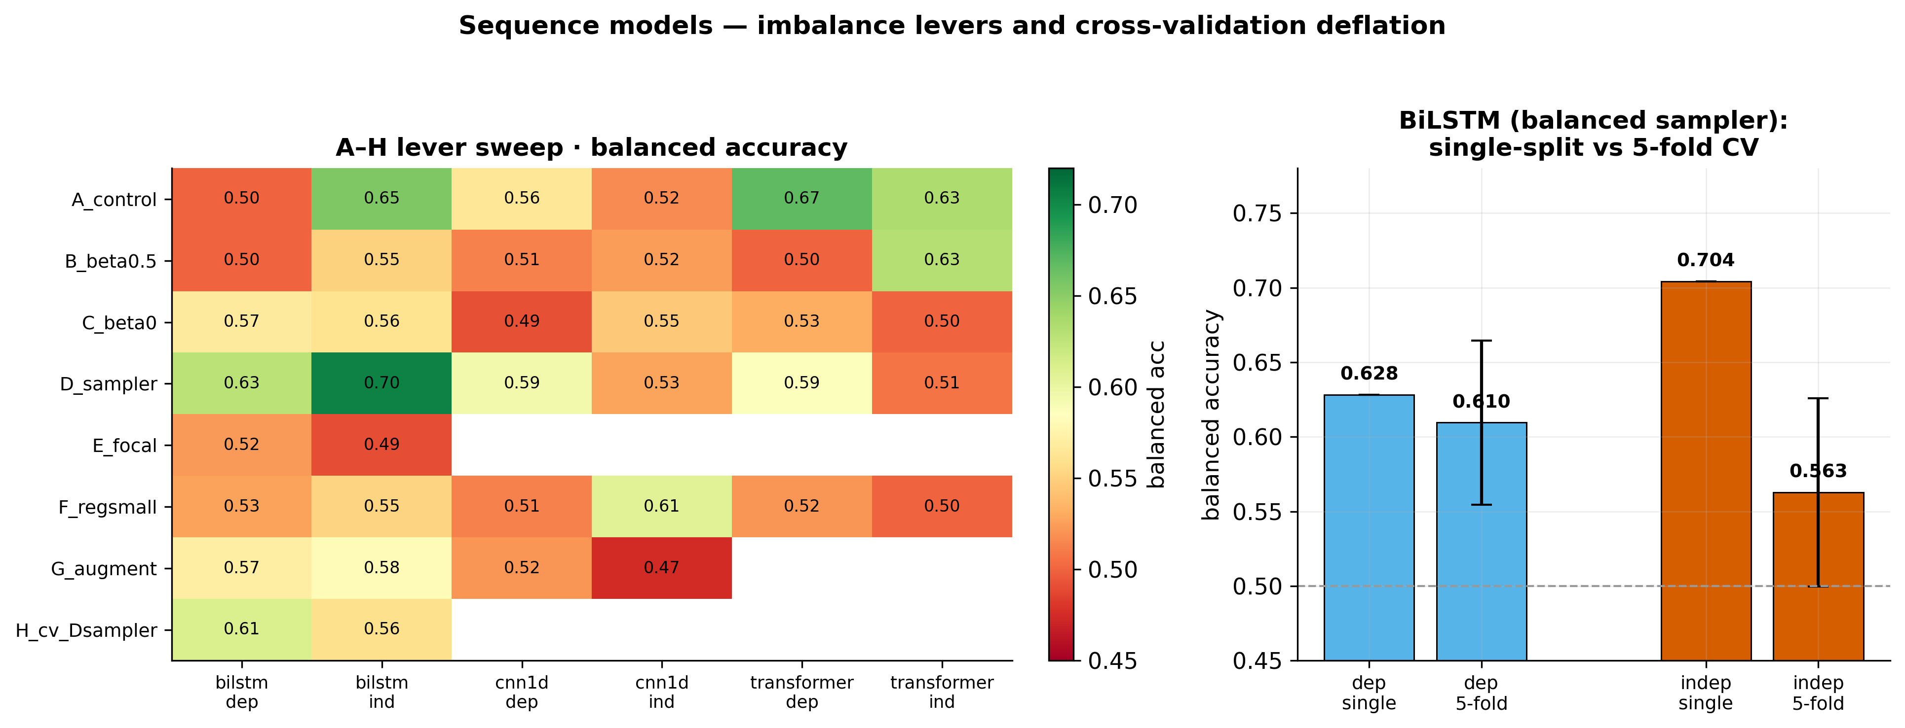
Figure 16. Left: balanced accuracy across the A–H imbalance-handling levers (E run only for BiLSTM). Right: the lucky single-split BiLSTM independent score (0.704) deflates to 0.563 ± 0.063 under 5-fold grouped CV — the honest sequence-model signal is weak and data-limited.

5.5 Decision-threshold tuning
Threshold tuning derives an operating point on the validation split and freezes it before the test set; it cannot change AUC but can move the precision/recall trade-off. Figure 17 shows the effect on TabPFN. On the dependent split, an F1- or target-recall objective lifts HT precision to ~0.62 (from 0.55) while holding HT recall ~0.81, and raises accuracy to ~0.82 — the only operating point that meaningfully exceeds the 0.50 precision wall, and then only in the optimistic regime. On the independent split, the Youden and balanced objectives degenerate (threshold collapses toward 0, HT recall →1, precision pinned ~0.48); a target-recall objective (recall floor ≈0.80) is the only sensible choice, keeping HT recall ~0.86 at precision ~0.46. Threshold tuning is thus best understood as leak-free operating-point hygiene, not as a way to break the feature-level ceiling.
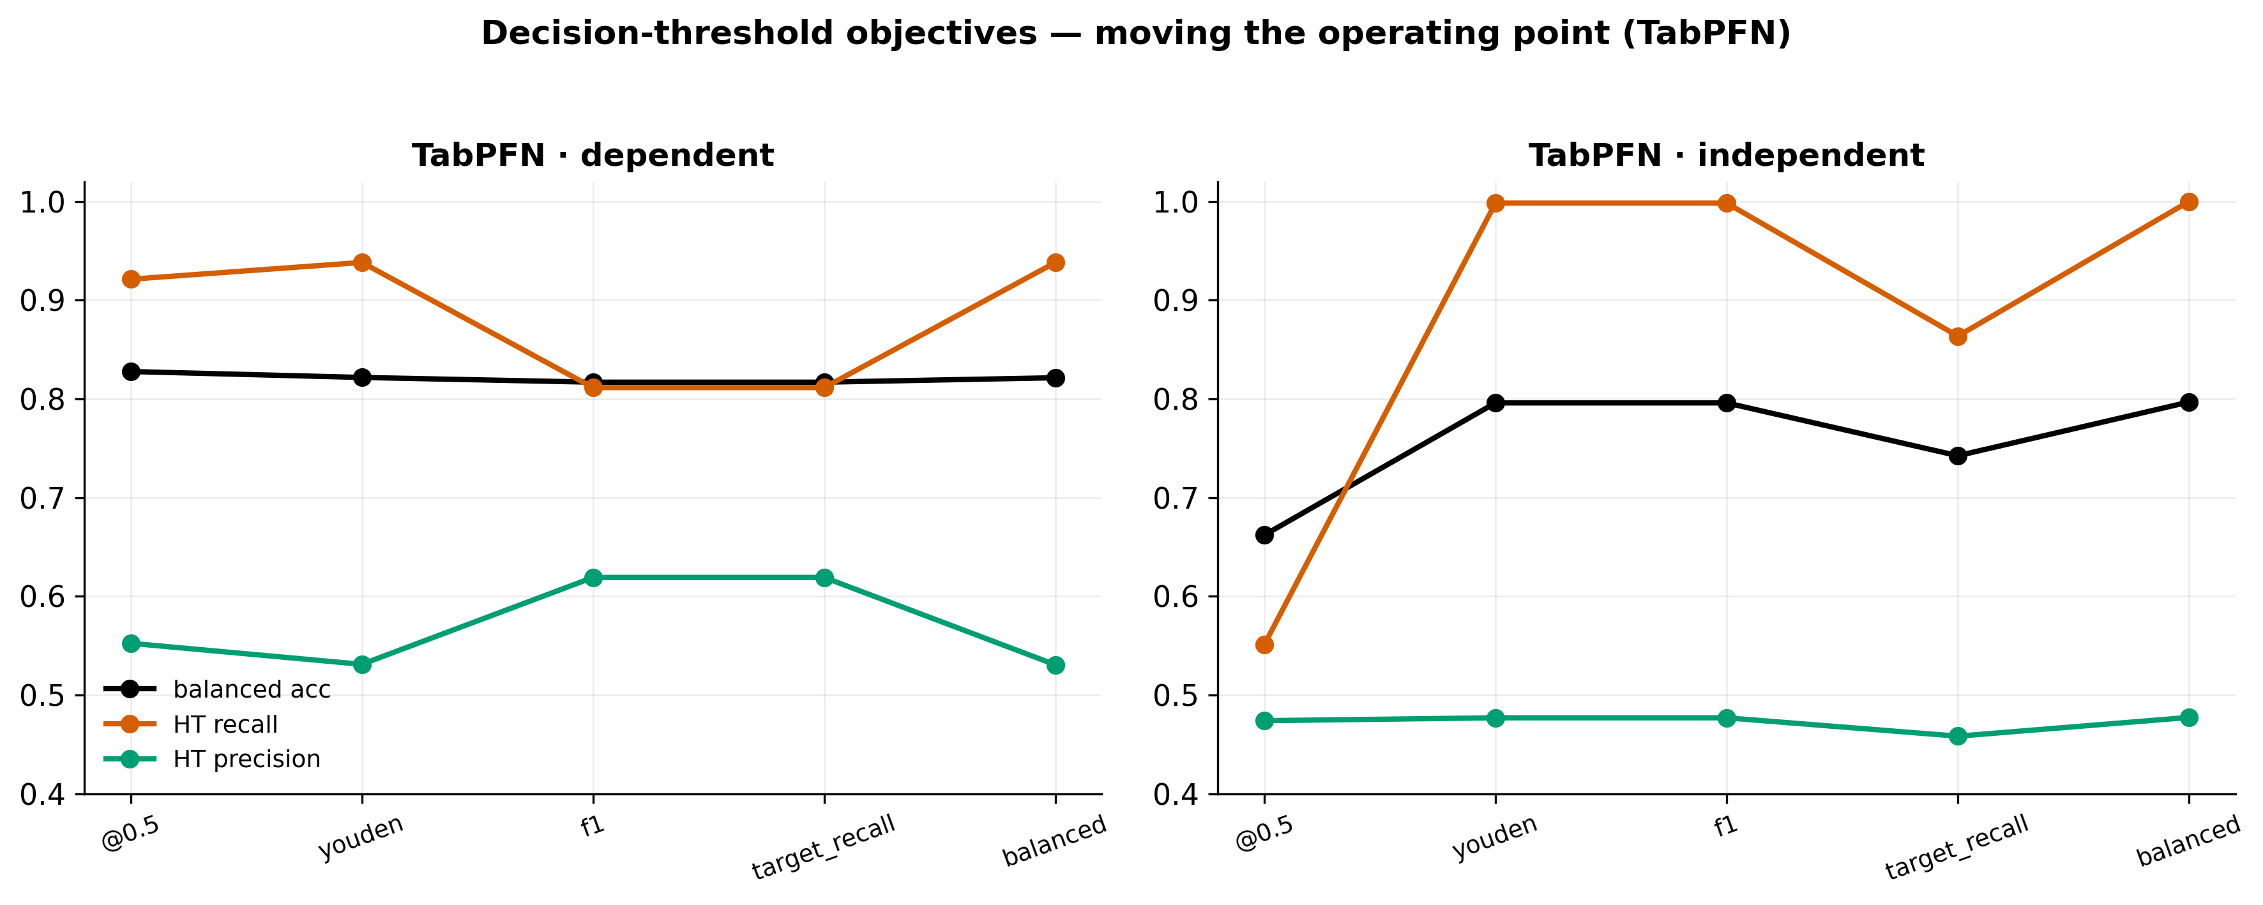
Figure 17. Effect of the threshold objective on TabPFN. On the dependent split, f1/target_recall lift HT precision to ~0.62 while holding recall ~0.81; on the independent split, Youden/balanced degenerate (recall→1, precision pinned ~0.48), so target_recall is the only sensible objective.

5.6 Per-strain analysis
Splitting the cohort by strain reveals a strong interaction (Figure 18, Table 3, XGBoost). On the strain1 cohort (2022–2024, mixed background) the models are highly separable even leak-free: XGBoost reaches independent accuracy 0.903, weighted F1 0.909, HT F1 0.753 — higher than the pooled dependent baseline. On the strain2 cohort (2015/2018, pure BALB/c, only 47 mice) the minority class collapses under the independent split: XGBoost independent HT recall falls to 0.089 (HT F1 0.122), and TabPFN independent reaches only 0.654 accuracy with HT F1 0.388.
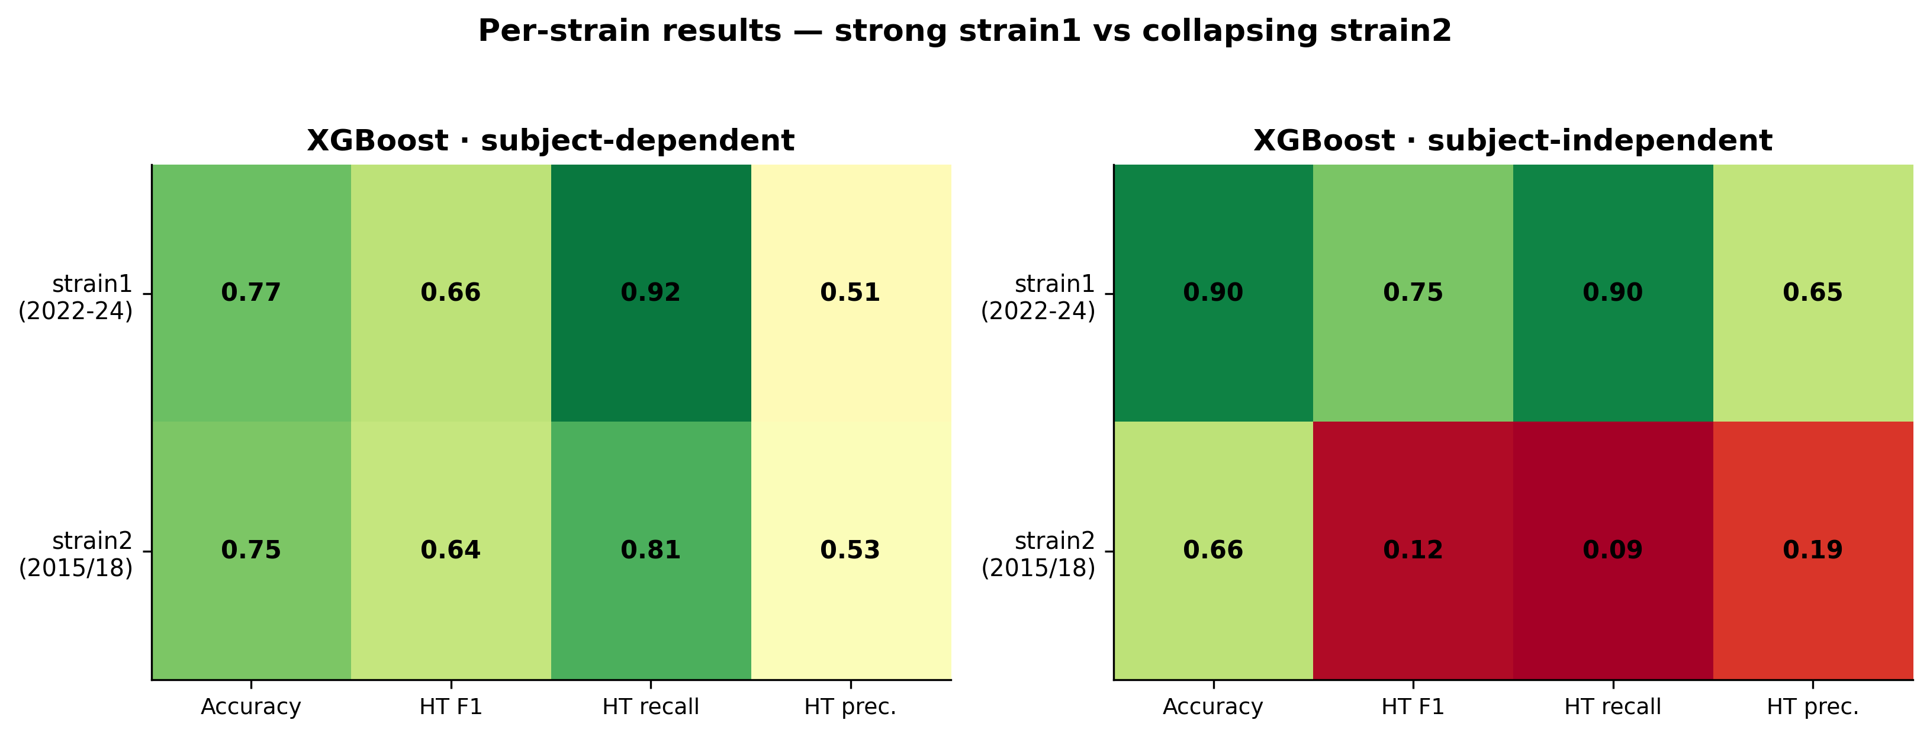
Figure 18. XGBoost per-strain results. strain1 (recent mixed-background cohort) is highly separable even leak-free (acc 0.90), whereas strain2 (small pure-BALB/c cohort) collapses on the minority class under the independent split — evidence that strain/cohort confounds genotype.

Table 3 — Per-strain XGBoost results.
Cohort | Split | Accuracy | Weighted F1 | HT recall | HT F1
strain1 (2022–24) | dependent | 0.774 | 0.791 | 0.919 | 0.657
strain1 (2022–24) | independent | 0.903 | 0.909 | 0.900 | 0.753
strain2 (2015/18) | dependent | 0.748 | 0.759 | 0.808 | 0.642
strain2 (2015/18) | independent | 0.657 | 0.609 | 0.089 | 0.122

This is the project's most important cautionary result. The exceptional strain1-independent score should not be read as a general headline: strain1 is a more recent, lower-HT-prevalence, more separable cohort, and because strain/background is confounded with genotype, a model trained on it may be reading cohort membership rather than the ASD phenotype. The strain2 collapse, despite subject-grouping, reflects both the small cohort and this confound. A genuine cross-cohort test (train on one strain, test on the other) is the honest validation and is left to future work.

5.7 Which features matter
Figure 19 shows the top-15 features by XGBoost gain importance, averaged over the dependent and independent models.
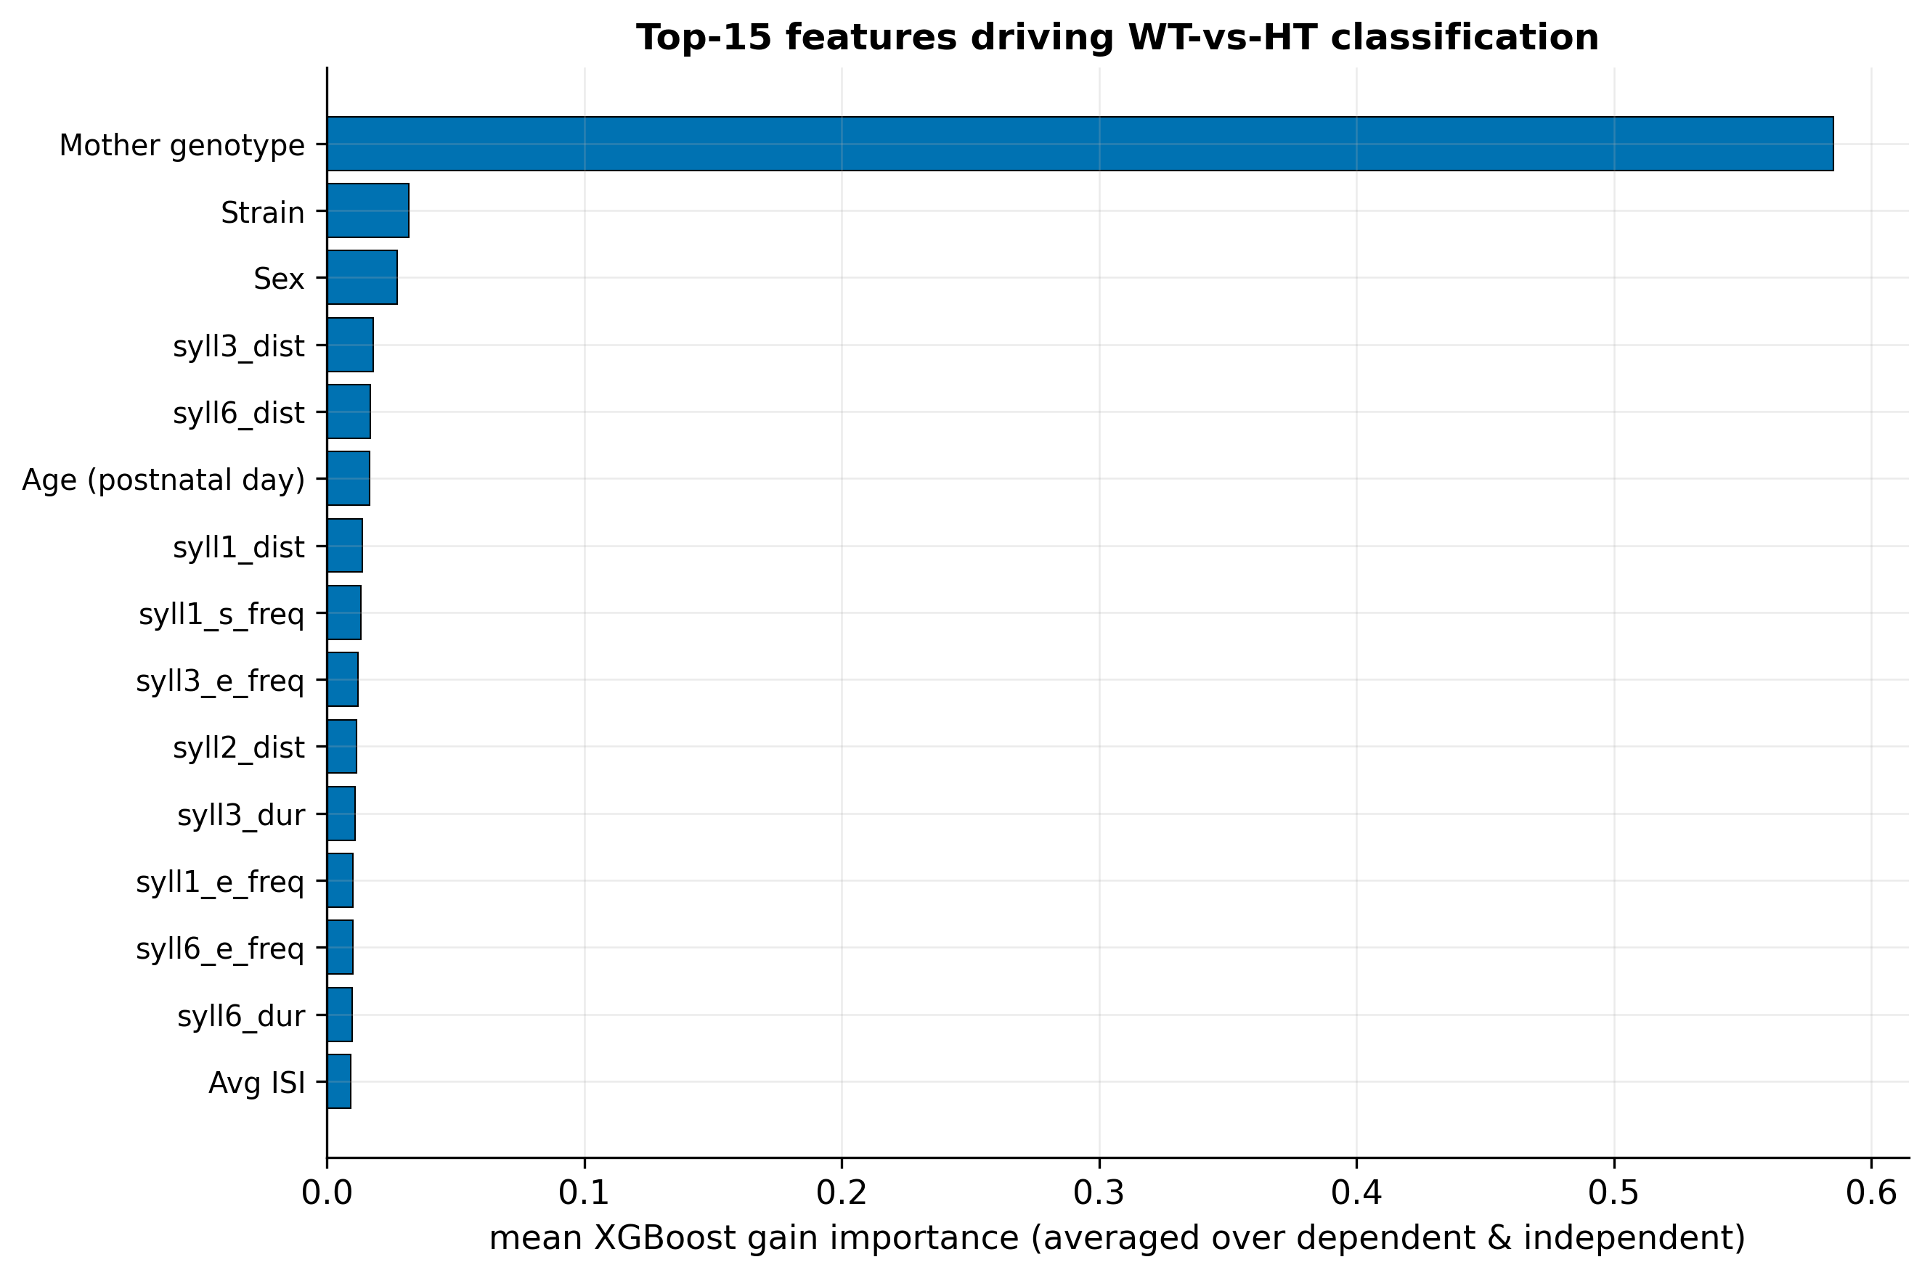
Figure 19. Top-15 features by XGBoost gain importance, averaged across the dependent and independent models. Per-syllable-type start/end frequencies and durations dominate — consistent with Shekel et al. (2021); note the syllN columns map type N→slot via a documented off-by-one.

The classification is driven overwhelmingly by the per-syllable-type start- and end-frequency aggregates and durations, with metadata features (age, session, strain) and the average ISI playing secondary roles. This is consistent with Shekel et al. (2021) [17], who identified start frequency, bandwidth, and duration as the most ASD-sensitive syllable features. The result partially answers RQ2: a small set of spectral/temporal feature families (boundary frequencies and durations) dominates, rather than any single feature — and the absence of a richer per-call descriptor (e.g. full frequency contour, bandwidth, frequency-modulation depth) is the most plausible explanation for the HT-precision wall (Section 6.2).

5.8 Best model per scenario
Table 4 collects the best model for each scenario, which is the practical answer the reader needs. The pattern is consistent: TabPFN is best on the pooled cohort in both regimes (by accuracy/weighted F1), strain1 is highly separable, strain2 does not generalize, and tabular models dominate sequence models at this data scale.
Table 4 — Best model per scenario (by weighted F1 / accuracy).
Cohort | Split | Best model | Accuracy | Weighted F1 | HT F1
pooled | dependent | TabPFN | 0.781 | 0.794 | 0.688
pooled | independent | TabPFN | 0.729 | 0.743 | 0.610
strain1 | dependent | XGBoost-tuned | 0.789 | 0.802 | 0.649
strain1 | independent | XGBoost | 0.903 | 0.909 | 0.753
strain2 | dependent | TabPFN | 0.801 | 0.809 | 0.703
strain2 | independent | TabPFN | 0.654 | 0.659 | 0.388
pooled (sequence) | dependent | Transformer | 0.659 | — | 0.481
pooled (sequence) | independent | 1D-CNN | 0.633 | — | 0.267

6. Discussion

6.1 What works, and in which regime
The results give a clear, calibrated answer to RQ1 and RQ3. Among the new models, TabPFN is the best generalizer on the pooled cohort, reaching 0.729 accuracy / 0.743 weighted F1 / 0.783 ROC-AUC on entirely unseen mice — a genuine improvement over the inherited XGBoost (0.693 / 0.706 / 0.770) and, notably, an honest independent score that matches the inherited model's optimistic dependent accuracy (0.733). The tuned XGBoost is the best minority-aware generalizer, with the highest independent balanced accuracy (0.725) and HT recall (0.869). The choice between them is a deployment decision: if the goal is overall correctness, TabPFN; if the goal is catching as many ASD-model pups as possible (high HT recall) at the cost of more false alarms, the tuned XGBoost or a target-recall threshold (Section 5.5).
The single most decision-relevant finding for the field is the size of the dependent→independent gap. Optimistic subject-dependent evaluation overstates generalization by roughly 4–10 accuracy points and, more dramatically, by up to 0.30 in HT recall for the inherited model. Any USV-classification result reported without subject-grouped splits should be read with this in mind. This is the practical payoff of the evaluation protocol that this project introduced.

6.2 Why minority precision is capped
The HT-precision wall near 0.50 (Sections 5.3, 5.5) is the most informative negative result. It is invariant to model family (trees vs foundation model), to tuning, and to split regime, and it survives threshold relocation (which trades recall for precision along a fixed ROC curve but cannot raise AUC). The natural conclusion is that the ceiling is set by the representation, not the estimator: the per-recording aggregates (mean start/end frequency, relative frequency, and mean duration per syllable type, plus a few metadata fields) summarise each recording into 46 numbers that rank WT and HT well (AUC up to 0.78 on unseen mice) but do not separate the two cleanly at the individual level. The feature-importance analysis (Section 5.7) points in the same direction: the model leans on boundary frequencies and durations — exactly the features Shekel et al. [17] flagged — but lacks richer per-call descriptors such as full frequency contours, bandwidth, and frequency-modulation depth. Enriching the per-call feature set is therefore the most promising route to breaking the wall, more so than larger models.

6.3 Sequence order did not help — at this scale
RQ3 asked whether temporal call order adds signal. The sequence models, motivated by Gal et al.'s [18] finding that call dynamics carry phenotypic information, did not beat the tabular aggregates, and several collapsed to degenerate predictors despite informative AUCs. Cross-validation deflated the most promising configuration from a single-split 0.704 to 0.563 ± 0.063 balanced accuracy. The most likely explanation is data scale: the session-level representation reduces the corpus to 408 sessions with ~19 HT sessions in an independent test fold, far too few for ~70k–150k-parameter networks to learn temporal structure reliably. This is a statement about the present dataset, not about the hypothesis: Gal et al.'s dynamics may well be real and learnable with more animals or with per-mouse aggregation of session predictions. We therefore frame the sequence result as "not supported at this data scale" rather than "temporal order is uninformative".

6.4 The strain confound
The per-strain analysis (Section 5.6) is a caution against over-claiming. Strain1 is almost perfectly separable leak-free (0.903), while strain2 collapses on the minority class (HT recall 0.089). Because strain/background, recording year, and HT prevalence all covary with genotype, a model trained within or across strains may be exploiting cohort membership rather than the ASD phenotype. The pooled independent numbers (Section 5.1) are the most defensible single summary precisely because they average across this confound, but even they cannot fully disentangle phenotype from cohort. The honest test — train on one strain, evaluate on the other — is identified as future work (Section 9).

6.5 The contribution in perspective
Read together, the scientific results are modest but honest: USVs support above-chance, AUC-0.78 generalization to unseen Mthfr mice, driven by spectral and temporal syllable features, with a clear feature-level ceiling on precision and no benefit from sequence modelling at this scale. The larger contribution of this iteration is methodological and infrastructural: a reproducible pipeline, a single source of truth, the discovery and correction of a data error that had inflated a prior result, and an evaluation protocol that separates optimistic from honest performance. In a field where descriptive, leakage-prone analyses are common, establishing what can and cannot be honestly claimed — and making it reproducible — is itself a result.

7. Reproducibility and Engineering Contribution
This chapter documents what is, by effort and by impact, the largest part of the project: turning an inherited, non-runnable prototype into a versioned, documented, end-to-end-reproducible system with a single source of truth, and building a graphical tool that lets the biology researcher curate the data in parallel. The chronology in this chapter is reconstructed from the project's version-control history and is used only to establish the sequence and scope of the work; every quantitative result elsewhere in the thesis is sourced from the result reports, never from commit messages.

7.1 The starting point: a broken inheritance
At handoff the repository was a monolithic prototype with hard-coded paths, authored years earlier and then left dormant. It contained a single classifier — a basic, subject-dependent XGBoost — and no other models, no modular structure, no documentation of the data, and no way to run the pipeline from a clean checkout. Reaching a state in which even that one model could be reproduced required rebuilding the whole pipeline. Figure 20 reconstructs the timeline of this work from the commit history, from the inherited prototype through the takeover, the whole-pipeline refactor, the discovery of data leakage, the genotype correction, and the successive additions of models.
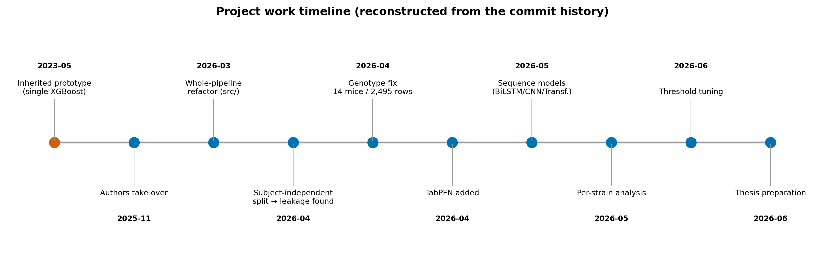
Figure 20. Milestones reconstructed from the local git history (chronology only — no metrics). From the inherited single-model prototype to the final multi-model, leak-free pipeline.

7.2 Inherited versus new
A precise accounting of what was inherited and what this project built is given in Table 5 and visualised in Figure 21. The distinction matters for both the scientific narrative (everything beyond the inherited model is a new result) and the assessment of the engineering contribution.
Table 5 — Inherited versus new capabilities.
Capability | Status
Basic subject-dependent XGBoost | Inherited (only model at handoff)
Modular, runnable pipeline (src/preprocessing, src/classification) | New
Subject-independent / group-aware evaluation | New
Tuned XGBoost (hyperparameter search) | New
TabPFN tabular model | New
Sequence models (BiLSTM, 1D-CNN, Transformer) | New
Per-strain cohort analysis | New
Decision-threshold tuning (leak-free, multi-objective) | New
Canonical external data source + baseline manifest | New
Genotype data-integrity correction | New
Graphical segmentation app for the researcher | New

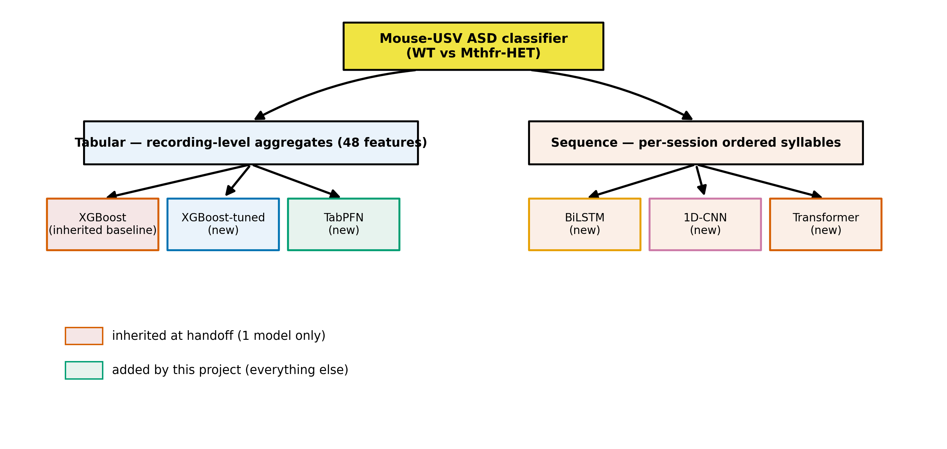
Figure 21. Model families tried, by representation. Only the single subject-dependent XGBoost existed at handoff; the tuned XGBoost, TabPFN, and all three sequence models were added by this project.

7.3 Single source of truth and data provenance
The data-integrity backbone of the rebuilt system is a single canonical input file with a versioned manifest, replacing the previous practice of scattered, undocumented spreadsheets. The provenance chain (Figure 6) runs: raw recordings → metadata extraction → the graphical segmentation tool → the canonical segmentation_classification_all_data.xlsx → baseline filters and manifest → the aggregated tabular and sequence training matrices → per-run result directories. Each stage has a documented script and, for the data, a manifest recording the exact input, the filter rules, and the resulting row counts (Section 3.4).
Two integrity findings emerged from this work and are recorded honestly in the thesis: the genotype mislabelling (14 mice / 2,495 rows corrected from HET to WT; Section 3.5) and the resulting, correct, lower baseline (Section 5.2). Both are consequences of having established a single, auditable source of truth where previously there was none.

7.4 The graphical segmentation app
To let the biology researcher (Dr. Hava Golan) curate and review the USV data without using the command line, the project built a graphical segmentation application that wraps the existing segmentation and typing algorithms behind a simple interface (select data and output folders, choose recording years, run, and inspect results). The tool runs the same algorithms as the Python pipeline and produces the canonical segmentation file that all model training consumes; it is the mechanism by which the data-curation process (and the discovery of the prior-data errors) was carried out in parallel with the modelling work. The application is published as a citable artifact: USV Segmentation (v1.0.2), Zenodo, doi:10.5281/zenodo.20096810 [20].

7.5 End-to-end reproducibility
The rebuilt system is runnable end-to-end from a clean checkout. Environment setup is pinned (a requirements file and a Dockerfile); the preprocessing pipeline is decomposed into documented steps (ingestion, segmentation, feature computation, typing, enrichment, aggregation); and training is driven by documented command-line flags that select the model, the split regime (--independent), the cohort scope (--strain), and the baseline data. Every run writes a result directory with its configuration, metrics, plots, and a human-readable README, so that each number in this thesis is traceable to a specific, reproducible run. The documentation set itself — the data manifest, the segmentation and preprocessing references, the CLI reference, and the per-run reports — is a deliverable of the project, and is what makes the integrity claims in this thesis checkable.

8. Limitations
This work is deliberately explicit about what it cannot claim.
Data scale and cohort. The corpus is 126 pups (29 HET) from one laboratory and one genetic model (Mthfr on BALB/c). After subject-grouped splitting, an independent test fold contains only a few dozen mice, and the sequence representation reduces to ~19 HT test sessions. This limits the power of any model — especially the neural sequence models — and means confidence intervals on the headline numbers are wide. The single-fold sequence results in particular must be read together with their cross-validated, deflated estimates (Section 5.4).
Strain/cohort confound. Recording year, strain/background label, and HT prevalence covary with genotype (Section 6.4). The strong strain1-independent result (0.903) and the strain2 collapse both reflect this confound. Without a cross-cohort experiment, we cannot fully separate a learned ASD phenotype from learned cohort membership. The strain label change between the 2018 and 2022 cohorts (pure BALB/c vs mixed BALB/c+C57) is itself unresolved — a genuine genetic cross or a labelling-convention change — and is flagged for the biology team.
Evaluation grain. Metrics are reported at the recording level (tabular) and session level (sequence); they are not aggregated to a single per-mouse decision. A per-subject vote (e.g. majority over a mouse's recordings) might change both the numbers and their interpretation and is left to future work. Consequently, tabular and sequence results are directional, not like-for-like.
Feature representation. The tabular features are per-syllable-type aggregates of boundary frequencies, relative frequencies, and durations. They lack richer per-call descriptors (full frequency contour, bandwidth, frequency-modulation depth). Section 6.2 argues this is the most likely cause of the HT-precision wall; it is a limitation of the inherited feature set, not a fundamental limit of USV-based classification.
Segmentation and typing provenance. The segmentation detector uses fixed, hand-set thresholds and has not been validated against hand-labelled ground truth, so its precision/recall and boundary accuracy are unquantified. The CNN syllable-typer has no published model card (training set, class balance, and per-class accuracy are unknown), and a weight shard is absent from the public checkout. Downstream features inherit any errors from these stages.
Preprocessing choices. The tabular track silently drops each recording's first syllable (undefined ISI) and all Undefined-typed syllables; the sequence track keeps both. These undocumented-in-prior-work choices were surfaced during the rebuild and are reasonable but not validated (e.g. ISI could be imputed instead of dropped).
Methodological scope vs. the original plan. The interim report proposed spectrogram-based CNN classifiers; the delivered system instead uses tabular tree-based models and syllable-sequence networks. This was a deliberate, advisor-guided pivot toward what the rebuilt, leakage-aware infrastructure could evaluate rigorously, but it means the spectrogram-CNN approach of the original plan (and of the prior project [19]) is not evaluated here.

9. Conclusions and Future Work

9.1 Conclusions
This project rebuilt an inherited, non-runnable USV-classification prototype into a versioned, documented, end-to-end-reproducible system with a single source of truth, and used it to evaluate — honestly and with leakage control — whether ASD-model (Mthfr-HET) mice can be distinguished from wild-type controls by their ultrasonic vocalizations.
Returning to the research questions:
- RQ1 (new models). Yes: TabPFN improves on the inherited XGBoost in both regimes and is the best pooled generalizer (independent accuracy 0.729, weighted F1 0.743, ROC-AUC 0.783). The tuned XGBoost is the best minority-aware generalizer (independent balanced accuracy 0.725, HT recall 0.869).
- RQ2 (features). Classification is driven by per-syllable-type boundary frequencies and durations — consistent with Shekel et al. [17] — but minority-class precision is capped near 0.50 across all models, a ceiling we attribute to the feature representation rather than the estimator.
- RQ3 (regime and generalization). The evaluation regime matters decisively: subject-dependent evaluation overstates generalization by several accuracy points and up to ~0.30 in HT recall. Per-strain results are strongly confounded by cohort (strain1 independent 0.903 vs strain2 collapse). Sequence models did not beat the tabular aggregates at this data scale; the most promising configuration deflated from 0.704 to 0.563 ± 0.063 under cross-validation.
- Engineering question. Yes: the pipeline is now reproducible end-to-end, with a single canonical data source, a versioned manifest, a graphical curation tool for the researcher, and per-run reports that make every number in this thesis traceable. The rebuild also surfaced and corrected an undocumented genotype error that had inflated a prior baseline.
The honest headline is therefore a calibrated one: USVs support above-chance, AUC-0.78 generalization to unseen Mthfr mice, with a clear feature-level precision ceiling and a strong cohort confound — findings that are now reproducible and auditable.

9.2 Future work
The results point to concrete next steps, in roughly descending order of expected value:
- Richer per-call features. Add full frequency-contour descriptors (mean/min/max/slope, bandwidth, frequency-modulation depth) to the tabular representation to test whether the HT-precision wall is broken — the highest-leverage experiment.
- A genuine cross-cohort test. Train on one strain and evaluate on the other to separate the learned ASD phenotype from cohort membership, and resolve the 2018→2022 strain-label question with the biology team.
- Per-subject decisions. Aggregate recording/session predictions into a single per-mouse vote and report subject-level metrics, which is the clinically meaningful grain.
- More data for sequence models. Re-test the temporal-dynamics hypothesis [18] with more animals or with per-mouse aggregation, before concluding on whether call order helps.
- Validate the front end. Quantify the segmentation detector against hand-labelled ground truth and publish a model card for the syllable-typing CNN, so that downstream feature quality is characterised.
- Threshold-calibrated deployment. If the tool is used to flag candidate ASD-model pups, adopt a target-recall operating point and report the expected false-alarm rate explicitly.

References
[1] M. L. Scattoni, J. Crawley, and L. Ricceri, "Ultrasonic vocalizations: a tool for behavioural phenotyping of mouse models of neurodevelopmental disorders," Neuroscience and Biobehavioral Reviews, vol. 33, no. 4, pp. 508–515, 2009. doi:10.1016/j.neubiorev.2008.08.003.
[2] A. Caruso, L. Ricceri, and M. L. Scattoni, "Ultrasonic vocalizations as a fundamental tool for early and adult behavioral phenotyping of Autism Spectrum Disorder rodent models," Neuroscience and Biobehavioral Reviews, vol. 116, pp. 31–43, 2020. doi:10.1016/j.neubiorev.2020.06.011.
[3] Z. Yang et al., "MADUV: The 1st INTERSPEECH Mice Autism Detection via Ultrasound Vocalization Challenge," in Proc. INTERSPEECH, 2025, pp. 1718–1722. doi:10.21437/Interspeech.2025-127.
[4] J. H. Lee, G. W. Lee, G. Bong, H. J. Yoo, and H. K. Kim, "Deep-Learning-Based Detection of Infants with Autism Spectrum Disorder Using Auto-Encoder Feature Representation," Sensors, vol. 20, no. 23, 6762, 2020. doi:10.3390/s20236762.
[5] M. Premoli, S. Pietropaolo, M. Wöhr, N. Simola, and S. A. Bonini, "Mouse and rat ultrasonic vocalizations in neuroscience and neuropharmacology: State of the art and future applications," European Journal of Neuroscience, vol. 57, no. 12, pp. 2062–2096, 2023. doi:10.1111/ejn.15957.
[6] A. Venkatraman et al., "Stress-Induced Ultrasonic Vocalization in Laboratory Rats and Mice: A Scoping Review," Brain Sciences, vol. 14, no. 11, 1109, 2024. doi:10.3390/brainsci14111109.
[7] K. Yao, M. Bergamasco, M. L. Scattoni, and A. P. Vogel, "A review of ultrasonic vocalizations in mice and how they relate to human speech," Journal of the Acoustical Society of America, vol. 154, no. 2, pp. 650–660, 2023. doi:10.1121/10.0020544.
[8] K. Qian, T. Koike, K. Tamada, T. Takumi, B. W. Schuller, and Y. Yamamoto, "Sensing the Sounds of Silence: A Pilot Study on the Detection of Model Mice of Autism Spectrum Disorder from Ultrasonic Vocalisations," in Proc. IEEE EMBC, 2021, pp. 68–71. doi:10.1109/EMBC46164.2021.9630793.
[9] A. C. Shembel, A. M. Johnson, M. R. Ciucci, C. L. Lunaris, R. A. Morrison, and D. M. Rudisch, "The role of ultrasonic vocalizations in rat laryngological investigations," Physiology & Behavior, vol. 294, 114887, 2025. doi:10.1016/j.physbeh.2025.114887.
[10] A. H. Fonseca, G. M. Santana, G. M. Bosque Ortiz, S. Bampi, and M. O. Dietrich, "Analysis of ultrasonic vocalizations from mice using computer vision and machine learning," eLife, vol. 10, e59161, 2021. doi:10.7554/eLife.59161.
[11] D. Baggi, M. Premoli, A. Gnutti, S. A. Bonini, R. Leonardi, M. Memo, and P. Migliorati, "Extended performance analysis of deep-learning algorithms for mice vocalization segmentation," Scientific Reports, vol. 13, no. 1, 11238, 2023. doi:10.1038/s41598-023-38186-7.
[12] S. Netser et al., "TrackUSF, a novel tool for automated ultrasonic vocalization analysis, reveals modified calls in a rat model of autism," BMC Biology, vol. 20, no. 1, 159, 2022. doi:10.1186/s12915-022-01299-y.
[13] A. M. Johnson, C. Lenell, E. Severa, D. M. Rudisch, R. A. Morrison, and A. C. Shembel, "Semi-automated training of rat ultrasonic vocalizations," Frontiers in Behavioral Neuroscience, vol. 16, 826550, 2022. doi:10.3389/fnbeh.2022.826550.
[14] K. J. Scott, L. J. Speers, and D. K. Bilkey, "Utilizing synthetic training data for the supervised classification of rat ultrasonic vocalizations," Journal of the Acoustical Society of America, vol. 155, no. 1, pp. 306–314, 2024. doi:10.1121/10.0024340.
[15] C. Wu et al., "Exploring the Power of Empirical Mode Decomposition for Sensing the Sound of Silence: A Pilot Study on Mice Autism Detection via Ultrasonic Vocalisation," in Proc. INTERSPEECH, 2025, pp. 1708–1712. doi:10.21437/Interspeech.2025-571.
[16] Z. Chen et al., "ARBUR, a machine learning-based analysis system for relating behaviors and ultrasonic vocalizations of rats," iScience, vol. 27, no. 6, 109998, 2024. doi:10.1016/j.isci.2024.109998.
[17] I. Shekel, S. Giladi, E. Raykin, M. Weiner, V. Chalifa-Caspi, D. Lederman, O. Kofman, and H. M. Golan, "Isolation-Induced Ultrasonic Vocalization in Environmental and Genetic Mice Models of Autism," Frontiers in Neuroscience, vol. 15, 769670, 2021. doi:10.3389/fnins.2021.769670.
[18] A. Gal, E. Raykin, S. Giladi, D. Lederman, O. Kofman, and H. M. Golan, "Temporal dynamics of isolation calls emitted by pups in environmental and genetic mouse models of autism spectrum disorder," Frontiers in Neuroscience, vol. 17, 1274039, 2023. doi:10.3389/fnins.2023.1274039.
[19] Prior HIT M.Sc. project, "Analysis of ultrasonic vocalization in mice for the diagnosis of autism," advisor D. Lederman, Holon Institute of Technology, Department of Data Sciences, 2024.
[20] C. Aharon and A. Bitton, USV Segmentation (v1.0.2) [Software]. Zenodo, 2026. doi:10.5281/zenodo.20096810.

Appendix

A.1 Reproducing the results
The pipeline runs end-to-end from a clean checkout. After installing the pinned environment (requirements.txt, or the provided Dockerfile), the canonical data is aggregated and models are trained through documented command-line entry points. Representative commands:
- Aggregate the canonical segmentation file into the tabular and sequence baselines: python scripts/run_external_aggregation.py.
- Train the inherited baseline and the new tabular models, in either regime: python src/classification/tabular/train_classifier.py --baseline --model {xgboost,tabpfn} [--independent] [--strain {1,2}].
- Train a sequence model: python src/classification/neural_networks/sequence_pipeline.py --baseline --model {bilstm,cnn1d,transformer} [--independent].
Each run writes a result directory containing its configuration, metrics, plots, and a human-readable README. The machine-readable master results table used to build every results figure in this thesis is thesis/master_results.csv; the figure manifest (caption and data source for each figure) is thesis/figure_manifest.json; the verified dataset composition is thesis/data_composition.json.

A.2 Project timelines
Figure 22 redraws the planned schedule from the interim report. Figure 20 reconstructs the actual work chronology from the version-control history (used for sequence and scope only, never for metrics): from the inherited single-model prototype, through the takeover and whole-pipeline refactor, the discovery of subject leakage, the genotype correction, and the successive additions of the tuned XGBoost, TabPFN, the sequence models, per-strain analysis, and threshold tuning.
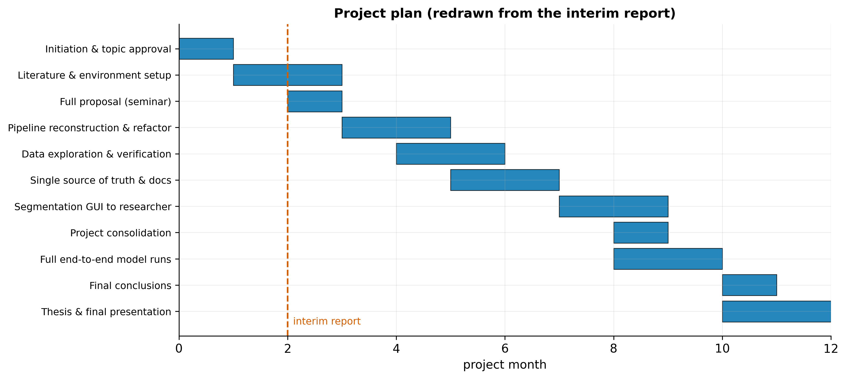
Figure 22. Planned project schedule redrawn from the interim report's work plan; the dashed line marks the interim-report milestone.

A.3 The graphical segmentation tool
The USV Segmentation application (v1.0.2; Zenodo doi:10.5281/zenodo.20096810 [20]) wraps the segmentation and typing algorithms behind a simple interface: the user selects a data folder and an output folder, chooses which recording years to process, runs the pipeline, and inspects the results. It runs the same algorithms as the Python pipeline and produces the canonical segmentation file that all model training consumes. It was the vehicle for the parallel data-curation work by the biology researcher, including the review that surfaced the genotype-labelling error.

A.4 Supplementary results
The complete set of runs (74 model runs, including the threshold and per-objective variants and the full A–H sequence-model lever sweep) is provided in machine-readable form in thesis/master_results.csv. The threshold-objective comparison summarised for TabPFN in Figure 17 is available in full in the project's threshold_objectives/summary_objectives.csv. The five-fold cross-validation per-fold values underlying the deflation result in Figure 16 are recorded in the corresponding sequence-model run reports.

A.5 Traceability and gaps
A traceability table mapping each key claim, figure, and number to its source artifact is provided as thesis/traceability.md. Open items and known gaps are listed in thesis/GAPS.md; the most important are the unresolved strain-label change between the 2018 and 2022 cohorts, the absence of a per-subject (per-mouse) aggregated metric, the unvalidated segmentation detector and un-carded typing CNN, and the recommendation to add richer per-call acoustic features. None of these affects the integrity of the reported numbers, which are all sourced from the result reports.

Traceability table
Maps each key claim, figure, and headline number to its source artifact. All metrics are sourced from result reports / data files; git history is used only for the process chronology, never for numbers.

Headline numbers
Claim | Value | Source
Best honest model (TabPFN, independent) accuracy | 0.729 | results/tabular_models/tabpfn_subject_eval_independent_baseline/comparison_vs_baseline.txt
TabPFN independent weighted F1 | 0.743 | results/tabular_models/tabpfn_subject_eval_independent_baseline/comparison_vs_baseline.txt
TabPFN independent ROC-AUC | 0.783 | results/tabular_models/threshold/tabpfn_subject_eval_independent_baseline/threshold_metrics.json
TabPFN dependent accuracy | 0.781 | results/tabular_models/tabpfn_subject_eval_dependent_baseline/comparison_vs_baseline.txt
Corrected XGBoost dependent baseline accuracy | 0.733 | results/tabular_models/xgboost_subject_eval_dependent_baseline/comparison_vs_baseline.txt
XGBoost independent accuracy | 0.693 | results/tabular_models/xgboost_subject_eval_independent_baseline/comparison_vs_baseline.txt
Legacy reported baseline (subject-dependent) | 0.829 | results/tabular_models/xgboost_subject_eval_dependent_baseline/comparison_vs_baseline.txt (baseline column)
Raw corpus syllables | 125,576 | outputs/external/input/segmentation_classification_all_data.csv
Pups / dams | 126 / 35 | outputs/external/input/segmentation_classification_all_data.csv
Baseline recordings | 12,323 | outputs/external/aggregated/tabular/all_data_external_baseline_labeled.csv
Recording-level class balance (WT/HT) | 9,283 / 3,040 | outputs/external/aggregated/tabular/all_data_external_baseline_labeled.csv
Genotype correction scope | 14 mice / 2,495 rows | docs/BASELINE_DATA_MANIFEST.md; docs/segmentation_process.md
BiLSTM independent 5-fold balanced acc | 0.563 ± 0.063 | results/neural_networks/experiments/H_cv_Dsampler__bilstm__independent/results.json
strain1 independent accuracy (XGBoost) | 0.903 | results/tabular_models/strain/xgboost_strain1_subject_eval_independent_baseline/comparison_vs_baseline.txt

Figures
Figure | Title | Data source(s)
F1 | End-to-end USV-to-decision pipeline | docs/segmentation_process.md; docs/preprocessing_pipeline.md; docs/model_development_and_experiments.md; thesis/data_composition.json
F2 | Data provenance & single source of truth | README.md; docs/BASELINE_DATA_MANIFEST.md; docs/segmentation_process.md; outputs/external/input/README.md
F3 | Experimental-design matrix | thesis/master_results.json
F4 | Model taxonomy — inherited vs new | thesis/master_results.json; docs/model_development_and_experiments.md
F5 | Dataset composition (small multiples) | thesis/data_composition.json; outputs/external/input/segmentation_classification_all_data.csv
F6 | Class balance and syllables-per-subject | thesis/data_composition.json; outputs/external/input/segmentation_classification_all_data.csv
F7 | Syllable-type distribution | thesis/data_composition.json; docs/segmentation_process.md
F8 | Acoustic-feature distributions by genotype | outputs/external/input/segmentation_classification_all_data.csv; hit/research/Shekel et al_2021 (3).pdf
F9 | Master performance — dependent vs independent | thesis/master_results.json
F10 | Generalization gap (HT recall & precision) | thesis/master_results.json
F11 | ROC curves (headline tabular models) | results/tabular_models/threshold/tabpfn_subject_eval_dependent_baseline/probabilities_test.csv; results/tabular_models/threshold/tabpfn_subject_eval_independent_baseline/probabilities_test.csv; results/tabular_models/threshold/xgboost_subject_eval_dependent_baseline/probabilities_test.csv; results/tabular_models/threshold/xgboost_subject_eval_independent_baseline/probabilities_test.csv; results/tabular_models/threshold/xgboost_tuned_dependent_subject_eval_dependent_baseline/probabilities_test.csv; results/tabular_models/threshold/xgboost_tuned_independent_subject_eval_independent_baseline/probabilities_test.csv
F12 | Precision–Recall curves (HT class) | results/tabular_models/threshold/tabpfn_subject_eval_dependent_baseline/probabilities_test.csv; results/tabular_models/threshold/tabpfn_subject_eval_independent_baseline/probabilities_test.csv; results/tabular_models/threshold/xgboost_subject_eval_dependent_baseline/probabilities_test.csv; results/tabular_models/threshold/xgboost_subject_eval_independent_baseline/probabilities_test.csv; results/tabular_models/threshold/xgboost_tuned_dependent_subject_eval_dependent_baseline/probabilities_test.csv; results/tabular_models/threshold/xgboost_tuned_independent_subject_eval_independent_baseline/probabilities_test.csv
F13 | Confusion matrices (headline models) | results/tabular_models/threshold/tabpfn_subject_eval_dependent_baseline/probabilities_test.csv; results/tabular_models/threshold/tabpfn_subject_eval_independent_baseline/probabilities_test.csv; results/tabular_models/threshold/xgboost_subject_eval_dependent_baseline/probabilities_test.csv
F14 | Feature importance (XGBoost) | results/tabular_models/xgboost_subject_eval_dependent_baseline/model/xgboost_model.pkl; results/tabular_models/xgboost_subject_eval_independent_baseline/model/xgboost_model.pkl
F15 | Per-strain comparison | thesis/master_results.json
F16 | HT-precision wall | thesis/master_results.json
F17 | Threshold-objective operating points | results/tabular_models/threshold_objectives/summary_objectives.csv
F18 | Sequence-model lever sweep and CV deflation | results/neural_networks/experiments/_summary/master_metrics.csv; results/neural_networks/experiments/H_cv_Dsampler__bilstm__independent/results.json; results/neural_networks/experiments/H_cv_Dsampler__bilstm__dependent/results.json
F19 | Annotated segmentation example | outputs/external/input/segmentation_classification_all_data.csv; docs/segmentation_process.md
F20 | Project timeline / Gantt (interim plan) | hit/project/Project+Midterm+-+Chen+Aharon+%26+Aviel+Bitton.pdf
F21 | Commit-derived work timeline | local git log (chronology only)
F4b | Reported-vs-corrected baseline | results/tabular_models/xgboost_subject_eval_dependent_baseline/comparison_vs_baseline.txt; results/tabular_models/xgboost_subject_eval_independent_baseline/comparison_vs_baseline.txt; results/tabular_models/tabpfn_subject_eval_independent_baseline/README.md

