**תרגיל 1**

EX1DS SEGMENT

LEN EQU 40

ARR DB 'Welcome to jamaica and have a nice day !'

EX1DS ENDS

sseg segment stack

dw 100h dup**(?)**

sseg ends

cseg segment

assume **ds:**ex1ds**,cs:**cseg**,ss:**sseg

check proc

;check that character is litter

**cmp** **al,**'a'

**jb** L1

**cmp** **al,**'w'

**ja** L1

**sub** **al,**20h ;set to upper case

L1**:** **ret**

check endp

start**:** **mov** **ax,**ex1ds

**mov** **ds,ax**

;initialisation

**mov** **cx,**LEN

**dec** **cx**

**mov** **si,**0

**mov** **al,**arr**[si]**

**call** check ;check first character in string

**mov** arr**[si],al**

;promotion of the array and call of procedure

L3**:** **inc** **si**

**mov** **al,**arr**[si]**

**cmp** **al,**' ' ;check that character is space

**jne** L2

**mov** **al,**arr**[si+**1**]** ;set first character in word

**call** check

**mov** arr**[si+**1**],al**

L2**:** **loop** L3

**mov** **ah,**4ch

**int** 21h

cseg ends

end start

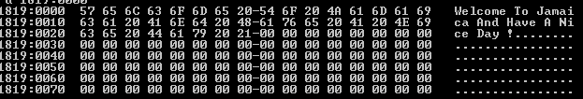

**תרגיל 2 (מה"ט 2012)**

EX2DS SEGMENT

A DB '1ab'**,**'2bb'**,**'1ba'**,**'1b2'**,**'1ba'

B DB '1ba'

NA DB 5

NB EQU 3

**C** DB 0

EX2DS ENDS

sseg segment stack

dw 100h dup**(?)**

sseg ends

cseg segment

assume **ds:**ex2ds**,cs:**cseg**,ss:**sseg

count proc

;initialisation

**mov** **bx,**NB

**dec** **bx**

;check of characters

L1**:** **mov** **al,**A**[si+bx]**

**cmp** **al,**B**[bx]** ;check of character from A with character from B

**jne** L2

**dec** **bx**

**jnz** L1

**inc** **C**

L2**:** **ret**

count endp

start**:** **mov** **ax,**ex2ds

**mov** **ds,ax**

;initialisation

**mov** **si,**0

**mov** **cx,**0

**mov** **cl,**NA

;promotion of the array and call of procedure

L3**:** **call** count

**add** **si,**NB

**loop** L3

SOF**:** **mov** **ah,**4ch

**int** 21h

cseg ends

end start

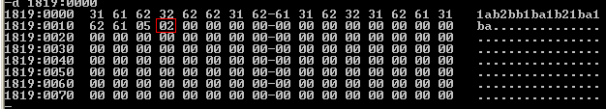

**תרגיל 3 (מה"ט 2001)**

EX3DS SEGMENT

A DB 4**,**3**,**2**,**0

DB 1**,**0**,**5**,**7

DB 6**,**1**,**7**,**2

DB 8**,**9**,**0**,**9

N EQU 4

M DB 1

EX3DS ENDS

sseg segment stack

dw 100h dup**(?)**

sseg ends

cseg segment

assume **ds:**ex3ds**,cs:**cseg**,ss:**sseg

sum proc

;initialisation

**mov** **bx,**N

**mov** **al,**0

;sum of row

L1**:** **add** **al,**A**[si]**

**inc** **si**

**dec** **bx**

**jnz** L1

**ret**

sum endp

start**:** **mov** **ax,**ex3ds

**mov** **ds,ax**

;initialisation

**mov** **si,**0

**mov** **cx,**N

**mov** **ax,**0

**mov** **dx,**0

;sum of first row

**call** sum

**dec** **cx**

**jz** SOF

;promotion of the array,call of procedure and check that matrix is grow

L2**:** **mov** **dx,ax**

**call** sum

**cmp** **dx,ax** ;that matrix is grow

**jb** L3

**mov** M**,**0

**jmp** SOF

L3**:** **loop** L2

SOF**:** **mov** **ah,**4ch

**int** 21h

cseg ends

end start

