**תרגיל 1**

EX1DS SEGMENT

N EQU 7 ;כמות הנתונים

MAX DB N DUP**(?)** ;max array

ARR1 DB **-**1**,**3**,**1011b**,**0FAh**,**9**,**77o**,**0Dh ;first array

ARR2 DB 12**,**0**,-**5**,**27**,-**4**,**8**,**1b ;second array

EX1DS ENDS

sseg segment stack

dw 100h dup**(?)**

sseg ends

cseg segment

assume **ds:**EX1DS**,cs:**cseg**,ss:**sseg

start**:** **mov** **ax,**EX1DS

**mov** **ds,ax**

;initialisation

**mov** **ax,**0

**mov** **cx,**0

**mov** **cl,**N

**mov** **si,**0

;check that number from first array bigger than number from second array

L1**:** **mov** **al,**ARR1**[si]**

**cmp** **al,**ARR2**[si]**

**jl** L2

;number from first array set to max array

**mov** MAX**[si],al**

**inc** **si**

**loop** L1

**jmp** SOF

;number from second array set to max array

L2**:** **mov** **al,**ARR2**[si]**

**mov** MAX**[si],al**

**inc** **si**

**loop** L1

SOF**:** **mov** **ah,**4ch

**int** 21h

cseg ends

end start

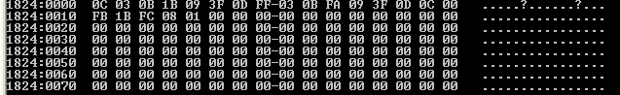

**תרגיל 2**

EX2DS SEGMENT

N EQU 3 ;size of matrix (NxN)

OK DB 0 ;every part of the diagonal of the matrix larger than its predecessors-1,otherwise-0

MATRIX DB **-**1**,**1**,**1**,**2**,**0**,**2**,**3**,-**3**,**3 ;matrix NxN

EX2DS ENDS

sseg segment stack

dw 100h dup**(?)**

sseg ends

cseg segment

assume **ds:**EX2DS**,cs:**cseg**,ss:**sseg

start**:** **mov** **ax,**EX2DS

**mov** **ds,ax**

;initialisation

**mov** **ax,**0

**mov** **cx,**0

**mov** **cl,**N

**dec** **cx**

**mov** **bx,**0

**mov** **bl,**N

**inc** **bx**

**mov** **si,**0

;check numbers in the diagonal

L1**:** **mov** **al,**MATRIX**[si]**

**cmp** **al,**MATRIX**[si+bx]**

**jge** SOF

**add** **si,bx**

**loop** L1

;end of check

**mov** OK**,**1

SOF**:** **mov** **ah,**4ch

**int** 21h

cseg ends

end start

OK=1

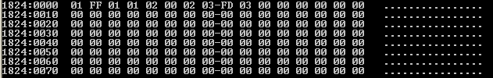

OK=0

