**תרגיל 1**

EX1DS SEGMENT

N EQU 7

COUNT DB 0

ARR DW **-**1**,**3**,-**200**,**4**,**9**,-**77**,-**125

EX1DS ENDS

sseg segment stack

dw 100h dup**(?)**

sseg ends

cseg segment

assume **ds:**EX1DS**,cs:**cseg**,ss:**sseg

start**:** **mov** **ax,**EX1DS

**mov** **ds,ax**

;initialisation

**mov** **si,**0

**mov** **bx,**N

;number for check

L3**:** **mov** **ax,**ARR**[si]**

**mov** **cx,**N

;check bit at number

L2**:** **shl** **ax,**1

**jnc** L1

**loop** L2

**inc** COUNT

;promotion of the array

L1**:** **add** **si,**2

**dec** **bx**

**jnz** L3

SOF**:** **mov** **ah,**4ch

**int** 21h

cseg ends

end start

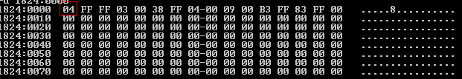

**תרגיל 2**

EX2DS SEGMENT

is2pow DB **?** ; 1- is pow, 0-is not pow

NUM DW 8192

EX2DS ENDS

sseg segment stack

dw 100h dup**(?)**

sseg ends

cseg segment

assume **ds:**EX2DS**,cs:**cseg**,ss:**sseg

start**:** **mov** **ax,**EX2DS

**mov** **ds,ax**

;initialisation

**mov** **si,**0

**mov** is2pow**,**0

**mov** **cx,**15

**mov** **ax,**NUM

;check bit number

L2**:** **shl** **ax,**1

**jc** L1

**loop** L2

;check that number is pow of 2

L1**:** **cmp** **ax,**0

**jnz** SOF

**mov** is2pow**,**1

SOF**:** **mov** **ah,**4ch

**int** 21h

cseg ends

end start

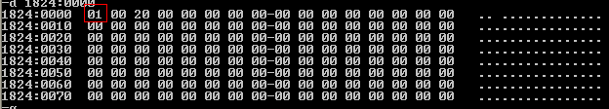

**תרגיל 3**

EX3DS SEGMENT

A DW 1ABCh

B DW 0

EX3DS ENDS

sseg segment stack

dw 100h dup**(?)**

sseg ends

cseg segment

assume **ds:**EX3DS**,cs:**cseg**,ss:**sseg

start**:** **mov** **ax,**EX3DS

**mov** **ds,ax**

**mov** **cl,**4

**mov** **ah,byte** ptr A

**ror** **ah,cl**

**mov** **al,byte** ptr a**+**1

**ror** **al,cl**

**mov** b**,ax**

SOF**:** **mov** **ah,**4ch

**int** 21h

cseg ends

end start

א) CBA1

ב)CBA1