Name: K Avinash Reddy
Reg no: 192312463

EXPERIMENT 1
Simulation-Based Analysis of N-Well CMOS Fabrication Techniques Using Cadence Design Environment

Circuit diagram:
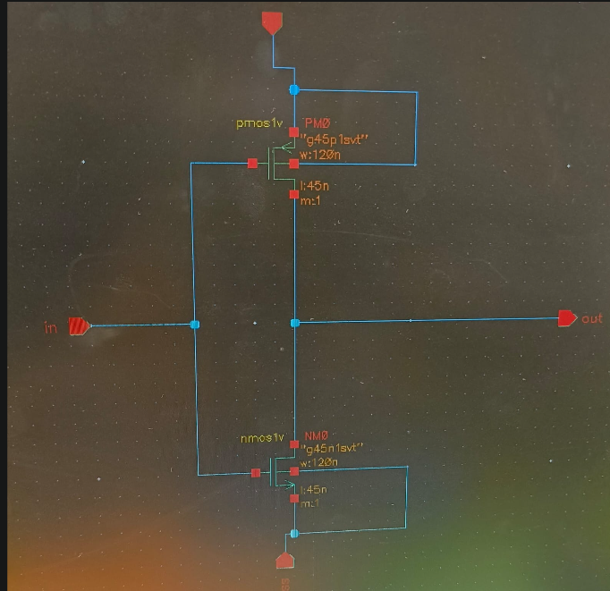

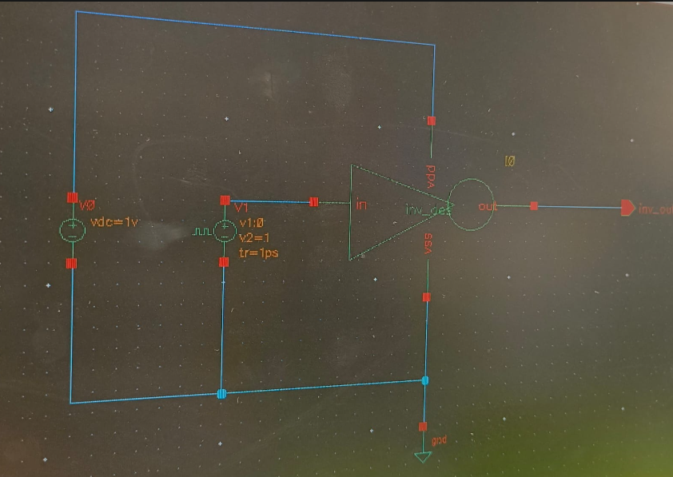

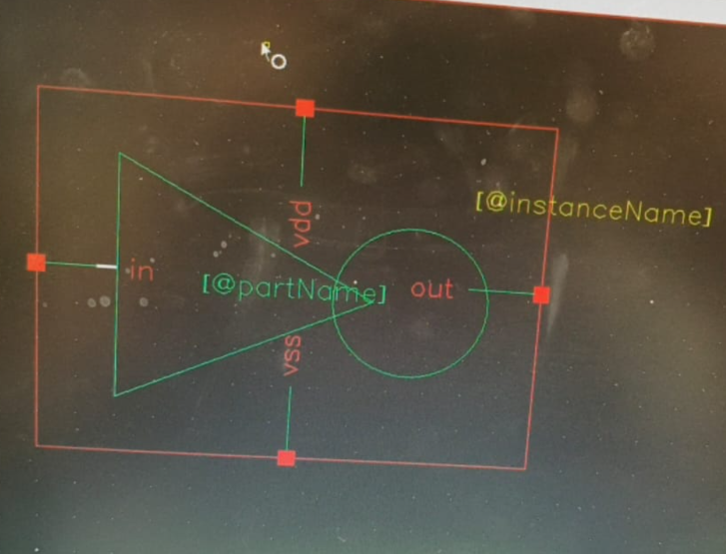

Output Parameter Table:
S.No. | Output Parameter | Theoretical / Expected Value | Practical / Simulated Value | % Deviation
1 | Fabrication sequence | Standard CMOS process flow | Standard CMOS fabrication sequence observed | 0% deviation
2 | Gate length | 180 nm | 180 nm | 0% deviation
3 | Gate oxide thickness | 4 nm | 4 nm | 0% deviation
4 | Source/Drain formation | Properly defined regions | Source and drain regions properly formed | 0% deviation
5 | Layer structure | Correct CMOS layers | Substrate, gate oxide, gate, source/drain and metal interconnect layers identified | 0% deviation
6 | Device dimensions | As per design | Record simulated device dimensions from Cadence | 0% deviation

Output:

