**2.TIMALIIDAE**

**2.1 OLD WORLD BABBLER**

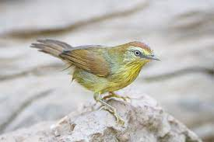

The Old World babblers or Timaliidae are a family of mostly Old World passerine birds. They are rather diverse in size and coloration, but are characterised by soft fluffy plumage. These are birds of tropical areas, with the greatest variety in Southeast Asia and the Indian subcontinent. The timaliids are one of two unrelated groups of birds known as babblers, the other being the Australasian babblers of the family Pomatostomidae also known as pseudo-babblers. Morphological diversity is rather high; most species resemble "warblers", jays or thrushes. This group is among those Old World bird families with the highest number of species still being discovered.

**CHARACTERISTICS**

Timaliids are small to medium birds. They have strong legs, and many are quite terrestrial. They typically have generalised bills, similar to those of a thrush or warbler, except for the scimitar babblers which, as their name implies, have strongly decurved bills. Most have predominantly brown plumage, with minimal difference between the sexes, but many more brightly coloured species also exist.

This group is not strongly migratory, and most species have short rounded wings, and a weak flight. They live in lightly wooded or scrubland environments, ranging from swamp to near-desert.

They are primarily insectivorous, although many will also take berries, and the larger species will even eat small lizards and other vertebrates.

Typical babblers live in communities of around a dozen birds, jointly defending a territory. Many even breed communally, with a dominant pair building a nest, and the remainder helping to defend and rear their young.

Young males remain with the group, while females move away to find a new group, and thus avoid inbreeding. They make nests from twigs, and hide them in dense vegetation.

**2.3 TURDOIDES**

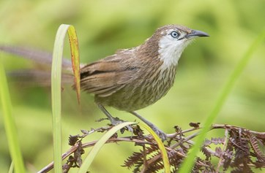

Turdoides is a genus of passerine birds in the laughingthrush family Leiothrichidae. The species are distributed across Africa and southern Asia and are typically fairly large, long-tailed birds which forage in noisy groups. The majority of species have drab brown or grey-brown plumage.

The genus contains the following species:

* [Brown babbler](https://en.wikipedia.org/wiki/Brown_babbler), *Turdoides plebejus*
* [Bare-cheeked babbler](https://en.wikipedia.org/wiki/Bare-cheeked_babbler), *Turdoides gymnogenys*
* [Arrow-marked babbler](https://en.wikipedia.org/wiki/Arrow-marked_babbler), *Turdoides jardineii*
* [Scaly babbler](https://en.wikipedia.org/wiki/Scaly_babbler), *Turdoides squamulata*
* [White-rumped babbler](https://en.wikipedia.org/wiki/White-rumped_babbler), *Turdoides leucopygia*
* [White-headed babbler](https://en.wikipedia.org/wiki/White-headed_babbler), *Turdoides leucocephala*
* [Blackcap babbler](https://en.wikipedia.org/wiki/Blackcap_babbler), *Turdoides reinwardtii*
* [Dusky babbler](https://en.wikipedia.org/wiki/Dusky_babbler), *Turdoides tenebrosa*
* [Southern pied babbler](https://en.wikipedia.org/wiki/Southern_pied_babbler" \o "), *Turdoides bicolor*
* [Northern pied babbler](https://en.wikipedia.org/wiki/Northern_pied_babbler" \o "Northern pied babbler), *Turdoides hypoleuca*
* [Black-lored babbler](https://en.wikipedia.org/wiki/Black-lored_babbler), *Turdoides sharpie*
* [Black-faced babbler](https://en.wikipedia.org/wiki/Black-faced_babbler), *Turdoides melanops*
* [Hartlaub's babbler](https://en.wikipedia.org/wiki/Hartlaub%27s_babbler), *Turdoides hartlaubii*
* [Hinde's babbler](https://en.wikipedia.org/wiki/Hinde%27s_babbler), *Turdoides hindei*
* [Spiny babbler](https://en.wikipedia.org/wiki/Spiny_babbler), *Turdoides nipalen*