Nepal is exceptionally rich for avian fauna with a total of 871 species recorded in just

about 200 years of modern ornithological research.

Nepal is exceptionally rich for avian fauna with a total of 871 species recorded in just

about 200 years of modern ornithological research.

Nepal is exceptionally rich for avian fauna with a total of 871 species recorded in just

about 200 years of modern ornithological research

**A CASE STUDY ON**

**SPINY BABBLER IN NEPAL** 

A Report Submitted to the

**Department of Microbiology,**

**St. Xavier’s College, Tribhuvan University**

Kathmandu, Nepal

**Submitted By:**

**Anisha Baskota**

T.U. Reg.No: 5-2-282-8-2018

Exam Roll no: 502820007 2021

© St. Xavier’s College

# RECOMMENDATION

It has been recommended that Anisha Baskota has completed her report entitled

  “**A Case Study on Spiny Blabber in Nepal**” under my guidance and supervision.

I hereby recommend this report for further approval.

…………..……….

Mr. Sundar Baral

Lecturer,

St. Xavier’s College,

Date: Maitighar, Kathmandu

# CERTIFICATE OF COMPLETION

This is to certify that Anisha Baskota, student of B.Sc. Microbiology of St. Xavier’s College, Kathmandu has completed report entitled “**A Case Study on Spiny Babbler in Nepal**” under our supervision.

I highly approve and recommend her work.

…..…………………

Ms. Pramila Parajuli

Head of Department,

Department of Microbiology,

St. Xavier’s College,

Date: Maitighar, Kathmandu

# ACKNOWLEDGEMENT

First of all, I would like to express my sincere gratitude to St. Xavier’s College and the Department of Microbiology for creating such a wonderful environment of learning and providing us the opportunity to perform this report.

I am feeling obliged to take the opportunity to sincerely thanks to my supervisor, lecturer, Mr. Sundar Baral for his continuous support and guidance during the period of study and research. He has time and again directed me towards my destination. Right from the start to completion of the report, he has relentlessly continued to help me improve in my performance. My very special thanks to Ms. Pramila Parajuli, Head of Department, Department of Microbiology, for her unparalleled suggestions and persistent support.

Last but not the least, I am thankful to my friends without whom, completion of the report would not have been possible. And I would also like to thank my parents and all of my teachers who have always been helping and encouraging me throughout. I have no valuable words to express my thanks, but my heart is still full of favors received from every person.

………………………..

Date: Anisha Baskota

# ABSTRACT

Nepal’s diverse topography, altitude variation, different ecosystems and changing climatic conditions host a large variety of faunal elements including birds, mammals, reptiles and amphibians. The spiny babbler is on the endangered list, and lives at 1,500-2,135m elevation in summer and at 500-1,830m in winter. It normally stays in thick bush, away from farmlands. According to The Status of Nepal’s Birds: The National Red List Series Volume VI, spiny babblers have been found all over Nepal, from Taplejung in the east to Baitadi in the west. They are frequently seen around Khaptad National Park and in Pokhara after the spread of community forestry. In an article titled Notes on the Spiny Babbler, Acanthoptila Nipalensis (Hodgson) in Kathmandu Valley, published in Journal of Bombay Natural History, D Proud mentions that the spiny babbler was found abundantly in Kathmandu Valley until 1950. Due to rapid urbanisation, that is no longer the case. They sing a variety of rather loud & melodic songs from their hideouts amongst thick bushes, which resounds across the hills nearby - waking you up the possibility of seeing them. However, the amount of activity seems quite subdued in winter. The Spiny Babbler, found only in Nepal, has fascinated ornithologists and bird lovers from around the world.

**Table of Contents**

**RECOMMENDATION 1**

**CERTIFICATE OF COMPLETION 2**

**ACKNOWLEDGEMENT 3**

**ABSTRACT 4**

**1. INTRODUCTION AND FASCINATING HISTORY 6**

**1.1 DISCOVERING THE SPINNY BLABBER 7**

**1.2 THE SPINNY BLABBER TODAY 8**

**1.3 CLASSIFICATION 8**

**2.TIMALIIDAE 8**

**2.1 OLD WORLD BABBLER 8**

**2.2 CHARACTERISTICS 9**

**2.3 TURDOIDES 9**

**3. External morphology 10**

**3.1 Measurements 11**

**3.2 PLUMAGE 11**

**3.3 FEET 13**

**3.4 BEAK 13**

**4. MIGRATION AND SONGS 13**

**5. DIET 14**

**6. BREEDING 14**

**7. DISTRIBUTION OF SPINY BABBLER 14**

# 1. INTRODUCTION AND FASCINATING HISTORY

Although more than 800 bird species are found in Nepal, the [Spiny Babbler](https://en.wikipedia.org/wiki/Spiny_babbler) (Turdoides nipalensis) is the only bird that is endemic to the country. The greyish-brown bird, called Kande Bhyakur in Nepali, lives in dense scrub and can be spotted more easily at elevations ranging from 500 meters to 2135 meters. Although the Spiny Babbler has been fascinating ornithologists the world around for years, environmental degradation is threatening this unique, much-loved bird. The bird is only found in Nepal; it is specifically seen around Kathmandu-valley, mostly around Godawari- Phulchowki region. Spiny Babbler belongs to Leiothrichidae family of the birds. Spiny babbler is a big brown-coloured bird with pointed beak and is shy in nature.

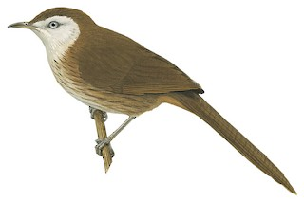

Talking about its size, Spiny Babbler is 28cm in length and is around 65 to 90 grams in weight. Likewise, they nurture on the grounds or lower scrub and they mostly aim for insects like grasshopper, butterflies, bugs, caterpillars, wasps and other various insects as their food. In addition, Earthworm also acts as a vital source of energy for them. Not only that they also consume berries, fruits, nectar and seeds. Once we enter any forest of Nepal, the feel of being around the natural enigma of the mystical world of birds and their songs in solitude really calms our heart. The soothing tone of Spiny babbler can be listened around the subtropical and the tropical lands of Nepal only as they are diffused around the trees at the height of 0.9 km. – 2.1 km. Apart from this, Kande Bhyakur breeds annually during April-June. Its nest is wide and deep shaped like a cup and is made up of grasses which is attached to the fork of trees.

## 1.1 DISCOVERING THE SPINNY BLABBER

Ripley hunted bird’s day after day. Ornithology involves not only watching, but also collecting birds by net or small bore shotgun, then preparing them as museum specimens. Late one afternoon, while walking stealthily downhill through the bush, he heard a series of low chuckles and “querr” noises. “I stopped short,” he writes. “There must be a flock of laughing thrushes or babblers about,” he thought, “the sort of birds that go around in small family parties, constantly talking to each other.”

“After waiting carefully, stock-still for several moments, I saw a group of birds hopping about, half on, and half off the ground, at the base of the big bush. They were dark and bulky-looking, as big as a big thrush, and they flicked and flirted their tails as they hopped about, in the characteristic manner of the noisy nervous babblers or laughing thrushes.”

He shot at them, then – “The flock dispersed, evaporated rather, as I rushed forward. A few moments of searching and I found my prize. It was a brownish bird the size of an American robin or an English blackbird. The throat and upper breast were white, the rest streaked brown. The feathers of the upper side, particularly the forehead and crown, had stiff wiry shafts as did those of the throat. As this bird lay in my palm, I could think of no species of laughing thrush known to me which it remotely resembled.”

It was late, so Ripley returned to camp and that evening his staff prepared it as a museum specimen. The next morning Ripley pondered the strange bird’s identity. “Holding my prize and thinking about it,” he writes, “I began to turn over all the Indian species in my mind. What could this bird be? In the field a problem like this was not an easy one when books were not ready to hand, when there were several hundreds of species to choose from. Finally, the stiff wiry shafts of the feathers gave the bird away. Although it was as big as a thrush, it could only be the Spiny Babbler.” He identified it as Acanthoptila nipalensis, though it is known today as Turdoides nipalensis, the only bird exclusive to Nepal.

Ripley had never seen one, and had only a century-old description to go by. “It was a species that had defied scientists for years, since 1843 or 1844. At that time Brian Hodgson’s Nepali collectors working for him in the unknown fastness of Nepal had secured several specimens,” he writes. The Spiny Babbler “had remained a mystery ever since, one of the five species of Indian birds, which, along with the Mountain Quail, had apparently vanished from the face of the earth. But not quite, for if my guess was right, here it was hopping about large as life on the wooded slopes above Rekcha.” It was a remarkable discovery, but although Ripley spent many more days searching he never saw another Spiny Babbler.

## 1.2 THE SPINNY BLABBER TODAY

We know now that the Spiny Babbler is (according to Fleming’s book) “Fairly common; in cutover scrub at the edge of fields. Greyish-brown with some white on face and chin; streaked and pale below. Single or in small, scattered parties. Shy, escaping into tangled thickets along streams. Mounts branches of bushes or small pine trees to sing, bill pointed upward and tail down.” We also know what it sounds like – “A good mimic with squeaks, chuckles and chirps. The Spiny Babbler is “the only endemic species of bird in Nepal”. They record it northwest of Pokhara and at Tansen, as well as in the hills around the Kathmandu Valley, especially near Tokha Sanatorium at the north. It is also noted as far east as Taplejung District, and as far west as Baitadi.

## 1.3 CLASSIFICATION

Kingdom: Animalia

Phylum: Chordata

Group: Craniata

Sub Phylum: Vertebrata

Division: Gnathostomata

Superclass: Tetrapoda

Class: Aves

Sub class: Neprnithes

Super order: Carinatae

Order: Passeriformes

Family: Timaliidae

Genus: Turdoides

Species: nipalenais

# 2.TIMALIIDAE

## 2.1 OLD WORLD BABBLER

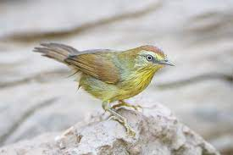

The Old-World babblers or Timaliidae are a family of mostly Old World passerine birds. They are rather diverse in size and coloration, but are characterised by soft fluffy plumage. These are birds of tropical areas, with the greatest variety in Southeast Asia and the Indian subcontinent. The timaliids are one of two unrelated groups of birds known as babblers, the other being the Australasian babblers of the family Pomatostomidae also known as pseudo-babblers. Morphological diversity is rather high; most species resemble "warblers", jays or thrushes. This group is among those Old-World bird families with the highest number of species still being discovered.

## 2.2 CHARACTERISTICS

Timaliids are small to medium birds. They have strong legs, and many are quite terrestrial. They typically have generalised bills, similar to those of a thrush or warbler, except for the scimitar babblers which, as their name implies, have strongly decurved bills. Most have predominantly brown plumage, with minimal difference between the sexes, but many more brightly coloured species also exist.

This group is not strongly migratory, and most species have short rounded wings, and a weak flight. They live in lightly wooded or scrubland environments, ranging from swamp to near-desert.

They are primarily insectivorous, although many will also take berries, and the larger species will even eat small lizards and other vertebrates.

Typical babblers live in communities of around a dozen birds, jointly defending a territory. Many even breed communally, with a dominant pair building a nest, and the remainder helping to defend and rear their young.

Young males remain with the group, while females move away to find a new group, and thus avoid inbreeding. They make nests from twigs, and hide them in dense vegetation.

## 2.3 TURDOIDES

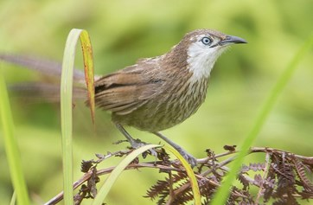

Turdoides is a genus of passerine birds in the laughingthrush family Leiothrichidae. The species are distributed across Africa and southern Asia and are typically fairly large, long-tailed birds which forage in noisy groups. The majority of species have drab brown or grey-brown plumage.

The genus contains the following species:

* [Brown babbler](https://en.wikipedia.org/wiki/Brown_babbler), *Turdoides plebejus*
* [Bare-cheeked babbler](https://en.wikipedia.org/wiki/Bare-cheeked_babbler), *Turdoides gymnogenys*
* [Arrow-marked babbler](https://en.wikipedia.org/wiki/Arrow-marked_babbler), *Turdoides jardineii*
* [Scaly babbler](https://en.wikipedia.org/wiki/Scaly_babbler), *Turdoides squamulata*
* [White-rumped babbler](https://en.wikipedia.org/wiki/White-rumped_babbler), *Turdoides leucopygia*
* [White-headed babbler](https://en.wikipedia.org/wiki/White-headed_babbler), *Turdoides leucocephala*
* [Blackcap babbler](https://en.wikipedia.org/wiki/Blackcap_babbler), *Turdoides reinwardtii*
* [Dusky babbler](https://en.wikipedia.org/wiki/Dusky_babbler), *Turdoides tenebrosa*
* [Southern pied babbler](https://en.wikipedia.org/wiki/Southern_pied_babbler), *Turdoides bicolor*
* [Northern pied babbler](https://en.wikipedia.org/wiki/Northern_pied_babbler), *Turdoides hypoleuca*
* [Black-lored babbler](https://en.wikipedia.org/wiki/Black-lored_babbler), *Turdoides sharpie*
* [Black-faced babbler](https://en.wikipedia.org/wiki/Black-faced_babbler), *Turdoides melanops*
* [Hartlaub's babbler](https://en.wikipedia.org/wiki/Hartlaub%27s_babbler), *Turdoides hartlaubii*
* [Hinde's babbler](https://en.wikipedia.org/wiki/Hinde%27s_babbler), *Turdoides hindei*
* [Spiny babbler](https://en.wikipedia.org/wiki/Spiny_babbler), *Turdoides nipalen*

# 3. External morphology

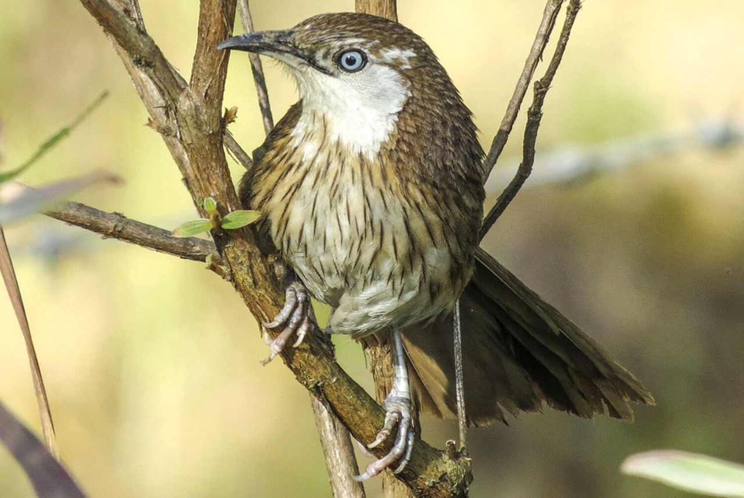

## 3.1 Measurements

* Length about 250 to 260mm
* Tail about 125 to 130
* Wings 85 to 90mm
* Tarsus about 30nm
* Cullman about 18 to 19mm

Its body is streamlined and is divisible into head, neck, trunk, and tail. Head is small and round, eyes are large, spherical and movable eyelids, pupil, rounded and nictitating membrane well developed. Jaws are modified into a beak. Teeth are absent in a beak but at the base of upper beak are two nostrils. Entire body surface except feet is covered with feathers. The feathers provide, insulation, thereby preventing the loss of heat and maintaining a constant temperature of the body. The flight muscles are well developed, which power the downward and upward motion of wings. Forelimbs are modified into wings containing flight features called remiges. Hind limbs are adapted for perching ability to rest on the trees which are supposed to be safer than ground. Each leg has four movable toe, three toes forward and one toe backwardly directed. A cloacal aperture is present between trunk and tail. Sexes separate. Female has only one functional ovary (egg). It reduces its weight.

## 3.2 PLUMAGE

The whole upper plumage, tail and visible portions of the wings are rich olive brown in color. The feathers of the head and back are provided with stiff, black shaft. Tail is cross-rayed darker. Lore’s and the feather behind and below the eyes are whitish. The ear-coverts are brown, mixed with white. The lower plumage is rufescent. Each feather is dark brown shaft-stripe, these increasing in size on the breast and abdomen. The undertail coverts and flanks are plain rufescent brown.

The colors of soft part-bill dusky horn; legs fleshy brown, Irish smoky brown. In summer the lore’s, the feather around the eye, the ear coverts, cheek, chin and the throat become white. The shaft of the throat feathers become glistening. The lower plumage becomes whiter, especially on the abdomen. This is known as summer plumage.

The spiny babbler has two plumages: summer plumage and winter plumage. The different specimens and studied by various ornithologist like Mandelli and Pinwill shows the bird with different plumage. On examining the Hodgson’s specimens of this bird, also one procured by Captain Pinwill and one by Mandelli, there can be little doubt that spiny babbler has a summer and winter plumage. Two specimens are in the summer plumage and one of these is moulting and acquiring some rufous feathers on the throat.

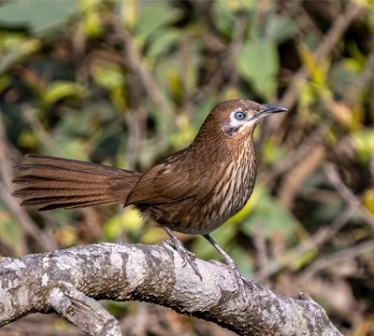

## 3.3 FEET

Their feet are typically small and have no feathers. They have three toes pointed forward and one-toe pointed backward. The toe arrangement is known as anisodactyl.

They have very little feeling in their feet because their feet have few nerves and blood vessels. This adaptation allows them to land on cold perches such as wires when the weather is frosty.

When they roost (settle down to rest), their belly feathers cover their feet to keep them warm. If the weather is especially cold, they will squat to cover their feet as they eat. They are able to keep their grip because perching birds have thin tendons called flexor tendons that extend from the leg muscles down the black of the tarsus bone and attached to the toes.

When a bird land on perch, these flexor tendons tighten, causing the toes to lock around the perch. It is an involuntary reflex. The tendon stays tight until the leg straightens. When the bird begins to stand up, it is legs straighten, causing the tendons to relax and the toes to unlock. This release the feet.

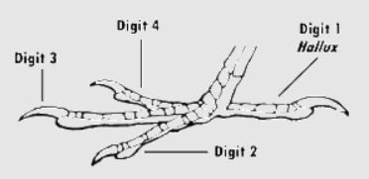

They also use their strong feet to dig out the insect from soil, perches, etc.

## 3.4 BEAK

The beak is short, peg like, stout and conical. This allows the bird to eat both insects as well as seed.

# 4. MIGRATION AND SONGS

The Spiny babbler is on the endangered list, and lives at 1,500-2,135m elevation in summer and at 500-1,830m in winter. It normally stays in thick bush, away from farmlands. According to The Status of Nepal’s Birds: The National Red List Series Volume VI, spiny babblers have been found all over Nepal, from Taplejung in the east to Baitadi in the west. They are frequently seen around Khaptad National Park and in Pokhara after the spread of community forestry.

Spiny babbler mimic other birds. Their song consist of series of alternating, quickly repeated notes, some like those of a thrush (*Turdus*),others scratchy and rather slurred, unlike songs of congeners; a phrase starts with a few fine whistles and then continues up scale, “tee-tee-ker-chee-ker-chee-ker-chee”,sometimes preceded by running thrill; many other variations; bursts of song often culminate in 3or 4 clear and loud “teer-teer-teer-teer”. A clear “el-el-el-el-ele” uttered while hopping about on ground. For contact and mild alarm a low deep musical “churrr”; female also has loud “wick-er-wick-er-wick-er”;partners occasionally burst out into wild crescendo of screaming calls similar in sound to those of *T. striata*.

# 5. DIET

They feed on the ground or among low scrub, mainly eating insects such as beetles, butterflies and caterpillars, dragonflies, bugs, wasps and other insects. Earthworms are also common in their diet. They also eat some fruits, barriers, seeds and nectars.

# 6. BREEDING

Spiny babblers breed in April-June. The nest is a deep cup made of grasses, placed in a low scrub, attached to a sturdy clump of grasses, or sometimes in a fork in a small tree. The female lays 3-4 pale blue eggs, which are incubated by both parents for 19-20 days. The chicks are fed by both parents and fledge 22-24 days after hatching, but only become fully independent 4-6 weeks later.

# 7. DISTRIBUTION OF SPINY BABBLER

Nepal has been recorded to have 867 species of birds, which rounds to be about 8% of the total bird species found worldwide. We are home to a total 35 globally threatened species around the world and 19 proximate threatened species and 15 restricted-range species.

Spiny Babbler (Scientific name: *Turdoides nipalensis* or Kande Bhyakur in Nepali) is one of the rare species of bird found in Nepal. The bird is only found in Nepal; it is specifically seen around Kathmandu-valley, mostly around Godawari- Phulchowki region. Nepal has been recorded to have 867 species of birds, which rounds to be about 8% of the total bird species found worldwide. We are home to a total 35 globally threatened species around the world and 19 proximate threatened species and 15 restricted-range species.

