PRACTICAL FILE
UI Design for Website
Course Code: 24COA1103

Student Name | __Avijot Singh_____________________________
Roll Number | __2610997010______________________________________
Class / Section | __BCA/A______________________________________
Academic Session | __2026-2029______________________________________

Department / University: ____Chitkara University__________________________________________

Practical 1: Write the basic HTML5 document structure and implement all six heading tags (<h1> to <h6>) with sample text.
Practical No. 1–2 | Subject: UI Design for Website

Aim
Create a basic HTML5 document and display all six heading levels.

HTML Code
<html>
<head>
<title>2610997010</title>
</head>

<body>
<h1>EPOCHAL</h1>
<h2> EPOCHAL </h2>
<h3> EPOCHAL </h3>
<h4> EPOCHAL </h4>
<h5> EPOCHAL </h5>
<h6> EPOCHAL </h6>
</body>
</html>

Output

Paste your output screenshot here, or describe the output.
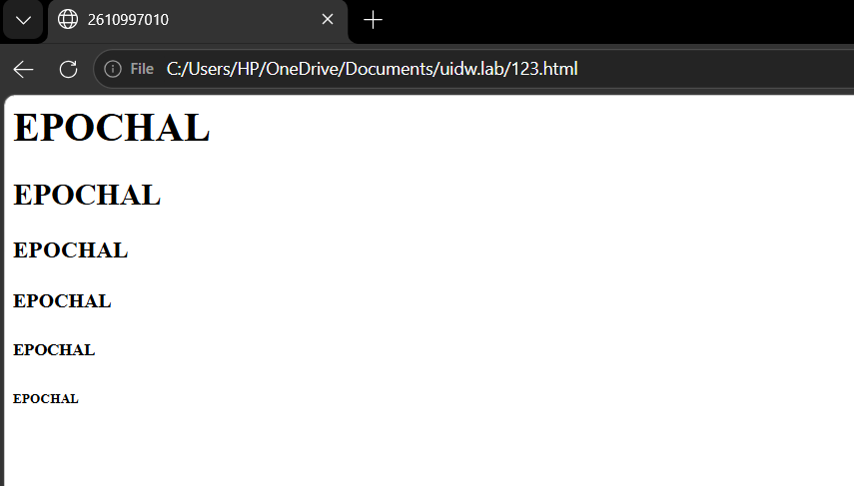

Practical 2: Create a paragraph and apply text formatting tags (<b>, <i>, <u>, <strong>, <em>) to given content.
Practical No. 3–4 | Subject: UI Design for Website

Aim
Create a paragraph and demonstrate the specified text-formatting tags.

HTML Code

Paste or type your HTML code here.
<html>
<head>

<title>2610997010</title>
</head>
<body>
<h1>HELLO</h1>
<p>
I am <b><u>bca first year-student</u></b> learning <i>html</i> and <i>css</i>.<br>
I enjoy <em>writing</em> and <em>learning</em> to <strong>design web pages.</strong>
</p>
</body>
</html>

Output
Paste your output screenshot here, or describe the output.
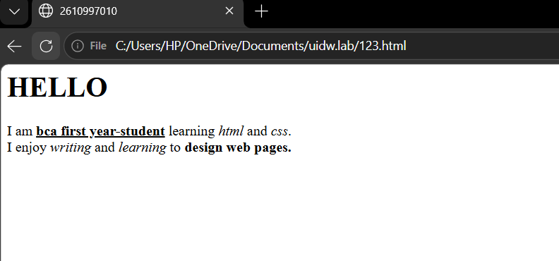

Practical 3: Create an ordered list (<ol>) for a recipe's steps and an unordered list (<ul>) for its ingredients on the same page.
Practical No. 5–6 | Subject: UI Design for Website

Aim
Display recipe ingredients in an unordered list and preparation steps in an ordered list.

HTML Code
Paste or type your HTML code here.

<html>
<head>
<title>2610997010</title>
</head>
<body>
<h2>Tea ingredients</h2>
<ul type="square">
<li>Water</li>
<li>Milk</li>
<li>tea</li>
<li>Sugar</li>
</ul>
<h2>Tea recipe</h2>
<ol type="1">
<li>Boil the water</li>
<li>Add tea and sugar</li>
<li>Boil for a few minutes</li>
<li>Serve hot</li>
</ol>
</body>
</html>

Output
Paste your output screenshot here, or describe the output.
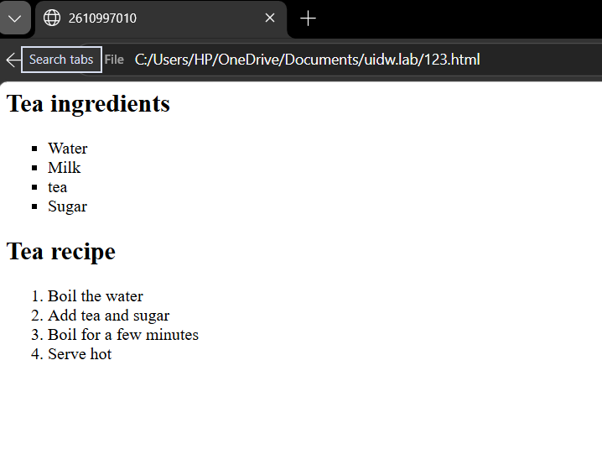

Practical 4: Build a nested list showing a book hierarchy: Category → Books → Chapters using <ul> and <ol> together.
Practical No. 7–8 | Subject: UI Design for Website

Aim
Create a nested list representing categories, books, and chapters.

HTML Code
Paste or type your HTML code here.
<html>
<head>
<title>2610997010</title>
</head>

<body>
<h1>BOOK Hierarchy</h1>
<h2>Programming</h2>
<ol type="1">
<li>C Programming</li>
<ul type="disc">
<li>Introduction</li>
<li>variable</li>
<li>Loops</li>
</ul>
<li>HTML</li>
<ul type="disc">
<li>Basic tags</li>
<li>Lists</li>
<li>Tables</li>

</ul>
</ol>
<h2>Mathematics</h2>
<ol type="1">
<li>Algebra</li>
<ul type="disc">
<li>Equation</li>
<li>Polynomials</li>
</ul>
<li>Matrices</li>
<ul type="disc">
<li>matrix operation</li>
<li>Determinants</li>
</ul>

</ol>
</body>
</html>

Output
Paste your output screenshot here, or describe the output.
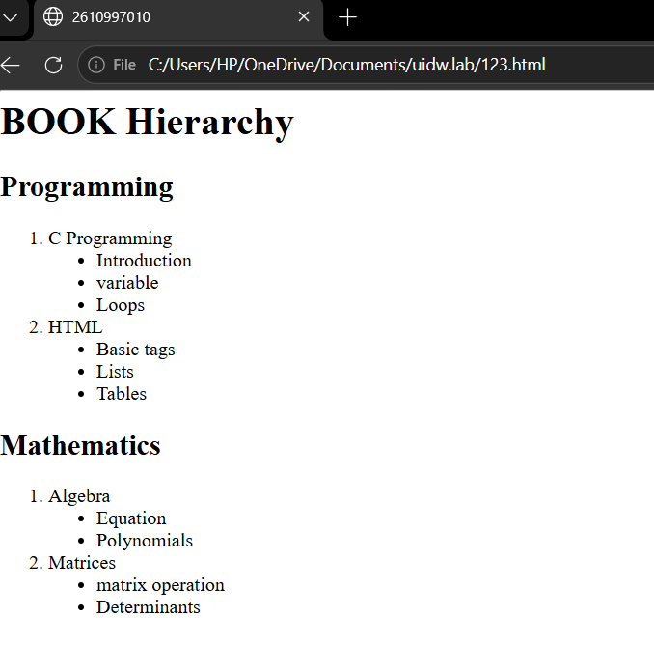

Practical 5: Insert an image using <img> and set src, alt, width, height, and title attributes with valid paths.
Practical No. 9–10 | Subject: UI Design for Website

Aim
Insert an image and demonstrate its required attributes.

HTML Code
Paste or type your HTML code here.
<html>
<head>
<title>2610997010</title>
</head>
<body>
<img src="C:\Users\HP\OneDrive\Pictures\Screenshots\Screenshot 2026-09-23 130751.png" width="550" height="650" title="College Image">
</body>
</html>

Output
Paste your output screenshot here, or describe the output.
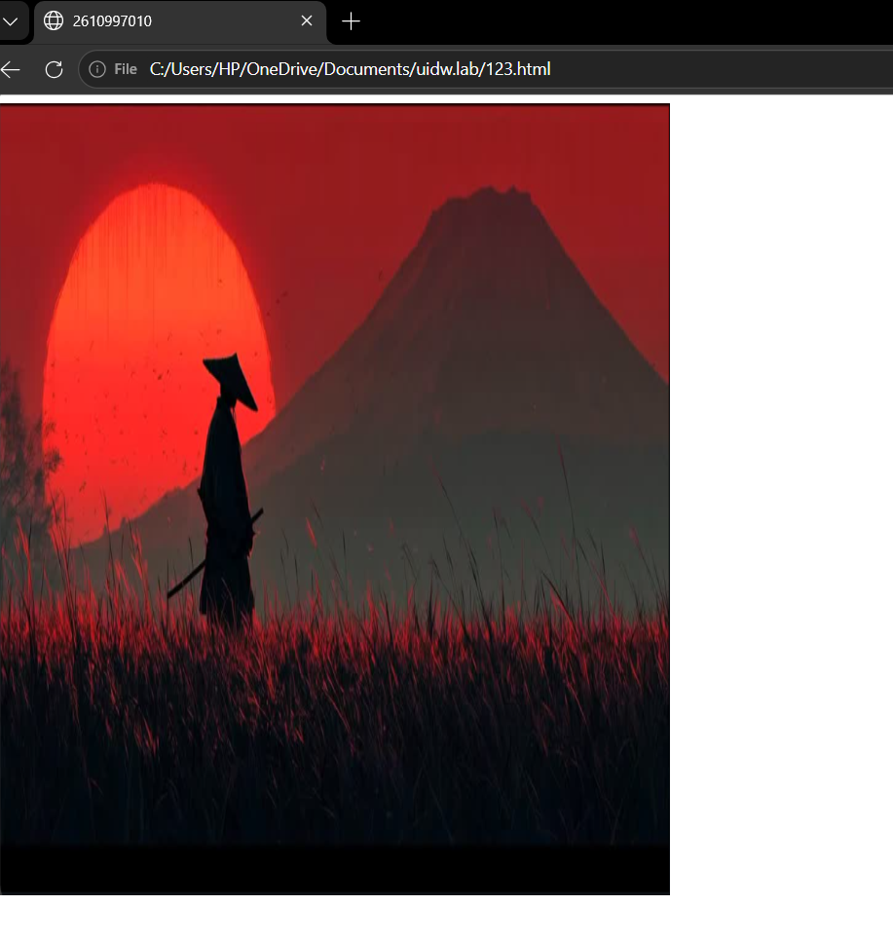

Practical 6: Set a background image for the entire webpage within the <body> tag.
Practical No. 11–12 | Subject: UI Design for Website

Aim
Apply a background image to the webpage.

HTML Code
Paste or type your HTML code here.
<html>
<head>
<title>2610997010</title>
</head>

<body background="C:\Users\HP\OneDrive\Pictures\midnight-eclipse-enigma-backiee-4K.jpg" text="white">
<h1> Where rules end</h1>
<p>Creation begins</p>
</body>
</html>

Output
Paste your output screenshot here, or describe the output.
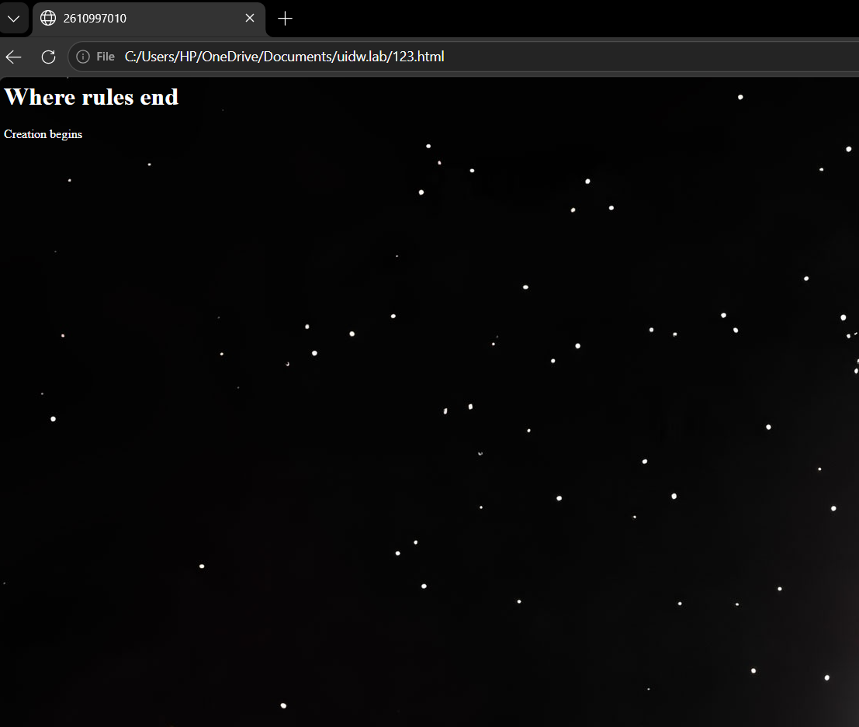

Practical 7: Create internal anchor links that jump to sections on the same page and one external link to a university website.
Practical No. 13–14 | Subject: UI Design for Website

Aim
Create working internal links and an external university link.

HTML Code
Paste or type your HTML code here.
<html>
<head>
<title>2610997010</title>
</head>

<body >
<center><h1>Websites</h1></center>
<a href="avijot.html"> another file</a><br>
<a href="https://www.chitkara.edu.in/">chitkara website</a><br>
<a href="avijot.html"><img src="C:\Users\bhavy\a"></a><br>
</body>
</html>

Output
Paste your output screenshot here, or describe the output.


Practical 8: Design an image map with clickable regions.
Practical No. 15–16 | Subject: UI Design for Website

Aim
Create an image map with clickable regions that link to different destinations.

HTML Code

Paste or type your HTML code here.

<html>
<head>
<title> 2610997010 </title>
</head>
<body>

<img src="C:\Users\HP\OneDrive\Pictures\India map.jpeg" usemap="#raptic">

<map name="raptic">

<area shape="poly" coords="416,287,417,342,434,291,440,416,404,407,370,427,348,367,304,323,372,323,308,351" href="https://en.wikipedia.org/wiki/Haryana"ss>
<area shape="poly" coords="469,251,507,242,545,258,574,277,568,303,557,321,550,360,519,354,505,344,478,323,448,325,443,288,449,252" href="https://en.wikipedia.org/wiki/Uttarakhand">
<area shape="poly" coords="270,298,306,266,301,233,327,210,346,203,366,227,391,260,404,288,392,308,373,323,355,330,314,321,279,316" href="https://en.wikipedia.org/wiki/Punjab,_India">
<area shape="poly" coords="286,82,331,82,382,69,418,37,475,69,481,101,501,163,451,175,373,153,354,192,325,192,291,171,284,149,288,117,267,98" href="https://en.wikipedia.org/wiki/Jammu_and_Kashmir_(union_territory)">
<area shape="poly" coords="348,208,358,189,373,159,402,162,430,164,449,177,469,189,481,215,483,238,457,250,443,266,445,289,416,280,392,255,369,230" href="https://en.wikipedia.org/wiki/Himachal_Pradesh">
<area shape="poly" coords="423,317,729,437,755,501,713,550,704,600,580,541,509,497,435,419" href="https://en.wikipedia.org/wiki/Uttar_Pradesh">
<area shape="poly" coords="266,317,470,472,308,669,109,534,89,471,141,437" href="https://en.wikipedia.org/wiki/Rajasthan">
<area shape="poly" coords="14,634,224,602,301,676,276,799,248,820,128,802" href="https://en.wikipedia.org/wiki/Gujarat">
<area shape="poly" coords="315,672,420,607,409,524,507,482,482,604,629,552,689,603,593,716,308,738" href="https://en.wikipedia.org/wiki/Madhya_Pradesh">
<area shape="poly" coords="730,424,852,461,928,453,893,557,737,575,771,504" href="https://en.wikipedia.org/wiki/Bihar">
<area shape="poly" coords="241,828,582,735,596,860,501,832,464,896,270,1047" href="https://en.wikipedia.org/wiki/Maharashtra">
<area shape="poly" coords="724,584,909,542,844,622,881,659,766,668" href="https://en.wikipedia.org/wiki/Jharkhand">
<area shape="poly" coords="600,870,656,646,718,601,752,676,656,910" href="https://en.wikipedia.org/wiki/Chhattisgarh">
<area shape="poly" coords="656,903,769,675,921,703,813,833,717,882" href="https://en.wikipedia.org/wiki/Odisha">
<area shape="poly" coords="470,1017,495,830,568,848,660,921" href="https://en.wikipedia.org/wiki/Telangana">
<area shape="poly" coords="307,1092,380,964,459,912,434,1081,521,1169,385,1231" href="https://en.wikipedia.org/wiki/Karnataka">
<area shape="poly" coords="448,1034,758,854,809,845,579,1156,519,1193,437,1098" href="https://en.wikipedia.org/wiki/Andhra_Pradesh">
<area shape="poly" coords="586,1143,425,1259,478,1427,598,1302" href="https://en.wikipedia.org/wiki/Tamil_Nadu">
<area shape="poly" coords="448,1408,346,1207,424,1266,466,1361" href="https://en.wikipedia.org/wiki/Kerala">
<area shape="poly" coords="1001,431,1253,340,1248,391,1160,533,1111,448,1038,477" href="https://en.wikipedia.org/wiki/Assam">
<area shape="poly" coords="925,701,845,623,940,551,988,689" href="https://en.wikipedia.org/wiki/West_Bengal">

</map>
</body>
</html>

Output
Paste your output screenshot here, or describe the output.
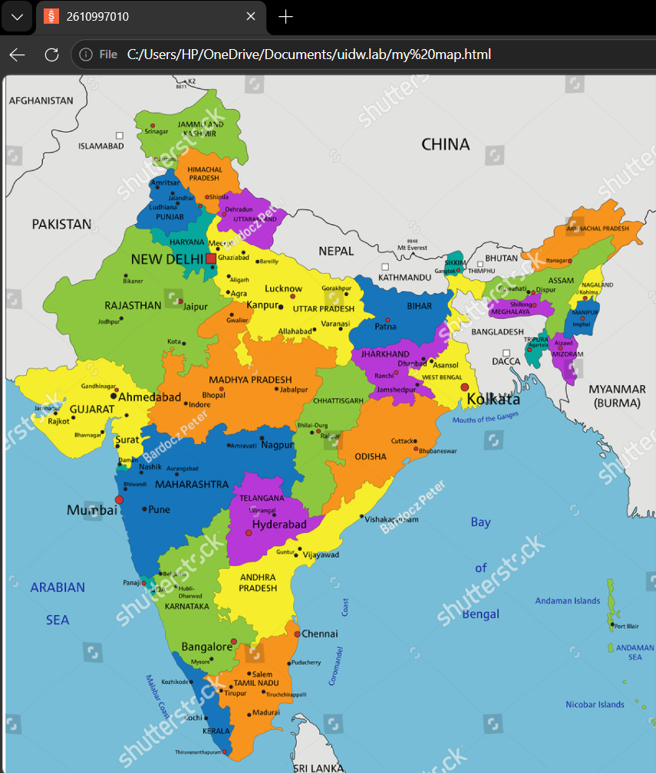

Practical 9: Build a student mark sheet table.
Practical No. 17–18 | Subject: UI Design for Website

Aim
Present student marks and results in a clear HTML table.

HTML Code

Paste or type your HTML code here.

<html>
<head>
<title>2610997010</table>
</head>
<body>
<table border="3px" height="500px" bgcolor="grey" bordercolor="black" width="1000px">
<tr bgcolor="red"><td>sr no.</td><td>name</td><td>roll number</td><td>marks</td></tr>
<tr bgcolor="white"><th bgcolor="white">1.</th><th>avijot</th><th>2610997010</th><th><table border="1px" bgcolor="yellow" bordercolor="black" height="100px" width="200px">
<tr><th>cs</th><th>20</th></tr>
<tr><th>pc</th><th>21</th><tr>
<tr><th>uidw</th><th>24</th><tr>
</table>
</tr>
<tr bgcolor="white"><th bgcolor="white">2.</th><th>bhavya</th><th>2610997014</th><th><table border="1px" bgcolor="yellow" bordercolor="black" width="200px" height="100px">
<tr><th>cs</th><th>24</th></tr>
<tr><th>pc</th><th>23</th><tr>
<tr><th>uidw</th><th>22</th><tr>
</table>
</tr>
<tr bgcolor="white"><th bgcolor="white">3.</th><th>ekamjot</th><th>2610997021</th><th><table border="1px" bgcolor="yellow" bordercolor="black" width="200px" height="100px">
<tr><th>cs</th><th>22</th></tr>
<tr><th>pc</th><th>21</th><tr>
<tr><th>uidw</th><th>22</th><tr>
</table>
</tr>
<tr bgcolor="white"><th bgcolor="white">4.</th><th>surpreet</th><th>2610997072</th><th><table border="1px" bgcolor="yellow" bordercolor="black" width="200px" height="100px">
<tr><th>cs</th><th>22</th></tr>

<tr><th>pc</th><th>20</th><tr>
<tr><th>uidw</th><th>20</th><tr>
</table>
</tr>
</table>

</body>
</html>

Output
Paste your output screenshot here, or describe the output.
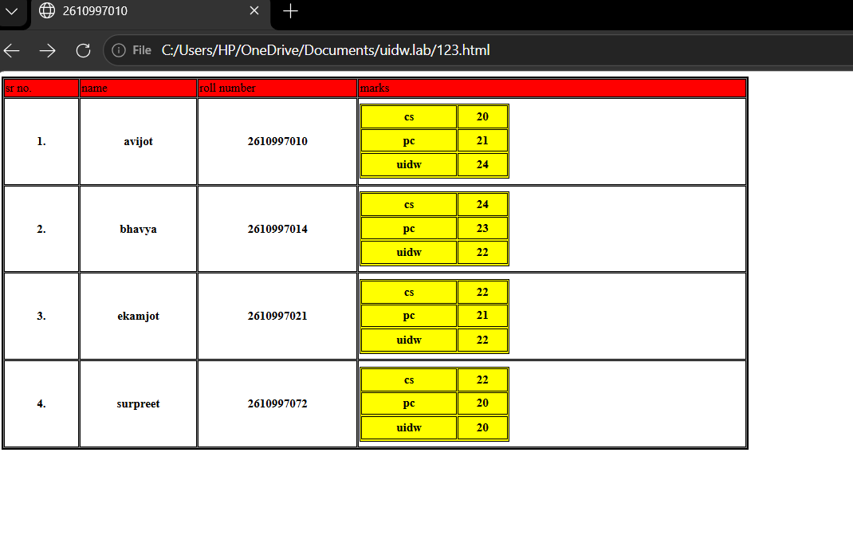

Practical 10: Create a nested timetable table.
Practical No. 19–20 | Subject: UI Design for Website

Aim
Organize a timetable using a nested HTML table structure.

HTML Code
Paste or type your HTML code here.

<html>
<head>
<title>Roll No: 2610997010</title>
</head>
<body>
<h2>TIME TABLE</h2>
<table border="1" cellpadding="5" cellspacing="1" width="60%">
<tr bgcolor="lightblue">
<th>Day / Time</th>
<th>9:00 - 10:00</th>
<th>10:00 - 12:00</th>
<th>1:00 - 2:0</th>
<th>3:00 - 4:30</th>
</tr>
<tr align="center">
<td><b>Monday</b></td>
<td bgcolor="lightyellow">Maths</td>
<td>
<table border="1" cellpadding="5" cellspacing="0" width="100%">
<tr align="center" bgcolor="lightblue">
<th>Group A</th>
<th>Group B</th>
</tr>
<tr align="center">
<td>UIDW-Lab</td>
<td bgcolor="lightpink">PC-Lab</td>
</tr>
</table>
</td>
<td></td>
<td bgcolor="lightgreen">Basic-CS</td>
</tr>
<tr align="center">
<td><b>Tuesday</b></td>
<td></td>
<td bgcolor="lightpink">PC-Lab</td>
<td bgcolor="lightyellow">Maths</td>
<td></td>
</tr>
<tr align="center">
<td><b>Wednesday</b></td>
<td bgcolor="lightpink">PC-Lab</td>
<td></td>
<td></td>
<td bgcolor="lightyellow">Maths</td>
</tr>
<tr align="center">
<td><b>Thursday</b></td>
<td></td>
<td bgcolor="lightpink">PC-Lab</td>
<td bgcolor="lightgreen">Basic-CS</td>
<td></td>
</tr>
<tr align="center">
<td><b>Friday</b></td>
<td bgcolor="lightgreen">Basic-CS</td>
<td></td>
<td><table border="1" cellpadding="5" cellspacing="0" width="100%">
<tr align="center" bgcolor="lightblue">
<th>Group A</th>
<th>Group B</th>
</tr>
<tr align="center">
<td>UIDW-Lab</td>
<td bgcolor="lightpink">PC-Lab</td>
</tr>
</table></td>
<td bgcolor="lightyellow">Maths</td>
</tr>
</table>
</body>
</html>

Output

Paste your output screenshot here, or describe the output.
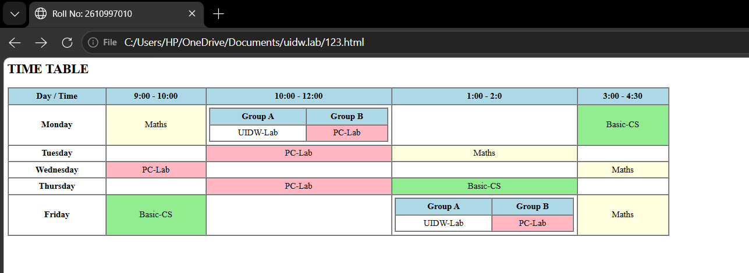

Practical 11: Design a table using rowspan and colspan.
Practical No. 21–22 | Subject: UI Design for Website

Aim
Create an HTML table and demonstrate the rowspan and colspan attributes.

HTML Code
Paste or type your HTML code here.

<html>
<head>
<title>2610997010</title>
</head>
<body>

<table border="2px" height="300px" width="1000px">

<tr>
<th>1</th>
<th>2</th>
<th>3</th>
<th>4</th>
</tr>

<tr>
<th>5<br> row-2</th>
<th>6<br>row-2</th>
<th rowspan="2">11- table-3<br> <table border="2px" height="150px" width="200px" align="center"><tr><th>13</th><th>14</th></tr><tr><th>15</th><th>16</th></tr><tr><td colspan="2" align="center">17</th></table> </th>
<th>12</th>
</tr>

<tr >
<th colspan="2"> 7(row-3) <table border="2px" height="150px" width="200px" align="center"> <tr><td colspan="2"> 8-table-2</th></tr><tr><td align="center">9</td><td align="centerkkk">10</td></table> </th>
<th>18<br>row-4</th>
<tr>

</table>
</body>
</html>

Output
Paste your output screenshot here, or describe the output.
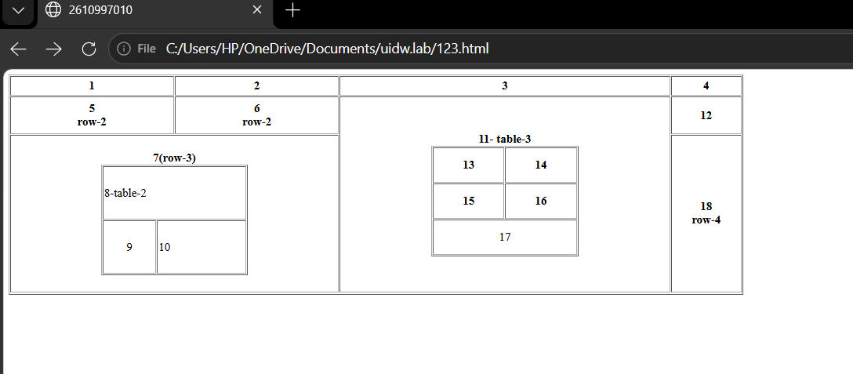

Practical 12: Build a registration form using the GET method.
Practical No. 23–24 | Subject: UI Design for Website

Aim
Create a registration form that submits its form data using the GET method.

HTML Code
Paste or type your HTML code here.

<html>
<head>
<title>2610997010</title>
</head>
<body bgcolor="pink">
<fieldset>
<legend align="center" >STUDENT REGISTRATION FORM</legend>
<table align="center">
<form method="get" action="thanksform.html">
<tr>
<td> FIRST NAME</td>
<td><input type="text" maxlength="30" required> (max 30 characters a-z and A-Z) <br></td>
</tr>
<tr>
<td>EMAIL ID</td>
<td> <input type="email" required ><br></td>
</tr>
<tr>
<td>PASSWORD</td>
<td> <input type="password" required><br></td>
</tr>
<tr>
<td> MOBILE NUMBER</td>
<td> <input type="text" maxlength="10" required><br></td>
</tr>
<tr>

<td>GENDER </td>
<td> Male<input type="radio" name="gen"> Female<input type="radio" name="gen"><br></td>
</tr>
<tr>
<td>ADDRESS</td>
<td> <textarea rows="4" cols="30"></textarea><br></td>
</tr>
<tr>
<td>CITY</td>
<td> <input type="text" maxlength="30" required>&nbsp;(max 30 characters a-z and A-Z)<br></td>
</tr>
<tr>
<td>PINCODE </td>
<td> <input type="text" maxlength="6">&nbsp;(6 digit pincode)<br></td>
</tr>
<tr>
<td>STATE</td>
<td><input type="text" maxlength="30">&nbsp;(max 30 characters a-z and A-Z) <br></td>
</tr>
<tr>
<td>COUNTRY</td>
<td><select>
<option>select country</option>
<option>india</option>
<option>usa</option>
<option>thailand</option>
<option>russia</option>
</select><br></td>
</tr>
<tr>
<td>HOBBES</td>
<td> Drawing <input type="radio" name="hb">Singing<input type="radio" name="hb">Dancing<input type="radio" name="hb">Sketching<input type="radio" name="hb">
other <input type="radio" name="hb"><input type="text" maxlenght="30"><br></td>
</tr>
<tr>
<td>QUALIFICATION</td>
<td>
<table>
<tr>
<th>SI.No.</th>
<th>Examination</th>
<th>Board</th>
<th>Percentage</th>
<th>Year of Passing</th>
</tr>
<tr>
<td>1.</td>
<td>class X</td>
<td><input type="text" maxlength="15" required></td>
<td><input type="text" maxlength="15" required></td>
<td><input type="text" maxlength="15" required></td>
</tr>
<tr>
<td>2.</td>
<td>class XII</td>
<td><input type="text" maxlength="15" required></td>
<td><input type="text" maxlength="15" required></td>
<td><input type="text" maxlength="15" required></td>
</tr>
<tr>
<td>3.</td>
<td>Gradution</td>
<td><input type="text" maxlength="15" ></td>
<td><input type="text" maxlength="15" ></td>
<td><input type="text" maxlength="15" ></td>
</tr>
<tr>
<td>4.</td>
<td>Masters</td>
<td><input type="text" maxlength="15" ></td>
<td><input type="text" maxlength="15" ></td>
<td><input type="text" maxlength="15" ></td>
</tr>

</table>
</td>
</tr>
<tr>
<td>COURSE APPLIED FOR</td>
<td>
BCA<input type="radio" name="course">B.Com<input type="radio" name="course"> B.Sc<input type="radio" name="course">B.A<input type="radio" name="course">
</td>
</tr>
<tr>
<td align="right">
<button type="submit">Submit</button></td>
<td>
<button type="reset">Reset</button></td>
</tr>

</table>
</form>
</fieldset>

</body>
</html>

Output
Paste your output screenshot here, or describe the output.
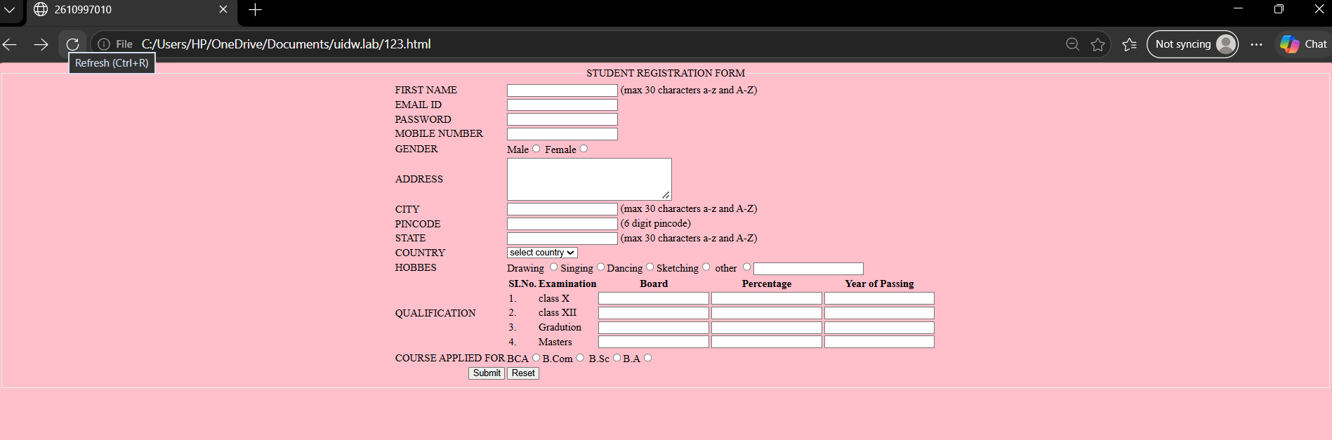

Practical 13: Build a feedback form using the POST method.
Practical No. 25–26 | Subject: UI Design for Website

Aim
Create a feedback form that submits its form data using the POST method.

HTML Code

Paste or type your HTML code here.

<html>
<head>
<title>2610997010</title>
</head>
<body bgcolor="pink">
<feildset>
<legend align="center"> HP AGENCY FEEDBACK FORM </legend>
<table align="center">
<form method="post" action="thanksform.html">
<tr>
<td>
Name
</td>
<td>
<input type="text" maxlength="30" required>

</td>
</tr>
<tr>
<td>Email id</td>
<td><input type="email" maxlength="30" required></td>
</tr>
<tr>
<td>Address</td>
<td><textarea rows="4" cols="10"></textarea></td>
</tr>

<tr>
<td>Pincode</td>
<td><input type="text" maxlength="6" required></td>
</tr>
<tr>
<td>
<td>
<table border="1px">
<tr>
<td>product id</td>
<td>product image</td>
<td>unit price</td>
<td>feedback</td>
<td>progress %</td>

</tr>
<tr>
<td><input type="text" maxlength="15" required></td>
<td><input type="file" accept=".jpg, .jpeg" ></td>
<td><input type="number" maxlength="8"></td>
<td> <textarea rows="1" cols="20" ></textarea></td>
<td><label file="uploading">uploading file:</label><progress id="uploading" max="100" value="80"></progress></td>
</tr>
<tr>
<td><input type="text" maxlength="15" ></td>
<td><input type="file" accept=".jpg, .jpeg"></td>
<td><input type="number" maxlength="8"></td>
<td> <textarea rows="1" cols="20"></textarea></td>
<td><label file="uploading">uploading file:</label><progress id="uploading" max="100" value="80"></progress></td>
</tr>
<tr>
<td><input type="text" maxlength="15" ></td>
<td><input type="file" accept=".jpg, .jpeg"></td>
<td><input type="number" maxlength="8"></td>
<td> <textarea rows="1" cols="20"></textarea></td>
<td><label file="uploading">uploading file</label><progress id="uploading" max="100" value="80"></progress>
</td>
</tr>
<tr>
<td><input type="text" maxlength="15" ></td>
<td><input type="file" accept=".jpg, .jpeg"></td>
<td><input type="number" maxlength="8"></td>
<td> <textarea rows="1" cols="20"></textarea></td>
<td><label file="uploading">uploading file</label><progress id="uploading" max="100" value="80"></progress></td>
</tr>
<tr>
<td><input type="text" maxlength="15" ></td>
<td><input type="file" accept=".jpg, .jpeg"></td>
<td><input type="number" maxlength="8"></td>
<td> <textarea rows="1" cols="20"></textarea></td>
<td><label file="uploading">uploading file</label><progress id="uploading" max="100" value="80"></progress></td>
</tr>
<tr>
<td><input type="text" maxlength="15" ></td>
<td><input type="file" accept=".jpg, .jpeg"></td>
<td><input type="number" maxlength="8"></td>
<td> <textarea rows="1" cols="20"></textarea></td>
<td><label file="uploading">uploading file</label><progress id="uploading" max="100" value="80"></progress></td>
</tr>
<tr>
<td><input type="text" maxlength="15" ></td>
<td><input type="file" accept=".jpg, .jpeg"></td>
<td><input type="number" maxlength="8"></td>
<td> <textarea rows="1" cols="20"></textarea></td>
<td><label file="uploading">uploading file</label> <progress id="uploading" max="100" value="80"></progress></td>
</tr>
<tr>
<td><input type="text" maxlength="15" ></td>
<td><input type="file" ></td>
<td><input type="number" maxlength="8"></td>
<td> <textarea rows="1" cols="20"></textarea></td>
<td><label file="uploading">uploading file</label><progress id="uploading" max="100" value="80"></progress></td>
</tr>

</table>
</td>
</tr>
<tr>
<td>credit card</td>
<td><input type="text" maxlength="16" required></td>
</tr>
<tr>
<td>comment</td>
<td><textarea rows="4 cols=15"></textarea></td>
</tr>
<tr>
<td align="right">
<button type="submit">submit</button>

<button type="reset">reset</button>
</td>

</tr>
</tr>
</form>
</table>
</feildset>
</body>
</html>

output
Paste your output screenshot here, or describe the output.
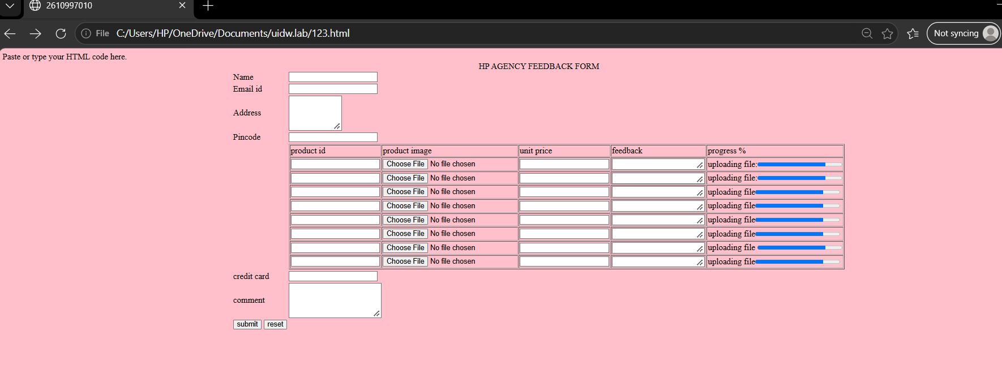

Practical 14: Compare GET and POST forms.
Practical No. 27–28 | Subject: UI Design for Website

Aim
Demonstrate and compare the GET and POST methods used by HTML forms.

HTML Code

Paste or type your HTML code here.

<html>
<head>
<title>2610997010</title>
</head>
<body>
<table border="2px" bgcolor="lightblue" width="500px" height="200px" >
<tr><td>
<h2> <center>GET METHOD FORM</center> </h2>
<form method="get" >
Name:<input type="text" maxlength="30" required name="name"> <br><br>
Email:<input type="email" required name="email"><br><br>
<button type="submit">submit</button>
<button type="reset">reset</button>
</form>
</td></tr></table>
<hr>

<table border="2px" bgcolor="lightblue" width="500px" height="200px" >
<tr><td>
<h2> <center>POST METHOD FORM</center> </h2>
<form method="post" >
Name:<input type="text" maxlength="30" required name="name"> <br><br>
Email:<input type="email" required name="email"><br><br>
<button type="submit">submit</button>
<button type="reset">reset</button>
</form>
</td></tr></table>

</body>
</html>

Output
Paste your output screenshot here, or describe the output.
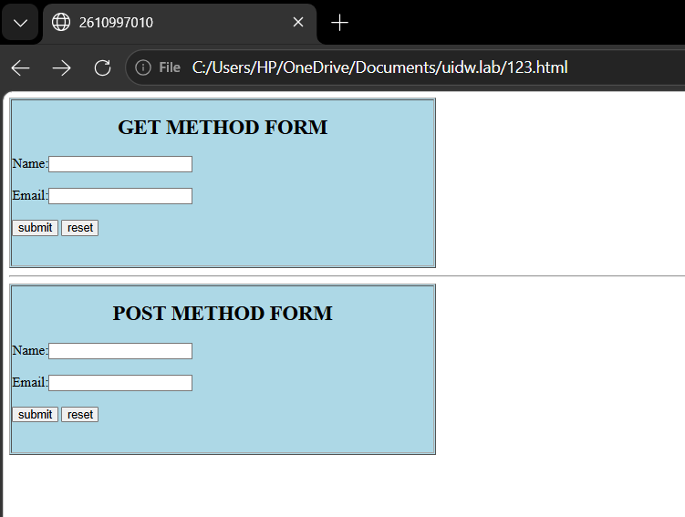

4. Difference between GET and POST

GET method form. | POST method form.
- Sends form data an the URL.  - Data is visible in the URL.  - Commonly used to retrieve information. | - Sends form data in the request body.  - Data is not normally visible in the URL.  - Commonly used to submit or send data .

Practical 15: Create a frameset with navigation and content frames.
Practical No. 29–30 | Subject: UI Design for Website

Aim
Create a frameset layout with separate navigation and content frames.

HTML Code
Paste or type your HTML code here.

<html>
<head>
<title>2610997010</title>
<frameset cols="10%,90%">
<frame src="navigation.html" name="main"></frame>
<frame src="content.html" name="mainfile"></frame>
</frameset>
</head>
<body>
</body>
</html>

Navigation file

<html>
<head>
<title>2610997010</title>
</head>
<body>
<h3>Navigation</h3>
<a href="content.html" target="content">Home</a><br><br>
<a href="avijot’s file7.html" target="content">About</a>
</body>
</html>

Content file

<html>
<head><title>2610997010</title></head>
<body>
<h2>Welcome</h2>
<p>This is the content frame.</p>
</body>
</html>

Output
Paste your output screenshot here, or describe the output.
