Game Design Document

Fill up the following document

1. Write the title of your project.

# **Super Bino Go Game**

1. What is the goal of the game?

# **To save the bino from the monsters .**

1. Write a brief story of your game.

# **In this a man name bino who has to reach his victory place and save his town from the monsters .**

1. Which are the playing characters of this game?

* Playing characters are the ones who respond to the user based on the input from the user.
* Cars, monkeys, dinos, wizards, etc., are the playing characters in the game.

|  |  |  |
| --- | --- | --- |
| Number | Character Name | What can this character do? |
| 1 | Bino | Who is the main player of the game in this the bino has to save his town people from the different monstores . |

5.Which are the Non-Playing Characters of this game?

* Non-Playing characters are the ones that don't have an action or behavior when the user interacts with the game.
* Hurdles, stones, bananas, coins, etc., are non-playing characters in the game.

|  |  |  |
| --- | --- | --- |
| Number | Character Name | What can this character do? |
| 1 | MONSTERS | When it touch the bino dies |
| 2 | SNAILS | When it crawl on bino it die |
| 3 | TURTULE | When it touches the bino he dies |
| 4 | A FROG | When it hop on bino it dies |
| 5 | OBSTACLE | If the bino is unable to jump on it he dies |
| 6 | HILLS | If the bino don’t jump on it he dies |
| 7 | CRAB | If the crab bite it the bino dies |
| 8 | EAGLE | If the eagle eat him the bino dies |

6.Draw your imagination of this game. What does this game look like?

* Draw the game either on your computer or on paper.
* Add images of the game scenes to show each of the playing and non-playing characters at least once.

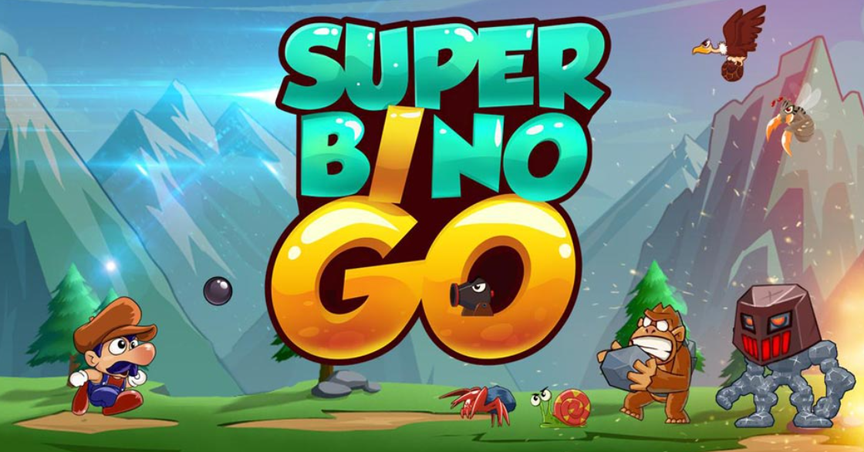

7.How do you plan to make your game engaging?

# **In this we could add points for the bino to collect and we could also add some lives for him that if he is tired then he could use his lives and we could aso add 3 tries for him that if he fails to reach his place he could restart his game from that same place .**