RV University — School of Computer Science and Engineering (SoCSE)
Explainable AI (XAI) — Laboratory Record
Name: Aviksha Nayana Pala | USN: 1RUB25CSE0003
Subject: Explainable AI (XAI) | Experiment No.: 2

Ex No: 2 | Explainable AI Using PDP, ICE, and PFI
Date: | Wine Quality Dataset (UCI)

Objective
To build a machine-learning model that predicts wine quality from its physicochemical properties using the UCI Wine Quality dataset, and to apply three post-hoc Explainable AI (XAI) techniques — Partial Dependence Plot (PDP), Individual Conditional Expectation (ICE), and Permutation Feature Importance (PFI) — in order to understand, respectively, the average effect of a feature on model predictions, the effect of a feature on predictions for individual samples, and the features that have the greatest impact on model performance.

Dataset
The UCI Wine Quality dataset (red wine variant) is used for this experiment. The dataset was loaded directly from the UCI Machine Learning Repository and contains 1,599 samples described by 11 physicochemical input features — fixed acidity, volatile acidity, citric acid, residual sugar, chlorides, free sulfur dioxide, total sulfur dioxide, density, pH, sulphates, and alcohol — along with the target variable quality, an integer sensory score. All 12 columns are numeric, and no missing values are present in the dataset.

Task 1: Load and Prepare the Dataset
The dataset was loaded using pandas.read_csv() with a semicolon (;) delimiter directly from the UCI repository URL. The resulting DataFrame has a shape of (1599, 12). Table 1 shows the first five records of the loaded dataset.
Fixed Acid. | Volatile Acid. | Citric Acid | Res. Sugar | Chlorides | Free SO2 | Total SO2 | Density | pH | Sulphates | Alcohol | Quality
7.4 | 0.7 | 0 | 1.9 | 0.076 | 11 | 34 | 0.9978 | 3.51 | 0.56 | 9.4 | 5
7.8 | 0.88 | 0 | 2.6 | 0.098 | 25 | 67 | 0.9968 | 3.2 | 0.68 | 9.8 | 5
7.8 | 0.76 | 0.04 | 2.3 | 0.092 | 15 | 54 | 0.997 | 3.26 | 0.65 | 9.8 | 5
11.2 | 0.28 | 0.56 | 1.9 | 0.075 | 17 | 60 | 0.998 | 3.16 | 0.58 | 9.8 | 6
7.4 | 0.7 | 0 | 1.9 | 0.076 | 11 | 34 | 0.9978 | 3.51 | 0.56 | 9.4 | 5
Table 1: First five records of the Wine Quality dataset.
All 11 input features are of type float64 and the target variable quality is of type int64. An explicit check using df.isnull().sum() confirmed zero missing values across all columns. Descriptive statistics (df.describe()) were also computed; the alcohol feature ranges from 8.4 to 14.9 (mean ≈ 10.42, std ≈ 1.07), volatile acidity ranges from 0.12 to 1.58 (mean ≈ 0.53), sulphates ranges from 0.33 to 2.0 (mean ≈ 0.66), and the target quality ranges from 3 to 8 (mean ≈ 5.64, std ≈ 0.81).
The input features (X) were separated from the target variable (y = quality), giving 11 input features and target values spanning {3, 4, 5, 6, 7, 8}. The dataset was then split into training and testing sets using an 80:20 split (test_size = 0.20, random_state = 42), resulting in 1,279 training samples and 320 testing samples.

Task 2: Train a Machine Learning Model
A Random Forest Regressor (sklearn.ensemble.RandomForestRegressor) was selected as the prediction model, configured with n_estimators = 200, random_state = 42, and n_jobs = -1. Random Forest was chosen because it can capture non-linear feature interactions while still supporting model-agnostic post-hoc explanation techniques such as PDP, ICE, and PFI. The model was trained on the training split (X_train, y_train) and evaluated on the held-out test split (X_test, y_test).
The performance of the trained model on the test set is summarised in Table 2.
Metric | Value
MAE | 0.4251
RMSE | 0.5531
R² | 0.5319
Table 2: Random Forest Regression performance on the test set.
The model achieves a Mean Absolute Error (MAE) of 0.4251 and a Root Mean Squared Error (RMSE) of 0.5531, indicating that predictions are, on average, within roughly half a quality point of the true sensory score. The R² value of 0.5319 indicates that the model explains approximately 53% of the variance in wine quality using the given physicochemical features — a reasonable but not perfect fit, consistent with the inherently subjective and noisy nature of sensory wine-quality scores.

Task 3: Partial Dependence Plot (PDP)
Partial Dependence Plots were generated for three selected features — alcohol, volatile acidity, and sulphates — using sklearn.inspection.PartialDependenceDisplay.from_estimator() with kind="average" and grid_resolution=30. The PDP shows how the average model prediction changes as a single feature is varied, with the effects of all other features marginalised (averaged) out. The resulting plots are shown in Figure 1.
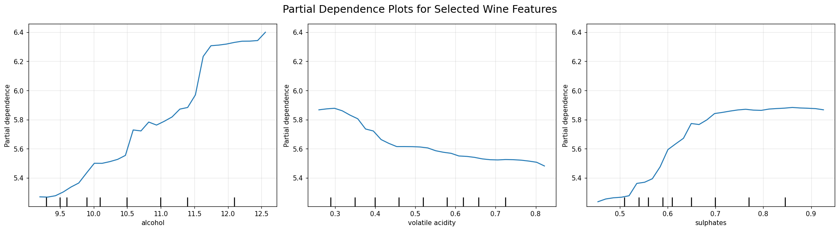
Figure 1: Partial Dependence Plots for alcohol, volatile acidity, and sulphates.
The PDP for alcohol shows a strong positive relationship with predicted wine quality — as alcohol content increases, predicted quality rises overall, with a particularly steep increase at higher alcohol values (around 10.5–12). Volatile acidity shows a generally negative relationship: predicted quality gradually decreases as volatile acidity increases. Sulphates show a positive relationship up to approximately 0.55–0.70, beyond which the curve flattens and predicted quality remains relatively stable. In all three cases the curves are non-linear rather than straight lines, indicating that the effect of each feature on predicted quality changes in strength across its range.

Task 4: Individual Conditional Expectation (ICE)
ICE plots were generated for the same three features (alcohol, volatile acidity, sulphates) using the first ten samples of the test set (X_test.iloc[:10]) and PartialDependenceDisplay.from_estimator() with kind="both", which overlays the individual ICE curves together with the average PDP curve (grid_resolution=30). Unlike the PDP, which shows only the average effect, ICE traces the predicted outcome for each individual wine sample as the selected feature is varied, holding all other feature values fixed at that sample's actual values. The resulting plots are shown in Figure 2.
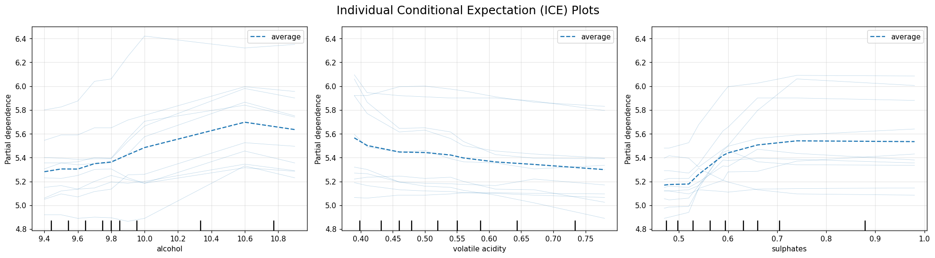
Figure 2: Individual Conditional Expectation (ICE) plots for alcohol, volatile acidity, and sulphates (10 test samples, dashed line = average PDP).
For alcohol, most of the individual curves rise as alcohol increases, consistent with the positive PDP trend, though the ten samples reach noticeably different prediction levels and increase at different rates. For volatile acidity, most curves show a decreasing tendency, again consistent with the PDP, but with varying steepness across samples. For sulphates, several individual curves increase and then stabilise, similar to the PDP shape, although the magnitude of the increase differs from sample to sample. Overall, the ICE curves broadly track the average PDP trend for each feature while revealing that individual wine samples do not all respond identically to the same feature change.

Task 5: Permutation Feature Importance (PFI)
Permutation Feature Importance was computed for all 11 input features using sklearn.inspection.permutation_importance() on the test set, with n_repeats=10, random_state=42, and scoring="r2". PFI measures the drop in model performance (here, R²) when a single feature's values are randomly shuffled, thereby breaking its relationship with the target while leaving all other features intact; a larger drop indicates a more important feature. The resulting ranked importances are shown in Table 3 and visualised as a bar chart in Figure 3.
Feature | PFI Mean | PFI Std
alcohol | 0.383628 | 0.032568
sulphates | 0.243227 | 0.022478
volatile acidity | 0.137699 | 0.015996
total sulfur dioxide | 0.071583 | 0.013334
pH | 0.029063 | 0.006865
density | 0.026423 | 0.004635
fixed acidity | 0.025494 | 0.004864
free sulfur dioxide | 0.023415 | 0.006452
chlorides | 0.016484 | 0.006655
residual sugar | 0.013135 | 0.004619
citric acid | 0.012999 | 0.004823
Table 3: Permutation Feature Importance results, ranked by mean decrease in R².
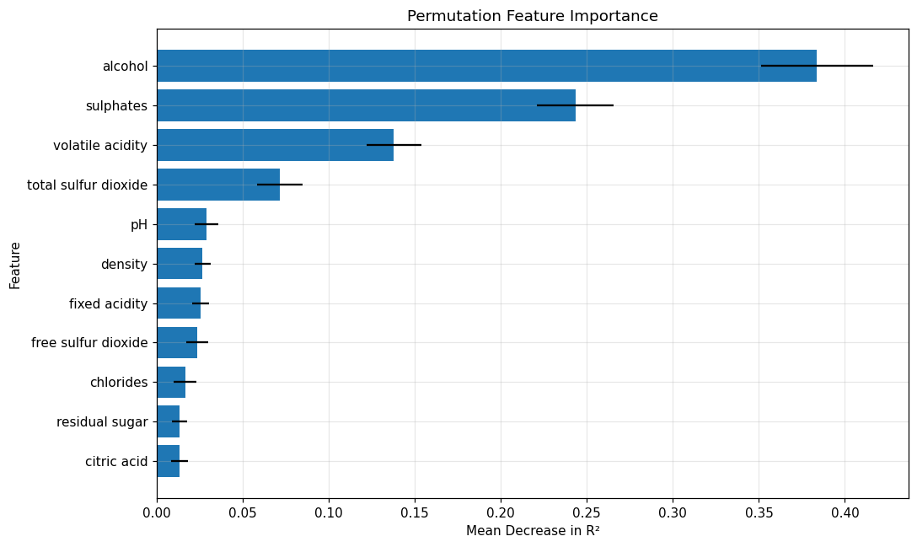
Figure 3: Permutation Feature Importance bar chart (mean decrease in R², with error bars showing standard deviation across repeats).
Alcohol emerges as by far the most influential feature, with a mean R² decrease of 0.3836, more than 1.5 times larger than the next-ranked feature. Sulphates ranks second (0.2432), followed by volatile acidity (0.1377). Total sulfur dioxide is a distant fourth (0.0716), while the remaining seven features (pH, density, fixed acidity, free sulfur dioxide, chlorides, residual sugar, and citric acid) all have PFI means below 0.03, indicating a comparatively minor contribution to the trained model's predictive performance.

Task 6: Compare PDP, ICE, and PFI
The results obtained from PDP, ICE, and PFI are compared below to build a combined understanding of both the importance and the behaviour of the wine-quality features.
Question 1: Which features are most influential?
Answer: Based on the Permutation Feature Importance (PFI) results, alcohol is the most influential feature, followed by sulphates and volatile acidity. Alcohol has the highest mean decrease in R², indicating that randomly permuting it causes the largest reduction in model performance. Sulphates and volatile acidity are the next most important features, while the remaining features have considerably smaller PFI values.
Question 2: What is the relationship between the important features and the prediction?
Answer: The PDP results show that alcohol has a strong positive relationship with predicted wine quality — as alcohol increases, predicted quality generally increases, with a particularly noticeable increase at higher alcohol values. For volatile acidity, the relationship is generally negative: as volatile acidity increases, predicted wine quality gradually decreases. For sulphates, predicted quality generally increases as sulphates increase, particularly between approximately 0.55 and 0.70, after which the curve becomes relatively stable.
Question 3: Is the relationship linear or nonlinear?
Answer: The relationships are nonlinear rather than strictly linear. The PDP curves do not form straight lines with constant slopes — for example, the effect of alcohol becomes considerably stronger at higher values, while the sulphates curve increases and then reaches a relatively stable region. Volatile acidity also shows a gradual decrease with changes in slope across its range. The model therefore captures varying effects of the features rather than assuming a constant linear relationship.
Question 4: Do individual ICE curves follow the average PDP trend?
Answer: The ICE plots show that the individual curves generally follow the overall PDP trends, but they do not all behave identically. For alcohol, most individual curves show an increasing prediction as alcohol increases, consistent with the positive PDP trend. For volatile acidity, most curves show a decreasing tendency, consistent with the PDP. For sulphates, several individual curves show an increase in prediction followed by stabilisation, although the magnitude of the change differs between samples. Thus, the PDP represents the average behaviour, while ICE reveals the variation between individual wine samples.
Question 5: Are there differences between individual samples?
Answer: Yes. The ICE plots clearly show differences between individual wine samples — the curves are spread across different prediction levels and their slopes are not identical. For example, when alcohol changes, some samples show a strong increase in predicted quality while others show a smaller change. Similar variation can be observed for volatile acidity and sulphates, indicating that the effect of a feature can depend on the characteristics of the individual wine sample.
Question 6: Does the PFI ranking agree with the PDP and ICE observations?
Answer: Yes, the results are broadly consistent. PFI identifies alcohol, sulphates, and volatile acidity as the three most important features, and these same features show noticeable prediction changes in the PDP plots and visible variation across individual samples in the ICE plots. Alcohol has the highest PFI score and also shows a strong positive PDP trend. Sulphates has the second-highest PFI score and shows a noticeable increasing relationship before reaching a plateau. Volatile acidity ranks third in PFI and shows a clear negative PDP trend. Therefore, the three XAI techniques provide complementary but consistent evidence about the importance and behaviour of these features.

Final Observation / Conclusion
This experiment demonstrates how PDP, ICE, and PFI provide complementary explanations of the trained Random Forest Regression model for wine quality prediction. PFI identified alcohol as the most influential feature, followed by sulphates and volatile acidity. The PDP results showed that alcohol and sulphates generally have positive effects on predicted wine quality, whereas volatile acidity has a negative effect. The curves were nonlinear, indicating that the effect of a feature is not constant across its entire range. The ICE plots further showed that individual wine samples can respond differently to changes in the same feature, although their overall trends generally agree with the PDP results. Therefore, combining PDP, ICE, and PFI provides both global and individual-level understanding of the model's behaviour and feature importance, and confirms that a moderately accurate but non-linear model (R² ≈ 0.53) relies primarily on alcohol, sulphates, and volatile acidity to form its predictions of wine quality.

