YUVА INTERNSHIP
WEEK 1 – MACHINE LEARNING USING PYTHON
RESEARCH & STRATEGIC PROJECT PLAN

Project Title
ML-Based Restaurant Demand Forecasting and Inventory Recommendation System

Item | Details
Internship Organization | Yuva
Week | 1
Domain | Machine Learning / Data Analytics
Technology | Python
Prepared by | Avikshit Macherla
Submission Type | Research and Strategic Planning Document

Executive Summary
This Week 1 document presents the research and strategic planning foundation for a machine learning project titled “ML-Based Restaurant Demand Forecasting and Inventory Recommendation System.” The proposed system uses historical restaurant sales and contextual variables to estimate future demand for menu items and translate those forecasts into practical inventory-planning recommendations. The project is suitable for implementation in Python using standard machine-learning workflows such as data preprocessing, exploratory data analysis, feature engineering, regression modeling, model evaluation, and visualization.
The research reviewed published work on restaurant demand forecasting, restaurant sales prediction, and food/inventory management. Existing studies show that point-of-sale history can be combined with factors such as day of week, seasonality, weather, events, promotions, and other contextual variables. The proposed internship project will begin with interpretable baseline models and tree-based regression models, while keeping more advanced sequence models as an optional extension.
The Week 1 strategy therefore focuses on defining the problem, understanding the literature, identifying the required data, selecting candidate algorithms, establishing evaluation metrics, identifying risks, and creating a phased implementation timeline. No final model performance is claimed at this stage; performance will be established only after implementation and testing on an appropriate dataset.

1. Project Identification

1.1 Proposed Project
ML-Based Restaurant Demand Forecasting and Inventory Recommendation System

1.2 Project Domain
Machine Learning, Predictive Analytics, Time-Series/Regression Forecasting, Restaurant Operations and Inventory Management.

1.3 Project Rationale
Restaurants must decide how much food and other inventory to prepare or order before actual demand is known. Historical sales data contains patterns related to menu items, weekdays, weekends, holidays, seasonality and promotions. A machine learning system can learn relationships in these data and provide demand estimates that support planning. The project is realistic for a student internship because it can be developed incrementally using publicly available or synthetic/anonymized data, and it demonstrates the complete ML lifecycle in Python.

1.4 Problem Statement
Traditional restaurant inventory planning may depend heavily on manual estimates, simple averages, or staff experience. These approaches can be difficult to scale when demand varies by item, day, season, promotion, weather, or other external conditions. Overestimating demand can contribute to excess stock and food waste, while underestimating demand can result in stock-outs, missed sales, and service problems. The proposed project investigates whether historical sales and contextual features can be used to build a machine learning model that predicts near-future item-level demand and produces a simple inventory recommendation.

1.5 Need for an ML Solution
- Demand can be nonlinear and influenced by several interacting variables.
- ML regression models can learn relationships from historical observations without requiring every relationship to be manually specified.
- Predictions can be generated at item/day or item/week level, enabling more granular planning than a single overall sales estimate.
- Feature importance and error analysis can help identify which variables contribute to prediction quality.
- Forecasts can be connected to inventory rules to create an actionable recommendation rather than only a numerical prediction.

2. Aim, Objectives and Research Questions

2.1 Aim
To design and evaluate a Python-based machine learning system that forecasts restaurant menu-item demand and converts the forecast into an interpretable inventory-planning recommendation.

2.2 Objectives
- Identify suitable restaurant sales and contextual datasets.
- Clean and preprocess the selected data while preserving the temporal structure.
- Perform exploratory data analysis to understand trends, seasonality, outliers and item-level behavior.
- Engineer time, calendar, lag, rolling-statistic and contextual features where appropriate.
- Build baseline and machine learning regression models for demand prediction.
- Evaluate models using MAE, RMSE, MAPE/sMAPE where appropriate, and R².
- Analyze model errors and feature importance.
- Translate demand predictions into a simple inventory recommendation using a documented rule.
- Prepare visualizations/dashboard outputs that make the results understandable to a non-technical user.
- Document limitations, risks and future improvements.

2.3 Research Questions
- RQ1: Which historical and contextual variables are most useful for restaurant demand prediction?
- RQ2: How do baseline regression models compare with tree-based ensemble models on the selected dataset?
- RQ3: How does adding calendar, lag and contextual features affect forecast error?
- RQ4: Can demand forecasts be converted into a transparent inventory recommendation rule?

3. Literature Review and Research Findings
The literature review focused on publicly accessible research related to restaurant demand forecasting, sales forecasting, machine learning methods, and the connection between forecasting and inventory decisions.
Study / Source | Focus | Key Finding | Relevance to Proposed Project
Sato et al. (2019) – Demand forecasting in restaurants using ML and statistical analysis | Restaurant demand forecasting using POS and external variables such as location, weather and events. | Shows the importance of store-specific models and combining internal and external data. | Supports including contextual variables where data is available.
Sato et al. (2020) – Restaurants store management based on demand forecasting | Uses machine learning for customer-order and inventory-order forecasting, including POS, weather and events. | Connects demand forecasting directly to store management and ordering decisions. | Supports the proposed forecast-to-inventory workflow.
Schmidt, Kabir & Hoque (2022) – Machine Learning Based Restaurant Sales Forecasting | Compares multiple ML and recurrent neural network approaches using real-world restaurant sales data. | Shows the importance of feature engineering, trend/seasonality and forecast horizon. | Supports baseline-vs-advanced model comparison.
Posch et al. (2022) – Bayesian prediction of food and beverage sales | Predicts restaurant/canteen sales to support food-stock ordering. | Highlights the operational and environmental relevance of accurate sales prediction. | Supports linking demand forecasts with stock planning.
Large restaurant-chain study (2024) – ML/DL demand forecasting | Combines internal sales information with external contextual variables and compares ML/DL approaches. | Shows that data sources and market conditions can affect model performance. | Supports testing multiple feature sets and monitoring model behavior.
Food demand forecasting under weather disruptions (2026) | Forecasting plus weather-disruption information for proactive inventory replenishment. | Shows the growing importance of adaptive forecasting under disruptions. | Provides a future-extension direction for weather-aware recommendations.

3.1 Research Synthesis
- Restaurant forecasting is not only a time-series problem; contextual variables can materially affect demand.
- POS/sales history is a central input, but external information may improve the ability to explain unusual demand.
- Feature engineering is important because calendar effects, lags and rolling statistics can expose temporal patterns to ML models.
- Simple and interpretable models are useful as baselines before introducing more complex algorithms.
- Forecasting has operational value when it is connected to decisions such as purchasing, preparation and staffing.
- Evaluation must respect time order. Randomly mixing future observations into training data can cause data leakage and produce misleading results.

4. Proposed Methodology
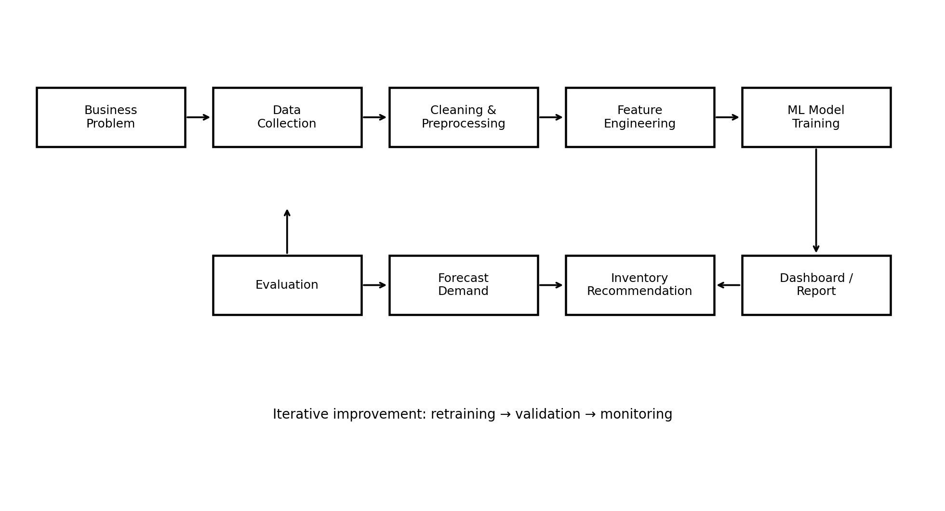
Figure 1. Proposed end-to-end workflow for the ML project.

4.1 Data Requirements
Data Category | Example Variables | Purpose
Sales / POS | date, item_id, quantity_sold, revenue | Primary target and historical demand
Calendar | day_of_week, weekend, month, holiday_flag | Capture recurring demand patterns
Product | category, price, promotion_flag | Explain product-level demand changes
Weather (optional) | temperature, rainfall, weather_type | Capture contextual demand variation
Events (optional) | event_flag, event_type | Capture abnormal demand periods
Inventory (if available) | opening_stock, closing_stock, stockout_flag | Support inventory recommendation and avoid distorted demand observations

4.2 Data Preprocessing
- Inspect missing values, duplicate records and invalid quantities.
- Convert date fields to a consistent datetime format.
- Aggregate transactions to the chosen forecasting level, such as item-day.
- Handle missing contextual values using documented methods.
- Detect extreme values and investigate whether they are genuine events or data errors.
- Avoid leakage by ensuring that features available only after the prediction time are not used.
- Split the data chronologically into training, validation and test periods.

4.3 Exploratory Data Analysis
- Daily and weekly sales trend plots.
- Top-selling and low-selling menu items.
- Weekday versus weekend demand comparison.
- Monthly/seasonal patterns.
- Correlation analysis for numeric variables.
- Outlier and stock-out analysis.
- Demand distribution by item/category.

4.4 Feature Engineering
- Calendar features: weekday, month, week-of-year, weekend and holiday indicator.
- Lag features: previous-day, previous-week and previous-period demand where appropriate.
- Rolling features: moving average or rolling median computed only from past observations.
- Price/promotion features where available.
- Weather/event features where available.
- Item/category identifiers using suitable encoding methods.

4.5 Candidate Models
Model | Role in Project | Expected Strength | Potential Limitation
Naive / moving-average baseline | Reference benchmark | Simple and interpretable | May miss nonlinear patterns
Linear Regression / Ridge | Baseline ML regression | Fast, interpretable, useful benchmark | Limited nonlinear representation
Decision Tree Regressor | Nonlinear baseline | Easy to interpret | Can overfit
Random Forest Regressor | Primary candidate | Captures nonlinear interactions and is robust for tabular data | Larger models can be less interpretable
Gradient Boosting Regressor | Primary candidate | Strong tabular regression performance potential | Needs parameter tuning
LSTM/GRU (optional) | Advanced extension | Can model sequential dependencies | Requires more data, tuning and computation

4.6 Model Evaluation
The primary evaluation will use a chronological hold-out test set. Metrics will be selected according to the target and data characteristics. MAE provides an easily interpretable average absolute error, RMSE gives greater weight to larger errors, MAPE or sMAPE can express relative error when their assumptions are satisfied, and R² can describe explained variance for regression.
Metric | Interpretation | Use in This Project
MAE | Average absolute prediction error | Primary error measure for easy interpretation
RMSE | Square-root of mean squared error | Highlights larger forecasting errors
MAPE / sMAPE | Relative forecasting error | Useful when zero/near-zero demand is handled appropriately
R² | Proportion of variance explained | Supplementary regression diagnostic

5. Proposed System Architecture
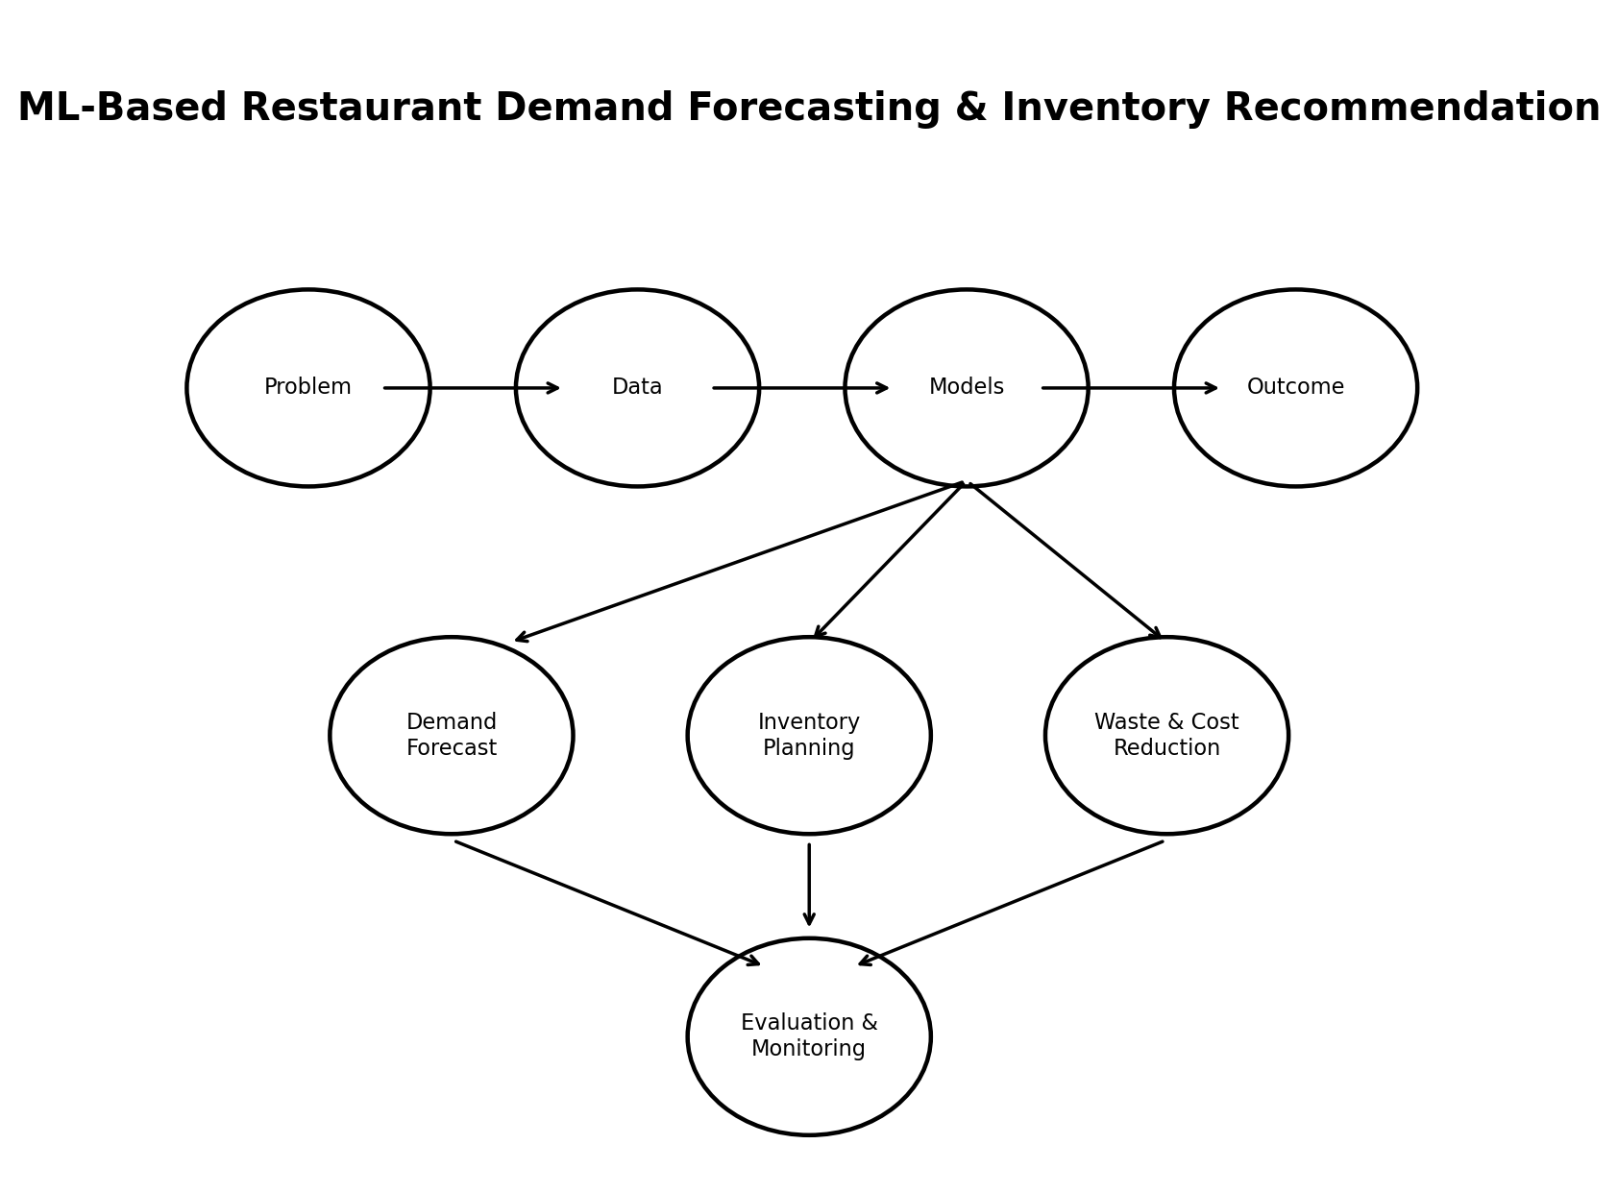
Figure 2. High-level project concept and research areas.

5.1 Functional Components
- Data ingestion module – loads sales and contextual datasets.
- Preprocessing module – cleans, transforms and validates the data.
- EDA module – generates descriptive statistics and visualizations.
- Feature engineering module – creates temporal and contextual predictors.
- Training module – trains candidate models using chronological validation.
- Evaluation module – calculates metrics and produces comparison tables.
- Forecasting module – generates future demand estimates.
- Inventory recommendation module – converts predicted demand into a documented suggested stock quantity.
- Visualization/reporting module – presents trends, forecasts, errors and recommendations.

6. Inventory Recommendation Logic
The project will not treat the ML prediction itself as an inventory order. Instead, the forecast will be passed through a transparent rule. A simple starting formulation is:
Recommended Stock = Forecast Demand + Safety Stock − Available Inventory
Safety stock can initially be defined using a simple fixed buffer or an error-based rule. During implementation, the exact formula will be selected based on the dataset and documented assumptions. This separation keeps the ML model focused on prediction while making the business decision rule understandable.

7. Resources Required
Resource | Requirement | Purpose
Hardware | Laptop/desktop with at least 8 GB RAM recommended | Data processing and model training
Operating System | Windows/Linux/macOS | Development environment
Programming | Python 3.x | Core implementation
Libraries | Pandas, NumPy, Matplotlib, Seaborn, scikit-learn | Data processing, visualization and ML
Optional libraries | XGBoost, TensorFlow/Keras | Advanced model experiments if required
Development environment | Jupyter Notebook / VS Code | Experimentation and coding
Dataset | Public, synthetic or anonymized restaurant sales data | Training and evaluation
Version control | Git/GitHub if permitted | Track project changes
Documentation | MS Word / DOCX | Internship deliverables

8. Expected Challenges and Risk Assessment
Risk | Likelihood | Impact | Mitigation
Limited or poor-quality data | High | High | Use a public dataset; document assumptions; validate schema.
Missing values | Medium | Medium | Profile missingness and use appropriate imputation or exclusion.
Data leakage | High | High | Use chronological splitting and construct lag/rolling features from past data only.
Seasonality and sudden events | Medium | High | Add calendar/event features and analyze residual errors.
Zero-demand items | Medium | Medium | Use MAE/RMSE and carefully select percentage metrics.
Model overfitting | Medium | High | Use validation data, regularization and controlled feature sets.
Insufficient data for deep learning | Medium | Medium | Prioritize classical ML; keep LSTM/GRU as optional.
Interpretability | Medium | Medium | Use feature importance and simple inventory rules.
Scope expansion | High | Medium | Freeze Week 1 scope and prioritize core forecast pipeline first.

9. Project Scope

9.1 In Scope
- Restaurant/menu-item demand forecasting using historical data.
- Python-based preprocessing, analysis, model training and evaluation.
- Comparison of baseline and ML regression models.
- Feature engineering using temporal and available contextual variables.
- Inventory recommendation based on forecast output.
- Result visualization and documentation.

9.2 Out of Scope for the Initial Version
- Automatic purchase-order placement with suppliers.
- Real-time integration with a commercial POS system.
- Guaranteed reduction in food waste or costs before field validation.
- Production-scale cloud deployment.
- Complex deep-learning architectures unless the dataset justifies them.

10. Week 1 Work Plan – 30 to 35 Hours
Activity | Estimated Time | Deliverable
Project selection and problem definition | 4 hours | Finalize title, problem statement, scope and objectives.
Literature research | 8 hours | Review papers, identify methodologies and research gaps.
Dataset investigation | 5 hours | Identify possible public datasets and inspect their variables.
ML methodology study | 5 hours | Study regression, tree ensembles, time-aware validation and metrics.
Project architecture and strategy | 4 hours | Design workflow, modules, resources and risk plan.
Documentation and visual aids | 5 hours | Prepare report, tables, flowchart and references.
Review and finalization | 2 hours | Proofread, verify references and finalize submission.

Total estimated Week 1 effort: 33 hours.

11. Suggested Overall Project Timeline
Week | Phase | Planned Work
Week 1 | Research & planning | Problem definition, literature review, scope, risks and methodology.
Week 2 | Data acquisition & understanding | Dataset selection, data dictionary, cleaning plan and EDA.
Week 3 | Preprocessing & feature engineering | Temporal, lag, rolling and contextual features.
Week 4 | Baseline ML models | Naive baseline, Linear/Ridge, Decision Tree.
Week 5 | Ensemble models | Random Forest and Gradient Boosting; tuning.
Week 6 | Evaluation & error analysis | Metrics, validation, feature importance and error analysis.
Week 7 | Inventory recommendation & visualization | Forecast-to-stock rule and dashboard/reporting.
Week 8 | Testing & documentation | Final experiments, limitations, presentation and report.

12. Expected Deliverables
- Week 1 research and strategic planning report.
- Cleaned and documented dataset or reproducible data-preparation pipeline.
- EDA notebook with visualizations and findings.
- Feature-engineering pipeline.
- Baseline and ML regression models.
- Model comparison report using defined metrics.
- Demand forecasting output.
- Inventory recommendation module.
- Final visualization/dashboard or results interface.
- Technical report, presentation and project demonstration.

13. Expected Outcomes
- A reproducible Python workflow for restaurant demand forecasting.
- A quantitative comparison of multiple ML approaches.
- Identification of important demand drivers in the selected dataset.
- A transparent method for converting forecasts into inventory recommendations.
- Practical experience with data preprocessing, feature engineering, model evaluation and documentation.

14. Limitations at the Research Stage
This is a Week 1 strategic plan and not a final experimental study. The actual performance of each algorithm cannot be determined until a suitable dataset is selected, preprocessing is completed, and the models are trained and tested. Results from published studies should not be directly interpreted as expected results for this project because datasets, forecast horizons, features, business conditions and evaluation procedures differ.

15. Conclusion
The proposed ML-based restaurant demand forecasting and inventory recommendation system provides a manageable and researchable machine learning problem for the internship. The literature indicates that restaurant demand is affected by historical sales patterns and contextual factors, and that machine learning can be used to support forecasting and operational planning. The project strategy deliberately begins with interpretable baselines and tabular ML models before considering advanced sequence models. The Week 1 plan establishes a clear path from problem identification and literature research to data preparation, model development, evaluation, and an actionable inventory recommendation.

16. References
- Sato, T., et al. (2019). Demand forecasting in restaurants using machine learning and statistical analysis. Procedia CIRP, 79, 679–683. DOI: 10.1016/j.procir.2019.02.042.
- Sato, T., et al. (2020). Restaurants store management based on demand forecasting. Procedia CIRP, 88, 580–583. DOI: 10.1016/j.procir.2020.05.101.
- Schmidt, A., Kabir, M. W. U., & Hoque, M. T. (2022). Machine Learning Based Restaurant Sales Forecasting. Machine Learning and Knowledge Extraction, 4(1), 105–130. DOI: 10.3390/make4010006.
- Posch, K., Truden, C., Hungerländer, P., & Pilz, J. (2022). A Bayesian approach for predicting food and beverage sales in staff canteens and restaurants. International Journal of Forecasting, 38(1), 321–338. DOI: 10.1016/j.ijforecast.2021.06.001.
- The value of data, machine learning, and deep learning in restaurant demand forecasting: Insights and lessons learned from a large restaurant chain. Decision Support Systems, 184, 114291 (2024).
- A proactive food demand forecasting-inventory management approach under weather disruptions. Cleaner Logistics and Supply Chain, 19, 100319 (2026).
- scikit-learn documentation. Machine learning in Python. Stable documentation consulted for candidate regression algorithms and workflow concepts.

17. Publicly Available Research Links
Restaurant demand forecasting using ML and statistical analysis: https://www.sciencedirect.com/science/article/pii/S2212827119301568
Restaurants store management based on demand forecasting: https://www.sciencedirect.com/science/article/pii/S2212827120304236
Machine Learning Based Restaurant Sales Forecasting: https://www.mdpi.com/2504-4990/4/1/6
Bayesian approach for predicting food and beverage sales: https://www.sciencedirect.com/science/article/pii/S0169207021001011
Large restaurant-chain demand forecasting study: https://www.sciencedirect.com/science/article/pii/S0167923624001246
Food demand forecasting under weather disruptions: https://www.sciencedirect.com/science/article/pii/S2772390926000247
scikit-learn documentation: https://scikit-learn.org/

Appendix A – Proposed Dataset Schema
Field | Type | Example | Description
date | Date | 2026-01-15 | Transaction/aggregation date
item_id | Categorical | ITEM_012 | Unique menu item
category | Categorical | Main Course | Menu category
quantity_sold | Numeric | 48 | Target demand variable
unit_price | Numeric | 180.00 | Price per unit
promotion_flag | Binary | 0/1 | Whether promotion was active
day_of_week | Categorical | Friday | Calendar feature
holiday_flag | Binary | 0/1 | Holiday indicator
temperature | Numeric | 29.4 | Optional weather variable
rainfall | Numeric | 4.2 | Optional weather variable
event_flag | Binary | 0/1 | Optional local event indicator
stockout_flag | Binary | 0/1 | Whether demand may have been constrained by stock availability

Appendix B – Week 1 Research Checklist
- ☐ Project title and problem statement finalized
- ☐ Need for machine learning justified
- ☐ At least five relevant research studies reviewed
- ☐ Research findings synthesized
- ☐ Dataset requirements identified
- ☐ Candidate ML algorithms identified
- ☐ Evaluation metrics defined
- ☐ System workflow designed
- ☐ Risks and mitigation strategies documented
- ☐ 30–35 hour Week 1 plan prepared
- ☐ Overall project timeline prepared
- ☐ References and public links verified
- ☐ Document proofread and formatted for submission

