Knowledge regarding hypertension and its risk factors among people residing in urban slums
Mr. Suresh Ray¹ Mrs. Vinita Jamdade²
¹Assitant Professor, Dept. of Community Health Nursing, Bharati Vidyapeeth Deemed University College of Nursing, Pune (e-mail id: raysureshkumar@gmail.com )
² Clinical Instructor, Dept. of Community Health Nursing, Bharati Vidyapeeth Deemed University College of Nursing, Pune (e-mail id: Vinita.jamdade@gmail.com )

Abstract
Background
Globally, the overall prevalence of raised blood pressure in adults aged 25 and over was around 40% in 2008. The number of people with hypertension rose from 600 million in 1980 to nearly 1 billion in 2008.The prevalence is significantly higher in geriatric population. Worldwide, raised blood pressure is estimated to cause 7.5 million deaths, about 12.8% of the total of all annual deaths. This accounts for 57 million DALY (disability adjusted life years)s or 3.7% of total DALYs. Raised blood pressure is a major risk factor for coronary heart disease and ischemic as well as hemorrhagic stroke. Blood pressure levels have been shown to be positively and progressively related to the risk for stroke and coronary heart disease. In some age groups, the risk of cardiovascular disease doubles for each incremental increase of 20/10 mmHg of blood pressure, starting as low as 115/75 mmHg. In addition to coronary heart diseases and stroke, complications of raised blood pressure include heart failure, peripheral vascular disease, renal impairment, retinal hemorrhage and visual impairment. Treating high systolic blood pressure and diastolic blood pressure so they are below 140/90 mmHg is associated with a reduction in cardiovascular complications. Blood pressure can be managed with drugs as well as non-pharmacological measures which consist of exercise, weight reduction, salt restriction, eating fruits and vegetables, etc. Non-pharmacological measures play an important role in management of hypertension. The present study was done to assess knowledge of hypertension and its associated risk factors.

Methods
This was a community-based, cross-sectional survey of 500 residents of urban slums. A set of questionnaires assessing knowledge of hypertension and its associated risk factors were used.
Results:
Most persons (73.6%), whether having hypertension or no, had average knowledge related to hypertension determinants, diagnosis, management and consequences, possibly due to their negative and neglected attitude towards health promotion. 45% of people knows about the risk factors related to hypertension correctly.
Conclusion:
It is urgently necessary to promote knowledge, awareness, and health literacy among urban slum residents to prevent hypertension and associated CVDs.
Key words: hypertension, knowledge, risk factors, urban slums, community

Introduction:
Hypertension is a worldwide risk factor for cardiovascular disease burden and mortality. 1 It is a disease related to risky health behaviors, including smoking, poor diet, overweight and obesity, alcohol consumption, physical inactivity and occupational lifestyle. The perception of hypertension by the individual also plays an important role in changing lifestyle and risky health behaviors.2 Some risk factors for hypertension are modifiable, such as smoking, diet, and overweight, whereas some are not modifiable, such as old age and genetic predisposition. Changing modifiable risk factors may result in a reduced burden of hypertension, and people have to know that they are at risk of hypertension to be able to make voluntary lifestyle changes. However, there are many barriers to such awareness in rural and minority populations, including lack of formal school education, communication gaps, and inaccessibility to routine health education programs. Many studies have reported the prevalence of hypertension and its risk factors, but few have paid attention to the prevalence of knowledge regarding hypertension and its associated risk factors in their study populations.
Material and Methods:

This study was conducted with the objective to assess the knowledge regarding hypertension and its risk factors among people in urban area & to associate the knowledge with selected demographic variables (ex: age, gender, education, lifestyle). Research approach was quantitative and exploratory survey design was used to conduct the study. The data for this study were collected from 500 urban slums residents of ambedkarnagar and chaitrban vashat of Pune city comprising the population of more than 10,000 residents.

This was the cross-sectional study in which structured questionnaire were administered by researcher to survey sociodemoghraphic profile, basic knowledge regarding hypertension, sign and symptoms, diagnosis, management, consequences and its associated risk factors. Stratified random sampling method was used to select the sample and its size. Content validity of the tool was done by giving to various experts from Community Health Nursing, Preventive and Social Medicine and field researches. Reliability of the data collection was done by using test-retest method and the reliability co-efficient was 0.87.

The data was collected between December 2013 and March 2014, and was approved by the ethics committee of Bharati Vidyapeeth Deemed University, College of Nursing, Pune. The aims of the study and its protocol were thoroughly explained to participants, and written informed consent was obtained. The analysis was planned and started in June 2014 and carried out until October 2014.

Major Finding of the study:
Section-I: Demographic Characteristics
Table. No.1: Characteristics of Sample population (n=500)
S.No. | Characteristics | Frequency (n) | Percentage (%)
1.1 | Age (years)
 | 30–40 | 127 | 25.4
 | 40–50 | 226 | 45.2
 | 50–60 | 108 | 21.6
 | >65 | 39 | 7.8
1.2 | Gender
 | Male | 203 | 40.6
 | Female | 297 | 59.4
1.3 | Educational Status
 | Up to Primary Level | 164 | 32.8
 | Secondary | 257 | 51.4
 | Higher Secondary | 52 | 10.4
 | Graduation | 22 | 4.4
 | Post Graduate and above | 05 | 1.0
1.4 | Working status
 | Daily wage earner | 317 | 63.4
 | Government service | 27 | 5.4
 | Shop owners | 15 | 3.0
 | Private service | 48 | 9.6
 | Housewives | 73 | 14.6
 | Not Working | 20 | 4.0
1.5 | Past history of Hypertension in the family
 | Yes | 178 | 35.6
 | No | 322 | 64.4

Table No.1 depicts the following:
1.1. Majority (45.2%) of the samples were from the age group of 40-50 yrs
1.2. Majority (59.4%) of the samples were female
1.3. Majority (51.4%) of the samples were completed their primary education
1.4. Majority (63.4%) were daily wedge earners
1.5. Majority (64.4%) of the samples were not having family history of Hypertension

Section-II (a): Knowledge related to hypertension
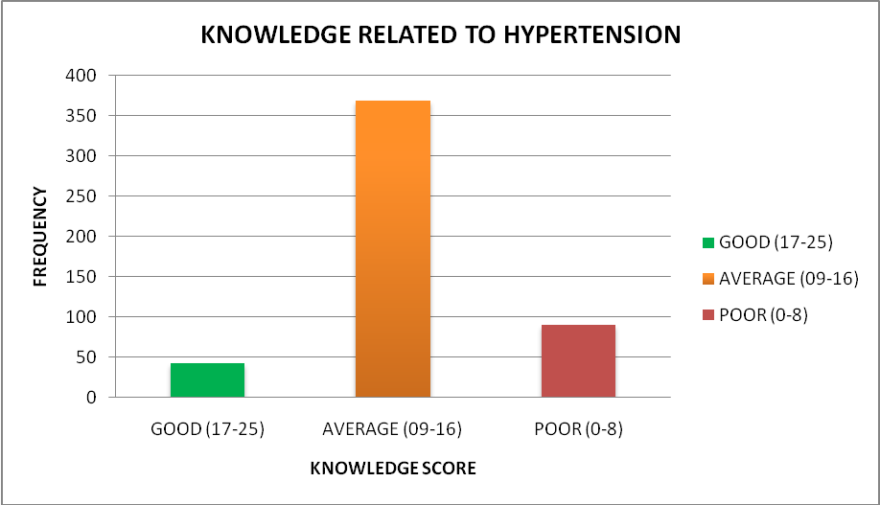
Fig.No.1 – Samples knowledge regarding hypertension
Above figure shows that majority of the people (73.6%) were having average knowledge regarding hypertension (comprises of basic facts, sign and symptoms, diagnosis, management and complications) as their knowledge scores were between 09-16. The total numbers of knowledge questions were 25.
Section-II (b): Knowledge of risk factors associated with hypertension
Majority (55.6%) of people were not given answers correctly in relation to risk factors associated with hypertension. 26.6% of people know that family history of hypertension is a risk factor, 90.4% of people said that young adults don’t get blood pressure, 72% of people responded that High blood pressure is a Man’s problem, 54.4% of people told smoking is not an associated risk factor of hypertension, 78.6% of people still thinks that drinking alcohol is the risk factor for hypertension. 52% of people reported that a diet that's high in calories, fats and sugars can’t lead to hypertension, 78.2% of people responded that stress is not the cause of hypertension & 66.8% of people said that tobacco chewing is associated with hypertension. More than 80% of the people reported that overweight, high salt diet and lack of physical activity were the associated factors leading hypertension.

Section-III: Association of knowledge with selected demographic variable
Association between Age, Gender and Education, working status and past history of family history and knowledge was determined . It reveled significant association between age and educational status and knowledge as p-values (0.027) corresponding to age and educational status is small (less than 0.05). The association between past history of hypertension in the family and knowledge of the people was also determined but the association was not very much signification as the calucationg p-value (0.045) was slightly less than corresponding value of 0.05

Conclusion:
Because hypertension is emerging as a major public health problem in many developing countries undergoing epidemiological transition, it is essential to gather both epidemiological and knowledge and awareness data on hypertension as crucial steps in the design of sound prevention and control programs. It is particularly important to maximize the efficiency of such programs in these countries to minimize delay in achieving effective hypertension control.
Despite the sample size of only 500, this study provides an insight about the level of knowledge regarding one of the most globally concerned diseases among urban slum residents was alarmingly low. Findings of the study clearly revealed that people are still not aware about the risk factors associated with hypertension. Promoting public education in such urban slums would be beneficial for raising community awareness and changing health risk behaviors. The results of the current study may be useful for devising an interventional strategy for prevention of the cardiovascular disease epidemic in such urban slums.

References:
- World Health Organization: Cardiovascular diseases: Key messages to protect heart health. 2011; Available from: http://www.who.int/cardiovascular_diseases/en/. Accessed August 22, 2011.
- Kusuma Y. Perceptions on hypertension among migrants in Delhi, India: a qualitative study. BMC Public Health. 2009;9(1):267.
- US Department of Health and Human Services. Hypertension and pre-hypertension, 2011. Available from: http://www.foh.hhs.gov/NYCU/hypertension.asp. Accessed April 1, 2012.
- Low S, Chin MC, Ma S, Heng D, Deurenberg-Yap M. Rationale for redefining obesity in Asians. Ann Acad Med Singapore. 2009;38(1):66–69.
- World Health Organization. Global database on body mass index; BMI classification. Available from: http://www.who.int/bmi/index.jsp?introPage=intro_3.html. Accessed April 1, 2012.
- Sliwa K, Stewart S, Gersh BJ. Hypertension: a global perspective. Circulation. 2011;123(24):2892–2896.
- World Health Organization. Global status report on noncommunicable diseases, 2010. Available from: http://www.who.int/nmh/publications/ncd_report2010/en/. Accessed April 1, 2012
- World Health Organization. Global health observatory (GHO): risk factors, 2011. Available from: http://www.who.int/gho/ncd/risk_factors/en/index.html. Accessed April 1, 2012.
- Manimunda SP, Sugunan AP, Benegal V, Balakrishna N, Rao MV, Pesala KS. Association of hypertension with risk factors and hypertension related behaviour among the aboriginal Nicobarese tribe living in Car Nicobar Island, India. Indian J Med Res. 2011;133(3):287–293.
- Gupta R, Pandey RM, Misra A, et al. High prevalence and low awareness, treatment and control of hypertension in Asian Indian women. J Hum Hypertens. September 1, 2011. [Epub ahead of print.]
- Howteerakul N, Suwannapong N, Sittilerd R, Rawdaree P. Health risk behaviours, awareness, treatment and control of hypertension among rural community people in Thailand. Asia Pac J Public Health. 2006;18(1):3–9.
- Aubert L, Bovet P, Gervasoni JP, Waeber B, Pacccaud F, Knowledge, Attitudes, and Practices on Hypertension in a Country in Epidemiological Transition, Hypertensionhyper.ahajournals.org, 1998; 31: 1136-1145

