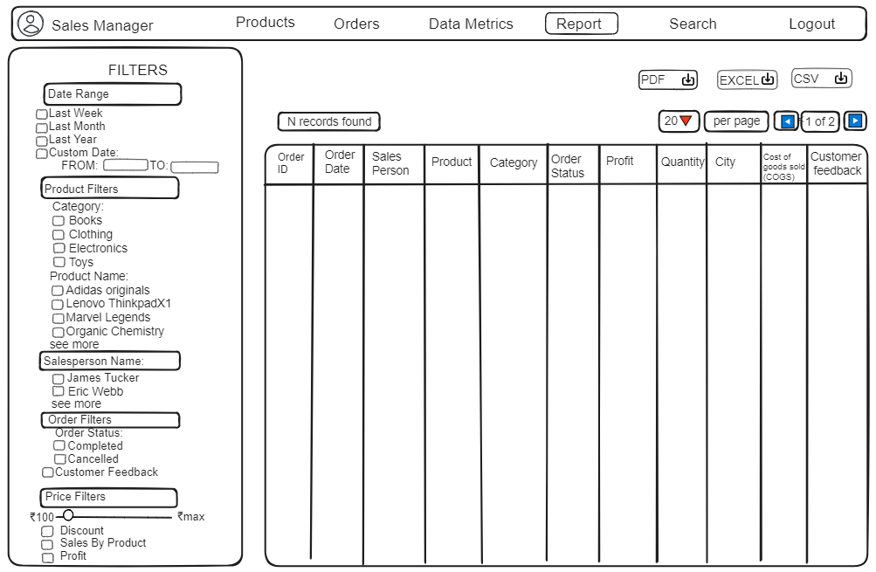

## **Overview**

This document describes the layout and functionality of the sales data report interface designed for Sales Manager. The report allows users to filter and analyse sales data based on various criteria and export the results in different formats.

## **Filters Section**

The Filters Section enables users to refine the displayed sales data. This section is divided into multiple sub-sections:

### **Time Period**

This filter allows users to select a specific time period for the sales data. Users can choose from predefined ranges or specify custom dates.

* **Options**:
  + **Last Week**: Filters data from the last seven days.
  + **Last Month**: Filters data from the previous month.
  + **Last Year**: Filters data from the previous year.
  + **Custom Date**: Users can define a custom date range by specifying the start (FROM) and end (TO) dates.

### **Product Filters**

This filter allows users to narrow down the sales data by specific product categories and names.

* **Category**:
  + **Books**: Filters sales data for products categorised as books.
  + **Clothing**: Filters sales data for clothing items.
  + **Electronics**: Filters sales data for electronic items.
  + **Toys**: Filters sales data for toys.
* **Product Name**:
  + **Adidas Originals**: Filters sales data for Adidas Originals products.
  + **Lenovo ThinkpadX1**: Filters sales data for Lenovo ThinkpadX1 products.
  + **Marvel Legends**: Filters sales data for Marvel Legends products.
  + **Organic Chemistry**: Filters sales data for Organic Chemistry products.
  + **See More**: Expands the list to show additional products.

### **Salesperson Name**

This filter allows users to filter the sales data by specific salespersons.

* **Options**:
  + **James Tucker**: Filters sales data for orders handled by James Tucker.
  + **Eric Webb**: Filters sales data for orders handled by Eric Webb.
  + **See More**: Expands the list to show additional salespersons.

### **Order Filters**

This filter allows users to filter the sales data based on order status and customer feedback.

* **Order Status**:
  + **Completed**: Filters data for orders that have been completed.
  + **Cancelled**: Filters data for orders that have been cancelled.
* **Customer Feedback**: Filters data to include orders with customer feedback.

### **Price Filters**

This filter allows users to filter the sales data based on price and additional financial metrics.

* **Price Range**: Users can specify a minimum and maximum price range (₹100 to ₹max).
* **Additional Filters**:
  + **Discount**: Filters data to include orders with discounts.
  + **Sales By Product**: Filters data based on sales by individual products.
  + **Profit**: Filters data to show profitable orders.

## **Report Section**

The Report Section displays the filtered sales data in a tabular format, with controls for pagination and exporting the data.

### **Data Table**

The table includes several columns that provide detailed information about each sales order:

* **Order ID**: A unique identifier for each order.
* **Order Date**: The date when the order was placed.
* **Salesperson**: The name of the salesperson handling the order.
* **Product**: The name of the product sold.
* **Category**: The category of the product sold.
* **Order Status**: The current status of the order (e.g., Completed, Cancelled).
* **Profit**: The profit earned from the order.
* **Quantity**: The number of items sold in the order.
* **City**: The city where the order was placed.
* **COGS (Cost of Goods Sold)**: The cost of goods sold for the order.
* **Customer Feedback**: Feedback received from the customer regarding the order.

### **Controls**

The controls section provides functionality to manage the display and export of the report data:

* **Records Found**: Displays the number of records that match the filter criteria.
* **Pagination**:
  + **Rows per page**: Allows users to select the number of rows to display per page (e.g., 20).
  + **Page Navigation**: Controls to navigate between pages of the report (e.g., Page 1 of 2).
* **Export Options**: Buttons to export the report data in different formats:
  + **PDF**: Export the report as a PDF document.
  + **Excel**: Export the report as an Excel spreadsheet.
  + **CSV**: Export the report as a CSV file.

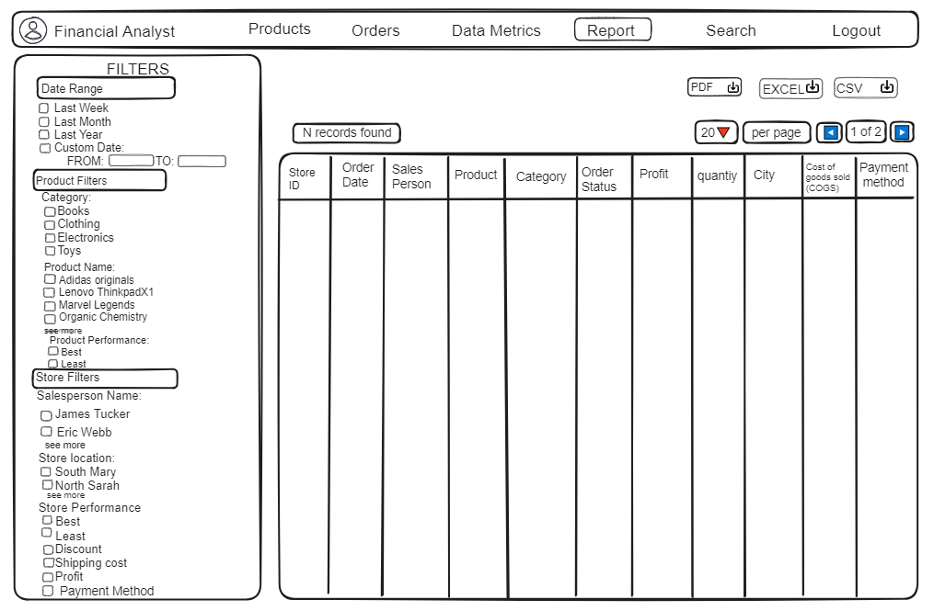

## 

## **Overview**

This document describes the layout and functionality of the sales data report interface designed for financial analysts. The interface provides various filters to refine the sales data and presents the results in a tabular format with export options.

## 

## **Filters Section**

The Filters Section is located on the left side of the interface. It allows users to apply different filters to the sales data, including time period, product details, salesperson information, and store-specific data.

**Time Period**

### This filter enables users to select the time frame for the sales data. Users can choose from predefined periods or specify custom dates.

* **Options**:
  + **Last Week**: Filters data from the last seven days.
  + **Last Month**: Filters data from the previous month.
  + **Last Year**: Filters data from the previous year.
  + **Custom Date**: Users can define a custom date range by specifying the start (FROM) and end (TO) dates.

### **Product Filters**

This filter allows users to refine the sales data based on product categories, specific product names, and product performance.

* **Category**:
  + **Books**: Filters sales data for products categorised as books.
  + **Clothing**: Filters sales data for clothing items.
  + **Electronics**: Filters sales data for electronic items.
  + **Toys**: Filters sales data for toys.
* **Product Name**:
  + **Adidas Originals**: Filters sales data for Adidas Originals products.
  + **Lenovo ThinkpadX1**: Filters sales data for Lenovo ThinkpadX1 products.
  + **Marvel Legends**: Filters sales data for Marvel Legends products.
  + **Organic Chemistry**: Filters sales data for Organic Chemistry products.
  + **See More**: Expands the list to show additional products.
* **Product Performance**:
  + **Best**: Filters data for top-performing products.
  + **Least**: Filters data for low-performing products.

### **Store Filters**

This filter allows users to refine the sales data based on salesperson information and store-specific criteria.

* **Salesperson Name**:
  + **James Tucker**: Filters sales data for orders handled by James Tucker.
  + **Eric Webb**: Filters sales data for orders handled by Eric Webb.
  + **See More**: Expands the list to show additional salespersons.
* **Store Location**:
  + **South Mary**: Filters data for the South Mary store.
  + **North Sarah**: Filters data for the North Sarah store.
  + **See More**: Expands the list to show additional storelocations.
* **Store Performance**:
  + **Best**: Filters data for top-performing stores.
  + **Least**: Filters data for low-performing stores.
* **Discount**: Filters data to include orders with discounts.
* **Shipping Cost**: Filters data based on shipping costs.
* **Profit**: Filters data to show profitable orders.
* **Payment Method**: Filters data based on the payment methods used.

## **Report Section**

The Report Section displays the filtered sales data in a table. This section is located on the right side of the interface and includes several columns that provide detailed information about each sales order.

### **Data Table**

The table includes the following columns:

* **Store ID**: Unique identifier for each store.
* **Order ID**: Unique identifier for each order.
* **Order Date**: The date when the order was placed.
* **Salesperson**: The name of the salesperson handling the order.
* **Product**: The name of the product sold.
* **Category**: The category of the product sold.
* **Order Status**: The current status of the order (e.g., Completed, Cancelled).
* **Profit**: The profit earned from the order.
* **Quantity**: The number of items sold in the order.
* **City**: The city where the order was placed.
* **COGS (Cost of Goods Sold)**: The cost of goods sold for the order.
* **Payment Method**: The method of payment used for the order.

### **Controls**

The controls section provides functionality to manage the display and export of the report data:

* **Records Found**: Displays the number of records that match the filter criteria.
* **Pagination**:
  + **Rows per page**: Allows users to select the number of rows to display per page (e.g., 20).
  + **Page Navigation**: Controls to navigate between pages of the report (e.g., Page 1 of 2).
* **Export Options**: Buttons to export the report data in different formats:
  + **PDF**: Export the report as a PDF document.
  + **Excel**: Export the report as an Excel spreadsheet.
  + **CSV**: Export the report as a CSV file.