# 

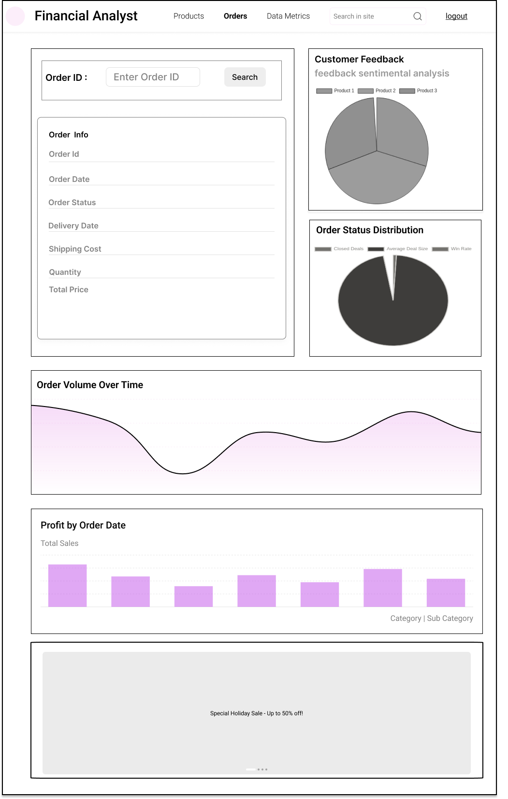

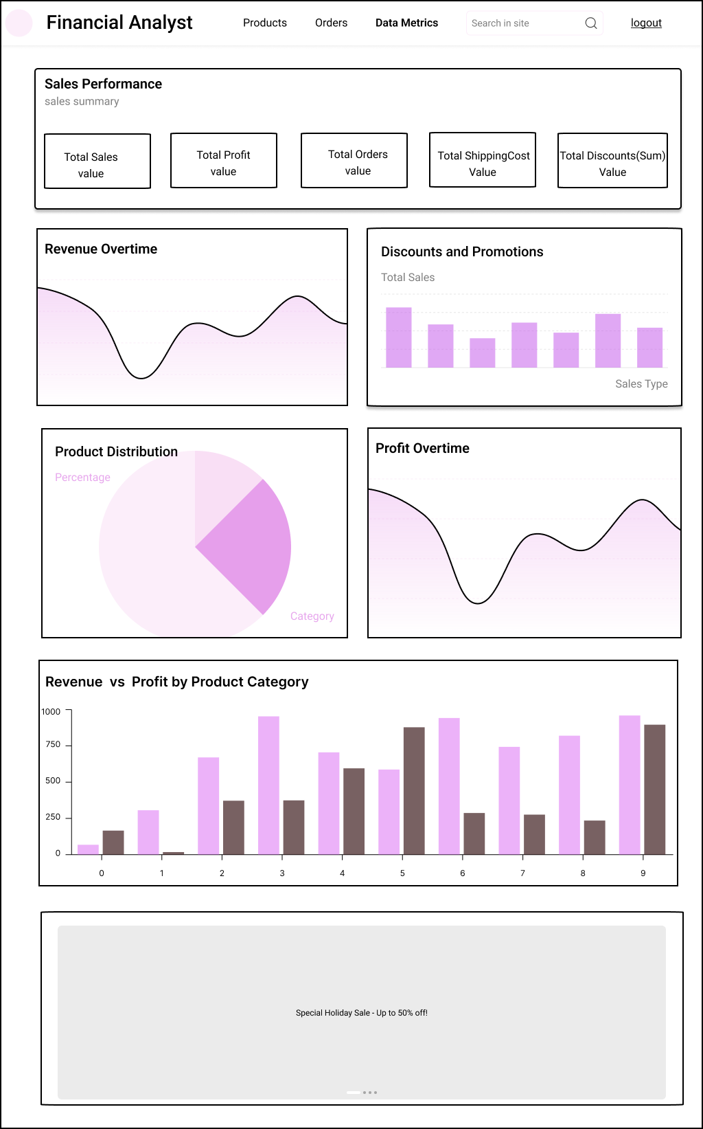

**Wireframe Documentation for Financial Analyst Dashboard**

**1. Introduction**

* **Purpose**: To provide a visual representation of the Financial Analyst Dashboard layout and functionality.
* **Audience**: Developers, designers, and testers involved in the project.
* **Tools Used**: Figma for wireframe creation.

**2. Overview**

* **Dashboard Name**: Financial Analyst
* **Description**: This dashboard provides an overview of sales performance, profit analysis, sales team performance, order analysis, customer feedback, and discounts and promotions.

**3. Wireframe**

## **Header Section**

* **Element**: Header
* **Description**: Contains the dashboard title, site search bar, and navigation links for different sections.

#### **Components:**

* **Logo**: Positioned on the left side of the header.
* **Title**: "Financial Analyst" next to the logo.
* **Navigation Links**:
  + **Products**: Navigates to the Products page.
  + **Contents**: Navigates to the Contents page.
  + **Data Metrics**: Navigates to the Data Metrics page (current page).
* **Site Search Bar**: Allows users to search for a specific store location.
* **Logout:** Allows to logout and exit from the dashboard

**Interactions**

* **Site Search Bar**:
  + **Function**: When a user types in the search bar, it suggests store locations based on the input.
  + **Result**: Upon selecting a store location, all the metrics and data visualizations on the dashboard update to reflect data for the selected store.
* **Products Page Link**:
  + **Function**: When the "Products" link is clicked, the user is navigated to the Products page.
  + **Result**: The Products page displays detailed information about the products, including product names, categories, subcategories, sales figures, and inventory status.
* **Contents Page Link**:
  + **Function**: When the "Contents" link is clicked, the user is navigated to the Contents page.
  + **Result**: The Contents page provides access to various content resources such as product descriptions, promotional materials, and marketing assets.
* **Data Metrics Page Link**:
  + **Function**: When the "Data Metrics" link is clicked, the user is navigated to the Data Metrics page.
  + **Result**: The Data Metrics page displays the dashboard with various sales and performance metrics, as outlined in the sections below.

#### **Logout Link:**

#### **Function**: When the "Logout" link is clicked, the user is securely logged out of the dashboard.

#### **Result**: The user is redirected to the login page or a confirmation screen, ensuring that their session is terminated and access to the financial data is securely closed. This helps to protect sensitive information and prevent unauthorized access.

* **For Products Page**

**Interactions**

* **Search Bar**:
  + **Function**: When a user enters a Product ID and clicks the search button, the Product Info Table updates to display information about the searched product.
  + **Result**: The Product Info Table refreshes to show details such as Product Name, Category, Subcategory, Unit Price, Quantity, Cost of Goods, and Profit.

**Section 1:**

1. **Product Information** 
   * **Components**:
     + **Product ID**: Input field for entering the Product ID.
     + **Search Button**: Initiates the search based on the entered Product ID.
   * **Product Info Table**:
     + - Product ID
       - Product Name
       - Category
       - Subcategory
       - Unit Price
       - Quantity
       - Cost of Goods
       - Profit
2. **Customer Feedback**
   * **Graph Type**: Pie Chart
   * **X-Axis**: Customer feedback
   * **Y-Axis**: Frequency
   * **Data Source**: CustomerFeedback column in OrderTable
   * **Filter**: StoreID
   * **Description**: Analyzes customer feedback to identify common themes or sentiments.
3. **Top Products**
   * **Table Columns**:
     + **Sr. No.**
     + **Product Name**
     + **Category**
   * **Filter**: StoreID
   * **Description**: Displays a table of top products.

**Section 2:**

1. **Sales Overtime**
   * **Graph Type**: Line Chart
   * **X-Axis**: OrderDate
   * **Y-Axis**: TotalSales (Sum of TotalPrice)
   * **Filter**: StoreID
   * **Description**: Visualizes total sales over a selected time period.

**Section 3:**

1. **Sales by Product Category and Subcategory**
   * **Graph Type**: Stacked Bar Chart
   * **X-Axis**: Category
   * **Y-Axis**: TotalSales (Sum of TotalPrice)
   * **Series**: Subcategory
   * **Join**: OrderTable and ProductTable on ProductID
   * **Filter**: StoreID
   * **Description**: Shows sales distribution across product categories and subcategories.

* **For Orders Page**

**Interactions**

* **Search Bar**:
  + **Function**: When a user enters a Order ID and clicks the search button, the Order Info Table updates to display information about the searched product.
  + **Result**: The Order Info Table refreshes to show details such as Order Date, Order Status, Delivery Date, Shipping Cost, Quantity, Total Price.

**Section 1:**

1. **Order Information**
   * **Components**:
     + **Order ID**: Input field for entering the Order ID.
     + **Search Button**: Initiates the search based on the entered Order ID.
   * **Order Info Table**:
     + **Columns**:
       - Order ID
       - Order Date
       - Order Status
       - Delivery Date
       - Shipping Cost
       - Quantity
       - Total Price
2. **Customer Feedback**
   * **Graph Type**: Pie Chart
   * **X-Axis**: Customer feedback
   * **Y-Axis**: Frequency
   * **Data Source**: CustomerFeedback column in OrderTable
   * **Filter**: StoreID
   * **Description**: Analyzes customer feedback to identify common themes or sentiments.
3. **Order Status Distribution**
   * **Graph Type**: Pie Chart
   * **X-Axis**: OrderStatus
   * **Y-Axis**: NumberOfOrders (Count of OrderID)
   * **Filter**: StoreID
   * **Description**: Shows the distribution of orders by their status.

**Section 2:**

1. **Order Volume Over Time**
   * **Graph Type**: Line Chart
   * **X-Axis**: OrderDate
   * **Y-Axis**: NumberOfOrders (Count of OrderID)
   * **Filter**: StoreID
   * **Description**: Illustrates the trend of order volumes over a specified period. This visualization provides a clear view of how the number of orders changes over time, enabling the financial analyst to identify patterns, peaks, and troughs in order activity.

**Section 3:**

1. **Profit by OrderDate**
   * **Graph Type**: Line Chart
   * **X-Axis**: OrderDate
   * **Y-Axis**: Profit (Sum of Profit)
   * **Filter**: StoreID
   * **Description**: Displays the profit margin over a selected time period.

* **For Data Metrics Page**

**Section 1:**

1. **Sales Performance**

**Sales Summary**

* + **Element**: Single Value KPIs
  + **Description**: Displays key performance indicators at a glance.
  + **Components**:
    - **Total Sales Value**: Shows the total sales amount.
    - **Total Profit Value**: Shows the total profit amount.
    - **Total Orders Value**: Displays the total number of orders.
    - **Total Shipping Value**: Shows the total shipping amount.
    - **Total Discount(Sum) Value**: Shows the total discount amount.

**Section 2:**

1. **Revenue Overtime**

* Graph Type: Line Chart
* X-Axis: OrderDate
* Y-Axis: Revenue (SUM(TotalPrice))
* Data: OrderDate, TotalPrice (from Order Table)

1. **Discounts and Promotions**
   * **Graph Type**: Bar Chart
   * **X-Axis**: SalesType (Discounted, Regular)
   * **Y-Axis**: TotalSales (Sum of TotalPrice)
   * **Data Source**: Derived from Discount column in OrderTable
   * **Filter**: StoreID
   * **Description**: Compares sales between discounted and regular priced items.

**Section 3:**

* + - * 1. **Profit Distribution**
  + **Graph Type**: Pie Chart
  + **X-Axis**: Category
  + **Y-Axis**: Profit (Sum of Profit)
  + **Filter**: StoreID
  + **Description**: Displays the profit distribution for categories.

1. **Profit Over Time**
   * **Graph Type**: Line Chart
   * **X-Axis**: OrderDate
   * **Y-Axis**: Profit (Sum of Profit)
   * **Filter**: StoreID
   * **Description**: Displays the profit margin over a selected time period.

**Section 4:**

1. **Revenue vs Profit by Product Category**
   * **Graph Type**: Bar Chart
   * **X-Axis**: Product Category
   * **Y-Axis**: Revenue (SUM(TotalPrice)) and Profit (SUM(Profit))
   * **Filter**: StoreID
   * **Description**: It features a bar chart that compares the total revenue and profit generated by each product category. This visualization is crucial for the financial analyst to assess the financial performance of different product categories, allowing for a detailed analysis of which categories are driving the most revenue and which are contributing the most profit.