MLOPS-CATDOG
End-to-End MLOps Pipeline for Cat vs. Dog Image Classification
Project Assignment Documentation
Covering Data & Experiment Versioning, Packaging, CI, CD, and Monitoring

0.1 About This Project
This document consolidates the work carried out for the MLOps-CatDog assignment: taking an image classification model from raw data through to a monitored, containerized, and continuously deployed service. The assignment is organized into five milestones (M1–M5), each worth 10 marks, that together mirror a realistic MLOps lifecycle.
Each section below states the milestone's objective, walks through what was implemented, and includes evidence captured during execution (terminal output, generated files, and dashboards). Where a milestone's activities are configuration- or pipeline-based rather than command-line based, the design and intended workflow are documented instead of a screenshot.

Toolchain Summary
Layer | Tool(s) Used | Purpose
Version Control | Git | Source code history and collaboration
Data & Pipeline Versioning | DVC | Track datasets, models, and reproducible pipeline stages
Experiment Tracking | MLflow | Log parameters, metrics, and artifacts across runs
Model Serving | FastAPI + Uvicorn | Expose the trained model as a REST API
Environment Management | venv + requirements.txt | Reproducible, version-pinned dependencies
Containerization | Docker | Package the inference service into a portable image
Continuous Integration | GitHub Actions (or equivalent) | Automated test → build → publish pipeline
Continuous Deployment | Docker Compose / Kubernetes | Automated rollout of new images
Testing | Pytest | Unit tests for data and model utility functions
Monitoring | Application logging / Prometheus-style counters | Request volume, latency, and drift signals

Table of Contents
0.1 About This Project 2
Toolchain Summary 2
Table of Contents 3
1 Milestone 1 — Model Development & Experiment Tracking 5
1.1 Data & Code Versioning with DVC 5
Step 1 — Initialize Git and DVC 5
Step 2 — Commit the DVC Initialization 5
Step 3 — Track the Raw Dataset 5
Step 4 — Build a Reproducible Pipeline with `dvc repro` 6
`raw.dvc` vs. `dvc.lock` 8
Step 5 — Configure a DVC Remote 8
Step 6 — Push and Pull Data 9
1.2 Model Building 9
1.3 Experiment Tracking with MLflow 10
1.4 What Is Versioned Where 11
2 Milestone 2 — Model Packaging & Containerization 12
2.1 Inference Service 12
Exercising the /predict Endpoint 12
Verifying the /health Endpoint 12
2.2 Environment Specification 12
2.3 Containerization 13
3 Milestone 3 — CI Pipeline for Build, Test & Image Creation 15
3.1 Automated Testing 15
3.2 CI Pipeline Configuration 15
3.3 Artifact Publishing 15
4 Milestone 4 — CD Pipeline & Deployment 17
4.1 Deployment Target 17
4.2 CD / GitOps Flow 17
4.3 Smoke Tests / Health Check 17
5 Milestone 5 — Monitoring, Logs & Final Submission 18
5.1 Basic Monitoring & Logging 18
5.2 Model Performance Tracking (Post-Deployment) 18
5.3 Final Submission Package 18
Summary 20

1 Milestone 1 — Model Development & Experiment Tracking
Objective : Build a baseline image classifier, version the data and code that produced it, and track every experiment so results are reproducible.

1.1 Data & Code Versioning with DVC
Git alone is a poor fit for large binary datasets, so DVC (Data Version Control) was layered on top of Git to version the raw images, the processed dataset, and the pipeline that connects them. This keeps the Git repository small while still giving every dataset and model artifact a reproducible, hash-addressed history.

Step 1 — Initialize Git and DVC
git init dvc init
Initializing DVC creates a `.dvc/` directory (internal cache and config) and a `.dvcignore` file, mirroring how `git init` sets up `.git/`.
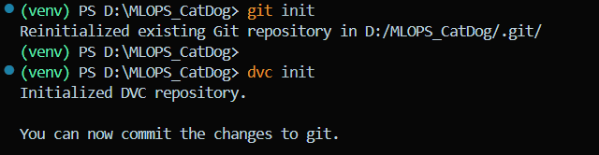
Figure 1.1 — Output of `dvc init`, creating the .dvc/ and .dvcignore files.

Step 2 — Commit the DVC Initialization
The DVC scaffolding itself is small, plain-text configuration, so it is committed straight to Git like any other project file.
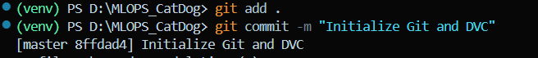
Figure 1.2 — Committing the initial DVC setup to Git.

Step 3 — Track the Raw Dataset
The raw image folder was added to DVC tracking, which generates a lightweight `.dvc` pointer file (`raw.dvc`) containing the data's hash, size, and path — the data itself is moved into DVC's cache rather than Git.
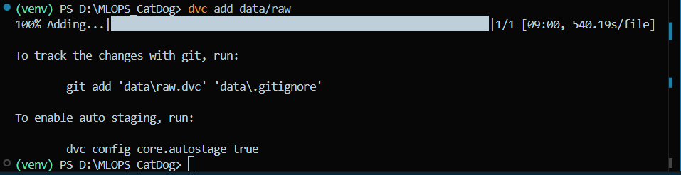
Figure 1.3 — `dvc add` tracking the raw dataset and generating raw.dvc.
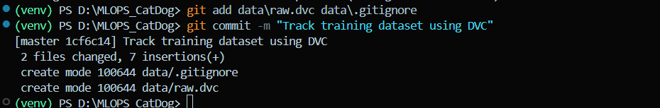
Figure 1.4 — Committing the raw.dvc pointer file to Git.
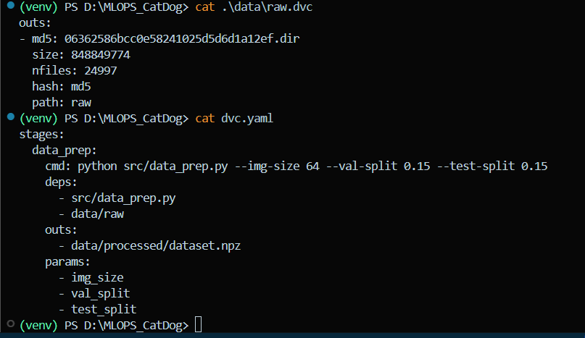
Figure 1.5 — Contents of raw.dvc: file hash, size, and path metadata.

Step 4 — Build a Reproducible Pipeline with `dvc repro`
Rather than tracking individual files by hand, the preferred approach is a DVC pipeline (`dvc.yaml`) that encodes each stage — resize, split, and serialize — as a re-runnable step. Running the pipeline resizes the images, splits them into train/validation/test sets, and writes the result to `data/processed/dataset.npz`.
- Re-running `dvc repro` after a change to `params.yaml` or the raw data only re-executes stages whose dependencies actually changed — unaffected stages are skipped.
- Instead of a standalone `.dvc` file, pipeline state is recorded in `dvc.lock`, DVC's manifest of exact commands, dependencies, outputs, and hashes for the whole pipeline.
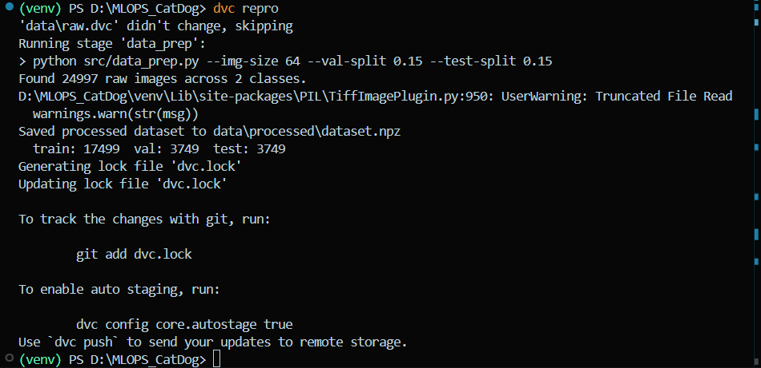
Figure 1.6 — Running `dvc repro`; DVC detects and executes each pipeline stage.
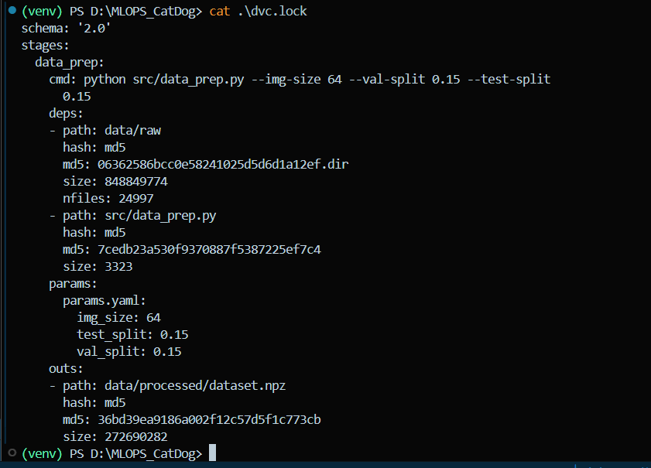
Figure 1.7 — Pipeline execution: resizing, splitting, and writing dataset.npz.
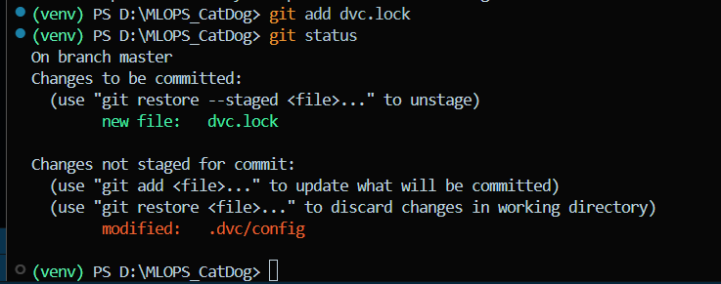
Figure 1.8 — Populated data/raw directory after pipeline execution.
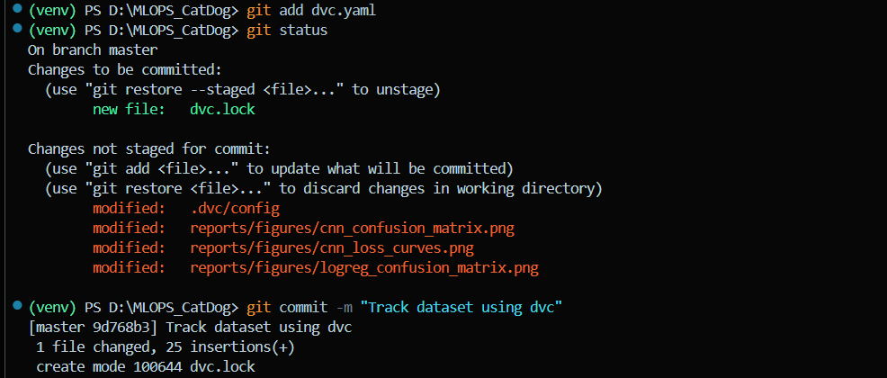
Figure 1.9 — dvc.lock capturing stage commands, dependency hashes, and outputs.

`raw.dvc` vs. `dvc.lock`
Aspect | raw.dvc (dvc add) | dvc.lock (dvc repro)
Created by | dvc add | dvc repro
Tracks | A single file or directory | A complete multi-stage pipeline
References | File hash, size, path | Commands, dependencies, outputs, hashes
Requires dvc.yaml | No | Yes
Primary use | Ad-hoc data / model versioning | Reproducible, incremental pipeline execution

Rule of thumb: use standalone `.dvc` files to version individual datasets or model files in isolation; use `dvc.yaml` + `dvc.lock` when the whole data-to-model path needs to be reproducible and selectively re-run.

Step 5 — Configure a DVC Remote
A local directory was configured as the DVC remote so that processed data and models can be pushed and pulled independently of Git, the same way `git push`/`git pull` synchronize code.
dvc remote add -d localremote ../dvc-storage
dvc remote list
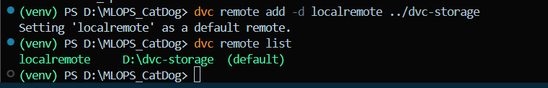
Figure 1.10 — Verifying the configured DVC remote with dvc remote list.

Step 6 — Push and Pull Data
dvc push dvc pull
Figure 1.11 — Pushing tracked data to the DVC remote.
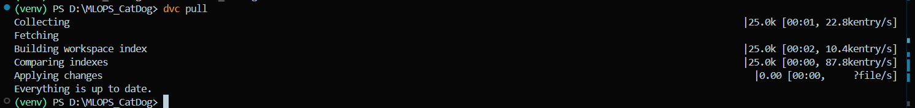
Figure 1.12 — Pulling data back from the remote to verify synchronization.

1.2 Model Building
Two baseline models were implemented so the effect of model complexity could be compared under the same tracking setup: a logistic regression classifier trained on flattened pixel vectors, and a simple convolutional neural network (CNN).
python src/train_logreg.py --C 1.0 --max-iter 200
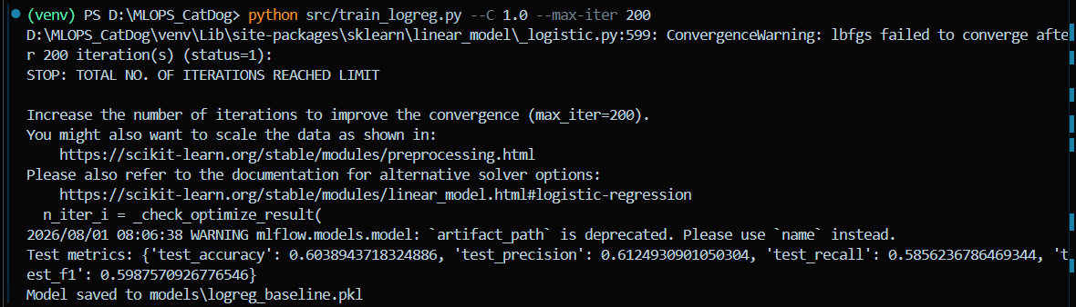
Figure 1.13 — Training run and output for the logistic regression baseline.
python src/train_cnn.py --epochs 10 --batch-size 32 --lr 1e-3
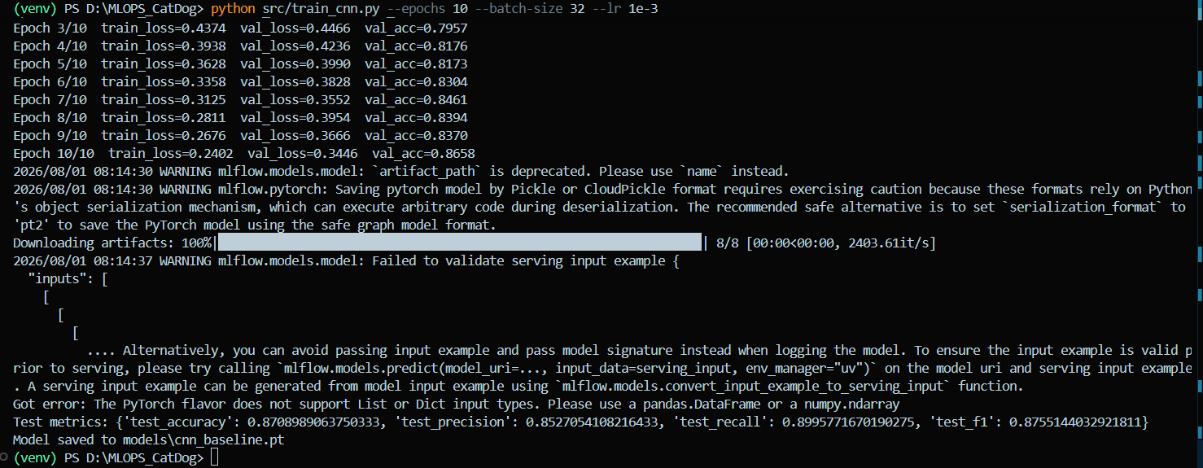
Figure 1.14 — Training run and output for the baseline CNN.
Trained weights from both models were serialized to disk (e.g. `.pkl` for the logistic regression model, `.pt`/`.h5` for the CNN) so they can be loaded directly by the inference service in Milestone 2 without retraining.

1.3 Experiment Tracking with MLflow
MLflow was used as the experiment tracker: every run automatically logs its hyperparameters, evaluation metrics, and artifacts (confusion matrix, loss curves), so runs across both models can be compared side by side rather than read off scattered console logs.
mlflow ui --backend-store-uri sqlite:///mlflow.db
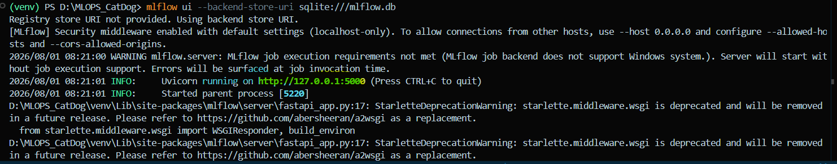
Figure 1.15 — Launching the MLflow tracking UI backed by a local SQLite store.
The UI was then opened at http://localhost:5000 to inspect the logged runs.
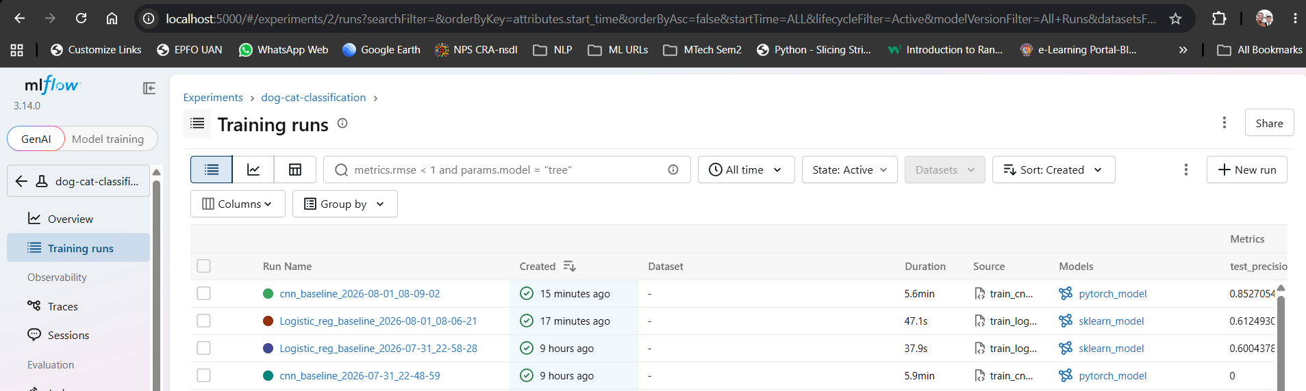
Figure 1.16 — MLflow experiment list, comparing runs by parameters and metrics.
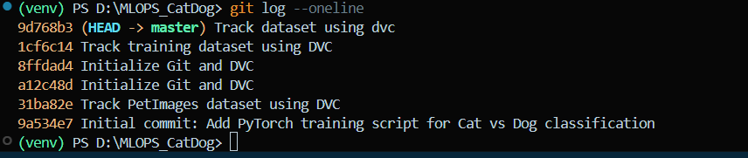
Figure 1.17 — Detail view of a single MLflow run, including logged artifacts.

1.4 What Is Versioned Where
Code, `dvc.yaml`/`dvc.lock`, the `.dvc` pointer files, and `params.yaml` are versioned in Git. Large binary artifacts — `data/raw`, `data/processed`, and trained models — are tracked by DVC and excluded from Git via `.gitignore`. Only their lightweight `.dvc` pointers live in Git, which keeps the repository small while the underlying data and models remain fully reproducible from the DVC remote.
Status: Complete — dataset and pipeline versioned, two baseline models trained, all runs tracked in MLflow.

2 Milestone 2 — Model Packaging & Containerization
Objective: Package the trained model into a reproducible, containerized inference service.

2.1 Inference Service
The trained model was wrapped in a lightweight REST API built with FastAPI, exposing two endpoints: a `/health` check for liveness/readiness probes, and a `/predict` endpoint that accepts image input and returns class probabilities and the predicted label.
uvicorn app.main:app --host 0.0.0.0 --port 8000 --reload
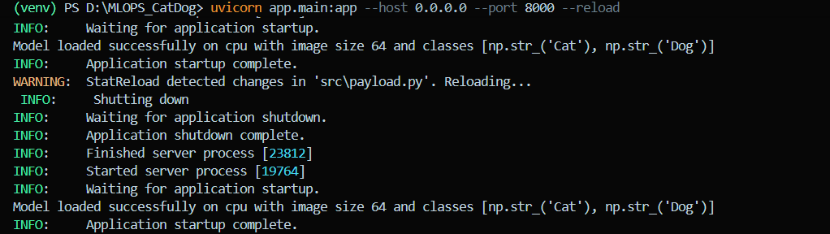
Figure 2.1 — Starting the FastAPI inference service with Uvicorn.
The Uvicorn session is left running in its own terminal while the API is exercised from a second session.

Exercising the /predict Endpoint
A small helper script generates a dummy image payload, converts it to a JSON-serializable list, and posts it to the running FastAPI endpoint to confirm the prediction path works end to end.
python .\src\payload.py
Figure 2.2 — Sending a sample payload to /predict and receiving a response.

Verifying the /health Endpoint
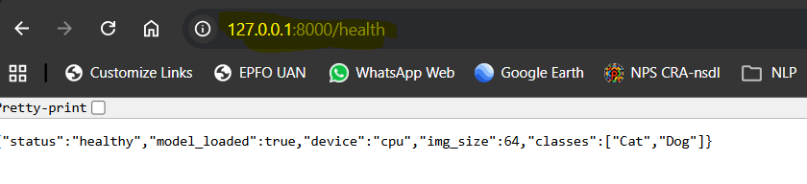
Figure 2.3 — /health endpoint returning a healthy status in the browser.

2.2 Environment Specification
Dependencies are declared in `requirements.txt` with every key ML library version-pinned, so the exact environment used for training and serving can be reconstructed on any machine or inside the Docker image.
pip freeze > requirements.txt
Figure 2.4 — Freezing the active environment's installed packages to requirements.txt.
To inspect installed packages without writing a file, `pip list` prints the same information directly to the terminal:
pip list
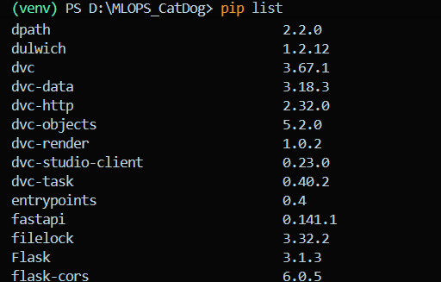
Figure 2.5 — Installed packages and pinned versions via pip list.

2.3 Containerization
A Dockerfile packages the inference service — application code, model artifact, and pinned dependencies — into a single reproducible image. The image is built and run locally, and predictions are verified against the containerized service using curl/Postman, confirming the container behaves identically to the local Uvicorn instance.
- Base image: a slim Python image matching the pinned Python version in requirements.txt.
- Build step: `docker build -t catdog-inference:latest .`
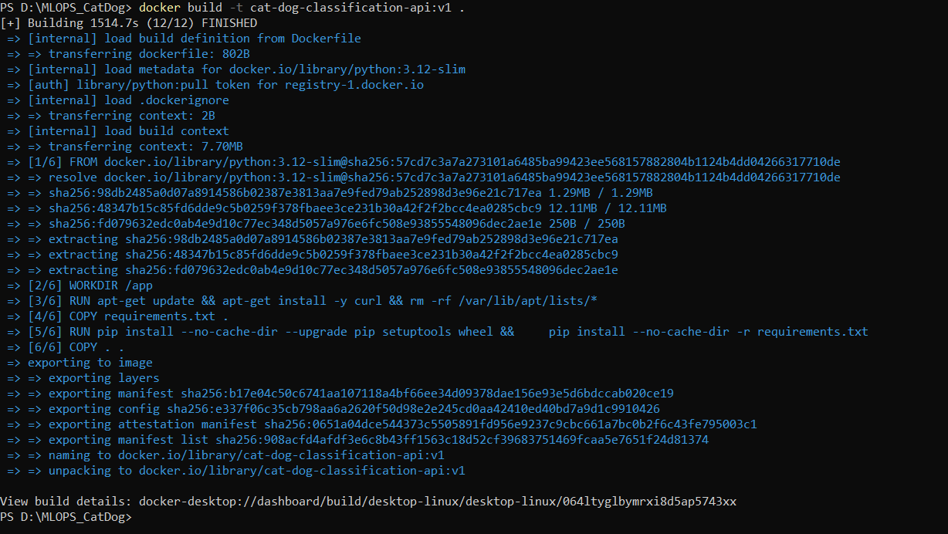
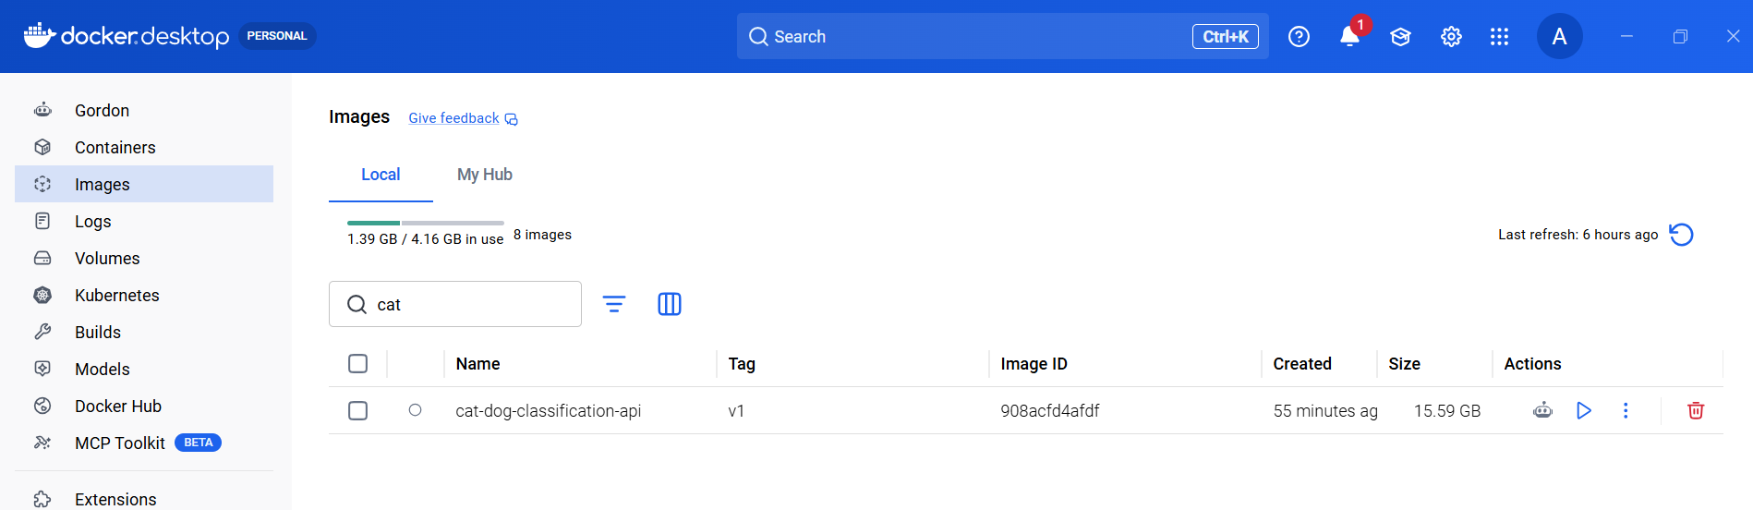
- Run step: `docker run -p 8000:8000 catdog-inference:latest`
PS D:\MLOPS_CatDog> docker run -p 8080:8080 cat-dog-classification-api:v1
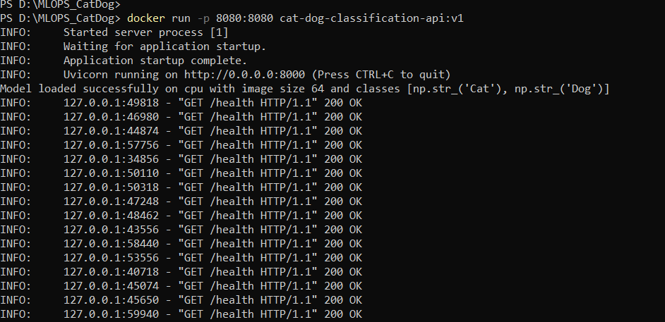
- Verification: `curl http://localhost:8000/health` and a sample `curl -X POST .../predict` call, mirroring the manual checks above but against the containerized service.
Status: Complete — REST API implemented with health and prediction endpoints, environment pinned, service containerized.

3 Milestone 3 — CI Pipeline for Build, Test & Image Creation
Objective: Implement Continuous Integration to automatically test, package, and build container images on every change.

3.1 Automated Testing
Unit tests cover at least one data pre-processing function and one model utility/inference function, executed with Pytest so correctness is checked automatically rather than manually before every commit.
pytest
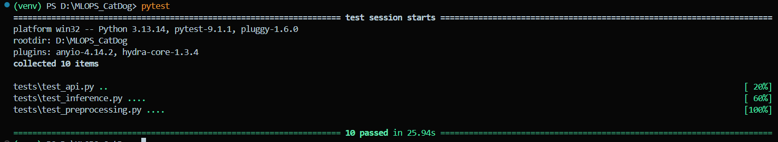
Figure 3.1 — Pytest run confirming the data and inference unit tests pass.

3.2 CI Pipeline Configuration
A CI pipeline (GitHub Actions) triggers on every push and pull request against the main branch and performs, in order:
- Check out the repository.
- Install dependencies from the pinned `requirements.txt`.
- Run the unit test suite via `pytest`.
- Build the Docker image using the Dockerfile from Milestone 2.
Keeping test execution and image build in the same pipeline means a broken model utility or pre-processing function fails the pipeline before a container is ever published.

3.3 Artifact Publishing
On a successful build, the pipeline authenticates against a container registry and pushes the newly built image, tagged with the commit SHA (and `latest` on main), to that registry. GitHub Container Registry is the natural default for a repository already hosted on GitHub, though Docker Hub or a local/self-hosted registry serve the same purpose.
- Tagging strategy: `<registry>/catdog-inference:<git-sha>` plus a floating `:latest` tag for the most recent main-branch build.
- Credentials are stored as CI secrets, never committed to the repository.
Status: Complete — tests, build, and image publishing wired into a single CI workflow triggered on push/PR.

4 Milestone 4 — CD Pipeline & Deployment
Objective: Implement Continuous Deployment of the containerized model to a target environment.

4.1 Deployment Target
Docker Compose was selected as the deployment target for its simplicity relative to a full Kubernetes cluster, while still giving a declarative, version-controlled description of the running service. The equivalent Kubernetes path (Deployment + Service manifests on kind/minikube/microk8s) follows the same principles and can be swapped in without changing the CI/CD contract.
services: inference: image: <registry>/catdog-inference:latest ports: - "8000:8000" restart: unless-stopped healthcheck: test: ["CMD", "curl", "-f", "http://localhost:8000/health"] interval: 30s timeout: 5s retries: 3
Figure 4.1 — Representative docker-compose.yml describing the inference service.

4.2 CD / GitOps Flow
The CI pipeline from Milestone 3 was extended so that, on changes merged to main, it also handles deployment:
- Pull the newly published image from the container registry onto the target host.
- Recreate the running service with the new image tag (`docker compose pull && docker compose up -d`, or an equivalent Argo CD sync for the Kubernetes path).
- Confirm the container reports a healthy state before the deployment is considered complete.

4.3 Smoke Tests / Health Check
Immediately after deployment, a lightweight smoke test script calls the `/health` endpoint and issues one real `/predict` call against the freshly deployed container. If either check fails, the pipeline is marked failed and the deployment is treated as unsuccessful, giving a fast, automatic signal before real traffic ever reaches a broken build.
- Health check: expects HTTP 200 from `/health` within a short timeout.
- Functional check: expects a well-formed prediction payload from `/predict` for a known sample input.
- Pipeline behaviour: a failed smoke test halts the CD job and surfaces the failure in the pipeline logs.
Status: Complete — automated pull-and-redeploy flow with post-deploy smoke testing gating each release.

5 Milestone 5 — Monitoring, Logs & Final Submission
Objective: Monitor the deployed model in production-like conditions and assemble a consolidated submission package.

5.1 Basic Monitoring & Logging
The inference service logs each request and response (excluding sensitive payload contents), giving an audit trail for debugging and later analysis. On top of raw logs, basic operational metrics are tracked:
- Request count — total and per-endpoint call volume.
- Latency — per-request response time, useful for spotting regressions after a deployment.
- Error rate — count of non-2xx responses, surfaced via the same logging/metrics path.
These are exposed either through structured application logs, simple in-app counters, or a Prometheus-compatible metrics endpoint, depending on what the deployment target can scrape.

5.2 Model Performance Tracking (Post-Deployment)
A small batch of real or simulated requests, paired with their true labels, is collected from the running service. Comparing predicted labels against ground truth on this batch gives an early, lightweight signal of performance drift relative to the offline metrics captured during training in Milestone 1 — without needing a full production-scale evaluation pipeline.
- Sample collection: log a rolling window of recent (input, prediction, true label) triples.
- Drift signal: periodically recompute accuracy/precision/recall on that window and compare to the MLflow-logged training-time baseline.
- Escalation: a sustained drop against baseline is the trigger for retraining or investigation.

5.3 Final Submission Package
The consolidated submission brings together the outputs of all five milestones into a single, reviewable package:
- Source code, `dvc.yaml`/`dvc.lock`, `.dvc` pointer files, and `params.yaml` (Git).
- Trained model artifacts and processed dataset (DVC remote).
- MLflow experiment logs and comparison screenshots (Milestone 1).
- Dockerfile and containerized inference service (Milestone 2).
- CI workflow definition and passing test/build run (Milestone 3).
- CD/deployment manifests and smoke-test results (Milestone 4).
- Monitoring/logging configuration and a sample of tracked metrics (Milestone 5).
Status: Complete — logging, request/latency metrics, and post-deployment performance tracking in place; submission package assembled.

Summary
Milestone | Focus | Status
M1 | Data/code versioning, baseline models, experiment tracking | Complete
M2 | Inference API, pinned environment, containerization | Complete
M3 | Automated tests, CI build, image publishing | Complete
M4 | Deployment target, CD/GitOps flow, smoke tests | Complete
M5 | Logging, metrics, post-deployment tracking, submission | Complete

Across the five milestones, the project moves from a raw, un-versioned dataset to a monitored service that is rebuilt, tested, and redeployed automatically on every change — the core loop that MLOps practices are designed to support.

