PROJECT TITLE: MONTHLY LAND INSTALLMENT PAYMENT SYSTEM.

STUDENT NAME: ATUKWATSE AVIN
REG NO: 2025/BCS/056/PS
COURSE UNIT: DATABASE SYSTEMS
COURSE CODE: CSC 1204
INSTITUTION: MBARARA UNIVERSITY OF SCIENCE AND TECHNOLOGY
FACULTY: COMPUTING AND INFORMATICS
PROGRAM: BACHELOR OF SCIENCE COMPUTER SCIENCE
SUBMISSION DATE: Thursday, 7th May, 2026

MONTHLY LAND INSTALLMENT PAYMENT SYSTEM.
1. Executive Summary
This report presents the design and practical implementation of a database-driven Monthly Land Installment Payment System, developed to address a common operational challenge in land sales organisations: keeping accurate, up-to-date records of monthly payments made by clients purchasing plots on a deferred payment basis. The system provides staff with tools to record each payment event, maintain a running balance per client account, and dispatch timely notifications through multiple communication channels.
The database was built using MySQL, which handles all core data operations including inserting, updating, and querying payment records. The schema uses well-defined tables linked by foreign key constraints, ensuring that every payment record is tied to a valid client, plot, and staff member. Sample data was loaded and a set of representative queries were executed to confirm that the system returns accurate and useful results.
This report walks through the full development process, covering the business case, logical and physical database designs, system implementation with table descriptions and query outputs, user interface design, and a concluding reflection on what was achieved.

2. Business Case
The purpose of the system is to collect and manage monthly land installment payment data for clients purchasing plots on a deferred payment schedule. This helps land-selling organisations to track payment status, identify overdue accounts, and send timely notifications to clients.

Application domain of the system.
This system supports real estate and land sales businesses by allowing:
- Staff to record each monthly installment payment per client and plot.
- Management to monitor outstanding balances and overdue payments.
- The system to automatically send payment reminders and confirmations to clients.
- Decision-making to identify trends in payment patterns and client reliability.
It has both tangible and intangible benefits;
Tangible Benefits include;
- Efficient recording and retrieval of installment payment data.
- Improved decision-making through structured financial records.
- Accountability tracking for both clients and processing staff.
- Better cash flow management for the land-selling organisation.
Intangible Benefits include;
- Enhanced client trust through timely and accurate payment notifications.
- Improved staff efficiency in payment processing.
- Reduced disputes due to transparent and auditable payment records.
The system has also got costs which are both tangible and intangible;
- Tangible costs: Development and database hosting expenses; staff training and IT support.
- Intangible costs: Resistance to adopting a digital payment tracking system; data privacy concerns regarding client financial information.
User Issues about the system are;

- There is need for basic computer skills to use the system.
- Need for training requirements for both clients and land sales staff.
Risks involved within the system include;
- Unauthorised access to sensitive financial and client data.
- Incorrect data entry leading to inaccurate payment records.
- Technical failures affecting data availability.
Limitations:
- Limited access for clients who are not digitally connected.
- Dependence on staff to enter data accurately and on time.
- No multi-currency support in the current design.
- Language barrier for non-English-speaking clients.

3. Database design based on the requirements.
Logical design
a. List of Entities:
- Client (clients)
- Plot / Parcel (parcels)
- Staff / Agent (agents)
- MonthlyLandInstallment (monthly_land_installments)
- InstallmentNotification (installment_notifications)

b. Entities and Attributes:
- Client: client_id, Name, Phone, Email, National ID, Address
- Plot: parcel_id, Description, Location, Size, Total Value
- Staff: agent_id, Name, Role, Phone, Email
- MonthlyLandInstallment: installment_id, sales_month, period_start, period_end, sale_id, plot_id, client_id, staff_id, installment_no, total_price, installment_amount, amount_paid, balance_remaining, due_date, paid_date, payment_method, status, is_open, notes, created_at, updated_at
- InstallmentNotification: notification_id, installment_id, notification_type, channel, client_id, sent_by, message, is_sent, sent_at, read_at, created_at

c. Entity Relationships:
Client – MonthlyLandInstallment relationship:
A client can have many installment records. This is a one-to-many relationship. Multiplicity is 1:n
Plot – MonthlyLandInstallment relationship:
A plot can be associated with many installment payment records. This is a one-to-many relationship. Multiplicity is 1:n
Staff – MonthlyLandInstallment relationship:
One staff member can process many installments. This is a one-to-many relationship. Multiplicity is 1:n
MonthlyLandInstallment – InstallmentNotification relationship:
Each installment can generate many notifications (reminders, confirmations, overdue alerts). This is a one-to-many relationship. Multiplicity is 1:n
Client – InstallmentNotification relationship:
Each notification is directed at one client, while a client can receive many notifications. Multiplicity is n:1

e. A comprehensive ERD for my database.

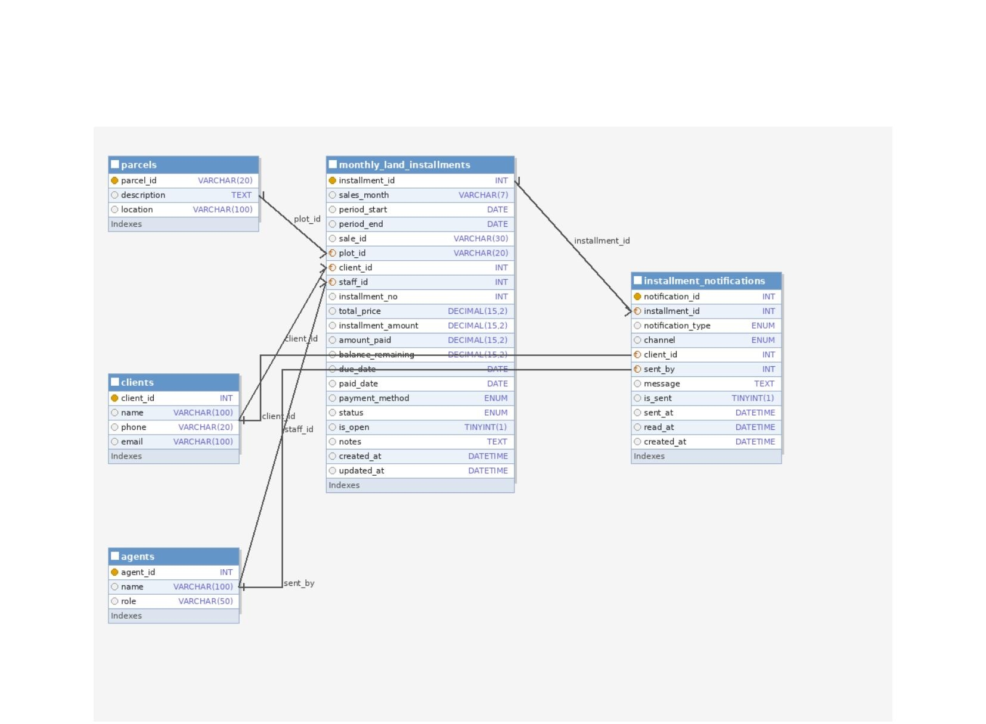
ERD — Monthly Land Installment Payment System

The Physical Design;
The Database Schema:
Table Name | Attributes | Primary Key | Foreign Keys
monthly_land_installments | installment_id, sales_month, period_start, period_end, sale_id, plot_id, client_id, staff_id, installment_no, total_price, installment_amount, amount_paid, balance_remaining, due_date, paid_date, payment_method, status, is_open, notes, created_at, updated_at | installment_id | plot_id, client_id, staff_id
installment_notifications | notification_id, installment_id, notification_type, channel, client_id, sent_by, message, is_sent, sent_at, read_at, created_at | notification_id | installment_id, client_id, sent_by

f. User Interface:
This system should be able to allow the user to enter information regarding installment payments, notifications, clients, plots and staff, and then store them.

Below is the interface for the Installment Payments.

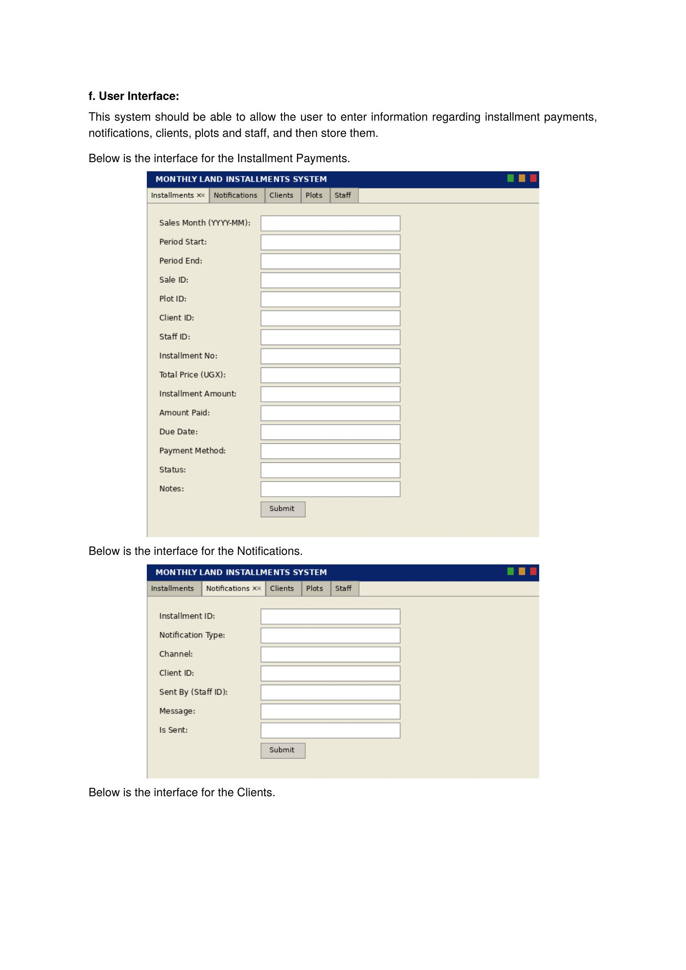

Below is the interface for the Notifications.

Below is the interface for the Clients.

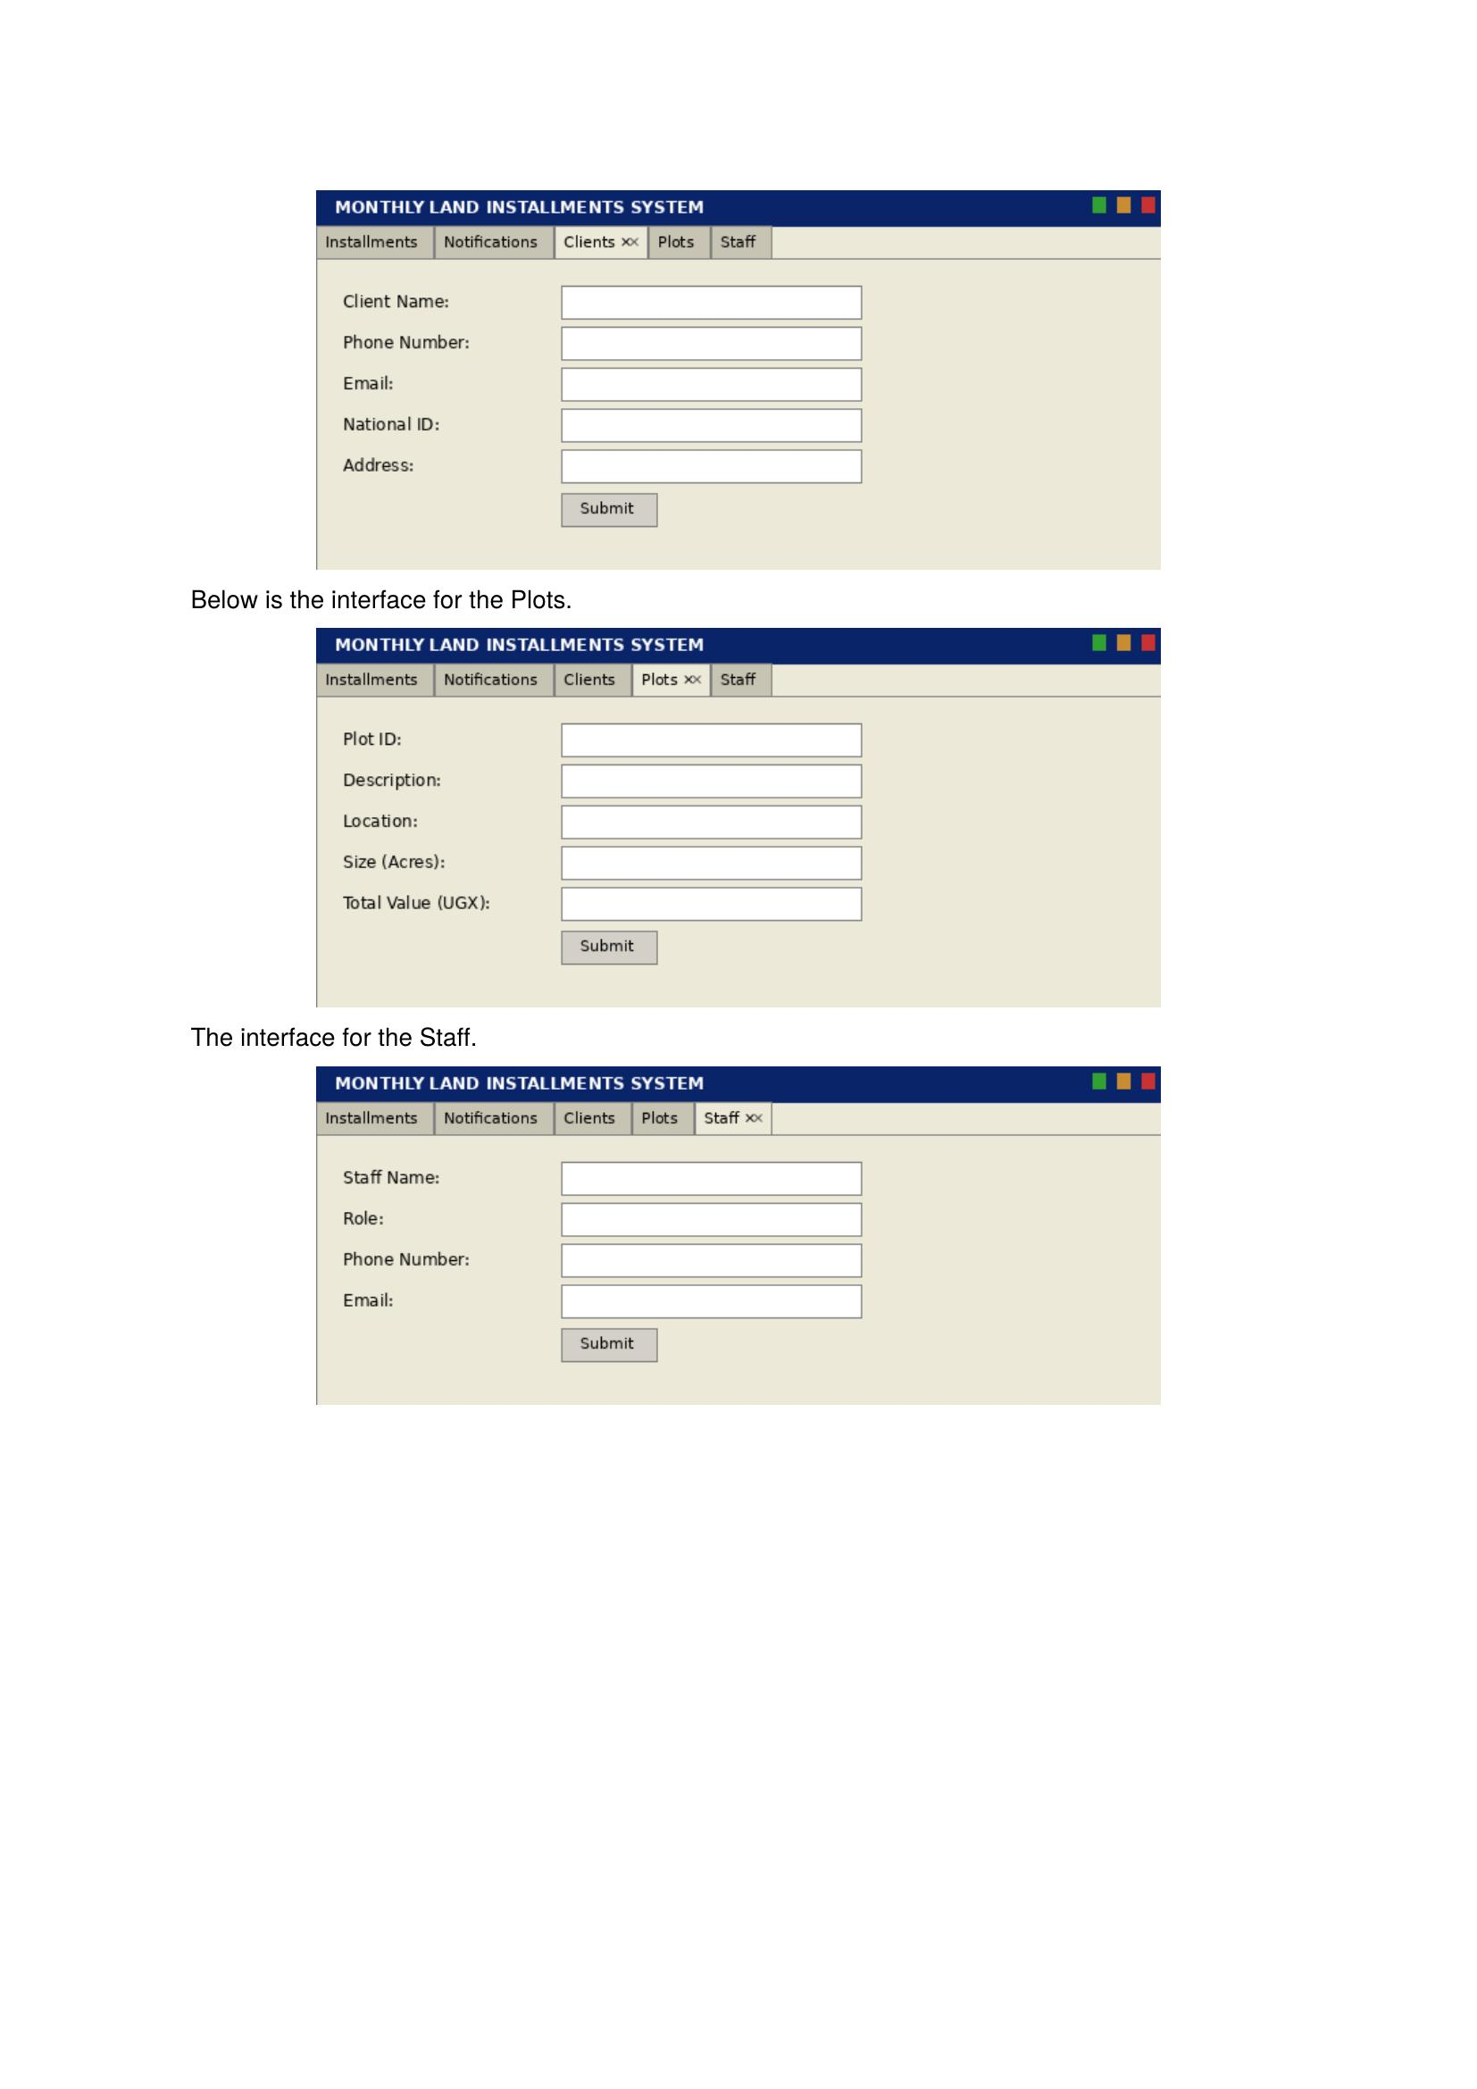

Below is the interface for the Plots.

The interface for the Staff.

PHYSICAL DESIGN.
The following SQL code is the physical implementation of the Monthly Land Installment Payment System which creates tables for the entities above.

SHOW DATABASES

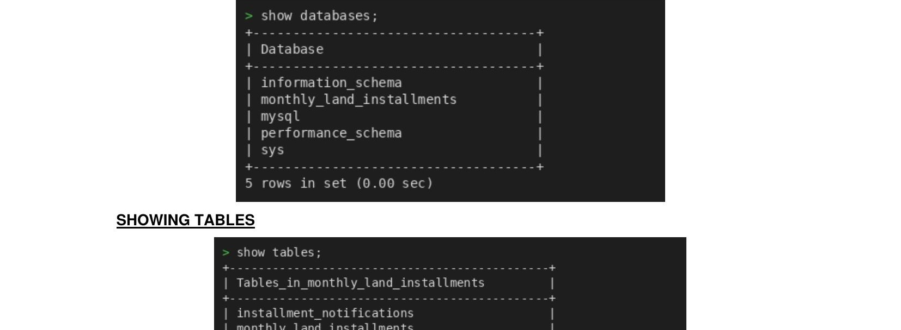

SHOWING TABLES

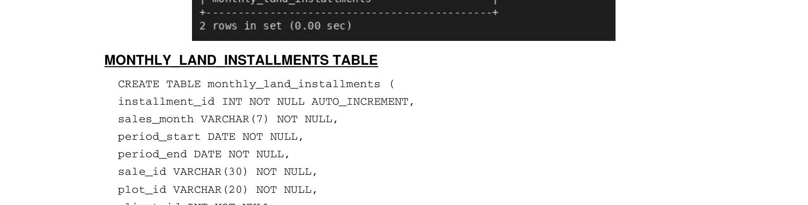

MONTHLY_LAND_INSTALLMENTS TABLE

CREATE TABLE monthly_land_installments (
installment_id INT NOT NULL AUTO_INCREMENT,
sales_month VARCHAR(7) NOT NULL,
period_start DATE NOT NULL,
period_end DATE NOT NULL,
sale_id VARCHAR(30) NOT NULL,
plot_id VARCHAR(20) NOT NULL,
client_id INT NOT NULL,
staff_id INT NOT NULL,
installment_no INT NOT NULL DEFAULT 1,
total_price DECIMAL(15,2) NOT NULL DEFAULT 0,
installment_amount DECIMAL(15,2) NOT NULL DEFAULT 0,
amount_paid DECIMAL(15,2) NOT NULL DEFAULT 0,
balance_remaining DECIMAL(15,2) NOT NULL DEFAULT 0,
due_date DATE NOT NULL,
payment_method ENUM('Cash','Bank Transfer','Mobile Money','Cheque') NOT NULL,
status ENUM('Pending','Paid','Overdue','Partially Paid','Cancelled') NOT NULL
DEFAULT 'Pending',
is_open TINYINT(1) NOT NULL DEFAULT 1,
notes TEXT DEFAULT NULL,
created_at DATETIME NOT NULL DEFAULT CURRENT_TIMESTAMP,
updated_at DATETIME NOT NULL DEFAULT CURRENT_TIMESTAMP ON UPDATE CURRENT_TIMESTAMP,
PRIMARY KEY (installment_id),
FOREIGN KEY (plot_id) REFERENCES parcels(parcel_id),
FOREIGN KEY (client_id) REFERENCES clients(client_id),
FOREIGN KEY (staff_id) REFERENCES agents(agent_id)

) ENGINE=InnoDB DEFAULT CHARSET=utf8mb4;

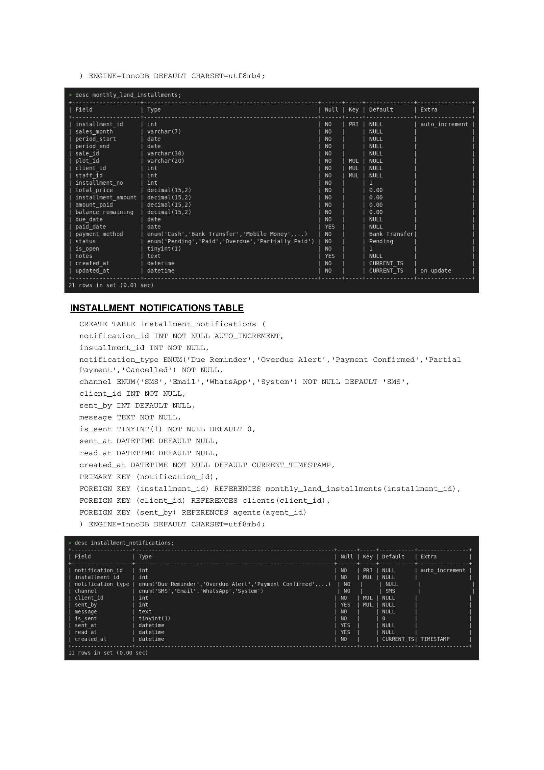

INSTALLMENT_NOTIFICATIONS TABLE

CREATE TABLE installment_notifications (
notification_id INT NOT NULL AUTO_INCREMENT,
installment_id INT NOT NULL,
notification_type ENUM('Due Reminder','Overdue Alert','Payment Confirmed','Partial
Payment','Cancelled') NOT NULL,
channel ENUM('SMS','Email','WhatsApp','System') NOT NULL DEFAULT 'SMS',
client_id INT NOT NULL,
sent_by INT DEFAULT NULL,
message TEXT NOT NULL,
is_sent TINYINT(1) NOT NULL DEFAULT 0,
sent_at DATETIME DEFAULT NULL,
read_at DATETIME DEFAULT NULL,
created_at DATETIME NOT NULL DEFAULT CURRENT_TIMESTAMP,
PRIMARY KEY (notification_id),
FOREIGN KEY (installment_id) REFERENCES monthly_land_installments(installment_id),
FOREIGN KEY (client_id) REFERENCES clients(client_id),
FOREIGN KEY (sent_by) REFERENCES agents(agent_id)
) ENGINE=InnoDB DEFAULT CHARSET=utf8mb4;

IMPLEMENTATION
This includes screenshots of implemented systems, descriptions of tables, queries and their results.

Table descriptions.

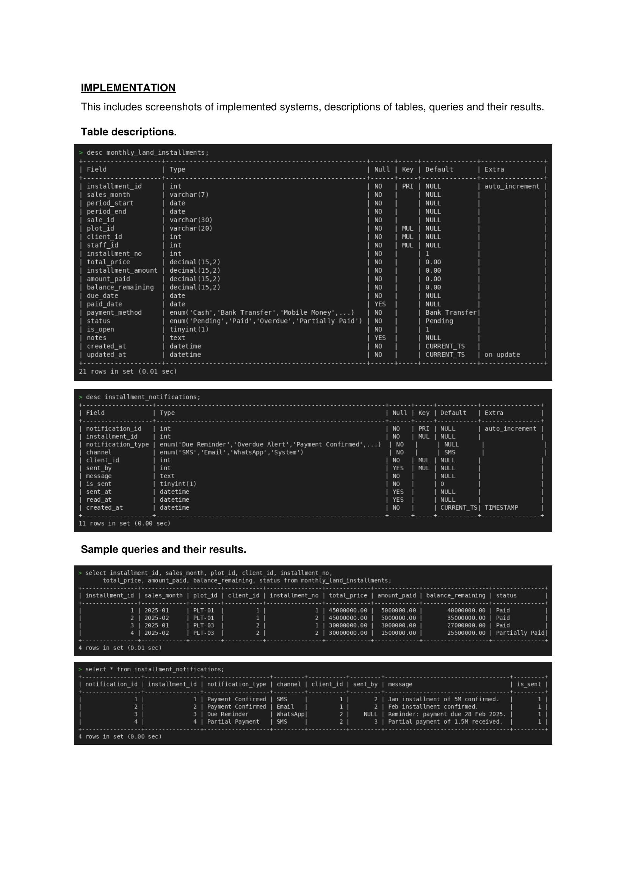

Sample queries and their results.

5. Conclusion.
The Monthly Land Installment Payment System brings order to a process that many land sales organisations still manage through paper ledgers or disconnected spreadsheets. By capturing every monthly payment against a structured relational schema, the system maintains an accurate running balance for each client account, flags overdue records automatically, and lays the groundwork for multi-channel client notifications through SMS, Email, and WhatsApp. The combination of foreign key constraints, ENUM-enforced status fields, and DECIMAL-typed monetary columns means the data remains consistent and arithmetically precise regardless of how many transactions are recorded. Query results confirmed that management can extract the financial summaries they need, from full payment histories down to filtered views of overdue accounts, without any manual consolidation.

6. Bibliography
- MySQL Documentation: https://dev.mysql.com/doc/
- Connolly, T. & Begg, C. — Database Systems: A Practical Approach to Design, Implementation, and Management, 6th Edition.
- Eclipse Foundation. (2025). Eclipse IDE for Java Developers. https://www.eclipse.org/
- Database design tutorials from W3Schools: https://www.w3schools.com/sql/

