ASSIGNMENT – 1 Name: Avinaash Venkat B
TOPIC : STRINGS
- Domain Checker Program
Flowchart Pseudocode
(Oval)
START
(Parallelogram)
Enter Email Address
(Diamond)
Does email contain "@gmail.com" ?
(Parallelogram)
Display "Email is Valid"
(Parallelogram)
Display "Email is not valid"
(Oval)
END
Code
n = input("Enter the Email Address: ").strip()
if '@gmail.com' in n:
print("Email is Valid")
else:
print("Email is not valid")
ouput:

- Reverse Password Program
Flowchart Pseudocode
(Oval)
START
(Parallelogram)
Enter password
(Parallelogram)
Enter method choice
(Diamond)
Is method equal to 1 ?
(Parallelogram)
Display password in reverse order
(Diamond)
Is method equal to 2 ?
(Parallelogram)
Display password as hidden symbols
(Oval)
END
Code
n = str(input("Enter your password: "))
method = int(input("Choose 1 to Display your password in reverse Order , Choose 2 to keep it hidden "))
match method:
case 1:
print(n[::-1])
case 2:
print(f'Password is confidential :{"#"*len(n)}')
OUPUT:
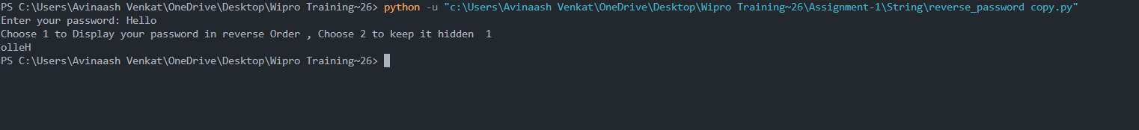
- Username Validation Program
Flowchart Pseudocode
(Oval)
START
(Parallelogram)
Enter username
(Diamond)
Is length of username >= 8 ?
(Parallelogram)
Display "Good"
(Parallelogram)
Display "Please Enter username greater than or equal to 8"
(Oval)
END
Code
n = input("enter you name").strip()
if len(n)>=8:
print("Good")
else:
print("Please Enter username greater than or equal to 8")
Output
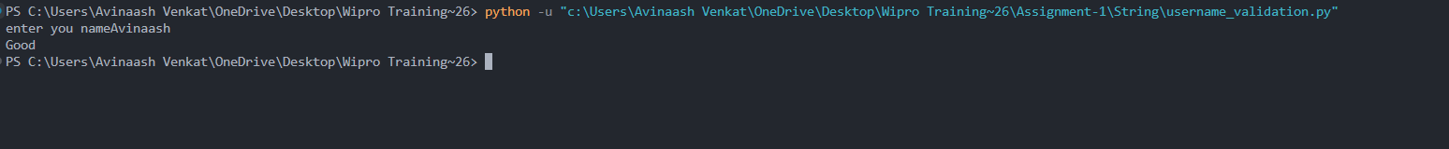
- Verify Palindrome Program
Flowchart Pseudocode
(Oval)
START
(Parallelogram)
Enter input string
(Diamond)
Is reversed string equal to original ?
(Parallelogram)
Display "It is a palindrome"
(Parallelogram)
Display "It is not a palindrome"
(Oval)
END
Code
n= input("Enter the input: ").strip()
if n[::-1] == n:
print("It is a palindrome")
else:
print("It is not a palindrome")
Output
- Vowels Count Program
Flowchart Pseudocode
(Oval)
START
(Parallelogram)
Enter feedback
(Rectangle)
Initialize vowel count to 0
(Rectangle)
Check each character
(Diamond)
Is character a vowel ?
(Rectangle)
Increase vowel count
(Parallelogram)
Display vowel count
(Oval)
END
Code
feedback = input("Enter your valuable Feeback: ").strip()
q = 0
for i in feedback:
if i in "aeiouAEIOU":
q+=1
print(f" The count of vowels in feedback is {q}")
Output
TOPIC : LISTS
- Expense Tracker Program
Flowchart Pseudocode
(Oval)
START
(Parallelogram)
Enter list of expenses
(Rectangle)
Calculate total expenses
(Rectangle)
Calculate average expenses
(Parallelogram)
Display total and average
(Oval)
END
Code
n = list(map(int,input("Enter your expenses: ").split()))
print(f'Total-Expenses-> {sum(n)} Average of expenses-> {sum(n)//len(n)}')
OUTPUT:
- Product Price Program
Flowchart Pseudocode
(Oval)
START
(Parallelogram)
Enter product price list
(Parallelogram)
Enter checking price
(Diamond)
Is price present in list ?
(Parallelogram)
Display result
(Oval)
END
Code
products = list(map(int,input("Ener you products price list--> ").split()))
price = int(input("Enter you checking price: "))
print("Yes it is there" if price in products else " No it is not there Man!!!")
output
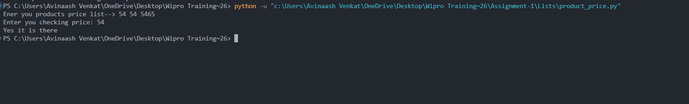
- Remove Duplicates Program
Flowchart Pseudocode
(Oval)
START
(Parallelogram)
Enter list of numbers
(Rectangle)
Remove duplicate elements
(Parallelogram)
Display updated list
(Oval)
END
Code
n = list(map(int,input().split()))
ans = list(set(n))
print(f'Removed Duplicates {ans}')
Output:
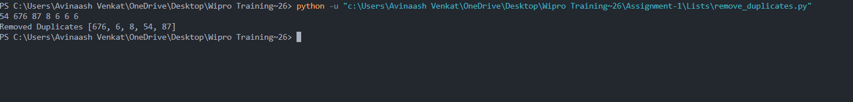
- Attendance Sort Program
Flowchart Pseudocode
(Oval)
START
(Parallelogram)
Enter attendance list
(Rectangle)
Apply bubble sort
(Rectangle)
Swap if needed
(Parallelogram)
Display sorted list
(Oval)
END
Code
attendance = list(map(int,input("Enter your attendance: ").split()))
def bubble_sort(lst):
Sorted = False
while not Sorted:
Sorted = True
for i in range(len(lst)-1):
if lst[i]>lst[i+1]:
Sorted = False
lst[i],lst[i+1] = lst[i+1],lst[i]
return lst
print(bubble_sort(attendance))
Output:
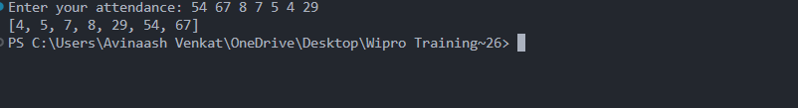
- Students Mark Analysis Program
Flowchart Pseudocode
(Oval)
START
(Parallelogram)
Enter students marks
(Rectangle)
Find highest mark
(Rectangle)
Find lowest mark
(Parallelogram)
Display highest and lowest
(Oval)
END
Code
marks = list(map(int,input("Enter the list of students marks:" ).split()))
print(f'Highest Marks-->{max(marks)}, Loweset Marks-->{min(marks)}')
Output:
TOPIC : FOR LOOPS
- Attendance Counter Program
Flowchart Pseudocode
(Oval)
START
(Parallelogram)
Enter attendance list
(Rectangle)
Initialize present and absent count
(Rectangle)
Check each value
(Diamond)
Is value zero ?
(Rectangle)
Increase absent
(Rectangle)
Increase present
(Parallelogram)
Display totals
(Oval)
END
Code
attendance= list(map(int,input().split()))
val = 0
absent = 1
for i in attendance:
if i!=0:
val+=1
else:
absent+=1
print(f"Total Students {val}")
if absent:
print(f"Total Absent : {absent}")
else:
print(f"Total Absent: {'Nil'}")
Ouput:
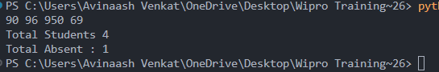

- Count Even Program
Flowchart Pseudocode
(Oval)
START
(Parallelogram)
Enter list of numbers
(Rectangle)
Initialize even count to 0
(Rectangle)
Check each number
(Diamond)
Is number even ?
(Rectangle)
Increase even count
(Parallelogram)
Display even count
(Oval)
END
Code
lst = list(map(int,input("Enter the list of numbers: ").split()))
cnt = 0
for i in lst:
if i%2==0:
cnt +=1
print(cnt)
Output:
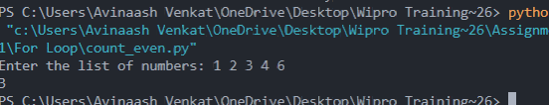
- First N Generator Program
Flowchart Pseudocode
(Oval)
START
(Parallelogram)
Enter positive number
(Diamond)
Is number greater than zero ?
(Rectangle)
Generate numbers from 1 to N
(Parallelogram)
Display natural numbers
(Parallelogram)
Display error message
(Oval)
END
Code
n = int(input("enter the poitive number as input man: "))
if n > 0:
print("--Natural Number-- ")
for i in range(1,n+1):
print(i)
else:
print("I said before right ?")
Output:
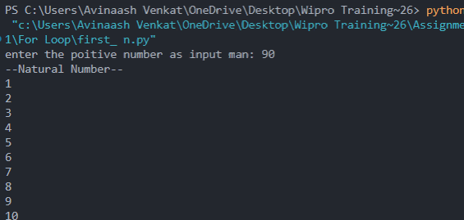
- Password Validator Program
Flowchart Pseudocode
(Oval)
START
(Parallelogram)
Enter password
(Rectangle)
Initialize check flag
(Rectangle)
Check each character
(Diamond)
Is character digit or special symbol ?
(Rectangle)
Set check flag true
(Diamond)
Is check flag true ?
(Parallelogram)
Display strong password
(Parallelogram)
Display weak password
(Oval)
END
Code
n = input("Enter your password: ")
check = False
for i in n:
if i in "!@#$%^&*()_+" or i in "1234567890":
check = True
if check:
print("Password is Strong: ")
else:
print("Password is Weak")
Output:
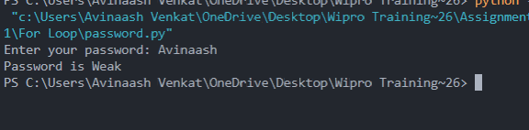
- Tables Generator Program
Flowchart Pseudocode
(Oval)
START
(Parallelogram)
Enter number
(Rectangle)
Repeat from 1 to 10
(Rectangle)
Multiply number with counter
(Parallelogram)
Display table
(Oval)
END
Code
tables = int(input("Enter the number: "))
for i in range(1,11):
print(f"{tables} X {i} = {tables*i}")
Output:
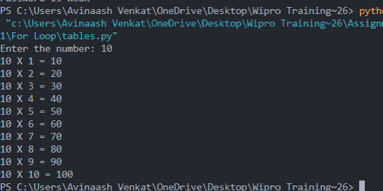
TOPIC : WHILE LOOPS
- ATM PIN RETRY Program
Flowchart Pseudocode
(Oval)
START
(Rectangle)
Set correct pin and chance
(Parallelogram)
Enter ATM pin
(Diamond)
Is pin correct ?
(Parallelogram)
Display success
(Rectangle)
Increase chance
(Parallelogram)
Display wrong pin
(Diamond)
Is chance equal to 3 ?
(Parallelogram)
Display card blocked
(Oval)
END
Code
correct_pin = "1928"
chance = 0
while chance <= 3:
atm = input("Enter ATM Pin: ").strip()
if atm==correct_pin:
print("Successfully Logged in! ")
break
else:
chance +=1
print("Wrong pin")
if chance==3:
print("Card Blocked")
Output:
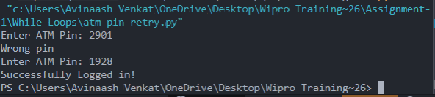

- Countdown Program
Flowchart Pseudocode
(Oval)
START
(Parallelogram)
Enter timer value
(Diamond)
Is timer >= 0 ?
(Parallelogram)
Display seconds
(Rectangle)
Decrease timer
(Parallelogram)
Display time over
(Oval)
END
Code
import time
timer = int(input("Enter the seconds For timer to drop: "))
while timer>=0:
print(f'{timer}seconds left')
timer -= 1
time.sleep(0.9)
print("Time over !!")
Output
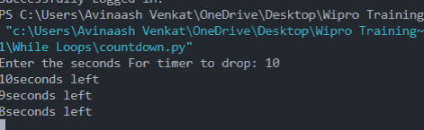
- Guess Game Program
Flowchart Pseudocode
(Oval)
START
(Parallelogram)
Enter number
(Rectangle)
Generate random number
(Diamond)
Is guess correct ?
(Parallelogram)
Display win message
(Parallelogram)
Display lose message
(Oval)
END
Code
import random
value = int(input("Enter you number 1-10 (Lets try your luck):"))
if value == (random.randint(1,10)):
print("Guessing Is blast Congrats : ",value)
else:
print("So bad man !")
Output 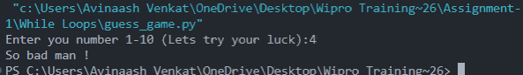Password Retry Program
Flowchart Pseudocode
(Oval)
START
(Rectangle)
Set correct password and chance
(Parallelogram)
Enter password
(Diamond)
Is password correct ?
(Parallelogram)
Display success
(Rectangle)
Increase chance
(Diamond)
Is chance equal to 3 ?
(Parallelogram)
Display retry message
(Oval)
END
Code
import time
correct_pin = "password"
chance = 0
while chance <= 3:
password = input("Enter Password: ").strip()
if password==correct_pin:
print("Successfully Logged in! ")
break
else:
chance +=1
print("Wrong!")
if chance==3:
print("try again after 10 seconds")
Output 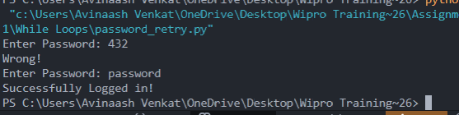Shopping Cart Program
Flowchart Pseudocode
(Oval)
START
(Rectangle)
Initialize shopping cart
(Rectangle)
Add products and prices
(Rectangle)
Calculate total
(Parallelogram)
Display total
(Oval)
END
Code
shopping_cart = []
for i in range(5):
product = input("Enter the prodcut >")
price = int(input("Enter the price >"))
shopping_cart.append((product,price))
tot = 0
i = 0
print(shopping_cart)
while i < len(shopping_cart):
tot += shopping_cart[i][1]
i+=1
print(f'total : {tot}')
Output
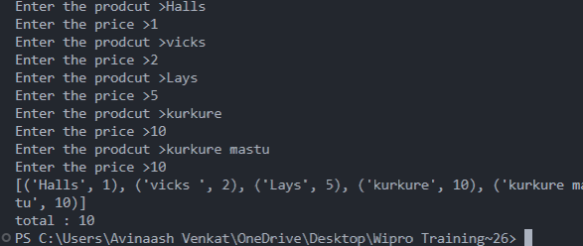v
TOPIC : CONDITIONAL CASES
1. Driving License Program
Flowchart Pseudocode
(Oval)
START
(Parallelogram)
Enter age
(Diamond)
Is age >= 18 ?
(Parallelogram)
Display eligible message
(Parallelogram)
Display not eligible message
(Oval)
END
Code
age = int(input("Enter your age: "))
if age >= 18:
print("Eligible for Driving License")
else:
print("Not Eligible for Driving License")
Output:
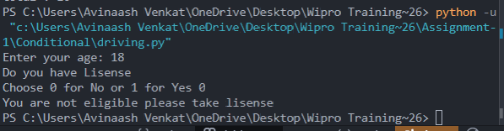
2. EB BILL Program
Flowchart Pseudocode
(Oval)
START
(Parallelogram)
Enter units consumed
(Diamond)
Check units range
(Rectangle)
Calculate bill
(Parallelogram)
Display bill amount
(Oval)
END
Code
units = int(input("Enter units: "))
if units <= 100:
bill = units * 1
elif units <= 200:
bill = (100*1) + (units-100)*2
else:
bill = (100*1) + (100*2) + (units-200)*3
print("Bill Amount:", bill)
Output:
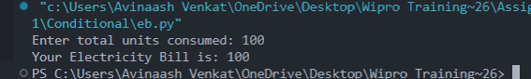
3. Exam Result Program
Flowchart Pseudocode
(Oval)
START
(Parallelogram)
Enter marks
(Diamond)
Check marks range
(Parallelogram)
Display grade
(Oval)
END
Code
marks = int(input("Enter the marks to know your Grade: "))
if marks >= 90:
print("A grade")
elif marks >= 75:
print("B grade")
elif marks >= 50:
print("C grade")
else:
print("Fail")
Output:
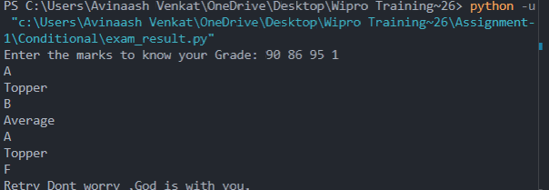
4. Loan Eligibility Program
Flowchart Pseudocode
(Oval)
START
(Parallelogram)
Enter age and income
(Diamond)
Check eligibility
(Parallelogram)
Display result
(Oval)
END
Code
age = int(input("Enter age: "))
income = int(input("Enter income: "))
if age >= 21 and income >= 20000:
print("Eligible for Loan")
else:
print("Not Eligible for Loan")
Output
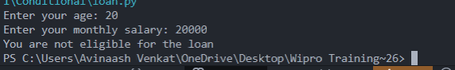
5. Temperature Program
Flowchart Pseudocode
(Oval)
START
(Parallelogram)
Enter temperature
(Diamond)
Check temperature range
(Parallelogram)
Display message
(Oval)
END
Code
temp = int(input("Enter temperature: "))
if temp < 0:
print("Freezing")
elif temp <= 30:
print("Normal")
else:
print("High Temperature")
Output
