HACKATHON PROJECT REPORT

TrafficSense
  - AI-Based Adaptive Signal Control
Camera-based signal recommendations with emergency priority and violation evidence.
Submission details | Complete before submission
Team name | Quantum Vortex
Team members | Avinaash: Vision & Evidence; [Member 2]: Logic & Backend  [Member 3]: Hardware & Control; [Member 4]: Dashboard & Data
Institution | USAR, GGSIPU EDC
Hackathon | hackFront Hackathon
Project date | 28 October 2026

Abstract
TrafficSense (AI-Based Adaptive Signal Control) is a local prototype for a four-road intersection. It accepts separate Front, Right, Back and Left videos, each with its own calibrated vehicle region, stop line and traffic-light crop. YOLO and ByteTrack estimate approach occupancy while one central controller recommends green durations and coordinates emergency priority. Additional checks identify red-light crossings, prolonged obstruction of a marked pedestrian crossing and repeated uncovered-head observations associated with motorcycle riders. The application stores review candidates with timestamps, place, optional plate OCR and whole-frame images containing the vehicle box. An Arduino Uno firmware and USB bridge connect the software to a tabletop LED junction. Software tests and controlled inference checks verify the main processing paths. The emergency and helmet models remain experimental, and physical hardware operation and real-intersection accuracy require further evaluation.
Keywords: computer vision, adaptive signals, emergency priority, number-plate OCR, Arduino Uno, evidence review.

Key features
- Calibrate once. Mark road boundaries directly on a camera frame.
- Smarter signals. Recommend green time based on traffic demand.
- Emergency first. Prioritize detected emergency vehicles.
- Violation evidence. Capture possible violations with photos and plate details.
- One dashboard. Monitor four roads and review incidents together.
- Arduino integration. Show signal decisions on an LED junction model (testing pending).

1. Problem, objectives and scope

Problem statement
Traffic demand changes across approaches, while fixed schedules may continue assigning similar green periods. Emergency vehicles can arrive during a conflicting phase. Operators also need a consistent way to review potential crossing and rider-safety incidents with evidence linked to the correct approach and time.
TrafficSense addresses these needs at the scale of road junction. Its goal is to make signal recommendations respond to measured occupancy while preserving clearance stages and a reviewable record of candidate incidents. Reduced waiting or improved emergency travel time are expected benefits to evaluate, not measured outcomes of the current prototype.

Project objectives
- Analyse four inputs with independent tracking identities and one shared signal controller.
- Let an operator calibrate a representative frame instead of hardcoding image coordinates.
- Coordinate emergency requests without conflicting green signals.
- Separate observed traffic-light state from controller recommendations and hardware acknowledgements.
- Store candidate incidents with time, place, vehicle number when readable and boxed image evidence.

Functional scope
Function | Current scope
Inputs | Four recorded videos, or four distinct local USB cameras. Mixed sessions are rejected.
Control | One approach green at a time, bounded timing, priority queue and pedestrian clearance hold.
Incidents | Red-light crossing, stationary crossing obstruction and associated no-helmet candidates.
Review | Filters, plate correction, confirm/dismiss and CSV export.
Actuation | USB serial protocol and Uno firmware for a 12-LED tabletop junction.

The prototype does not implement every jurisdiction-specific traffic rule, automatic penalties, vehicle registration lookup or public-road signal actuation.

2. System architecture
The laptop performs video decoding, object detection, tracking, incident rules, OCR and dashboard hosting. The Arduino receives compact signal commands and independently enforces its LED-transition rules. This separation keeps computer-vision workloads off the microcontroller.
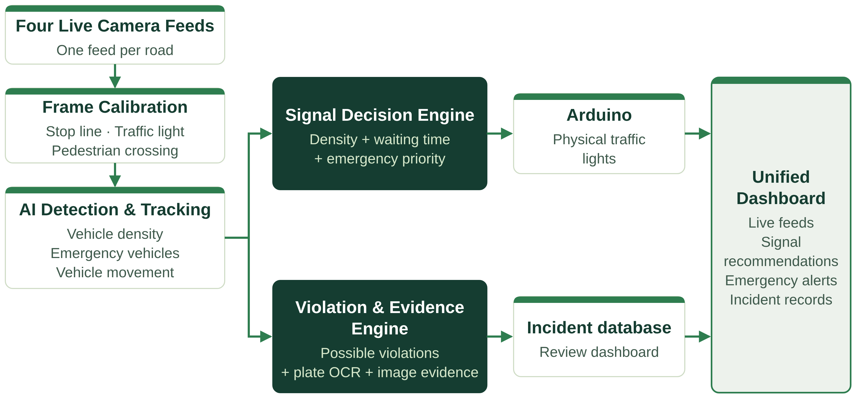
Figure 1. System architecture. The laptop performs AI analysis; the Arduino controls the physical signal model.
Four camera feeds are calibrated once, then analysed by AI detection and tracking. Processing then splits into two branches. The signal decision engine combines density, waiting time and emergency priority and sends commands to the Arduino. The violation and evidence engine records possible violations with plate OCR and image evidence in the incident database. Both branches appear together on one unified dashboard.
Component | Responsibility
Input calibration | Stores a source token, region geometry, approach, video offset and optional capture start.
Four tracking contexts | Each source owns its own YOLO/ByteTrack instance. Camera identity forms part of every stored track ID.
Shared scheduler | Processes recorded sources at a common video time and publishes successful road states together.
Controller | Uses occupancy and waiting demand, queues emergencies and preserves pedestrian/phase clearance.
Evidence worker | Captures candidate frames and runs optional plate localization/OCR through a bounded job queue.
SQLite and dashboard | Persists events, shows four annotated feeds, exposes review tools and exports typed records.
USB bridge and Uno | Sends commands, displays real acknowledgements, rejects conflicts and handles communication loss.

Technology stack
Layer | Technology
Dashboard | HTML, CSS, JavaScript
Backend & control logic | Python
Computer vision | OpenCV, YOLO, ByteTrack
Number plate recognition | EasyOCR
Database | SQLite
Hardware | Arduino Uno, LEDs, embedded C++
Communication | USB serial using pySerial

Clock and synchronization model
For a recorded source, analysis time equals the shared master time plus that video's configured offset. Inputs may use different frame rates. The scheduler skips intermediate frames to meet the selected analysis rate. Processing may run slower than real time on CPU. Signal-controller timing and Arduino clearance use wall time, while incident timestamps use the source-video clock. Live-camera timing uses approximate host elapsed time.

Three distinct signal states
Observed state comes from the lamp crop or a synchronized signal CSV. Recommended state comes from the adaptive controller. Acknowledged state comes from the Uno after firmware interlocks. Only the observed state can establish a red-light event in prerecorded footage. Changing tabletop LEDs cannot change a recorded traffic light.

3. Dashboard and frame calibration
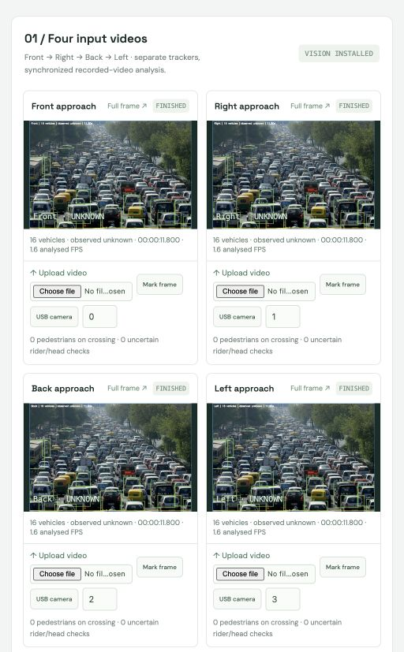  Figure 2. Actual dashboard with repeated-photo test clips. | Calibration workflow  Choose a source. Upload the video for the selected road or preview its USB camera.  Take a frame. Use the first readable frame or seek to a representative time.  Mark vehicles. Draw two corners around the upstream region to count.  Mark the stop line. Set endpoints A and B, then check the displayed direction arrow.  Mark the actual lamp. Use a tight crop so ambiguous colors remain unknown.  Mark the crossing. Click four boundary corners if obstruction monitoring is required.  Save and align. Save each approach. Adjust source offsets and enter a place name before starting all four videos.
The geometry applies throughout a fixed-camera video. Camera movement or a change of framing requires recalibration. Choosing a preview-frame time does not change the analysis offset. If the capture start time is unknown, the system displays video-relative time instead of inventing a capture date.
The four feeds show tracked counts, observed signal state, source time, measured processing throughput and model uncertainty. A full-frame link supports closer inspection. Calibration stays tied to the current source preview token, which prevents reuse of stale drawings after an input changes.

4. Signal timing, emergency priority and pedestrians

Normal adaptive timing
Each approach receives a separate phase. The current green target follows the bounded occupancy heuristic below. The controller also considers waiting demand when choosing the next approach.
green_target = max(10, min(35, 10 + 1.3 × occupancy)) seconds
Normal green therefore remains between 10 and 35 seconds. A waiting threshold of 90 seconds gives occupied competing approaches additional priority after the active minimum green. This threshold does not guarantee a strict maximum waiting time.
Stage or guard | Prototype behaviour
Yellow | 3 seconds during normal phase switching.
All-red | At least 2 seconds before a new green.
Freshness | All four required inputs must be running and fresh. Default stale threshold: 5 seconds.
Failure/EOF/pause | Effective hardware commands remain all-red when required input is unavailable.
Pedestrian request | A requested phase provides 10 seconds of all-red after clearance.

Emergency priority
The emergency model looks for ambulance, police-car and fire-truck classes. Three consecutive observations inside an approach can request a bounded 20-second priority lease. This lease includes the clearance period. One approach holds priority at a time. Other requests queue, and queued requests expire after 60 wall-clock seconds. Continuous sightings do not indefinitely renew the same lease.
A conflicting green first transitions through yellow and all-red. The priority approach then receives green. An operator request follows the same controller path and carries a separate source label. The model does not verify whether a detected emergency vehicle is officially on duty.

Pedestrian clearance
Tracked pedestrians inside a marked crossing can hold the next green at all-red until the crossing clears. The application excludes clearly associated motorcycle riders from pedestrian occupancy. There is no dedicated physical pedestrian lamp in the current LED circuit.

5. Incident rules and evidence

Red-light crossing
A tracked vehicle's bottom-center point must cross the finite stop-line segment in the configured direction while the observed signal is red. The rule suppresses duplicates for a continuous track and resets stale geometric history. Unknown, yellow and green observations produce no red-light record. Tracking switches and signal changes between frames can still cause errors.

Pedestrian-crossing obstruction
The ground-contact approximation must remain inside the marked crossing with limited motion for the configured duration, normally three source-video seconds. Moving passage over a crossing does not automatically qualify. Perspective, slow creeping and inaccurate markings can affect the result, so records remain review candidates.

Motorcycle rider without helmet
The system requires explicit uncovered-head evidence, a unique spatial association between a head, tracked rider and motorcycle, and repetition over three frames. It does not interpret missing helmet detections as proof of a violation. Tiny, occluded, low-confidence, ambiguous or conflicting head observations stay uncertain. The current head/helmet checkpoint uses experimental prompts.

Record format and review
Record group | Stored information
Time and location | Source-video time, optional capture datetime, processing UTC, junction and approach.
Identity and classification | Session-qualified track ID, incident type, detector score and optional OCR plate/score.
Evidence | Whole frame with a vehicle box, vehicle crop and successful plate crop.
Review | Needs review, confirmed or dismissed, with manual correction of plate text.

Plate OCR uses a dedicated plate detector when supplied, or a contour/aspect-ratio localization fallback. Unread or failed results remain unavailable. The UI filters by road and incident type and exports CSV. A reviewer can correct a plate and change the review status. No automatic penalty follows a candidate event.

Proposed database design
The current prototype keeps these fields together in one SQLite Violations table: event ID, session ID, road, vehicle tracking ID, violation type, location, timestamps, image paths, plate text with confidence scores, and review status. Images are stored as files, with their paths held in SQLite. The structure below is a proposed design for a more structured database. It is not the current implementation, and these entities are not separate tables today.
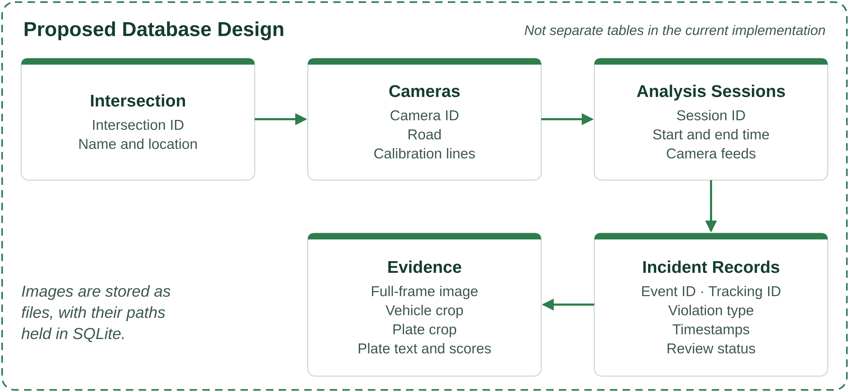
Figure 3. Proposed Database Design: Intersection → Cameras → Analysis Sessions → Incident Records → Evidence.

6. Arduino hardware integration
Reference hardware consists of an Arduino Uno R3, four groups of red/yellow/green LEDs, twelve 1kΩ resistors, a breadboard, jumper wires and a USB data cable. Each LED has its own series resistor and shares the board ground. The laptop runs AI inference.
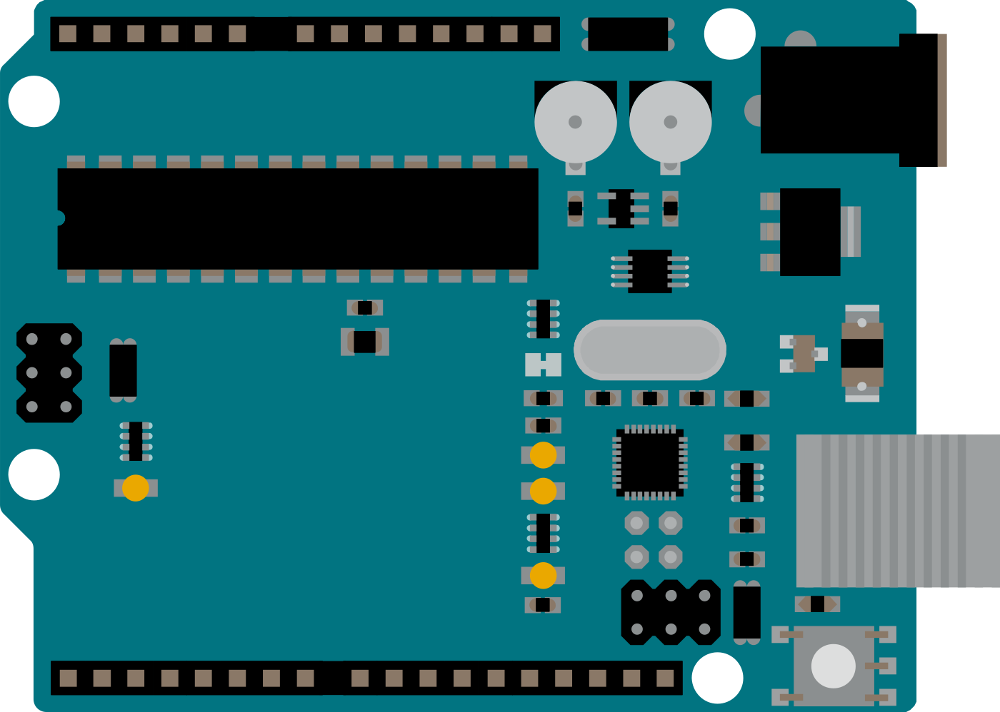
Figure 4. Official Uno R3 reference illustration [4]. Physical assembly/testing remains pending.
Approach | Red | Yellow | Green
Front (N) | D2 | D3 | D4
Right (E) | D5 | D6 | D7
Back (S) | D8 | D9 | D10
Left (W) | D11 | D12 | D13

D0 and D1 remain available for USB serial. The firmware starts all-red, permits at most one non-red approach, enforces clearance and rejects premature or conflicting commands. Same-state heartbeats do not restart clearance timing.

Protocol and fallback
The bridge uses 115200-baud serial. SET commands specify Front/Right/Back/Left aspects using R, Y and G. For example, SET 42 GRRR requests Front green. The board replies with an ACK containing actual aspects, or NACK when an interlock holds a transition. STOP requests immediate all-red. A watchdog forces all-red after three seconds without valid commands.
The dashboard shows actual board acknowledgements separately from recommendations. The native firmware state-machine test checks transitions, conflict rejection, STOP and watchdog behaviour. An Uno-specific compile/upload and real USB/LED test are still required. This circuit is a tabletop educational demonstration.

7. Verification, results and limitations
The project records 28 passing unit and controlled integration tests. These checks establish specific software behaviours. They do not establish detection accuracy on a real four-camera junction.
Verification level | Evidence and interpretation
Controller/geometry tests | Clearance, waiting priority, emergency expiry/queue, finite directed crossing, uncertainty and stationary occupancy checks.
Controlled four-video test | Four isolated trackers produced one red crossing, one obstruction and one no-helmet candidate using mocked detections and real video/evidence IO.
Real-model smoke check | Four uploads, frame selection, detector/OCR loading, annotated images, priority stages and typed CSV export completed.
Browser checks | Frame marking, incident filtering, plate correction, review dismissal and responsive four-feed layout worked.
Firmware logic test | Native C++ stubs checked board state transitions and watchdog logic. No physical Uno test has occurred.

The real-model smoke source consists of four independent copies of a traffic photograph encoded as short clips. The final frame yielded 16 tracked detections for each identical input. This verifies processing paths and tracker separation, not real intersection coverage, recall, precision or traffic-flow improvement.

Current limitations
- Emergency and head/helmet models use zero-shot prompts. They need local labelled footage and held-out evaluation.
- Contour-based plate crops and single-frame OCR can fail with distance, glare, skew, night scenes and occlusion.
- Video processing may run slower than real time. The dashboard reports actual per-feed throughput.
- Live cameras and physical Arduino operation remain untested. Host-elapsed camera time is not a hardware capture timestamp.
- The prototype does not yet provide a complete audit trail for manual edits, production authentication or automated retention.

8. Feasibility, viability and impact

Feasibility and viability
Aspect | Assessment
Practical prototype | Runs on a laptop with camera inputs. The Arduino signal model connects over USB serial. Physical assembly and live-camera testing remain pending.
Affordable demonstration | Uses open-source software and readily available electronic components.
Adaptable setup | Frame calibration configures the system for different fixed-camera intersections.
Local processing | Core analysis can operate without continuous internet access.
Deployment requirements | Real-world use needs validated models, sufficient computing power and integration with approved signal hardware.

Prototype compared with deployment
 | Prototype | Real-world deployment
Compute | Laptop | Sufficient computing power
Models | Open-source models | Validated models
Signals | Arduino LED model | Approved signal hardware

Impact and intended benefits
- Faster emergency passage through priority signal recommendations.
- Less unnecessary waiting when competing roads are empty.
- More responsive signals based on traffic demand.
- Better incident review through timestamped images and plate details.
- Greater traffic visibility through one dashboard for four roads.
These benefits require field evaluation; traffic-delay reductions have not yet been measured.

9. Demonstration, evaluation plan and references

Demonstration sequence
- Start the application with python3 run.py and open the local dashboard.
- Upload and calibrate the four recordings. Show the vehicle region, directed stop line, actual lamp and optional crossing polygon.
- Run analysis and explain the difference between observed lights, recommendations and Arduino acknowledgements.
- Demonstrate emergency priority and a queued request through the clearance stages. Show the operator override separately.
- Review a labelled example of each incident type with boxed evidence and OCR text or Unread. Demonstrate correction, dismissal and CSV export.
- After assembling the board, demonstrate pause/input loss/USB loss returning the LED junction to all-red.

Evaluation and next milestones
Collect synchronized, licensed fixed-camera clips with visible lights and readable plates. Label legal crossings, genuine obstructions, clear helmets, uncovered heads and uncertain cases. Measure count error, incident precision/recall, duplicate rate, uncertainty rate, plate exact-match and unread rate, emergency errors, processing delay and time to acknowledged priority green. Compare adaptive recommendations with a fixed-time baseline under identical demand before claiming congestion reduction.
Next implementation steps include locally trained emergency/head models, plate-specific localization, multi-frame OCR, capture synchronization and an immutable review/evidence history. Physical Uno assembly and failure-recovery checks are the immediate hardware milestone.

