

import pkg_resources  
  
# Получение информации о пакете  
pkg_info = pkg_resources.get_distribution("matplotlib").get_metadata("METADATA")  
  
# Вывод информации о пакете  
print(pkg_info)

git clone <https://github.com/matplotlib/matplotlib.git>



git clone https://github.com/expressjs/express.git --depth 1

const fs = require('fs');

fs.readFile('node_modules/express/package.json', 'utf8', (err, data) => {

if (err) {

console.log('Ошибка при чтении файла:', err);

return;

}

console.log(data);

});



output_file = f"matplotlib_dependencies.svg"

subprocess.run(["pydeps", "matplotlib", "--noshow", "--max-bacon=2", "--output", output_file])

path_to_file = os.path.abspath(output_file)

with open(path_to_file) as f:

dot_graph = f.read()

src = Source(dot_graph)

src.render(view=True)





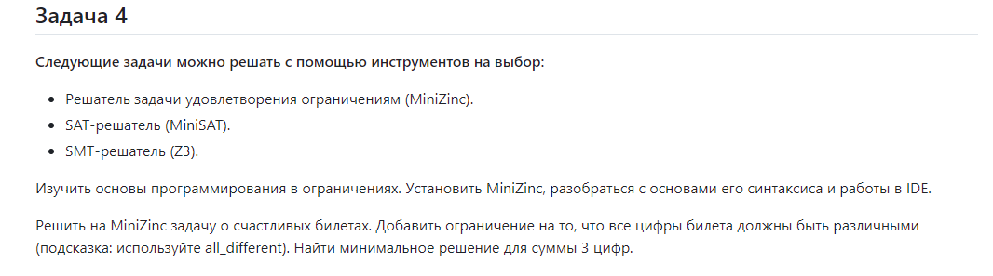

include *"globals.mzn"*;

var 0..9: digit1;

var 0..9: digit2;

var 0..9: digit3;

var 0..9: digit4;

var 0..9: digit5;

var 0..9: digit6;

constraint all_different([digit1, digit2, digit3, digit4, digit5, digit6]);

constraint digit1 + digit2 + digit3 == digit4 + digit5 + digit6;

var int: sum_group1 = digit1 + digit2 + digit3;

solve minimize sum_group1;

output [

*"Счастливый билет с равными суммами:\n"*,

*"Первая группа: "*, show(digit1), *" + "*, show(digit2), *" + "*, show(digit3), *" = "*, show(digit1 + digit2 + digit3), *"\n"*,

*"Вторая группа: "*, show(digit4), *" + "*, show(digit5), *" + "*, show(digit6), *" = "*, show(digit4 + digit5 + digit6), *"\n"*,

*"Все цифры: "*, show([digit1, digit2, digit3, digit4, digit5, digit6])

];

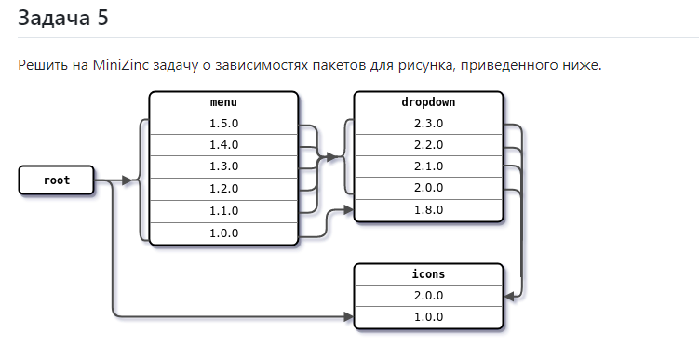

array [0..1] of var 0..1: icons;

array [0..5] of var 0..1: menu;

array [0..4] of var 0..1: dropdown;

var 0..1: ic;

var 0..5: me;

var 0..4: dr;

constraint sum(icons) <= 1;

constraint sum(menu) <= 1;

constraint sum(dropdown) <= 1;

constraint icons[1] == 0;

constraint menu[0] + menu[5] >= 1;

constraint menu[0] <= dropdown[0];

constraint forall (i in 1..5) (menu[i] <= dropdown[4] + dropdown[1]);

constraint forall (i in 1..4) (dropdown[i] <= icons[1]);

constraint forall(i in 0..1) (

if icons[i] == 1

then ic=i

else true

endif

);

constraint forall(i in 0..5) (

if menu[i] == 1

then me=i

else true

endif

);

constraint forall(i in 0..4) (

if dropdown[i] == 1

then dr=i

else true

endif

);

output [

*"icons version: "*, show(ic), *"\n"*,

*"menu version: "*, show(me), *"\n"*,

*"dropdown version: "*, show(dr)

];

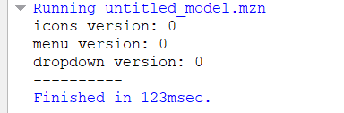

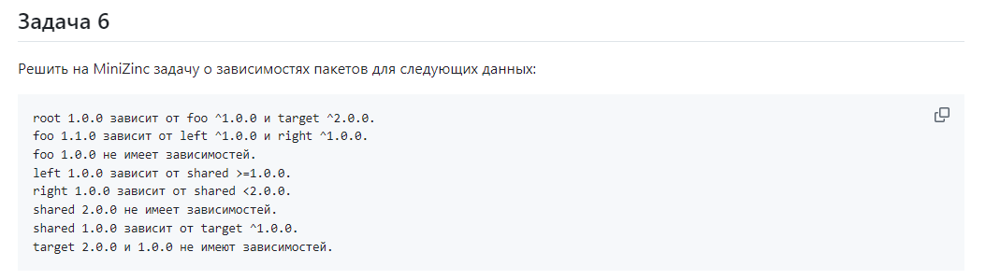

var 0..1: foo_min;

var 1..9: foo_maj;

var 0..9: target_min;

var 1..9: target_maj;

var 0..9: left_min;

var 1..9: left_maj;

var 0..9: right_min;

var 1..9: right_maj;

var 0..9: shared_min;

var 1..9: shared_maj;

constraint foo_maj == 1;

constraint target_maj == 2;

constraint (

if foo_min == 1

then left_maj = 1 /\ right_maj = 1

else true

endif

);

constraint (

if left_maj == 1

then shared_maj >= 1

else true

endif

);

constraint (

if right_maj == 1

then shared_maj < 2

else true

endif

);

constraint (

if shared_maj == 1

then target_maj = 1

else true

endif

);

output [

*"foo "*, show(foo_maj), *"."*, show(foo_min), *".0\n"*,

*"target "*, show(target_maj), *"."*, show(target_min), *".0\n"*,

*"left "*, show(left_maj), *"."*, show(left_min), *".0\n"*,

*"right "*, show(right_maj), *"."*, show(right_min), *".0\n"*,

*"shared "*, show(shared_maj), *"."*, show(shared_min), *".0"*

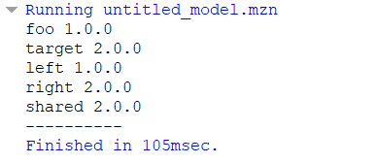];



import requests  
  
  
def get_package_info(package_name):  
 response = requests.get(f"https://pypi.org/pypi/{package_name}/json")  
 if response.status_code == 200:  
 data = response.json()  
 return data  
 else:  
 raise Exception(f"Не удалось получить информацию о пакете: {package_name}")  
  
  
def parse_dependencies(data):  
 dependencies = []  
 try:  
 releases = data['info']['requires_dist'] or []  
 for release in releases:  
 dependencies.append(release.split(' ')[0])  
 return dependencies  
 except KeyError:  
 return dependencies  
  
  
if __name__ == "__main__":  
 package_name = input("Введите имя пакета: ")  
 package_data = get_package_info(package_name)  
 dependencies = parse_dependencies(package_data)  
 print(f"Зависимости для пакета {package_name}: {dependencies}")

