**Практическое занятие №1. Введение, основы работы в командной строке**

## Задача 1

Вывести отсортированный в алфавитном порядке список имен пользователей в файле passwd

Решение:

**cut -d':' -f1 /etc/passwd | sort**

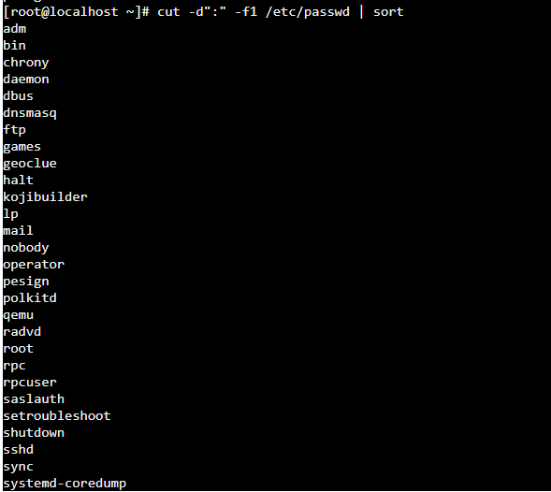

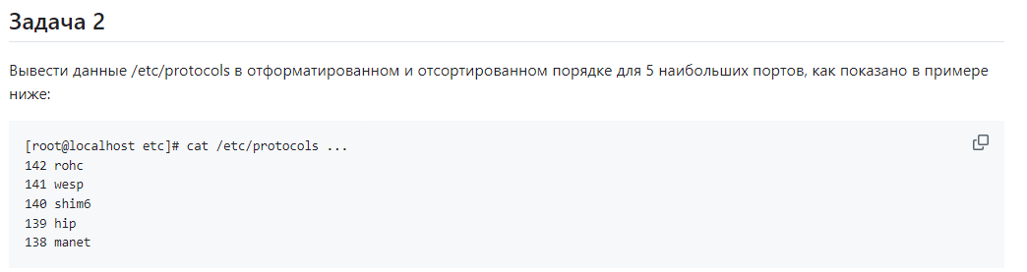

Решение:

**cat /etc/protocols | sort -nrk 2 | awk '{print $2, $1}' | head -5**

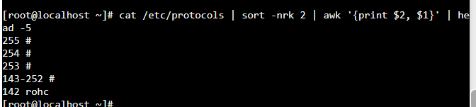

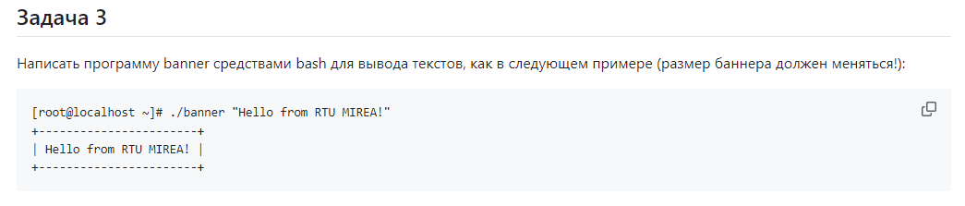

#!/bin/bash

string=$1

size=${#string}

echo -n "+"

for ((i=-2;i<size;i++))

do

echo -n "-"

done

echo "+"

echo "| $string |"

echo -n "+"

for ((i=-2;i<size;i++))

do

echo -n "-"

done

echo "+"

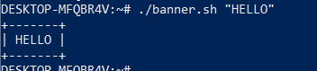

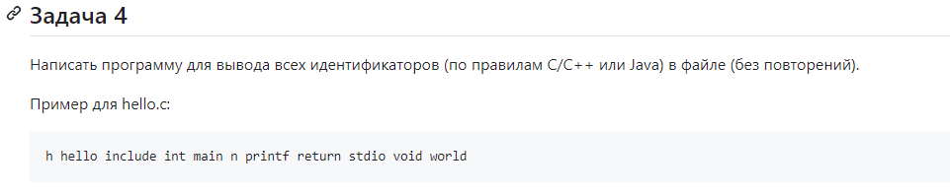

**grep -o '\b[a-zA-Z_][a-zA-Z0-9_]*\b' main.cpp | sort | uniq**

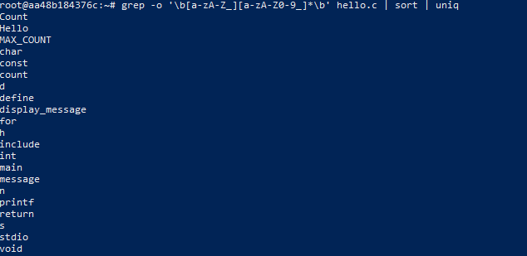

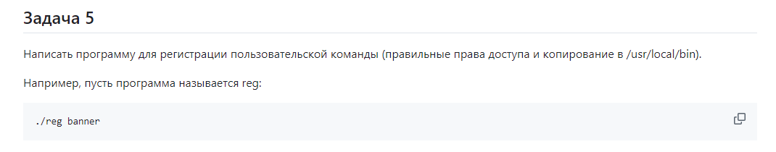

#!/bin/bash

chmod +x "$1"

sudo cp "$1" /usr/local/bin/



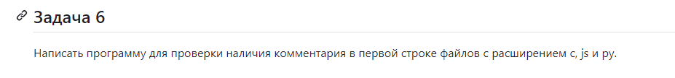#!/bin/bash

for file in "$@"; do

if [[ "$file" =~ \.(c|js|py)$ ]]; then

first_line=$(head -n 1 "$file")

if [[ "$file" =~ \.c$ && "$first_line" =~ ^// ]] || \

[[ "$file" =~ \.js$ && "$first_line" =~ ^// ]] || \

[[ "$file" =~ \.py$ && "$first_line" =~ ^# ]]; then

echo "$file has a comment in the first line."

else

echo "$file does not have a comment in the first line."

fi

fi

done



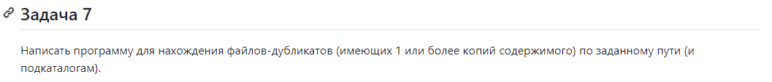

#!/bin/bash

temp_file=$(mktemp)

find "$1" -type f -exec md5 -r {} + -maxdepth 1 | sort > "$temp_file"

awk '{seen[substr($0, 1, 32)]++} seen[substr($0, 1, 32)] == 2 {print $2}' "$temp_file"

rm "$temp_file"



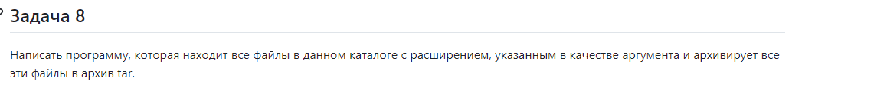

find . -name "*.$1" -print0 -maxdepth 1 | tar -czvf archive.tar.gz --null -T -



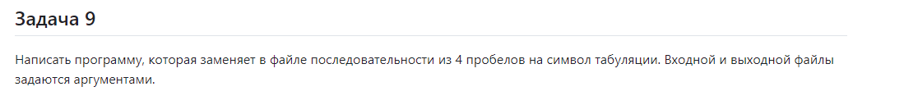

**sed 's/ /\t/g' "$1" > "$2"**

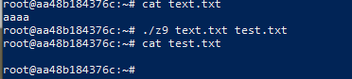

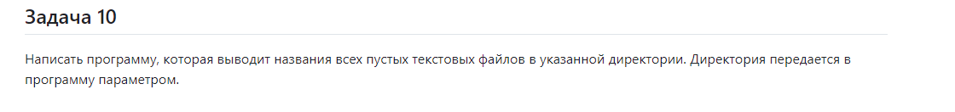

find "$1" -type f -empty -name "*.txt"

