**LEGAL DOCUMENT ANALYSIS AND AUTOMATED CONTRACT GENERATION USING AI**

**A PROJECT REPORT**

***Submitted by***

**Avinash Singh Haobijam 21BCS11467**

**Debasish Hazarika 21BCS11696**

***In partial fulfillment for the award of the degree of***

**BACHELOR OF ENGINEERING**

**IN**

COMPUTER SCIENCE WITH SPECIALIZATION IN

ARTIFICIAL INTELLIGENCE AND MACHINE LEARNING



**Chandigarh University**

April, 2025



**BONAFIDE CERTIFICATE**

Certified that this project report “**Legal Document Analysis and Automated Contract Generation Using AI”** is the bonafide work of “**Avinash Singh Haobijam, Debasish Hazarika**” who carried out the project work under my/our supervision.

|  |  |
| --- | --- |
| SIGNATURE | SIGNATURE |
| Dr. Priyanka Kaushik | Ms Kiran Preet Bedi |
| HEAD OF THE DEPARTMENT | **SUPERVISOR** |
| AIT-CSE Department | Assistant Professor  AIT-CSE Department |

Submitted for the project viva-voce examination held on

**INTERNAL EXAMINER EXTERNAL EXAMINER**

**ACKNOWLEDGEMENT**

We would like to extend our heartfelt gratitude to our Project Supervisor ‘**Ms.** **Kiran Preet**’, who gave us the golden opportunity to do this project on “**Legal Document Analysis and Automated Contract Generation Using AI**”. We would also like to thank our friends and colleagues, who helped us in finalizing and completing this project with their constant encouragement and understanding.

Table of Content

Chapter 1 Introduction 9

1.1 The Transformative Role of AI in Modern Legal Practice 9

1.2 The Power of AI in Legal Document Analysis: Enhancing Efficiency and Accuracy 10

1.3 Retrieval-Augmented Generation (RAG): Grounding AI in Legal Knowledge 12

1.4 Automated Contract Generation: The Rise of AI Agents in Contract Lifecycle Management 13

1.5 Timeline 15

Chapter 2 Literature Survey 17

2.1 Literature Survey 17

2.2 LITERATURE REVIEW 29

2.3 Objective 32

Chapter 3 Design flow/Process 34

3.1 System architecture 34

3.2 Natural Language Understanding (NLU) 35

3.2.1 Neural Network Era (RNNs and LSTMs) 36

3.2.2 The Transformer Revolution (2017) 38

3.2.3 Modern LLMs 40

3.2.4 Reasoning Ability of LLMs 42

3.3 Agents 43

3.4 Decision Engine 44

3.5 Challenges in Ethical consideration- 44

Chapter 4 Results Analysis and Validation 46

4.1 Model overview 46

4.2 Prototype 46

4.3 Evaluation Metrics 51

Chapter 5 Conclusion and future work 54

5.1 Conclusion 54

5.2 Future Work 54

References 56

**List of figures**

Figure 1: Time line 16

Figure 2: System architecture 34

Figure 3 RNN 37

Figure 4 LSTM 38

Figure 5 Transformer Architecture 39

Figure 6 Multi-head attention mechanism 40

Figure 7 Generative pretrained transformer 42

Figure 8 Decision engine 44

Figure 9: Legal analysis chatbot prototype 47

Figure 10: Analysing doc type file 48

Figure 11: Generating employee contract 49

Figure 12: Service contract generation 50

Figure 13: Sales contract generation 51

Figure 14: comparison between base and agent-based model 52

**List of Tables**

Table 2.1 Literature Review summary 29

Table 2: Evaluation of Legal document analysis and Contract generation 52

**ABSTRACT**

Analyzing legal documents requires to maintain high precision, as even minor errors can result in severe consequences. Legal documents are usually large in volume and have repetitive nature that make manual analysis tedious and prone to mistake. Recent advancements in large language models (LLMs) present potential solutions for automating legal document processing. This work presents an innovative approach using an agentic-based LLM to analyze legal documents and generate contracts. The method integrates generative capabilities of LLMs with LangGraph framework to construct an intelligent agent capable of refining responses iteratively. This study compares between zero-shot generation and an iterative approach and highlights trade-offs between the two approaches. The proposed method is evaluated based on precision, recall, and clause detection for legal analysis and LangChain evaluation framework for contract generation. Experimental results demonstrate agentic-based LLM with an iterative process achieves 85% precision, 83% recall, and 89% accuracy in generating appropriate responses. These findings point out iterative refinement improves effectiveness of LLM-based legal analysis and contract generation, making it a viable solution for improving accuracy in the legal domain.

**Keywords**: Agent, LangGraph, LangChain, LLMs, RAG

# Introduction

This chapter provides an overview of how Artificial Intelligence (AI) is currently reshaping the legal industry. With legal professionals facing increasing amounts of complex information, AI offers new ways to make tasks more efficient and accurate. This section introduces the significant changes AI brings, focusing on two key areas: analyzing legal documents and automatically generating contracts. The chapter will explain how AI helps with reading and understanding legal texts and creating new agreements. It will also touch upon how specific AI techniques, like Retrieval-Augmented Generation (RAG) and the use of AI agents, play a role in improving these legal processes

## The Transformative Role of AI in Modern Legal Practice

The legal industry stands at the cusp of a significant transformation, driven by the rapid advancements in Artificial Intelligence (AI). Legal professionals are increasingly recognizing the immense potential of AI technologies to optimize and revolutionize traditional workflows. Among the most impactful applications of AI in law are legal document analysis and automated contract generation. The ever-increasing volume and complexity of legal information necessitate the adoption of more efficient and accurate tools to manage and derive insights from this vast data landscape. AI offers promising solutions by automating time-consuming tasks, enhancing accuracy, and providing deeper analytical capabilities.

Two key areas where AI is making substantial inroads are the intelligent processing of legal documents and the automated creation of contracts. Legal document analysis leverages AI techniques to rapidly examine, categorize, and extract critical information from various legal texts, including case law, statutes, and contracts. This capability streamlines the review process, improves accuracy, and allows legal professionals to focus on more strategic aspects of their work. Complementing this, automated contract generation utilizes AI to create legally sound and customized contracts based on predefined templates and user inputs. This not only accelerates the contract drafting process but also reduces the potential for human error and ensures consistency across agreements.

Enhancing the effectiveness of these AI applications are sophisticated techniques like Retrieval-Augmented Generation (RAG) and the deployment of intelligent AI agents. RAG is a method that significantly improves the accuracy and reliability of AI-generated text, particularly in specialized domains like law, by first retrieving relevant documents from a knowledge base and then using this information as context for generating responses. This grounding in real-world data helps mitigate the risk of AI producing inaccurate or irrelevant information. Furthermore, AI agents are emerging as autonomous systems designed to perform specific legal tasks, such as reviewing contracts for compliance or generating initial contract drafts. These agents operate intelligently, leveraging AI capabilities to streamline workflows and improve overall efficiency in legal operations. The confluence of these AI-driven approaches signifies a fundamental shift in how legal work is conducted, promising to reshape the roles and responsibilities within the legal profession.

## The Power of AI in Legal Document Analysis: Enhancing Efficiency and Accuracy

Artificial intelligence is revolutionizing the way legal professionals approach document analysis, offering a suite of techniques that significantly enhance both efficiency and accuracy. Several core AI methodologies underpin these advancements, each contributing unique capabilities to the process. Natural Language Processing (NLP) is crucial, enabling AI systems to understand, interpret, and process the nuances of legal language found in statutes, case law, and contracts. Machine Learning (ML) algorithms play a vital role by allowing AI to identify patterns, learn from vast datasets of legal documents, and make predictions or classifications based on this learning. Additionally, Optical Character Recognition (OCR) technology is essential for converting scanned or handwritten documents into digital, searchable text, thereby making previously inaccessible information available for AI analysis.

The integration of these AI techniques into legal document review offers a multitude of benefits. One of the most significant advantages is the sheer speed and efficiency with which AI can analyze large volumes of documents, drastically reducing the time lawyers spend on these tasks. This rapid processing allows for quicker identification of key information, such as relevant clauses, critical dates, and involved parties. Furthermore, AI enhances accuracy by minimizing human error in the often tedious and repetitive process of document review. By automating tasks like eDiscovery, document summarization, and even the initial drafting of certain documents, AI streamlines workflows and allows legal professionals to focus on higher-level strategic thinking.

AI's ability to identify and extract pertinent information quickly is a cornerstone of its value in legal document analysis. Tools can automatically sort documents based on relevance, type, and content, making it easier to manage large datasets. This capability is particularly beneficial in eDiscovery, where AI can significantly speed up the retrieval and review of relevant electronic materials. Moreover, AI can generate concise summaries of lengthy legal documents, enabling lawyers to quickly grasp the essential details and prioritize their review efforts. Certain AI tools are also adept at detecting potential risks and compliance issues within documents, flagging areas that require closer scrutiny. For instance, AI can analyze contracts to identify unusual terms or missing clauses that could pose a risk. Additionally, AI-powered translation tools can efficiently translate legal documents, improving accessibility and reducing the time and cost associated with manual translation.

Several AI-powered tools and platforms are specifically designed to assist with legal document review. These include platforms like Logikcull and Everlaw, which utilize advanced technologies such as machine learning and natural language processing to automate document review and extract valuable insights from legal data. Spellbook is another example, offering features like contract analysis with identification of key clauses and explanations of legal implications. Harvey AI serves as a broader AI legal platform that can assist with various legal workflows, including generating insights and recommendations based on data. PocketLaw also provides AI-powered tools to help legal and non-legal professionals understand the content of legal documents more effectively. The responsible implementation of AI in legal document review is paramount. This requires establishing clear guidelines for AI usage, ensuring consistent human oversight of AI-generated results, prioritizing robust data security measures to protect sensitive legal information, adhering to ethical standards within the legal industry, and investing in ongoing training for legal teams to effectively utilize these tools. The integration of AI into legal document analysis represents a significant step towards a more efficient, accurate, and streamlined legal practice.

## Retrieval-Augmented Generation (RAG): Grounding AI in Legal Knowledge

Retrieval-Augmented Generation (RAG) has emerged as a powerful framework for enhancing the capabilities of AI in legal technology, particularly for tasks involving legal document analysis and policy retrieval. Unlike traditional language models that rely solely on their pre-existing training data, RAG first retrieves relevant information from an external knowledge base, such as a database of legal documents, and then uses this retrieved information as context to generate more accurate and reliable responses. This approach helps to ground the AI's output in real-world legal knowledge, significantly reducing the risk of generating inaccurate or "hallucinated" information, a crucial concern in the legal domain where precision is paramount.

The benefits of employing RAG in legal tech are manifold. By providing AI with access to a vast and up-to-date repository of legal information, RAG enhances the accuracy of its responses, making it a more trustworthy assistant for legal professionals. The retrieved documents provide crucial context, ensuring that the AI's output is not only accurate but also contextually relevant to the user's specific query. This is particularly valuable for tasks like legal research, where finding the most pertinent case law or statutes quickly can save significant time and effort. For instance, a legal professional could ask a question about a specific legal precedent, and the RAG system would first retrieve the relevant case documents before generating a summary or answer based on that specific information.

RAG also proves highly effective in policy retrieval. Users can pose questions about internal policies or external regulations, and the system will first locate the relevant policy documents or sections before generating an answer grounded in that specific content. This ensures that the information provided is accurate and directly addresses the user's query, improving compliance and reducing the time spent searching through lengthy policy documents. Furthermore, RAG can facilitate more efficient contract analysis by identifying similar clauses across a large number of contracts, aiding in due diligence and negotiation processes.

The RAG process fundamentally involves two key steps: information retrieval and text generation. When a user poses a query, the system first searches its internal knowledge base for the most relevant legal documents and data using techniques like semantic search. Once the relevant information is retrieved, it is then used by advanced language models to generate a coherent and contextually appropriate response. Key components in this process include "chunks," which are smaller sections of the documents in the knowledge base, "queries," which are the user's questions, and "prompts," which are the instructions given to the language model, combining the query with the retrieved information.

The effectiveness of a RAG system heavily relies on the quality and relevance of the data it retrieves. In the legal field, this underscores the importance of using gold-standard legal content to ensure the reliability of the AI's output. Different types of RAG models exist, ranging from simple models for broad analysis to more advanced models capable of handling complex queries requiring precise information. Graph RAG models, for example, leverage knowledge graphs to map out relationships between legal entities, offering a sophisticated approach for understanding the deeper connections within legal texts. While RAG significantly mitigates the risk of hallucinations, practical considerations such as context window limitations (the amount of text an AI model can process at once), the potential for occasional inaccuracies, the need for up-to-date data, and the importance of well-crafted prompts remain crucial for optimizing the performance of RAG models in legal applications. Several legal research tools are now incorporating RAG to enhance their capabilities, providing legal professionals with more accurate and contextually relevant information.

## Automated Contract Generation: The Rise of AI Agents in Contract Lifecycle Management

Automated contract generation is another area where AI is making significant strides in transforming legal practice. Contract AI, broadly defined, involves the use of text-based machine learning applied to contracts to enhance the efficiency of drafting, reviewing, and managing these crucial legal documents. AI automates contract generation by first understanding the language used in legal contracts, identifying patterns, key terms, and concepts through machine learning algorithms. Generative AI, powered by large language models (LLMs), can then produce contract drafts in mere seconds based on user-provided prompts and customizable templates. This automation not only accelerates the initial drafting process but also allows for the creation of contracts tailored to specific needs and use cases.

A key development in this domain is the emergence of AI agents specifically designed for contract management. These intelligent digital assistants are transforming how businesses handle the entire contract lifecycle, from the initial drafting to compliance checks and beyond. AI agents can automate a wide range of routine tasks, including contract creation, review, and amendments, thereby reducing the time spent on manual processes and speeding up the entire contract lifecycle. By leveraging natural language processing, these agents can quickly analyze contract terms and conditions, saving legal teams countless hours of manual review.

The capabilities of AI agents in contract management are extensive. In automated drafting, agents can generate initial contract drafts using standardized templates and specific data inputs, ensuring consistency in language and terms across all agreements. For contract review and analysis, AI agents can highlight deviations from standard terms, flag unusual clauses for human review, and identify key terms, obligations, and potential risks within the contract. Some agents can even suggest and optimize contract clauses, ensuring they align with best practices and legal requirements. Compliance monitoring is another critical function, with AI agents actively scanning contracts to ensure they adhere to relevant laws, regulations, and company policies, providing alerts for any potential breaches. Furthermore, AI agents can assess contracts for potential risks based on predefined parameters, providing risk scores and suggesting mitigation strategies. They also manage version control, tracking changes made to contract documents over time and allowing for easy comparison between different versions. To ensure timely action, AI agents can send expiry alerts, notifying stakeholders of approaching contract expiration dates and prompting renewal or renegotiation processes. Data extraction is another valuable capability, with agents automatically extracting key terms, obligations, and dates from contracts and populating databases to keep information up to date. Certain AI agents can also validate agreements against predefined company policies and rules, ensuring compliance and reducing risks, and automate reminders for pending contract signatures to ensure timely execution. Finally, some AI agents can generate concise summaries of lengthy contracts, highlighting key points and obligations.

The adoption of AI agents for contract generation and management offers numerous benefits. It leads to increased productivity by automating routine tasks, resulting in faster contract turnaround times. The enhanced accuracy provided by AI agents minimizes human errors and reduces legal risks by identifying potential non-compliance issues early on. This automation also translates to cost savings by reducing the need for extensive legal consultations and decreasing labor costs. AI agents improve compliance tracking by continuously monitoring contracts and generating detailed reports on adherence to contractual obligations. Moreover, by analyzing vast amounts of contract data, AI agents can provide valuable insights into contract performance and trends, supporting strategic decision-making.

A growing number of AI-powered contract management platforms and tools are available to legal professionals. These include platforms like Juro, which offers an AI-enabled contract collaboration platform; Legitt AI, which provides an AI contract generator that intelligently drafts contracts and evaluates them for risks and compliance; Icertis, which offers AI-powered contract intelligence copilots for automated summarization, clause extraction, and negotiation support; and ConvergePoint, which provides AI-assisted contract management software for document generation and automated review. Bloomberg Law Contract Solutions leverages AI for advanced contract analysis, while ZBrain AI offers a suite of AI agents for various contract-related tasks, including drafting, validation, and summarization. Beam AI provides a contract management AI agent that automates the handling of contracts from drafting to tracking, and Automation Anywhere offers AI agents for streamlining contract management processes. Despite the sophistication of these AI-powered tools, human oversight remains crucial to ensure accuracy.

## Timeline

The development of an AI-powered legal system for document analysis and contract generation, incorporating agentic capabilities and Retrieval-Augmented Generation (RAG), follows a structured timeline beginning with the foundational phase of Research and Planning. This involves understanding the specific needs for legal automation, surveying existing AI/NLP techniques relevant to the legal domain (like those mentioned in the literature), defining the system's scope for document analysis and contract generation, and selecting the core technologies, including the base LLM, agent framework such as LangGraph, and the need for components like RAG and a decision engine.

Following this initial step, the timeline moves into the Data Preparation and NLU Development phase. This is where legal datasets are gathered, preprocessed, and prepared for the system. The Natural Language Understanding (NLU) component, powered by the chosen LLM, is configured and fine-tuned to accurately process and comprehend complex legal texts, identifying key elements like clauses, terms, and relationships.

Subsequently, the Component Development phase begins, often running in parallel for different parts of the system. This includes:

* Building or integrating the Retrieval-Augmented Generation (RAG) mechanism, setting up the legal knowledge base and developing effective retrieval strategies.
* Designing and implementing the Agent System using the selected framework (like LangGraph), defining the specific roles and workflows for agents handling analysis and generation tasks.
* Developing the Decision Engine, including defining the specific legal rules and criteria it will use to validate system outputs for compliance and accuracy.

The timeline then progresses to the Integration and Initial Testing phase, where the developed NLU, RAG, Agent, and Decision Engine components are combined into a cohesive system. Initial testing is conducted to ensure the components work together and perform basic analysis and generation tasks.

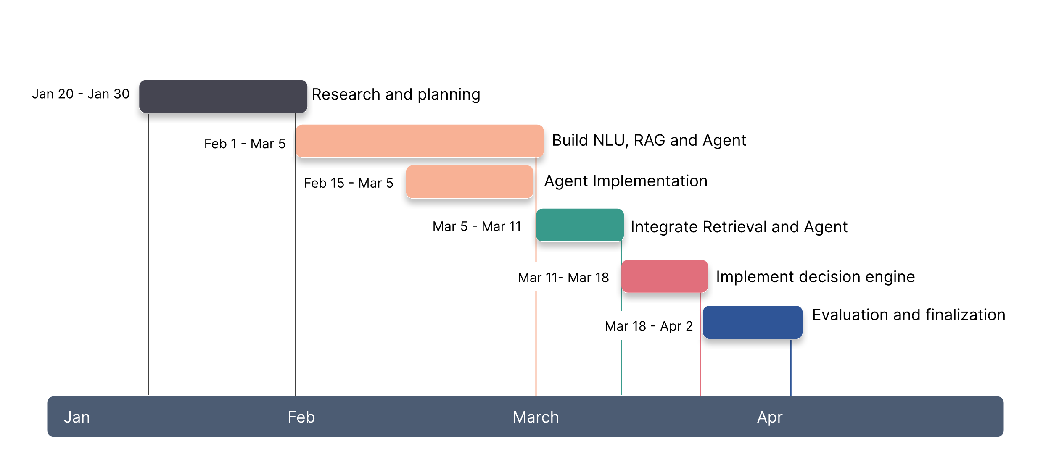Finally, the project moves into the Evaluation and Finalization phase. The system undergoes rigorous testing using predefined legal metrics (like precision, recall, clause detection, and evaluation frameworks for generation) to measure its performance. The results are analyzed, the system is documented, and any final adjustments are made before deployment or further research.

Figure 1: Time line

# Literature Survey

This chapter surveys current research applying artificial intelligence (AI) and natural language processing (NLP) to legal tasks. The reviewed studies explore how these technologies can help with areas like understanding and analyzing legal documents, automating parts of legal research, predicting outcomes, and generating legal text and contracts, including smart contracts. Researchers are using various techniques, such as machine learning algorithms, large language models, and knowledge graphs, to process and extract information from different types of legal materials. The work presented addresses challenges like improving efficiency in tasks like document review, dealing with legal text in multiple languages, making AI systems more reliable and explainable in legal settings, and enhancing access to legal information. This survey looks at these different applications and the methods researchers have used to apply AI and NLP within the legal domain

## Literature Survey

The researchers employed Natural Language Processing (NLP) techniques and Machine Learning (ML) algorithms for the automated analysis of construction contracts[1]. Specifically, they utilized vectorization techniques like Bag of Words and algorithms for text classification and ensemble methods for performance improvements. Python libraries such as spaCy, PDFMiner, and scikit-learn were integral in their preprocessing and modeling.

The study targets construction risk management, particularly the automated review of construction contracts to identify risks, responsibilities, and rights. It focuses on analyzing contractual clauses to support risk management plans. The research addresses a gap where manual review processes are time-consuming and error-prone, especially under time constraints like bidding periods. While prior studies explored NLP for contract management, this research introduces a unique taxonomy and focuses on FIDIC (International Federation of Consulting Engineers) standard contracts for practical application.

The best model achieved 89% accuracy for identifying sentence types and 83% accuracy for classifying related parties. Automated contract reviews demonstrated significant potential in accelerating risk management processes, with robust identification of risks and responsibilities

The study focuses on how advancements in technology, particularly AI, block-chain, and big data, are reshaping modern legal practices. It examines their role in improving efficiency, access to justice, and legal education[2].

The paper aims to bridge the gap between traditional, labor-intensive legal procedures and the opportunities provided by digital tools. Specific issues include: Enhancing efficiency in repetitive legal tasks, expanding access to justice for marginalized communities, Tackling ethical challenges like algorithmic bias and data security in legal AI applications.

The researchers used AI-driven tools to analyze the efficiency of legal workflows, focusing on areas such as automated document processing and predictive analytics. Experiments were conducted to evaluate the effectiveness of AI in improving legal research accuracy and streamlining processes like dispute resolution and client profiling.

The study primarily utilized Big Data Analytics to analyze citation and download trends, Statistical Methods such as regression analysis, hypothesis testing, and uncertainty analysis to evaluate variations in legal systems and AI adoption [3], AI Algorithms like Natural Language Processing (NLP), Machine Learning (ML), Predictive Analytics, and Computer Vision for evidence analysis, document review, and case prediction.

The research focuses on applying AI and Big Data for legal evidence analysis, particularly in, Document review, Case and contract analysis, Evidence gathering, Predictive analytics of legal trends. Additionally, it explores AI's role in mitigating ethical challenges such as privacy concerns, algorithmic biases, and transparency within the legal sector. The paper seeks to address, the lack of efficient tools for rapid and accurate evidence analysis in legal contexts, Ethical and legal ambiguities surrounding AI applications in law, such as fairness and bias in algorithms, The scarcity of global frameworks for integrating AI technologies into legal systems.

AI tools significantly improved the speed and accuracy of document review and case analysis. Predictive analytics enabled better forecasting of litigation outcomes. Enhanced identification of biases in legal systems, providing a basis for ethical regulation.

The research explores how AI, particularly the GPT-4 model, can assist in legal analysis and reasoning [4]. GPT-4 was employed as the primary tool to examine its ability to enhance human performance in legal tasks, with specific focus on both multiple-choice and essay-based questions within the legal education context. The study zeroes in on how AI could mitigate inequalities in the legal profession by improving the performance of those at lower skill levels while probing its limited utility in addressing more complex, nuanced legal challenges like essay writing. Addressing the gap in understanding the interaction between human expertise and AI assistance, the experiment analyzed students' performance before and after introducing GPT-4, with training provided to optimize its use.

The process included real law school exams where participants used GPT-4 under controlled conditions, and different prompting strategies were tested for effective AI responses. Results demonstrated that GPT-4 significantly improved performance on straightforward tasks, such as multiple-choice questions, with a notable 29-percentile point enhancement. However, it had no average impact on essay writing. Interestingly, lower-performing students achieved massive gains, while top-performing students experienced slight declines. Metrics like percentile gains and grading improvements measured the outcomes. Improvement areas highlighted include refining AI's capabilities in complex reasoning tasks, enhancing its ethical and unbiased usage, and integrating it effectively into the legal field for more advanced applications

Explores the transformative role of Artificial Intelligence (AI) and Machine Learning (ML) in modern legal research [5]. The researchers employed tools like AI-powered platforms (ROSS Intelligence, Kira Systems, Lex Machina) utilizing Natural Language Processing (NLP) and ML algorithms. These tools assist in automating tasks such as legal document review, contract analysis, and predictive analytics.

The study focuses on enhancing legal research efficiency, improving accuracy, and addressing the challenges of traditional manual methods. It highlights how AI and ML are reshaping areas like document analysis, e-discovery, and litigation strategies, while also tackling ethical considerations such as algorithmic bias and data security.

The research aims to address gaps such as the inefficiencies of manual legal research, errors in document analysis, and delays in legal processes. It emphasizes the need for ethical oversight and interdisciplinary collaboration to integrate AI effectively into legal systems.

The experimental process included case studies and empirical analysis of AI tools in various legal scenarios. Models used include NLP algorithms for document sentiment analysis, ML-based predictive analytics (e.g., Lex Machina), and AI-assisted platforms like Kira for contract review.

Results demonstrated significant improvements in efficiency and precision. Metrics like processing speed, prediction accuracy, and overall time savings were used to evaluate the outcomes. For example, tools like Kira significantly reduced contract review time, while Lex Machina enhanced predictive capabilities in litigation outcomes.

Improvement areas include addressing algorithmic biases, ensuring transparency, developing ethical guidelines, and expanding access to AI-driven legal tools across diverse user groups. Further research is encouraged to refine AI's role in complex legal reasoning and its integration into global legal frameworks.

Investigates the performance of general-purpose AI, like ChatGPT, in legal question-answering tasks and advocates for an open-source, domain-specific approach to address current shortcomings[6]. The researchers utilized tools such as GPT-4 and Mixtral-8x7B, both of which represent state-of-the-art generative language models. The study primarily focused on practical legal question-answering tasks within real-world contexts, aiming to improve access to justice, increase accuracy, and enhance transparency in legal AI.

The research identifies gaps in the current usage of general-purpose AI for legal tasks, including issues of hallucinated outputs, biases, and lack of domain specificity. It also highlights the restricted accessibility of closed systems offered by large legal database providers, which limit broader legal community benefits and hinder transparency.

The experimental process involved curating a new dataset called *LegalQA*, comprising over 2000 real-world legal questions sourced from online platforms, annotated by legal experts, and paired with questions from Law Stack Exchange. The study evaluated GPT-4 and Mixtral-8x7B on these datasets using factuality assessments and qualitative feedback from law students. Models were assessed based on their ability to provide concise, factual, and citation-backed answers.

Results showed that GPT-4 performed relatively well, with less than 5% of its responses being factually incorrect. However, the open-source Mixtral-8x7B underperformed significantly. Metrics used to measure outcomes included evaluation of factual consistency, conciseness, and citation relevance. Feedback highlighted limitations in GPT-4’s verbose answers and lack of sufficient citations, which reduced its utility in precise legal reasoning tasks.

The paper emphasizes the need for improvement in key areas such as algorithmic transparency, concise response generation, domain-specific data curation, and ethical AI development. The authors propose open-source solutions like *OpenJustice.ai* to foster collaborative and transparent development of legal AI tools that address these shortcomings effectively.

Explores the role of Natural Language Processing (NLP) techniques in automating critical legal tasks[7]. The researchers primarily utilized NLP tools, including foundational models like Bag of Words (BoW), alongside more advanced language models incorporating distributional semantics. These tools aim to process and extract meaningful information from unstructured legal texts such as contracts, judicial opinions, and written agreements.

The study focuses on leveraging NLP for automating document review, legal brief analysis, and case outcome predictions. It highlights the potential of NLP to enhance efficiency and reduce repetitive tasks in the legal profession, while also emphasizing its limitations in tasks requiring complex legal reasoning or structured legal ontologies.

A major gap addressed by the paper is the limited applicability of current NLP models in capturing intricate legal concepts and reasoning. The study notes that while NLP performs well in prediction or classification tasks with abundant labeled data, its effectiveness diminishes in reasoning-intensive legal tasks. This gap underscores the need for domain-specific NLP advancements tailored for legal applications.

The experimental process involved creating predictive pipelines where legal texts were converted into numerical vectors using models like BoW. These vectors were then input into machine learning classifiers for tasks such as identifying privileged documents or predicting case outcomes. While NLP tools demonstrated strong performance in certain prediction tasks, they struggled with tasks requiring semantic depth or abstract reasoning.

Results showed that NLP significantly improved processing speed and accuracy for repetitive tasks, such as document review. Metrics like precision, recall, and overall classification accuracy were used to evaluate performance. However, limitations in semantic understanding led to inaccuracies in nuanced legal contexts.

The paper identifies key areas for improvement, including enhancing NLP's ability to derive legal ontologies, reducing dependency on large datasets for training, and improving accuracy in semantic interpretation. It emphasizes the need for domain-specific efforts to overcome these limitations and integrate NLP more effectively into the legal tech landscape

Explores the application of Natural Language Processing (NLP) in handling large-scale legal texts[8]. The researchers utilized tools like CLAUDETTE (Clause Detector) and frameworks such as Deep Learning models and Word2Vec embeddings, applying them to tasks like text classification, argument mining, and multilingual legal document processing.

The study focuses on automating legal document analysis, including identifying unfair clauses, extracting arguments, and improving information retrieval in legal texts. It addresses the gap where existing manual and time-consuming approaches struggle with large datasets and multilingual documents.

The experimental process varied across applications. For instance, CLAUDETTE used machine learning to detect potentially unfair clauses in terms of service agreements, while other researchers developed corpora and applied deep learning to train legal word embeddings. Models used included supervised and unsupervised learning techniques like semantic similarity models and neural networks.

Results demonstrated significant improvements in tasks like clause detection, legal argument extraction, and multilingual corpus analysis. Metrics such as classification accuracy, semantic similarity scores, and efficiency improvements were employed to measure outcomes.

Improvement areas identified include refining the performance of models in detecting nuanced legal semantics, addressing multilingual challenges, and expanding the development of legal-specific datasets for training. This study highlights the potential of NLP to enhance the efficiency and accessibility of legal processes.

Explores the application of Natural Language Processing (NLP) in addressing challenges specific to India's diverse legal and linguistic landscape[9]. The researchers employed tools like Indic NLP Library for text processing and pre-trained language models such as IndicBERT and MultilingualBART to handle various Indian languages. These tools supported tasks such as text classification, machine translation, and legal document summarization.

The study focuses on enhancing legal documentation processes, including automating legal text translation, document classification, and legal opinion summarization. The key focus is on improving access to justice by bridging linguistic gaps and making legal information more accessible. The paper addresses the gap in handling multilingual complexity, regional dialects, and the lack of tailored NLP tools for Indian legal documents.

The experimental process involved creating annotated datasets like the Hindi Legal Documents Corpus (HLDC) and the Telugu Legal Corpus (TeLC) for training models. The study leveraged advanced NLP methods such as contextual embeddings and supervised learning to classify documents, extract legal entities, and translate legal texts. Models like IndicBERT were fine-tuned for specific legal tasks.

Results demonstrated significant improvements in legal document classification and translation accuracy. Metrics like classification accuracy, BLEU scores for translation, and recall and precision rates were used to evaluate the models. While the models showed promising results in automating repetitive tasks, challenges such as semantic understanding of legal jargon and scalability across diverse Indian languages persist.

The paper highlights improvement areas, including the need for: Enhancing the performance of models in understanding nuanced legal semantics, Expanding annotated corpora for underrepresented languages, Incorporating Explainable AI for better trust and transparency. ,Addressing regional linguistic variations and ambiguities in legal texts.

The paper presents the creation of a chatbot designed to process and answer queries related to legal documents efficiently. The researchers employed the LangChain framework, [10] a Natural Language Processing (NLP) tool that integrates with Large Language Models (LLMs) like OpenAI's GPT. LangChain was utilized to process user queries by embedding and analyzing their semantic meaning, retrieving relevant text chunks using a technique called Cosine Similarity. The chatbot was developed as an Android application with a backend supported by Flask, which facilitates communication through REST APIs.

The study focuses on automating the handling of legal documentation, aiming to assist users both laypersons and legal aspirants in understanding complex legal texts, including judgments and clauses from documents like the Indian Constitution. The research addresses the challenges of manually processing extensive legal documentation, which is time-consuming and prone to errors, by providing a streamlined AI-based solution.

The experimental process involved integrating LangChain for query processing, wherein legal documents were segmented into smaller chunks, stored in vector format, and analyzed for semantic relevance. The backend, developed using Flask, enabled seamless query processing through POST requests. The chatbot was tested using Postman before the final integration with the Android application. The primary model used in this study was OpenAI's GPT, leveraged through LangChain for generating embeddings and understanding user prompts.

The results highlighted the chatbot's ability to process legal queries effectively, providing contextually accurate responses. Metrics used to evaluate the chatbot included query response accuracy and its ability to handle document-specific contexts effectively. The chatbot was found to significantly improve user comprehension of legal documents by responding to queries with relevant information extracted from the provided texts.

Improvement areas identified include enhancing the user interface of the Android application, increasing the chatbot's query token limit, and providing features like document uploads within the application. Additionally, future work could focus on training the chatbot for a wider range of legal contexts and improving its scalability to handle a larger user base.

The paper presents an innovative approach to enhancing the reliability and precision of artificial intelligence (AI) in legal contexts. The researchers utilized tools such as Retrieval-Augmented Generation (RAG), Knowledge Graphs (KG), and Reinforcement Learning from Human Feedback (RLHF) to create an adaptive system tailored for legal applications[11]. These tools were integrated into a Mixture of Experts (MoE) framework, allowing domain-specific modules to handle specialized legal tasks like document review, case analysis, and statutory interpretation.

The study focuses on improving the efficiency and accuracy of legal AI systems while addressing the critical issue of "hallucinations," where AI models generate incorrect or misleading information. This issue undermines trust and reliability in AI-driven legal solutions. The research aimed to bridge the gap between general-purpose AI models and the demands of the legal profession by creating a framework that ensures contextual relevance, domain-specific precision, and operational scalability.

The experimental process involved designing a system architecture that combines RAG with Knowledge Graphs to enhance data retrieval and relational understanding. The researchers employed datasets such as LegalQA, CaseHold, and COLIEE for tasks including legal question answering, document summarization, and judgment prediction. The framework utilized models such as LegalBERT, fine-tuned for legal applications, and applied cosine similarity measures and structured operational guidelines for retrieval and analysis.

Results demonstrated substantial improvements in task performance across various legal benchmarks. Metrics like Rouge-L, BLEU scores, and F1 scores highlighted the system's enhanced accuracy in information retrieval, text summarization, and document analysis. Additionally, the RLHF component aligned system outputs with user feedback, further refining the system's reliability and contextual relevance.

Areas for improvement include expanding expert modules to cover additional legal sub-domains, enhancing real-time processing capabilities, and addressing challenges in multilingual legal texts. The study emphasizes the importance of continuous refinement and the integration of ethical standards to ensure the transparency and trustworthiness of AI in the legal sector

The paper,introduces a method to enhance legal research by predicting similar cases through the use of a Legal Knowledge Graph (LKG). [12] The researchers employed tools like Relational Graph Convolutional Networks (RGCN) and LegalBERT, along with rule-based and neural approaches to construct the LKG. This graph captures the relationships between entities in Indian court cases, judgments, and legislation, enabling tasks such as citation link prediction and case similarity.

The study focuses on intellectual property rights (IPR) cases within the Indian judiciary, aiming to assist legal professionals in finding similar cases to expedite settlements, improve case documentation, and achieve faster judgments. It addresses the gap in traditional manual legal research, which is time-intensive and error-prone, by introducing automated, AI-driven methods.

The experimental process involved creating an LKG from unstructured legal documents, using tools like Latent Dirichlet Allocation (LDA) for topic modeling to identify key legal concepts. Features were extracted and incorporated into graph models, such as a baseline RGCN, an RGCN enhanced with handcrafted features (law points), and another using LegalBERT for feature encoding. The models were evaluated on tasks like citation link prediction and case similarity using datasets sourced from platforms like IndianKanoon and Casemine.

The results showed that the RGCN with handcrafted features achieved a ROC-AUC score of 0.620 for citation prediction and 0.556 for case similarity. The LegalBERT-based model improved citation prediction accuracy to 0.725 but had negligible impact on case similarity tasks. Metrics like ROC-AUC scores were used to evaluate performance.

Improvement areas identified include incorporating domain-specific terminology into models like LegalBERT to better represent Indian legal contexts, expanding the feature set for clustering approaches, and exploring methods to directly infuse knowledge graphs into large language models. Future efforts also focus on improving explainability in predictions and enhancing the system's scalability to handle a broader range of cases

[13] The paper,investigates the application of machine learning (ML) and explainable artificial intelligence (XAI) techniques for enhancing legal document review processes. The primary tools used include predictive text classification models, rationale detection mechanisms, and explainability frameworks tailored for text-based legal documents. These were implemented in the analytics platform *Predict*, developed by Ankura Consulting Group.

The study focuses on legal document review, particularly the task of identifying responsive documents, such as those relevant to discovery requests or internal investigations. It aims to address a significant challenge: the "black box" perception of predictive coding models in the legal domain. Attorneys often struggle to understand why specific documents are classified as responsive, undermining their confidence in such models. The research aims to make the decision-making process more transparent and interpretable.

The experimental process involved creating a framework to identify rationales text snippets within documents that justify the model's classification as "responsive." The system classified documents, broke them into text snippets, and applied scoring mechanisms based on snippet complement scores, snippet token contributions, and integration of multiple scoring methods. The experiments were conducted using a dataset of 688,294 legal documents (including emails, PDFs, and other text-based files), with 41,739 labeled as responsive. Annotated rationales for these documents served as ground truth.

Results demonstrated that the framework effectively identified relevant rationales, enhancing interpretability for users. Metrics used to evaluate the system included precision, recall, and ranking scores of the identified rationales, along with their alignment with annotated rationales provided by attorneys. The proposed framework not only improved decision transparency but also reduced the time required for document review by narrowing the focus to specific responsive snippets.

Improvement areas identified include refining rationale detection for complex documents with overlapping contexts, improving scalability for even larger datasets, and enhancing user interfaces to support practical applications in real-world legal scenarios. The study emphasizes the potential of XAI to increase trust in AI systems within the legal profession

The paper, proposes an advanced framework, SCLA, to enhance the summarization of smart contracts using large language models (LLMs) augmented by control flow prompts[14]. The researchers leveraged tools like Gemini-1.5-Pro (an advanced LLM), control flow graphs (CFGs), and Sentence-Transformer (SBERT) for semantic analysis and similarity matching. The framework integrates control flow graphs and semantic facts derived from Abstract Syntax Trees (ASTs) to improve the contextual and structural understanding of smart contract code.

The study focuses on smart contract code summarization, a critical task for efficient maintenance and vulnerability mitigation. It addresses the gap in existing methods that fail to capture the control structures and hierarchical relationships within the code, leading to information loss and suboptimal summarization quality.

The experimental process involved: Semantic Extraction: Segmenting smart contract code and extracting semantic facts like function call graphs and variables using the SemFlow component, Prompt Construction: Utilizing few-shot learning and SBERT to identify semantically similar examples for LLM prompts, combining CFGs and semantic details, LLM Inference: Feeding the enhanced prompts into Gemini-1.5-Pro to generate accurate and contextual smart contract summaries.

Results showed significant improvements compared to state-of-the-art methods. SCLA outperformed others with gains of 26.7% in BLEU-4, 23.2% in METEOR, 16.7% in ROUGE-L, and 14.7% in BLEURT scores. These metrics evaluated the quality of generated summaries against human annotations. Moreover, the framework demonstrated strong generalizability when applied to Java and Python datasets, outperforming baseline models.

The improvement areas highlighted include refining the framework for multilingual code contexts, optimizing token consumption for cost-effectiveness in few-shot learning, and expanding its capabilities for broader programming domains. The study underscores the importance of CFG-based prompts in enhancing the accuracy and interpretability of code summarization tasks.

[15] The paper, introduces an AI-assisted framework, AIASCG, for generating smart contracts efficiently and collaboratively. The researchers used tools such as Separation Inference (SpIn), an AI-based automatic word segmentation technique, to handle natural language inputs and convert them into machine-readable formats. The framework also leveraged Collaborative Signs Dictionary (CoDic) and Universal Case Grammar (UCG) for semantic consistency and universal representation of contract terms.

The study focuses on smart contract generation and negotiation, aiming to bridge the gap between natural language legal contracts and executable smart contracts. It tackles challenges like semantic ambiguity in contract terms, inefficiencies in manual drafting, and translation issues across different languages, which often lead to misunderstandings and disputes.

The experimental process involved using the SpIn model for word segmentation to automatically split sentences into semantically meaningful units. These units were then matched with concepts in the CoDic to create a machine-readable representation. This representation was converted into Machine Natural Language (MNL) for generating smart contract clauses. The process was tested on multilingual datasets to evaluate robustness and user satisfaction, combining both automated and human-in-the-loop methods.

The results showed that SpIn achieved state-of-the-art F1 scores and high recall for out-of-vocabulary (R_OOV) words on multiple segmentation tasks. Human evaluations indicated that 88.67% of the sentences required 80–100% less time for manual adjustments due to the automation. Metrics included F1 scores, recall for R_OOV, and human satisfaction ratings to measure performance and effectiveness.

Improvement areas identified include extending support for additional languages, refining the accuracy of word segmentation for complex sentences, and enhancing user interfaces for easier adoption. The paper underscores the potential of AI-assisted methods in revolutionizing contract generation processes

## LITERATURE REVIEW

Table 2.1 Literature Review summary

|  |  |  |  |  |  |
| --- | --- | --- | --- | --- | --- |
| **Year and**  **Citation** | **Article/ Author** | **Tools/ Software** | **Technique** | **Source** | **Evaluation Parameter** |
| Jan 2025 | Automated construction contract analysis for risk and responsibility assessment using natural language processing and machine learning | Natural Language Processing (NLP), Machine Learning | Twelve models were trained and benchmarked for performance using metrics like accuracy and F1 scores. Techniques like binary classification and ensemble integration were applied to enhance accuracy | *Computers in Industry* | Accuracy |
| Jan. 2024 | The Future of Legal Practice: The Impact of Technology | Natural language processing, Machine learning, Predictive Model | The researchers used **AI-driven tools** to analyze the efficiency of legal workflows, focusing on areas such as automated document processing and predictive analytics | *International Journal of Research Publication and Reviews* | Accuracy |
| Dec. 2024 | Big data and AI-driven evidence analysis: a global perspective on citation trends, accessibility, and future research in legal applications | Big Data Analytics, Statistical Methods, AI Algorithms | NLP for document review. Predictive models for forecasting legal trends. Computer Vision for analyzing image and video evidence. | *Journal of Big Data* | Accuracy |
| Jan. 2023 | AI assistance in Legal Analysis: an Empirical study | GPT-4, | The experiment analyzed students' performance before and after introducing GPT-4, with training provided to optimize its use | *Electronic Journal* | percentile gains |
| Mar. 2024. | Artificial Intelligence and Machine Learning in Legal Research: A Comprehensive Analysis | ROSS Intelligence, Kira Systems, Lex Machina | Case studies and empirical analysis of AI tools in various legal scenarios | *QJSS*, | processing speed, prediction accuracy |
| Apr 2024 | Evaluating AI for Law: Bridging the Gap with Open-Source Solutions | GPT-4 , Mixtral-8x7B | Evaluated GPT-4 and Mixtral-8x7B on these datasets using factuality assessments and qualitative feedback from law students | springer | evaluation of factual consistency |
| Jan 2022 | Natural language processing in legal tech | Bag of Words (BoW), Advanced language models | Process involved creating predictive pipelines where legal texts were converted into numerical vectors and put into machine learning models | *SSRN Electronic Journal* | precision, recall, and overall classification accuracy were used |
| Apr 2019 | Introduction for artificial intelligence and law: special issue ‘natural language processing for legal texts | Deep Learning models and Word2Vec embeddings | Using machine learning to detect potentially unfair clauses in terms of service cagreements | *Artificial Intelligence and Law* | classification accuracy, semantic similarity scores |
| 2020 | Natural Language Processing for Legal Documentation in Indian Languages | Indic NLP Librar, IndicBERT, MultilingualBART | Creating annotated datasets like the Hindi Legal Documents Corpus (HLDC) and the Telugu Legal Corpus (TeLC) for training models | *International Journal of Natural Language Processing (IJNLP)* | classification accuracy, BLEU scores |
| Jan 2023 | Development of a legal document AI-Chatbot | LangChain framework, NLP, Open AI API | Integrating LangChain for query processing, wherein legal documents were segmented into smaller chunks, stored in vector format, and analyzed for semantic relevance | *arXiv (Cornell University)* | query response accuracy |
| Dec 2024 | A framework for reliable legal AI: combining specialized expert systems and adaptive refinement | Retrieval-Augmented Generation (RAG), Knowledge Graphs (KG), and Reinforcement Learning | Designing a system architecture that combines RAG with Knowledge Graphs to enhance data retrieval and relational understanding | *arXiv (Cornell University)* | Rouge-L, BLEU scores, and F1 scores |
| Jan 2021 | Similar Cases Recommendation using Legal Knowledge Graphs | Relational Graph Convolutional Networks (RGCN) and LegalBERT | Creating an LKG from unstructured legal documents, using tools like Latent Dirichlet Allocation (LDA) for topic modeling to identify key legal concepts | *arXiv (Cornell University)* | ROC-AUC scores |
| Jan 2019 | A framework for Explainable text Classification in Legal Document review | Text classification models, rationale detection mechanisms | Design framework to identify rationales text snippets within documents that justify the model's classification as "responsive." | *arXiv (Cornell University)* | Precision, Recall, and Ranking scores |
| Jul 2024 | Automated Smart Contract Summarization via LLMS | Gemini-1.5-Pro, Sentence BERT | Semantic Extraction, Prompt Construction, LLM Inference | *arXiv (Cornell University)* | BLEU, METEOR, ROUGE-L |
| May 2022 | Smart contract generation assisted by AI-Based word segmentation | Separation inference (SpIn) | Utilized SpIn model for word segmentation to automatically split sentences into semantically meaningful units | *Applied Sciences* | F1 score, high recall for out-of-vocabulary |

## Objective

The Objective of this paper is to investigate and evaluate an innovative methodology for automating critical legal tasks, specifically the analysis of large volumes of existing legal documents and the generation of new legal contracts. This research aims to address the inherent limitations of manual legal processes, which are often tedious, time-consuming, and prone to errors, especially given the high precision required in legal work. To achieve this, the paper proposes the design and implementation of a system centered around an agentic-based large language model. This system integrates the generative power of LLMs with the LangGraph framework to construct intelligent agents capable of autonomously managing workflows, selecting appropriate tools for tasks like clause detection, and crucially, iteratively refining their outputs based on feedback mechanisms. The study will detail this approach and compare its performance, particularly highlighting how iterative refinement enhances effectiveness in achieving high precision and accuracy in legal analysis and contract generation compared to simpler methods.

# Design flow/Process

Working with legal text and creating contracts can be difficult. Understanding documents like laws, court cases, and agreements, and then writing new, correct contracts, requires careful attention to language and rules. This chapter presents a system built to help with these tasks. It uses a large language model (LLM) set up to act like an agent. The system is designed to analyze existing legal documents and generate new contracts. The system has three main parts working together:

This chapter will explain how these parts are put together and how they work to perform legal analysis and contract creation

## System architecture

Figure 2: System architecture

This methodology introduces a system that leverages an agentic-based large language model (LLM) to perform two legal tasks: analyzing existing legal documents and generating new contracts. The system’s architecture is structured around three interconnected components

* **Natural Language Understanding (NLU):** Powered by Cohere LLM to process and comprehend complex legal texts.
* **Agents**: Developed using the LangGraph framework to autonomously manage workflows and tool selection.
* **Decision Engine**: A rule-based module ensuring outputs meet legal compliance and contextual relevance.

## Natural Language Understanding (NLU)

The NLU component, powered by Cohere LLM, is the first pillar of this methodology, responsible for parsing and comprehending a wide range of legal texts, including case law, statutes, and contracts.

The Cohere LLM processes input documents by breaking them down into their constituent parts—clauses, terms, and relationships. For example, in a contract, it identifies obligations (e.g., payment terms), conditions (e.g., termination clauses), and dependencies (e.g., references to external statutes). This deep understanding is foundational for both analyzing existing documents and generating new ones.

Cohere, a leader in optimized LLMs, provides a model tailored for text comprehension and generation. Its pre-training on diverse datasets, combined with fine-tuning for legal contexts, allows it to handle the specialized vocabulary and structure of legal documents with high accuracy.

By extracting critical information, the NLU component ensures that subsequent steps like agent-driven workflows or decision engine evaluations—are based on a robust and accurate interpretation of the input. This is particularly important in legal settings, where misinterpreting a single term can lead to significant consequences.

In the early days, language models relied on n-grams simple statistical approaches that predicted the next word based on the previous n words. While effective for basic tasks, n-grams struggled with long-range dependencies and lacked the ability to capture deep contextual relationships, making them inadequate for complex domains like legal text analysis.

### Neural Network Era (RNNs and LSTMs)

The advent of neural networks marked a significant leap forward. Recurrent Neural Networks (RNNs) and Long Short-Term Memory (LSTM) units, introduced in the 1990s and refined in the 2000s, improved the handling of sequential data by maintaining a memory of previous inputs. Unlike their predecessors, these architectures maintained an internal state that functioned as a form of memory, allowing information to persist across sequence processing. Long Short-Term Memory (LSTM) units, a specialized RNN variant, further refined this capability by explicitly designing memory cells that could retain information over extended sequences.

Despite these advancements, RNNs and LSTMs still struggled with very long sequences due to the vanishing gradient problem where gradients became vanishingly small during backpropagation, preventing effective learning of long-range dependencies. This limitation was particularly problematic for processing complex documents where meaningful relationships could span extensive textual distances.

**Recurrent Neural Networks (RNNs)**

RNNs are designed to process sequential data by maintaining a hidden state that acts as a memory of past inputs. As the network processes each word in a sequence, its hidden state is updated based on the current input and the previous hidden state. This allows the network to, in theory, retain information about earlier parts of the sequence.

In language modeling, an RNN takes a sequence of words as input and predicts the next word at each step. The hidden state at each step encapsulates the information learned from the words processed so far.

RNNs struggle with the vanishing gradient problem, especially when dealing with very long sequences. During the training process (backpropagation), gradients can become increasingly small as they are propagated backward through time, effectively preventing the network from learning long-range dependencies. This limits their ability to understand context that spans many 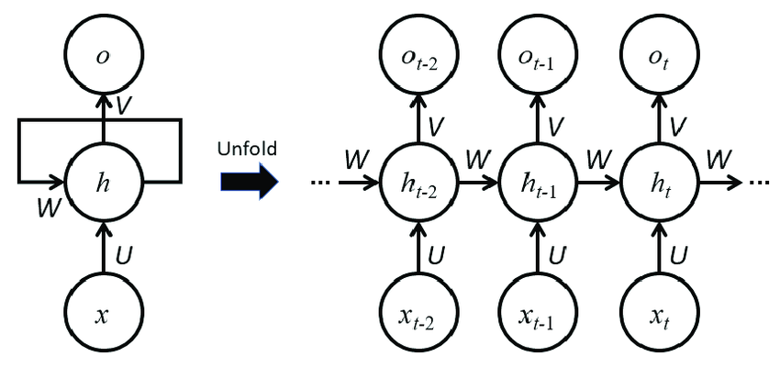words or sentences.

Figure 3 RNN

**Long Short-Term Memory (LSTM) Networks:**

LSTMs were designed to address the vanishing gradient problem in RNNs. They introduce a more complex memory cell with gating mechanisms (input gate, forget gate, output gate) that control the flow of information into and out of the cell.

* Forget Gate: Determines which information from the previous cell state should be discarded.
* Input Gate: Decides which new information from the current input should be added to the cell state.
* Output Gate: Controls which information from the cell state should be outputted to the hidden state.

LSTMs can effectively learn and retain information over longer sequences compared to traditional RNNs, making them more suitable for tasks like machine translation, text summarization, and, to some extent, analyzing longer documents. While LSTMs significantly

improved upon RNNs, they still process sequences sequentially, which can be computationally expensive for very long sequences. Additionally, capturing very long-range dependencies across entire documents could still be challenging.

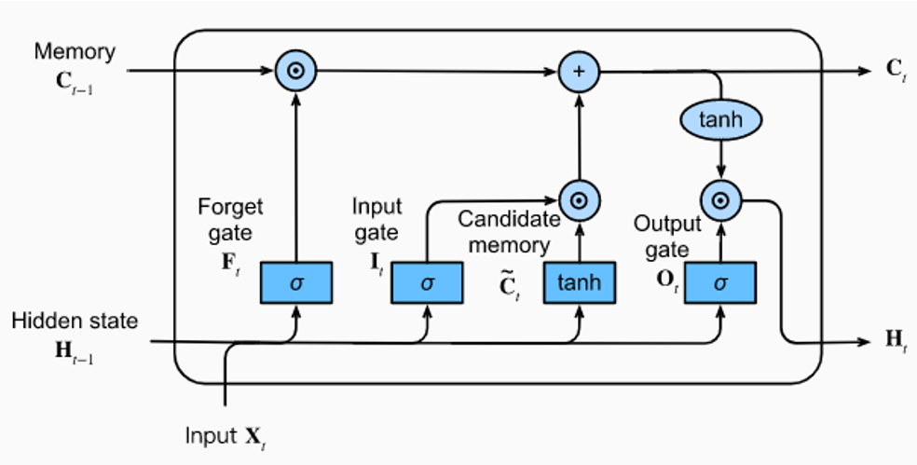Figure 4 LSTM

### The Transformer Revolution (2017)

The introduction of the transformer architecture by Vaswani et al. in their 2017 paper, "Attention is All You Need", transformed natural language processing (NLP). Unlike RNNs, transformers rely on a mechanism called self-attention, which allows the model to weigh the importance of every word in a sequence relative to others, regardless of their distance. This breakthrough enabled the capture of long-range dependencies and complex contextual relationships critical for legal texts where terms and clauses are often interlinked across documents.

**Self-Attention Mechanism:**

Unlike RNNs that process words sequentially, self-attention allows the model to directly assess the importance of each word in the input sequence relative to all other words in the same sequence.

For each word in the input sequence, the transformer calculates three vectors:

* Query (Q): Represents what the current word is looking for in other words.
* Key (K): Represents what information other words can offer.
* Value (V): Represents the actual information content of other words.

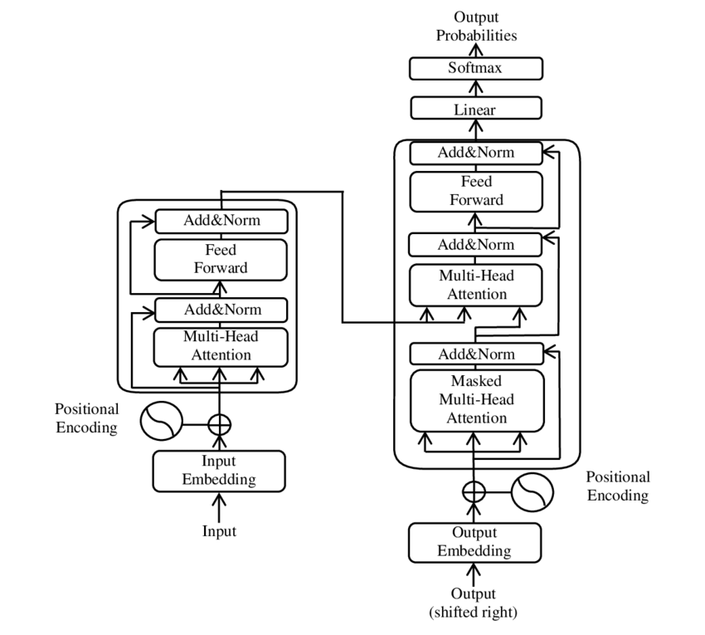Figure 5 Transformer Architecture

The attention score between two words is calculated by taking the dot product of the query vector of one word and the key vector of the other word. This score indicates how relevant the second word is to the first word.

These attention scores are then normalized (using a softmax function) to obtain weights that represent the importance of each word in the sequence for the current word.

Finally, these weights are used to compute a weighted sum of the value vectors of all words, resulting in an attention output for the current word. This output captures the context of the current word by considering its relationships with all other words in the sequence.

Significance: Self-attention enables the model to directly capture long-range dependencies without being limited by the sequential nature of RNNs. A word can directly attend to any other word in the sequence, regardless of their distance.

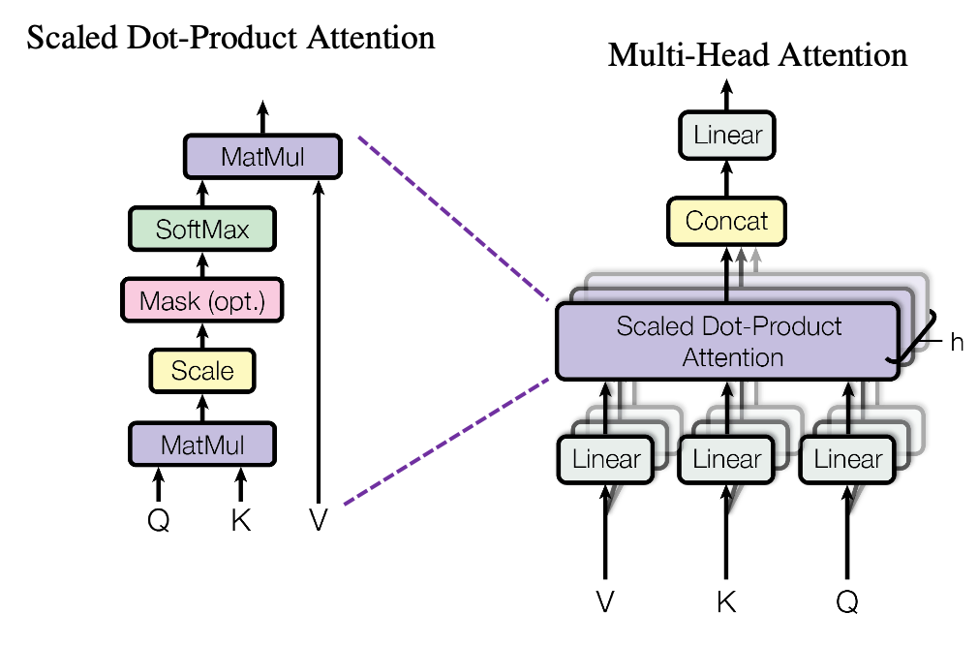**Multi-Head Attention:** The transformer employs multiple parallel self-attention mechanisms (heads), allowing the model to attend to different aspects of the relationships between words simultaneously.

Figure 6 Multi-head attention mechanism

**Positional Encoding:** Since the transformer processes all words in parallel, it needs a mechanism to understand the order of words in the sequence. Positional encoding adds a vector to each word embedding that represents its position in the sequence.

**Feed-Forward Networks:** After the attention layer, each word's representation is passed through a feed-forward neural network.

**Encoder-Decoder Architecture:** The original transformer architecture consisted of an encoder (to process the input sequence) and a decoder (to generate the output sequence), often used in tasks like machine translation.

### Modern LLMs

Building on transformers, models like BERT (Bidirectional Encoder Representations from Transformers) and GPT (Generative Pre-trained Transformer) emerged. These models are pre-trained on vast text corpora and fine-tuned for specific tasks, offering unprecedented capabilities in understanding and generating human-like text. The Cohere LLM, utilized in this methodology, exemplifies this class of models, optimized for tasks like legal text comprehension.

Building upon the foundation of the transformer architecture, modern Large Language Models (LLMs) have emerged, demonstrating unprecedented capabilities in understanding and generating human-like text.

* Transformer-Based Architecture: LLMs are primarily based on the transformer architecture, often with variations and optimizations.
* Massive Pre-training: These models are pre-trained on extremely large datasets of text and code, often containing billions or even trillions of tokens. This pre-training allows the model to learn general-purpose representations of language, capturing a vast amount of knowledge about grammar, semantics, and even the world.
* Scale of Parameters: LLMs typically have a very large number of parameters (ranging from hundreds of millions to hundreds of billions or even trillions), which allows them to learn complex patterns in the data.
* Fine-tuning for Specific Tasks: After pre-training, LLMs can be fine-tuned on smaller, task-specific datasets to adapt their learned representations to perform particular tasks, such as text classification, question answering, text generation, and, legal text comprehension.

BERT (Bidirectional Encoder Representations from Transformers): BERT is designed to understand the context of words in both directions (left and right) within a sentence. It is often used for tasks that require understanding the meaning of text, such as sentiment analysis, named entity recognition, and question answering.

GPT (Generative Pre-trained Transformer): GPT models are primarily designed for generating text. They are trained to predict the next word in a sequence and can be used for tasks like text generation, translation, and summarization.

Cohere LLM: This models, like others in this are optimized for various natural language processing tasks, including legal text comprehension, which often requires understanding language and complex relationships between different parts of a document.

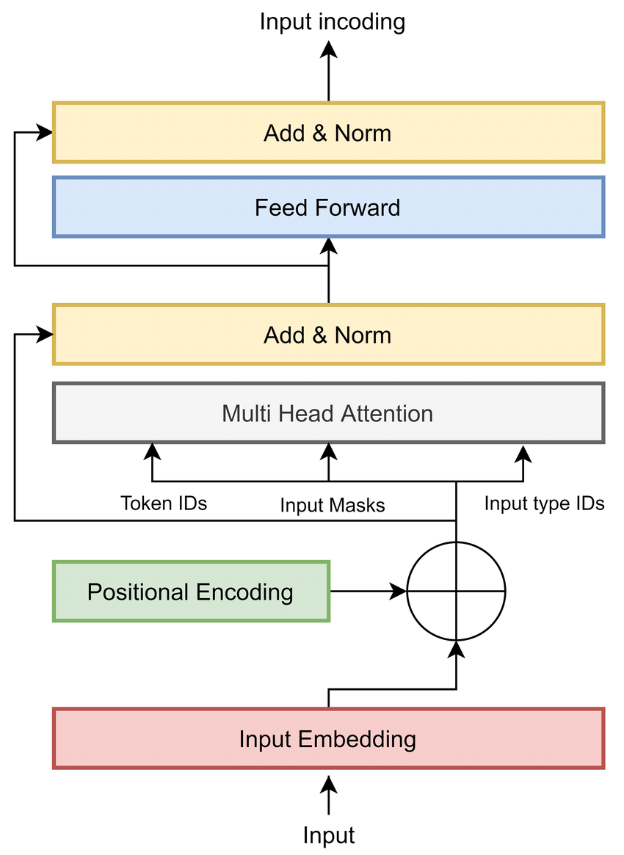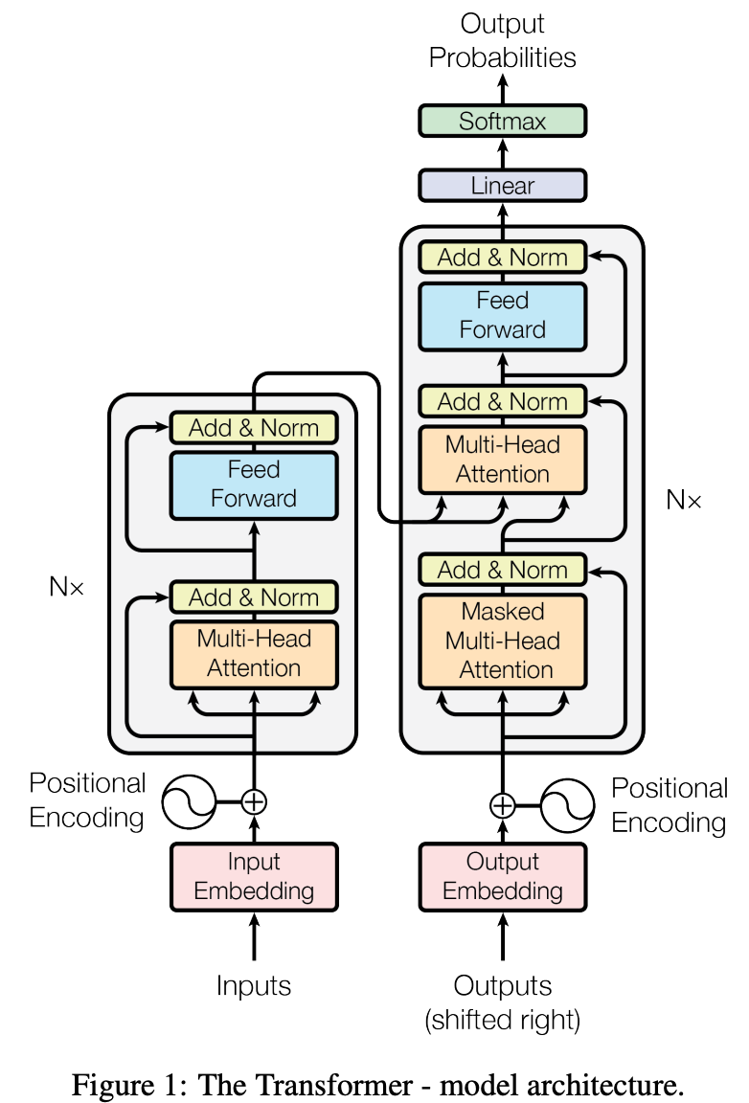Figure 7 Generative pretrained transformer

### Reasoning Ability of LLMs

The reasoning capacity of LLMs is a critical factor in this methodology, influencing all components but especially the agents’ ability to orchestrate workflows and the decision engine’s evaluation process.

Modern LLMs exhibit impressive reasoning skills, such as answering questions, following logical sequences, or drafting coherent text. However, this “reasoning” is primarily pattern-based, derived from extensive training data rather than true symbolic reasoning. For example, an LLM can infer that a contract’s termination clause requires notice based on patterns in similar documents, but it may not independently deduce legal principles without prior exposure.

Application in Legal Tasks: In this system, reasoning is essential for understanding clause implications (e.g., ensuring consistency between payment and penalty terms) and generating compliant contracts. While the Cohere LLM excels at pattern recognition, complex legal reasoning like anticipating unenforceable clauses may still require augmentation.

Limitations and Enhancements: To address potential gaps, the methodology integrates the decision engine’s rule-based logic and iterative feedback loops, compensating for the LLM’s reliance on statistical patterns. This hybrid approach balances the LLM’s strengths with structured oversight.

## Agents

The second component, Agents, leverages the LangGraph framework to introduce an agentic approach, enabling autonomous management of workflows and tool selection.

The Agentic Approach: Unlike traditional LLMs that produce outputs in a single pass, an agentic system allows the model to interact with its environment, make decisions, and execute multi-step processes. In this methodology, agents act as orchestrators, determining the tools and steps needed based on the task e.g., analyzing a statute versus drafting a contract.

LangGraph Framework: While LangChain is a well-known framework for building LLM-based applications with agents, tools, and memory, “LangGraph” may refer to a specialized extension or a related concept. Assuming it’s a graph-based framework, LangGraph likely structures workflows as nodes (tasks/tools) and edges (data/control flow). For instance:

* **Node 1**: Text parser extracts clauses.
* **Node 2**: Template matcher identifies standard sections.
* **Edge**: Parsed clauses flow to the matcher for alignment.

Functionality: Agents select tools like text parsers or legal databases based on the input such as a contract or case law and context like jurisdiction. They also initiate an iterative reasoning process, refining outputs through feedback from the decision engine. For example, if drafting a contract, an agent might retrieve a template, populate it with clauses, and adjust based on compliance feedback.

Significance: This autonomy and adaptability make the agents ideal for handling the dynamic nature of legal tasks, ensuring context-aware and legally sound outputs.

## Decision Engine

The Decision Engine is the final component, acting as a quality assurance layer to ensure outputs meet legal standards.

Functionality: This rule-based module evaluates NLU analyses and agent-generated contracts against predefined legal guidelines (e.g., statutory requirements, jurisdictional rules). For example, it checks if a contract’s indemnification clause aligns with local law or if a summary omits critical case law details.

Iterative Feedback: If an output is non-compliant or contextually inaccurate, the decision engine triggers a reiteration. The agent refines the output, and the process repeats until standards are met. This iterative approach ensures precision but may introduce delays, a trade-off for reliability.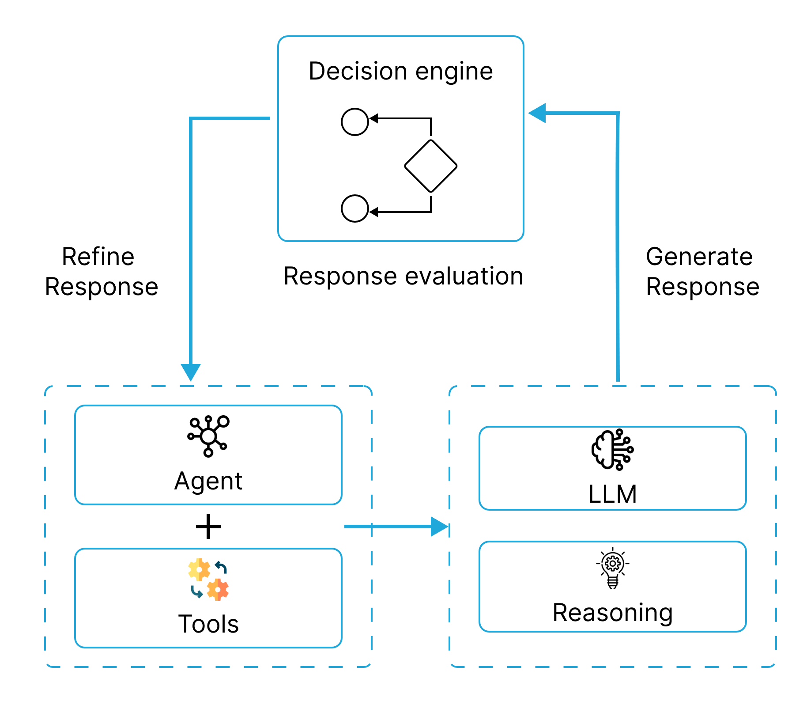

Figure 8 Decision engine

## Challenges in Ethical consideration-

The integration of AI into legal workflows, while promising significant benefits, also presents several challenges and raises important ethical considerations that must be carefully addressed. Data security and privacy are paramount concerns when dealing with sensitive legal information. Robust protocols must be in place to protect client confidentiality and comply with relevant regulations. Ethical considerations surrounding the use of AI in law include the potential for bias in algorithms, which could lead to unfair or discriminatory outcomes. Ensuring transparency in how AI systems make decisions is also crucial, as the "black box" nature of some AI models can be problematic in a field that demands accountability. The need for human oversight remains essential to validate AI-generated results, ensure accuracy, and maintain accountability for legal advice and decisions.

Integrating AI tools with existing legal technology infrastructure can also pose challenges, requiring seamless interoperability to avoid disrupting established workflows. The initial cost of implementing AI solutions and the ongoing investment in training legal professionals to use these tools effectively can also be significant barriers to adoption. Furthermore, in a rapidly evolving legal landscape, maintaining the freshness of the data used to train AI models is critical to ensure the relevance and accuracy of their output.

Several ethical considerations warrant particular attention. Bias in the training data used to develop AI models can lead to skewed results, potentially perpetuating existing societal inequalities in the legal system. The lack of transparency in some AI algorithms makes it difficult to understand the reasoning behind their decisions, which can be problematic in legal contexts where explainability is often required. The increasing automation of legal tasks raises questions about the impact on the legal profession and the future of legal jobs. Finally, determining responsibility and liability for errors made by AI systems is a complex issue that needs careful consideration.

Looking ahead, the field of legal AI is poised for significant advancements. We can expect to see the development of more sophisticated RAG models with improved capabilities for retrieving and generating contextually relevant legal information. AI agents are likely to become more autonomous and capable of handling increasingly complex legal tasks, potentially managing entire aspects of the contract lifecycle or conducting more in-depth legal research. The integration of AI with other emerging technologies, such as blockchain for secure and transparent contract management, could also become more prevalent. Future AI tools for legal professionals will likely focus on enhanced user-friendliness and accessibility, catering to those without deep technical expertise. We may also see increased specialization of AI tools for niche areas of law, providing highly tailored solutions for specific legal domains

# Results Analysis and Validation

This chapter analyzes and validates the performance of our text-to-speech model with emotion infusion. We employed the Tacotron model as the baseline architecture and embedded emotion vectors along with text vectors for emotional speech generation.

## Model overview

The model for legal document generation and analysis addresses specific challenges in legal document processing. Built on Cohere's large language model, it processes user queries about contract clauses, risk assessments, and improvement suggestions, delivering context-aware responses.

This model implements an agentic-based approach using the LangGraph framework, enabling iterative refinement of responses rather than relying solely on zero-shot generation. This methodology helps maintain the precision required for legal documents where errors can have significant consequences. The iterative approach helps address the challenges of processing lengthy, repetitive legal texts that are traditionally prone to human error during manual review

## Prototype

The prototype developed for legal document generation and analysis system is designed to handle legal contracts. This tool enables users to analyze existing legal documents and generate new contracts with minimal effort. The interface is structured in left and right panel. the left side of the layout displays the full conversation history, allowing users to track and refer back to previous interactions, while the right side is conversational chatbox where users can input queries or commands and receive AI-generated responses in real time. At the heart of this prototype is Cohere, a powerful large language model (LLM) used for natural language understanding and response generation. Cohere processes user queries related to legal documents such as explanations of contract clauses, risk assessments, or suggestions for improvement and returns detailed, context-aware insights.

The prototype accepts a variety of file formats to accommodate user needs, including PDF, DOC, DOCX, JPG, JPEG, and PNG. This broad file compatibility ensures that users can upload and analyze legal documents regardless of their original format. For image-based documents (JPG, JPEG, and PNG), the system incorporates Pytesseract, a Python-based Optical Character Recognition (OCR) library, to extract text content from the images, making it possible to analyze printed or scanned documents as well. Once uploaded, users can interact with the document via the chat interface to ask questions, highlight concerns, or request modifications.

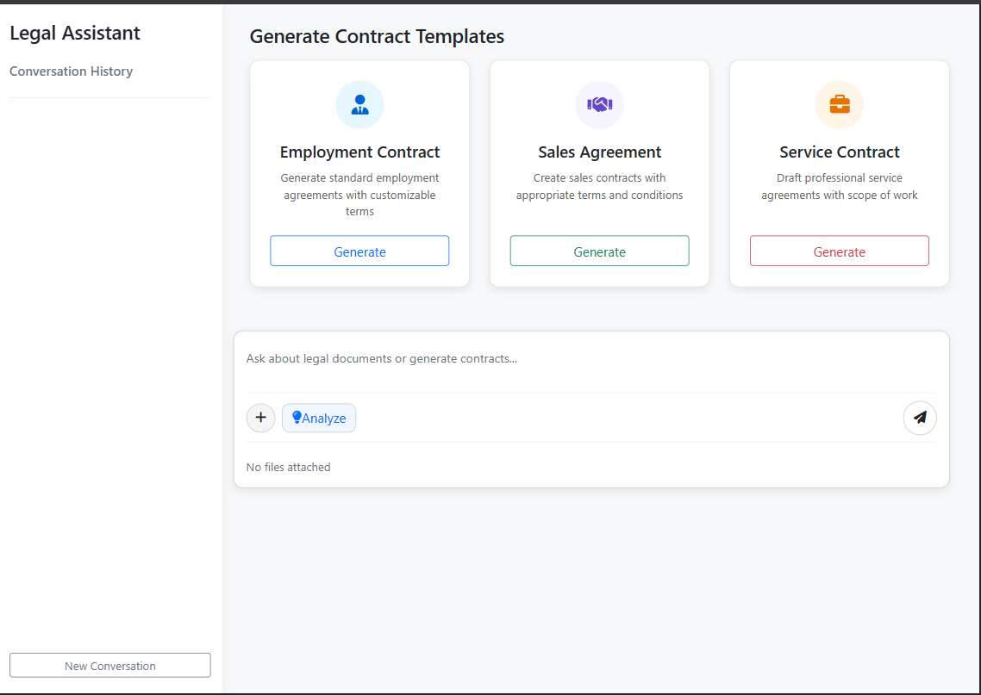The prototype supports the creation and customization of three core contract types: Sales Contracts, Employee Contracts, and Service Contracts. Users have the flexibility to modify these contracts manually through a text editor or conversationally through the AI-powered chat interface, which can generate or revise clauses based on user input. This dual-mode editing allows for both precision and ease of use, catering to users with varying levels of legal expertise. Due to current system limitations related to API usage, each user is allowed up to 20 interactions or queries per session, ensuring balanced resource utilization

Figure 9: Legal analysis chatbot prototype

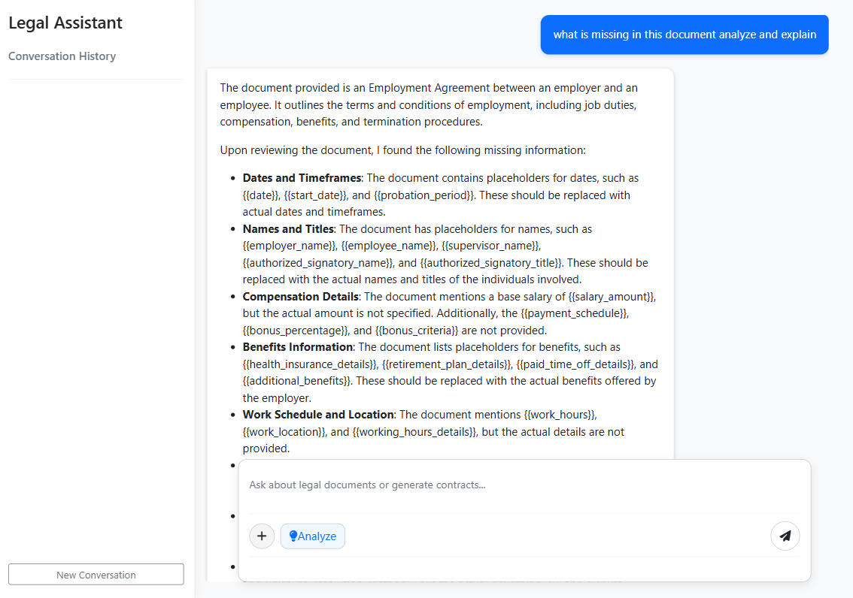The figure 10 displays the prototype's interface during the analysis of a legal document. Users can upload contracts in various formats such as PDF, DOCX, JPG, or PNG. The AI, powered by Cohere, processes the content and returns a detailed analysis through the chatbox on the right. The conversation history on the left tracks all previous interactions, making it easy for users to follow the analysis and revisit earlier queries.

Figure 10: Analysing doc type file

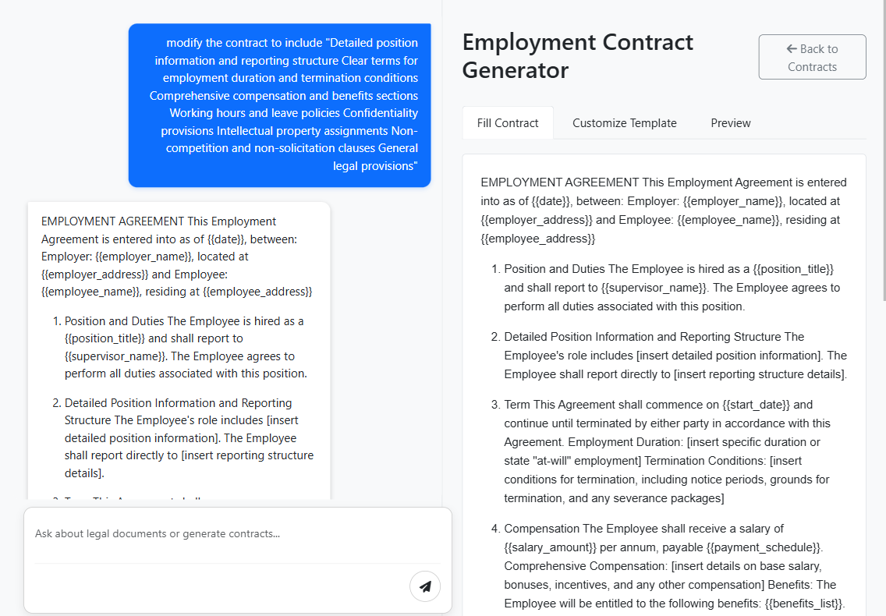figure 11 highlights the prototype's capability to generate a customized Employee Contract. Users can request the creation of an employment agreement through the chatbox, either by providing specific terms or by selecting from predefined templates. The system uses natural language processing to create a legally coherent draft, which users can further edit manually or refine through the chat.

Figure 11: Generating employee contract

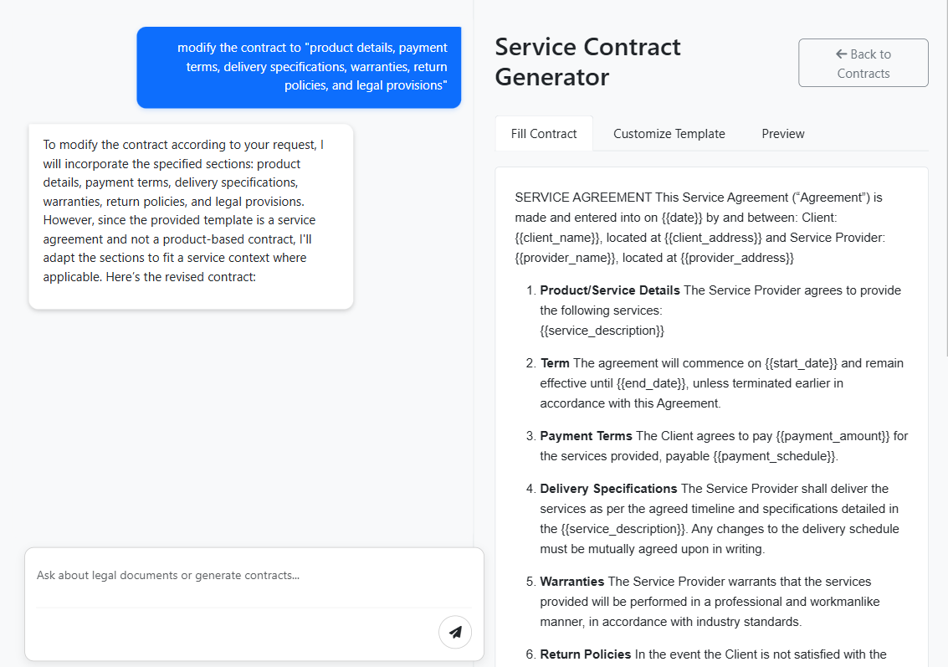This figure demonstrates the generation of a **Service Contract**, enabling users to define agreements for professional services. The chat-driven interface allows users to describe the scope of services, duration, payment structure, and other essential elements. The AI interprets the input and generates a clear, structured contract, ready for review and adjustment

Figure 12: Service contract generation

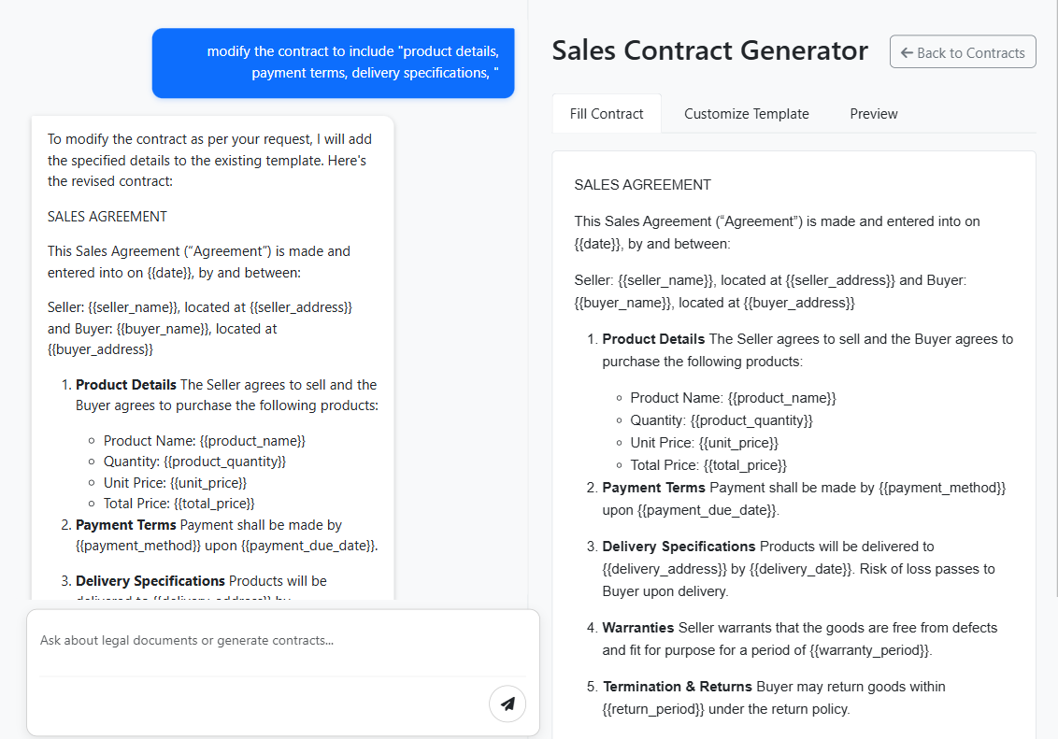Shows the process of generating a **Sales Contract** using the prototype. Through a simple conversation in the chatbox, the user specifies key details such as buyer/seller information, payment terms, and delivery conditions. The AI then produces a draft that conforms to standard legal formats, allowing the user to customize it further as needed

Figure 13: Sales contract generation

## Evaluation Metrics

To assess the effectiveness of the proposed legal document analysis and generation method, a comprehensive evaluation was conducted using both quantitative and framework-based metrics. For the legal analysis component, three key evaluation parameters were used: precision, recall, and clause detection accuracy. Precision measures the proportion of relevant information correctly identified by the system out of all information retrieved, while recall assesses the system’s ability to retrieve all relevant clauses from the input document. Clause detection accuracy reflects how

effectively the system can identify and interpret distinct legal clauses within various document types. These metrics are essential in evaluating the reliability of the model in extracting meaningful and contextually accurate legal information.

Table 2: Evaluation of Legal document analysis and Contract generation

|  |  |  |
| --- | --- | --- |
| Metrics | Legal Document Analysis (%) | Contract Generation (%) |
| Precision | 82 | 84 |
| Recall | 78 | 81 |

For the contract generation component, the LangChain evaluation framework was employed. This framework evaluates the coherence, structure, and legal soundness of the generated contracts, ensuring that outputs are both syntactically valid and contextually appropriate.

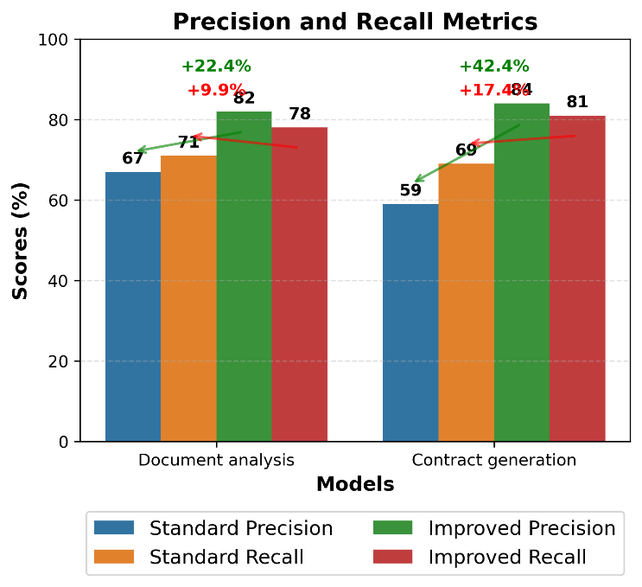

Figure 14: comparison between base and agent-based model

The experimental results demonstrate the robustness of the proposed agentic-based large language model (LLM), which operates using an iterative refinement process. The model achieved a precision of 82%, indicating that the majority of its outputs were relevant and accurate. A recall of 84% shows its strong ability to extract pertinent legal content from diverse formats, and an overall clause detection accuracy of 89% confirms its high performance in recognizing and analyzing legal clauses. These results validate the prototype’s effectiveness in both understanding legal documents and generating high-quality contractual content.

# Conclusion and future work

## Conclusion

The integration of Artificial Intelligence into legal practice is rapidly transforming how legal professionals approach document analysis and contract management. AI offers significant opportunities to enhance efficiency, improve accuracy, and streamline complex workflows. Techniques like Retrieval-Augmented Generation are proving invaluable in grounding AI-generated content in reliable legal knowledge, mitigating the risks of inaccuracies and hallucinations. Furthermore, the rise of AI agents tailored for contract management promises to revolutionize the entire contract lifecycle, from initial drafting to post-execution management.

The benefits of these AI-powered solutions are substantial, including increased productivity, faster turnaround times, reduced errors, cost savings, and improved compliance. However, the adoption of AI in the legal field is not without its challenges. Concerns surrounding data security, ethical implications such as algorithmic bias, and the necessity of maintaining human oversight must be carefully addressed to ensure responsible and effective implementation.

The future of legal practice in the age of AI will likely involve a collaborative partnership between legal professionals and intelligent machines. By thoughtfully embracing these technologies and addressing the associated challenges, the legal industry can unlock new levels of efficiency, accuracy, and ultimately, better serve their clients in an increasingly complex world. The key lies in adopting a balanced approach that leverages the power of AI while retaining the essential human judgment, ethical considerations, and nuanced understanding that define the legal profession

## Future Work

There are several directions that could further advance the capabilities and impact of AI-driven legal tools. One promising area is the improvment of domain-specific knowledge integration, allowing systems to better adapt to jurisdictional nuances and evolving regulations. This would enable more context-aware analysis and drafting, tailored to specific legal environments. Additionally, refining user interaction mechanisms such as adaptive conversational interfaces and guided editing experiences could make these tools more accessible and intuitive for legal professionals and non-experts alike.

Another important area involves improving multilingual support and cross-border document handling, which would expand the applicability of these solutions in global legal contexts. There is also significant potential in exploring adaptive learning systems that evolve through real-world use, enabling them to offer increasingly personalized and context-sensitive recommendations.

From a technical standpoint, further research into safeguarding mechanisms, including audit trails and transparency features, will be essential to reinforce trust in automated processes. Exploring secure federated learning models could also help address data privacy concerns while allowing models to benefit from distributed learning across firms or institutions. Future iterations should not only focus on improving functionality but also on aligning with legal values and professional standards, ensuring that technology remains a responsible and reliable partner in legal decision-making

# References

1. I. Dikmen, G. Eken, H. Erol, and M. T. Birgonul, “Automated construction contract analysis for risk and responsibility assessment using natural language processing and machine learning,” Computers in Industry, vol. 166, p. 104251, Jan. 2025, doi: 10.1016/j.compind.2025.104251.
2. Agarwal, R., Sharma, A. “The Future of Legal Practice: The Impact of Technology,” International Journal of Research Publication and Reviews (IJRPR), Vol 5(11), 2024, 6292–6300. https://ijrpr.com/uploads/V5ISSUE11/IJRPR35521.pdf
3. C. Kerdvibulvech, “Big data and AI-driven evidence analysis: a global perspective on citation trends, accessibility, and future research in legal applications,” Journal of Big Data, vol. 11, no. 1, Dec. 2024, doi: 10.1186/s40537-024-01046-w.
4. J. H. Choi and D. Schwarcz, “AI assistance in Legal Analysis: an Empirical study,” SSRN Electronic Journal, Jan. 2023, doi: 10.2139/ssrn.4539836.
5. M. H. Zakir, S. Bashir, R. N. Ali, and S. H. Khan, “Artificial Intelligence and Machine Learning in Legal Research: A Comprehensive Analysis,” QJSS, vol. 5, no. 1, pp. 307–317, Mar. 2024, doi: 10.55737/qjss.203679344.
6. R. Bhambhoria, S. Dahan, J. Li, and X. Zhu, “Evaluating AI for Law: Bridging the Gap with Open-Source Solutions,” arXiv (Cornell University), Apr. 2024, doi: 10.48550/arxiv.2404.12349.
7. J. Frankenreiter and J. Nyarko, “Natural language processing in legal tech,” SSRN Electronic Journal, Jan. 2022, doi: 10.2139/ssrn.4027030.
8. L. Robaldo, S. Villata, A. Wyner, and M. Grabmair, “Introduction for artificial intelligence and law: special issue ‘natural language processing for legal texts,’” Artificial Intelligence and Law, vol. 27, no. 2, pp. 113–115, Apr. 2019, doi: 10.1007/s10506-019-09251-2.
9. Vinay, S. B. "Natural Language Processing for Legal Documentation in Indian Languages." International Journal of Natural Language Processing (IJNLP) 2, no. 1 (2024): 1-11.
10. P. N. Devaraj, P. V. R. Teja, A. Gangrade, and M. K. R, “Development of a legal document AI-Chatbot,” arXiv (Cornell University), Jan. 2023, doi: 10.48550/arxiv.2311.12719.
11. S. Nasir, Q. Abbas, S. Bai, and R. A. Khan, “A comprehensive framework for reliable legal AI: combining specialized expert systems and adaptive refinement,” arXiv (Cornell University), Dec. 2024, doi: 10.48550/arxiv.2412.20468.
12. J. S. Dhani, R. Bhatt, B. Ganesan, P. Sirohi, and V. Bhatnagar, “Similar Cases Recommendation using Legal Knowledge Graphs,” arXiv (Cornell University), Jan. 2021, doi: 10.48550/arxiv.2107.04771.
13. C. J. Mahoney, J. Zhang, N. Huber-Fliflet, P. Gronvall, and H. Zhao, “A framework for Explainable text Classification in Legal Document review,” arXiv (Cornell University), Jan. 2019, doi: 10.48550/arxiv.1912.09501.
14. Y. Mao, X. Li, Z. Li, and W. Li, “Automated Smart Contract Summarization via LLMS,” arXiv (Cornell University), Feb. 2024, doi: 10.48550/arxiv.2402.04863.
15. Z. Li et al., “AutoFlow: Automated workflow generation for large language model agents,” arXiv (Cornell University), Jul. 2024, doi: 10.48550/arxiv.2407.12821.
16. Y. Tong, W. Tan, J. Guo, B. Shen, P. Qin, and S. Zhuo, “Smart contract generation assisted by AI-Based word segmentation,” Applied Sciences, vol. 12, no. 9, p. 4773, May 2022, doi: 10.3390/app12094773.
17. Vaswani et al., “Attention is all you need,” arXiv (Cornell University), Jan. 2017, doi: 10.48550/arxiv.1706.03762.