**Legal Document Analysis and Automated Contract Generation Using AI**

Avinash Singh Haobijam  
*Computer Science and Engineering Apex Institute of Technology, Chandigarh University*

Gharuan, Mohali, Punjab, India, 140413,

Avinash2062002@gmail.com

Kiran Preet Bedi

*Computer Science and Engineering*

*Apex Institute of Technology,*

*Chandigarh University*

Gharuan, Mohali, Punjab, India, 140413,

Kiranbedi572@gmail.com

Debasish Hazarika

*Computer Science and Engineering*

*Apex Institute of Technology,*

*Chandigarh University*

Gharuan, Mohali, Punjab, India, 140413,

debasishhazu@gmail.com

*Abstract*—Analyzing legal documents requires to maintain high precision, as even minor errors can result in severe consequences. Legal documents are usually large in volume and have repetitive nature that make manual analysis tedious and prone to mistake. Recent advancements in large language models (LLMs) present potential solutions for automating legal document processing. This work presents an innovative approach using an agentic-based LLM to analyze legal documents and generate contracts. The method integrates generative capabilities of LLMs with LangGraph framework to construct an intelligent agent capable of refining responses iteratively. This study compares between zero-shot generation and an iterative approach and highlights trade-offs between the two approaches. The proposed method is evaluated based on precision, recall, and clause detection for legal analysis and LangChain evaluation framework for contract generation. Experimental results demonstrate agentic-based LLM with an iterative process achieves 82% precision, 84% recall, and 89% accuracy in generating appropriate responses. These findings points out iterative refinement improves effectiveness of LLM-based legal analysis and contract generation, making it a viable solution for improving accuracy in the legal domain.

Keywords—Agent, LangGraph, LangChain, LLMs, RAG

# Introduction

The legal industry stands at the point for a significant transformation, driven by rapid advancements in Artificial Intelligence. Legal professionals are increasingly recognizing the potential of AI technologies to optimize traditional workflows. Among impactful application of AI in law are legal document analysis and automated contract generation. The increase volume and complexity of legal information necessitates adoption of more efficient and accurate tools to manage and drive insights from this vast data. Several core AI methodologies underpin those advancements, each contributing unique capabilities to the process. Being able to understand human language is prominent, NLP enables AI system to understand, interpret and process case law, legal document and contract. Machine learning (ML) algorithms can identify patterns, learn from vast datasets of legal documents, and make predictions or classification based on learned parameters.

Two key areas where AI being used in legal domain are processing of legal documents and automated creating of contracts. Legal documents analysis uses Natural language processing techniques to examine, categorize and extract critical information from various legal documents including case law, statutes, and contracts. This capability facilitates review process, improves accuracy, and allow legal professionals to focus on more strategic aspects of their work. Legal contract generation utilizes large language model to create legally sound and customized contracts based on predefined templates and user input. This approach accelerates contract drafting process and reduces potential human error and ensure consistency across agreement.

Large language models are efficient and effective at analyzing and reasoning large amount of data. LLMs are limited to training data, they can only refer to existing knowledge in there paraments. When asked beyond trained data they tend to hallucinate and this behavior can result in a serious damage in legal matters or any other domain. To improve their domain knowledge, Retrieval Augmented Generation (RAG) has emerged to enhance their capability. Unlike traditional language models that rely solely on their pre-existing training data, RAG first retrieve relevant information from an external knowledge base, such as database or legal documents and use retrieved information as context to generate more accurate and reliable responses. This approach helps to ground LLM output in real-world legal knowledge significantly reducing risk of generating incorrect or hallucinated information.

The RAG process fundamentally involves two key steps information retrieval and text generation. When a user poses a query, system first searches its internal knowledge base for most relevant legal documents and data using techniques like semantic search. Once relevant information is retrieved, it is then used by advanced language models to generate a coherent and contextually appropriate response. Key component in this process includes chunk which are smaller sections of document in knowledge base, queries, which are user’s questions and prompts, which are instructions given to language model, combining query with retrieved information. The effectiveness of RAG system heavily relies on quality and relevance of data it retrieves. Different RAG model exists ranging from simple models for broad analysis to more advanced model capable of handling complex queries requiring precise information. Graph RAG models for example leverages knowledge graphs to map out relationships between legal entities, offering a sophisticated approach for understanding deeper connections within legal text. While RAG significantly mitigates risk of hallucination, practical consideration such as context window limitations, the potential of inaccurate, the need of well-crafted prompts remains crucial for optimizing performance of RAG models.

Automated contract generation is another area where AI is making notable effects in transforming legal practices. Contact generation involves the use of LLMs to understand the language used in legal contacts, identifying pattern, key term and concept through machine learning algorithm. Generative models then produce contract drafts based on user-provided prompts and customizable templates. A key development in this domain is the emergence of AI agents. The capabilities of AI agents in contract generations are wide, starting from automating drafts, agents can generate initial contract drafts using standard templates and specific data input, contract review and analysis AI agents can highlight deviations from standard terms, flag unusual clauses for human review, and identify key terms, obligation and potential risk within contracts.

# Literature Review

The integration of advanced technologies into legal domain has shown remarkable progress, evolving from foundational applications of Natural Language Processing (NLP) and Machine Learning (ML) to sophisticated Artificial Intelligence (AI) frameworks that address complex legal challenges. This literature review explores previous work based on the emergence and progression of these technologies, explaining the progress of innovation that builds logically from one advancement to the next.

## NLP and ML in Contract Analysis

The application of NLP and ML to automate analysis of legal contracts, tackling inefficiencies of manual processes. NLP techniques such as Bag of Words vectorization and ML algorithms such as text classification and ensemble methods to analyze construction contracts [1]. Utilizing Python libraries including spaCy, PDFMiner, and scikit-learn, they focused on the FIDIC standard contracts to identify risks, responsibilities, and rights. Achieving 89% accuracy in sentence type identification and 83% in classifying related parties, this work demonstrated the potential of automation to accelerate risk management, laying a critical foundation for subsequent legal tech innovations.

Building on this groundwork, [2] explored NLP’s broader utility in legal tasks beyond contracts. Using foundational models like Bag of Words alongside advanced distributional semantics, researchers automated document review, legal brief analysis, and case outcome predictions. While effective in repetitive tasks, the study revealed NLP’s limitations in complex legal reasoning, signaling a need for more advanced tools and setting the stage for the field’s expansion.

The scalability of NLP was tested in a subsequent effort [3] that tackled large-scale legal texts. Employing tools like CLAUDETTE and Deep Learning models with Word2Vec embeddings, researchers automated the detection of unfair clauses in terms of service agreements and extracted arguments from multilingual documents. This work highlighted NLP’s ability to handle vast datasets, a critical step toward broader legal applications.

Recognizing linguistic diversity, another study [4], tailored NLP to India’s multilingual legal landscape. Using the Indic NLP Library and models like IndicBERT, researchers automated translation, classification, and summarization of legal texts across regional languages. This adaptation not only bridged linguistic gaps but also underscored the versatility of NLP, paving the way for its integration with emerging AI technologies.

As NLP matured, the focus shifted to broader AI applications, integrating additional technologies to transform legal practices. One study examined how AI, blockchain, and big data could enhance efficiency, access to justice, and legal education [5]. By analyzing workflows with AI-driven tools, researchers demonstrated improvements in document processing and predictive analytics, marking a pivotal transition from specialized NLP tasks to comprehensive AI solutions.

This momentum continued with the exploration of Big Data Analytics and AI in legal evidence analysis [6], Employing NLP, ML, predictive analytics, and computer vision, the study improved document review, case prediction, and evidence gathering. It also addressed ethical challenges like algorithmic bias, illustrating AI’s growing role in tackling both practical and moral dimensions of legal work.

The introduction of LLMs marked a significant leap forward. Researchers [7] investigated GPT-4’s ability to assist in legal analysis and reasoning, testing it on law school exams. While it boosted performance on multiple-choice questions by 29 percentile points particularly for lower-performing students its limited impact on essay writing highlighted the need for further refinement. This study bridged foundational NLP with advanced AI, pushing the boundaries of legal education and practice. Concurrently, another study, showcased AI and ML’s transformative role in legal research [8]. Using platforms like ROSS Intelligence, Kira Systems, and Lex Machina, researchers automated document review, contract analysis, and litigation predictions. Achieving significant time savings and precision, this work emphasized AI’s practical benefits while calling for ethical oversight, reinforcing the narrative of responsible innovation.

The development of legal chatbots emerged as a natural progression [9]. Evaluated general-purpose AI like ChatGPT for legal question-answering, advocating for domain-specific models like Mixtral-8x7B. Testing on the LegalQA dataset, founding GPT-4 more reliable but verbose, driving the push for tailored solutions. Complementing this, another effort [10] built a chatbot using LangChain and GPT, enabling efficient query processing for legal documents like the Indian Constitution. Together, these studies highlighted AI’s potential to enhance accessibility, setting the stage for more reliable systems.

To address AI’s reliability, a framework integrating Retrieval-Augmented Generation (RAG), Knowledge Graphs, and Reinforcement Learning from Human Feedback (RLHF) was proposed [11]. This Mixture of Experts approach, tested on datasets like LegalQA, reduced hallucinations and improved accuracy in document review and interpretation, reflecting a maturing focus on precision and trust in legal AI.

## LLM and RAG in legal document analysis

The need for transparency motivates the adoption of Explainable AI. One method is combining ML and XAI in the Predict platform to enhance legal document review [12]. By identifying rationales for classifications in a dataset of 688,294 documents, it improved interpretability and trust, 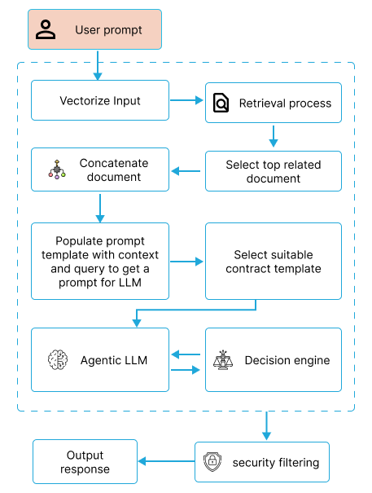addressing the “black box” challenge and building on earlier AI applications.

Parallel to this, Knowledge Graphs (KGs) emerged to structure legal information. Researchers constructed a Legal Knowledge Graph for Indian IPR cases using Relational Graph Convolutional Networks (RGCN) and LegalBERT [13]. Achieving a ROC-AUC of 0.725 for citation prediction, this work expedited case similarity searches, enhancing research efficiency and connecting AI’s analytical power with structured data.

The narrative culminates with innovations in smart contracts. One study [14] introduced the SCLA framework, using LLMs like Gemini-1.5-Pro with control flow prompts to summarize smart contract code. Outperforming baselines by 26.7% in BLEU-4 scores, it improved maintenance and vulnerability detection, reflecting the field’s shift toward specialized, code-centric applications.

AI-assisted smart contract generation framework, AIASCG, was proposed [15]. Leveraging Separation Inference (SpIn) and Collaborative Signs Dictionary, it translated natural language contracts into executable code, reducing manual adjustments by 80–100% for 88.67% of sentences. This work synthesized prior NLP and AI advancements, offering a vision for streamlined legal execution.

## Proposed System

This study presents an innovative application of large language models (LLMs) integrated with the LangGraph framework to automate legal document analysis and contract generation. The system leverages an agentic-based approach that iteratively refines responses to ensure precise extraction of critical legal information from texts such as case law, statutes, and contracts show in Fig 1. In this context, the method not only segments and organizes legal data but also employs a rule-based decision engine to validate and enhance generated contract drafts. The approach balances the trade-offs between zero-shot generation and iterative refinement, with performance guided by metrics such as precision, recall, and clause detection accuracy. This ensures that the final outputs adhere strictly to legal standards while significantly reducing the potential for human error.

# METHODOLOGY

This study leverages an agentic-based large language model (LLM) for both legal document analysis and contract generation. The system architecture is built around three primary components

**Natural Language Understanding (NLU):** Uses Cohere LLM to process and comprehend legal texts.

**Agents:** Developed with the LangGraph framework to autonomously manage tool selection and workflow.

**Decision Engine:** A rule-based module that evaluates outputs for legal compliance and contextual relevance.

## Natural Language understanding

Powered by Cohere LLM, this component serves as the analytical brain of the system. It parses various legal documents—including case law, statutes, and contracts

Fig 1 Agentic LLM system for document analysis and contract generation

extracting key clauses, terminologies, and interrelationships. This in-depth understanding ensures that critical legal information is accurately captured, which is vital for both document analysis and subsequent contract generation

## Agent

Using the LangGraph framework, the agents function autonomously to orchestrate the system’s workflow. They select the appropriate tools such as text parsers and template matchers based on the input document type and context extract utilized RAG as shown in Fig 2. The agents are also responsible for initiating an iterative reasoning process, where outputs are continuously refined through feedback loops with the decision engine. This dynamic adaptation is crucial for generating legally sound and context-aware contracts

## Decision Engine

The decision engine acts as a quality assurance module. It applies a set of predefined legal rules and guidelines to assess whether the generated summaries or contracts meet binding legal standards. If the output is found to be out of context or non-compliant, the engine triggers a reiteration of the generation process. Illustrated Fig 3 This feedback mechanism is essential for maintaining high precision and relevance, though it also introduces potential delays.

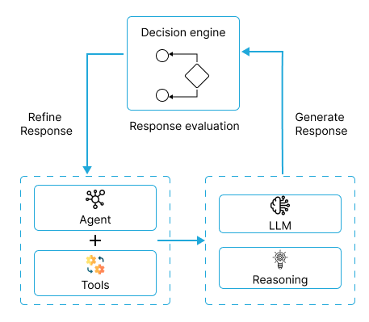Fig 2 RAG system

Fig 3 Decision engine

# Result

The experimental framework was implemented using LangChain and LangGraph, with Cohere LLM as the core NLU component. The evaluation was conducted in two parts

## Legal Document Analysis:

A dataset comprising five lease agreement samples spanning diverse file formats (PDF, DOC, PNG, JPG, and scanned documents) was used. For text-based formats (PDF and DOC), the model achieved complete parsing accuracy. For image-based documents, Tesseract OCR was integrated, resulting in an 85-90% accurate extraction rate, thereby testing the model’s parsing robustness across varied formats.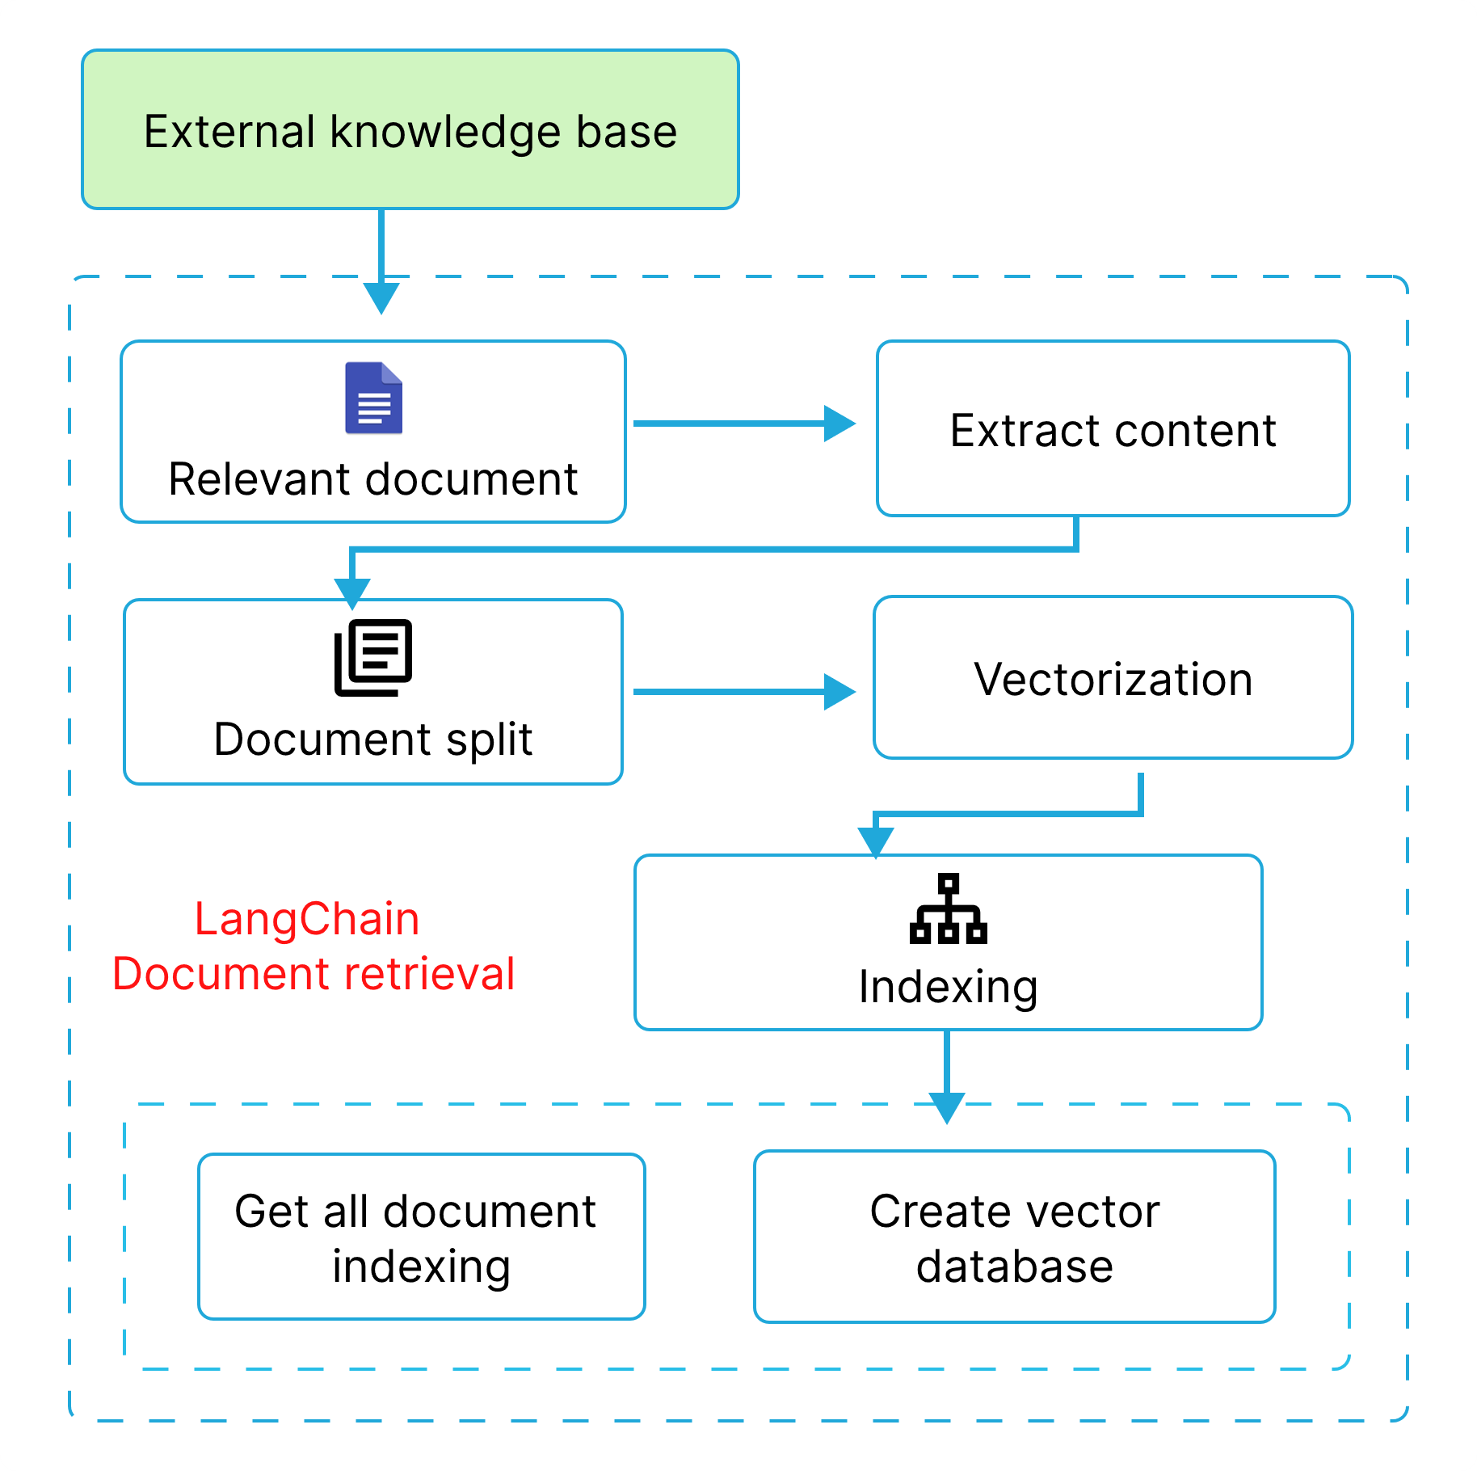

## Contract Generation:

Ten contract templates from three categories (services, sales, and employee contracts) were employed. Users provided input prompts alongside a chosen template to generate contracts. The agentic system then iteratively refined the draft to ensure legal consistency. Performance was measured using precision, recall, and clause detection accuracy for document analysis, and the LangChain Evaluation Framework for contract generation. The iterative process yielded an 85% precision, 83% recall, and 89% accuracy, significantly outperforming the zero-shot generation baseline shown in Table 1.

Table 1 Evaluation of Legal document analysis and Contract generation

|  |  |  |
| --- | --- | --- |
| Metrics | Legal Document Analysis (%) | Contract Generation (%) |
| Precision | 82 | 84 |
| Recall | 78 | 81 |

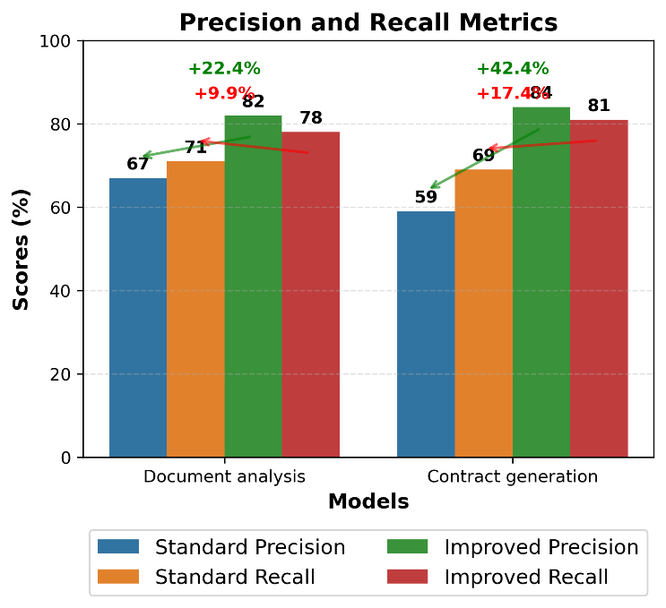

Fig 4 comparison between zero-shot and iterative model

# Conclusion

The findings demonstrate that integrating an agentic-based LLM with an iterative refinement process substantially improves the accuracy and reliability of legal document analysis and contract generation. This approach not only enhances the precision of legal information extraction but also ensures that generated contracts are legally compliant and contextually appropriate. Consequently, the proposed method presents a promising avenue for automating complex legal tasks while reducing the potential for human error.

However, several limitations exist Iterative Generation: The repeated refinement process may lead to increased response times. Parsing Limitations: While effective for standard formats, parsing non-standard or heavily formatted documents remains challenging. Context Window Constraints: The inherent limitations of current LLMs restrict processing very long or detailed legal texts. Future research should address these issues to further enhance efficiency and scalability in legal applications

##### References

1. I. Dikmen, G. Eken, H. Erol, and M. T. Birgonul, “Automated construction contract analysis for risk and responsibility assessment using natural language processing and machine learning,” Computers in Industry, vol. 166, p. 104251, Jan. 2025, doi: 10.1016/j.compind.2025.104251.
2. J. Frankenreiter and J. Nyarko, “Natural language processing in legal tech,” SSRN Electronic Journal, Jan. 2022, doi: 10.2139/ssrn.4027030
3. L. Robaldo, S. Villata, A. Wyner, and M. Grabmair, “Introduction for artificial intelligence and law: special issue ‘natural language processing for legal texts,’” Artificial Intelligence and Law, vol. 27, no. 2, pp. 113–115, Apr. 2019, doi: 10.1007/s10506-019-09251-2.
4. Vinay, S. B. "Natural Language Processing for Legal Documentation in Indian Languages." International Journal of Natural Language Processing (IJNLP) 2, no. 1 (2024): 1-11.
5. Agarwal, R., Sharma, A.. “The Future of Legal Practice: The Impact of Technology,” International Journal of Research Publication and Reviews (IJRPR), Vol 5(11), 2024, 6292–6300. https://ijrpr.com/uploads/V5ISSUE11/IJRPR35521.pdf.
6. C. Kerdvibulvech, “Big data and AI-driven evidence analysis: a global perspective on citation trends, accessibility, and future research in legal applications,” Journal of Big Data, vol. 11, no. 1, Dec. 2024, doi: 10.1186/s40537-024-01046-w.
7. J. H. Choi and D. Schwarcz, “AI assistance in Legal Analysis: an Empirical study,” SSRN Electronic Journal, Jan. 2023, doi: 10.2139/ssrn.4539836.
8. M. H. Zakir, S. Bashir, R. N. Ali, and S. H. Khan, “Artificial Intelligence and Machine Learning in Legal Research: A Comprehensive Analysis,” QJSS, vol. 5, no. 1, pp. 307–317, Mar. 2024, doi: 10.55737/qjss.203679344.
9. R. Bhambhoria, S. Dahan, J. Li, and X. Zhu, “Evaluating AI for Law: Bridging the Gap with Open-Source Solutions,” arXiv (Cornell University), Apr. 2024, doi: 10.48550/arxiv.2404.12349.
10. P. N. Devaraj, P. V. R. Teja, A. Gangrade, and M. K. R, “Development of a legal document AI-Chatbot,” arXiv (Cornell University), Jan. 2023, doi: 10.48550/arxiv.2311.12719.
11. S. Nasir, Q. Abbas, S. Bai, and R. A. Khan, “A comprehensive framework for reliable legal AI: combining specialized expert systems and adaptive refinement,” arXiv (Cornell University), Dec. 2024, doi: 10.48550/arxiv.2412.20468.
12. C. J. Mahoney, J. Zhang, N. Huber-Fliflet, P. Gronvall, and H. Zhao, “A framework for Explainable text Classification in Legal Document review,” arXiv (Cornell University), Jan. 2019, doi: 10.48550/arxiv.1912.09501.
13. J. S. Dhani, R. Bhatt, B. Ganesan, P. Sirohi, and V. Bhatnagar, “Similar Cases Recommendation using Legal Knowledge Graphs,” arXiv (Cornell University), Jan. 2021, doi: 10.48550/arxiv.2107.04771.
14. Y. Mao, X. Li, Z. Li, and W. Li, “Automated Smart Contract Summarization via LLMS,” arXiv (Cornell University), Feb. 2024, doi: 10.48550/arxiv.2402.04863.
15. Z. Li et al., “AutoFlow: Automated workflow generation for large language model agents,” arXiv (Cornell University), Jul. 2024, doi: 10.48550/arxiv.2407.12821.
16. Y. Tong, W. Tan, J. Guo, B. Shen, P. Qin, and S. Zhuo, “Smart contract generation assisted by AI-Based word segmentation,” Applied Sciences, vol. 12, no. 9, p. 4773, May 2022, doi: 10.3390/app12094773.
17. Vaswani et al., “Attention is all you need,” arXiv (Cornell University), Jan. 2017, doi: 10.48550/arxiv.1706.03762.